**eFigure 2. COVID-19 Infections by Date and Vaccine Type**

mRNA-1273 (n=387)

*

BNT162b2 (n=212)

*

Ad26.COV2.S (n=10)

*

Unvaccinated (n=10)

Boosted (n=28)

Delta

Alpha

Dominant variant in NYSa

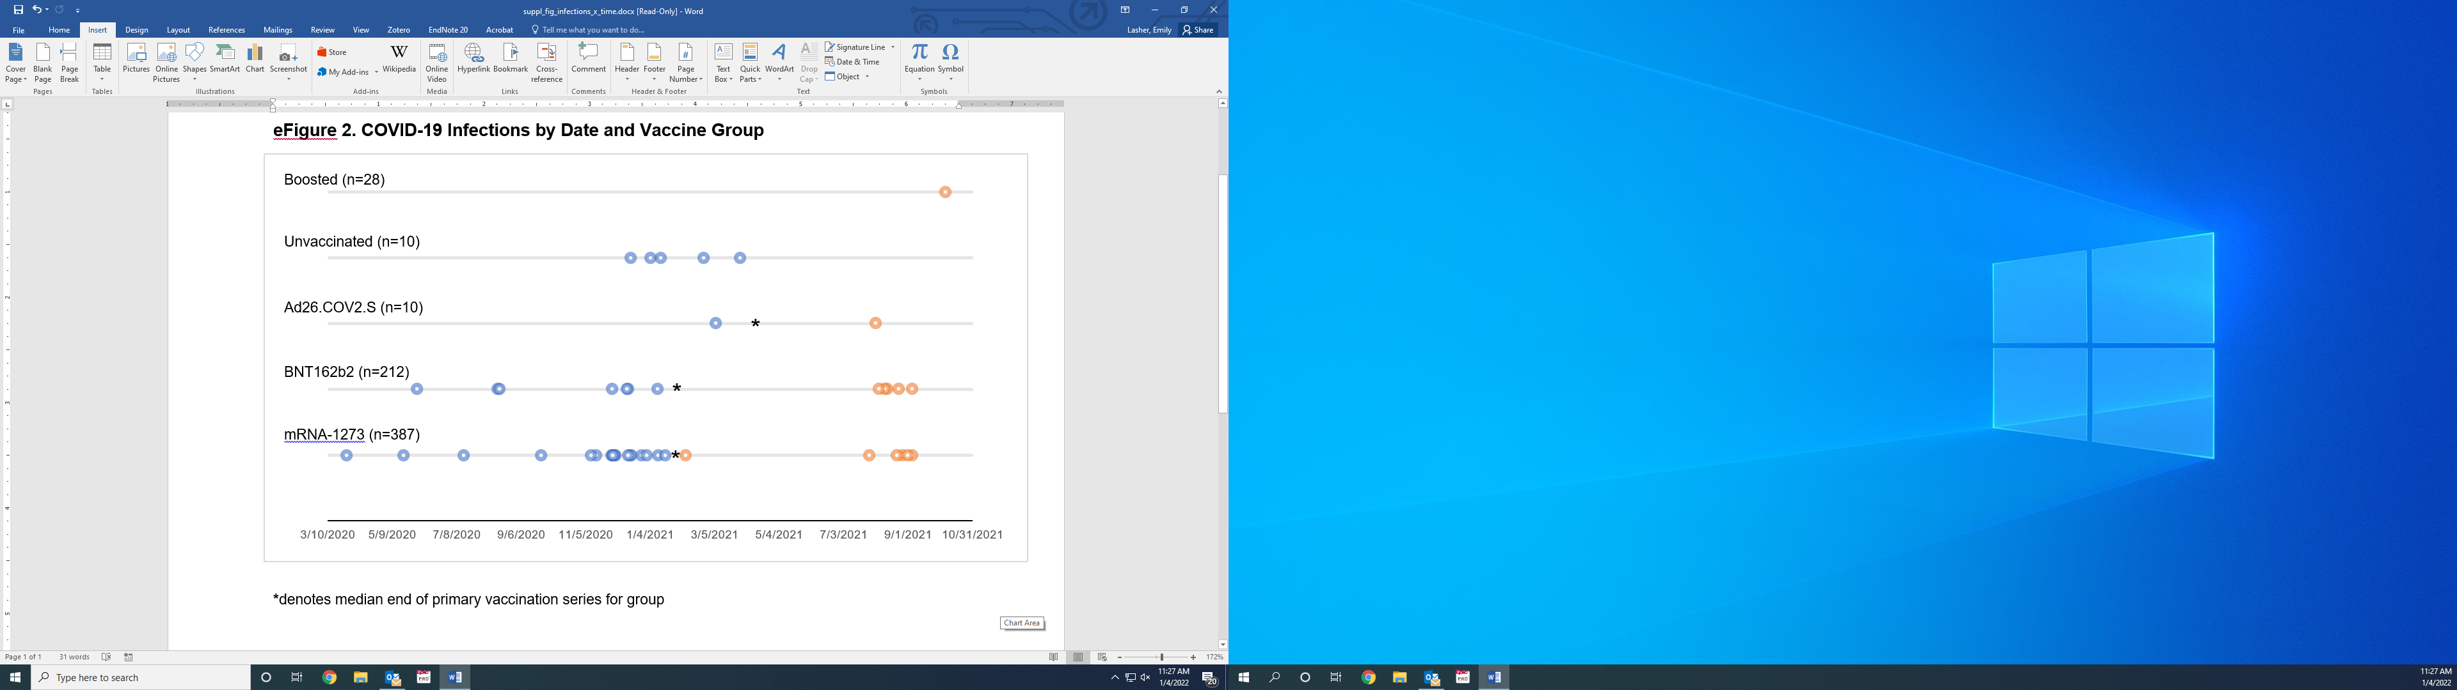 COVID-19 infection pre-vaccination

Breakthrough COVID-19 infection

*

Median end of primary vaccination series

aData from the New York State Department of Health: <https://coronavirus.health.ny.gov/covid-19-variant-data>