**Supplementary Figure**

**Supplementary Figure 1. Biplot from Principal Component Analysis on the combined genotype data of 1000Genome reference panel1 and the ABCD study participants (colored blue).** Super-populations are defined broadly as: AFR African, AMR admixed American, EAS East Asian, EUR European, SAS South Asian. To facilitate the understanding of genetic ancestry of the study participants, PCA was performed with 1000Genome phase3 reference panel and plotted with the first two principal components. Since ABCD participants reside on a continuum of genetic ancestry as American population (AMR), rather than distinct population groups, and none of them belongs to either African (AFR) or East Asian (EAS) populations, we did not exclude any genetic outliers based on the plot. 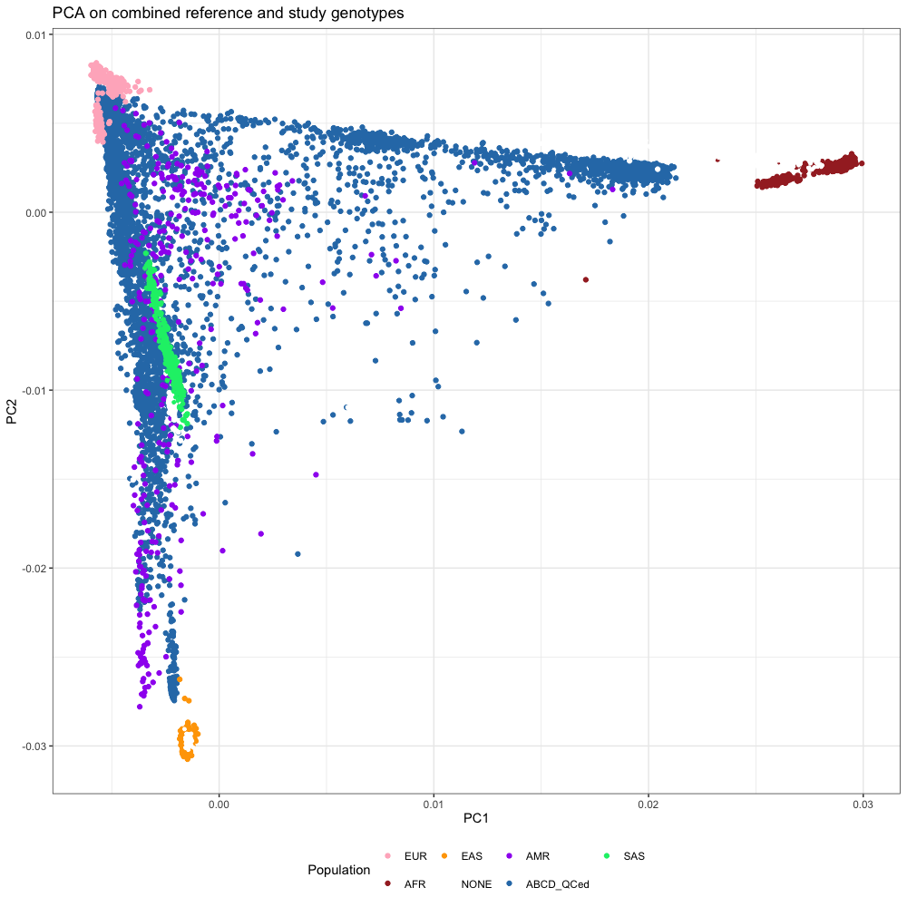

**Supplementary Figure 2.** **The result of generalized linear models between brain connectome and CP GPS (a, b), EA GPS (c, d).** The dotted line indicates the significance threshold (*Pbonferroni* = 0.05).

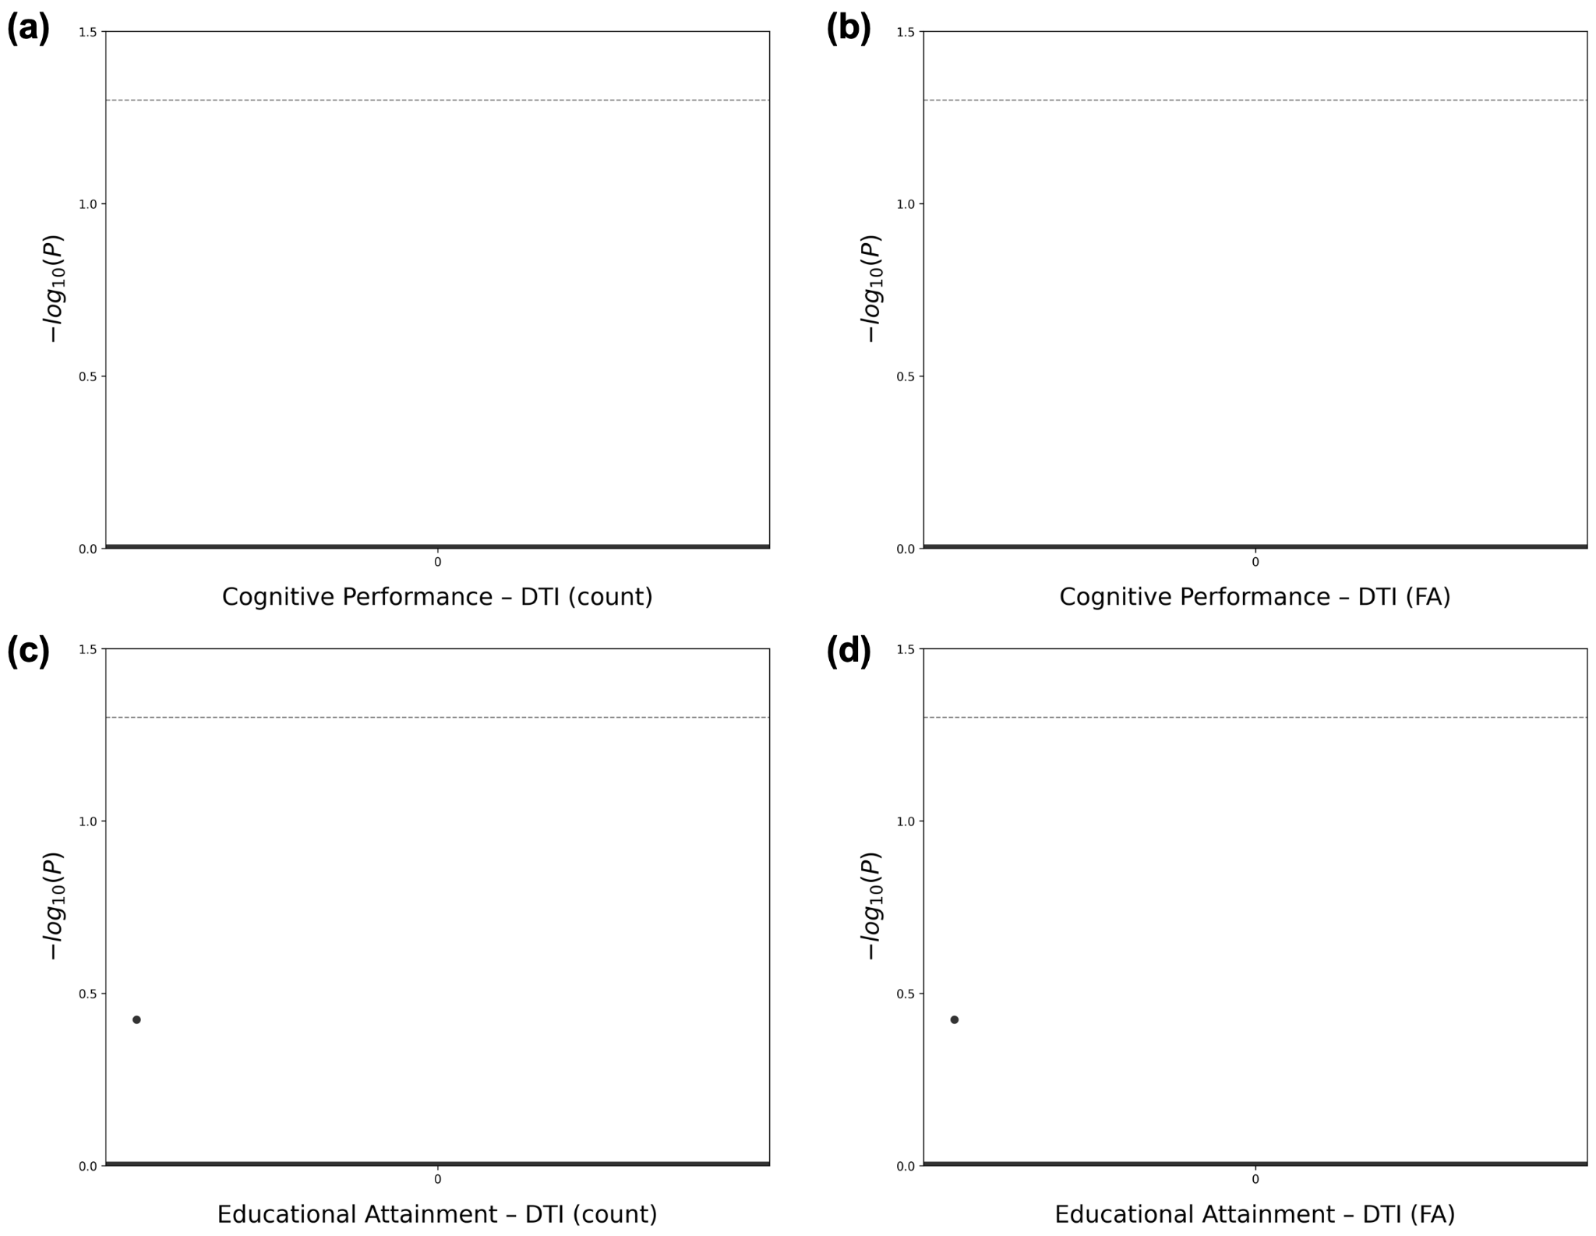

**Supplementary Figure 3. Proportion of explained variances by principal components from cognitive GPSs-related brain morphometric features.**

**Supplementary Figure 4. PCA biplot of cognitive GPSs-related brain morphometric features regarding covariates.**

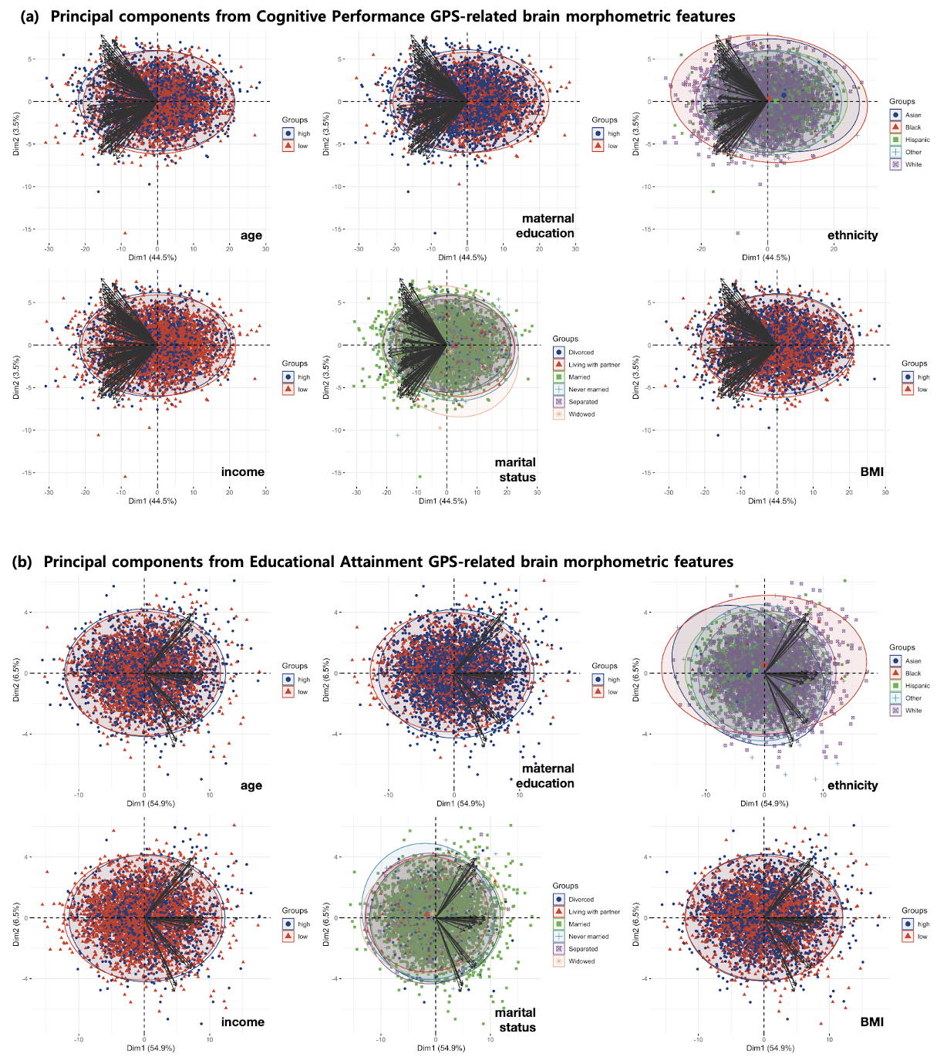

**Supplementary Figure 5.** **PCA biplot of cognitive GPSs-related brain morphometric features regarding sex.** The p-values from the Welch t-test were below 2.2e-16 both in BrainCP GPS and BrainEA GPS.

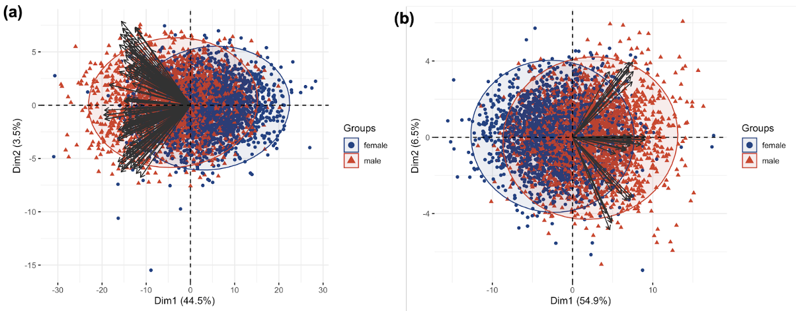

**Supplementary Figure 6. Effect of ELS on the relationships of CP GPS-brain-cognition.** The impact of *household challenges*, *neglect*, and *abuse* were not significantly moderate the effect of Cognitive Performance GPS on BrainCP GPS, consequently cognition.

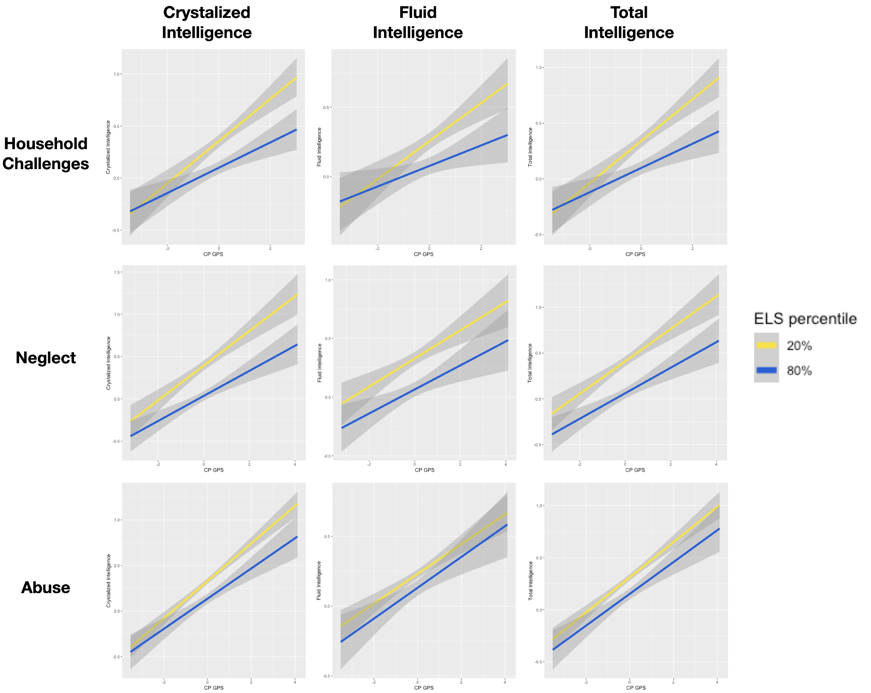

**Supplementary Figure 7. Effect of *household challenges* and *neglect* on the relationships of EA GPS-brain-cognition.** The impact of *household challenges* and *abuse* were not significantly moderate the effect of Educational Attainment GPS on BrainEA GPS, consequently cognition.

### 