Supplementary materials

Appendix 1. Data source description

The Columbia University Irving Medical Center (CUIMC) database comprises electronic health records on more than 6 million patients, with data collection starting in 1985. CUIMC is a Northeast US quaternary care center with primary care practices in northern Manhattan and surrounding areas, and the database includes inpatient and outpatient care. The database currently holds information about the person (demographics), visits (inpatient and outpatient), conditions (billing diagnoses and problem lists), drugs (outpatient prescriptions and inpatient orders and administrations), devices, measurements (laboratory tests and vital signs), and other observations (symptoms). The data sources include current and previous electronic health record systems (homegrown Clinical Information System, homegrown WebCIS, Allscripts Sunrise Clinical Manager, Allscripts TouchWorks, Epic Systems), administrative systems (IBM PCS-ADS, Eagle Registration, IDX Systems, Epic Systems), and ancillary systems (homegrown LIS, Sunquest, Cerner Laboratory). Additionally, it contains the information on vaccination from New York City and State immunization registries.

Appendix 2. Retrospective cohort COVID-19 vaccine effectiveness study design overview.
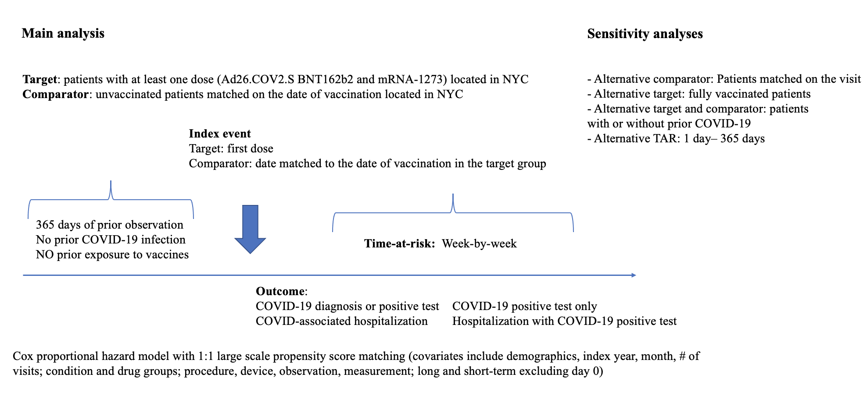

Appendix 3. Cohort definitions and codes for the absolute COVID-19 vaccine effectiveness study

3.1 Cohort definitions for target comparator and outcome cohorts for studying absolute effectiveness of COVID-19 vaccines.

 | Definition and link to the public repository
Target cohorts | Target cohorts were defined as patients with at least one dose of the corresponding vaccine (Pfizer, Moderna, Janssen)  Index event: first exposure to the corresponding vaccine  Inclusion and exclusion criteria:  - 365 days of prior observation  - no other COVID-19 vaccine exposure in 120 days prior and 120 days after the index date  - no prior COVID-19 infection (diagnosis code of COVID-19 or positive test)  - residence in New York City determined by the zip code recorded  For the analysis on fully vaccinated patients, we applied the same criteria and required patients to have a) the second dose of Pfizer or Moderna vaccine (if applicable) within 14 to 56 days after the first dose b) at least 14 days of observation after the second dose (one dose of Janssen).  Links:  https://atlas.ohdsi.org/#/cohortdefinition/498  https://atlas.ohdsi.org/#/cohortdefinition/494  https://atlas.ohdsi.org/#/cohortdefinition/497  https://atlas.ohdsi.org/#/cohortdefinition/418  https://atlas.ohdsi.org/#/cohortdefinition/417  https://atlas.ohdsi.org/#/cohortdefinition/420
Comparator cohorts | Comparator cohorts were created separately for each target cohort by selecting patients with no COVID-19 vaccination in their record (any vaccine), 365 days of prior observation and New York City residence. The patients were matched on the index date of one of the target group participants for the comparator anchored on a date and on the date of a healthcare encounter within 3-day corridor for the comparator anchored on a visit.
Outcome cohorts | For the main analysis COVID-19 infection was defined as a COVID-19 test with the result ‘Positive’ or ‘Detected’.  COVID-19 associated hospitalization was defined as an inpatient, emergency department or intensive care unit admission with a positive COVID-19 test recorded within 30 days prior or during hospitalization.  For a sensitivity analysis we applied the abovementioned criteria with adding COVID-19 diagnosis as an alternative for positive COVID-19 test.  Links:  https://atlas.ohdsi.org/#/cohortdefinition/425  https://atlas.ohdsi.org/#/cohortdefinition/422

3.2 Codes used in the study.

- Pfizer vaccine:
RxNorm 2468235 SARS-CoV-2 (COVID-19) vaccine, mRNA-BNT162b2 0.1 MG/ML Injectable Suspension

- Moderna vaccine:
RxNorm 2470234 SARS-CoV-2 (COVID-19) vaccine, mRNA-1273 0.2 MG/ML Injectable Suspension

- Janssen vaccine:
CVX 212 SARS-COV-2 (COVID-19) vaccine, vector non-replicating, recombinant spike protein-Ad26, preservative free, 0.5 mL

- COVID-19 diagnosis:
ICD10-CM U07.1 Emergency use of U07.1 | COVID-19

- COVID-19 test:
LOINC 94500-6 SARS-CoV-2 (COVID-19) RNA [Presence] in Respiratory specimen by NAA with probe detection
LOINC 94558-4 SARS-CoV-2 (COVID-19) Ag [Presence] in Respiratory specimen by Rapid immunoassay

Appendix 4. Negative controls

SNOMED concept id | SNOMED concept name
438945 | Accidental poisoning by benzodiazepine-based tranquilizer
434455 | Acquired claw toes
316211 | Acquired spondylolisthesis
201612 | Alcoholic liver damage
438730 | Alkalosis
441258 | Anemia in neoplastic disease
432513 | Animal bite wound
4171556 | Ankle ulcer
4098292 | Antiphospholipid syndrome
77650 | Aseptic necrosis of bone
4239873 | Benign neoplasm of ciliary body
23731 | Benign neoplasm of larynx
199764 | Benign neoplasm of ovary
195500 | Benign neoplasm of uterus
4145627 | Biliary calculus
4108471 | Burn of digit of hand
75121 | Burn of lower leg
4284982 | Calculus of bile duct without obstruction
434327 | Cannabis abuse
78497 | Cellulitis and abscess of toe
4001454 | Cervical spine ankylosis
4068241 | Chronic instability of knee
195596 | Chronic pancreatitis
4206338 | Chronic salpingitis
4058397 | Claustrophobia
74816 | Contusion of toe
73302 | Curvature of spine
4151134 | Cyst of pancreas
77638 | Displacement of intervertebral disc without myelopathy
195864 | Diverticulum of bladder
201346 | Edema of penis
200461 | Endometriosis of uterus
377877 | Esotropia
193530 | Follicular cyst of ovary
4094822 | Foreign body in respiratory tract
443421 | Gallbladder and bile duct calculi
4299408 | Gouty tophus
135215 | Hashimoto thyroiditis
442190 | Hemorrhage of colon
43020475 | High risk heterosexual behavior
194149 | Hirschsprung's disease
443204 | Human ehrlichiosis
4226238 | Hyperosmolar coma due to diabetes mellitus
4032787 | Hyperosmolarity
197032 | Hyperplasia of prostate
140362 | Hypoparathyroidism
435371 | Hypothermia
138690 | Infestation by Pediculus
4152376 | Intentional self poisoning
192953 | Intestinal adhesions with obstruction
196347 | Intestinal parasitism
137977 | Jaundice
317510 | Leukemia
765053 | Lump in right breast
378165 | Nystagmus
434085 | Obstruction of duodenum
4147016 | Open wound of buttock
4129404 | Open wound of upper arm
438120 | Opioid dependence
75924 | Osteodystrophy
432594 | Osteomalacia
30365 | Panhypopituitarism
4108371 | Peripheral gangrene
440367 | Plasmacytosis
439233 | Poisoning by antidiabetic agent
442149 | Poisoning by bee sting
4314086 | Poisoning due to sting of ant
4147660 | Postural kyphosis
434319 | Premature ejaculation
199754 | Primary malignant neoplasm of pancreas
4311499 | Primary malignant neoplasm of respiratory tract
436635 | Primary malignant neoplasm of sigmoid colon
196044 | Primary malignant neoplasm of stomach
433716 | Primary malignant neoplasm of testis
133424 | Primary malignant neoplasm of thyroid gland
194997 | Prostatitis
80286 | Prosthetic joint loosening
443274 | Psychostimulant dependence
314962 | Raynaud's disease
37018294 | Residual osteitis
4288241 | Salmonella enterica subspecies arizonae infection
45757269 | Sclerosing mesenteritis
74722 | Secondary localized osteoarthrosis of pelvic region
200348 | Secondary malignant neoplasm of large intestine
43020446 | Sedative withdrawal
74194 | Sprain of spinal ligament
4194207 | Tailor's bunion
193521 | Tropical sprue
40482801 | Type II diabetes mellitus uncontrolled
74719 | Ulcer of foot
196625 | Viral hepatitis A without hepatic coma
197494 | Viral hepatitis C
4284533 | Vitamin D-dependent rickets

Link to the original list of negative controls used in EUMAEUS study: https://ohdsi-studies.github.io/Eumaeus/Protocol.html#8_Research_Methods

Appendix 5. Summary of manual chart review of COVID-19 infection cases during week 1 after the index date, patients vaccinated with mRNA vaccines and unvaccinated patients.

 | Pfizer- BioNTech | Moderna | Pfizer- BioNTech and Moderna | Unvaccinated  patients
Total | 36 | 25 | 61 | 28
Average age | 65 | 67.8 | 65.8 | 58
COVID-19 symptoms
Severe | 14 (39%) | 7 (28%) | 21 (34%) | 6 (21%)
Mild | 18 (50%) | 11 (44%) | 29 (48%) | 11 (39%)
Asymptomatic | 2 (6%) | 7 (28%) | 9 (15%) | 11 (39%)
Reason for coming for initial healthcare encounter
COVID-19 symptoms | 17 (47%) | 8 (32%) | 25 (41%) | 18 (64%)
Exposure to COVID-19 | 3 (8%) | 4 (16%) | 7 (11%) | 5 (18%)
For other reason (co-morbidities, procedures etc.) | 13 (36%) | 11 (44%) | 24 (39%) | 6 (21%)
Type of initial healthcare encounter
Telehealth/phone | 5 (14%) | 6 (24%) | 11 (18%) | 3 (11%)
Test only | 3 (8%) | 2 (8%) | 5 (8%) | 6 (21%)
OP | 4 (11%) | 3 (12%) | 7 (11%) | 1 (4%)
ED or IP | 24 (67%) | 14 (56%) | 38 (62%) | 18 (64%)

Appendix 6. Estimates for absolute effectiveness of COVID-19 vaccines for time-at-risk of 1 day – 365 days after the first dose in the vaccinated patients without prior COVID-19 infection compared to unvaccinated patients residing in NYC.

 | COVID-19 infection |  | COVID-19 hospitalization |  | COVID-19 positive test only |  | COVID-19 positive test only hospitalization
 | VE (95% CI), % | P-value | VE (95% CI), % | P-value | VE (95% CI), % | P-value | VE (95% CI), % | P-value
Pfizer- BioNTech | 42 (37 – 47) | <0.01 | 63 (56-70) | <0.01 | 71 (66 - 75) | <0.01 | 69 (62 - 75) | <0.01
Moderna | 54 (48 – 60) | <0.01 | 76 (69 – 82) | <0.01 | 78 (73 – 83) | <0.01 | 81 (74 – 87) | <0.01
Janssen | 24 (0-55) | 0.31 | 64 (0.1 – 1.06) | 0.09 | 53 (0 – 82) | 0.1 | 70 (2 – 93) | 0.08

Appendix 7. Estimates for absolute effectiveness of COVID-19 vaccines for time-at-risk of 1 day – 365 days after full vaccination in fully vaccinated patients without prior COVID-19 infection compared to unvaccinated patients residing in NYC.

 | COVID-19  positive test only |  | COVID-19 positive test only hospitalization |  | COVID-19 infection |  | COVID-19 hospitalization
 | VE (95% CI), % | P-value | VE (95% CI), % | P-value | VE (95% CI), % | P-value | VE (95% CI), % | P-value
Pfizer- BioNTech | 94 (91- 95) | <0.01 | 95 (92-97) | <0.01 | 70 (66-74) | <0.01 | 88 (84-92) | <0.01
Moderna | 97 (94-98) | <0.01 | 96 (92-99) | <0.01 | 72 (66 – 77) | <0.01 | 92 (87-95) | <0.01
Janssen | 81 (50-94) | <0.01 | 92 (58-100) | 0.03 | 55 (23 – 75) | 0.01 | 87 (56-98) | 0.01

Appendix 8. Comparison of the absolute effectiveness estimates in fully vaccinated patients obtained in our study and those from the randomized clinical trials of the corresponding vaccines.
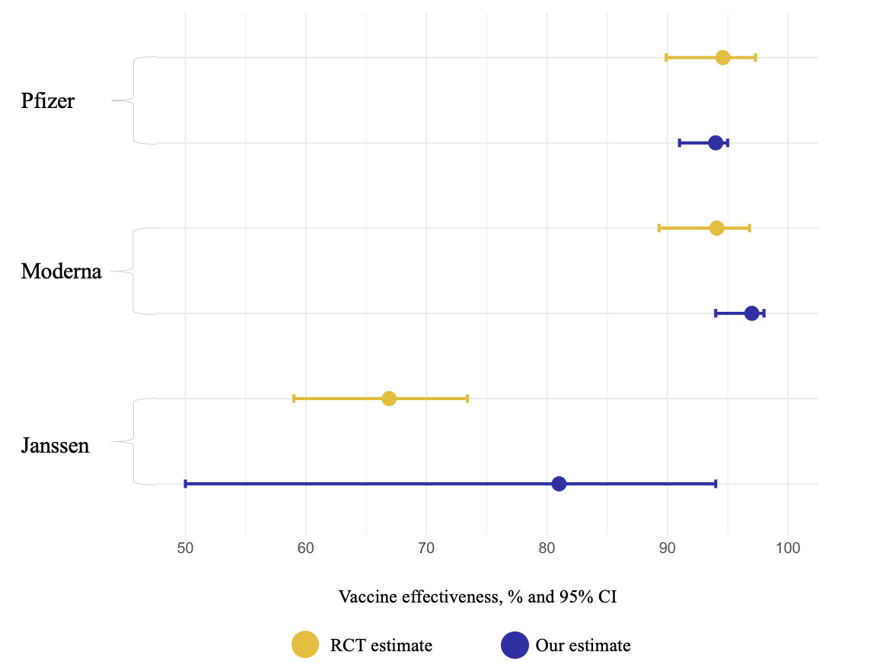

Appendix 9. Estimates for absolute effectiveness of COVID-19 vaccines for time-at-risk of 1 day – 365 days after the first dose in the vaccinated patients with or without prior COVID-19 infection compared to unvaccinated patients residing in NYC.

 | COVID-19 infection |  | COVID-19 hospitalization |  | COVID-19 positive test only |  | COVID-19 positive test only hospitalization
 | VE (95% CI), % | P-value | VE (95% CI), % | P-value | VE (95% CI), % | P-value | VE (95% CI), % | P-value
Pfizer- BioNTech | 43 (38-48) | <0.01 | 64 (57-70) | <0.01 | 71 (66-75) | <0.01 | 71(64-76) | <0.01
Moderna | 51 (45-57) | <0.01 | 71 (63-78) | <0.01 | 76 (71-81) | <0.01 | 81 (73-86) | <0.01
Janssen | 15 (0-49) | 0.52 | 60 (2-86) | 0.06 | 45 (0-75) | 0.12 | 63 (0-90) | 0.09

