## **Supplement**

## **Superspreading of SARS-CoV-2 infections: A Systematic Review and Meta-analysis**

Zhanwei Du1,2, Chunyu Wang1,2, Caifen Liu1,2, Yuan Bai1,2, Sen Pei3, Dillon C. Adam1, Lin Wang4, Peng Wu1,2, Eric H. Y. Lau1,2, Benjamin J. Cowling1,2*

1 WHO Collaborating Centre for Infectious Disease Epidemiology and Control, School of Public Health, Li Ka Shing Faculty of Medicine, The University of Hong Kong, Hong Kong Special Administrative Region, China.

2 Laboratory of Data Discovery for Health, Hong Kong Science and Technology Park, New Territories, Hong Kong Special Administrative Region, China

3 Department of Environmental Health Sciences, Mailman School of Public Health, Columbia University, New York, NY 10032, USA

4 Department of Genetics, University of Cambridge, Cambridge, CB2 3EH, UK

ZD, CW and CL contributed equally to this manuscript.

Corresponding author: Benjamin J. Cowling ([bcowling@hku.hk](mailto:bcowling@hku.hk))

**Running title.** Superspreading of SARS-CoV-2 infections

**Keywords**. COVID-19; SARS-CoV-2; superspreading; dispersion parameter; systematic review; meta-analysis.

**Table S1. Description of studies included in the systematic review and meta-analysis**

| **Study** | **Method** | **Dispersion parameter (*k*), (95% CI)** | **Period** | **Region** |
| --- | --- | --- | --- | --- |
| Sun K et al.[[1]](https://paperpile.com/c/24WLDq/HWkUq) | Negative binomial distribution | 0.30 (0.23, 0.39) | 2020-1-16 to 2020-4-3 | Mainland China |
| Adam DC et al.[[2]](https://paperpile.com/c/24WLDq/aBjrT) | Negative binomial distribution | 0.43 (0.29, 0.67) | 2020-1-23 to 2020-4-28 | Hong Kong,  China |
| Bi Q et al.[[3]](https://paperpile.com/c/24WLDq/6Y34W) | Negative binomial distribution | 0.58 (0.35,1.18) | 2020-1-14 to 2020-2-12 | Mainland China |
| He D et al.[[4]](https://paperpile.com/c/24WLDq/6iiy7) | Negative binomial distribution | 0.70 (0.59, 0.98) | 2020-1-15 to 2020-2-29 | Mainland China |
| Hasan A et al.[[5]](https://paperpile.com/c/24WLDq/9kOE7) | Negative binomial distribution | 0.06 (0.05, 0.07) | 2020-3-2 to 2020-3-31 | Indonesia |
| Hasan A et al.[[5]](https://paperpile.com/c/24WLDq/9kOE7) | Negative binomial distribution | 0.20 (0.09, 0.31) | 2020-3-19 to 2020-4-7 | Indonesia |
| Kwok KO et al.[[6]](https://paperpile.com/c/24WLDq/z8SrY) | Negative binomial distribution | 2.30 (0.02, 4.58) | By 2020-3-3 | Hong Kong,  China |
| Kwok KO et al.[[6]](https://paperpile.com/c/24WLDq/z8SrY) | Negative binomial distribution | 0.51 (0.21, 1.59) | By 2020-3-3 | Japan |
| Kwok KO et al.[[6]](https://paperpile.com/c/24WLDq/z8SrY) | Negative binomial distribution | 1.78 (0.09, 3.47) | By 2020-3-3 | **Singapore** |
| Lau MSY et al.[[7]](https://paperpile.com/c/24WLDq/YTVFK) | Negative binomial distribution | 0.63 (0.54, 0.85) | 2020-3-1 to 2020-4-3 | USA |
| Lau MSY et al.[[7]](https://paperpile.com/c/24WLDq/YTVFK) | Negative binomial distribution | 0.66 (0.60, 0.71) | 2020-3-1 to 2020-4-3 | USA |
| Lau MSY et al.[[7]](https://paperpile.com/c/24WLDq/YTVFK) | Negative binomial distribution | 0.62 (0.54, 0.75) | 2020-3-1 to 2020-4-3 | USA |
| Lau MSY et al.[[7]](https://paperpile.com/c/24WLDq/YTVFK) | Negative binomial distribution | 0.64 (0.53, 0.75) | 2020-3-1 to 2020-4-3 | USA |
| Lau MSY et al.[[7]](https://paperpile.com/c/24WLDq/YTVFK) | Negative binomial distribution | 0.39 (0.37, 0.44) | 2020-3-1 to 2020-4-3 | USA |
| Miller D et al.[[8]](https://paperpile.com/c/24WLDq/ehNyN) | Phylodynamic analysis | 2.97 (2.86, 3.08) | By 2020-4-22 | Israel |
| Tariq A et al. [[9]](https://paperpile.com/c/24WLDq/BW69O) | Negative binomial distribution | 0.11 (0.05, 0.25) | 2020-1-23 to 2020-3-17 | Singapore |
| Wang L et al.[[10]](https://paperpile.com/c/24WLDq/d91HA) | Phylodynamic analysis | 0.23 (0.13, 0.38) | 2019-12-24 to 2020-2-14 | Mainland China |
| Zhao S et al.[[11]](https://paperpile.com/c/24WLDq/qaJAi) | Negative binomial distribution (Zero-truncated framework) | 0.37 (0.29, 0.48) | 2020-1-15 to 2020-2-29 | Mainland China |
| Zhao S et al.[[11]](https://paperpile.com/c/24WLDq/qaJAi) | Negative binomial distribution (Zero-truncated framework) | 0.32 (0.15, 0.64) | 2020-1-23 to 2020-4-28 | Hong Kong, China |
| Zhao S et al.[[11]](https://paperpile.com/c/24WLDq/qaJAi) | Negative binomial distribution (Zero-truncated framework) | 0.18 (0.01, 1.79) | 2020-1-21 to 2020-2-26 | Mainland China |
| Zhang Y et al.[[12]](https://paperpile.com/c/24WLDq/EudDD) | Negative binomial distribution | 0.25 (0.13, 0.88) | 2020-1-21 to 2020-2-26 | Mainland China |
| Shi Q et al.[[13]](https://paperpile.com/c/24WLDq/bmJ5M) | Negative binomial distribution | 0.21 (0.13, 0.33) | 2020-1-21 to 2020-4-10 | Mainland China |
| James A et al.[[14]](https://paperpile.com/c/24WLDq/IfjBo) | Negative binomial distribution | 0.29 (0.10, 2.05) | 2020-3-25 to 2020-4-22 | New Zealand |
| Kremer C et al.[[15]](https://paperpile.com/c/24WLDq/tfrVU) | Negative binomial distribution | 0.43 (0.38, 0.49) | 2020-1-23 to 2020-4-18 | Hong Kong, China |
| Kremer C et al.[[15]](https://paperpile.com/c/24WLDq/tfrVU) | Negative binomial distribution | 0.50 (0.50, 0.51) | By 2020-8-1 | India |
| Kremer C et al.[[15]](https://paperpile.com/c/24WLDq/tfrVU) | Negative binomial distribution | 0.56 (0.29, 0.83) | By 2020-12-31 | Rwanda |
| Endo A.[[16]](https://paperpile.com/c/24WLDq/P3BuM) | Negative binomial distribution | 0.10 (0.05, 0.20) | By 2020-2-27 | Global |
| Riou J et al.[[17]](https://paperpile.com/c/24WLDq/T5DKl) | Negative binomial distribution | 0.54 (0.01, 8.18) | By 2020-1-18 | Global |

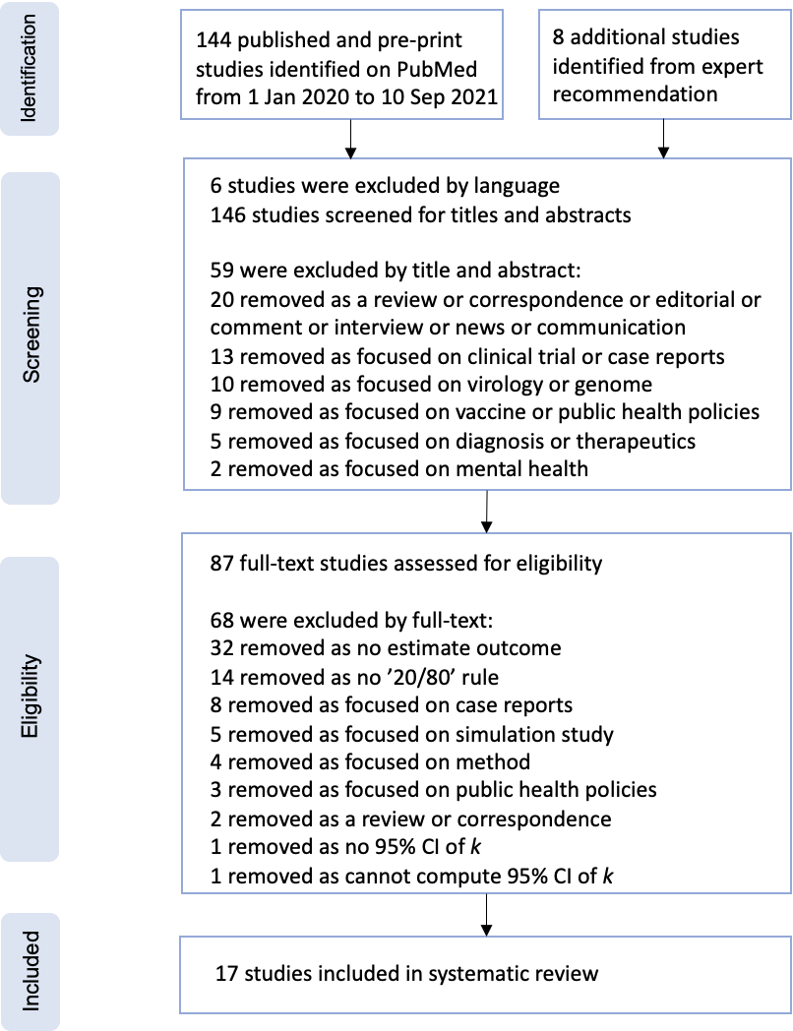

**Figure S1. PRISMA (Preferred Reporting Items for Systematic Reviews and Meta-Analyses) flow diagram for the studies used to obtain studies that reported measurements of the dispersion parameter.** We used PubMed for our primary search.

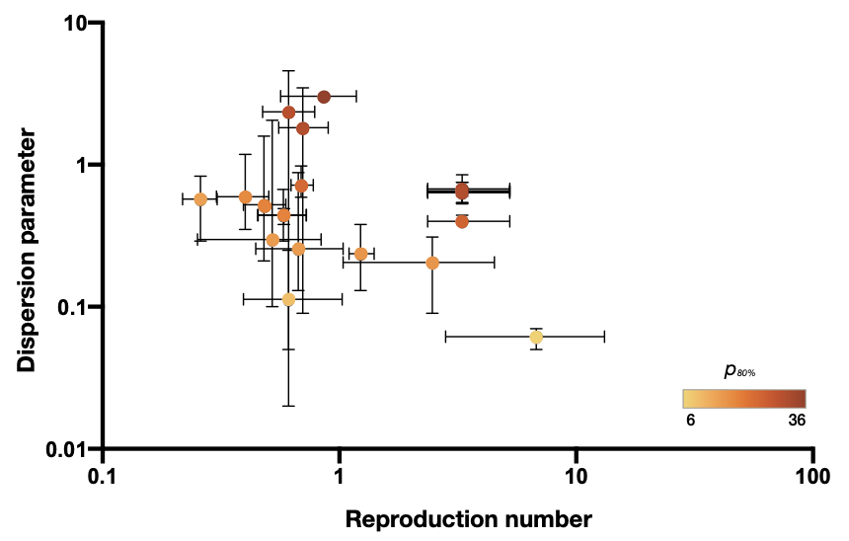

**Figure S2. Dispersion parameter estimates and reproduction numbers for coronavirus disease 2019 (COVID-19) reported in 19 unique studies presented by country.** The error bars show the mean values and 95% confidence interval of the dispersion parameter estimates and reported reproduction numbers in studies (**Supplement**). The color denotes the estimated proportion of cases accounting for 80% of all transmissions (*p80%*).

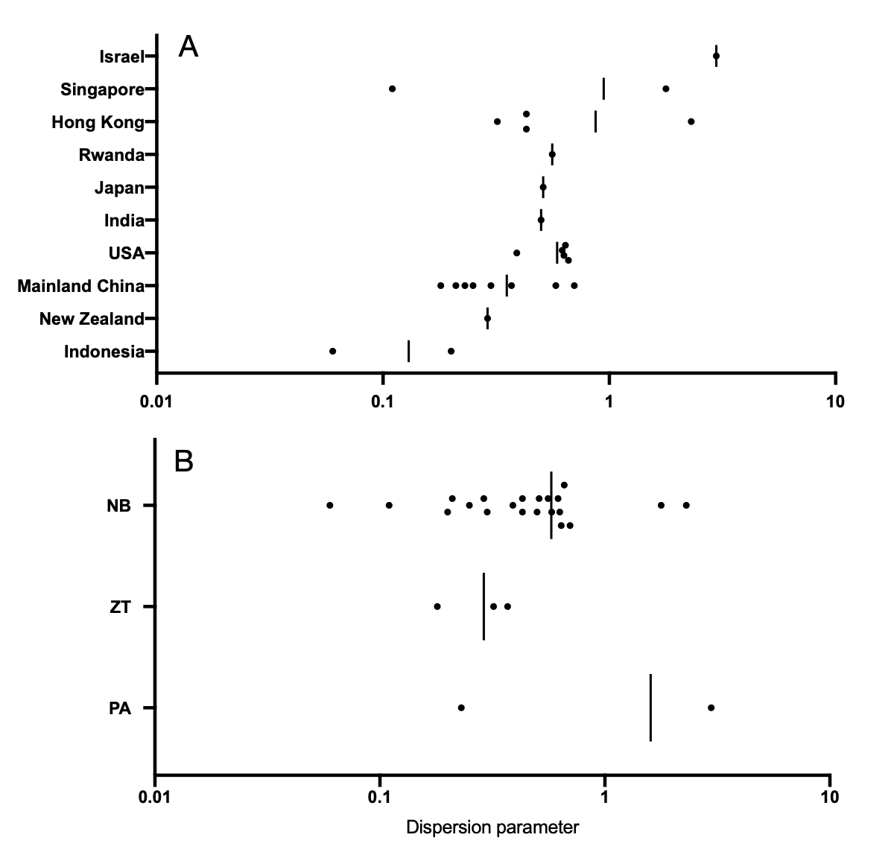

**Figure S3. Distribution of the estimated mean dispersion parameter with respect to (A) countries studied and (B) methods studied.** Black circles denote the mean estimates across studies. Vertical lines denote the mean values by averaging that for each country or method. NB: Negative binomial distribution; ZT: Negative binomial distribution (Zero-truncated framework); PA: Phylodynamic analysis.

**References**

1. [Sun K, Wang W, Gao L, et al. Transmission heterogeneities, kinetics, and controllability of SARS-CoV-2. Science **2021**; 371. Available at:](http://paperpile.com/b/24WLDq/HWkUq) <http://dx.doi.org/10.1126/science.abe2424>[.](http://paperpile.com/b/24WLDq/HWkUq)

2. [Adam DC, Wu P, Wong JY, et al. Clustering and superspreading potential of SARS-CoV-2 infections in Hong Kong. Nat Med **2020**; Available at:](http://paperpile.com/b/24WLDq/aBjrT) <http://dx.doi.org/10.1038/s41591-020-1092-0>[.](http://paperpile.com/b/24WLDq/aBjrT)

3. [Bi Q, Wu Y, Mei S, et al. Epidemiology and transmission of COVID-19 in 391 cases and 1286 of their close contacts in Shenzhen, China: a retrospective cohort study. Lancet Infect Dis **2020**; 20:911–919.](http://paperpile.com/b/24WLDq/6Y34W)

4. [He D, Zhao S, Xu X, et al. Low dispersion in the infectiousness of COVID-19 cases implies difficulty in control. BMC Public Health **2020**; 20:1558.](http://paperpile.com/b/24WLDq/6iiy7)

5. [Hasan A, Susanto H, Kasim MF, et al. Superspreading in early transmissions of COVID-19 in Indonesia. Sci Rep **2020**; 10:22386.](http://paperpile.com/b/24WLDq/9kOE7)

6. [Kwok KO, Chan HHH, Huang Y, et al. Inferring super-spreading from transmission clusters of COVID-19 in Hong Kong, Japan, and Singapore. J Hosp Infect **2020**; 105:682–685.](http://paperpile.com/b/24WLDq/z8SrY)

7. [Lau MSY, Grenfell B, Thomas M, Bryan M, Nelson K, Lopman B. Characterizing superspreading events and age-specific infectiousness of SARS-CoV-2 transmission in Georgia, USA. Proc Natl Acad Sci U S A **2020**; 117:22430–22435.](http://paperpile.com/b/24WLDq/YTVFK)

8. [Miller D, Martin MA, Harel N, et al. Full genome viral sequences inform patterns of SARS-CoV-2 spread into and within Israel. Nat Commun **2020**; 11:5518.](http://paperpile.com/b/24WLDq/ehNyN)

9. [Tariq A, Lee Y, Roosa K, et al. Real-time monitoring the transmission potential of COVID-19 in Singapore, March 2020. BMC Med **2020**; 18:166.](http://paperpile.com/b/24WLDq/BW69O)

10. [Wang L, Didelot X, Yang J, et al. Inference of person-to-person transmission of COVID-19 reveals hidden super-spreading events during the early outbreak phase. Nat Commun **2020**; 11:5006.](http://paperpile.com/b/24WLDq/d91HA)

11. [Zhao S, Shen M, Musa SS, et al. Inferencing superspreading potential using zero-truncated negative binomial model: exemplification with COVID-19. BMC Med Res Methodol **2021**; 21:30.](http://paperpile.com/b/24WLDq/qaJAi)

12. [Zhang Y, Li Y, Wang L, Li M, Zhou X. Evaluating Transmission Heterogeneity and Super-Spreading Event of COVID-19 in a Metropolis of China. Int J Environ Res Public Health **2020**; 17. Available at:](http://paperpile.com/b/24WLDq/EudDD) <http://dx.doi.org/10.3390/ijerph17103705>[.](http://paperpile.com/b/24WLDq/EudDD)

13. [Shi Q, Hu Y, Peng B, et al. Effective control of SARS-CoV-2 transmission in Wanzhou, China. Nat Med **2021**; 27:86–93.](http://paperpile.com/b/24WLDq/bmJ5M)

14. [James A, Plank MJ, Hendy S, Binny RN, Lustig A, Steyn N. Model-free estimation of COVID-19 transmission dynamics from a complete outbreak. PLoS One **2021**; 16:e0238800.](http://paperpile.com/b/24WLDq/IfjBo)

15. [Kremer C, Torneri A, Boesmans S, et al. Quantifying superspreading for COVID-19 using Poisson mixture distributions. Sci Rep **2021**; 11:14107.](http://paperpile.com/b/24WLDq/tfrVU)

16. [Endo A, Centre for the Mathematical Modelling of Infectious Diseases COVID-19 Working Group, Abbott S, Kucharski AJ, Funk S. Estimating the overdispersion in COVID-19 transmission using outbreak sizes outside China. Wellcome Open Res **2020**; 5:67.](http://paperpile.com/b/24WLDq/P3BuM)

17. [Riou J, Althaus CL. Pattern of early human-to-human transmission of Wuhan 2019 novel coronavirus (2019-nCoV), December 2019 to January 2020. Euro Surveill **2020**; 25. Available at:](http://paperpile.com/b/24WLDq/T5DKl) <http://dx.doi.org/10.2807/1560-7917.ES.2020.25.4.2000058>[.](http://paperpile.com/b/24WLDq/T5DKl)