Supplementary Materials

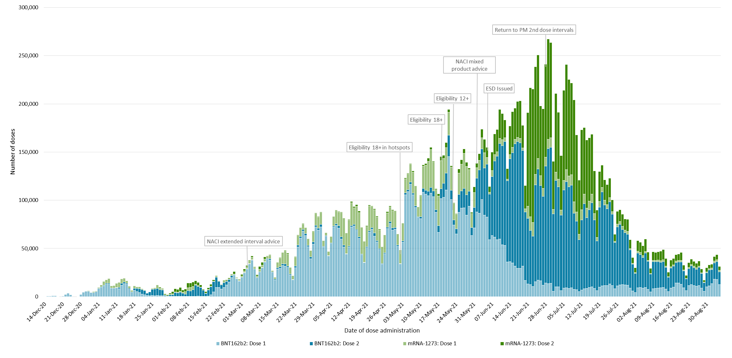
Figure 1. Number of COVID-19 mRNA vaccine doses administered in Ontario by dose number and vaccine product and overview of vaccine program changes
NACI: National Advisory Committee on Immunization; ESD: Enhanced Surveillance Directive; PM: Product Monograph

Figure 2. Myocarditis/pericarditis reports following COVID-19 mRNA vaccines by dose number and time to symptom onset*
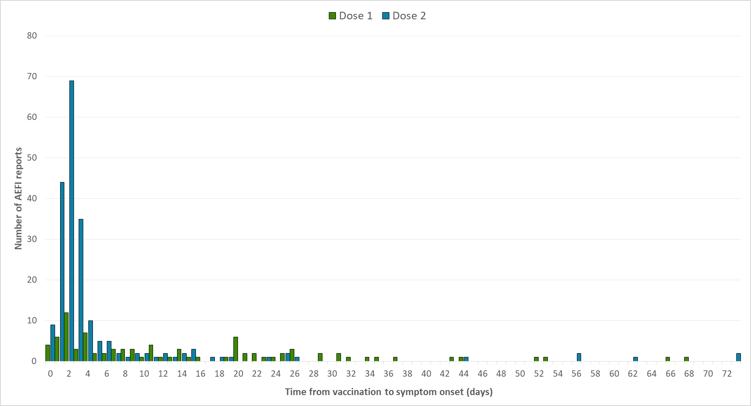
*2 reports with unknown time to onset were excluded from this figure

Table 1. Definition for identifying myocarditis/pericarditis using administrative data to estimate background rates¹
Outcome | Definition
Myocarditis/pericarditis | Acute pericarditis, pericarditis in disease classified elsewhere, acute myocarditis, myocarditis in diseases classified elsewhere, myocarditis, unspecified:  ICD-10-CA codes: I30.x, I32.x, I40.x, I41.x, I51.4

Table 2. Clinical diagnosis and severity of myocarditis/pericarditis
 | Myocarditis (n=105) | Pericarditis (n=85) | Myopericarditis* (n=107) | Total (N=297)
Age group (years)
12-17 | 28 (26.7%) | 8 (9.4%) | 19 (17.8%) | 55 (18.5%)
18-24 | 30 (28.6%) | 16 (18.8%) | 50 (46.7%) | 96 (32.3%)
25-39 | 30 (28.6%) | 12 (14.1%) | 30 (28.0%) | 72 (24.2%)
≥40 | 17 (16.2%) | 49 (57.6%) | 8 (7.5%) | 74 (24.9%)
Healthcare utilization/outcome
Emergency department | 101 (96.2%) | 83 (97.6%) | 106 (99.1%) | 290 (97.6%)
In-patient hospitalization | 87 (82.9%) | 33 (38.8%) | 90 (84.1%) | 210 (70.7%)
Intensive care unit admission | 5 (4.8%) | 5 (5.9%) | 4 (3.7%) | 14 (4.7%)
Death | 0 | 0 | 0 | 0
BC level
1 | 34 (32.4%) | 5 (5.9%) | 28 (26.2%) | 67 (22.6%)
2 | 68 (64.8%) | 73 (85.9%) | 79 (73.8%) | 220 (74.1%)
3 | 3 (2.9%) | 7 (8.2%) | 0 (0.0%) | 10 (3.4%)
*Myopericarditis reports were assessed against Brighton Collaboration (BC) case definitions for myocarditis and pericarditis. The highest level of certainty was assigned to the report (e.g., if a report met level 1 for myocarditis and level 3 for pericarditis, it was assigned as level 1).

Table 3. Crude reporting rate of myocarditis meeting BC level 1 and 2 only per million doses administered by vaccine product, dose number, age, and sex: series initiated on or after June 1, 2021
BNT162b2
 | All |  | Female |  | Male
Age group (years) | Dose 1 | Dose 2 | Dose 1 | Dose 2 | Dose 1 | Dose 2
12-17 | 21.5 (10.7 - 38.4) | 49.7 (30.8 – 76.0) | 8.1 (1.0 - 29.1) | 9.7 (1.2 - 35.1) | 34.2 (15.6 - 64.9) | 88.1 (53.0 - 137.5)
18-24 | 10.7 (2.2 - 31.3) | 19.0 (3.9 - 55.5) | 7.9 (0.2 - 44.1) | 0.0 (0.0 - 50.5) | 13.1 (1.6 - 47.3) | 35.5 (7.3 - 103.7)
25-39 | 9.3 (3.0 - 21.7) | 12.8 (3.5 - 32.9) | 0.0 (0.0 - 14.3) | 13.1 (1.6 - 47.5) | 17.9 (5.8 - 41.8) | 12.6 (1.5 - 45.4)
≥40 | 0.0 (0.0 - 7.3) | 0.0 (0.0 - 11.7) | 0.0 (0.0 - 14.8) | 0.0 (0.0 - 23.5) | 0.0 (0.0 - 14.4) | 0.0 (0.0 - 23.3)
Total | 10.2 (6.1 - 15.9) | 23.2 (15.4 - 33.5) | 3.4 (0.7 - 9.8) | 6.8 (1.9 - 17.4) | 16.6 (9.5 – 27.0) | 38.8 (24.9 - 57.8)
mRNA-1273
 | All |  | Female |  | Male
Age group (years) | Dose 1 | Dose 2 | Dose 1 | Dose 2 | Dose 1 | Dose 2
12-17* | - | - | - | - | - | -
18-24 | 0.0 (0.0 - 39.8) | 195.5 (117.7 - 305.3) | 0.0 (0.0 - 95.1) | 69.1 (14.2 - 201.9) | 0.0 (0.0 - 68.7) | 299.5 (171.2 - 486.4)
25-39 | 16.2 (3.3 - 47.3) | 48.9 (23.5 – 90.0) | 0.0 (0.0 - 45.4) | 21.5 (2.6 - 77.7) | 28.8 (5.9 - 84.3) | 72.1 (31.1 – 142.0)
≥40 | 10.0 (1.2 - 36.1) | 0.0 (0.0 – 19.0) | 0.0 (0.0 - 40.5) | 0.0 (0.0 - 40.9) | 18.3 (2.2 - 66.2) | 0.0 (0.0 - 35.6)
Total | 10.4 (3.4 - 24.4) | 58.4 (39.1 - 83.9) | 0.0 (0.0 - 17.5) | 22.0 (7.1 - 51.4) | 18.7 (6.1 - 43.7) | 89.4 (57.3 – 133.0)
*Estimates were not provided for individuals aged 12-17 for mRNA-1273 because this product was not used for this age group in Ontario.
Table 4. Crude reporting rate of myocarditis/pericarditis per million doses administered by vaccine product, dose number, age, and sex: series initiated on or after December 14, 2020
BNT162b2
 | All |  | Female |  | Male
Age group (years) | Dose 1 | Dose 2 | Dose 1 | Dose 2 | Dose 1 | Dose 2
12-17 | 24.7 (14.9 - 38.6) | 53.6 (37.5 - 74.2) | 15.9 (5.8 - 34.6) | 12.0 (3.3 - 30.8) | 33.4 (17.8 – 57.0) | 94.5 (64.6 - 133.4)
18-24 | 18.8 (10.5 - 31.1) | 24.3 (13.0 - 41.6) | 7.5 (1.5 - 21.8) | 7.2 (0.9 - 25.9) | 30.6 (15.8 - 53.5) | 43.4 (21.7 - 77.6)
25-39 | 8.2 (4.6 - 13.4) | 13.2 (7.7 - 21.2) | 5.3 (1.7 - 12.3) | 11.7 (5.0 – 23.0) | 11.3 (5.4 - 20.7) | 15.0 (6.9 - 28.5)
≥40 | 4.2 (2.5 - 6.5) | 6.4 (4.2 - 9.5) | 2.0 (0.7 - 4.7) | 4.7 (2.3 - 8.7) | 6.8 (3.7 - 11.3) | 8.5 (4.8 - 14.1)
Total | 8.5 (6.6 - 10.8) | 14.3 (11.5 - 17.5) | 4.5 (2.7 - 7.1) | 7.0 (4.5 - 10.5) | 13.1 (9.7 - 17.3) | 22.7 (17.6 - 28.8)
mRNA-1273
 | All |  | Female |  | Male
Age group (years) | Dose 1 | Dose 2 | Dose 1 | Dose 2 | Dose 1 | Dose 2
12-17 | - | - | - | - | - | -
18-24 | 16.2 (4.4 - 41.4) | 177.8 (136.9 - 227.1) | 17.4 (2.1 – 63.0) | 45.7 (19.7 – 90.0) | 15.2 (1.8 - 54.8) | 305.2 (230.6 - 396.4)
25-39 | 10.5 (3.9 - 22.9) | 39.1 (27.1 - 54.6) | 7.5 (0.9 - 27.1) | 12.1 (3.9 - 28.2) | 13.3 (3.6 - 33.9) | 63.9 (42.8 - 91.8)
≥40 | 10.1 (5.2 - 17.7) | 8.3 (4.9 - 13.2) | 8.2 (2.7 - 19.1) | 3.7 (1.0 - 9.4) | 12.3 (4.9 - 25.3) | 13.2 (7.2 - 22.1)
Total | 11.0 (6.9 - 16.6) | 34.2 (28.3 - 41) | 9.1 (4.1 - 17.2) | 10.1 (5.9 - 16.2) | 12.9 (6.9 - 22.1) | 58.2 (47.3 - 70.9)
*Estimates were not provided for individuals aged 12-17 for mRNA-1273 because this product was not used for this age group in Ontario.
Figure 3. Reporting rate following dose 2 of mRNA vaccine for all sexes in Ontario as of September 4, 2021

Table 5. Rate or myocarditis/pericarditis per million by dose 2 product and interval, for individuals receiving dose 2 on or after June 1, 2021
BNT162b2 – Dose 2
 | Females | Males | 12-17 years** | 18-24 years | 25-39 years | ≥40 years | OVERALL
Product schedule*
BNT162b2- BNT162b2 | 5.9 (3.5 – 9.5) | 25.0 (19.3 – 32.0) | 53.8 (37.7 - 74.5) | 26.9 (14.3 - 45.9) | 13.4 (7.5 - 22.1) | 5.4 (3.1 - 8.6) | 14.9 (11.9 - 18.6)
mRNA-1273 –BNT162b2 | 0.0 (0.0 - 58.5) | 14.6 (0.4 - 81.2) | - | 0.0 (0.0 - 218.8) | 0.0 (0.0– 107.0) | 12.5 (0.3 - 69.7) | 7.6 (0.2 - 42.3)
Interval (days)
≤30 | 25.8 (8.4 - 60.3) | 79.3 (44.4 - 130.8) | 101.9 (55.7 - 170.9) | 45.3 (5.5 - 163.7) | 42.5 (11.6 - 108.7) | 0.0 (0.0 – 34.4) | 52.1 (31.8 - 80.5)
31-55 | 4.1 (1.1 - 10.6) | 28.2 (18.6 – 41.0) | 37.7 (21.6 - 61.3) | 34.7 (15.9 - 66) | 8.7 (2.8 - 20.3) | 1.5 (0.0 - 8.3) | 16.1 (10.9 - 22.8)
≥56 | 4.5 (2.0 – 9.0) | 15.6 (9.9 - 23.4) | 55.7 (20.4 - 121.2) | 10.1 (1.2 - 36.5) | 12.3 (4.5 - 26.7) | 6.9 (4.0 - 11.1) | 9.6 (6.5 - 13.6)
mRNA-1273 – Dose 2
 | Females | Males | 12-17 years** | 18-24 years | 25-39 years | ≥40 years | OVERALL
Product schedule
mRNA-1273 -mRNA-1273 | 9.5 (3.8 - 19.6) | 58.3 (42.4 - 78.3) | - | 162.0 (108.5 - 232.6) | 30.1 (16.0 - 51.4) | 10.2 (4.7 - 19.4) | 34.2 (25.4 - 44.9)
BNT162b2 -mRNA-1273 | 13.1 (6.0 – 25.0) | 72.5 (53.8 - 95.6) | - | 203.9 (142.0 - 283.6) | 52.0 (32.2 - 79.5) | 3.8 (0.8 – 11.0) | 42.9 (32.6 - 55.3)
Interval (days)
≤30 | 36.2 (7.5 - 105.8) | 125.7 (64.9 - 219.5) | - | 353.1 (182.4 - 616.8) | 39.5 (8.1 - 115.4) | 0.0 (0.0 – 53.9) | 83.9 (47.0 - 138.4)
31-55 | 9.4 (3.5 - 20.5) | 96.0 (74.4 - 121.9) | - | 184.0 (133.7 – 247.0) | 45.0 (29.1 - 66.4) | 7.4 (2.0 – 19.0) | 54.6 (42.8 - 68.7)
≥56 | 10.0 (4.0 - 20.6) | 23.1 (12.9 – 38.0) | - | 103.2 (44.5 - 203.3) | 29.4 (10.8 - 64) | 7.5 (3.2 - 14.7) | 16.2 (10.2 - 24.6)
*There were 5 reports following ChAdOx1-mRNA-1273 among 350,628 doses administered and 5 reports following ChAdOx1-BNT162b2 among 279,805 doses administered. These are excluded from Table 5.
**Estimates were not provided for individuals aged 12-17 for mRNA-1273 because this product was not used for this age group in Ontario.

Table 6. Observed vs. expected episodes of myocarditis/pericarditis using a 7 day risk window following COVID-19 mRNA vaccines, by dose number, age group, sex, and vaccine product: series initiated on or after December 14, 2020
Age group (years) | Females |  |  | Males
 | Individuals with 1 dose | Expected* | Observed | Individuals with 1 dose | Expected* | Observed
BNT162b2 – Dose 1
12-17 | 379,140 | 0.1-0.2 | 2 | 391,153 | 0.5-0.6 | 9
18-24 | 404,251 | 0.4-0.5 | 2 | 394,006 | 1.4-1.6 | 8
25-29 | 320,290 | 0.3-0.4 | 0 | 311,179 | 0.9-1.1 | 1
30-39 | 630,243 | 0.7-0.9 | 2 | 581,517 | 1.7-2.0 | 3
40-49 | 556,678 | 0.8-0.9 | 0 | 461,753 | 1.3-1.5 | 1
50-59 | 610,789 | 1.1-1.3 | 1 | 529,436 | 1.5-1.7 | 0
60-69 | 562,757 | 1.3-1.5 | 0 | 488,803 | 1.6-1.8 | 0
70-79 | 459,321 | 1.3-1.6 | 0 | 398,875 | 1.6-1.9 | 0
≥80 | 274,282 | 0.7-0.9 | 0 | 198,072 | 0.7-0.9 | 0
mRNA-1273 – Dose 1
12-17** | - | - | - | - | - | -
18-24 | 115,633 | 0.1-0.2 | 0 | 132,730 | 0.5-0.5 | 1
25-29 | 90,224 | 0.1-0.1 | 0 | 107,662 | 0.3-0.4 | 3
30-39 | 177,843 | 0.2-0.3 | 1 | 196,422 | 0.6-0.7 | 0
40-49 | 145,018 | 0.2-0.2 | 1 | 148,715 | 0.4-0.5 | 2
50-59 | 153,080 | 0.3-0.3 | 0 | 158,275 | 0.4-0.5 | 1
60-69 | 143,787 | 0.3-0.4 | 0 | 141,062 | 0.5-0.5 | 0
70-79 | 88,857 | 0.3-0.3 | 1 | 80,904 | 0.3-0.4 | 0
≥80 | 82,842 | 0.2-0.3 | 0 | 45,978 | 0.2-0.2 | 0
BNT162b2 – Dose 2
12-17 | 332,911 | 0.1-0.1 | 4 | 339,559 | 0.4-0.6 | 31
18-24 | 280,256 | 0.3-0.4 | 2 | 254,608 | 0.9-1.0 | 10
25-29 | 225,758 | 0.2-0.3 | 3 | 202,924 | 0.6-0.7 | 2
30-39 | 461,226 | 0.5-0.7 | 4 | 398,150 | 1.2-1.3 | 6
40-49 | 465,951 | 0.6-0.8 | 0 | 378,631 | 1.0-1.2 | 1
50-59 | 530,800 | 0.9-1.1 | 0 | 453,440 | 1.3-1.5 | 1
60-69 | 488,865 | 1.1-1.3 | 0 | 420,538 | 1.3-1.6 | 3
70-79 | 393,725 | 1.1-1.3 | 1 | 340,235 | 1.3-1.6 | 3
≥80 | 242,747 | 0.6-0.8 | 0 | 174,289 | 0.6-0.8 | 0
mRNA-1273 – Dose 2
12-17** | - | - | - | - | - | -
18-24 | 175,568 | 0.2-0.2 | 7 | 183,837 | 0.7-0.8 | 55
25-29 | 138,273 | 0.1-0.2 | 0 | 154,706 | 0.4-0.5 | 12
30-39 | 276,662 | 0.3-0.4 | 5 | 299,961 | 0.9-1.0 | 15
40-49 | 273,693 | 0.4-0.5 | 2 | 282,300 | 0.8-0.9 | 5
50-59 | 307,704 | 0.5-0.6 | 1 | 321,942 | 0.9-1.0 | 3
60-69 | 261,343 | 0.6-0.7 | 0 | 260,313 | 0.8-1.0 | 2
70-79 | 150,699 | 0.4-0.5 | 0 | 138,649 | 0.5-0.6 | 1
≥80 | 104,124 | 0.3-0.3 | 0 | 62,645 | 0.2-0.3 | 0
*The expected range is estimated from the confidence intervals around the mean background rate from 2015-2019.
**Estimates were not provided for individuals aged 12-17 for mRNA-1273 because this product was not used for this age group in Ontario.
Bold results indicate where the observed number was greater than the upper confidence limit of the expected number.

References

- Sturkenboom MCJM, Willame C, Belbachir L, Duran C. ACCESS-Background rate of adverse events-definition –Myocarditis and/or pericarditis. Zenodo. 2021. https://doi.org/10.5281/zenodo.5172798. Accessed November 15, 2021.

