Supplementary video link
https://drive.google.com/file/d/1vXEVpVSi_x_8P8bva58qL_Wqh7u5bRRB/view?usp=sharing

Supplementary Fig 1: Pay-it-forward model overview

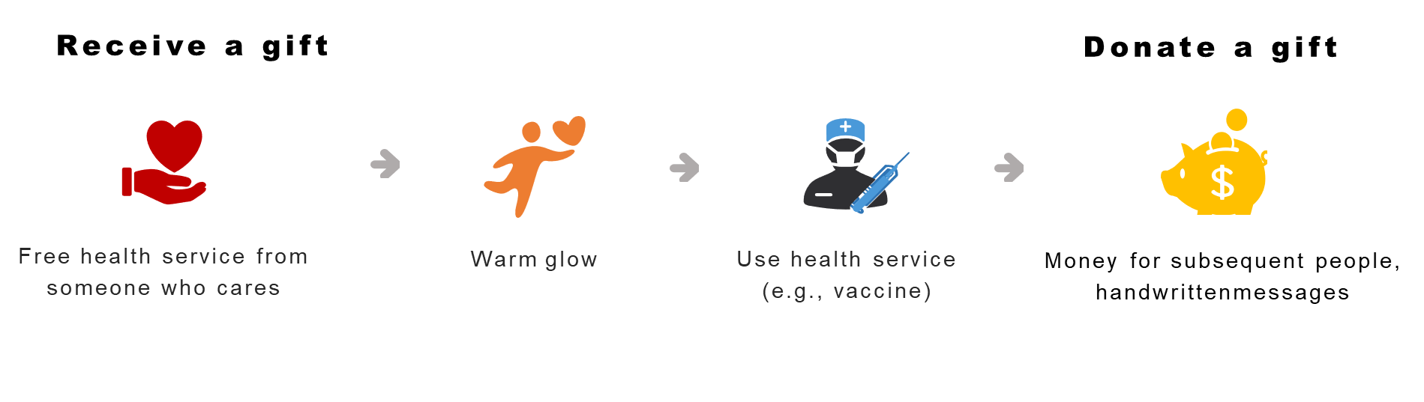

Supplementary Fig 2 postcard example
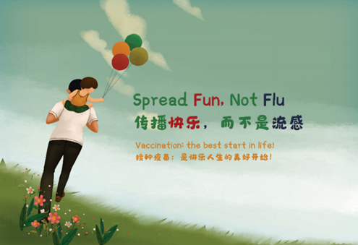

Supplementary Fig 3: translated hand-written postcard messages
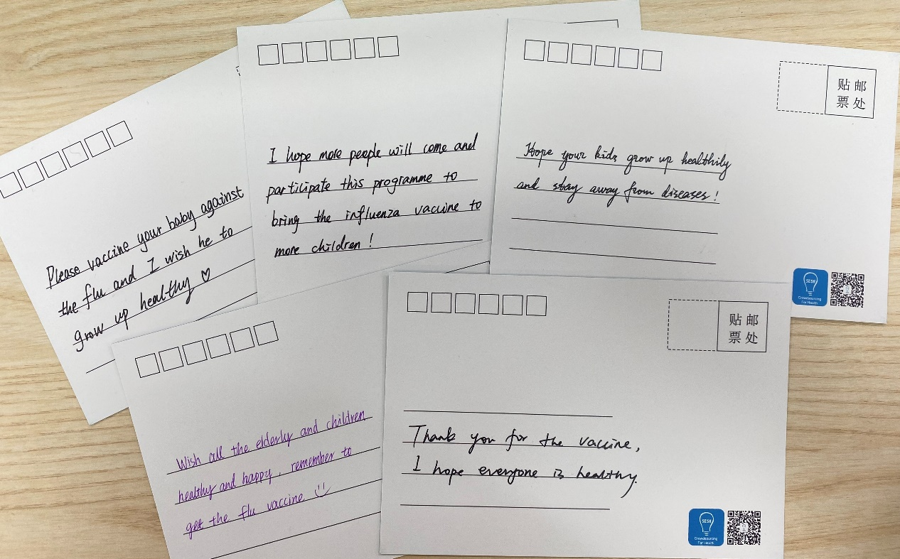

Supplementary Fig 4 Time-based recruitment for the three study arms at three study sites¹

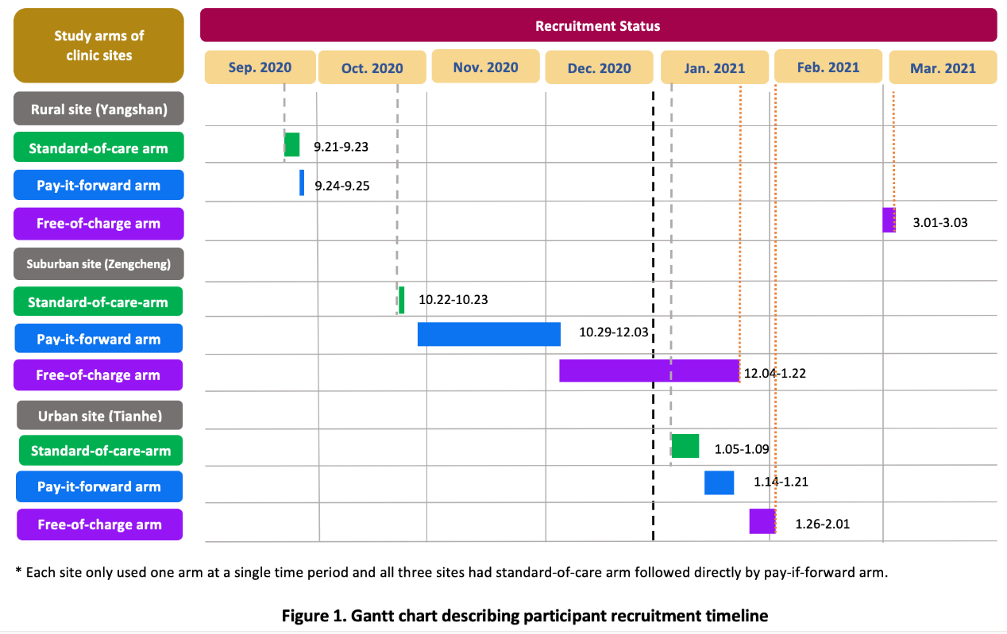
Footnote: The recruitment in Yangshan was spaced out because of occasional stock outs. The lengths of time for the three arms at the study sites varied due to variations in patient volume and recruitment pace.

Supplementary Fig 5: Introduction to influenza (English translation).
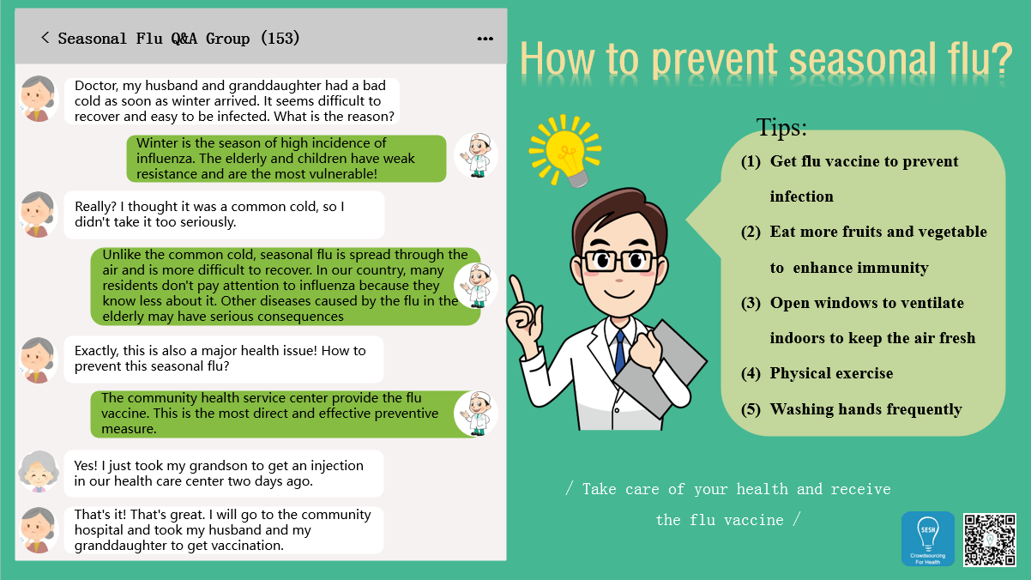

Supplementary Fig 6: pay-it-forward pamphlet (English translation).
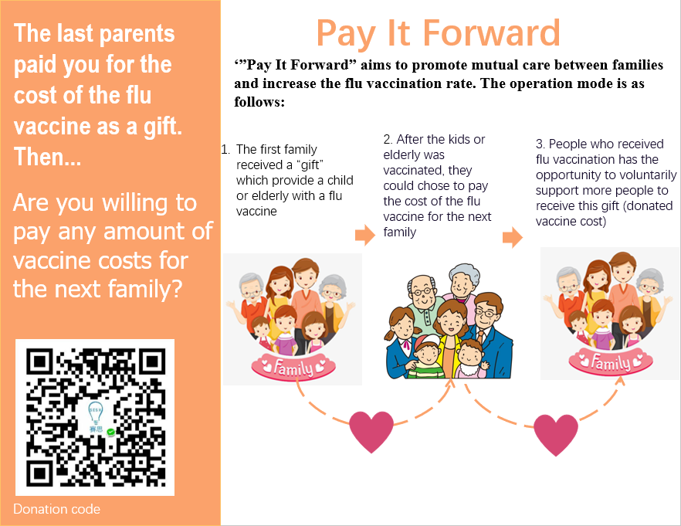
Supplementary Fig 7: Distribution of donation amounts by study site (n=107)
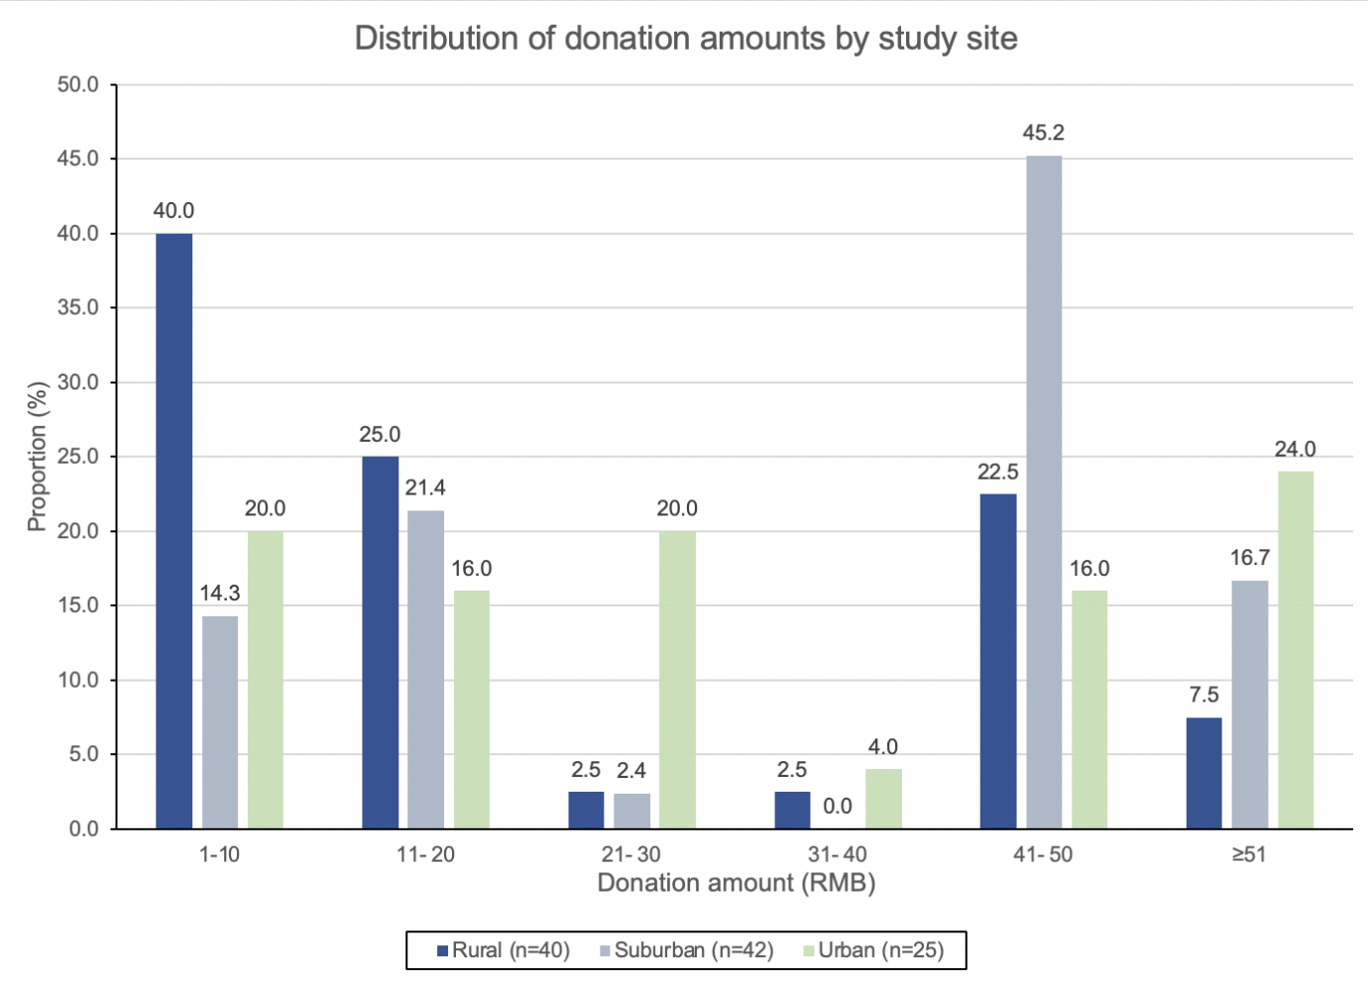
Note: 1 US$=6.59 RMB

Supplementary table 1 Proportion differences in influenza vaccination rates between the three study arms by age groups in Guangdong Province, China, 2020-2021 (N=450)
 | Children  N=225 |  | Older adults  N=225
Uptake (n,%) |  | P value |  | P value
 |  | <0.0001 |  | <0.0001
Standard of care | 40 (53.3) |  | 15 (20)
Pay-it-forward | 66 (88) |  | 45 (60)
Free vaccine | 64 (85.3) |  | 50 (66.7)
Study arms | Crude proportion difference (95%CI) | P value | Crude proportion difference (95%CI) | P value
Pay-it-forward vs Standard of care | 34.7 (21.2, 48.1) | <0.0001 | 40.0 (25.7, 54.3) | <0.0001
Free vaccine vs Standard of care | 32.0 (18.2, 45.8) | <0.0001 | 46.7 (32.7, 60.7) | <0.0001
Pay-it-forward vs Free vaccine | 2.7 (-8.2, 13.5) | 0.81 | -6.7 (-22.1, 8.7) | 0.50
Adjusting study site | Adjusted proportion difference (95%CI) | P value | Adjusted proportion difference (95%CI) | P value
Pay-it-forward vs Standard of care | 34.7 (21.4, 47.9) | <0.0001 | 40.0 (26.3, 53.7) | <0.0001
Free vaccine vs Standard of care | 32.0 (18.4, 45.6) | <0.0001 | 46.7 (33.0, 60.3) | <0.0001
Pay-it-forward vs Free vaccine | 2.7 (-7.7, 13.0) | 0.80 | -6.7 (-21.3, 8.0) | 0.476
Adjusting education level
Pay-it-forward vs Standard of care | 36.3 (22.1, 50.5) | <0.0001 | 41.1 (27.1, 55.1) | <0.0001
Free vaccine vs Standard of care | 36.3 (22.9, 50.0) | <0.0001 | 45.8 (31.9, 59.7) | <0.0001
Pay-it-forward vs Free vaccine | 3.3 (-7.9, 14.5) | 0.81 | -5.6 (-20.6, 9.3) | 0.486

Supplementary table 2: Distribution of donation status and participants with a donation of 50 RMB or above by study site
Characteristic | Rural  (n=50) | Suburban  (n=50) | Urban  (n=50) | p-value*
Donation status (n=150)  - Donated  - Did not donate | 80.0 (40)  20.0 (10) | 84.0 (42)  16.0 (8) | 50.0 (25)  50.0 (25) | <0.001
Characteristic | Rural  (n=40) | Suburban  (n=42) | Urban  (n=25) | p-value*
Donation amount  (n=107)  - <50 RMB  - >=50 RMB | 70.0 (28)  30.0 (12) | 38.1 (16)  61.9 (26) | 60.0 (15)  40.0 (10) | 0.013
Note: US$ 1 = RMB 6.59

Supplementary costs file

Title: Pay-it-forward to improve influenza vaccine uptake and public engagement among children and older adults in China: A quasi-experimental pragmatic study

Costs file Table 1: Unit costs (in 2020 USD) and frequency of vaccine use
Intervention | Cost item | Unit cost | Resource use | Source
Pay-it-forward |  | Staff wage per hour (USD/hour)*
- Start-up costs
 | Time designing postcards to be written on by participants in the PIF programme† | 7.47 | 1 x 5 hr | Personal communication with research staff
 | Time of research fellow participating in preparatory workshop† | 12.7 | 1 x 5 hr | Personal communication with research staff
 | Time of research assistant participating in preparatory workshop† | 7.47 | 1 x 5 hr | Personal communication with research staff
 | Time of nurses participating in preparatory workshop | 4.81 | 3 x 1 hr | Personal communication with research staff  China Social Welfare Foundation (12)
 | Time of clinic coordinators participating in preparatory workshop | 4.81 | 3 x 1 hr | Personal communication with research staff China Social Welfare Foundation(12)
- Fixed costs
 | Vaccinators (doctors) for the three clinics | 11.07 | 3 x 70 hr | China Social Welfare Foundation (12)
- Recurrent costs
 | Time of nurses in recruiting patients to join the PIF programme†† | 4.81 | 3 x 25 hr | Personal communication with research staff  China Social Welfare Foundation (12)
 | Time of clinic coordinators in performing administrative work for the PIF programme†† | 4.81 | 3 x 25 hr | Personal communication with research staff  China Social Welfare Foundation (12)
 |  | Cost per vaccine (USD)
 | Cost of adult vaccines in Yangshan# | 22.9 | 41 | Health clinic reimbursement invoices
 | Cost of adult vaccine in Zengcheng | 22.9 | 17 | Health clinic reimbursement invoices
 | Cost of child vaccine in Zengcheng | 8.38 | 25 | Health clinic reimbursement invoices
 | Cost of adult vaccine in Tianhe# | 12.2 | 28 | Health clinic reimbursement invoices
 |  | Cost per item / batch (USD)
 | Introductory pamphlets for the PIF programme (batch cost) | 29.0 | 1 | Project research staff invoices
 | Ballpoint pens (for writing messages on PIF postcards) (batch cost) | 2.25 | 1 | Project research staff invoices
 | Cost of printing postcards (batch cost) | 7.41 | 1 | Project research staff invoices
 | Surgical gloves | 0.075 | 222 | Personal communication with research staff

Intervention | Cost item | Unit cost | Resource use | Source
Standard-of-care |  | Staff wage per hour (USD/hour)*
- Start-up costs | Time of nurses participating in preparatory workshop | 4.81 | 3 x 1 hr | China Social Welfare Foundation (12)
 | Time of clinic coordinators participating in preparatory workshop | 4.81 | 3 x 1 hr | China Social Welfare Foundation (12)
- Fixed costs
 | Vaccinators for the three clinics | 11.07 | 3 x 70 hr | China Social Welfare Foundation (12)
- Recurrent costs
 | Time of nurses in recruiting patients to receive seasonal influenza vaccination†† | 4.81 | 3 x 12.5 hr | Personal communication with research staff  China Social Welfare Foundation (12)
 | Time of clinic coordinators in performing administrative work for influenza vaccination†† | 4.81 | 3 x 12.5 hr | Personal communication with research staff  China Social Welfare Foundation (12)
 |  | Cost per vaccine (USD)
 | Cost of adult vaccines in Yangshan# | 22.9 | 15 | Health clinic reimbursement invoices
 | Cost of adult vaccine in Zengcheng | 22.9 | 5 | Health clinic reimbursement invoices
 | Cost of child vaccine in Zengcheng | 8.38 | 14 | Health clinic reimbursement invoices
 | Cost of adult vaccine in Tianhe# | 12.2 | 21 | Health clinic reimbursement invoices
 |  | Cost per item (USD)
 | Surgical gloves | 0.075 | 110 | Personal communication with research staff
Intervention | Cost item | Unit cost | Resource use | Source
Free vaccination
- Start-up costs |  | Staff wage per hour (USD/hour)*
 | Time of nurses participating in preparatory workshop | 4.81 | 3 x 1 hr | Personal communication with research staff  China Social Welfare Foundation (12)
 | Time of clinic coordinators participating in preparatory workshop | 4.81 | 3 x 1 hr | Personal communication with research staff  China Social Welfare Foundation (12)
- Fixed costs
 | Vaccinators for the three clinics | 11.07 | 3 x 70 hr | China Social Welfare Foundation (12)
- Recurrent costs
 | Time of nurses in recruiting patients to join the PIF programme†† | 4.81 | 3 x 12.5 hr | Personal communication with research staff  China Social Welfare Foundation (12)
 | Time of clinic coordinators in performing administrative work for the PIF programme†† | 4.81 | 3 x 12.5 hr | Personal communication with research staff  China Social Welfare Foundation (12)
 |  | Cost per vaccine (USD)
 | Cost of adult vaccines in Yangshan# | 22.9 | 42 | Health clinic reimbursement invoices
 | Cost of adult vaccine in Zengcheng | 22.9 | 13 | Health clinic reimbursement invoices
 | Cost of child vaccine in Zengcheng | 8.38 | 18 | Health clinic reimbursement invoices
 | Cost of adult vaccine in Tianhe# | 12.2 | 41 | Health clinic reimbursement invoices
 |  | Cost per item / batch (USD)
 | Surgical gloves | 0.075 | 228 | Personal communication with research staff
 | Information pamphlet for free vaccination arm | 20.4 | 1 | Project research staff invoices
PIF - pay-it-forward, USD – United States dollars
*Hourly wages were calculated from monthly or yearly wages based on an assumption of 250 working days per year and 10 working hours per day.
†These costs were annualised over a three-year period at a discount rate of 3% as they were part of the preparatory workshop for the conception of PIF programme specifically. The training, supplies and expertise gained through these sessions are expected to be useful in future years to inform further iterations of the programme and were therefore annualised over three years.
†† It was assumed that each nurse spent 10 minutes per patient to recruit and persuade participants to be vaccinated in the pay-it-forward programme, while they spent 5 minutes per patient for the standard-of-care group, and 5 minutes per patient in the free vaccination arm.
#Only adult influenza vaccine was used in Yangshan and Tianhe, i.e. children were inoculated with the same influenza vaccine as the adults in those study sites.

Addendum: Breakdown for obtaining the total economic cost and the total financial cost of each intervention arm
Total economic cost of an intervention
= Start-up costs + Fixed costs + Recurrent costs

Total financial cost of an intervention
= Start-up costs + Fixed costs + Recurrent costs – (Payment / Donation contributions)

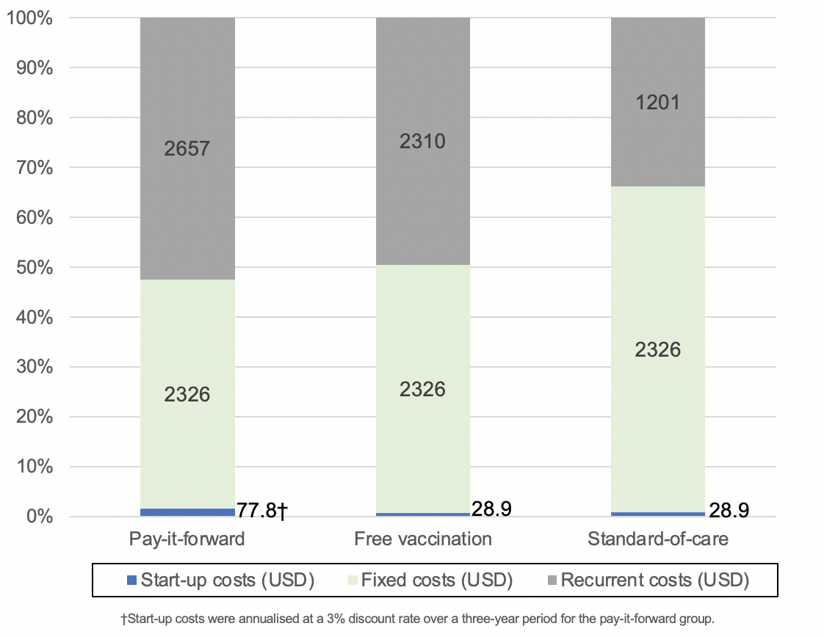
Costs file Figure 1: Breakdown of economic costs by category in the three intervention arms

Costs file Table 2: Total economic costs and total financial costs by intervention arm
Intervention arm | Total economic cost (USD) | Total financial cost (USD)
Pay-it-forward | 5062 | 4477
Free vaccination | 4665 | 4665
Standard-of-care | 3557 | 2725
Note: See Table 1 for detailed breakdown of the economic and financial costs
Sensitivity analysis
One-way deterministic sensitivity analysis
The results of the one-way deterministic sensitivity analysis are shown below in the tornado diagram (Figure 2-5). Overall, they indicate the study is most sensitive to the effectiveness of each intervention in increasing vaccine uptake, which was indicated by the variable of ‘vaccine uptake’. The difference in proportions of vaccinated people between different intervention groups greatly affect the ICER by vastly increasing or decreasing the denominator for the ICER (i.e. the incremental number of vaccinations).
Other important factors that affected the ICER of the two interventions included the combined cost of all types of vaccines in all three study sites, the cost of adult vaccines in Yangshan, Zengcheng, and Tianhe respectively. For the ICER obtained using financial costs, the amount of pay-it-forward donations received was also able to shift the ICER by more than 10% above and below the original ICER estimate.
Figure 8 shows the ICER comparing pay-it-forward against standard-of-care calculated using financial costs and Figure 9 shows the ICER comparing the same two groups calculated using economic costs.
The most important factor that affected the outcome of the ICER was that of the difference in vaccine uptake between the pay-it-forward and standard-of-care groups, which shifted the upper limit of the ICER to 77.19 USD per person vaccinated, which is 2.46 times that of the original estimate of 31.29 USD. The lower limit value of the effect size of the pay-it-forward intervention compared to standard-of-care also resulted in significant improvement of the ICER to 16.56 USD per person vaccinated, halving the original estimate. This shows that the current intervention is only effective if the difference in vaccine uptake of pay-it-forward and standard-of-care groups remain substantial in future iterations of the programme and has the potential to be even more cost-effective if a higher vaccine uptake rate could be achieved in pay-it-forward.
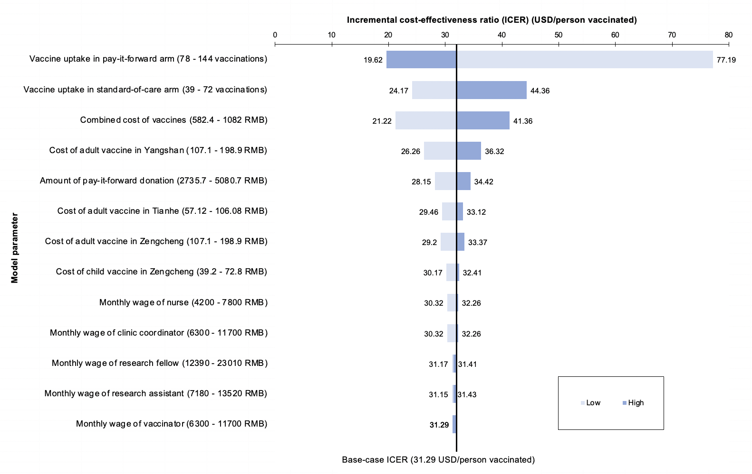

Supplementary Figure 2: Tornado diagram showing the effect of varying different input parameters on the ICER comparing pay-it-forward against standard-of-care calculated using financial costs

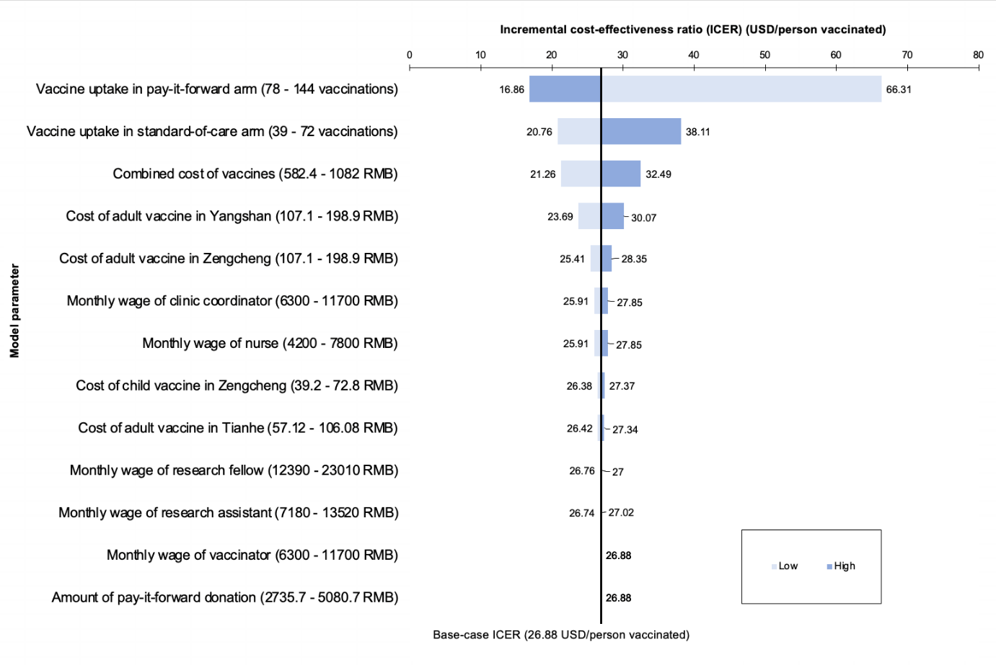
Supplementary Figure 3: Tornado diagram showing the effect of varying different input parameters on the ICER comparing pay-it-forward against standard-of-care calculated using economic costs

Below figures show the ICER comparing pay-it-forward against free vaccination calculated using financial costs and the ICER comparing the same two groups calculated using economic costs.
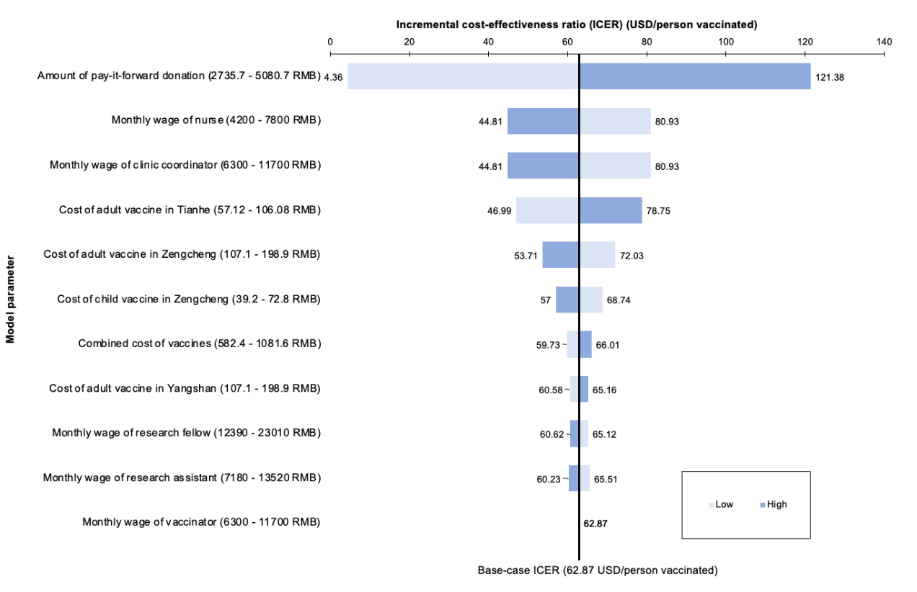
Supplementary Figure 4: Tornado diagram showing the effect of varying different parameters on the ICER comparing pay-it-forward against free vaccination calculated using financial costs
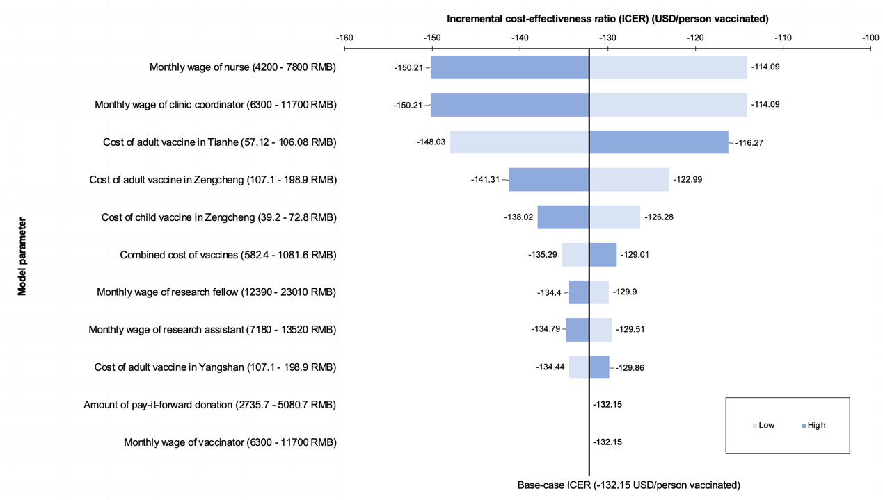
Supplementary Figure 5: Tornado diagram showing the effect of varying different parameters on the ICER comparing pay-it-forward against free vaccination calculated using economic costs
The variables of vaccine uptake in the pay-it-forward and free vaccination groups were omitted from the tornado graphs (Figure 6-7) in the one-way DSA comparing these two groups. This was because he difference in their effect sizes (i.e. the denominator for the ICER) approached zero, and produced ICERs which were not interpretable.

Questionnaire survey
Influenza vaccination for children and elderly people
About this study:
You are invited to participate in this influenza vaccination study. The results of this study can provide evidence for the government to develop better intervention strategies to promote influenza vaccination in China and prevent seasonal influenza among at-risk populations.
Details of this study:
You will need to fill out a questionnaire. This questionnaire will ask about your socio-demographic information and opinions towards influenza vaccine. To protect your privacy, all your answers will be transformed into digital formats and password encrypted. If you are eligible to participate in this program, out project personnel will provide you with more detailed information. To confirm whether you are qualified to participate in this program, we will first ask you a few screening questions. If you are not eligible for this program, we will not keep your survey information.
Note: If the participant is a child, the guardian will need to consent on the child’s behalf and fill in the questionnaire. For the purpose of equality, only one quota is provided for each participating family, either for a child or an elderly individual.

Screening questions (all groups)
i.Which category do you belong to____
○Caregivers of a 3-8 year-old children
○Elderly people (>=60)

ii. Your age (fill in a number) ____
iii. Your gender（male-1, female-2）___
iv. Have you been vaccinated against influenza in the past year?
○Yes (Please skip to the end of the questionnaire and submit the answer sheet)
○No
A. Basic information (all groups)
1. Ethnicity
○Han
○Other, please specify： ____________

2. Your highest education level:
○Primary school
○Junior middle school
○High school
○Undergraduate or college
○Postgraduate or above

3. Your occupation is:
○Student
○Civil servant
○Farmer
○Ordinary workers (blue collar)
○Company staff (white collar)
○Technical personnel
○Unemployed or retired
○Other：___________________*
4. Your personal monthly income:
○0-1000 RMB/Month
○1000-5000 RMB/Month
○5000-10,000 RMB/Month
○10,000 RMB/Month or above

5. Your current legal marriage status is:
○Unmarried
○Engaged or married
○Separated or divorced
○Widowed (skip questions 6-9)

6. Age of your partner：____

7. The highest education level of your partner:
○Primary school
○Junior middle school
○High school
○Undergraduate or college
○Postgraduate

8. The occupation of your partner is:
○Student
○Civil servant
○Farmer
○Ordinary workers (blue collar)
○Company staff (white collar)
○Technical personnel
○Unemployed or retired
○Other：___________________*

9. Your partner’s personal monthly income
○0-1000 RMB/Month
○1000-5000 RMB/Month
○5000-10,000 RMB/Month
○10,000 RMB/Month or above

10 Do you have children in your family?
○Yes
○No (skip question16)

11. How many children are there in your family? (fill in your children's age and sex in chronological order, for example, Child 1, 2 years old, male-1 or female-2)
○Child 1
Age_____
Sex_____
○Child 2
Age_____
Sex_____
○Child 3
Age_____
Sex______
○Child 2
Age_____
Sex_____
○Child 2
Age_____
Sex_____

12. Do you have elderly people in your family?
○Yes
○No

13. How many elderly people (>=60 years) are there in your family? Age and gender?
○Elderly individual 1
Age:
Sex:
○Elderly individual 2
Age:
Sex:
B-0. “Standard of care” group
1. Main purpose of coming to the clinic？
○See a doctor for myself
○Take my child(ren) to see a doctor
○Take my child(ren) to vaccinate
○Accompany elderly family members to see a doctor
○ Body examination
○Other： ____________________ *

2. The researcher has introduced the influenza vaccine. Would you like to participate in the program to vaccinate your child (or yourself if older than 60 years) today?
○Yes
○No（Please skip to the question 22）

3. Who would you like to vaccinate today?
○My Child
○Elderly family member

4.The information of the vaccination recipient?
○Sex___
○Age___

5. Has anyone in your family got seasonal flu in the past year?
○Yes
○No（Skip to the Question 24）

6.If yes, who got seasonal flu in your family?
○Children
○Elderly people
○Children’s parents

7. If you want your family to vaccinate, what is the main reason?
○Children in my family are easy to get seasonable flu
○Elderly people in my family are easy to get seasonable flu
○Both my children and the old people in my family are easy to get seasonable flu
○I’m easy to get seasonable flu
○Recommended by my friends/family member
○Recommendation by HCP the clinic
○Other, please note： ______________ *
8. If you don't want to vaccinate your child or an elderly individual in your family today, why not? [multiple choices] * (if you answered "yes" to question 2, skip this item)
□I don't know enough about seasonal influenza
□I'm not sure about the effect of the influenza vaccine
□My family don't need vaccinations
□It’s too cumbersome
□I'm worried about the side effects
□ I think it is too expensive
□Other, please specify: _______________*

B-1. “Pay it forward” group
1. Main purpose of coming to the clinic？
○See a doctor for myself
○Take my child(ren) to see a doctor
○Take my child(ren) to vaccinate
○Accompany elderly family members to see a doctor
○Other： ____________________ *

2. The researcher has introduced the influenza vaccine and ‘Pay it forward’ program to you. Would you like to participate in the program to vaccinate your child (or yourself if older than 60 years) today?
○Yes
○No（Please skip to the question 27）

3. Who would you like to vaccinate today?
○My Child
○Elderly family member

4.The information of the vaccination recipient?
○Sex___
○Age___

5. Are you willing to donate some money to the next family to get the same influenza vaccination?
○Yes
○No（Skip to the Question 25）

6. How much would you like to donate to the next family?
○200 RMB (support one family to get vaccination (1elderly+1children))
○150 RMB (support 1 elderly or 3 children get vaccination)
○100 RMB (support 2 children get vaccination)
○50 RMB (support 1 children to get vaccination)
○Other amount_____

7. If you want your family to vaccinate, what is the main reason?
○Children in my family are easy to get seasonable flu
○Elderly people in my family are easy to get seasonable flu
○Both my children and the old people in my family are easy to get seasonable flu
○I’m easy to get seasonable flu
○Recommended by my friends/family member
○Recommendation by medical personnel at the clinic (irrelevant to ‘Pay it forward’ program)
○The ‘Pay it forward’ program
○Other, please note： ______________ *

8. What do you think are the benefits of the ‘Pay it forward’ program?
[Multiple choice]
□Other families’ donation can lower my financial burden
□I learn about influenza vaccines that can prevent flus
□Can promote more families to be vaccinated against influenza
□Can reduce the spread of influenza
□Spread love and warmth within the community
□Other： _______________________ *

9. If you don't want to vaccinate your child or an elderly individual in your family today, why not? [multiple choices] * (if you answered "yes" to question 2, skip this item)
□I don't know enough about seasonal influenza
□I'm not sure about the effect of the influenza vaccine
□My family don't need vaccinations
□It’s too cumbersome
□I'm worried about the side effects
□Other, please specify: _______________*

B-2. “Free vaccination” group
1. Main purpose of coming to the clinic？
○See a doctor for myself
○Take my child(ren) to see a doctor
○Take my child(ren) to vaccinate
○Accompany elderly family members to see a doctor
○ Body examination
○ elderly get vaccination
○Other： ____________________ *

2. The researcher has introduced the influenza vaccine and free vaccination programme. Would you like to participate in the program to vaccinate your child (or yourself if older than 60 years) today?
○Yes
○No（Please skip to the question 27）

3. Who would you like to vaccinate today?
○My Child
○Elderly family member

4.The information of the vaccination recipient?
○Sex___
○Age___

5. Has anyone in your family got seasonal flu in the past year?
○Yes
○No（Skip to the Question 25）

6.If yes, who got seasonal flu in your family?
○Children
○Elderly people
○Children’s parents

7. If you want your family to vaccinate, what is the main reason?
○Children in my family are easy to get seasonable flu
○Elderly people in my family are easy to get seasonable flu
○Both my children and the old people in my family are easy to get seasonable flu
○I’m easy to get seasonable flu
○Recommended by my friends/family member
○Recommendation by HCP at the clinic
○Because the free vaccination programme
○Other, please note： ______________ *
8. If you don't want to vaccinate your child or an elderly individual in your family today, why not? [multiple choices] * (if you answered "yes" to question 2, skip this item)
□I don't know enough about seasonal influenza
□I'm not sure about the effect of the influenza vaccine
□My family don't need vaccinations
□It’s too cumbersome
□I'm worried about the side effects
□Other, please specify: _______________*

C. Vaccine related information (all groups)

1. Have you heard about the flu vaccine before this program?
○Yes ○No
2. In general, I think influenza vaccine is important. [Single choice] *
○Strong disagree | ○Disagree | ○Agree | ○Strongly agree
3. In general, I think the influenza vaccine is safe. [Single choice] *
○Strong disagree | ○Disagree | ○Agree | ○Strongly agree
4. In general, I think the influenza vaccine is effective. [Single choice] *
○Strong disagree | ○Disagree | ○Agree | ○Strongly agree
5. Has your child ever been vaccinated against influenza?
(if there is no child in your family, please skip this question) [Single choice] *
○Yes ○No
6. Have elderly people in your family ever been vaccinated against influenza
(if there are no elderly individuals in your family, please skip this question) [Single choice] *
○Yes ○No
7. Have you ever been hesitant about having your child or elderly family members to get the flu vaccine (except for allergies)? [Single choice] *
○Yes ○No
8. Have you ever postponed your child or elderly family members to get the flu vaccine (except for allergies)? [Single choice] *
○Yes ○No
9. Have you ever been refused to have your child or elderly family members to get the flu vaccine (except for allergies)? [Single choice] *
○Yes ○No
10. Have you ever heard about negative information about influenza vaccine?
○Yes ○No
11. Do any of your friends or relatives object to the influenza vaccination?
○Yes ○No
12. Have you or people around you had adverse reactions to influenza vaccination?
○Yes ○No
13. Do you trust the advice provided by the medical personnel in the clinic on influenza vaccine?
○Yes ○No
14. Is price of the vaccine a barrier for your child and/or elderly individuals in your family to get the influenza vaccine?
○Yes ○No

