Postvaccination SARS-CoV-2 infection among healthcare workers – A systematic review and meta-analysis

Saurabh Chandan MD¹, Shahab R. Khan MBBS², Smit Deliwala MD³, Babu P. Mohan MD⁴, Daryl Ramai MD⁴, Ojasvini C. Chandan MD⁵, Antonio Facciorusso MD PhD⁶

SUPPLEMENTARY MATERIALS
APPENDIX-1: Literature search strategy
APPENDIX-2: MOOSE Checklist
APPENDIX-3: PRISMA Flow Diagram
Supplementary Table 1: Newcastle-Ottawa Scale - Study quality assessment
Supplementary Figures 2: Forest Plot, COVID-19 infections in unvaccinated HCWs
Supplementary Figures 3: Forest Plot, vaccinated HCWs hospitalized for COVID-19 infection
Supplementary Figures 4: Forest Plot, vaccinated HCWs admitted to ICU for COVID-19 infection
Supplementary Figures 5: Forest Plot, vaccinated HCWs died from COVID-19 infection
Supplementary Figures 6 (a-c): Funnel Plot, Publication Bias

APPENDIX-1: Literature search strategy
Literature Database | Search items | Items found
Embase via Ovid (1974+) | ('covid-19'/exp OR 'covid-19' OR 'coronavirus disease') AND ('health care worker'/exp OR 'health care worker') AND ('vaccine'/exp OR 'vaccine') | 475
MEDLINE via Ovid (1946+) | "covid-19" OR "coronavirus disease" AND "health care worker" AND "vaccine" | 25
Scopus via Elsevier (1970+) | TITLE-ABS-KEY ( "covid-19" AND "health care workers" AND "vaccine" ) | 186
Web of Science Core Collection via Clarivate Analytics (1975+) | "covid-19" OR "coronavirus disease" AND "health care workers" AND “vaccine” | 428

APPENDIX-2: MOOSE Checklist

Item No | Recommendation | Reported on Page No
Reporting of background should include
1 | Problem definition | 4-5
2 | Hypothesis statement | 5
3 | Description of study outcome(s) | 5
4 | Type of exposure or intervention used | 5
5 | Type of study designs used | 5
6 | Study population | 6
Reporting of search strategy should include
7 | Qualifications of searchers (eg, librarians and investigators) | 5
8 | Search strategy, including time period included in the synthesis and key words | 5
9 | Effort to include all available studies, including contact with authors | 6
10 | Databases and registries searched | 5
11 | Search software used, name and version, including special features used (eg, explosion) | 5
12 | Use of hand searching (eg, reference lists of obtained articles) | -NA-
13 | List of citations located and those excluded, including justification | 8-9,  Suppl Appendix 3
14 | Method of addressing articles published in languages other than English | -NA-
15 | Method of handling abstracts and unpublished studies | 6
16 | Description of any contact with authors | -NA-
Reporting of methods should include
17 | Description of relevance or appropriateness of studies assembled for assessing the hypothesis to be tested | 5-6
18 | Rationale for the selection and coding of data (eg, sound clinical principles or convenience) | 6
19 | Documentation of how data were classified and coded (eg, multiple raters, blinding and interrater reliability) | 6
20 | Assessment of confounding (eg, comparability of cases and controls in studies where appropriate) | 6
21 | Assessment of study quality, including blinding of quality assessors, stratification or regression on possible predictors of study results | 7
22 | Assessment of heterogeneity | 8
23 | Description of statistical methods (eg, complete description of fixed or random effects models, justification of whether the chosen models account for predictors of study results, dose-response models, or cumulative meta-analysis) in sufficient detail to be replicated | 8
24 | Provision of appropriate tables and graphics | Tables 1-2, Figs 1-3
Reporting of results should include
25 | Graphic summarizing individual study estimates and overall estimate | Fig 1-3 Suppl Fig 1-5
26 | Table giving descriptive information for each study included | Table 1-2
27 | Results of sensitivity testing (eg, subgroup analysis) | 12-13
28 | Indication of statistical uncertainty of findings | 12-13

APPENDIX-3: PRISMA Flow Diagram
Records excluded
(n = 161)
Records screened
(n = 244)
Records after duplicates removed
(n = 477)

Identification

Eligibility

Included

Screening

Records identified through database searching
(n = 1114)

Full-text articles excluded, with reasons
(n = 65)
(Total vaccinated HCWs not reported, letter to the editors, Systematic Reviews)

S
Full-text articles assessed for eligibility
(n = 83)

Studies included in quantitative synthesis (meta-analysis)
(n = 18)

Supplementary Table 1: Newcastle-Ottawa Scale - Study quality assessment
STUDY | SELECTION |  |  |  | COMPARABILITY | OUTCOME |  |  | SCORE | QUALITY
 | Representativeness of the average adult in community | Cohort size | Information on clinical outcomes | Outcome not present at start | Factors comparable between the groups | Adequate clinical assessment | Follow up time | Adequacy of follow-up | MAX=8 | HIGH>6, MEDIUM 4 to 6, LOW <4
 | Population based: 1; Multi-center: 0.5; Single-center: 0 | >40 patients: 1; 39 to 20: 0.5; <20: 0 | Information with clarity: 1; Information derived from percentage value: 0.5; Unclear: 0 | not present: 1; present: 0 | yes: 1; no: 0 | yes: 1; no: 0 | yes: 1; not mentioned: 0 | All patients followed up: 1; >50% followed up: 0.5; <50% followed up OR not mentioned: 0
Amit, 2021 | 0 | 1 | 1 | 1 | 1 | 1 | 1 | 1 | 7 | HIGH
Azamgarhi, 2021 | 0 | 1 | 1 | 1 | 1 | 1 | 1 | 1 | 7 | HIGH
Bouton, 2021 | 0 | 1 | 1 | 1 | 1 | 1 | 1 | 1 | 7 | HIGH
Tang, 2021 | 0 | 1 | 1 | 1 | 1 | 1 | 1 | 1 | 7 | HIGH
Cucunawangsiha, 2021 | 0 | 1 | 1 | 1 | 1 | 1 | 1 | 1 | 7 | HIGH
Hall, 2021 | 0.5 | 1 | 1 | 1 | 1 | 1 | 1 | 1 | 6.5 | HIGH
Issac, 2021 | 0 | 1 | 1 | 1 | 1 | 1 | 1 | 1 | 7 | HIGH
Jacobson, 2021 | 0 | 1 | 1 | 1 | 1 | 1 | 1 | 1 | 7 | HIGH
Maroof, 2021 | 0.5 | 1 | 1 | 1 | 1 | 1 | 1 | 1 | 6.5 | HIGH
Mathema, 2021 | 0.5 | 1 | 1 | 1 | 1 | 1 | 1 | 1 | 6.5 | HIGH
North, 2021 | 0.5 | 1 | 1 | 1 | 1 | 1 | 1 | 1 | 6.5 | HIGH
Pandurangaiah, 2021 | 0 | 1 | 1 | 1 | 1 | 1 | 1 | 1 | 7 | HIGH
Sabnis, 2021 | 0 | 1 | 1 | 1 | 1 | 1 | 1 | 1 | 7 | HIGH
Vaishya, 2021 | 0.5 | 1 | 1 | 1 | 1 | 1 | 1 | 1 | 6.5 | HIGH
Keehner, 2021 | 0.5 | 1 | 1 | 1 | 1 | 1 | 1 | 1 | 6.5 | HIGH
Tyagi, 2021 | 0 | 1 | 1 | 1 | 1 | 1 | 1 | 1 | 7 | HIGH
Sharma, 2021 | 0 | 1 | 1 | 1 | 1 | 1 | 1 | 1 | 7 | HIGH

Supplementary Figure 2: Forest Plot, COVID-19 infections in unvaccinated HCWs

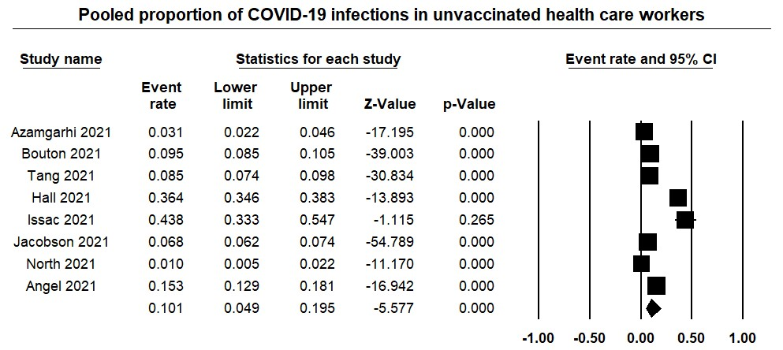

Supplementary Figure 3: Forest Plot, vaccinated HCWs hospitalized for COVID-19 infection

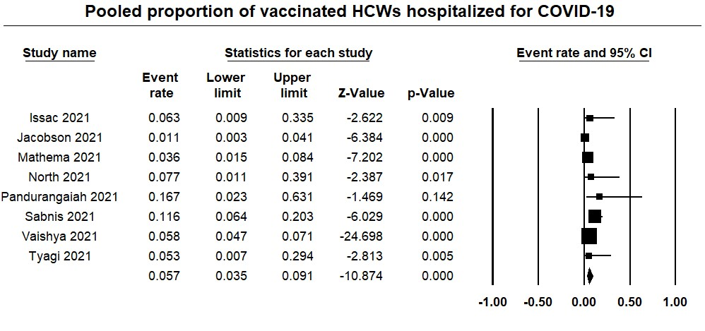

Supplementary Figure 4: Forest Plot, vaccinated HCWs admitted to ICU for COVID-19 infection

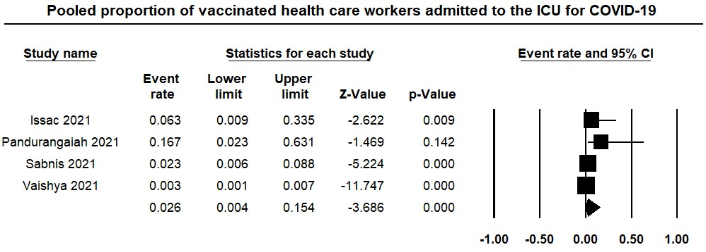

Supplementary Figure 5: Forest Plot, vaccinated HCWs died from COVID-19 infection

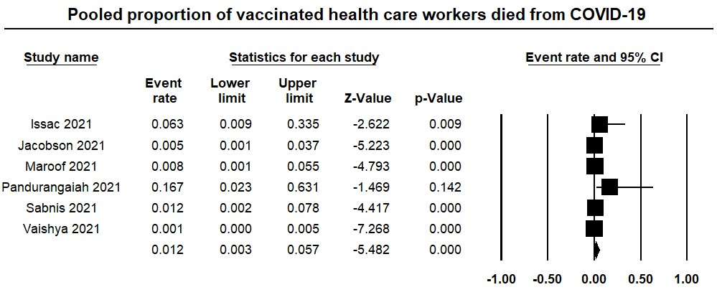

Supplementary Figures 6 (a-c): Fu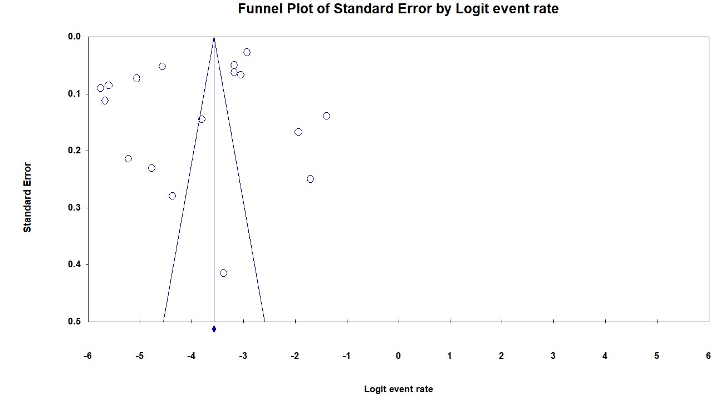nnel Plot, Publication Bias
