Title: Tracking the temporal variation of COVID-19 surges through wastewater-based epidemiology during the peak of the pandemic: a six-month long study in Charlotte, North Carolina
Authors: Visva Bharati Barua^{a*}, Md Ariful Islam Juel^{a*}, A. Denene Blackwood^{b}, Thomas Clerkin^{b}, Mark Ciesielski^{b}, Adeola Julian Sorinoluª, David A. Holcomb^{c}, Isaiah Youngª, Gina Kimble^{d}, Shannon Sypolt^{d}, Lawrence S. Engel^{c}, Rachel T. Noble^{b}, Mariya Munirª
ªDepartment of Civil and Environmental Engineering, University of North Carolina Charlotte, 9201 University City Boulevard, Charlotte, NC 28223, USA
^{b}Institute of Marine Sciences, The University of North Carolina at Chapel Hill, Morehead City, NC 28557, USA
^{c}Department of Epidemiology, Gillings School of Global Public Health, The University of North Carolina at Chapel Hill, Chapel Hill, NC 27599, USA

^{d}Charlotte Water, 5100 Brookshire Blvd., Charlotte, NC 28216, USA

Corresponding author: mmunir@uncc.edu (Mariya Munir)
* These authors contributed equally
Supplementary file
(a)
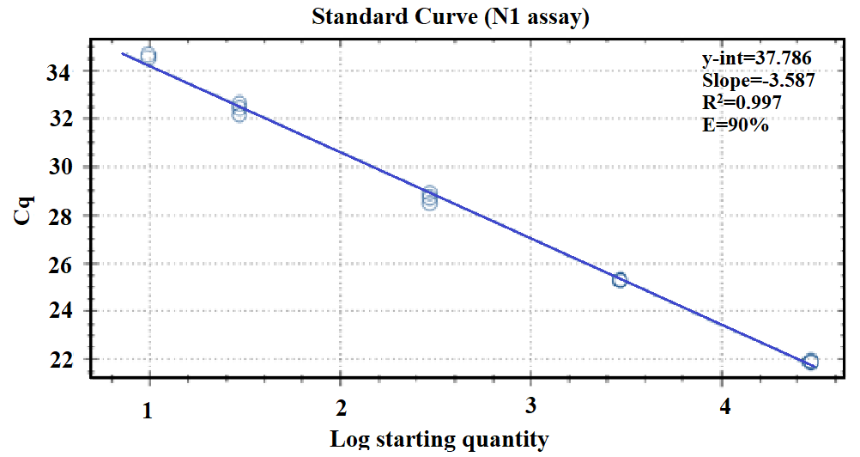

(b)
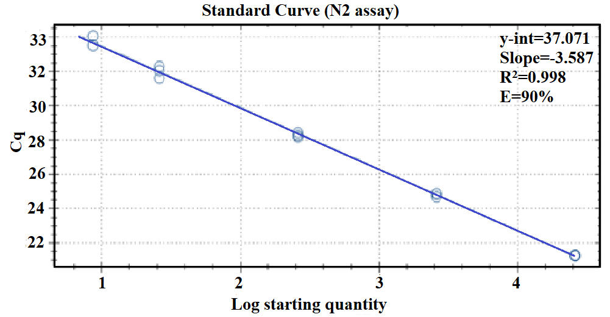
Fig. S1. Standard curve for (a) N1 and (b) N2 assay using workflow 1.
Table S1. Primers and probe sequences utilized in this WBE study.
Assay | Primer/Probe | Sequences | Reference
CDC N1 | Forward  Reverse  Probe | GACCCCAAAATCAGCGAAAT  TCTGGTTACTGCCAGTTGAATCTG  FAM-ACCCCGCATTACGTTTGGTGGACC-BHQ1 | ¹CDC (2020)
CDC N2 | Forward  Reverse  Probe | TTACAAACATTGGCCGCAAA  GCGCGACATTCCGAAGAA  FAM-ACAATTTGCCCCCAGCGCTTCAG-BHQ1 | ¹CDC (2020)
BCoV | Forward  Reverse  Probe | CTGGAAGTTGGTGGAGTT  ATTATCGGCCTAACATACATC  FAM-CCTTCATATCTATACACATCAAGTTGTT-BHQ1 | ²Decaro et al., 2008
Hep G | Forward  Reverse  Probe | CGG CCA AAA GGT GGT GGA TG  CGA CGA GCC TGA CGT CGG G  HEX-AGG TCC CTC TGG CGC TTG TGG CGA G-BHQ1 | ³Schlueter et al., 1996

Table S2. Average recovery efficiency of BCoV and HepG for workflow 1
 | Workflow 1
Plant | BCoV recovery (%) | Hep G recovery (%)
A | 21.5±15 | 41.31±18.1
B | 22±23 | 43.4±21
C | 20.2±24 | 38±22.7
D | 30.9±29 | 44±17.4

Table S3. Average recovery efficiency of BCoV and HepG for workflow 2
 | Workflow 2
Plant | BCoV recovery (%) | Hep G recovery (%)
A | 24.76±20 | 26.22±15.5
B | 22.3±17 | 17.3±11.5
C | 23.3±18 | 24±13.6
D | 26±25 | 29.8±19.6

Table S4. Inhibition control data for N1 gene for workflow 1 (RT-qPCR)

Date | Plant | Undiluted |  |  |  | Diluted (1:5)
 |  | Cq |  |  |  | Cq
 |  | Rep#1 | Rep#2 | Rep#3 | Avg. Cq | Rep#1 | Rep#2 | Rep#3 | Avg. Cq
11/23/2020 | A | 33.67 | 31.89 | 32.34 | 32.63 | 35.54 | ND | 36.29 | 35.9
 | B | 34.24 | 33.37 | 33.92 | 33.77 | ND | ND | ND | NA
 | C | 34.7 | 32.96 | 34.94 | 34.20 | ND | ND | ND | NA
11/25/2020 | A | 33.24 | 33.27 | 33.33 | 33.28 | ND | ND | ND | NA
 | B | 36.07 | 33.31 | 33.92 | 34.43 | ND | ND | ND | NA
 | C | 32.00 | 32.54 | 32.01 | 32.18 | 36.85 | ND | ND | NA
 | D | ND | ND | ND | NA | ND | ND | ND | NA
11/30/2020 | A | 32.9 | 32.92 | 32.19 | 32.67 | 36.00 | ND | ND | NA
 | B | 31.87 | 33.3 | 33.07 | 32.74 | ND | ND | 35.44 | 35.44
 | C | 32.33 | 32.1 | 32.24 | 32.22 | 36.24 | ND | ND | 36.24
Date | Plant | Undiluted |  |  |  | Diluted (1:3)
 |  | Cq |  |  |  | Cq
 |  | Rep#1 | Rep#2 | Rep#3 | Avg. Cq | Rep#1 | Rep#2 | Rep#3 | Avg. Cq
7/1/2020 | A | 33.93 | 32.92 | - | 33.42 | 33.87 | 35.55 | 35.87 | 35.10
 | B | ND | ND | - | NA | ND | ND | ND | NA
 | C | 34.17 | 35.16 | - | 34.66 | 34.41 | 36.47 | ND | 35.44
 | D | 34.61 | 32.52 | - | 33.57 | 33.19 | ND | 34.74 | 33.97
7/8/2020 | B | 37.81 | 35.45 | - | 36.63 | 37.80 | ND | ND | 37.63
 | C | 36.22 | 34.36 | - | 35.29 | ND | 35.97 | ND | 35.97
 | D | ND | ND | - | NA | ND | ND | ND | NA
7/22/2020 | A | 33.07 | 32.10 | - | 32.59 | ND | 33.01 | 34.02 | 34.81
 | B | 36.83 | 36.12 | - | 36.47 | ND | ND | ND | NA
 | C | 37.21 | 32.47 | - | 34.84 | ND | 35.28 | ND | 35.28
 | D | 37.05 | 34.71 | - | 35.88 | ND | ND | ND | NA
7/29/2020 | A | ND | ND | - | NA | ND | ND | ND | NA
 | B | 33.73 | ND | - | NA | ND | ND | ND | NA
 | C | 35.12 | 33.69 | - | 34.41 | 35.96 | ND | ND | 35.96
 | D | ND | ND | - | NA | 35.36 | 35.29 | 33.94 | 34.86

Table S5. Inhibition control data for N2 gene for workflow 2 (ddPCR)

Date | Plant |  | Undiluted |  |  |  |  |  |  |  |  |  |  |  |  |  |  | Diluted (1:3)
 |  |  | Cq |  |  |  |  |  |  |  |  |  |  |  |  |  |  | Cq
 |  |  | Rep#1 |  |  |  | Rep#2 |  |  |  | Rep#3 |  |  |  | Avg. Cq |  |  | Rep#1 |  |  |  | Rep#2 |  |  |  | Rep#3 |  |  | Avg. Cq
7/1/2020 | A |  | 35.23 |  |  |  | 34.22 |  |  |  | 37.43 |  |  |  |  | 35.63 |  | 35.29 |  |  |  | 34.76 |  |  |  | ND |  |  | 35.03
 | B |  | ND |  |  |  | ND |  |  |  | ND |  |  |  |  | NA |  | ND |  |  |  | ND |  |  |  | ND |  |  | NA
 | C |  | ND |  |  |  | 37.15 |  |  |  | 36.06 |  |  |  |  | 36 |  | 34.61 |  |  |  | ND |  |  |  | 37.33 |  |  | 35.97
 | D |  | ND |  |  |  | 41.17 |  |  |  | 39.34 |  |  |  |  | 40.25 |  | 35.53 |  |  |  | ND |  |  |  | 33.85 |  |  | 34.69
7/8/2020 | B |  | ND |  |  |  | ND |  |  |  | ND |  |  |  |  | NA |  | ND |  |  |  | ND |  |  |  | ND |  |  | NA
 | C |  | ND |  |  |  | ND |  |  |  | 35.39 |  |  |  |  | 35.39 |  | ND |  |  |  | ND |  |  |  | ND |  |  | NA
 | D |  | ND |  |  |  | ND |  |  |  | ND |  |  |  |  | NA |  | ND |  |  |  | ND |  |  |  | ND |  |  | NA
7/22/2020 | A |  | 33.60 |  |  |  | 33.79 |  |  |  | 34.33 |  |  |  |  | 35.91 |  | ND |  |  |  | 35.94 |  |  |  | ND |  |  | 35.94
 | B |  | ND |  |  |  | ND |  |  |  | ND |  |  |  |  | NA |  | ND |  |  |  | ND |  |  |  | ND |  |  | NA
 | C |  | 33.97 |  |  |  | 36.93 |  |  |  | 34.29 |  |  |  |  | 35.06 |  | ND |  |  |  | 35.94 |  |  |  | ND |  |  | 35.94
 | D |  | ND |  |  |  | ND |  |  |  | ND |  |  |  |  | NA |  | ND |  |  |  | 36.74 |  |  |  | ND |  |  | 36.74
7/29/2020 | A |  | 36.75 |  |  |  | ND |  |  |  | ND |  |  |  |  | 36.75 |  | ND |  |  |  | ND |  |  |  | ND |  |  | NA
 | B |  | ND |  |  |  | ND |  |  |  | ND |  |  |  |  | NA |  | ND |  |  |  | ND |  |  |  | 39.80 |  |  | 39.80
 | C |  | 36.46 |  |  |  | 34.16 |  |  |  | 36.52 |  |  |  |  | 35.71 |  | ND |  |  |  | ND |  |  |  | 36.43 |  |  | 36.43
 | D |  | ND |  |  |  | ND |  |  |  | ND |  |  |  |  | NA |  | 37.93 |  |  |  | ND |  |  |  | ND |  |  | NA
Date | Plant | Undiluted |  |  |  |  |  |  |  |  |  |  |  |  |  |  |  | Diluted (1:2)
 |  | Cq |  |  |  |  |  |  |  |  |  | Avg. Cq |  |  |  |  |  | Cq |  |  |  |  |  |  |  |  |  |  | Avg. Cq
7/15/2020 | A | ND |  |  | ND |  |  |  | ND |  |  | NA |  |  |  |  |  | ND |  |  | ND |  |  |  | ND |  |  |  | NA
 | C | ND |  |  | ND |  |  |  | ND |  |  | NA |  |  |  |  |  | ND |  |  | ND |  |  |  | ND |  |  |  | NA
8/19/2020 | C | ND |  |  | ND |  |  |  | ND |  |  | NA |  |  |  |  |  | ND |  |  | ND |  |  |  | ND |  |  |  | NA
 | D | ND |  |  | ND |  |  |  | ND |  |  | NA |  |  |  |  |  | ND |  |  | ND |  |  |  | ND |  |  |  | NA
8/26/2020 | A | ND |  |  | ND |  |  |  | ND |  |  | NA |  |  |  |  |  | ND |  |  | ND |  |  |  | ND |  |  |  | NA
 | B | ND |  |  | ND |  |  |  | ND |  |  | NA |  |  |  |  |  | ND |  |  | ND |  |  |  | ND |  |  |  | NA
 | C | ND |  |  | ND |  |  |  | ND |  |  | NA |  |  |  |  |  | ND |  |  | ND |  |  |  | ND |  |  |  | NA
9/23/2020 | A | ND |  |  | ND |  |  |  | ND |  |  | NA |  |  |  |  |  | ND |  |  | ND |  |  |  | ND |  |  |  | NA
 | B | ND |  |  | ND |  |  |  | ND |  |  | NA |  |  |  |  |  | ND |  |  | ND |  |  |  | ND |  |  |  | NA
 | C | ND |  |  | ND |  |  |  | ND |  |  | NA |  |  |  |  |  | ND |  |  | ND |  |  |  | ND |  |  |  | NA
 | D | ND |  |  | ND |  |  |  | ND |  |  | NA |  |  |  |  |  | ND |  |  | ND |  |  |  | ND |  |  |  | NA
9/30/2020 | C | ND |  |  | ND |  |  |  | ND |  |  | NA |  |  |  |  |  | ND |  |  | ND |  |  |  | ND |  |  |  | NA
10/7/2020 | A | ND |  |  | ND |  |  |  | ND |  |  | NA |  |  |  |  |  | ND |  |  | ND |  |  |  | ND |  |  |  | NA
 | B | ND |  |  | ND |  |  |  | ND |  |  | NA |  |  |  |  |  | ND |  |  | ND |  |  |  | ND |  |  |  | NA
 | C | ND |  |  | ND |  |  |  | ND |  |  | NA |  |  |  |  |  | ND |  |  | ND |  |  |  | ND |  |  |  | NA
 | D | ND |  |  | ND |  |  |  | ND |  |  | NA |  |  |  |  |  | ND |  |  | ND |  |  |  | ND |  |  |  | NA
11/23/2020 | A | ND |  |  | ND |  |  |  | ND |  |  | NA |  |  |  |  |  | 33.22 |  |  | 33.65 |  |  |  | ND |  |  |  | 33.44
 | B | ND |  |  | ND |  |  |  | ND |  |  | NA |  |  |  |  |  | 35.55 |  |  | 34.52 |  |  |  | 34.04 |  |  |  | 34.70
 | C | ND |  |  | ND |  |  |  | ND |  |  | NA |  |  |  |  |  | 33.51 |  |  | 33.41 |  |  |  | ND |  |  |  | 33.46
11/25/2020 | A | ND |  |  | ND |  |  |  | ND |  |  | NA |  |  |  |  |  | 34.26 |  |  | 33.78 |  |  |  | 33.9 |  |  |  | 33.98
 | B | ND |  |  | ND |  |  |  | ND |  |  | NA |  |  |  |  |  | ND |  |  | 35.16 |  |  |  | 35.67 |  |  |  | 35.42
 | C | ND |  |  | ND |  |  |  | ND |  |  | NA |  |  |  |  |  | 33.69 |  |  | 34.13 |  |  |  | 33.38 |  |  |  | 33.73
 | D | ND |  |  | ND |  |  |  | ND |  |  | NA |  |  |  |  |  | ND |  |  | ND |  |  |  | ND |  |  |  | NA
11/30/2020 | A | ND |  |  | ND |  |  |  | ND |  |  | NA |  |  |  |  |  | ND |  |  | 33.66 |  |  |  | 33.5 |  |  |  | 33.58
 | B | ND |  |  | ND |  |  |  | ND |  |  | NA |  |  |  |  |  | 33.78 |  |  | 33.74 |  |  |  | ND |  |  |  | 33.76
 | C | ND |  |  | ND |  |  |  | ND |  |  | NA |  |  |  |  |  | ND |  |  | 33.16 |  |  |  | 33.97 |  |  |  | 33.57
12/2/2020 | A | ND |  |  | ND |  |  |  | ND |  |  | NA |  |  |  |  |  | 31.37 |  |  | 31.21 |  |  |  | 32.03 |  |  |  | 31.54
 | B | ND |  |  | ND |  |  |  | ND |  |  | NA |  |  |  |  |  | 32.93 |  |  | 33.51 |  |  |  | 33.01 |  |  |  | 33.15
 | C | ND |  |  | ND |  |  |  | ND |  |  | NA |  |  |  |  |  | 33.64 |  |  | 33.1 |  |  |  | ND |  |  |  | 33.37
 | D | ND |  |  | ND |  |  |  | ND |  |  | NA |  |  |  |  |  | ND |  |  | ND |  |  |  | ND |  |  |  | NA
12/7/2020 | A | ND |  |  | ND |  |  |  | ND |  |  | NA |  |  |  |  |  | 32.69 |  |  | 33.15 |  |  |  | 32.96 |  |  |  | 32.93
 | B | ND |  |  | ND |  |  |  | ND |  |  | NA |  |  |  |  |  | 34.18 |  |  | 33.82 |  |  |  | ND |  |  |  | 34
 | C | ND |  |  | ND |  |  |  | ND |  |  | NA |  |  |  |  |  | ND |  |  | 33.18 |  |  |  | 35.03 |  |  |  | 34.12
ND- Not detected; NA- Not applicable

Table S6. Inhibiton control data for workflow 2 (ddPCR)
Date | Inhibition efficiency (%)
 | Plant A | Plant B | Plant C | Plant D
6/24/2020 | 101 | 101 | 100 | -
7/1/2020 | 101 | 101 | 104 | 99
7/8/2020 | 96 | 104 | 98 | 101
7/15/2020 | 102 | 98 | 100 | 97
7/22/2020 | 99 | 98 | 103 | 99
7/29/2020 | 98 | 99 | 97 | 98
8/5/2020 | 94 | 98 | NT | 98
8/12/2020 | 100 | 98 | 100 | 97
8/19/2020 | 101 | 98 | 97 | 102
8/26/2020 | 97 | 100 | 99 | 97
9/2/2020 | 97 | 96 | 99 | 94
9/9/2020 | 95 | 92 | - | 98
9/15/2020 | - | 98 | 89 | -
9/30/2020 | 98 | 97 | 94 | 91
10/7/2020 | 96 | 90 | 94 | 95
10/14/2020 | 98 | 95 | 94 | 97
10/28/2020 | 96 | 95 | 101 | 93
11/2/2020 | 98 | 105 | 100 | -
11/4/2020 | 96 | 93 | - | -
11/11/2020 | 93 | 94 | 101 | 96
11/16/2020 | 93 | 100 | 94 | -
11/18/2020 | 95 | 93 | 97 | -
11/23/2020 | 97 | 97 | 96 | -
11/25/2020 | 94 | 93 | 94 | 96
11/30/2020 | 96 | 101 | 97 | -
12/7/2020 | 101 | 96 | 94 | -
12/9/2020 | 90 | 95 | 95 | 91
12/14/2020 | - | 95 | 91 | -

Table S7a. Detailed reagents and methods utilized in workflow 2
Kingfisher Magnetic bead extraction
Quantity | Description | Vendor | Catalog Number
1 | Tip comb | Fisher Sci. | 22-387-029
7 | 96 well, DWP | Fisher Sci. | 22-387-031
800 µL | Wash Buffer 1 | Biomerieux | 280130
1000 µL | Wash Buffer 2 | Biomerieux | 280131
500 µL | Wash Buffer 3 | Biomerieux | 280132
50 µL | Magnetic silica | Biomerieux | 280134
100 µL | Buffer AE | Life Technologies | 19077
Extraction protocol for workflow 2
Lysate Plate
- Dispense up to 950 µL of supernatant of lysed sample into a 96 Deep Well plate containing 50 mL of magnetic beads.
- Incubate 96 well Deep Well plate containing sample and Magnetic Beads for 10 minutes at room temperature.
- While incubating, set up other plates.
Wash 1 Plate
- Dispense 400 μL of Wash Buffer 1 into each well
Wash 2 Plate
- Dispense 400 μL of Wash Buffer 1 into each well
Wash 3 Plate
- Dispense 500 μL of Wash Buffer 2 into each well
Wash 4 Plate
- Dispense 500 μL of Wash Buffer 2 into each well
Wash 5 Plate
- Dispense 500 μL of Wash Buffer 3 into each well
Eluate Plate
- Dispense 100 μL of AE Elution Buffer into each well
Tip Comb Plate
- Place 96 DW tip comb into plate
After 10-minutes of incubation, plates were added to the Kingfisher Instrument as the program directed.
Table S7b. Sample preparation for Reverse Transcription
Quantity | Description | Vendor | Catalog Number
50 µL | Superscript VILO IV MM | Fisher Sci. | 11756050
1 | Foil seal | BioRad | 1814040
1 | 96 well PCR plate | BioRad | 12001925
1µL | Mouse Lung RNA | BioChain | R1334152-50

RT MasterMIX | µL
Volume per rxn | 70
Superscript IV VILO 5X | 14
RNA template | 35
Mouse Lung RNA | 1
Water | 20

References
(1) CDC, (2020). (https://www.cdc.gov/healthywater/surveillance/wastewater-surveillance/testing-methods.html)
(2) Decaro, N.; Elia, G.; Campolo, M.; Desario, C.; Mari, V.; Radogna, A.; Colaianni, M. L.; Cirone, F.; Tempesta, M.; Buonavoglia, C. Detection of Bovine Coronavirus Using a TaqMan-Based Real-Time RT-PCR Assay. J. Virol. Methods 2008, 151 (2), 167–171. https://doi.org/10.1016/j.jviromet.2008.05.016.
(3) Schlueter, V.; Schmolke, S.; Stark, K.; Hess, G.; Ofenloch-Haehnle, B.; Engel, A. M. Reverse Transcription-PCR Detection of Hepatitis G Virus. J. Clin. Microbiol. 1996, 34 (11), 2660–2664. https://doi.org/10.1128/jcm.34.11.2660-2664.1996.

