**SUPPLEMENTAL MATERIAL**

**Supplemental Figure 1**. Calibration curves of machine learning models.

LogReg: Logistic regression

Nnet: Neural network

Ensemb: Ensemble model

base: model trained on base training set

over: model trained on oversampled training set

syn: model trained on synthetic training set

**Supplemental Table 1**. Demographic and clinical variables from NHANES III.



**Supplemental Table 2**. Selected electrocardiogram measures from NHANES III (highlighted variables used for model training following pre-processing)

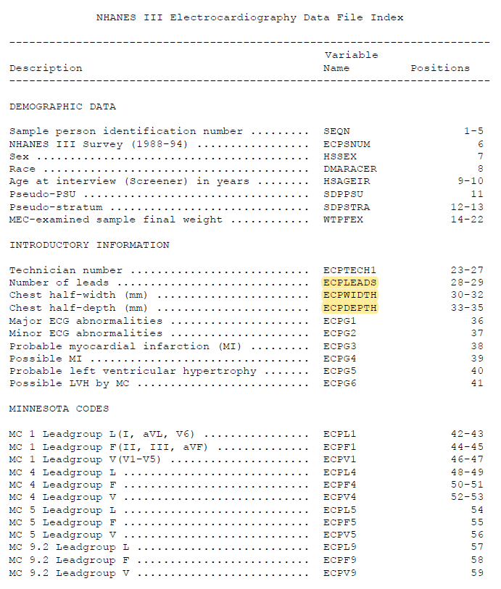

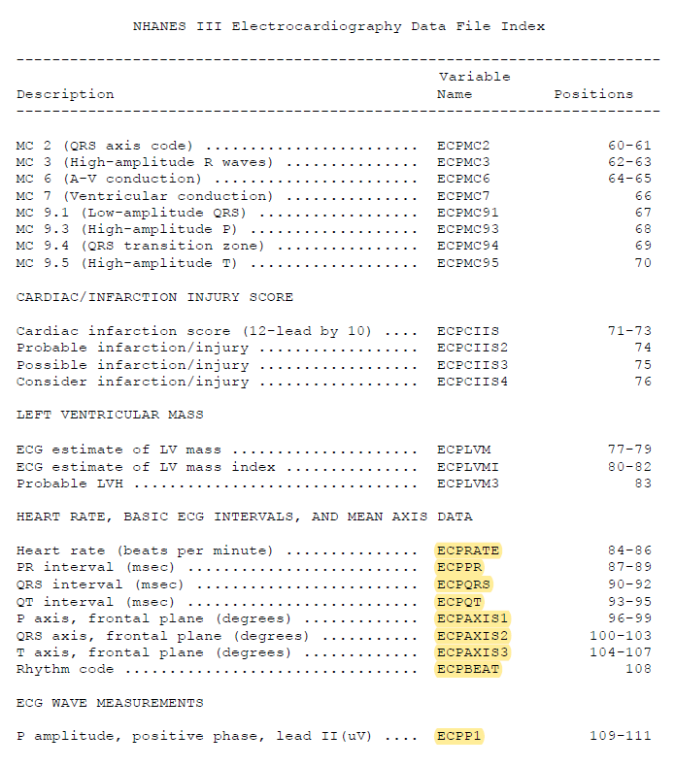

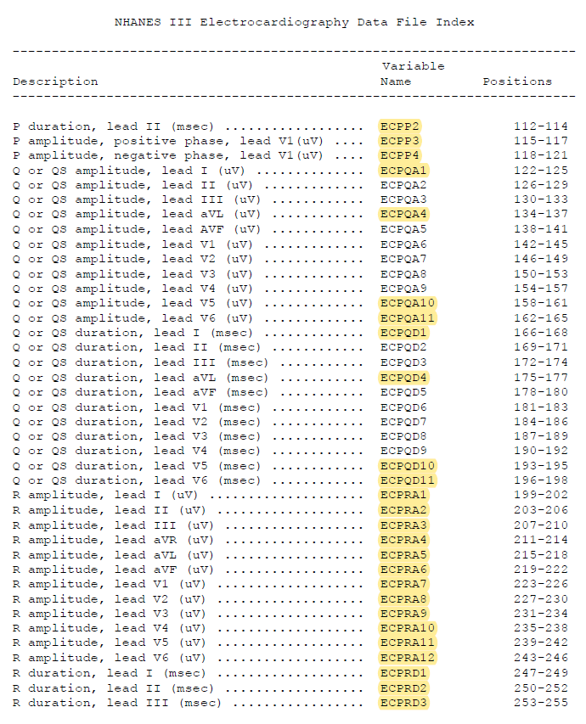

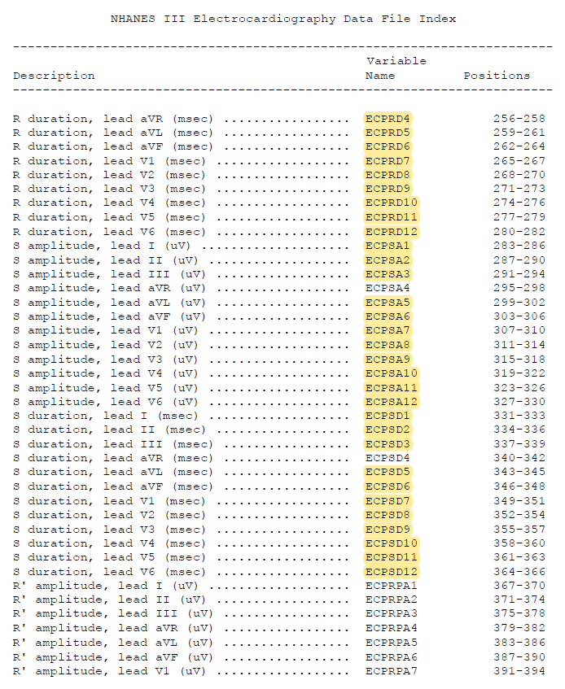

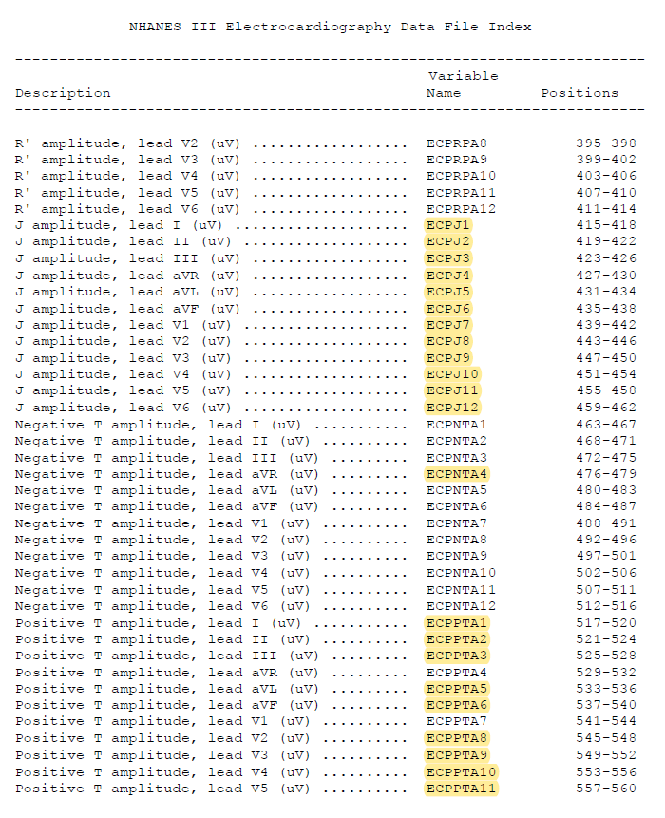

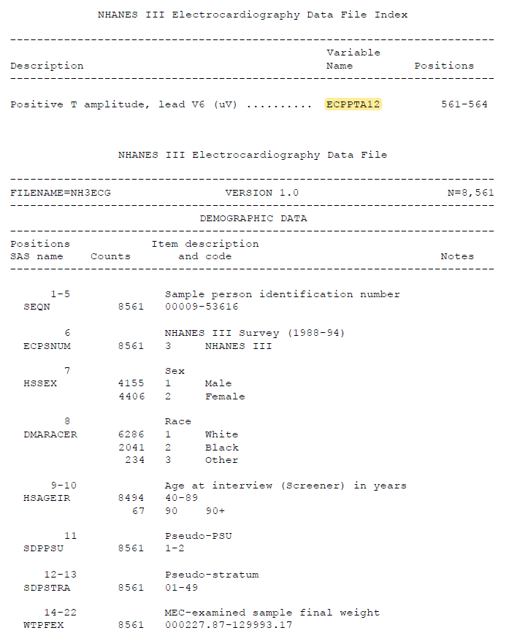

**Supplemental Table 3**. Model performance comparison (full).

PCE: Pooled Cohort Equations, ECG: Electrocardiogram, AUROC: Area under receiver operating characteristic curve, AUPRC: Area under precision-recall curve, Confidence Interval (bootstrap)

aClassification performance assessed at 10 years, with threshold value set to maximize AUPRC

bmodel trained on base training set

cmodel trained on oversampled training set

dmodel trained on synthetic training set



**Supplemental Table 4**. Variable importance comparison between prediction models

LR: Logistic regression, GBM: Gradient boosting machine, SVM: Support vector machine

amodel trained on base training set

bmodel trained on oversampled training set

cmodel trained on synthetic training set

Color schema based on frequency of importance: Dark green(7), Light green(6), Yellow(5), Light orange(4), Orange(3)

