**Supplementary File 2 PRISMA 2020 flow diagram**

Clinical question 1 (remdesivir)

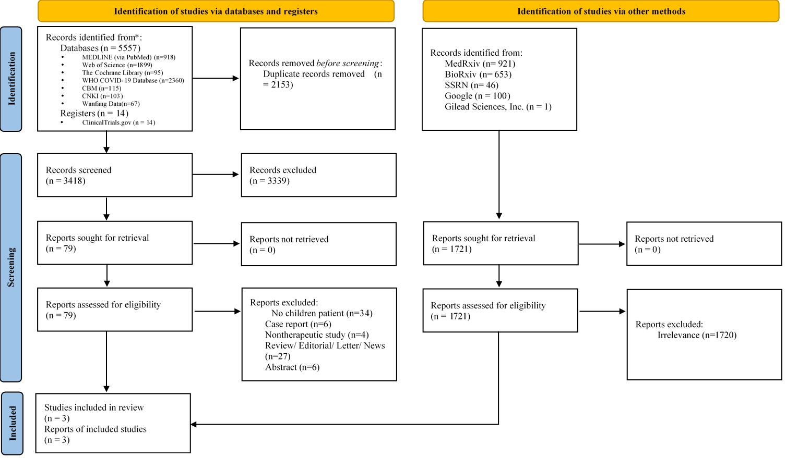

Clinical question 2 (glucocorticoids)

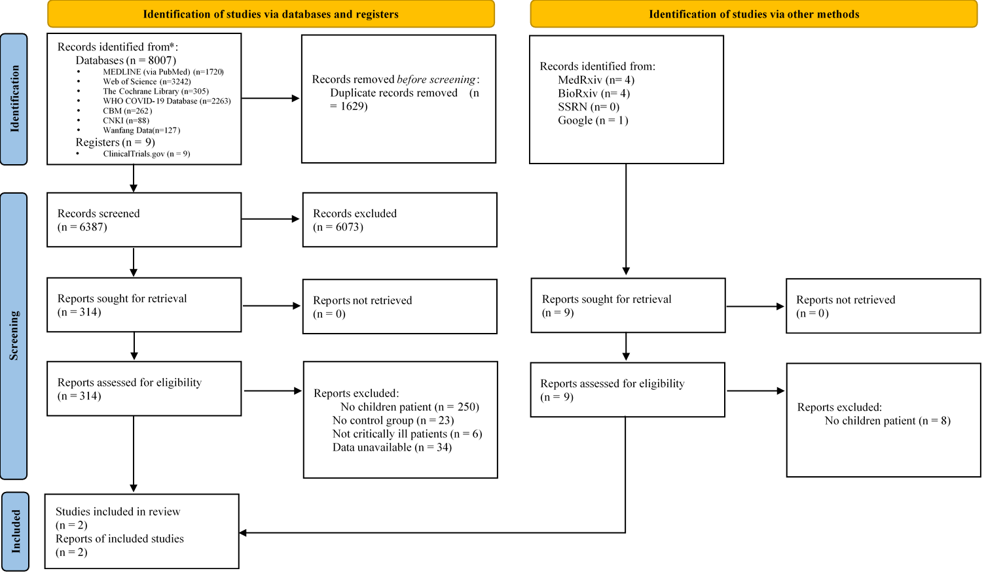

Clinical question 3 (IVIG)

