SUPPLEMENTAL MATERIAL

Items | Page
Supplemental Methods | 3
Supplemental Table 1. Baseline replication cohort characteristics by endophenotype | 4
Supplemental Table 2. Baseline cohort characteristics by endophenotype in European-ancestry participants of the UK Biobank | 5
Supplemental Table 3. Distribution and characteristics of variants in LDL-C associated genetic testing panels of interest | 6
Supplemental Table 4. Distribution and characteristics of variants in QTc-associated genetic testing panels of interest | 7
Supplemental Table 5. Distribution and characteristics of variants in MODY-associated genetic testing panels of interest | 8
Supplemental Table 6. Distribution and characteristics of variants in LDL-C associated genetic testing panels of interest in FOURIER | 9
Supplemental Table 7. Distribution and characteristics of variants in QTc-associated genetic testing panels of interest in TOPMed | 10
Supplemental Table 8. Distribution and characteristics of variants in MODY-associated genetic testing panels of interest in FOURIER | 11
Supplemental Table 9. Discriminative ability of various effect size thresholds | 12
Supplemental Table 10. Characteristics of VUS and C variants with evidence of pathogenicity | See Excel
Supplemental Table 11. Characteristics of variants not reported in ClinVar with evidence of pathogenicity | See Excel
Supplemental Table 12. Genetic testing panels of interest | 13
Supplemental Figure 1. CONSORT diagram of LDL-C endophenotype analysis | 14
Supplemental Figure 2. CONSORT diagram of QTc endophenotype analysis | 15
Supplemental Figure 3. CONSORT diagram of MODY endophenotype analysis | 16
Supplemental Figure 4. Association between variant effect size and pathogenicity for three endophenotypes and a control panel | 17
Supplemental Figure 5. Association between variant effect size and pathogenicity for three endophenotypes in a European-ancestry cohort | 18
Supplemental Figure 6. Association between variant effect size and pathogenicity for three endophenotypes for variants with MAC ≤ 5 | 19
Supplemental Figure 7. Association between variant effect size and pathogenicity for three endophenotypes in replication cohorts | 20
Supplemental Figure 8. Discrimination of variant pathogenicity by effect size with replication variants independent of the UK Biobank | 21
Supplemental Acknowledgements | 22-25
Supplemental References | 26

Supplemental Methods

Estimation of genetic ancestry for TOPMed
To estimate genetic ancestry within the TOPMed cohort, we selected common (MAF ≥ 5%), high confidence (missingness rate <1%) variants in the 1000G dataset that were also present in TOPMed. We pruned these variants within five ethnic groups in the 1000G dataset (European, East Asian, South Asian, Admixed American, and African American) using PLINK (“--indep-pairwise 50 5 0.2).¹ We used ADMIXTURE to learn the genetic structure of the five reference ethnic groups, and then projected the TOPMed participants on the reference groups.² We classified TOPMed individuals into one of the five ethnic groups when the probability of being a member of that group was > 80%. Individuals with <80% probability of being a member of all five ethnic groups were classified as “Undetermined”.

Clinical covariates and exclusion criteria in the UKBB
Baseline history of myocardial infarction was defined centrally using an algorithmically defined outcome, which takes self-reports, hospital admissions and death records into account.³ Baseline history of heart failure was defined using: self-reported non-cancer illness codes 1076, 1079 and 1588; ICD10 codes I11.0, I13.0, I.13.2, I25.5, I42.0, I42.1, I42.2, I42.5, I42.8, I42.9, I50, I50.0, I50.1 and I50.9 among main diagnoses, secondary diagnoses, primary causes of death and secondary causes of death; and ICD9 codes 4254, 4280, 4281 and 4289 among main and secondary diagnoses. Presence of cardiac pacemaker was defined using: self-reported presence of pacemaker during interview; self-reported operation codes 1096, 1548 and 1549; ICD10 code Z45.0 among main and secondary diagnoses; operative procedure codes K60, K60.1, K60.2, K60,3, K60.4, K60.5, K60.6, K60.7, K60.8, K60.9, K61, K61.1, K61.2, K61.3, K61.4, K61.5, K61.6, K61.7, K61.8 and K61.9 among main and secondary OPCS. Wolff-Parkinson-White syndrome was defined using: self-reported non-cancer illness code 1484; ICD10 code I45.6 among main diagnoses, secondary diagnoses, primary causes of death and secondary causes of death; ICD9 code 4267 among primary and secondary diagnoses; operative procedure codes K52.4 and K57.4 among main and secondary OPCS. Additionally, for the LDL analysis, HDL was measured by the same Beckman Coulter AU5800 device at the time of LDL measurement. Statin usage was ascertained via self-reported data at initial assessment.

Supplemental Table 1. Baseline replication cohort characteristics by endophenotype
Characteristic | LDL-C (mg/dL) | QTc (ms) | HbA1c (%)
Cohort name | FOURIER | TOPMed | FOURIER
Participants with a measurable endophenotype, n | 14,038 | 26,976 | 12,798
Median endophenotype value (Q1-Q3) | 92.0 (80.0-109.0) | 421.0 (409.0-437.0) | 5.8 (5.5-6.3)
Male, n (%) | 10,720 (76.4) | 9,332 (34.6) | 9,731 (76.0)
European ancestry, n (%) | 14,023 (100.0%) | 16,074 (59.5) | 12,783 (99.8)
Mean age, years (SD) | 62.8 (8.8) | 59.8 (12.5) | 62.9 (8.8)
Myocardial infarction, n (%) | 11,470 (81.7) | 2,361 (8.8) | -
Statin usage, n (%) | 14,039 (100.0) | - | -
Mean high-density lipoprotein, mg/dL (SD) | 46.7 (12.7) | - | -
Heart failure, n (%) | - | 1,788 (6.6) | -
Beta blocker usage, n (%) | - | 3,415 (12.6) | -
Calcium channel blocker usage, n (%) | - | 3,043 (11.3) | -
Type 2 diabetes medication usage, n (%) | - | - | 3,265 (25.6)
Mean corpuscular volume, femtoliters (SD) | - | - | 92.8 (4.8)
NB: only select relevant characteristics for the given monogenic disease of interest are displayed

Supplemental Table 2. Baseline cohort characteristics by endophenotype in European-ancestry participants of the UK Biobank
Characteristic | LDL-C (mg/dL) | QTc (ms) | HbA1c (%)
Participants with a measurable endophenotype, n | 165,786 | 28,249 | 166,337
Median endophenotype value (Q1-Q3) | 136.6 (114.5-159.6) | 411.3 (396.4-426.4) | 5.4 (5.1-5.6)
Male, n (%) | 74,749 (45.1) | 14,138 (50.0) | 74,984 (45.1)
Mean age, years (SD) | 57.3 (8.0) | 53.0 (5.6) | 57.3 (8.0)
Myocardial infarction, n (%) | 2,668 (1.6) | 422 (1.5) | -
Statin usage, n (%) | 27,796 (16.8) | - | -
Mean high-density lipoprotein, mg/dL (SD) | 56.3 (14.2) | - | -
Heart failure, n (%) | - | 66 (0.2) | -
Beta blocker usage, n (%) | - | 1,490 (5.3) | -
Calcium channel blocker usage, n (%) | - | 1,968 (7.0) | -
Type 2 diabetes medication usage, n (%) | - | - | 5,700 (3.4)
Mean corpuscular volume, femtoliters (SD) | - | - | 91.4 (4.2)
NB: only select relevant characteristics for the given monogenic disease of interest are displayed

Supplemental Table 3. Distribution and characteristics of variants in LDL-associated genetic testing panels of interest
 | Definitive FH genes | Commercially available  FH panel | Commercially available hereditary cancer panel
Total variants in SVA | 3,505 | 3,676 | 25,078
Variants of MAF < 1% | 3,487 | 3,655 | 24,953
Variants of MAF < 1% not in ClinVar | 2,030 | 2,159 | 7,656
Variants of MAF < 1% in ClinVar | 1,457 | 1,496 | 17,297
Pathogenic (P) variants | 44 | 46 | 755
Mean effect size, mg/dL(SD) | 47.02 (53.10) | 44.91 (52.86) | -0.54 (24.60)
Median MAC (Q1-Q3) | 2 (1-5) | 2 (1-4.75) | 2 (1-4)
Likely pathogenic (LP) variants | 18 | 18 | 163
Mean effect size, mg/dL(SD) | 44.50 (58.43) | 44.50 (58.43) | -2.52 (24.14)
Median MAC (Q1-Q3) | 2 (1-2) | 2 (1-2) | 2 (1-4)
Likely benign (LB) variants | 410 | 422 | 4,350
Mean effect size, mg/dL(SD) | -2.15 (21.52) | -2.04 (21.36) | 0.25 (21.86)
Median MAC (Q1-Q3) | 4 (2-10) | 4 (2-10.75) | 2 (1-6)
Benign (B) variants | 45 | 45 | 1,014
Mean effect size, mg/dL(SD) | -0.95 (12.69) | -0.95 (12.69) | 0.05 (11.59)
Median MAC (Q1-Q3) | 22 (7-55) | 22 (7-55) | 28 (8-101)
Variants of uncertain significance (VUS) | 620 | 638 | 8,693
Mean effect size, mg/dL(SD) | -2.06 (22.01) | -1.98 (22.00) | 0.56 (23.30)
Median MAC (Q1-Q3) | 4 (2-10) | 4 (2-10) | 2 (1-4)
Variants of conflicting interpretations (C) | 320 | 327 | 2,322
Mean effect size, mg/dL(SD) | 4.45 (19.80) | 4.36 (19.60) | -0.05 (16.22)
Median MAC (Q1-Q3) | 14 (4-67.5) | 14 (4-71) | 7 (2-22)

FH: Familial Hypercholesterolemia, SVA: single variant association, MAF: minor allele frequency, B: benign, LB: likely benign, LP: likely pathogenic, P: pathogenic, VUS: variant of uncertain significance, C: conflicting

Supplemental Table 4. Distribution and characteristics of variants in QTc-associated genetic testing panels of interest
 | Definitive LQTS genes | Commercially available  LQTS panel | Commercially available hereditary cancer panel
Total variants in SVA | 1,091 | 2,217 | 11,450
Variants of MAF < 1% | 1,083 | 2,201 | 11,316
Variants of MAF < 1% not in ClinVar | 319 | 673 | 2,782
Variants of MAF < 1% in ClinVar | 764 | 1,528 | 8,534
Pathogenic (P) variants | 19 | 23 | 287
Mean effect size, ms (SD) | 30.10 (29.90) | 26.79 (28.10) | 0.89 (19.57)
Median MAC (Q1-Q3) | 1 (1-2) | 2 (1-2) | 1 (1-2)
Likely pathogenic (LP) variants | 13 | 16 | 64
Mean effect size, ms (SD) | 11.54 (36.98) | 11.01 (33.55) | -1.64 (26.68)
Median MAC (Q1-Q3) | 2 (1-2) | 1.5 (1-2) | 1 (1-2)
Likely benign (LB) variants | 230 | 470 | 2,126
Mean effect size, ms (SD) | 1.80 (17.00) | 1.84 (17.31) | 0.60 (19.23)
Median MAC (Q1-Q3) | 2 (1-4) | 2 (1-4) | 1 (1-3)
Benign (B) variants | 47 | 146 | 869
Mean effect size, ms (SD) | -0.58 (11.10) | 0.51 (8.85) | -0.04 (12.02)
Median MAC (Q1-Q3) | 8 (4-26) | 13 (5-47.75) | 9 (3-31)
Variants of uncertain significance (VUS) | 276 | 574 | 3,644
Mean effect size, ms (SD) | 0.08 (18.46) | 0.55 (18.00) | -0.47 (19.29)
Median MAC (Q1-Q3) | 1 (1-3) | 2 (1-3) | 1 (1-2)
Variants of conflicting interpretations (C) | 179 | 299 | 1,544
Mean effect size, ms (SD) | 0.89 (15.67) | 0.67 (13.51) | -0.08 (15.69)
Median MAC (Q1-Q3) | 3 (1.5-11) | 4 (2-15) | 3 (1-8)

LQTS: Long-QT syndrome, SVA: single variant association, MAF: minor allele frequency, B: benign, LB: likely benign, LP: likely pathogenic, P: pathogenic, VUS: variant of uncertain significance, C: conflicting

Supplemental Table 5. Distribution and characteristics of variants in MODY-associated genetic testing panels of interest
 | Common MODY genes | Commercially available  MODY panel | Commercially available hereditary cancer panel
Total variants in SVA | 1,052 | 6,600 | 24,962
Variants of MAF < 1% | 1,046 | 6,565 | 24,836
Variants of MAF < 1% not in ClinVar | 859 | 5,723 | 7,591
Variants of MAF < 1% in ClinVar | 187 | 842 | 17,245
Pathogenic (P) variants | 20 | 52 | 754
Mean effect size, % (SD) | 0.70 (0.70) | 0.31 (0.56) | 0.01 (0.38)
Median MAC (Q1-Q3) | 1.5 (1-2) | 2 (1-3) | 2 (1-4)
Likely pathogenic (LP) variants | 6 | 24 | 161
Mean effect size, % (SD) | 0.45 (0.37) | 0.25 (0.50) | -0.03 (0.28)
Median MAC (Q1-Q3) | 1 (1-1.75) | 1 (1-2) | 2 (1-4)
Likely benign (LB) variants | 29 | 188 | 4,311
Mean effect size, % (SD) | -0.05 (0.19) | 0.00 (0.35) | -0.01 (0.39)
Median MAC (Q1-Q3) | 11 (4-33) | 8.5 (3-24) | 2 (1-7)
Benign (B) variants | 30 | 132 | 1,019
Mean effect size, % (SD) | 0.05 (0.20) | 0.00 (0.14) | 0.00 (0.20)
Median MAC (Q1-Q3) | 39 (16-76) | 71 (24.5-222.5) | 27 (7-95)
Variants of uncertain significance (VUS) | 67 | 301 | 8,678
Mean effect size, % (SD) | 0.01 (0.27) | 0.02 (0.28) | -0.00 (0.43)
Median MAC (Q1-Q3) | 5 (2-17.5) | 6 (2-22) | 2 (1-4)
Variants of conflicting interpretations (C) | 35 | 145 | 2,322
Mean effect size, % (SD) | 0.04 (0.23) | 0.01 (0.17) | 0.00 (0.33)
Median MAC (Q1-Q3) | 11 (5.5-39.5) | 21 (8-83) | 7 (2-21)

MODY: maturity-onset diabetes of the young, SVA: single variant association, MAF: minor allele frequency, B: benign, LB: likely benign, LP: likely pathogenic, P: pathogenic, VUS: variant of uncertain significance, C: conflicting

Supplemental Table 6. Distribution and characteristics of variants in LDL-associated genetic testing panels of interest in FOURIER
 | Definitive FH genes | Commercially available  FH panel | Commercially available hereditary cancer panel
Total variants in SVA | 898 | 938 | 5,402
Variants of MAF < 1% | 883 | 921 | 5,296
Variants of MAF < 1% not in ClinVar | 324 | 346 | 892
Variants of MAF < 1% in ClinVar | 559 | 575 | 4,404
Pathogenic (P) variants | 58 | 59 | 145
Mean effect size, mg/dL(SD) | 61.19 (58.15) | 61.00 (57.66) | 4.09 (30.16)
Median MAC (Q1-Q3) | 1 (1-2) | 1 (1-1.5) | 1 (1-2)
Likely pathogenic (LP) variants | 19 | 19 | 33
Mean effect size, mg/dL(SD) | 36.70 (57.75) | 36.7 (57.7) | -0.31 (19.45)
Median MAC (Q1-Q3) | 2 (1-2) | 1 (1-1.5) | 1 (1-1)
Likely benign (LB) variants | 102 | 104 | 988
Mean effect size, mg/dL(SD) | 2.69 (21.87) | 2.67 (21.90) | -0.40 (23.35)
Median MAC (Q1-Q3) | 2 (1-5) | 1 (1-2) | 1 (1-2)
Benign (B) variants | 19 | 19 | 524
Mean effect size, mg/dL(SD) | -4.95 (12.89) | -4.95 (12.89) | 1.21 (18.86)
Median MAC (Q1-Q3) | 2 (1-5) | 1 (1-2) | 3 (1-10)
Variants of uncertain significance (VUS) | 192 | 199 | 1827
Mean effect size, mg/dL(SD) | -0.25 (22.98) | -0.52 (22.72) | 0.90 (30.69)
Median MAC (Q1-Q3) | 1 (1-2) | 1 (1-2) | 1 (1-1)
Variants of conflicting interpretations (C) | 169 | 175 | 887
Mean effect size, mg/dL(SD) | 8.51 (44.94) | 8.07 (44.25) | -0.11 (18.83)
Median MAC (Q1-Q3) | 2 (1-8) | 3 (1-9) | 2 (1-5)

FH: Familial Hypercholesterolemia, SVA: single variant association, MAF: minor allele frequency, B: benign, LB: likely benign, LP: likely pathogenic, P: pathogenic, VUS: variant of uncertain significance, C: conflicting

Supplemental Table 7. Distribution and characteristics of variants in QTc-associated genetic testing panels of interest in TOPMed
 | Definitive LQTS genes | Commercially available  LQTS panel | Commercially available hereditary cancer panel
Total variants in SVA | 1,190 | 2,471 | 11,915
Variants of MAF < 1% | 1,171 | 2,427 | 11,697
Variants of MAF < 1% not in ClinVar | 327 | 769 | 2,144
Variants of MAF < 1% in ClinVar | 844 | 1,658 | 9,553
Pathogenic (P) variants | 23 | 30 | 282
Mean effect size, ms (SD) | 37.20 (35.94) | 29.54 (35.14) | 2.67 (20.93
Median MAC (Q1-Q3) | 1 (1-1.5) | 1 (1-2) | 1 (1-2)
Likely pathogenic (LP) variants | 12 | 15 | 65
Mean effect size, ms (SD) | 11.61 (34.24) | 11.53 (30.54) | 0.75 (20.32)
Median MAC (Q1-Q3) | 1 (1-2.25) | 1 (1-2) | 1 (1-2)
Likely benign (LB) variants | 243 | 499 | 2,398
Mean effect size, ms (SD) | 1.48 (25.19) | 1.19 (20.87) | 0.38 (18.52)
Median MAC (Q1-Q3) | 2 (1-3) | 2 (2-5) | 1 (1-3)
Benign (B) variants | 49 | 146 | 917
Mean effect size, ms (SD) | 1.89 (11.67) | 0.86 (8.65) | 0.10 (10.80)
Median MAC (Q1-Q3) | 24 (3-75) | 42 (6.25-148.25) | 13 (1-89)
Variants of uncertain significance (VUS) | 303 | 636 | 4,145
Mean effect size, ms (SD) | -0.86 (21.29) | -0.86 (18.95) | -0.33 (19.70)
Median MAC (Q1-Q3) | 1 (1-3) | 2 (1-3) | 1 (1-2)
Variants of conflicting interpretations (C) | 214 | 332 | 1,746
Mean effect size, ms (SD) | 0.81 (14.83) | -0.27 (13.42) | 0.51 (15.37)
Median MAC (Q1-Q3) | 3 (2-11.75) | 4 (2-17) | 3 (1-8)

LQTS: Long-QT syndrome, SVA: single variant association, MAF: minor allele frequency, B: benign, LB: likely benign, LP: likely pathogenic, P: pathogenic, VUS: variant of uncertain significance, C: conflicting

Supplemental Table 8. Distribution and characteristics of variants in MODY-associated genetic testing panels of interest in FOURIER
 | Common MODY genes | Commercially available  MODY panel | Commercially available hereditary cancer panel
Total variants in SVA | 387 | 2,370 | 9,993
Variants of MAF < 1% | 375 | 2,326 | 9,781
Variants of MAF < 1% not in ClinVar | 320 | 2,017 | 5,640
Variants of MAF < 1% in ClinVar | 55 | 309 | 4,141
Pathogenic (P) variants | 2 | 10 | 134
Mean effect size, ms (SD) | 1.68 (0.55) | 0.41 (1.01) | 0.08 (0.88)
Median MAC (Q1-Q3) | 1 (1-1) | 1 (1-1) | 1 (1-1)
Likely pathogenic (LP) variants | 4 | 5 | 30
Mean effect size, ms (SD) | -0.06 (1.04) | 0.05 (0.94) | 0.18 (0.79)
Median MAC (Q1-Q3) | 1 (1-1) | 1 (1-1) | 1 (1-1)
Likely benign (LB) variants | 11 | 65 | 927
Mean effect size, ms (SD) | 0.32 (0.98) | 0.04 (0.78) | 0.02 (0.86)
Median MAC (Q1-Q3) | 3 (1-5) | 2 (1-7) | 1 (1-2)
Benign (B) variants | 7 | 61 | 508
Mean effect size, ms (SD) | -0.14 (0.31) | 0.04 (0.53) | 0.01 (0.63)
Median MAC (Q1-Q3) | 2 (1-3) | 5 (2-18) | 3 (1-10)
Variants of uncertain significance (VUS) | 17 | 97 | 1,693
Mean effect size, ms (SD) | 0.09 (0.94) | -0.05 (0.71) | 0.02 (0.86)
Median MAC (Q1-Q3) | 2 (1-4) | 1 (1-3) | 1 (1-1)
Variants of conflicting interpretations (C) | 14 | 71 | 849
Mean effect size, ms (SD) | -0.17 (0.69) | -0.06 (0.46) | 0.01 (0.68)
Median MAC (Q1-Q3) | 1.5 (1-8.75) | 5 (1-15) | 2 (1-5)

MODY: maturity-onset diabetes of the young, SVA: single variant association, MAF: minor allele frequency, B: benign, LB: likely benign, LP: likely pathogenic, P: pathogenic, VUS: variant of uncertain significance, C: conflicting

Supplemental Table 9. Discriminative ability of various effect size thresholds
Endophenotype | LDL-C |  |  | QTc |  |  | HbA1c
Standard deviation of endophenotype distribution | Effect size (mg/dL) | Sensitivity# (%) | Specificity# (%) | Effect size (ms) | Sensitivity (%) | Specificity (%) | Effect size (%) | Sensitivity (%) | Specificity (%)
0.125 | 4.18 | 82 | 67 | 2.97 | 84 | 61 | 0.08 | 80 | 80
0.25 | 8.36 | 80 | 75 | 5.93 | 84 | 67 | 0.15 | 80 | 88
0.50* | 16.72 | 75 | 87 | 11.86 | 79 | 75 | 0.31 | 70 | 95
0.75 | 25.09 | 68 | 95 | 17.80 | 74 | 85 | 0.46 | 65 | 98
1.00 | 33.45 | 66 | 97 | 23.73 | 58 | 92 | 0.61 | 65 | 98
*A priori determined threshold
#Sensitivity and specificity are properties of the effect size threshold’s ability to discriminate ClinVar designated pathogenic variants from non-pathogenic variants (likely benign and benign).

Supplemental Table 12. Genetic testing panels of interest
Gene panel name | Number of genes | Genes included
Definitive FH genes | 3 | LDLR, APOB, PCSK9
Commercially available FH panel | 4 | LDLR, APOB, PCSK9, LDLRAP
Definitive LQTS genes | 3 | KCNQ1, KCNH2, SCN5A
Commercially available LQTS panel | 13 | ANK2, CACNA1C, CALM1, CALM2, CALM3, CAV3*#, KCNE1*#, KCNE2*#, KCNH2, KCNJ2*#, KCNQ1, SCN5A, TRDN
Common MODY genes | 4 | GCK, HNF1A, HNF1B, HNF4A
Commercially available MODY panel | 28 | ABCC8, APPL1, BLK, EIF2AK3, FOXP3#, GATA4, GATA6, GCK, GLIS3, HNF1A, HNF1B, HNF4A, IER3IP1, INS, KCNJ11, KLF11, MNX1#, NEUROD1#, NEUROG3#, NKX2-2#, PAX4, PDX1#, PPARG, PTF1A, RFX6, SLC19A2, WFS1, ZFP57
Commercially available hereditary cancer panel (control) | 47 | APC, ATM, AXIN2, BARD1, BMPR1A, BRCA1, BRCA2, BRIP1, CDH1, CDK4, CDKN2A, CHEK2, CTNNA1, DICER1, EPCAM, GREM1*#, HOXB13*#, KIT, MEN1, MLH1, MSH2, MSH3, MSH6, MUTYH, NBN, NF1, NTHL1, PALB2, PDGFRA, PMS2, POLD1, POLE, PTEN, RAD50, RAD51C, RAD51D, SDHA, SDHB, SDHC, SDHD, SMAD4, SMARCA4, STK11, TP53, TSC1, TSC2, VHL
#No variants from ClinVar were recovered from this gene in UK Biobank analyses
*No variants from ClinVar were recovered from this gene in replication analyses
FH: Familial hypercholesterolemia
LQTS: Long-QT syndrome
MODY: Maturity-onset diabetes of the young

Supplemental Figure 1. CONSORT diagram of LDL-C endophenotype analysis

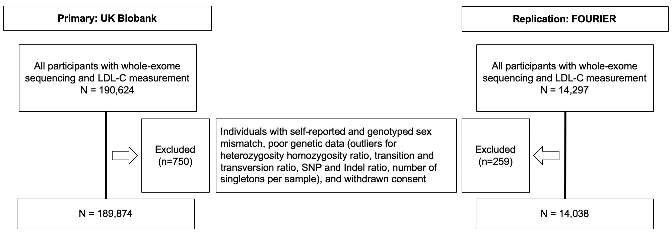

Each row from top to bottom shows the numbers of individuals excluded at each step. The individuals excluded from the UKBB cohort are on the left, and from the FOURIER cohort are on the right.

Supplemental Figure 2. CONSORT diagram of QTc endophenotype analysis

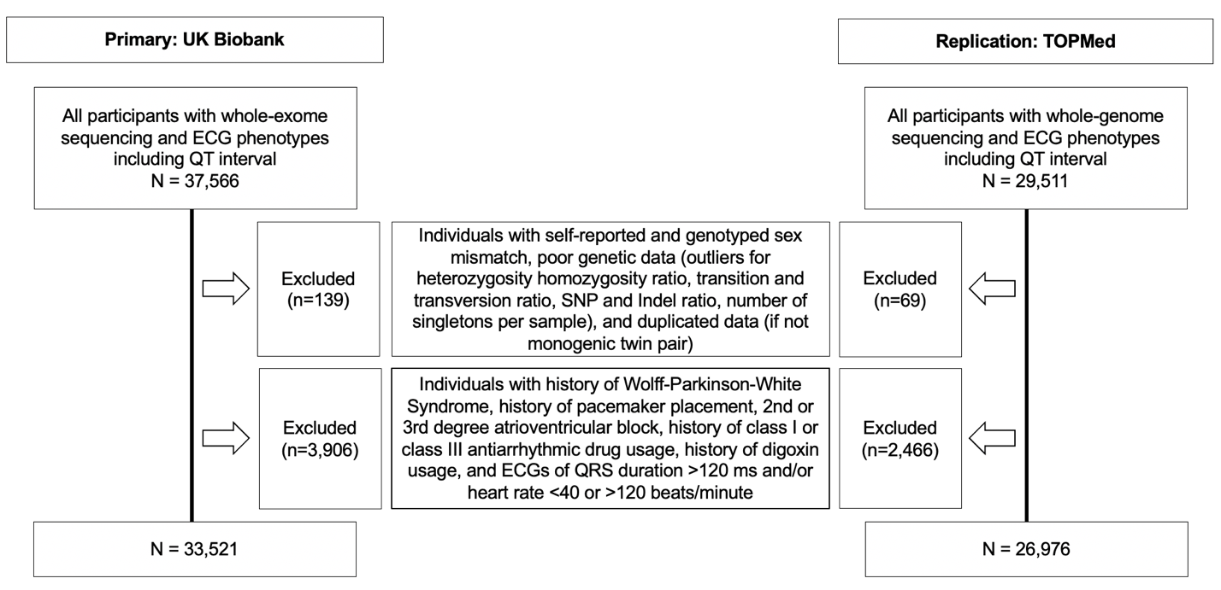

Each row from top to bottom shows the numbers of individuals excluded at each step. The individuals excluded from the UKBB cohort are on the left, and from the TOPMed cohort are on the right.

Supplemental Figure 3. CONSORT diagram of MODY endophenotype analysis

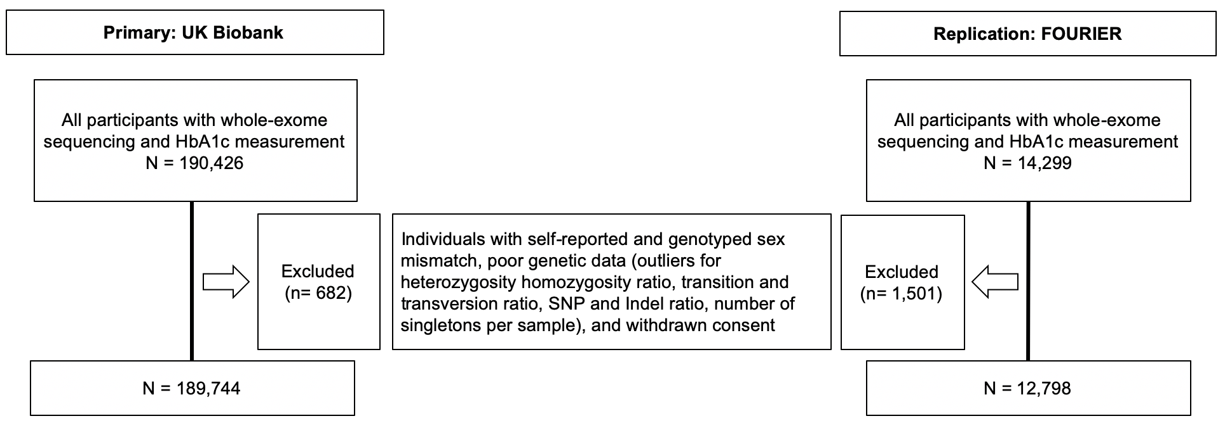

Each row from top to bottom shows the numbers of individuals excluded at each step. The individuals excluded from the UKBB cohort are on the left, and from the FOURIER cohort are on the right.

Supplemental Figure 4. Association between variant effect size and pathogenicity for three endophenotypes and a control panel
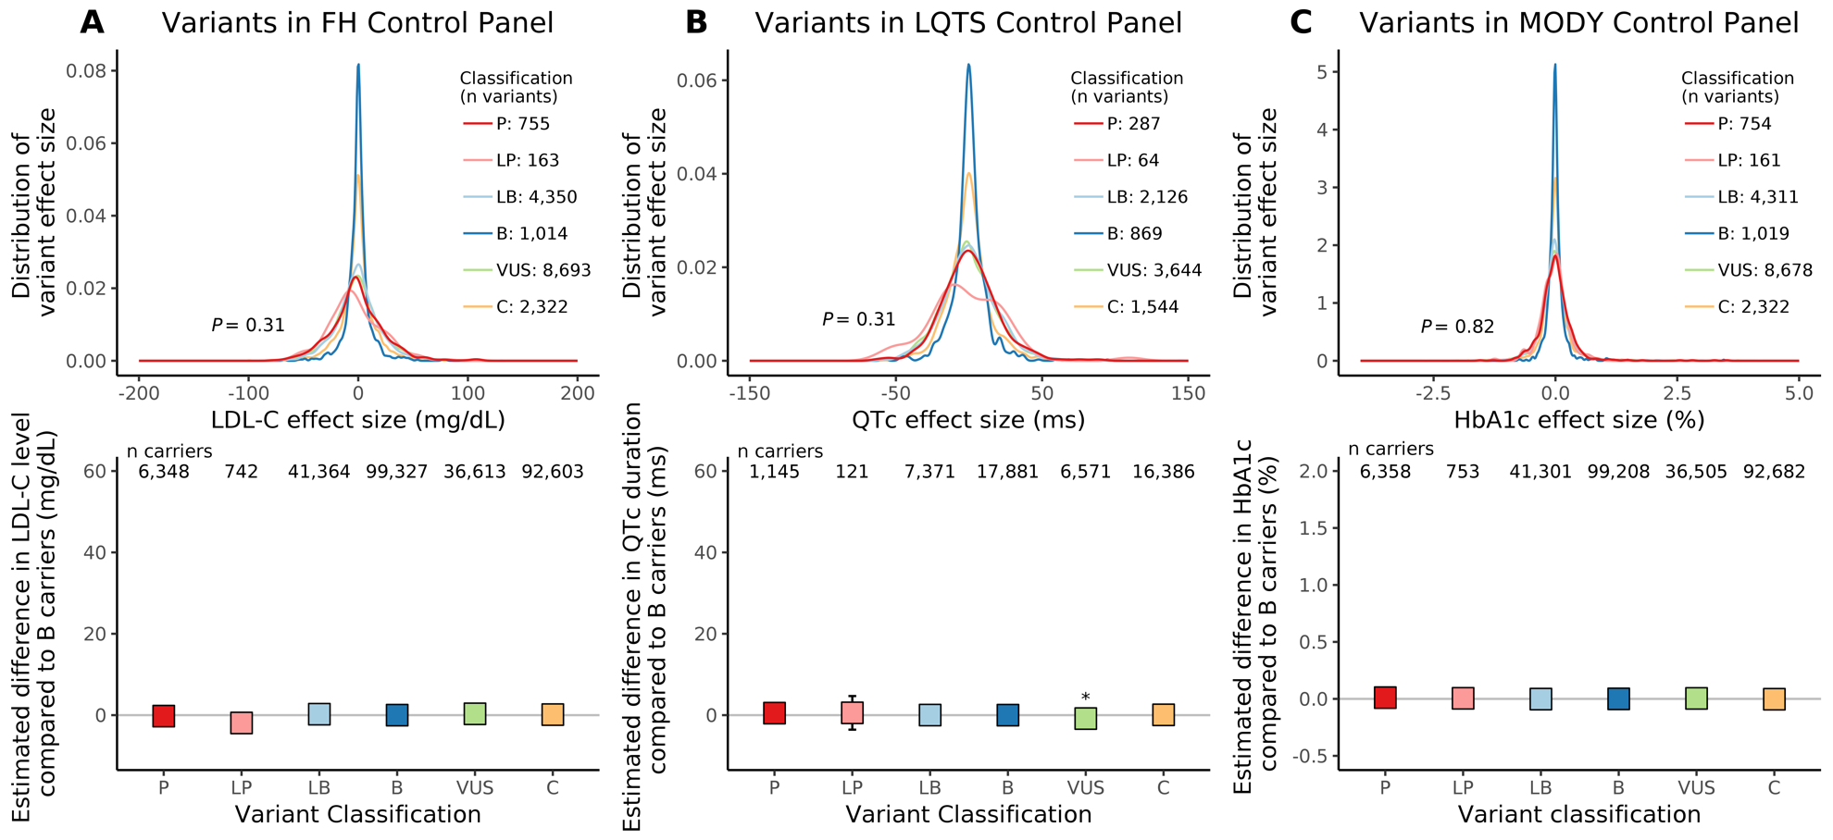Association between effect size and variant pathogenicity for three monogenic disease endophenotypes in the control panel of hereditary cancer genes. Panels A, B, and C display data for the LDL-C, QTc, and HbA1c endophenotypes, respectively, for rare variants found in the UK Biobank. Row 1 in each panel displays the variant effect size distribution by ClinVar pathogenicity category (colored). Row 2 in each panel displays the estimated difference in endophenotype value comparing carriers of a variant in each ClinVar pathogenicity category to carriers of benign variants (boxes) and 95% confidence intervals (whiskers); * indicates P < 0.05. Variant classification includes B: benign, LB: likely benign, LP: likely pathogenic, P: pathogenic, VUS: variant of uncertain significance, C: conflicting.

Supplemental Figure 5. Association between variant effect size and pathogenicity for three endophenotypes in a European-ancestry cohort
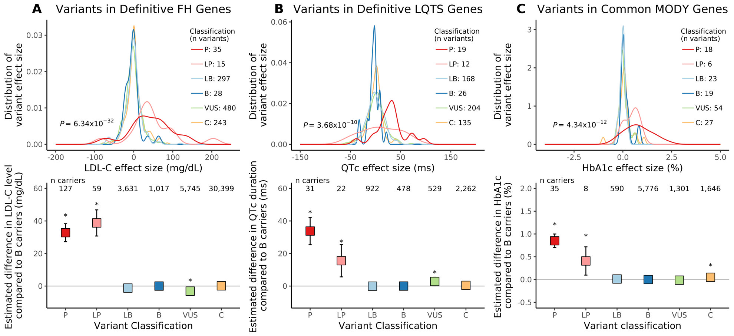Association between effect size and variant pathogenicity for three monogenic disease endophenotypes for rare variants found in participants of white European ancestry in the UK Biobank. Panels A, B, and C display data for the LDL-C, QTc, and HbA1c endophenotypes, respectively, for rare variants found in the UK Biobank. Definitive familial hypercholesterolemia (FH) genes include LDLR, APOB, PCSK9; definitive long-QT syndrome (LQTS) genes include KCNQ1, KCNH2, SCN5A; common maturity-onset diabetes of the young (MODY) genes include HNF1A, HNF1B, HNF4A, GCK. Row 1 in each panel displays the variant effect size distribution by ClinVar pathogenicity category (colored). Row 2 in each panel displays the estimated difference in endophenotype value comparing carriers of a variant in each ClinVar pathogenicity category to carriers of benign variants (boxes) and 95% confidence intervals (whiskers); * indicates P < 0.05. Variant classification includes B: benign, LB: likely benign, LP: likely pathogenic, P: pathogenic, VUS: variant of uncertain significance, C: conflicting.

Supplemental Figure 6. Association between variant effect size and pathogenicity for three endophenotypes for variants with MAC ≤ 5
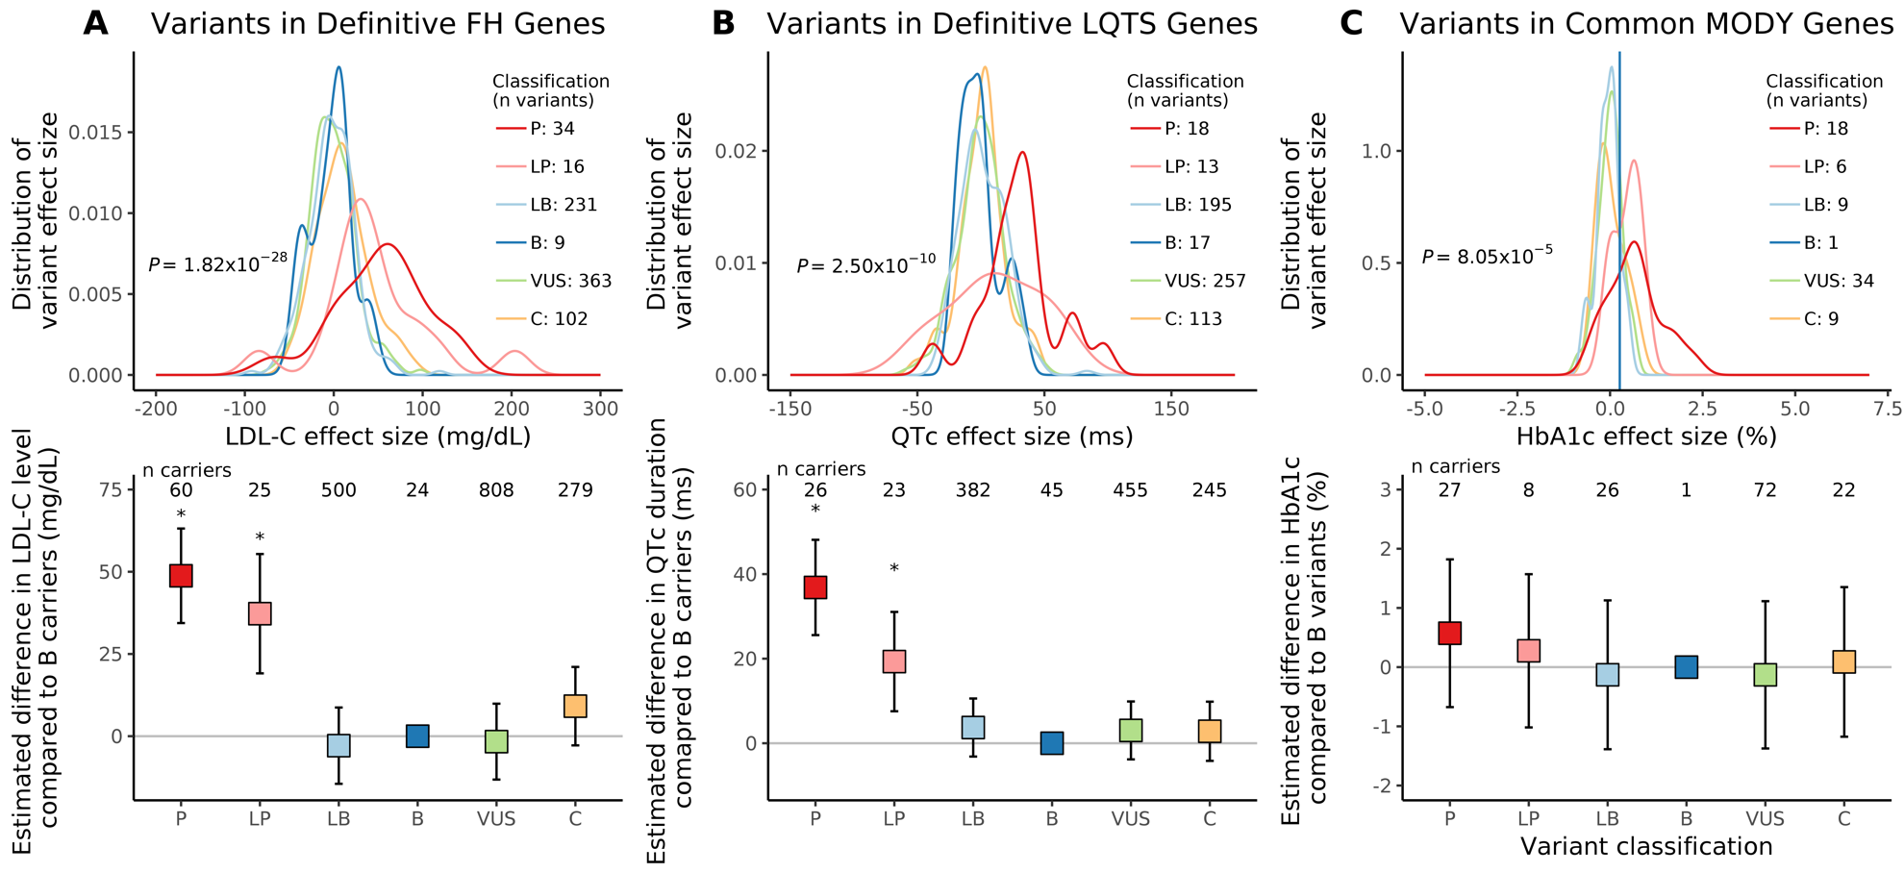Association between effect size and variant pathogenicity for three monogenic disease endophenotypes, for variants with minor allele count ≤ 5 in the UK Biobank. Panels A, B, and C display data for the LDL-C, QTc, and HbA1c endophenotypes, respectively, for rare variants found in the UK Biobank. Definitive familial hypercholesterolemia (FH) genes include LDLR, APOB, PCSK9; definitive long-QT syndrome (LQTS) genes include KCNQ1, KCNH2, SCN5A; common maturity-onset diabetes of the young (MODY) genes include HNF1A, HNF1B, HNF4A, GCK. Row 1 in each panel displays the variant effect size distribution by ClinVar pathogenicity category (colored). Row 2 in each panel displays the estimated difference in endophenotype value comparing carriers of a variant in each ClinVar pathogenicity category to carriers of benign variants (boxes) and 95% confidence intervals (whiskers); * indicates P < 0.05. Variant classification includes B: benign, LB: likely benign, LP: likely pathogenic, P: pathogenic, VUS: variant of uncertain significance, C: conflicting.

Supplemental Figure 7. Association between variant effect size and pathogenicity for three endophenotypes in replication cohorts

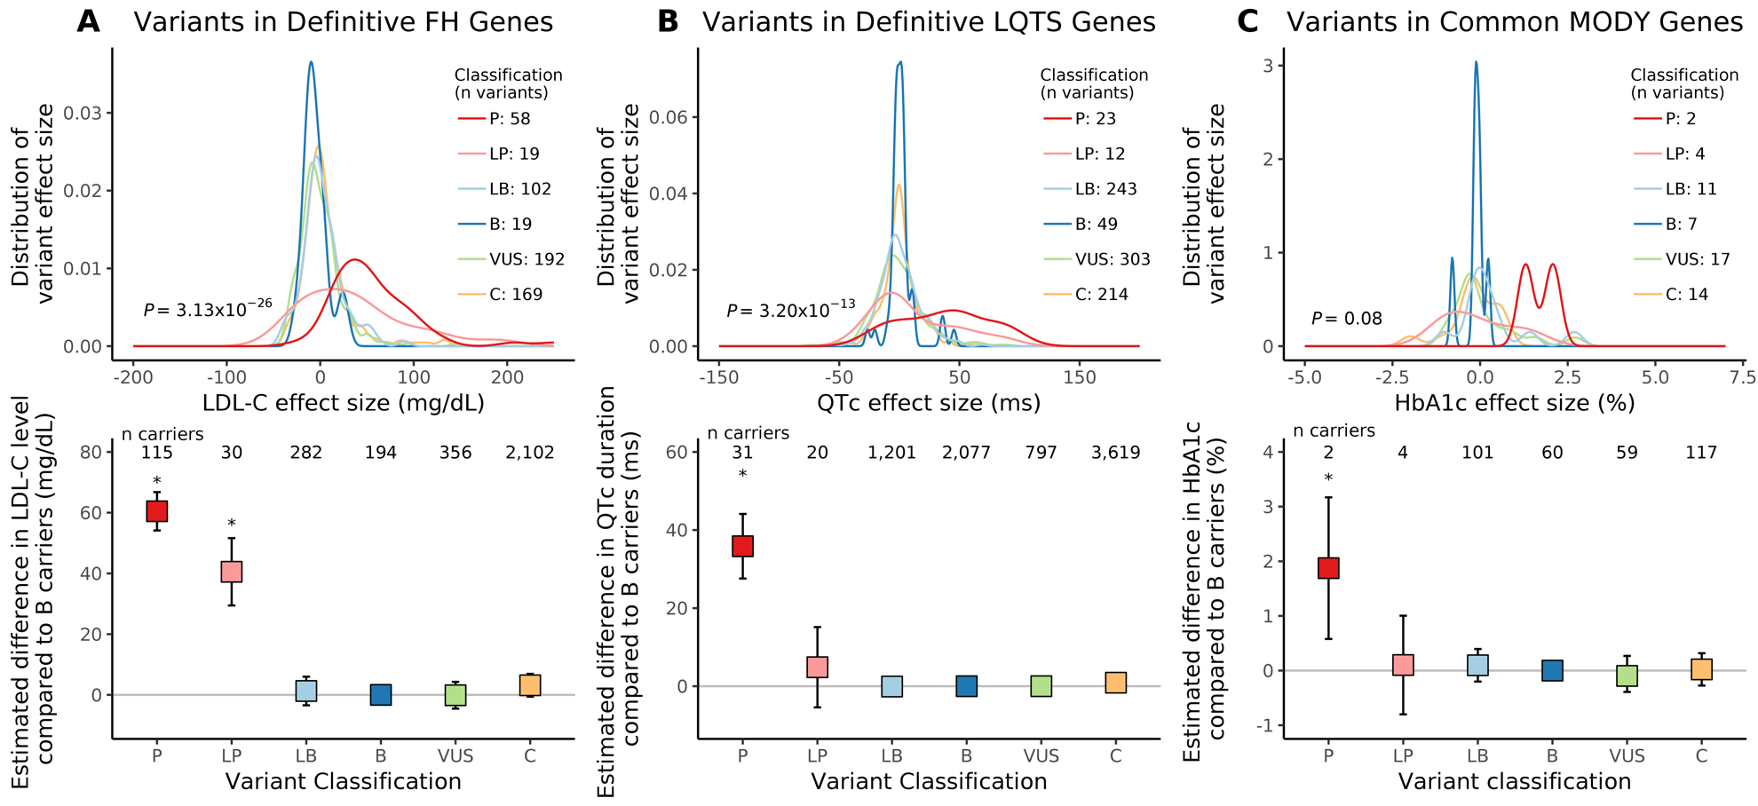Association between effect size and variant pathogenicity for three monogenic disease endophenotypes, for rare variants found in replication cohorts. Panels A, B, and C display data for the LDL-C, QTc, and HbA1c endophenotypes, respectively, for rare variants found in the FOURIER, TOPMed, and FOURIER, respectively. Definitive familial hypercholesterolemia (FH) genes include LDLR, APOB, PCSK9; definitive long-QT syndrome (LQTS) genes include KCNQ1, KCNH2, SCN5A; common maturity-onset diabetes of the young (MODY) genes include HNF1A, HNF1B, HNF4A, GCK. Row 1 in each panel displays the variant effect size distribution by ClinVar pathogenicity category (colored). Row 2 in each panel displays the estimated difference in endophenotype value comparing carriers of a variant in each ClinVar pathogenicity category to carriers of benign variants (boxes) and 95% confidence intervals (whiskers); * indicates P < 0.05. Variant classification includes B: benign, LB: likely benign, LP: likely pathogenic, P: pathogenic, VUS: variant of uncertain significance, C: conflicting.

Supplemental Figure 8. Discrimination of variant pathogenicity by effect size with novel variants in replication cohorts not observed in the UK Biobank

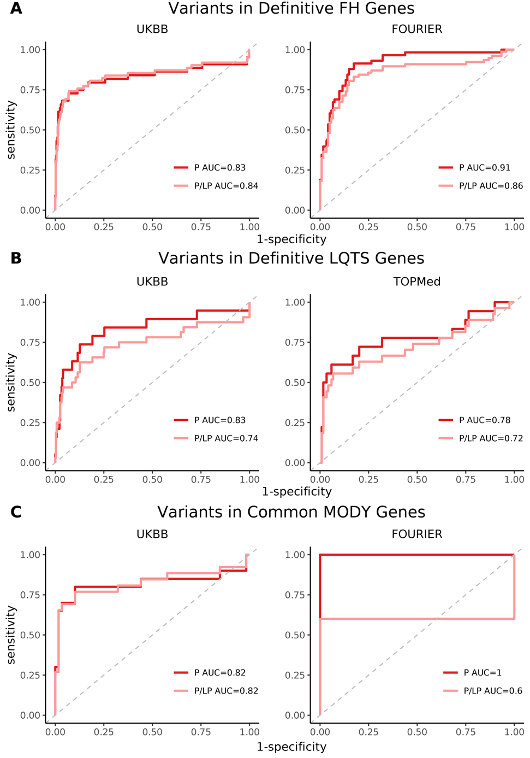

Row A includes variants within familial hypercholesterolemia (FH) genes recommended for secondary findings return (LDLR, APOB, PCSK9); Row B includes variants within the long-QT syndrome (LQTS) genes recommended for secondary findings return (KCNQ1, KCNH2, SCN5A); Row C includes variants within common maturity-onset diabetes of the young (MODY) genes (HNF1A, HNF1B, HNF4A, GCK). Column 1 includes variants from the UK Biobank, the primary cohort; Column 2 includes variants from FOURIER and TOPMed, the replication cohorts, with removal of variants found in the UK Biobank. ROC curves represent the ability of effect size in discriminating pathogenic variants as defined by ClinVar. The red curve includes “Pathogenic” variants only; the pink curve includes “Pathogenic” and “Likely pathogenic” variants combined; AUC values are reported in the legend.

Supplemental Acknowledgements

UK Biobank: Use of UK Biobank data was performed under application number 17488 and was
approved by the local Massachusetts General Hospital institutional review board.

Trans-Omics in Precision Medicine (TOPMed) program: Whole genome sequencing for the Trans-Omics in Precision Medicine (TOPMed) program was supported by the National Heart, Lung and Blood Institute (NHLBI). Whole genome sequencing for “NHLBI TOPMed: the Atherosclerosis Risk in Communities” (phs001211.v1.p1) was performed at the Broad Institute of MIT and Harvard (3R01HL092577-06S1) and Baylor Human Genome Sequencing Center (3U54HG003273-12S2, HHSN268201500015C). Whole genome sequencing for “NHLBI TOPMed: Genetics of Cardiometabolic Health in the Amish” (phs000956.v1.p1) was performed at the Broad Institute of MIT and Harvard (3R01HL121007-01S1). Whole genome sequencing for “NHLBI TOPMed: Mount Sinai BioMe Biobank” (phs001644.v1.p1) was performed at the Baylor Human Genome Sequencing Center (HHSN268201600033I) and McDonnell genome institute (HHSN268201600037I). Whole genome sequencing for “NHLBI TOPMed: Cleveland Family Study - Whole genome sequencing Collaboration” (phs000954.v1.p1) was performed at the University of Washington northwest genomics center (3R01HL098433-05S1, HHSN268201600032I). Whole genome sequencing for “NHLBI TOPMed: Cardiovascular Health Study” (phs001368.v1.p1) was performed at the Baylor Human Genome Sequencing Center (3U54HG003273-12S2, HHSN268201500015C, HHSN268201600033I). Whole genome sequencing for “NHLBI TOPMed: Framingham Heart Study” (phs000974.v1.p1) was performed at the Broad institute of MIT and Harvard (3R01HL092577-06S1, 3U54HG003067-12S2). Whole genome sequencing for “NHLBI TOPMed: The Jackson Heart Study” (phs000964.v1.p1) was performed at the University of Washington Northwest Genomics Center (HHSN268201100037C). Whole genome sequencing for “NHLBI TOPMed: Multi-Ethnic Study of Atherosclerosis” (phs001416.v1.p1) was performed at the Broad Institute of MIT and Harvard (3U54HG003067-13S1). Whole genome sequencing for “NHLBI TOPMed: Womens Health Initiative” (phs001237.v1.p1) was performed at the Broad Institute of MIT and Harvard (HHSN268201500014C). Core support including read mapping and genotype calling, along with variant quality metrics and filtering were provided by the TOPMed Informatics Research Center (3R01HL-117626-02S1; contract HHSN268201800002I). Phenotype harmonization, data management, sample-identity QC, and general study coordination were provided by the TOPMed Data Coordinating Center (3R01HL-120393-02S1; contract HHSN268201800001I). We gratefully acknowledge the studies and participants who provided biological samples and data for TOPMed.

TOPMed Study Specific Acknowledgements:
Amish: Genetics of Cardiometabolic Health in the Amish
The TOPMed component of the Amish Research Program was supported by NIH grants R01
HL121007, U01 HL072515, and R01 AG18728. See publication: PMID: 18440328

BioMe: BioMe Biobank at Mount Sinai
The Mount Sinai BioMe Biobank has been supported by The Andrea and Charles Bronfman
Philanthropies and in part by Federal funds from the NHLBI and NHGRI (U01HG00638001;
U01HG007417; X01HL134588). We thank all participants in the Mount Sinai Biobank. We also
thank all our recruiters who have assisted and continue to assist in data collection and
management and are grateful for the computational resources and staff expertise provided by
Scientific Computing at the Icahn School of Medicine at Mount Sinai.

ARIC: Atherosclerosis Risk in Communities study
The Atherosclerosis Risk in Communities study has been funded in whole or in part with Federal
funds from the National Heart, Lung, and Blood Institute, National Institutes of Health,
Department of Health and Human Services (contract numbers HHSN268201700001I,
HHSN268201700002I, HHSN268201700003I, HHSN268201700004I and
HHSN268201700005I). The authors thank the staff and participants of the ARIC study for their
important contributions.

WGS for “NHLBI TOPMed: Atherosclerosis Risk in Communities (ARIC) Study” (phs001211) was performed at the Baylor College of Medicine Human Genome Sequencing Center (HHSN268201500015C and 3U54HG003273-12S2) and the Broad Institute for MIT and Harvard (3R01HL092577- 06S1). Centralized read mapping and genotype calling, along with variant quality metrics and filtering were provided by the TOPMed Informatics Research Center (3R01HL-117626-02S1). Phenotype harmonization, data management, sample-identity QC, and general study coordination, were provided by the TOPMed Data Coordinating Center (3R01HL- 120393- 02S1). We gratefully acknowledge the studies and participants who provided biological samples and data for TOPMed.

CHS: Cardiovascular Health Study
Cardiovascular Health Study: This research was supported by contracts HHSN268201200036C,
HHSN268200800007C, HHSN268201800001C, N01HC55222, N01HC85079, N01HC85080,
N01HC85081, N01HC85082, N01HC85083, N01HC85086, 75N92021D00006 and grants U01HL080295 and U01HL130114 from the National Heart, Lung, and Blood Institute (NHLBI), with additional contribution from the National Institute of Neurological Disorders and Stroke (NINDS). Additional support was provided by R01AG023629 from the National Institute on Aging (NIA). A full list of principal CHS investigators and institutions can be found at CHS-NHLBI.org. The content is solely the responsibility of the authors and does not necessarily represent the official views of the National Institutes of Health.

CFS: Cleveland Family Study
The Cleveland Family Study has been supported in part by National Institutes of Health grants
[R01-HL046380, KL2-RR024990, R35-HL135818, and R01-HL113338].

FHS: Framingham Heart Study
The Framingham Heart Study (FHS) acknowledges the support of contracts NO1-HC-25195, HHSN268201500001I and 75N92019D00031 from the National Heart, Lung and Blood Institute and grant supplement R01 HL092577-06S1 for this research. We also acknowledge the dedication of the FHS study participants without whom this research would not be possible. Dr. Vasan is supported in part by the Evans Medical Foundation and the Jay and Louis Coffman Endowment from the Department of Medicine, Boston University School of Medicine.

JHS: Jackson Heart Study
The Jackson Heart Study (JHS) is supported and conducted in collaboration with Jackson State
University (HHSN268201800013I), Tougaloo College (HHSN268201800014I), the Mississippi
State Department of Health (HHSN268201800015I) and the University of Mississippi Medical
Center (HHSN268201800010I, HHSN268201800011I and HHSN268201800012I) contracts
from the National Heart, Lung, and Blood Institute (NHLBI) and the National Institute on Minority Health and Health Disparities (NIMHD). The authors also wish to thank the staffs and
participants of the JHS.

The views expressed in this manuscript are those of the authors and do not necessarily represent the views of the National Heart, Lung, and Blood Institute; the National Institutes of Health; or the U.S. Department of Health and Human Services.

MESA: Multi-Ethnic Study of Atherosclerosis
MESA and the MESA SHARe project are conducted and supported by the National Heart, Lung, and Blood Institute (NHLBI) in collaboration with MESA investigators. Support for MESA is provided by contracts 75N92020D00001, HHSN268201500003I, N01-HC-95159, 75N92020D00005, N01-HC-95160, 75N92020D00002, N01-HC-95161, 75N92020D00003, N01-HC-95162, 75N92020D00006, N01-HC-95163, 75N92020D00004, N01-HC-95164, 75N92020D00007, N01-HC-95165, N01-HC-95166, N01-HC-95167, N01-HC-95168, N01-HC-95169, UL1-TR-000040, UL1-TR-001079, UL1-TR-001420. Funding for SHARe genotyping was provided by NHLBI Contract N02-HL-64278. Genotyping was performed at Affymetrix (Santa Clara, California, USA) and the Broad Institute of Harvard and MIT (Boston, Massachusetts, USA) using the Affymetrix Genome-Wide Human SNP Array 6.0. MESA Family is conducted and supported by the National Heart, Lung, and Blood Institute (NHLBI) in collaboration with MESA investigators. Support is provided by grants and contracts R01HL071051, R01HL071205, R01HL071250, R01HL071251, R01HL071258, R01HL071259, by the National Center for Research Resources, Grant UL1RR033176. The provision of genotyping data was supported in part by the National Center for Advancing Translational Sciences, CTSI grant UL1TR001881, and the National Institute of Diabetes and Digestive and Kidney Disease Diabetes Research Center (DRC) grant DK063491 to the Southern California Diabetes Endocrinology Research Center.

WHI: Women’s Health Initiative
The WHI program is funded by the National Heart, Lung, and Blood Institute, National Institutes of Health, U.S. Department of Health and Human Services through contracts 75N92021D00001, 75N92021D00002, 75N92021D00003, 75N92021D00004, 75N92021D00005.

TOPMed Omics Support Acknowledgements
TOPMed Accession Number | TOPMed Project | Parent Study | TOPMed Phase | Omics Center | Omics Support | Omics Type
phs000956 | Amish | Amish | 1 | Broad Genomics | 3R01HL121007-01S1 | WGS
phs001211 | AFGen | ARIC AFGen | 1 | Broad Genomics | 3R01HL092577-06S1 | WGS
phs001211 | VTE | ARIC | 2 | Baylor | 3U54HG003273-12S2 / HHSN268201500015C | WGS
phs001644 | AFGen | BioMe AFGen | 2.4 | MGI | 3UM1HG008853-01S2 | WGS
phs001644 | BioMe | BioMe | 3 | Baylor | HHSN268201600033I | WGS
phs001644 | BioMe | BioMe | 3 | MGI | HHSN268201600037I | WGS
phs000954 | CFS | CFS | 1 | NWGC | 3R01HL098433-05S1 | WGS
phs000954 | CFS | CFS | 3.5 | NWGC | HHSN268201600032I | WGS
phs001368 | CHS | CHS | 3 | Baylor | HHSN268201600033I | WGS
phs001368 | VTE | CHS VTE | 2 | Baylor | 3U54HG003273-12S2 / HHSN268201500015C | WGS
phs000974 | AFGen | FHS AFGen | 1 | Broad Genomics | 3R01HL092577-06S1 | WGS
phs000974 | FHS | FHS | 1 | Broad Genomics | 3U54HG003067-12S2 | WGS
phs000964 | JHS | JHS | 1 | NWGC | HHSN268201100037C | WGS
phs001416 | AA_CAC | MESA AA_CAC | 2 | Broad Genomics | HHSN268201500014C | WGS
phs001416 | MESA | MESA | 2 | Broad Genomics | 3U54HG003067-13S1 | WGS
phs001237 | WHI | WHI | 2 | Broad Genomics | HHSN268201500014C | WGS
ARIC: Atherosclerosis Risk in Communities (ARIC) study, Amish: Genetics of Cardiometabolic Health in the Amish, Baylor: Baylor College of Medicine Human Genome Sequencing Center, BioMe: Mount Sinai BioMe Biobank, Broad Genomics: Broad Institute Genomics Platform, CFS: Cleveland Family Study, CHS: Cardiovascular Health Study, FHS: Framingham Heart Study, JHS: Jackson Heart Study, MESA: Multi-Ethnic Study of Atherosclerosis, MGI: McDonnell Genome Institute, NWGC: Northwest Genomics Center, TOPMed: Transomics for Precision Medicine, WGS: Whole Genome Sequencing, WHI: Women’s Health Initiative

References

1. Chang, C. C. et al. Second-generation PLINK: rising to the challenge of larger and richer datasets. Gigascience 4, 7 (2015).
2. Alexander, D. H., Novembre, J. & Lange, K. Fast model-based estimation of ancestry in unrelated individuals. Genome Res. 19, 1655–1664 (2009).
3. UKB : Data-Field 42001. https://biobank.ndph.ox.ac.uk/showcase/field.cgi?id=42001.

