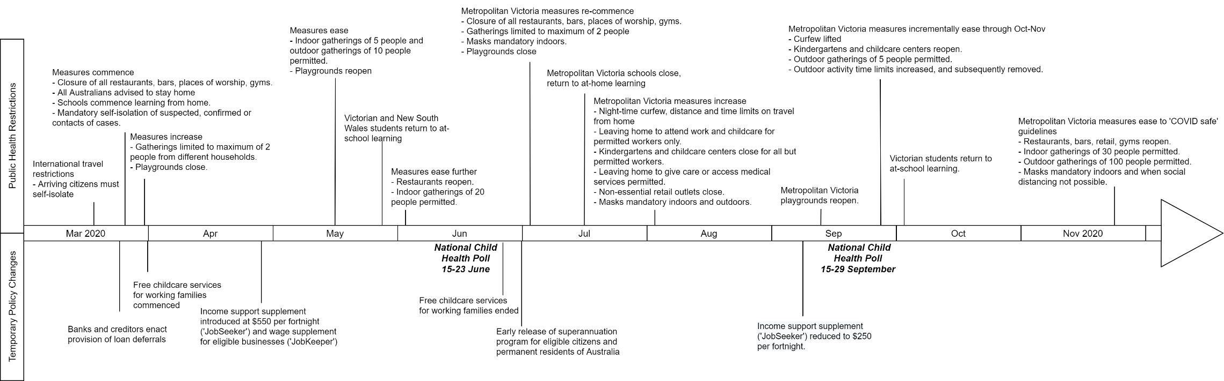
S1 Fig. Timeline of Australia’s COVID-19 public health restrictions and policy changes from March to November 2020.
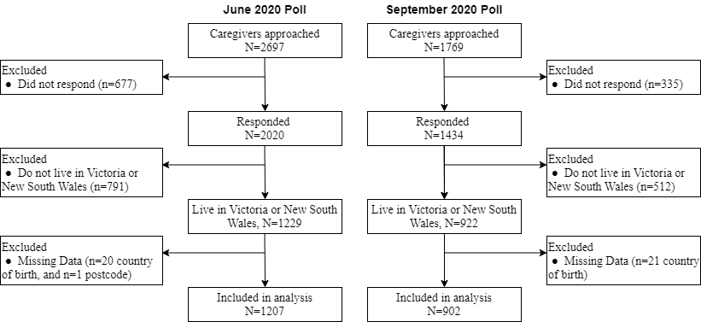
S2 Fig. Respondent flowchart for analytic sample.

