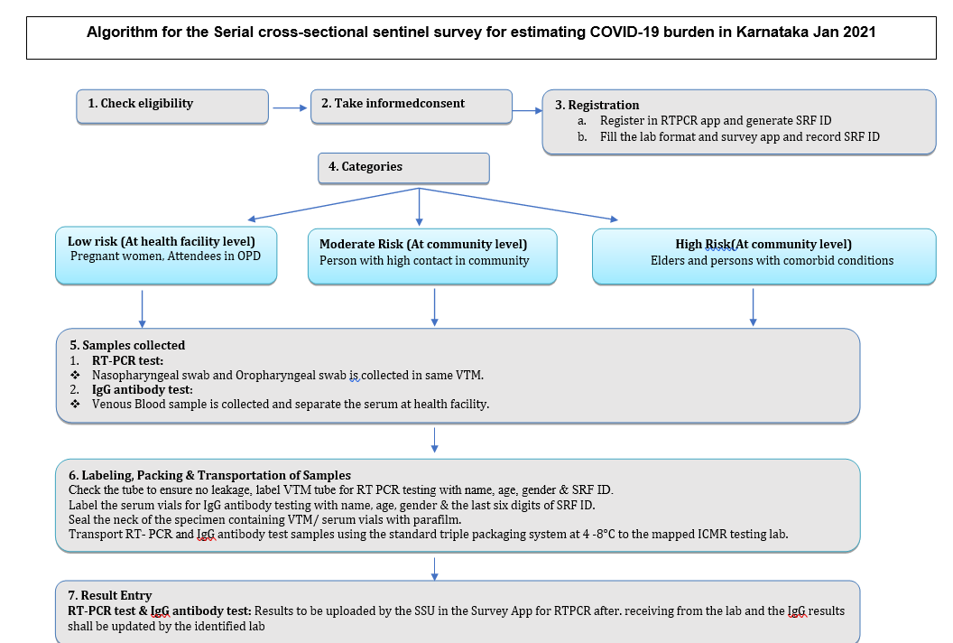

**Supplementary Figure 2: Algorithm for the serial cross-sectional sentinel survey for estimating COVID-19 burden in Karnataka.**