Supplementary Figure 1: Women included in study from 1st March 2020 to 11th July 2021

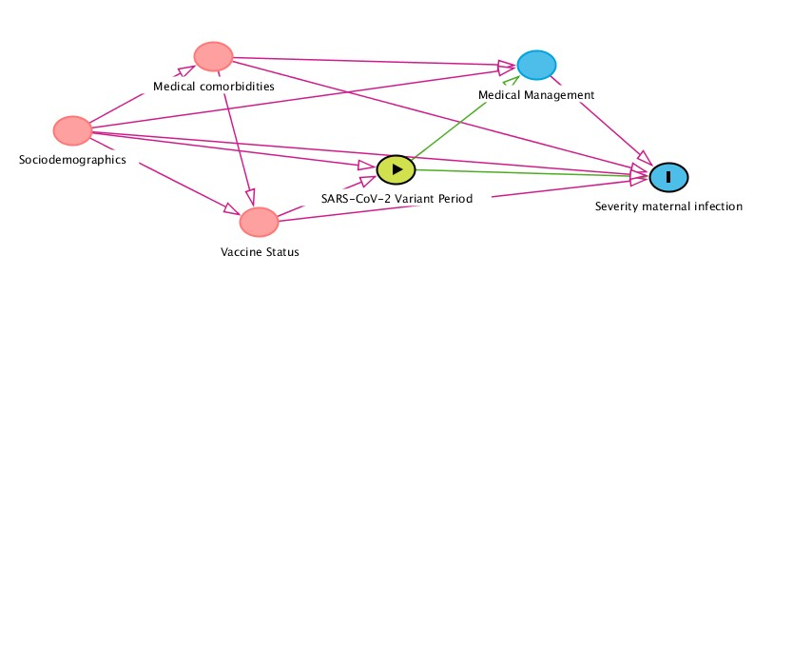

Supplementary Figure 2: Directed acyclic graphs indicating covariates and mediators on relationship between SARS-CoV-2 variant and severity of maternal infection.

