Supplementary Data
Note: key tables referenced in text are provided in the supplementary data, however, all raw output is also available on github: https://github.com/opensafely/carehome-noncarehome-death-research/tree/master/released_outputs/output/tables

Table of Contents
Supplementary Data 1
Figure S1a-c. Age-standardised a) all-cause, b) covid and c) non-covid mortality risks according to care home type, among men. 2
Figure S2a-c Age-standardised risks according to care home type, among women. 3
Figure S3a-c. Age-standardised relative a) all-cause, b) covid and c) non-covid mortality risks according to age group, among men 4
Figure S4a-c. Age-standardised relative a) all-cause, b) covid and c) non-covid mortality risks according to age group, among women 5
Table S1a. Age-standardised all-cause mortality risks by gender 6
Table S1b. Age-standardised COVID mortality risks by gender 8
Table S1c. Age-standardised non-covid mortality risks by gender 10
Table S2a. Comparative Mortality Figure (all-cause) comparing Care Homes to Private Homes, by gender 12
Table S2b. Comparative Mortality Figure (covid) comparing Care Homes to Private Homes, by gender 14
Table S2c. Comparative Mortality Figure (non-covid) comparing Care Homes to Private Homes, by gender 16
Table S3. Demographic and Clinical Characteristics of Care Home and Private Home Residents on the 1st of February 2020 18
Table S4. Demographic and Clinical Characteristics of Care Home and Private Home Residents on the 1st of February 2021 20

Figure S1a-c. Age-standardised a) all-cause, b) covid and c) non-covid mortality risks according to care home type, among men.

- b) c)

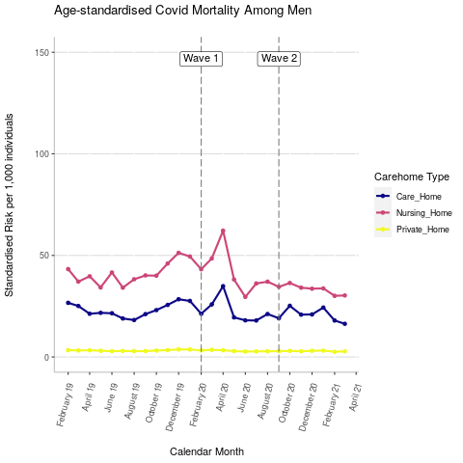
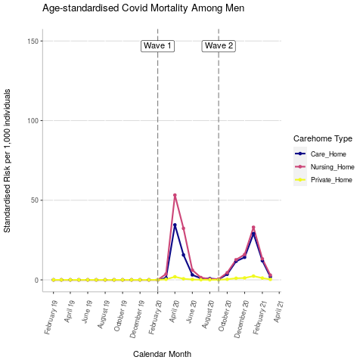
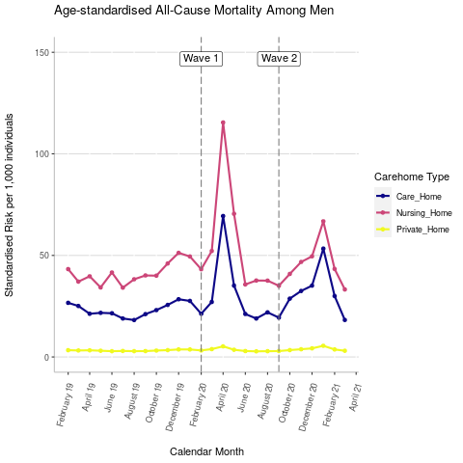

Figure S2a-c Age-standardised risks according to care home type, among women.

- b) c)

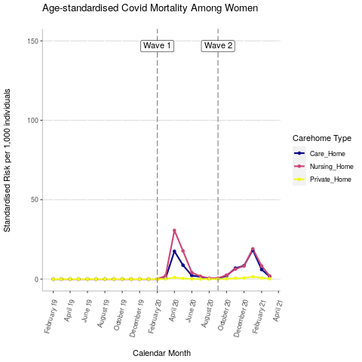
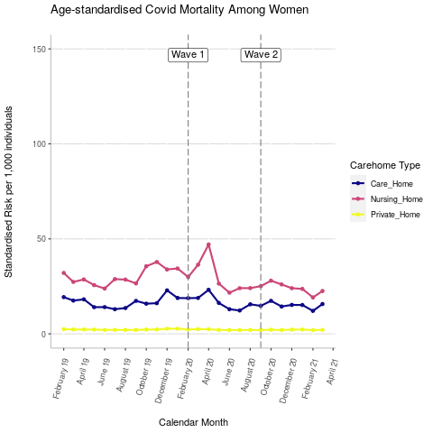
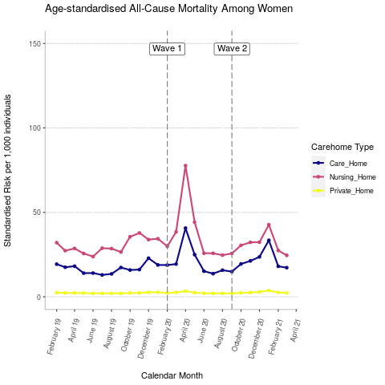

Figure S3a-c. Age-standardised relative a) all-cause, b) covid and c) non-covid mortality risks according to age group, among men

- b) c)

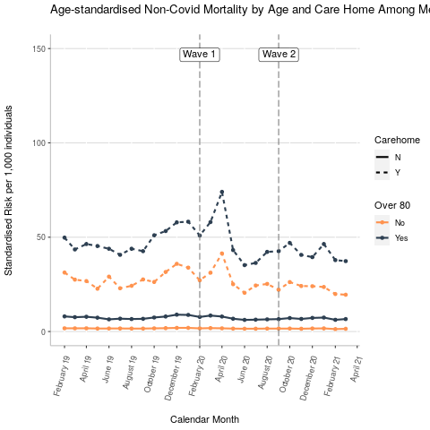
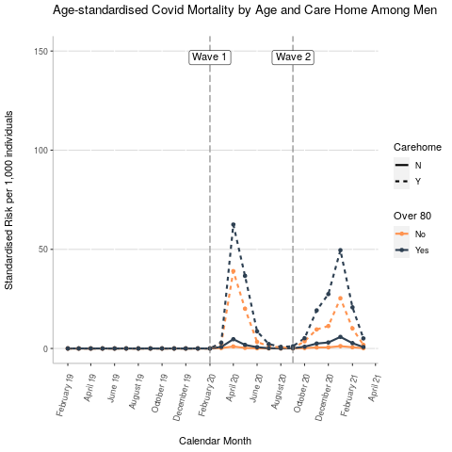
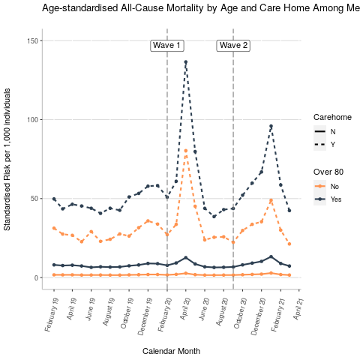

Figure S4a-c. Age-standardised relative a) all-cause, b) covid and c) non-covid mortality risks according to age group, among women

- b) c)

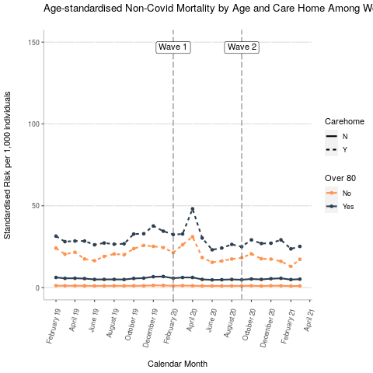
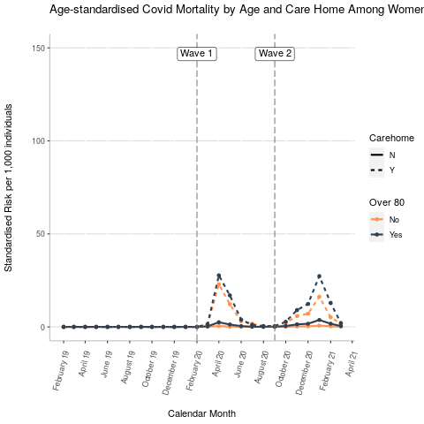
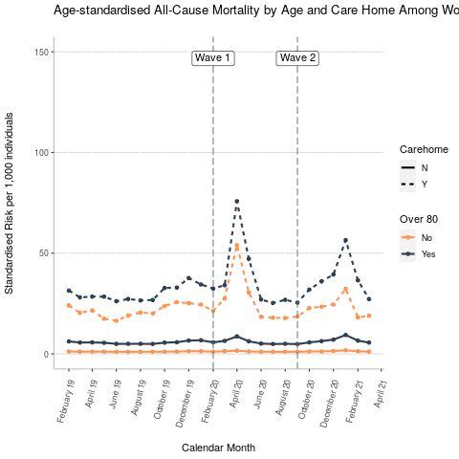

Table S1a. Age-standardised all-cause mortality risks by gender

Gender | Date | Care or Nursing Home Standardised Risk | Care or Nursing Home Confidence Interval | Private Home Standardised Risk | Private Home Confidence Interval
F | 01/02/2019 | 25.96 | 23.26-28.66 | 2.45 | 2.39-2.51
F | 01/03/2019 | 22.35 | 19.82-24.89 | 2.27 | 2.21-2.34
F | 01/04/2019 | 23.34 | 20.92-25.76 | 2.29 | 2.23-2.35
F | 01/05/2019 | 20.27 | 18.07-22.47 | 2.22 | 2.16-2.28
F | 01/06/2019 | 18.92 | 16.75-21.08 | 2.03 | 1.98-2.09
F | 01/07/2019 | 21.13 | 18.79-23.46 | 2.06 | 2-2.12
F | 01/08/2019 | 22.05 | 19.53-24.57 | 2.06 | 2-2.12
F | 01/09/2019 | 21.79 | 19.43-24.14 | 2.05 | 1.99-2.11
F | 01/10/2019 | 26.07 | 23.46-28.68 | 2.24 | 2.18-2.3
F | 01/11/2019 | 27.55 | 24.82-30.27 | 2.32 | 2.26-2.38
F | 01/12/2019 | 28.37 | 25.72-31.03 | 2.68 | 2.62-2.75
F | 01/01/2020 | 27.02 | 24.46-29.58 | 2.69 | 2.62-2.76
F | 01/02/2020 | 24.22 | 21.79-26.64 | 2.28 | 2.22-2.34
F | 01/03/2020 | 29.17 | 26.38-31.96 | 2.62 | 2.56-2.69
F | 01/04/2020 | 59.57 | 55.88-63.27 | 3.4 | 3.33-3.47
F | 01/05/2020 | 34.77 | 31.96-37.58 | 2.49 | 2.42-2.55
F | 01/06/2020 | 20.61 | 18.39-22.82 | 2.12 | 2.06-2.17
F | 01/07/2020 | 19.81 | 17.57-22.05 | 2.03 | 1.97-2.09
F | 01/08/2020 | 20.11 | 17.96-22.26 | 2.04 | 1.99-2.1
F | 01/09/2020 | 20.3 | 18.04-22.57 | 2.02 | 1.96-2.08
F | 01/10/2020 | 25.1 | 22.62-27.58 | 2.34 | 2.28-2.4
F | 01/11/2020 | 26.65 | 24.24-29.07 | 2.52 | 2.46-2.58
F | 01/12/2020 | 28.31 | 25.84-30.78 | 2.87 | 2.81-2.94
F | 01/01/2021 | 38.46 | 35.63-41.28 | 3.73 | 3.66-3.81
F | 01/02/2021 | 22.81 | 20.76-24.86 | 2.64 | 2.58-2.71
F | 01/03/2021 | 21.08 | 18.92-23.25 | 2.26 | 2.2-2.32
M | 01/02/2019 | 36 | 32.94-39.06 | 3.33 | 3.24-3.41
M | 01/03/2019 | 31.6 | 28.76-34.44 | 3.2 | 3.11-3.28
M | 01/04/2019 | 31.77 | 28.99-34.55 | 3.27 | 3.19-3.36
M | 01/05/2019 | 28.49 | 25.86-31.11 | 3.06 | 2.98-3.14
M | 01/06/2019 | 32.87 | 29.93-35.81 | 2.84 | 2.76-2.91
M | 01/07/2019 | 27.47 | 24.91-30.04 | 2.94 | 2.86-3.02
M | 01/08/2019 | 29.27 | 26.66-31.87 | 2.85 | 2.77-2.93
M | 01/09/2019 | 31.44 | 28.53-34.34 | 2.88 | 2.8-2.96
M | 01/10/2019 | 32.62 | 29.89-35.34 | 3.16 | 3.07-3.24
M | 01/11/2019 | 37.11 | 34.11-40.11 | 3.35 | 3.27-3.44
M | 01/12/2019 | 41.51 | 38.31-44.71 | 3.71 | 3.62-3.8
M | 01/01/2020 | 40.09 | 37.08-43.11 | 3.68 | 3.59-3.77
M | 01/02/2020 | 33.23 | 30.5-35.96 | 3.21 | 3.13-3.3
M | 01/03/2020 | 40.66 | 37.62-43.71 | 3.86 | 3.77-3.95
M | 01/04/2020 | 94.76 | 90.25-99.26 | 5.23 | 5.12-5.34
M | 01/05/2020 | 54.02 | 50.53-57.51 | 3.55 | 3.46-3.63
M | 01/06/2020 | 28.96 | 26.33-31.59 | 2.9 | 2.82-2.98
M | 01/07/2020 | 28.84 | 26.14-31.54 | 2.77 | 2.69-2.85
M | 01/08/2020 | 30.2 | 27.47-32.93 | 2.83 | 2.75-2.91
M | 01/09/2020 | 27.8 | 25.3-30.31 | 2.9 | 2.82-2.97
M | 01/10/2020 | 35.54 | 32.73-38.36 | 3.37 | 3.29-3.46
M | 01/11/2020 | 40.4 | 37.35-43.45 | 3.8 | 3.71-3.89
M | 01/12/2020 | 43.41 | 40.33-46.5 | 4.23 | 4.13-4.32
M | 01/01/2021 | 60.99 | 57.45-64.53 | 5.5 | 5.39-5.61
M | 01/02/2021 | 37.32 | 34.44-40.2 | 3.68 | 3.59-3.77
M | 01/03/2021 | 26.67 | 24.33-29.02 | 3.05 | 2.97-3.13

Table S1b. Age-standardised COVID mortality risks by gender

Gender | Date | Care or Nursing Home Standardised Risk | Care or Nursing Home Confidence Interval | Private Home Standardised Risk | Private Home Confidence Interval
F | 01/02/2019 | 0 | 0-0 | 0 | 0-0
F | 01/03/2019 | 0 | 0-0 | 0 | 0-0
F | 01/04/2019 | 0 | 0-0 | 0 | 0-0
F | 01/05/2019 | 0 | 0-0 | 0 | 0-0
F | 01/06/2019 | 0 | 0-0 | 0 | 0-0
F | 01/07/2019 | 0 | 0-0 | 0 | 0-0
F | 01/08/2019 | 0 | 0-0 | 0 | 0-0
F | 01/09/2019 | 0 | 0-0 | 0 | 0-0
F | 01/10/2019 | 0 | 0-0 | 0 | 0-0
F | 01/11/2019 | 0 | 0-0 | 0 | 0-0
F | 01/12/2019 | 0 | 0-0 | 0 | 0-0
F | 01/01/2020 | 0 | 0-0 | 0 | 0-0
F | 01/02/2020 | 0 | 0-0 | 0 | 0-0
F | 01/03/2020 | 1.33 | 0.64-2.02 | 0.14 | 0.13-0.16
F | 01/04/2020 | 24.13 | 21.67-26.6 | 0.99 | 0.95-1.03
F | 01/05/2020 | 13.39 | 11.57-15.21 | 0.45 | 0.42-0.48
F | 01/06/2020 | 3.22 | 2.26-4.19 | 0.15 | 0.13-0.17
F | 01/07/2020 | 1.54 | 0.87-2.21 | 0.04 | 0.03-0.05
F | 01/08/2020 | 0.39 | 0.13-0.64 | 0.02 | 0.01-0.02
F | 01/09/2020 | 0.39 | 0.11-0.66 | 0.03 | 0.02-0.03
F | 01/10/2020 | 2.29 | 1.53-3.06 | 0.19 | 0.17-0.21
F | 01/11/2020 | 6.65 | 5.52-7.78 | 0.52 | 0.49-0.55
F | 01/12/2020 | 8.43 | 7.09-9.76 | 0.66 | 0.63-0.69
F | 01/01/2021 | 19.05 | 17.02-21.08 | 1.47 | 1.42-1.52
F | 01/02/2021 | 7.16 | 6.05-8.26 | 0.69 | 0.66-0.73
F | 01/03/2021 | 1.78 | 1.19-2.38 | 0.2 | 0.18-0.22
M | 01/02/2019 | 0 | 0-0 | 0 | 0-0
M | 01/03/2019 | 0 | 0-0 | 0 | 0-0
M | 01/04/2019 | 0 | 0-0 | 0 | 0-0
M | 01/05/2019 | 0 | 0-0 | 0 | 0-0
M | 01/06/2019 | 0 | 0-0 | 0 | 0-0
M | 01/07/2019 | 0 | 0-0 | 0 | 0-0
M | 01/08/2019 | 0 | 0-0 | 0 | 0-0
M | 01/09/2019 | 0 | 0-0 | 0 | 0-0
M | 01/10/2019 | 0 | 0-0 | 0 | 0-0
M | 01/11/2019 | 0 | 0-0 | 0 | 0-0
M | 01/12/2019 | 0 | 0-0 | 0 | 0-0
M | 01/01/2020 | 0 | 0-0 | 0 | 0-0
M | 01/02/2020 | 0 | 0-0 | 0 | 0-0
M | 01/03/2020 | 2.6 | 1.76-3.44 | 0.35 | 0.32-0.37
M | 01/04/2020 | 45.01 | 41.83-48.2 | 1.93 | 1.87-2
M | 01/05/2020 | 24.31 | 22.01-26.6 | 0.67 | 0.63-0.71
M | 01/06/2020 | 4.68 | 3.73-5.63 | 0.23 | 0.21-0.26
M | 01/07/2020 | 1.39 | 0.8-1.98 | 0.06 | 0.05-0.07
M | 01/08/2020 | 0.63 | 0.22-1.03 | 0.02 | 0.02-0.03
M | 01/09/2020 | 0.43 | 0.22-0.63 | 0.05 | 0.04-0.06
M | 01/10/2020 | 4.01 | 2.98-5.05 | 0.38 | 0.36-0.41
M | 01/11/2020 | 12.06 | 10.43-13.68 | 1.01 | 0.96-1.05
M | 01/12/2020 | 15.44 | 13.76-17.11 | 1.19 | 1.14-1.24
M | 01/01/2021 | 31.55 | 29.04-34.06 | 2.37 | 2.3-2.45
M | 01/02/2021 | 12.83 | 11.16-14.49 | 1.13 | 1.08-1.18
M | 01/03/2021 | 2.61 | 1.94-3.28 | 0.29 | 0.27-0.32

Table S1c. Age-standardised non-covid mortality risks by gender

Gender | Date | Care or Nursing Home Standardised Risk | Care or Nursing Home Confidence Interval | Private Home Standardised Risk | Private Home Confidence Interval
F | 01/02/2019 | 25.96 | 23.26-28.66 | 2.45 | 2.39-2.51
F | 01/03/2019 | 22.35 | 19.82-24.89 | 2.27 | 2.21-2.34
F | 01/04/2019 | 23.34 | 20.92-25.76 | 2.29 | 2.23-2.35
F | 01/05/2019 | 20.27 | 18.07-22.47 | 2.22 | 2.16-2.28
F | 01/06/2019 | 18.92 | 16.75-21.08 | 2.03 | 1.98-2.09
F | 01/07/2019 | 21.13 | 18.79-23.46 | 2.06 | 2-2.12
F | 01/08/2019 | 22.05 | 19.53-24.57 | 2.06 | 2-2.12
F | 01/09/2019 | 21.79 | 19.43-24.14 | 2.05 | 1.99-2.11
F | 01/10/2019 | 26.07 | 23.46-28.68 | 2.24 | 2.18-2.3
F | 01/11/2019 | 27.55 | 24.82-30.27 | 2.32 | 2.26-2.38
F | 01/12/2019 | 28.37 | 25.72-31.03 | 2.68 | 2.62-2.75
F | 01/01/2020 | 27.02 | 24.46-29.58 | 2.69 | 2.62-2.76
F | 01/02/2020 | 24.22 | 21.79-26.64 | 2.28 | 2.22-2.34
F | 01/03/2020 | 27.84 | 25.13-30.55 | 2.48 | 2.42-2.54
F | 01/04/2020 | 35.44 | 32.62-38.26 | 2.41 | 2.35-2.48
F | 01/05/2020 | 21.38 | 19.22-23.55 | 2.04 | 1.98-2.09
F | 01/06/2020 | 17.38 | 15.38-19.39 | 1.97 | 1.91-2.02
F | 01/07/2020 | 18.27 | 16.13-20.41 | 1.99 | 1.93-2.04
F | 01/08/2020 | 19.72 | 17.59-21.86 | 2.03 | 1.97-2.08
F | 01/09/2020 | 19.92 | 17.67-22.17 | 1.99 | 1.94-2.05
F | 01/10/2020 | 22.81 | 20.44-25.18 | 2.15 | 2.09-2.21
F | 01/11/2020 | 20 | 17.86-22.14 | 2 | 1.94-2.06
F | 01/12/2020 | 19.88 | 17.79-21.97 | 2.21 | 2.15-2.27
F | 01/01/2021 | 19.41 | 17.41-21.41 | 2.26 | 2.2-2.32
F | 01/02/2021 | 15.66 | 13.92-17.39 | 1.95 | 1.89-2.01
F | 01/03/2021 | 19.3 | 17.22-21.38 | 2.07 | 2.01-2.12
M | 01/02/2019 | 36 | 32.94-39.06 | 3.33 | 3.24-3.41
M | 01/03/2019 | 31.6 | 28.76-34.44 | 3.2 | 3.11-3.28
M | 01/04/2019 | 31.77 | 28.99-34.55 | 3.27 | 3.19-3.36
M | 01/05/2019 | 28.49 | 25.86-31.11 | 3.06 | 2.98-3.14
M | 01/06/2019 | 32.87 | 29.93-35.81 | 2.84 | 2.76-2.91
M | 01/07/2019 | 27.47 | 24.91-30.04 | 2.94 | 2.86-3.02
M | 01/08/2019 | 29.27 | 26.66-31.87 | 2.85 | 2.77-2.93
M | 01/09/2019 | 31.44 | 28.53-34.34 | 2.88 | 2.8-2.96
M | 01/10/2019 | 32.62 | 29.89-35.34 | 3.16 | 3.07-3.24
M | 01/11/2019 | 37.11 | 34.11-40.11 | 3.35 | 3.27-3.44
M | 01/12/2019 | 41.51 | 38.31-44.71 | 3.71 | 3.62-3.8
M | 01/01/2020 | 40.09 | 37.08-43.11 | 3.68 | 3.59-3.77
M | 01/02/2020 | 33.23 | 30.5-35.96 | 3.21 | 3.13-3.3
M | 01/03/2020 | 38.06 | 35.13-41 | 3.51 | 3.42-3.6
M | 01/04/2020 | 49.74 | 46.42-53.06 | 3.3 | 3.21-3.38
M | 01/05/2020 | 29.72 | 27.03-32.4 | 2.88 | 2.8-2.96
M | 01/06/2020 | 24.28 | 21.82-26.74 | 2.67 | 2.59-2.75
M | 01/07/2020 | 27.45 | 24.81-30.09 | 2.71 | 2.64-2.79
M | 01/08/2020 | 29.58 | 26.87-32.28 | 2.81 | 2.73-2.88
M | 01/09/2020 | 27.38 | 24.88-29.87 | 2.85 | 2.77-2.92
M | 01/10/2020 | 31.53 | 28.9-34.16 | 2.99 | 2.91-3.07
M | 01/11/2020 | 28.34 | 25.73-30.95 | 2.79 | 2.72-2.87
M | 01/12/2020 | 27.98 | 25.36-30.6 | 3.03 | 2.95-3.12
M | 01/01/2021 | 29.44 | 26.88-32 | 3.12 | 3.04-3.21
M | 01/02/2021 | 24.49 | 22.12-26.87 | 2.55 | 2.48-2.62
M | 01/03/2021 | 24.06 | 21.81-26.32 | 2.76 | 2.68-2.84

Table S2a. Comparative Mortality Figure (all-cause) comparing Care Homes to Private Homes, by gender

Gender | Date | Comparative Mortality Risk | Confidence Interval
F | 01/02/2019 | 10.59 | 9.51-11.81
F | 01/03/2019 | 9.83 | 8.74-11.06
F | 01/04/2019 | 10.2 | 9.16-11.37
F | 01/05/2019 | 9.13 | 8.16-10.22
F | 01/06/2019 | 9.3 | 8.26-10.47
F | 01/07/2019 | 10.26 | 9.15-11.52
F | 01/08/2019 | 10.7 | 9.5-12.04
F | 01/09/2019 | 10.63 | 9.5-11.9
F | 01/10/2019 | 11.63 | 10.47-12.91
F | 01/11/2019 | 11.88 | 10.71-13.18
F | 01/12/2019 | 10.58 | 9.6-11.67
F | 01/01/2020 | 10.05 | 9.1-11.09
F | 01/02/2020 | 10.61 | 9.56-11.78
F | 01/03/2020 | 11.13 | 10.07-12.3
F | 01/04/2020 | 17.52 | 16.38-18.74
F | 01/05/2020 | 13.99 | 12.84-15.24
F | 01/06/2020 | 9.74 | 8.71-10.89
F | 01/07/2020 | 9.76 | 8.68-10.98
F | 01/08/2020 | 9.85 | 8.81-11.01
F | 01/09/2020 | 10.05 | 8.95-11.29
F | 01/10/2020 | 10.72 | 9.67-11.89
F | 01/11/2020 | 10.57 | 9.61-11.63
F | 01/12/2020 | 9.85 | 8.99-10.79
F | 01/01/2021 | 10.3 | 9.53-11.13
F | 01/02/2021 | 8.63 | 7.86-9.48
F | 01/03/2021 | 9.31 | 8.37-10.36
M | 01/02/2019 | 10.82 | 9.89-11.84
M | 01/03/2019 | 9.88 | 8.99-10.87
M | 01/04/2019 | 9.7 | 8.84-10.64
M | 01/05/2019 | 9.31 | 8.45-10.26
M | 01/06/2019 | 11.59 | 10.54-12.75
M | 01/07/2019 | 9.33 | 8.46-10.3
M | 01/08/2019 | 10.26 | 9.34-11.28
M | 01/09/2019 | 10.93 | 9.91-12.05
M | 01/10/2019 | 10.33 | 9.45-11.29
M | 01/11/2019 | 11.06 | 10.15-12.06
M | 01/12/2019 | 11.2 | 10.31-12.16
M | 01/01/2020 | 10.89 | 10.05-11.8
M | 01/02/2020 | 10.34 | 9.47-11.28
M | 01/03/2020 | 10.54 | 9.73-11.42
M | 01/04/2020 | 18.12 | 17.17-19.12
M | 01/05/2020 | 15.24 | 14.2-16.36
M | 01/06/2020 | 9.98 | 9.06-10.98
M | 01/07/2020 | 10.4 | 9.42-11.48
M | 01/08/2020 | 10.67 | 9.69-11.74
M | 01/09/2020 | 9.6 | 8.73-10.56
M | 01/10/2020 | 10.53 | 9.68-11.46
M | 01/11/2020 | 10.63 | 9.81-11.52
M | 01/12/2020 | 10.27 | 9.52-11.08
M | 01/01/2021 | 11.09 | 10.42-11.81
M | 01/02/2021 | 10.13 | 9.33-11
M | 01/03/2021 | 8.74 | 7.97-9.59

Table S2b. Comparative Mortality Figure (covid) comparing Care Homes to Private Homes, by gender
Gender | Date | Comparative Mortality Risk | Confidence Interval
F | 01/02/2019
F | 01/03/2019
F | 01/04/2019
F | 01/05/2019
F | 01/06/2019
F | 01/07/2019
F | 01/08/2019
F | 01/09/2019
F | 01/10/2019
F | 01/11/2019
F | 01/12/2019
F | 01/01/2020
F | 01/02/2020
F | 01/03/2020 | 9.48 | 5.59-16.07
F | 01/04/2020 | 24.47 | 21.9-27.34
F | 01/05/2020 | 29.78 | 25.65-34.58
F | 01/06/2020 | 21.56 | 15.72-29.58
F | 01/07/2020 | 38.02 | 23.51-61.5
F | 01/08/2020 | 22.93 | 11.02-47.69
F | 01/09/2020 | 14.11 | 6.69-29.75
F | 01/10/2020 | 12.01 | 8.49-16.99
F | 01/11/2020 | 12.78 | 10.68-15.29
F | 01/12/2020 | 12.73 | 10.78-15.03
F | 01/01/2021 | 12.95 | 11.58-14.49
F | 01/02/2021 | 10.31 | 8.77-12.13
F | 01/03/2021 | 8.98 | 6.35-12.71
M | 01/02/2019
M | 01/03/2019
M | 01/04/2019
M | 01/05/2019
M | 01/06/2019
M | 01/07/2019
M | 01/08/2019
M | 01/09/2019
M | 01/10/2019
M | 01/11/2019
M | 01/12/2019
M | 01/01/2020
M | 01/02/2020
M | 01/03/2020 | 7.52 | 5.39-10.48
M | 01/04/2020 | 23.31 | 21.52-25.24
M | 01/05/2020 | 36.47 | 32.6-40.8
M | 01/06/2020 | 20.03 | 15.99-25.09
M | 01/07/2020 | 23.06 | 14.52-36.61
M | 01/08/2020 | 25.35 | 12.45-51.63
M | 01/09/2020 | 8.53 | 5.08-14.35
M | 01/10/2020 | 10.44 | 7.97-13.66
M | 01/11/2020 | 11.99 | 10.39-13.84
M | 01/12/2020 | 12.96 | 11.53-14.57
M | 01/01/2021 | 13.29 | 12.19-14.49
M | 01/02/2021 | 11.32 | 9.87-13
M | 01/03/2021 | 8.98 | 6.85-11.77

Table S2c. Comparative Mortality Figure (non-covid) comparing Care Homes to Private Homes, by gender
Gender | Date | Comparative Mortality Risk | Confidence Interval
F | 01/02/2019 | 10.59 | 9.51-11.81
F | 01/03/2019 | 9.83 | 8.74-11.06
F | 01/04/2019 | 10.2 | 9.16-11.37
F | 01/05/2019 | 9.13 | 8.16-10.22
F | 01/06/2019 | 9.3 | 8.26-10.47
F | 01/07/2019 | 10.26 | 9.15-11.52
F | 01/08/2019 | 10.7 | 9.5-12.04
F | 01/09/2019 | 10.63 | 9.5-11.9
F | 01/10/2019 | 11.63 | 10.47-12.91
F | 01/11/2019 | 11.88 | 10.71-13.18
F | 01/12/2019 | 10.58 | 9.6-11.67
F | 01/01/2020 | 10.05 | 9.1-11.09
F | 01/02/2020 | 10.61 | 9.56-11.78
F | 01/03/2020 | 11.22 | 10.14-12.43
F | 01/04/2020 | 14.68 | 13.49-15.98
F | 01/05/2020 | 10.5 | 9.45-11.68
F | 01/06/2020 | 8.84 | 7.84-9.96
F | 01/07/2020 | 9.19 | 8.14-10.38
F | 01/08/2020 | 9.74 | 8.7-10.9
F | 01/09/2020 | 10 | 8.89-11.24
F | 01/10/2020 | 10.61 | 9.52-11.82
F | 01/11/2020 | 10 | 8.94-11.18
F | 01/12/2020 | 8.99 | 8.06-10.03
F | 01/01/2021 | 8.58 | 7.71-9.55
F | 01/02/2021 | 8.03 | 7.16-9.01
F | 01/03/2021 | 9.34 | 8.35-10.45
M | 01/02/2019 | 10.82 | 9.89-11.84
M | 01/03/2019 | 9.88 | 8.99-10.87
M | 01/04/2019 | 9.7 | 8.84-10.64
M | 01/05/2019 | 9.31 | 8.45-10.26
M | 01/06/2019 | 11.59 | 10.54-12.75
M | 01/07/2019 | 9.33 | 8.46-10.3
M | 01/08/2019 | 10.26 | 9.34-11.28
M | 01/09/2019 | 10.93 | 9.91-12.05
M | 01/10/2019 | 10.33 | 9.45-11.29
M | 01/11/2019 | 11.06 | 10.15-12.06
M | 01/12/2019 | 11.2 | 10.31-12.16
M | 01/01/2020 | 10.89 | 10.05-11.8
M | 01/02/2020 | 10.34 | 9.47-11.28
M | 01/03/2020 | 10.84 | 9.98-11.77
M | 01/04/2020 | 15.08 | 14.02-16.22
M | 01/05/2020 | 10.32 | 9.38-11.36
M | 01/06/2020 | 9.1 | 8.18-10.12
M | 01/07/2020 | 10.12 | 9.15-11.2
M | 01/08/2020 | 10.54 | 9.57-11.61
M | 01/09/2020 | 9.62 | 8.74-10.59
M | 01/10/2020 | 10.55 | 9.65-11.52
M | 01/11/2020 | 10.14 | 9.2-11.18
M | 01/12/2020 | 9.22 | 8.36-10.17
M | 01/01/2021 | 9.42 | 8.59-10.33
M | 01/02/2021 | 9.61 | 8.67-10.64
M | 01/03/2021 | 8.72 | 7.9-9.62

Table S3. Demographic and Clinical Characteristics of Care Home and Private Home Residents on the 1st of February 2020
 |  | Overall |  | Care or Nursing Home |  | Private Home
 |  | N | % | N | % | N | %
Total |  | 4410388 | 100 | 101055 | 100 | 4309333 | 100
Care Home Type | Care Home | 52630 | 1.19 | 52630 | 52.08
 | Care or Nursing Home | 2422 | 0.05 | 2422 | 2.4
 | Nursing Home | 46003 | 1.04 | 46003 | 45.52
 | Private Home | 4309333 | 97.71 |  |  | 4309333 | 100
Gender | Female | 2372622 | 53.8 | 70634 | 69.9 | 2301988 | 53.42
 | Male | 2037766 | 46.2 | 30421 | 30.1 | 2007345 | 46.58
Age in Years | Mean, SD | 75 | 7.52 | 86 | 7.88 | 75 | 7.32
Self - reported Ethnicity | Asian or British Asian | 118874 | 2.7 | 600 | 0.59 | 118274 | 2.74
 | Black | 34907 | 0.79 | 483 | 0.48 | 34424 | 0.8
 | Missing | 1019287 | 23.11 | 24610 | 24.35 | 994677 | 23.08
 | Mixed | 12818 | 0.29 | 202 | 0.2 | 12616 | 0.29
 | Other | 28386 | 0.64 | 351 | 0.35 | 28035 | 0.65
 | White | 3196116 | 72.47 | 74809 | 74.03 | 3121307 | 72.43
Geographical Region | East | 1039428 | 23.57 | 23393 | 23.15 | 1016035 | 23.58
 | East Midlands | 781700 | 17.72 | 18514 | 18.32 | 763186 | 17.71
 | London | 169793 | 3.85 | 1843 | 1.82 | 167950 | 3.9
 | North East | 202664 | 4.6 | 4476 | 4.43 | 198188 | 4.6
 | North West | 409382 | 9.28 | 9913 | 9.81 | 399469 | 9.27
 | South East | 325023 | 7.37 | 8362 | 8.27 | 316661 | 7.35
 | South West | 740911 | 16.8 | 16992 | 16.81 | 723919 | 16.8
 | West Midlands | 155270 | 3.52 | 3109 | 3.08 | 152161 | 3.53
 | Yorkshire and The Humber | 585269 | 13.27 | 14441 | 14.29 | 570828 | 13.25
 | Missing | 948 | 0.02 | 12 | 0.01 | 936 | 0.02
Quintile of Index of Multiple Deprivation | 1 - Least Deprived | 623477 | 14.14 | 18408 | 18.22 | 605069 | 14.04
 | 2 | 772496 | 17.52 | 20635 | 20.42 | 751861 | 17.45
 | 3 | 991751 | 22.49 | 22333 | 22.1 | 969418 | 22.5
 | 4 | 1010024 | 22.9 | 20470 | 20.26 | 989554 | 22.96
 | 5 - Most Deprived | 985648 | 22.35 | 18589 | 18.39 | 967059 | 22.44
 | Missing | 26992 | 0.61 | 620 | 0.61 | 26372 | 0.61
History of Stroke |  | 295451 | 6.7 | 21898 | 21.67 | 273553 | 6.35
Dementia |  | 214471 | 4.86 | 60021 | 59.39 | 154450 | 3.58
Diabetes |  | 985697 | 22.35 | 25044 | 24.78 | 960653 | 22.29
Chronic Kidney Disease |  | 449459 | 10.19 | 20971 | 20.75 | 428488 | 9.94
Cancer |  | 665420 | 15.09 | 16640 | 16.47 | 648780 | 15.06
Chronic Liver Disease |  | 39473 | 0.9 | 1023 | 1.01 | 38450 | 0.89
Chronic Cardiac Disease |  | 880098 | 19.96 | 31031 | 30.71 | 849067 | 19.7
Chronic Respiratory Disease |  | 500848 | 11.36 | 13588 | 13.45 | 487260 | 11.31

Table S4. Demographic and Clinical Characteristics of Care Home and Private Home Residents on the 1st of February 2021
 |  | Overall |  | Care or Nursing Home |  | Private Home
 |  | N | % | N | % | N | %
Total |  | 4452375 | 100 | 95295 | 100 | 4357080 | 100
Care Home Type | Care Home | 50183 | 1.13 | 50183 | 52.66
 | Care or Nursing Home | 2128 | 0.05 | 2128 | 2.23
 | Nursing Home | 42984 | 0.97 | 42984 | 45.11
 | Private Home | 4357080 | 97.86 |  |  | 4357080 | 100
Gender | Female | 2393928 | 53.77 | 67592 | 70.93 | 2326336 | 53.39
 | Male | 2058447 | 46.23 | 27703 | 29.07 | 2030744 | 46.61
Age in Years | Mean, SD | 75 | 7.47 | 86 | 8.01 | 75 | 7.29
Self - reported Ethnicity | Asian or British Asian | 123749 | 2.78 | 627 | 0.66 | 123122 | 2.83
 | Black | 36002 | 0.81 | 451 | 0.47 | 35551 | 0.82
 | Missing | 1012050 | 22.73 | 21728 | 22.8 | 990322 | 22.73
 | Mixed | 13455 | 0.3 | 200 | 0.21 | 13255 | 0.3
 | Other | 29913 | 0.67 | 320 | 0.34 | 29593 | 0.68
 | White | 3237206 | 72.71 | 71969 | 75.52 | 3165237 | 72.65
Geographical Region | East | 1049954 | 23.58 | 21922 | 23 | 1028032 | 23.59
 | East Midlands | 787862 | 17.7 | 17415 | 18.27 | 770447 | 17.68
 | London | 172211 | 3.87 | 1739 | 1.82 | 170472 | 3.91
 | North East | 203248 | 4.56 | 4153 | 4.36 | 199095 | 4.57
 | North West | 413879 | 9.3 | 9553 | 10.02 | 404326 | 9.28
 | South East | 328073 | 7.37 | 7716 | 8.1 | 320357 | 7.35
 | South West | 751365 | 16.88 | 16466 | 17.28 | 734899 | 16.87
 | West Midlands | 154524 | 3.47 | 2928 | 3.07 | 151596 | 3.48
 | Yorkshire and The Humber | 590256 | 13.26 | 13378 | 14.04 | 576878 | 13.24
 | Missing | 1003 | 0.02 | 25 | 0.03 | 978 | 0.02
Quintile of Index of Multiple Deprivation | 1 - Least Deprived | 622464 | 13.98 | 17312 | 18.17 | 605152 | 13.89
 | 2 | 776306 | 17.44 | 19592 | 20.56 | 756714 | 17.37
 | 3 | 1000070 | 22.46 | 21033 | 22.07 | 979037 | 22.47
 | 4 | 1021600 | 22.95 | 19681 | 20.65 | 1001919 | 23
 | 5 - Most Deprived | 998254 | 22.42 | 17003 | 17.84 | 981251 | 22.52
 | Missing | 33681 | 0.76 | 674 | 0.71 | 33007 | 0.76
History of Stroke |  | 292461 | 6.57 | 20182 | 21.18 | 272279 | 6.25
Dementia |  | 194738 | 4.37 | 54435 | 57.12 | 140303 | 3.22
Diabetes |  | 1017418 | 22.85 | 24431 | 25.64 | 992987 | 22.79
Chronic Kidney Disease |  | 402903 | 9.05 | 17392 | 18.25 | 385511 | 8.85
Cancer |  | 673175 | 15.12 | 15398 | 16.16 | 657777 | 15.1
Chronic Liver Disease |  | 41425 | 0.93 | 1073 | 1.13 | 40352 | 0.93
Chronic Cardiac Disease |  | 871017 | 19.56 | 28623 | 30.04 | 842394 | 19.33
Chronic Respiratory Disease |  | 493455 | 11.08 | 12707 | 13.33 | 480748 | 11.03

