**Supplemental Information**

**Increased circulating IL-18 levels in severe mental disorders indicate systemic inflammasome activation**

Attila Szabo,1,2 Kevin S. O`Connell,1 Thor Ueland,3,4,5 Mashhood A. Sheikh,3 Ingrid Agartz,6,7,8 Dimitrios Andreou,6,7 Pål Aukrust,3,4,9 Birgitte Boye,10,11 Erlend Bøen,11 Ole Kristian Drange,12,13,14 Torbjørn Elvsåshagen,1,4,15 John Abel Engh,1,2 Sigrun Hope,1,16 Margrethe Collier Høegh,1 Inge Joa,17,18 Erik Johnsen,19,20,21 Rune Andreas Kroken,19,20,21 Trine Vik Lagerberg,1 Tove Lekva,3 Ulrik Fredrik Malt,4 Ingrid Melle,1,4 Gunnar Morken,12,14 Terje Nærland,4,22,23 Vidar Martin Steen,20,21 Kjetil Sørensen,24 Kirsten Wedervang-Resell,1 Melissa Auten Weibell,17,18 Lars T. Westlye,1,22,25 Nils Eiel Steen,1 Ole Andreassen,1 Srdjan Djurovic2,20

1Norwegian Centre for Mental Disorders Research, NORMENT, Division of Mental Health and Addiction, Oslo University Hospital, Oslo, Norway

2Department of Medical Genetics, Oslo University Hospital, Oslo, Norway

3Research Institute of Internal Medicine, Oslo University Hospital Rikshospitalet, Oslo, Norway

4Institute of Clinical Medicine, University of Oslo, Oslo, Norway

5K.G. Jebsen Thrombosis Research and Expertise Center, University of Tromsø, Tromsø, Norway

6Norwegian Centre for Mental Disorders Research, NORMENT, Institute of Clinical Medicine, University of Oslo, Oslo, Norway

7Centre for Psychiatry Research, Department of Clinical Neuroscience, Karolinska Institutet & Stockholm Health Care Services, Stockholm Region, Stockholm, Sweden

8Department of Psychiatric Research, Diakonhjemmet Hospital, Oslo, Norway

9Section of Clinical Immunology and Infectious Diseases, Oslo University Hospital Rikshospitalet, Oslo, Norway

10Institute of Basic Medical Sciences, University of Oslo, Oslo, Norway

11Psychosomatic and Consultation-liason Psychiatry, Division of Mental Health and Addiction, Oslo University Hospital, Oslo, Norway

12Department of Mental Health, Norwegian University of Science and Technology, NTNU, Trondheim, Norway

13Department of Østmarka, Division of Mental Health, St. Olavs University Hospital, Trondheim, Norway

14Department of Psychiatry, St Olav University Hospital, Trondheim, Norway

15Department of Neurology, Oslo University Hospital, Oslo, Norway

16Department of Neuro Habilitation, Oslo University Hospital Ullevål, Oslo, Norway

17TIPS, Centre for Clinical Research in Psychosis, Stavanger University Hospital, Stavanger, Norway

18Network for Medical Sciences, Faculty of Health, University of Stavanger, Stavanger, Norway

19Division of Psychiatry, Haukeland University Hospital, Bergen, Norway

20 NORMENT, Department of Clinical Science, University of Bergen, Bergen, Norway

21Dr. Einar Martens Research Group for Biological Psychiatry, Department of Medical Genetics, Haukeland University Hospital, Bergen, Norway

22K.G. Jebsen Center for Neurodevelopmental Disorders, Oslo, Norway

23Department of Rare Disorders and Disabilities, Oslo University Hospital, Oslo, Norway

24Department of Psychiatry, St. Olav’s University Hospital, Trondheim, Norway

25Department of Psychology, University of Oslo, Oslo, Norway

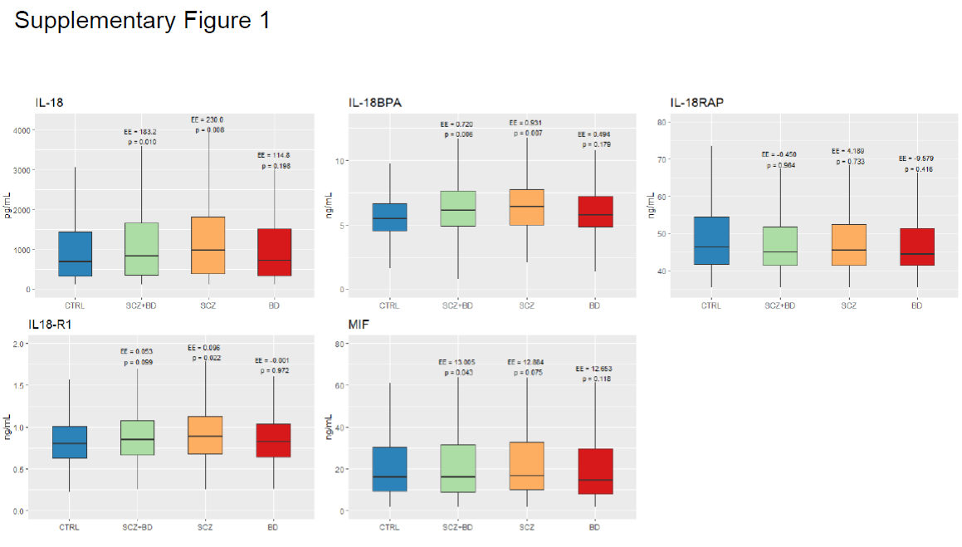

**Supplementary Figure 1.: Plasma levels of IL-18 family cytokines and MIF are elevated in patients with SMI relative to healthy controls.** Circulating levels of IL-18 (A), IL-18BPA (B), IL-18RAP (C), IL-18R1 (D), and MIF (E) are shown in patients with SMI (SCZ+BD), with SCZ, BD, or in controls (CTRL), controlling for age, sex, BMI, and CRP levels. Boxplots show median (line at 50% quantile) and interquartile ranges (bottom of boxplot at 25% quantile, top at 75% quantile). p values and effect estimates (EE) are presented on top of each bar relative to CTRL.