Appendix
A1. Cross-Correlation between Excess Death Factor and Mobility Statistics
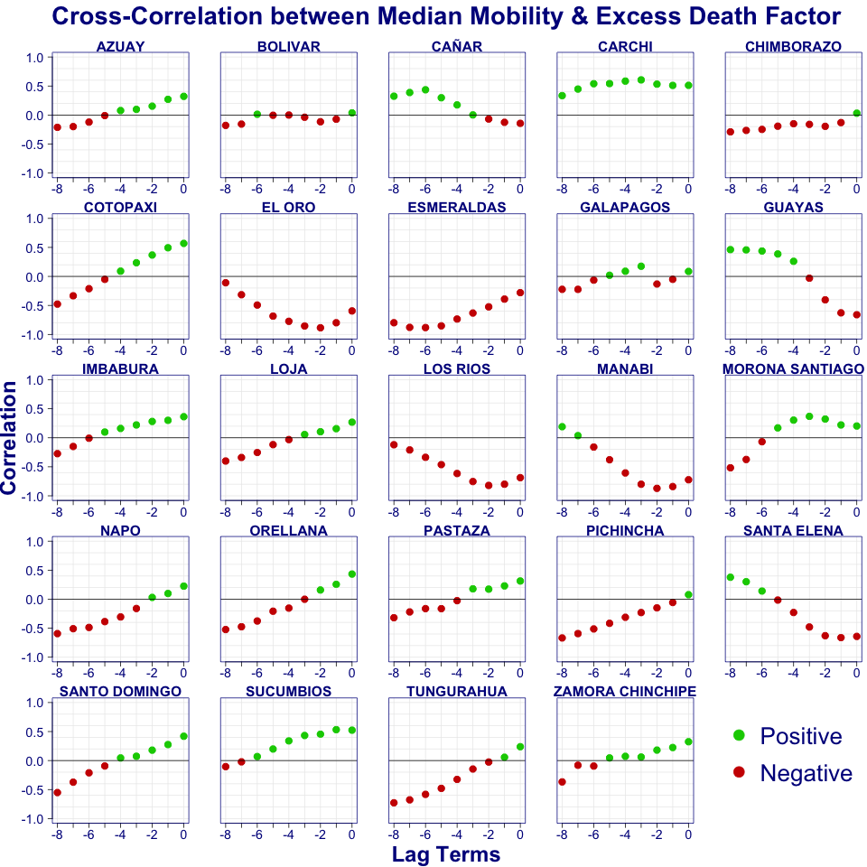
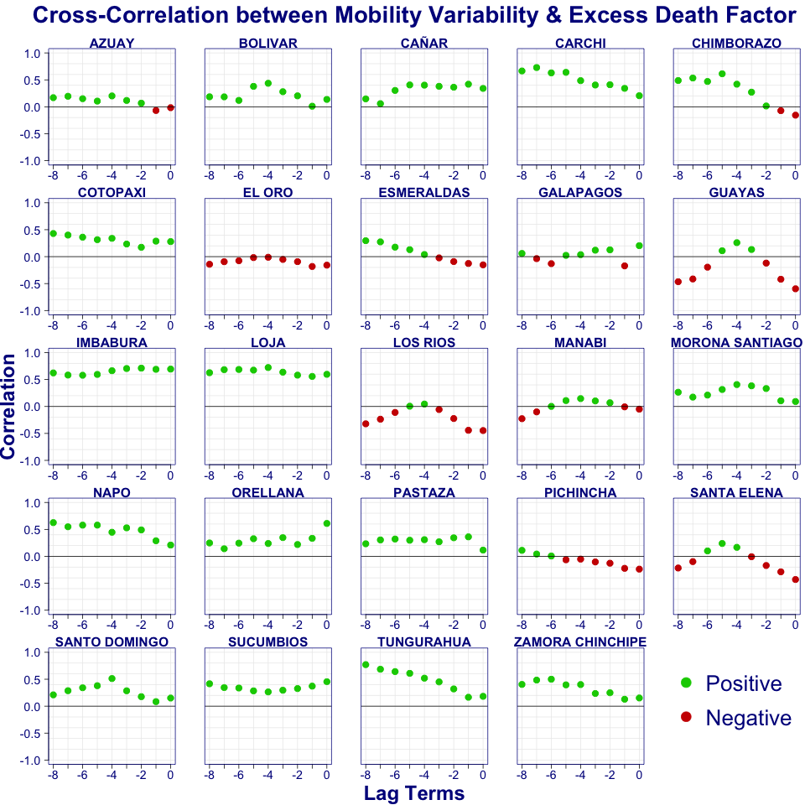
Figure 9 Cross-correlation of excess death factor and median and IQR’s mobility

A2. Table of coefficient from log-linear regression
Table 2 displays the estimated coefficient from a Poisson log-linear regression, after model selection. Only the statistically significant coefficients are shown. The provinces are in order of the date of the first time the excess death factor was 2.
Table 2 Regression coefficients of mobility statistics lags
Jurisdiction | Median |  |  | IQR |  |  | % Var. Explained
 | Lag 2 | Lag 3 | Lag 4 | Lag 2 | Lag 3 | Lag 4
GUAYAS | -5.38 | 2.18 | 2.19 | 2.19 | -2.94 | 1.58 | 80%
SANTA ELENA | -3.70 | -1.60 | 1.92 | -0.75 | 2.25 | 2.41 | 81%
BOLIVAR | -0.47 |  |  |  |  | 1.34 | 32%
CANAR | -1.11 |  | 0.90 | 1.52 |  |  | 28%
EL ORO | -1.67 |  | -0.52 |  |  | 0.28 | 88%
LOS RIOS | -1.68 |  |  |  |  | 1.22 | 80%
MANABI | -2.15 | -0.72 | 0.51 | 0.55 | -0.55 |  | 82%
ESMERALDAS |  |  | -1.76 |  |  | 0.90 | 72%
NAPO | 1.85 | -2.09 |  | 1.09 | 1.67 | 0.97 | 57%
ZAMORA CHINCHIPE |  |  |  |  |  | 0.99 | 18%
MORONA SANTIAGO | 1.22 |  |  |  |  | 1.84 | 38%
SANTO DOMINGO DE LOS TSACHILAS | 1.00 |  | -0.71 |  |  | 2.86 | 45%
COTOPAXI | 0.90 |  | -0.67 |  |  | 0.64 | 38%
ORELLANA | 2.20 |  | -2.48 |  | 1.01 | 0.95 | 35%
TUNGURAHUA |  | 1.87 | -1.74 | 0.88 |  | 2.68 | 52%
SUCUMBIOS | 1.20 |  |  |  |  |  | 25%
PASTAZA |  | 2.41 | -2.29 | 1.68 |  | 2.14 | 39%
PICHINCHA | 0.57 | 1.82 | -2.54 | -1.01 | 0.70 | 1.55 | 29%
CHIMBORAZO |  |  |  | -0.88 |  | 1.41 | 29%
IMBABURA | 0.85 |  |  | 1.07 | 1.17 | 1.00 | 72%
CARCHI |  | 0.98 | 0.91 |  |  | 0.82 | 46%
LOJA |  | 0.45 |  |  |  | 1.57 | 63%
AZUAY | 0.74 |  | -0.42 |  | 0.89 | 1.20 | 25%
GALAPAGOS | -2.79 | 2.82 |  |  |  |  | 14%

A3. Geographical and Temporal distribution of excess death factors
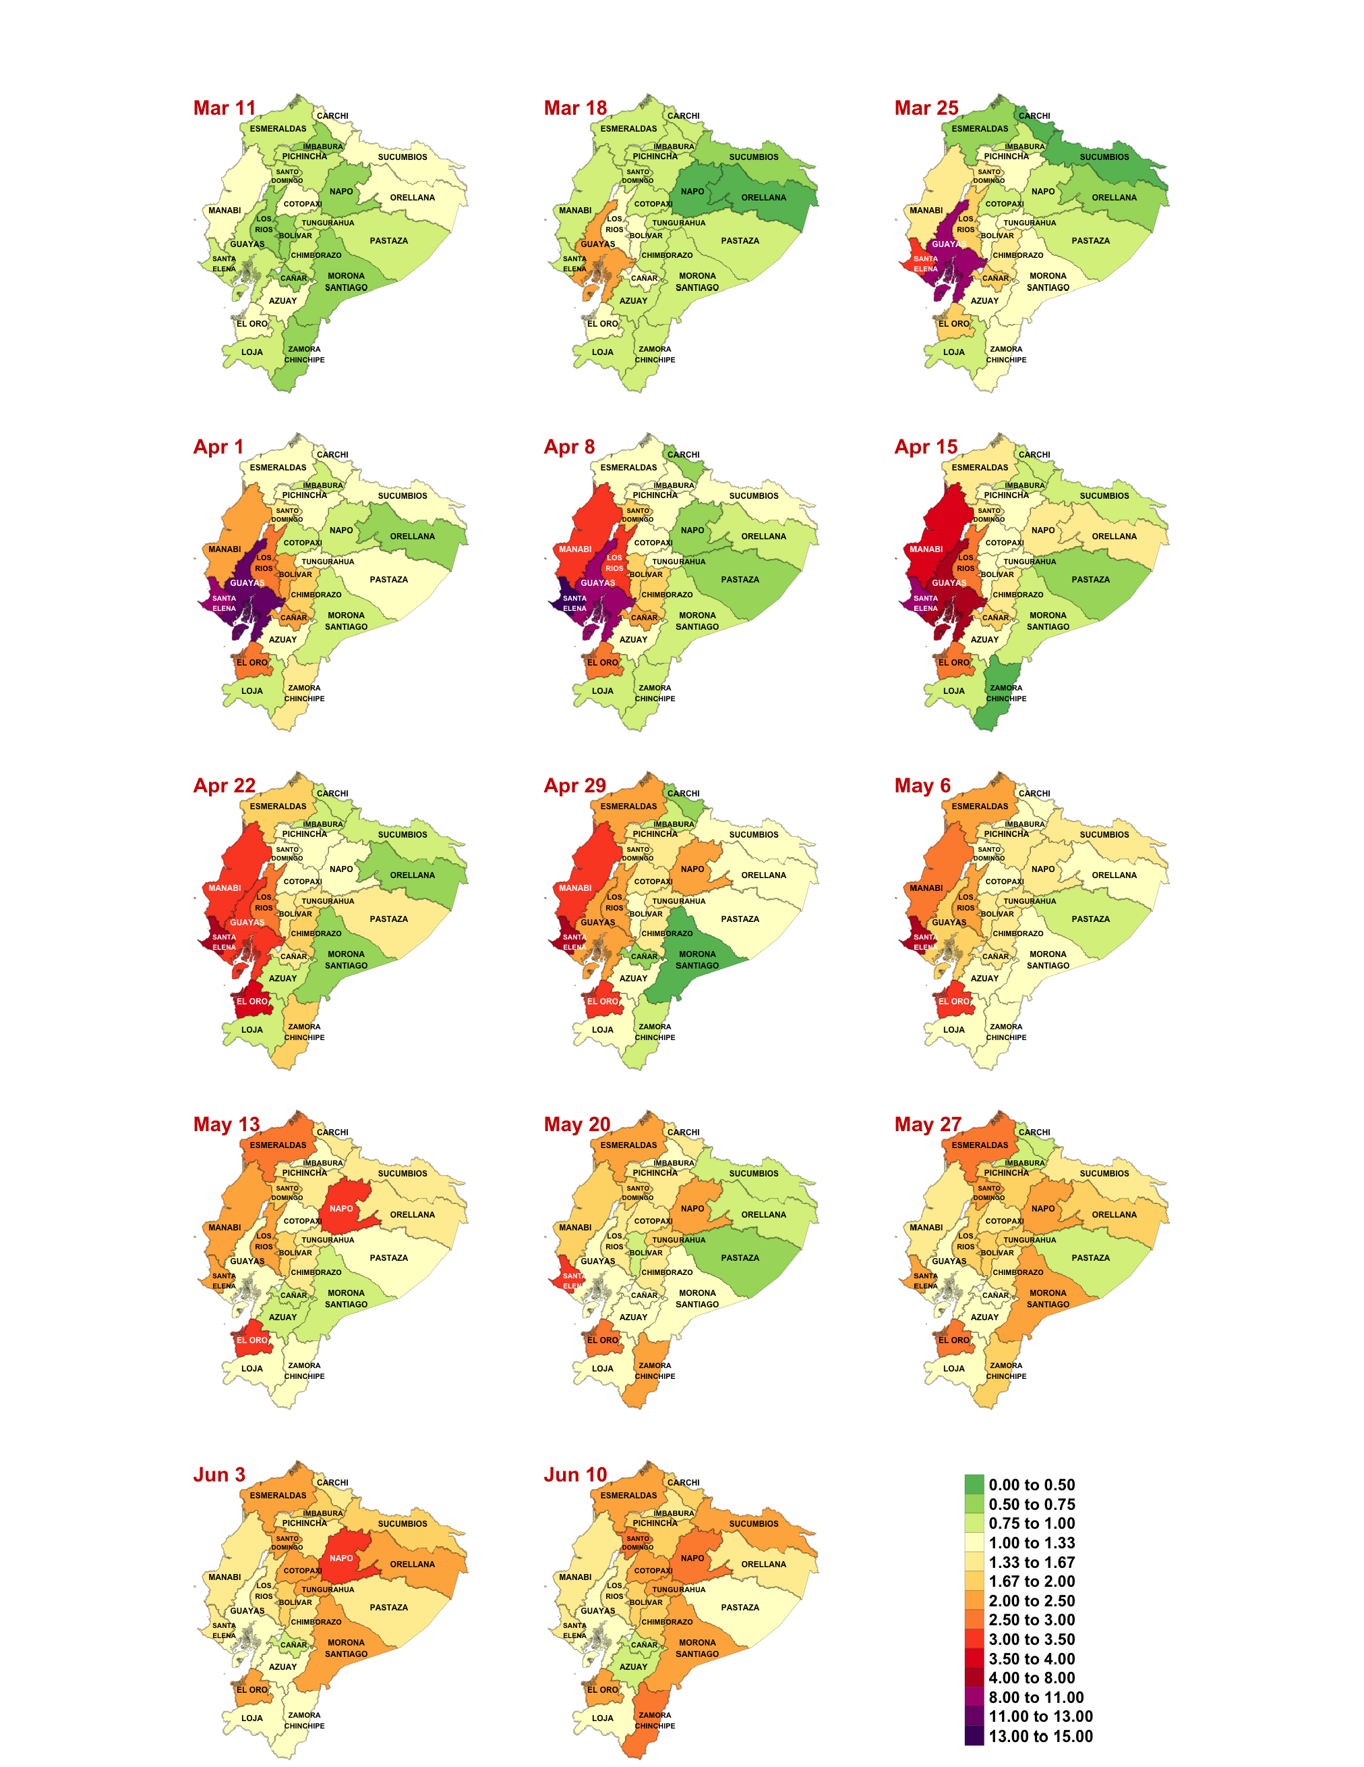
Figure 10 Weekly geographical evolution of excess death factor from March 11 to June16, 2020
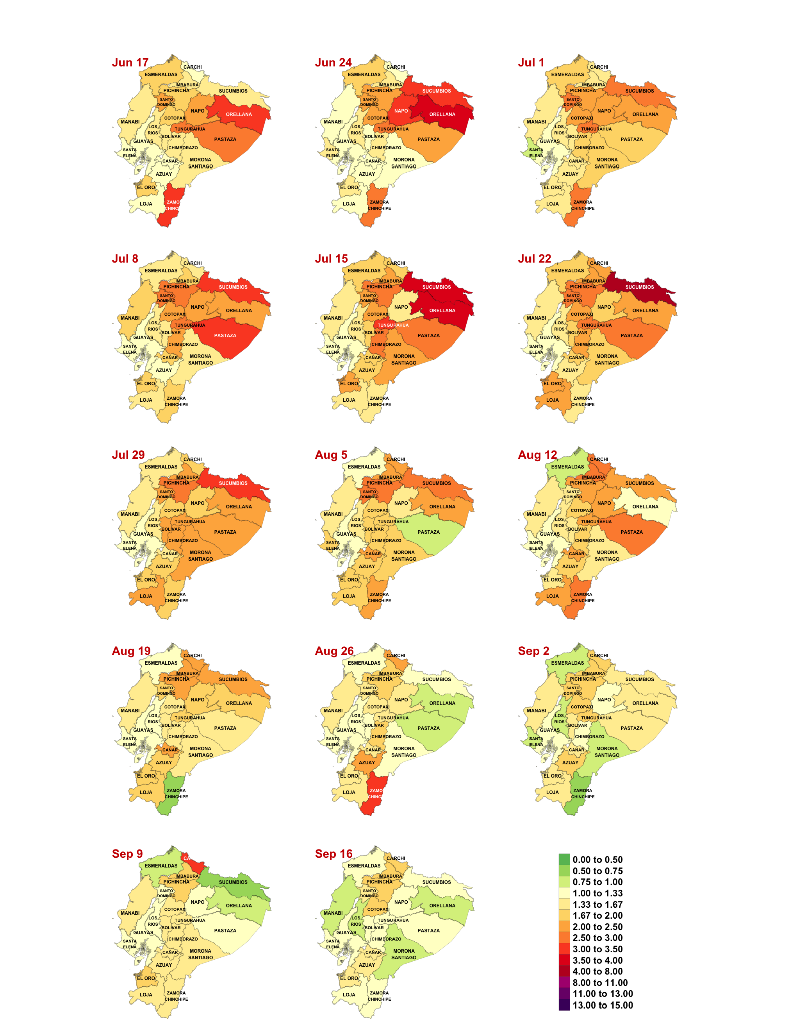
Figure 11 Weekly geographical evolution of excess death factor from June 17 to September 23, 2020

