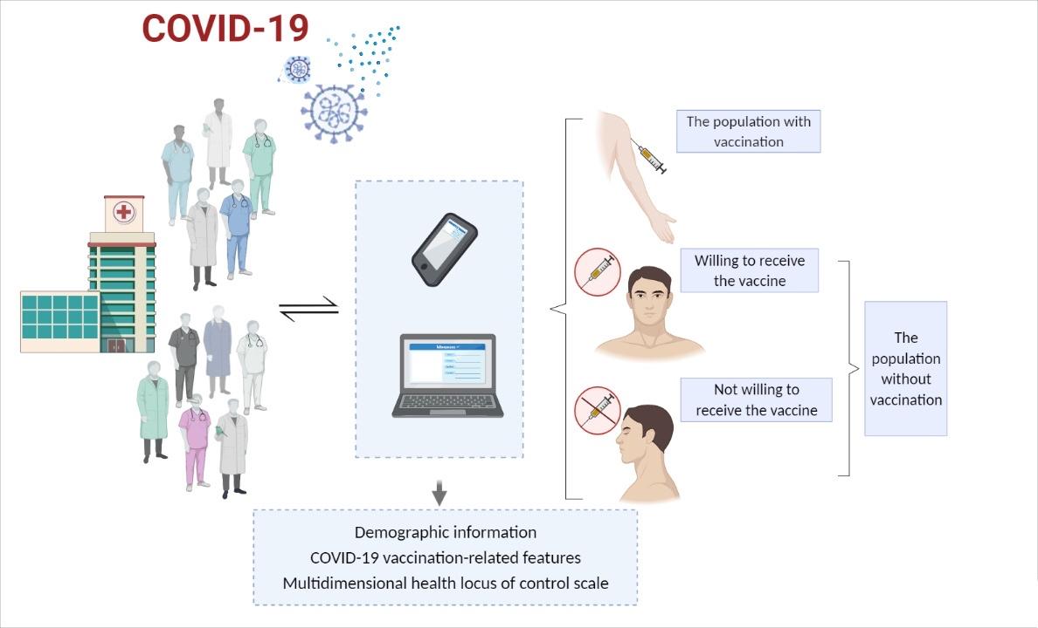

FIGURE 1: The flowchart of the present study.