RUNNING HEAD: Brain Structure and Cognition in Schizophrenia

Structural Brain Correlates of Cognitive Function in Schizophrenia: A Meta-Analysis
SUPPLEMENTARY MATERIAL

Marianne Khalil^{1,2}, Philippine Hollander^{2,3}, Delphine Raucher-Chéné^{1,2,4,5}, Martin Lepage^{1,2}, Katie M. Lavigne^{1,2,6*}

¹ Department of Psychiatry, McGill University, Montreal, Quebec, Canada
² Douglas Mental Health University Institute, McGill University, Montreal, Quebec, Canada
³ Faculty of Psychology and Neuroscience, Maastricht University, Maastricht, Netherlands
⁴ Department of Psychiatry, University Hospital of Reims, EPSM Marne, Reims, France
⁵ Cognition, Health, and Society Laboratory (EA 6291), University of Reims, Champagne-Ardenne, Reims, France
⁶ Montreal Neurological Institute, McGill University, Montreal, Quebec, Canada

*Corresponding Author:
Katie M. Lavigne, F1128.1, 6875 boulevard Lasalle, Frank B. Common Pavilion, Douglas Mental Health University Institute, Montreal, QC H4H 1R3, Canada. Phone: 1- 514-761-6131 x 3384. Email: katie.lavigne@mcgill.ca
Table of Contents
PRISMA Checklist (2020) 3
Figure S1. Schematic process of the meta-analyses performed on the included data. 6
Table S1. Reported brain regions and the final categorization into brain structures or networks. 7
Table S2. Description of included articles in the literature review with the cognitive domains and structural metrics reported 10
Table S3. Scoring of articles included in the meta-analysis based on five criteria to determine overall quality of studies. 51
Figure S2. Forest plot of the correlation between speed of processing and all brain structures reported in the included studies 53
Figure S3. Forest plot of the correlation between attention and vigilance and all brain structures reported in included studies 54
Figure S4. Forest plot of the correlation between working memory and all brain structures reported in the included studies 55
Figure S5. Forest plot of the correlation between verbal learning and memory and all brain structures reported in the included studies 57
Figure S6. Forest plot of the correlation between visual learning and memory and all brain structures reported in the included studies 60
Figure S7. Forest plot of the correlation between reasoning and executive functions and all brain structures reported in the included studies 62
Figure S8. Forest plot of the correlation between social cognition and all brain structures reported in the included studies 67
Figure S9. Forest plot of the correlation between verbal fluency and all brain structures reported in the included studies 68
Figure S10. Forest plot of the correlation between emotional processing tasks of social cognition and all brain structures reported in included studies 69
Figure S11. Forest plot of the correlation between theory of mind tasks of social cognition and all brain structures reported in included studies 70
Table S4. Values of effects, corrected with FDR, observed between the eight cognitive domains and the seven networks as well as brain regions categorized in the networks. 71
Table S5. Values of effects, corrected with FDR, observed between the eight cognitive domains and the three structures selected. 75
Figure S12. A) Circle plot of the FDR significant correlations between the seven brain networks and the eight cognitive domains. B) Circle plot of the correlations between the brain regions categorized in the seven brain networks and the eight cognitive domains. 76
References of Included articles 77

PRISMA Checklist (2020)
Section and Topic | Item # | Checklist item | Location where item is reported
TITLE
Title | 1 | Identify the report as a systematic review. | p. 1
ABSTRACT
Abstract | 2 | See the PRISMA 2020 for Abstracts checklist. | p. 2
INTRODUCTION
Rationale | 3 | Describe the rationale for the review in the context of existing knowledge. | p. 6
Objectives | 4 | Provide an explicit statement of the objective(s) or question(s) the review addresses. | p. 6
METHODS
Eligibility criteria | 5 | Specify the inclusion and exclusion criteria for the review and how studies were grouped for the syntheses. | p. 7 (2.3)
Information sources | 6 | Specify all databases, registers, websites, organisations, reference lists and other sources searched or consulted to identify studies. Specify the date when each source was last searched or consulted. | p. 6 (2.2)
Search strategy | 7 | Present the full search strategies for all databases, registers and websites, including any filters and limits used. | p. 6 (2.2)
Selection process | 8 | Specify the methods used to decide whether a study met the inclusion criteria of the review, including how many reviewers screened each record and each report retrieved, whether they worked independently, and if applicable, details of automation tools used in the process. | p. 8 (2.4)
Data collection process | 9 | Specify the methods used to collect data from reports, including how many reviewers collected data from each report, whether they worked independently, any processes for obtaining or confirming data from study investigators, and if applicable, details of automation tools used in the process. | p. 8 (2.5)
Data items | 10a | List and define all outcomes for which data were sought. Specify whether all results that were compatible with each outcome domain in each study were sought (e.g. for all measures, time points, analyses), and if not, the methods used to decide which results to collect. | p. 8 (2.5)
 | 10b | List and define all other variables for which data were sought (e.g. participant and intervention characteristics, funding sources). Describe any assumptions made about any missing or unclear information. | p. 8 (2.5)
Study risk of bias assessment | 11 | Specify the methods used to assess risk of bias in the included studies, including details of the tool(s) used, how many reviewers assessed each study and whether they worked independently, and if applicable, details of automation tools used in the process. | p. 11 (2.7.1.1)
Effect measures | 12 | Specify for each outcome the effect measure(s) (e.g. risk ratio, mean difference) used in the synthesis or presentation of results. | p.10-13 (2.7)
Synthesis methods | 13a | Describe the processes used to decide which studies were eligible for each synthesis (e.g. tabulating the study intervention characteristics and comparing against the planned groups for each synthesis (item #5)). | p. 7 (2.3)
 | 13b | Describe any methods required to prepare the data for presentation or synthesis, such as handling of missing summary statistics, or data conversions. | p.10-13 (2.7)
 | 13c | Describe any methods used to tabulate or visually display results of individual studies and syntheses. | p.10-13 (2.7)
 | 13d | Describe any methods used to synthesize results and provide a rationale for the choice(s). If meta-analysis was performed, describe the model(s), method(s) to identify the presence and extent of statistical heterogeneity, and software package(s) used. | p.10-13 (2.7)
 | 13e | Describe any methods used to explore possible causes of heterogeneity among study results (e.g. subgroup analysis, meta-regression). | p. 11 (2.7.1.1)
 | 13f | Describe any sensitivity analyses conducted to assess robustness of the synthesized results. | p. 9 (2.6) + p. 12 (2.7.1.2)
Reporting bias assessment | 14 | Describe any methods used to assess risk of bias due to missing results in a synthesis (arising from reporting biases). | -
Certainty assessment | 15 | Describe any methods used to assess certainty (or confidence) in the body of evidence for an outcome. | p. 10 (2.7)
RESULTS
Study selection | 16a | Describe the results of the search and selection process, from the number of records identified in the search to the number of studies included in the review, ideally using a flow diagram. | p. 14 (3.1)
 | 16b | Cite studies that might appear to meet the inclusion criteria, but which were excluded, and explain why they were excluded. | Table S2
Study characteristics | 17 | Cite each included study and present its characteristics. | Table S2
Risk of bias in studies | 18 | Present assessments of risk of bias for each included study. | p. 15 (3.3.1)
Results of individual studies | 19 | For all outcomes, present, for each study: (a) summary statistics for each group (where appropriate) and (b) an effect estimate and its precision (e.g. confidence/credible interval), ideally using structured tables or plots. | Table S2
Results of syntheses | 20a | For each synthesis, briefly summarise the characteristics and risk of bias among contributing studies. | p. 15 (3.3.1)
 | 20b | Present results of all statistical syntheses conducted. If meta-analysis was done, present for each the summary estimate and its precision (e.g. confidence/credible interval) and measures of statistical heterogeneity. If comparing groups, describe the direction of the effect. | p. 14-19
 | 20c | Present results of all investigations of possible causes of heterogeneity among study results. | p. 15 (3.3.1)
 | 20d | Present results of all sensitivity analyses conducted to assess the robustness of the synthesized results. | p. 15 (3.3.2)
Reporting biases | 21 | Present assessments of risk of bias due to missing results (arising from reporting biases) for each synthesis assessed. | -
Certainty of evidence | 22 | Present assessments of certainty (or confidence) in the body of evidence for each outcome assessed. | p. 15 (3.3.2)
DISCUSSION
Discussion | 23a | Provide a general interpretation of the results in the context of other evidence. | p. 19-27
 | 23b | Discuss any limitations of the evidence included in the review. | p. 27 (4.3)
 | 23c | Discuss any limitations of the review processes used. | p. 27 (4.3)
 | 23d | Discuss implications of the results for practice, policy, and future research. | p. 28 (4.4)
OTHER INFORMATION
Registration and protocol | 24a | Provide registration information for the review, including register name and registration number, or state that the review was not registered. | p. 6 (2.1)
 | 24b | Indicate where the review protocol can be accessed, or state that a protocol was not prepared. | p. 6 (2.1)
 | 24c | Describe and explain any amendments to information provided at registration or in the protocol. | p. 7 (2.3)
Support | 25 | Describe sources of financial or non-financial support for the review, and the role of the funders or sponsors in the review. | p. 30
Competing interests | 26 | Declare any competing interests of review authors. | p. 30

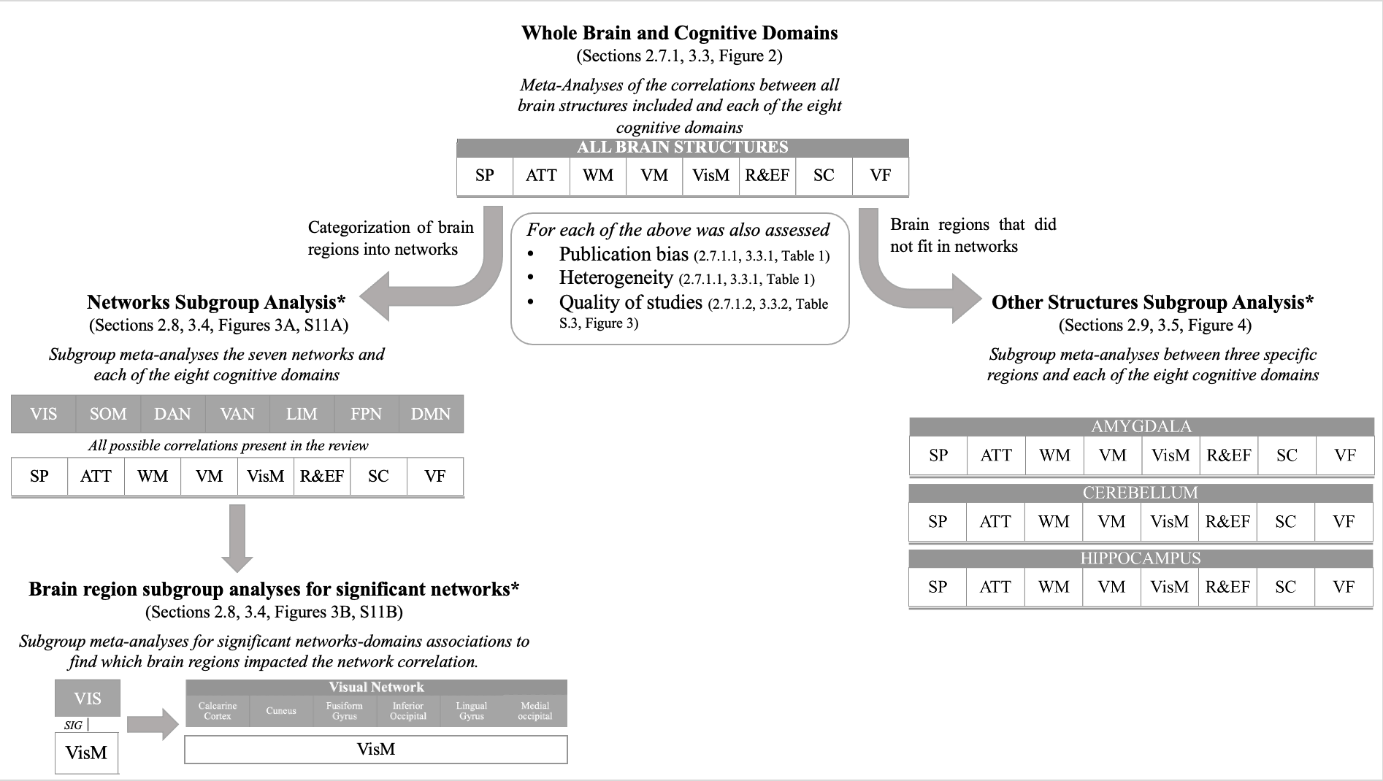
Figure S1. Schematic process of the meta-analyses performed on the included data.
The sections and figures refer to where the methods or the results are discussed in the manuscript.
*These correlations were corrected for multiple comparisons using the false discovery rate (FDR) of 0.05.

Table S1. Reported brain regions and the final categorization into brain structures or networks.
Final reported structures | Network  (if applicable) | Atlas/Segmentation  (if applicable)
Amygdala | - | -
Angular gyrus | DMN | WFU PickAtlas
Anterior cingulate gyrus | DMN | AUT
Anterior cingulate gyrus | DMN | DSK
Anterior cingulate gyrus | DMN | FreeSurfer Software
Anterior cingulate gyrus | DMN | SPM5
Anterior cingulate gyrus | DMN | WFU PickAtlas
BANKSTS | VEN | DSK
Calcarine cortex | VIS | DSK
Caudate | - | -
Cerebellum | - | -
Claustrum | SOM | MNI
Corpus callosum | - | -
Cuneus | VIS | AUT
Dorsolateral prefrontal cortex | FPN | Broadmann
Entorhinal cortex | LIM | Broadmann
Frontal lobe | - | -
Fronto-temporal lobe | - | -
Fusiform gyrus | VIS | AUT
Fusiform gyrus | VIS | Broadmann
Fusiform gyrus | VIS | MAN
Grey matter | - | -
Gyrus rectus | LIM | AUT
Heschl's gyrus | SOM | Broadmann
Hippocampus | - | -
Inferior frontal gyrus | FPN | Broadman
Inferior frontal gyrus | FPN | DSK
Inferior frontal gyrus | FPN | WFU PickAtlas
IFG pars opercularis | DOR | Broadmann
IFG pars orbitalis | DMN | Broadmann
IFG pars triangularis | FPN | Broadmann
Inferior occipital | VIS | Broadmann
Inferior parietal lobule | DMN | AUT
Inferior parietal lobule | DMN | Broadmann
Inferior parietal lobule | DMN | MNI
Inferior parietal lobule | DMN | WFU PickAtlas
Inferior temporal gyrus | DMN | Broadmann
Inferior temporal gyrus | DMN | DKT
Insula | VEN | DKT
Insula | VEN | WFU PickAtlas

Final reported structures | Network  (if applicable) | Atlas/Segmentation  (if applicable)
Lateral occipital | DMN | DKT
Lingual gyrus | VIS | Broadmann
Medial frontal cortex | FPN | AUT
Medial frontal cortex | FPN | Broadmann
Medial frontal cortex | FPN | MAN
Medial occipital lobe | VIS | AUT
Middle cingulate gyrus | VEN | AUT
Middle cingulate gyrus | VEN | WFU PickAtlas
Middle frontal gyrus | FPN | AUT
Middle frontal gyrus | FPN | Broadmann
Middle frontal gyrus | FPN | DSK
Middle occipital lobe | VIS | AUT
Middle temporal gyrus | DMN | AUT
Middle temporal gyrus | DMN | Broadmann
Nucleus accumbens | - | -
Occipital lobe | VIS | AUT
Operculum | VEN | Broadmann
Orbitofrontal cortex | LIM | AUT
Orbitofrontal cortex | LIM | TAL
Orbitofrontal cortex | LIM | WFU PickAtlas
Pallidum | - | -
Parahippocampal gyrus | LIM | AUT
Parietal lobe | - | -
Parieto-occipital lobe | - | -
Pituitary | - | -
Planum temporale | SOM | Broadmann
Posterior cingulate gyrus | DMN | AUT
Posterior cingulate gyrus | DMN | Broadmann
Precentral gyrus | SOM | DKT
Precuneus | DMN | MNI
Prefrontal cortex | - | -
Presubiculum | - | -
Putamen | - | -
Striatum | - | -
Subcortex | - | -
Subiculum | - | -
Superior frontal gyrus | VEN | AUT
Superior frontal gyrus | VEN | Broadmann
Superior parietal lobule | DOR | DKT
Superior temporal gyrus | SOM | AUT
Superior temporal gyrus | SOM | Broadmann
Supplementary motor area | SOM | MNI
Supramarginal gyrus | FPC | DKT
Temporal lobe | - | -
Final reported structures | Network  (if applicable) | Atlas/Segmentation  (if applicable)
Temporal pole | DMN | Broadmann
Temporal pole | DMN | MAN
Temporal pole | DMN | WFU PickAtlas
Temporal horns | - | -
Temporoparietal | - | -
Temporoparietal junction | VEN | -
Thalamus | - | -
Ventricles | - | -
White matter | - | -
Whole brain | - | -

For the networks: DMN: Default mode network, DOR: dorsal attention network, FPN: frontoparietal network, LIM: limbic network, SOM: somatomotor network, VEN: ventral attention network, VIS: visual network. For the atlases and segmentation methods: AUT: automatic segmentation with a software, Broadmann: Broadmann areas, DKT: Desikian-Killiany Atlas, DSK: Destrieux cortical Atlas, FreeSurfer: Freesurfer software for brain mapping, MAN: manual segmentation based on reported criteria, MNI: Montreal Neurological Institute atlas, SPM5: Statistical Parametric Mapping (5th version), TAL: Talairach Atlas, WFU PickAtlas: Wake Forest University statist

Table S2. Description of included articles in the literature review with the cognitive domains and structural metrics reported
Article | Brain region | Cognitive Domain | Cognitive test | Structural measure | Value of Effect | N patients
Abbs et al. (2011) | prefrontal cortex  prefrontal cortex  inferior parietal  hippocampus  prefrontal cortex  prefrontal cortex  prefrontal cortex  inferior parietal  hippocampus  prefrontal cortex | VM | CVLT Trial 5  CVLT Semantic Clustering  CVLT Semantic Clustering  CVLT Semantic Clustering  CVLT Serial Clustering  CVLT Trial 5  CVLT Semantic Clustering  CVLT Semantic Clustering  CVLT Semantic Clustering  CVLT Serial Clustering | Volume | r = 0.40  r = 0.09 (ns)  r = -0.04 (ns)  r = 0.32  r = 0.49  r = −0.51  r = -0.45  r = 0.38  r = 0.03 (ns)  r = -0.32 | 59  29
Antonova, Sharma, Morris, and Kumari (2004) | Review |  | Review |  | Review
Antonova et al. (2005) | precuneus  occipital lobe white matter  occipital lobe white matter  whole brain | VM  ATT  ATT  VF | Buschke Selective Reminding Test - consistent recall  Stroop Test - words  Stroop Test - colors  Letter and Category verbal fluency - phonological | Volume | r = 0.40  r = 0.44 (ns)  r = 0.48 (ns)  r = 0.37 | 45
Antoniades et al. (2018) | Meta-Analysis |  | Meta-Analysis |  | Meta-Analysis
Baare et al. (1999) | total prefrontal cortex  left prefrontal cortex  right prefrontal cortex  total orbital gyrus  grey orbital gyrus  total prefrontal cortex  right prefrontal cortex  total prefrontal cortex | VM  SP | CVLT - immediate recall  CVLT - immediate recall  CVLT - immediate recall  CVLT - immediate recall  CVLT - immediate recall  WMS-R Visual reproduction - immediate  WMS-R Visual reproduction - immediate  Semantic fluency | Volume | r = 0.46 (ns)  r = 0.69  r = 0.83  r = 0.32 (ns)  r = 0.37 (ns)  r = 0.6  r = 0.76  r = 0.64 | 13
Banaj et al. (2018) | left inferior parietal cortex  left insula  right middle temporal cortex  left cerebellum – lobule 6 (BA18)  right cerebellum –lobuleVIIb  right cerebellum – CRUS 1 | VM  VisM | Rey's 15-word Immediate Recall  Rey's 15-word Immediate Recall  Rey-Osterrieth Complex Figure Test – delayed recall  Rey-Osterrieth Complex Figure Test – delayed recall  Rey-Osterrieth Complex Figure Test – delayed recall  Rey-Osterrieth Complex Figure Test – delayed recall | Volume | t = 7.32  t = 6.16  t = 7.15  t = 6.23  t = 6.27  t = 6.49 | 28
Bonilha et al. (2008) | BA 9  BA 9  BA 46 | R&EF | Trail making test B  Wisconsin Card Sorting Task - errors  Wisconsin Card Sorting Task - failure to maintain | Volume | r = −0.70*  r = −0.65*  r = −0.56* | 14
Bornstein, Schwarzkopf, Olson, and Nasrallah (1992) | third ventricle  third ventricle  third ventricle  lateral ventricle  third ventricle  lateral ventricle  third ventricle  third ventricle  third ventricle  third ventricle  third ventricle | R&EF  VM  WM  SP  WM | Wisconsin Card Sorting Task - category  Wisconsin Card Sorting Task - perseveration  Verbal Concept Formation Test  WMS-R Visual Memory Span - forward  WMS-R Visual Memory Span - forward  WMS-R Visual Memory Span - backward  WMS-R Visual Memory Span - backward  WMS-R Digit Span - forward  WMS-R Digit Span - backward  Trail making test A  Knox cube delay | Volume | r = -0.34  r = 0.22*  r = -0.33  r = -0.33  r = -0.30  r = -0.29  r = -0.29  r = -0.29  r = -0.28  r = 0.23  r = -0.27 | 72
Caldiroli et al. (2018) | right insula  left insula  right insula  left insula  right insula  left insula  right insula  left insula  right insula  left insula  right insula  left insula  right insula  left insula  right insula  left insula  right insula  left insula  right insula  left insula  right insula  left insula | VisM  SC | BFRT score  BFRT score  DFAR percentage neutral faces  DFAR percentage neutral faces  DFAR percentage happy faces  DFAR percentage happy faces  DFAR percentage fearful faces  DFAR percentage fearful faces  DFAR percentage angry faces  DFAR percentage angry faces  DFAR percentage (all faces)  DFAR percentage (all faces)  EMT second order belief score  EMT second order belief score  EMT second order emotion score  EMT second order emotion score  EMT first order emotion score  EMT first order emotion score  EMT first order belief score  EMT first order belief score  EMT control question score  EMT control question score | Volume | t = −0.63 (ns)  t = 0.50 (ns)  t = 0.61 (ns)  t = −0.72 (ns)  t = 0.91 (ns)  t = −0.28 (ns)  t = 0.15 (ns)  t = 1.86 (ns)  t = −0.19 (ns)  t = −0.84 (ns)  t = 0.05 (ns)  t = 0.48 (ns)  t = −0.17 (ns)  t = 0.69 (ns)  t = 0.82 (ns)  t = −1.00 (ns)  t = −0.38 (ns)  t = 1.51 (ns)  t = −0.04 (ns)  t = 0.14 (ns)  t = 0.25 (ns)  t = −1.01 (ns) | 133
Crespo-Facorro, Barbadillo, Pelayo-Teran, and Rodriguez-Sanchez (2007) | Review |  | Review |  | Review
DeLisi et al. (1991) | left temporal lobe  right temporal lobe  left frontal lobe  right frontal lobe  left lateral ventricles  right lateral ventricles  left parahippocampal gyrus  right parahippocampal gyrus  left temporal lobe  right temporal lobe  left frontal lobe  right frontal lobe  left lateral ventricles  right lateral ventricles  left parahippocampal gyrus  right parahippocampal gyrus  left temporal lobe  right temporal lobe  left frontal lobe  right frontal lobe  left lateral ventricles  right lateral ventricles  left parahippocampal gyrus  right parahippocampal gyrus  left temporal lobe  right temporal lobe  left frontal lobe  right frontal lobe  left lateral ventricles  right lateral ventricles  left parahippocampal gyrus  right parahippocampal gyrus  left temporal lobe  right temporal lobe  left frontal lobe  right frontal lobe  left lateral ventricles  right lateral ventricles  left parahippocampal gyrus  right parahippocampal gyrus  left temporal lobe  right temporal lobe  left frontal lobe  right frontal lobe  left lateral ventricles  right lateral ventricles  left parahippocampal gyrus  right parahippocampal gyrus  left temporal lobe  right temporal lobe  left frontal lobe  right frontal lobe  left lateral ventricles  right lateral ventricles  left parahippocampal gyrus  right parahippocampal gyrus  left temporal lobe  right temporal lobe  left frontal lobe  right frontal lobe  left lateral ventricles  right lateral ventricles  left parahippocampal gyrus  right parahippocampal gyrus | VM  VisM  VM  VisM  R&EF  VF  R&EF | WMS - Logical memory  WMS - Logical memory  WMS - Logical memory  WMS - Logical memory  WMS - Logical memory  WMS - Logical memory  WMS - Logical memory  WMS - Logical memory  WMS associate learning  WMS associate learning  WMS associate learning  WMS associate learning  WMS associate learning  WMS associate learning  WMS associate learning  WMS associate learning  WMS visual reproduction  WMS visual reproduction  WMS visual reproduction  WMS visual reproduction  WMS visual reproduction  WMS visual reproduction  WMS visual reproduction  WMS visual reproduction  California Verbal Learning Test  California Verbal Learning Test  California Verbal Learning Test  California Verbal Learning Test  California Verbal Learning Test  California Verbal Learning Test  California Verbal Learning Test  California Verbal Learning Test  Benton Visual Retention Test  Benton Visual Retention Test  Benton Visual Retention Test  Benton Visual Retention Test  Benton Visual Retention Test  Benton Visual Retention Test  Benton Visual Retention Test  Benton Visual Retention Test  Wisconsin Card Sorting Test  Wisconsin Card Sorting Test  Wisconsin Card Sorting Test  Wisconsin Card Sorting Test  Wisconsin Card Sorting Test  Wisconsin Card Sorting Test  Wisconsin Card Sorting Test  Wisconsin Card Sorting Test  Controlled Oral Word Association  Controlled Oral Word Association  Controlled Oral Word Association  Controlled Oral Word Association  Controlled Oral Word Association  Controlled Oral Word Association  Controlled Oral Word Association  Controlled Oral Word Association  Trail making test B  Trail making test B  Trail making test B  Trail making test B  Trail making test B  Trail making test B  Trail making test B  Trail making test B | Volume | r = 0.10 (ns)  r = 0.06 (ns)  r = -0.11 (ns)  r = -0.17 (ns)  r = -0.15 (ns)  r = -0.04 (ns)  r = 0.33 (ns)  r = 0.31 (ns)  r = 0.07 (ns)  r = 0.04 (ns)  r = -0.11 (ns)  r = -0.19 (ns)  r = -0.08 (ns)  r = 0.09 (ns)  r = 0.45  r = 0.40  r = 0.16 (ns)  r = 0.09 (ns)  r = 0.20 (ns)  r = 0.17 (ns)  r = -0.22 (ns)  r = -0.05 (ns)  r = -0.31 (ns)  r = -0.17 (ns)  r = 0.10 (ns)  r = 0.17 (ns)  r = -0.01 (ns)  r = 0.00 (ns)  r = 0.04 (ns)  r = 0.14 (ns)  r = 0.13 (ns)  r = 0.13 (ns)  r = 0.15 (ns)  r = -0.02 (ns)  r = 0.17 (ns)  r = 0.07 (ns)  r = -0.25 (ns)  r = -0.12 (ns)  r = -0.05 (ns)  r = -0.08 (ns)  r = -0.02* (ns)  r = 0.05* (ns)  r = -0.21* (ns)  r = -0.14* (ns)  r = 0.33* (ns)  r = 0.09* (ns)  r = 0.14* (ns)  r = 0.12* (ns)  r = -0.05 (ns)  r = -0.06 (ns)  r = 0.06 (ns)  r = -0.02 (ns)  r = -0.13 (ns)  r = -0.07 (ns)  r = -0.04 (ns)  r = -0.09 (ns)  r = -0.11* (ns)  r = -0.11* (ns)  r = 0.05* (ns)  r = 0.05* (ns)  r = 0.23* (ns)  r = 0.29* (ns)  r = 0.01* (ns)  r = 0.00 (ns) | 45
Dickey et al. (2007) | right hippocampus  left hippocampus  right hippocampus  left hippocampus  right hippocampus  left hippocampus  right hippocampus  left hippocampus  right hippocampus  left hippocampus | WM  VM | Delayed Alternation test - total errors  Delayed Alternation test - total errors  Delayed Alternation test - perseverations  Delayed Alternation test - perseverations  Delayed Alternation test - failure to maintain  Delayed Alternation test - failure to maintain  WMS-R Logical Memory 1  WMS-R Logical Memory 1  CVLT - total words  CVLT - total words | Volume | ρ = 0.098 (ns)  ρ = −0.528  ρ = 0.218 (ns)  ρ = −0.435  ρ = −0.191 (ns)  ρ = −0.468  ρ = −0.262 (ns)  ρ = −0.104 (ns)  ρ = −0.205 (ns)  ρ = 0.112 (ns) | 20
Edgar et al. (2012) | left Heschel's gyrus  left planum temporale  left lateral aspect  right Heschl's gyrus  right planum temporale  right lateral aspect  left inferior orbital cortex  left inferior triangularis  left middle frontal gyrus  left inferior opercular gyrus  right inferior opercular cortex  right middle frontal gyrus  right inferior orbital  right inferior triangularis | ATT | TMT A + Connors' Continuous Performance Test  TMT A + Connors' Continuous Performance Test  TMT A + Connors' Continuous Performance Test  TMT A + Connors' Continuous Performance Test  TMT A + Connors' Continuous Performance Test  TMT A + Connors' Continuous Performance Test  TMT A + Connors' Continuous Performance Test  TMT A + Connors' Continuous Performance Test  TMT A + Connors' Continuous Performance Test  TMT A + Connors' Continuous Performance Test  TMT A + Connors' Continuous Performance Test  TMT A + Connors' Continuous Performance Test  TMT A + Connors' Continuous Performance Test  TMT A + Connors' Continuous Performance Test | Cortical Thickness | r = 0.46  r = 0.34 (ns)  r = 0.26 (ns)  r = 0.54  r = 0.36 (ns)  r = 0.05 (ns)  r = 0.52  r = 0.31  r = 0.3  r = 0.18 (ns)  r = 0.48  r = 0.33  r = 0.18 (ns)  r = 0.25 (ns) | 51
Ehrlich et al. (2012) | right middle/sup temporal gyrus  left hippocampus  right hippocampus  left hippocampus  right hippocampus  left hippocampus  right hippocampus  left hippocampus  right hippocampus | WM  VM  VisM  VM | WAIS letter number sequencing - recall  WAIS letter number sequencing - recall  WAIS letter number sequencing - recall  Hopkins Verbal Learning Test-Revised - learning  Hopkins Verbal Learning Test-Revised - learning  Benton Visual Retention Test  Benton Visual Retention Test  WMS - Logical memory immediate recall  WMS - Logical memory immediate recall | Thickness  Volume | r = 0.391  t = 2.386  t = 1.951  t = 2.951  t = 1.764  t = 2.123  t = 1.014  t = 2.517  t = 2.038 | 131
Exner, Boucsein, Degner, Irle, and Weniger (2004) | right amygdala  right amygdala | VisM  SC | WMS-R Visual paired associates immediate recall  ERT Emotion recognition | Volume | r = 0.832  r = 0.612 | 16
Exner et al. (2008) | right hippocampus  right hippocampus | VisM | WMS-R Visual Reproduction 1  WMS-R Visual Reproduction 1 | Volume | r = 0.54  r = 0.23 | 14  7
Francis et al. (2016) | posterior splenium  anterior splenium  posterior splenium  anterior splenium  posterior splenium  anterior splenium  posterior splenium  anterior splenium  posterior splenium  anterior splenium  posterior splenium  anterior splenium  posterior splenium  anterior splenium  posterior splenium  anterior splenium  posterior splenium  anterior splenium  posterior splenium  anterior splenium | VM  WM  VF  SP  R&EF  VM  WM  VF  SP  R&EF | BACS verbal memory  BACS verbal memory  BACS digit sequencing  BACS digit sequencing  BACS verbal fluency  BACS verbal fluency  BACS symbol coding  BACS symbol coding  BACS tower test  BACS tower test  BACS verbal memory  BACS verbal memory  BACS digit sequencing  BACS digit sequencing  BACS verbal fluency  BACS verbal fluency  BACS symbol coding  BACS symbol coding  BACS tower test  BACS tower test | Volume | r = 0.12 (ns)  r = 0.13 (ns)  r = 0.13 (ns)  r = 0.05 (ns)  r = 0.12 (ns)  r = 0.08 (ns)  r = 0.14 (ns)  r = 0.13 (ns)  r = 0.09 (ns)  r = 0.07 (ns)  r = 0.02 (ns)  r = 0.10 (ns)  r = -0.06 (ns)  r = -0.06 (ns)  r = -0.001 (ns)  r = -0.001 (ns)  r = -0.10 (ns)  r = -0.10 (ns)  r = 0.03 (ns)  r = 0.03 (ns) | 224  142
Frascarelli et al. (2015) | left medial frontal gyrus  left medial frontal gyrus  left medial frontal gyrus  left medial frontal gyrus | R&EF | WCST Perseverative responses  WCST Perseverative errors  WCST Perseverative responses  WCST Perseverative errors | Volume | R² = 0.018 (ns)  R² = 0.187 (ns)  R² = 0.079 (ns)  R² = 0.297 (ns) | 18  15
Fujiwara et al. (2007) | left cingulate sulcus  left anterior cingulate cortex  right anterior cingulate cortex  left anterior cingulate cortex  right anterior cingulate cortex  right anterior cingulate cortex | SC | Perception of Affect Tasks (PAT) - Subtask 1  Perception of Affect Tasks (PAT) - Subtask 2  Perception of Affect Tasks (PAT) - Subtask 3  Perception of Affect Tasks (PAT) - Subtask 3  Perception of Affect Tasks (PAT) - Subtask 4  Perception of Affect Tasks (PAT) - Subtask 4 | Volume | t = 2.899  r = 0.399  r = 0.415  r = 0.433  r = 0.48  r = 0.446 | 26
Fujiwara, Yassin, and Murai (2015) | Review |  | Review |  | Review
Garlinghouse, Roth, Isquith, Flashman, and Saykin (2010) | left frontal  right frontal  left temporal  right temporal  left parietal  right parietal  total intracranial | WM | WAIS-III Digit span backwards  WAIS-III Digit span backwards  WAIS-III Digit span backwards  WAIS-III Digit span backwards  WAIS-III Digit span backwards  WAIS-III Digit span backwards  WAIS-III Digit span backwards | Volume | r = −0.40  r = −0.28 (ns)  r = −0.45  r = −0.46  r = 0.17 (ns)  r = 0.03 (ns)  r = 0.25 (ns) | 29
(Goghari, MacDonald, & Sponheim, 2014) | bilateral superior prefrontal  left inferior prefrontal  right inferior prefrontal  bilateral superior prefrontal  left inferior prefrontal  right inferior prefrontal | WM | Spatial working memory task (hold)  Spatial working memory task (hold)  Spatial working memory task (hold)  Spatial working memory task (flip)  Spatial working memory task (flip)  Spatial working memory task (flip) | Volume | r = 0.46 (ns)  r = 0.33 (ns)  r = 0.11 (ns)  r = 0.57  r = 0.56  r = 0.33 (ns) | 17
Goldberg, Torrey, Berman, and Weinberger (1994) | left hippocampus  right hippocampus  lateral ventricles  third ventricle  left hippocampus  right hippocampus  lateral ventricles  third ventricle  left hippocampus  right hippocampus  lateral ventricles  third ventricle  left hippocampus  right hippocampus  lateral ventricles  third ventricle  left hippocampus  right hippocampus  lateral ventricles  third ventricle  left hippocampus  right hippocampus  lateral ventricles  third ventricle  left hippocampus  right hippocampus  lateral ventricles  third ventricle  left hippocampus  right hippocampus  lateral ventricles  third ventricle  left hippocampus  right hippocampus  lateral ventricles  third ventricle | ATT  VM  VisM  VM  SP  R&EF  VF | Continuous Performance Test  Continuous Performance Test  Continuous Performance Test  Continuous Performance Test  Stroop Color Test  Stroop Color Test  Stroop Color Test  Stroop Color Test  Logical memory  Logical memory  Logical memory  Logical memory  Visual reproduction  Visual reproduction  Visual reproduction  Visual reproduction  Paired association  Paired association  Paired association  Paired association  TMT A  TMT A  TMT A  TMT A  WCST - categories  WCST - categories  WCST - categories  WCST - categories  WCST - perseverative errors  WCST - perseverative errors  WCST - perseverative errors  WCST - perseverative errors  Verbal fluency test  Verbal fluency test  Verbal fluency test  Verbal fluency test | Volume | r = 0.009 (ns)  r = 0.18 (ns)  r = -0.17 (ns)  r = -0.28 (ns)  r = -0.16 (ns)  r = -0.15 (ns)  r = 0.34 (ns)  r = -0.13 (ns)  r = 0.57  r = 0.05 (ns)  r = -0.18 (ns)  r = -0.18 (ns)  r = -0.19 (ns)  r = -0.05 (ns)  r = -0.19 (ns)  r = -0.02 (ns)  r = -0.45 (ns)  r = -0.5 (ns)  r = 0.28 (ns)  r = 0.1 (ns)  r = -0.12 (ns)  r = -0.1 (ns)  r = 0.08 (ns)  r = -0.08 (ns)  r = -0.06 (ns)  r = -0.25 (ns)  r = 0.39 (ns)  r = -0.33 (ns)  r = 0.29* (ns)  r = 0.49* (ns)  r = -0.52*  r = 0.03* (ns)  r = -0.32 (ns)  r = -0.2 (ns)  r = 0.27 (ns)  r = 0.33 (ns) | 15
Goldstein et al. (2011) | right BA44  right BA45 | WM | CANTAB - spatio-visual working memory  CANTAB - spatio-visual working memory | Volume | r = 0.04 (ns)  r = -0.02 (ns) | 29
R. E. Gur et al. (1998) | Some results missing
R. C. Gur, Ragland, and Gur (1997) | Review |  | Review |  | Review
R. E. Gur, Turetsky, Bilker, and Gur (1999) | grey matter  grey matter  grey matter  grey matter  grey matter  grey matter  grey matter  grey matter | R&EF  VM  VisM  R&EF | Neuropsychological tests - abstraction**  Neuropsychological tests - abstraction**  Neuropsychological tests - verbal memory***  Neuropsychological tests - verbal memory***  Neuropsychological tests - spatial memory   Neuropsychological tests - spatial memory   Neuropsychological tests - spatial abilities *****  Neuropsychological tests - spatial abilities ***** | Volume | r = 0.15 (ns)  r = 0.2 (ns)  r = 0.41  r = 0.36  r = 0.33  r = -0.04 (ns)  r = 0.42  r = 0.13 (ns) | 75  55  75  55  75  55  75  55
R. E. Gur, Cowell, et al. (2000) | orbitomedial prefrontal | VM | Composite score verbal****** | Volume | r = 0.49 | 30
R. E. Gur, Turetsky, et al. (2000) | hippocampus  hippocampus | VM | Neurocognitive battery - verbal memory***  Neurocognitive battery - verbal memory*** | Volume | r = 0.35  r = 0.26 | 58  42
Habets et al. (2008) | Some missing results
Hanford, Pinnock, Hall, and Heinrichs (2019) | Some results are missing
Hartberg, Sundet, Rimol, Haukvik, Lange, Nesvag, Dale, et al. (2011) | left temporal pole  left transverse temporal  left pars opercularis  right fusiform  left transverse temporal | SP  WM  R&EF | WAIS-III Digit Symbol  WAIS-III Digit Symbol  WAIS-III Digit Span  D-KEFS Color-Word Inhibition  D-KEFS Color-Word Inhibition | Cortical Thickness | r = 0.27 (ns)  r = 0.28  r = 0.24 (ns)  r = -0.25 (ns)  r = -0.24 (ns) | 117
Hartberg, Sundet, Rimol, Haukvik, Lange, Nesvag, Melle, et al. (2011) | Left putamen  Right putamen  Left putamen  Right putamen  Left putamen  Right putamen  Left putamen  Right putamen | VM  WM  R&EF | CVLT - list A1-A5  CVLT - list A1-A6  WAIS-III Digit Span  WAIS-III Digit Span  D-KEFS Color-Word interference test  D-KEFS Color-Word interference test  D-KEFS Verbal Fluency - category switching  D-KEFS Verbal Fluency - category switching | Volume | r = -0.26  r = -0.28  r = -0.28  r = -0.27  r = 0.3  r = 0.25 (ns)  r = -0.31  r = -0.27 | 117
Herold et al. (2015) | Left hippocampus  Right hippocampus  Left anterior hippocampus  Left posterior hippocampus  Right anterior hippocampus  Right posterior hippocampus  Left hippocampus  Right hippocampus  Left anterior hippocampus  Left posterior hippocampus  Right anterior hippocampus  Right posterior hippocampus  Left hippocampus  Right hippocampus  Left anterior hippocampus  Left posterior hippocampus  Right anterior hippocampus  Right posterior hippocampus  Left hippocampus  Right hippocampus  Left anterior hippocampus  Left posterior hippocampus  Right anterior hippocampus  Right posterior hippocampus  Left hippocampus  Right hippocampus  Left anterior hippocampus  Left posterior hippocampus  Right anterior hippocampus  Right posterior hippocampus  Left hippocampus  Right hippocampus  Left anterior hippocampus  Left posterior hippocampus  Right anterior hippocampus  Right posterior hippocampus  Left hippocampus  Right hippocampus  Left anterior hippocampus  Left posterior hippocampus  Right anterior hippocampus  Right posterior hippocampus | VM  WM  SP  R&EF  VisM | WMS - Logical memory immediate recall  WMS - Logical memory immediate recall  WMS - Logical memory immediate recall  WMS - Logical memory immediate recall  WMS - Logical memory immediate recall  WMS - Logical memory immediate recall  WMS - Logical memory delayed recall  WMS - Logical memory delayed recall  WMS - Logical memory delayed recall  WMS - Logical memory delayed recall  WMS - Logical memory delayed recall  WMS - Logical memory delayed recall  Digit span forward  Digit span forward  Digit span forward  Digit span forward  Digit span forward  Digit span forward  Digit span backward  Digit span backward  Digit span backward  Digit span backward  Digit span backward  Digit span backward  Trail-Making Test A  Trail-Making Test A  Trail-Making Test A  Trail-Making Test A  Trail-Making Test A  Trail-Making Test A  Trail-Making Test B  Trail-Making Test B  Trail-Making Test B  Trail-Making Test B  Trail-Making Test B  Trail-Making Test B  Bielefelder Famous Faces Test(BFFT)  Bielefelder Famous Faces Test(BFFT)  Bielefelder Famous Faces Test(BFFT)  Bielefelder Famous Faces Test(BFFT)  Bielefelder Famous Faces Test(BFFT)  Bielefelder Famous Faces Test(BFFT) | volume | r=0.201(ns)  r=0.33  r=0.223(ns)  r=0.18(ns)  r=0.344  r=0.314  r=0.155(ns)  r=0.294  r=0.194(ns)  r=0.124(ns)  r=0.321  r=0.271(ns)  r=0.201(ns)  r=0.087(ns)  r=0.204(ns)  r=0.193(ns)  r=0.113(ns)  r=0.068(ns)  r=0.26(ns)  r=0.291  r=0.319  r=0.213(ns)  r=0.325  r=0.264(ns)  r=0.181(ns)  r=0.141(ns)  r=0.193(ns)  r=0.167(ns)  r=0.142(ns)  r=0.137(ns)  r=0.446*  r=0.426*  r=0.466*  r=0.419*  r=0.412*  r=0.427*  r=0.073(ns)  r=0.03(ns)  r=0.098(ns)  r=0.054(ns)  r=0.054(ns)  r=0.014(ns) | 48
Hidese et al. (2017) | Not included in meta-analyses |  | Results not compatible with software
Hirao et al. (2008) | posterior dorsolat prefrontal cortex  left ventrolateral prefrontal cortex  anterior dorsolateral prefrontal  right insula  ventro-medial prefrontal cortex  anterior cingulate cortex | SC | ToM task - Reading the Mind in the Eyes test  ToM task - Reading the Mind in the Eyes test  ToM task - Reading the Mind in the Eyes test  ToM task - Reading the Mind in the Eyes test  ToM task - Reading the Mind in the Eyes test  ToM task - Reading the Mind in the Eyes test | Volume | r = 0.24 (ns)  r = 0.48  r = 0.19 (ns)  r = 0.26 (ns)  r = 0.13 (ns)  r = 0.14 (ns) | 20
Hooker, Bruce, Lincoln, Fisher, and Vinogradov (2011) | left anterior sup temporal sulcus  right superior parietal gyrus  left anterior cingulate sulcus  left anterior cingulate cortex  right superior frontal gyrus  right superior temporal gyrus  right mid cingulate/suppl. motor  right sup frontal gyrus ant/ dors  left middle occipital gyrus  left sup frontal/sup orbital gyrus  right anterior cingulate cortex  right hippocampus  left anterior cingulate cortex  left supplementary motor area  left sup temporal/Herschl's gyrus  left rolandic operculum/insula  right mid occipital gyrus post  left precuneus  right rolandic operculum/insula  left middle frontal gyrus - anterior  right middle occipital gyrus - post  right posterior cingulate cortex  right superior frontal gyrus  right supplementary motor area  left middle/ant cingulate cortex  right rolandic operculum (SRC)  left angular gyrus  right insula/rolandic operculum  right superior frontal gyrus  right middle frontal gyrus - ant.  right anterior orbital gyrus  right middle cingulate gyrus  left precentral gyrus  right anterior cingulate gyrus  left supplementary motor area  left inf frontal gyrus-triangularis  right post insula/rolandic operc  left ant cingulate/cingulate sulcus  right anterior insula (SRC)  left post insula/rolandic operc  left sup frontal gyrus dor/ant  left orbital frontal gyrus - ant  right ant cingulate/supraorbital sul  left precentral gyrus  left middle frontal gyrus - ant  right anterior cingulate cortex  left middle frontal gyrus  right sup frontal gyrus/cing sulc  left precentral gyrus  right precuneus  right inferior frontal gyrus-triang  right supplementary motor area  right precuneus | SC | Faux Pas Score  Faux Pas Score  Faux Pas Score  Faux Pas Score  Faux Pas Score  Faux Pas Score  Faux Pas Score  Faux Pas Score  Faux Pas Score  Faux Pas Score  Faux Pas Score  IRI Perspective-Taking  IRI Perspective-Taking  IRI Perspective-Taking  IRI Perspective-Taking  IRI Perspective-Taking  IRI Perspective-Taking  IRI Perspective-Taking  IRI Perspective-Taking  IRI Perspective-Taking  IRI Perspective-Taking  IRI Perspective-Taking  IRI Perspective-Taking  IRI Perspective-Taking  IRI Perspective-Taking  IRI Perspective-Taking  IRI Perspective-Taking  IRI Perspective-Taking  QLS-Empathy  QLS-Empathy  QLS-Empathy  QLS-Empathy  QLS-Empathy  QLS-Empathy  QLS-Empathy  QLS-Empathy  QLS-Empathy  QLS-Empathy  QLS-Empathy  QLS-Empathy  QLS-Empathy  QLS-Empathy  QLS-Empathy  QLS-Empathy  QLS-Empathy  QLS-Empathy  QLS-Empathy  QLS-Empathy  QLS-Empathy  QLS-Empathy  QLS-Empathy  QLS-Empathy  QLS-Empathy | Volume | t = 4.80 (ns)  t = 4.66 (ns)  t = 4.43 (ns)  t = 3.97 (ns)  t = 5.15 (ns)  t = 5.04 (ns)  t = 4.26 (ns)  t = 4.31 (ns)  t = 4.40 (ns)  t = 4.35 (ns)  t = 3.75 (ns)  t = 7.09 (ns)  t = 5.81  t = 5.57 (ns)  t = 4.72 (ns)  t = 4.71 (ns)  t = 5.21 (ns)  t = 6.35 (ns)  t = 4.71 (ns)  t = 4.28 (ns)  t = 4.12 (ns)  t = 4.05 (ns)  t = 5.33 (ns)  t = 4.83 (ns)  t = 4.41 (ns)  t = 4.36 (ns)  t = 4.35 (ns)  t = 4.09 (ns)  t = 6.50 (ns)  t = 5.71 (ns)  t = 4.87 (ns)  t = 8.05 (ns)  t = 4.59 (ns)  t = 6.89  t = 5.18 (ns)  t = 4.90 (ns)  t = 4.77 (ns)  t = 5.15  t = 5.40 (ns)  t = 4.32 (ns)  t = 4.29 (ns)  t = 4.24 (ns)  t = 4.13 (ns)  t = 4.59 (ns)  t = 3.92 (ns)  t = 4.15 (ns)  t = 3.72 (ns)  t = 4.49 (ns)  t = 4.92 (ns)  t = 4.44 (ns)  t = 4.30 (ns)  t = 4.16 (ns)  t = 3.94 (ns) | 21
Hoptman et al. (2005) | right OFC grey  right OFC white  right OFC grey  left OFC white  right OFC white | ATT  R&EF | Attention and Processing Speed  Attention and Processing Speed  TMT B Errors  TMT B Errors  WCST Perseverative errors | Volume | r = −0.48  r = -0.55  r = 0.45*  r = 0.51*  r = -0.40* | 49
Hoseth et al. (2016) | hippocampal formation  CA1  CA2/3  CA4/DG  Presubiculum  Subiculum  hippocampal formation  CA1  CA2/3  CA4/DG  Presubiculum  Subiculum  hippocampal formation  CA1  CA2/3  CA4/DG  Presubiculum  Subiculum  hippocampal formation  CA1  CA2/3  CA4/DG  Presubiculum  Subiculum | VM | WMS-III - Logical Memory immediate recall  WMS-III - Logical Memory immediate recall  WMS-III - Logical Memory immediate recall  WMS-III - Logical Memory immediate recall  WMS-III - Logical Memory immediate recall  WMS-III - Logical Memory immediate recall  WMS-III - Logical Memory delayed recall  WMS-III - Logical Memory delayed recall  WMS-III - Logical Memory delayed recall  WMS-III - Logical Memory delayed recall  WMS-III - Logical Memory delayed recall  WMS-III - Logical Memory delayed recall  CVLT - Summed recall over learning list  CVLT - Summed recall over learning list  CVLT - Summed recall over learning list  CVLT - Summed recall over learning list  CVLT - Summed recall over learning list  CVLT - Summed recall over learning list  CVLT - Delayed free recall  CVLT - Delayed free recall  CVLT - Delayed free recall  CVLT - Delayed free recall  CVLT - Delayed free recall  CVLT - Delayed free recall | Volume | t = 0.48 (ns)  t = 0.42 (ns)  t = 0.77 (ns)  t = 0.92 (ns)  t = 0.06 (ns)  t = 0.73 (ns)  t = 1.49 (ns)  t = 0.57 (ns)  t = 0.90 (ns)  t = 1.13 (ns)  t = 0.78 (ns)  t = 1.00 (ns)  t = 2.78  t = 1.78 (ns)  t = 2.87  t = 2.72  t = 2.05  t = 3.04  t = 2.71  t = 2.23  t = 2.89  t = 2.72  t = 2.19  t = 2.91 | 46
Kareken et al. (1995) | whole brain  whole brain  whole brain  whole brain  whole brain | R&EF  ATT  VM  VisM  R&EF | Neuropsychological tests - abstraction/mental flex  Neuropsychological tests - attention  Neuropsychological tests - verbal memory  Neuropsychological tests - visuo-spatial memory  Neuropsychological tests - visuo-spatial perception | Volume | r = 0.28  r = 0.12 (ns)  r = 0.21  r = 0.20 (ns)  r = 0.18 (ns) | 68
Karnik-Henry et al. (2012) | left hippocampus | VM/VisM | Neuropsychological tests (episodic memory: family pictures, logical memory, CVLT) | Volume | r = 0.29 | 39
Kelly et al. (2019) | Review |  | Review |  | Review
Killgore, Rosso, Gruber, and Yurgelun-Todd (2009) | left amygdala  left amygdala  right amygdala | VM  VisM | WMS - Prose recall immediate  WMS- Prose recall delayed  WMS - Figure reproduction delayed | Volume | r = -0.51  r = -0.49  r = -0.57 | 19
Knochel, Reuter, et al. (2016) | left pars opercularis (IFG)  left pars opercularis (IFG) | SP  R&EF | Trail making test A  Trail making test B | Cortical Thickness | ρ = -0.52*  ρ = -0.84* | 32
Knochel, Stablein, et al. (2016) | bilateral thalamus  left middle frontal gyrus  left superior frontal gyrus  left middle frontal gyrus  left middle frontal gyrus | VM  SP  R&EF | HVLT-R  HVLT-R  HVLT-R  Trail Making Test A  Trail Making Test B | Volume | r = −0.51  r = 0.64  r = 0.52  r = −0.52  r = -0.61 | 57
Kochunov et al. (2020) | grey matter thickness  subcortical volume  grey matter thickness  subcortical volume  grey matter thickness  subcortical volume  grey matter thickness  subcortical volume  grey matter thickness  subcortical volume  grey matter thickness  subcortical volume | SP  WM  VM  VisM  R&EF  SC | MCCB speed of processing  MCCB speed of processing  MCCB working memory  MCCB working memory  MCCB verbal learning and memory  MCCB verbal learning and memory  MCCB visual learning and memory  MCCB visual learning and memory  MCCB reasoning and problem solving  MCCB reasoning and problem solving  MCCB social cognition  MCCB social cognition | Cort Thick  Volume  Cort Thick  Volume  Cort Thick  Volume  Cort Thick  Volume  Cort Thick  Volume  Cort Thick  Volume | r = -0.14 (ns)  r = -0.21  r = -0.19  r = -0.20  r = -0.14 (ns)  r = -0.28  r = -0.26  r = -0.08 (ns)  r = -0.17 (ns)  r = -0.11 (ns)  r = -0.05 (ns)  r = -0.13 (ns) | 28
Koshiyama et al. (2018a) | left hippocampus  right hippocampus  left amygdala  right amygdala  left thalamus  right thalamus  left nucleus accumbens  right nucleus accumbens  left caudate  right caudate  left putamen  right putamen  left pallidum  right pallidum  left hippocampus  right hippocampus  left amygdala  right amygdala  left thalamus  right thalamus  left nucleus accumbens  right nucleus accumbens  left caudate  right caudate  left putamen  right putamen  left pallidum  right pallidum  left hippocampus  right hippocampus  left amygdala  right amygdala  left thalamus  right thalamus  left nucleus accumbens  right nucleus accumbens  left caudate  right caudate  left putamen  right putamen  left pallidum  right pallidum  left hippocampus  right hippocampus  left amygdala  right amygdala  left thalamus  right thalamus  left nucleus accumbens  right nucleus accumbens  left caudate  right caudate  left putamen  right putamen  left pallidum  right pallidum  left hippocampus  right hippocampus  left amygdala  right amygdala  left thalamus  right thalamus  left nucleus accumbens  right nucleus accumbens  left caudate  right caudate  left putamen  right putamen  left pallidum  right pallidum  left hippocampus  right hippocampus  left amygdala  right amygdala  left thalamus  right thalamus  left nucleus accumbens  right nucleus accumbens  left caudate  right caudate  left putamen  right putamen  left pallidum  right pallidum  left hippocampus  right hippocampus  left amygdala  right amygdala  left thalamus  right thalamus  left nucleus accumbens  right nucleus accumbens  left caudate  right caudate  left putamen  right putamen  left pallidum  right pallidum  left hippocampus  right hippocampus  left amygdala  right amygdala  left thalamus  right thalamus  left nucleus accumbens  right nucleus accumbens  left caudate  right caudate  left putamen  right putamen  left pallidum  right pallidum  left hippocampus  right hippocampus  left amygdala  right amygdala  left thalamus  right thalamus  left nucleus accumbens  right nucleus accumbens  left caudate  right caudate  left putamen  right putamen  left pallidum  right pallidum | WM  SP  WM  R&EF  SP | WAIS-III working memory  WAIS-III working memory  WAIS-III working memory  WAIS-III working memory  WAIS-III working memory  WAIS-III working memory  WAIS-III working memory  WAIS-III working memory  WAIS-III working memory  WAIS-III working memory  WAIS-III working memory  WAIS-III working memory  WAIS-III working memory  WAIS-III working memory  WAIS-III processing speed  WAIS-III processing speed  WAIS-III processing speed  WAIS-III processing speed  WAIS-III processing speed  WAIS-III processing speed  WAIS-III processing speed  WAIS-III processing speed  WAIS-III processing speed  WAIS-III processing speed  WAIS-III processing speed  WAIS-III processing speed  WAIS-III processing speed  WAIS-III processing speed  WAIS-III arithmetic  WAIS-III arithmetic  WAIS-III arithmetic  WAIS-III arithmetic  WAIS-III arithmetic  WAIS-III arithmetic  WAIS-III arithmetic  WAIS-III arithmetic  WAIS-III arithmetic  WAIS-III arithmetic  WAIS-III arithmetic  WAIS-III arithmetic  WAIS-III arithmetic  WAIS-III arithmetic  WAIS-III digit span  WAIS-III digit span  WAIS-III digit span  WAIS-III digit span  WAIS-III digit span  WAIS-III digit span  WAIS-III digit span  WAIS-III digit span  WAIS-III digit span  WAIS-III digit span  WAIS-III digit span  WAIS-III digit span  WAIS-III digit span  WAIS-III digit span  WAIS-III letter number sequencing  WAIS-III letter number sequencing  WAIS-III letter number sequencing  WAIS-III letter number sequencing  WAIS-III letter number sequencing  WAIS-III letter number sequencing  WAIS-III letter number sequencing  WAIS-III letter number sequencing  WAIS-III letter number sequencing  WAIS-III letter number sequencing  WAIS-III letter number sequencing  WAIS-III letter number sequencing  WAIS-III letter number sequencing  WAIS-III letter number sequencing  WAIS-III Block Design  WAIS-III Block Design  WAIS-III Block Design  WAIS-III Block Design  WAIS-III Block Design  WAIS-III Block Design  WAIS-III Block Design  WAIS-III Block Design  WAIS-III Block Design  WAIS-III Block Design  WAIS-III Block Design  WAIS-III Block Design  WAIS-III Block Design  WAIS-III Block Design  WAIS-III Matrix Reasoning  WAIS-III Matrix Reasoning  WAIS-III Matrix Reasoning  WAIS-III Matrix Reasoning  WAIS-III Matrix Reasoning  WAIS-III Matrix Reasoning  WAIS-III Matrix Reasoning  WAIS-III Matrix Reasoning  WAIS-III Matrix Reasoning  WAIS-III Matrix Reasoning  WAIS-III Matrix Reasoning  WAIS-III Matrix Reasoning  WAIS-III Matrix Reasoning  WAIS-III Matrix Reasoning  WAIS-III Digit symbol coding  WAIS-III Digit symbol coding  WAIS-III Digit symbol coding  WAIS-III Digit symbol coding  WAIS-III Digit symbol coding  WAIS-III Digit symbol coding  WAIS-III Digit symbol coding  WAIS-III Digit symbol coding  WAIS-III Digit symbol coding  WAIS-III Digit symbol coding  WAIS-III Digit symbol coding  WAIS-III Digit symbol coding  WAIS-III Digit symbol coding  WAIS-III Digit symbol coding  WAIS-III Symbol Search  WAIS-III Symbol Search  WAIS-III Symbol Search  WAIS-III Symbol Search  WAIS-III Symbol Search  WAIS-III Symbol Search  WAIS-III Symbol Search  WAIS-III Symbol Search  WAIS-III Symbol Search  WAIS-III Symbol Search  WAIS-III Symbol Search  WAIS-III Symbol Search  WAIS-III Symbol Search  WAIS-III Symbol Search | Volume | r = 0.219 (ns)  r = 0.207 (ns)  r = 0.207 (ns)  r = 0.093 (ns)  r = 0.144 (ns)  r = 0.247  r = 0.086 (ns)  r = 0.21 (ns)  r = 0.022 (ns)  r = -0.052 (ns)  r = 0.119 (ns)  r = 0.139 (ns)  r = -0.031 (ns)  r = 0.001 (ns)  r = 0.252  r = 0.252  r = 0.166 (ns)  r = 0.173 (ns)  r = 0.1 (ns)  r = 0.261  r = 0.16 (ns)  r = 0.244  r = 0.014 (ns)  r = -0.014 (ns)  r = 0.114 (ns)  r = 0.128 (ns)  r = -0.048 (ns)  r = 0.007 (ns)  r = 0.187 (ns)  r = 0.149 (ns)  r = 0.166 (ns)  r = 0.033 (ns)  r = 0.094 (ns)  r = 0.214 (ns)  r = 0.128 (ns)  r = 0.161 (ns)  r = 0.093 (ns)  r = 0.002 (ns)  r = 0.111 (ns)  r = 0.119 (ns)  r = -0.003 (ns)  r = -0.053 (ns)  r = 0.201 (ns)  r = 0.166 (ns)  r = 0.165 (ns)  r = 0.126 (ns)  r = 0.135 (ns)  r = 0.218 (ns)  r = 0.05 (ns)  r = 0.243 (ns)  r = 0.002 (ns)  r = -0.047 (ns)  r = 0.068 (ns)  r = 0.12 (ns)  r = -0.022 (ns)  r = 0.037 (ns)  r = 0.155 (ns)  r = 0.192 (ns)  r = 0.198 (ns)  r = 0.09 (ns)  r = 0.109 (ns)  r = 0.162 (ns)  r = 0.031 (ns)  r = 0.14 (ns)  r = -0.051 (ns)  r = -0.094 (ns)  r = 0.104 (ns)  r = 0.109 (ns)  r = -0.058 (ns)  r = -0.004 (ns)  r = 0.212 (ns)  r = 0.263  r = 0.137 (ns)  r = 0.171 (ns)  r = 0.073 (ns)  r = 0.132 (ns)  r = 0.086 (ns)  r = 0.172 (ns)  r = 0.061 (ns)  r = 0.009 (ns)  r = 0.095 (ns)  r = 0.091 (ns)  r = -0.101 (ns)  r = -0.125 (ns)  r = 0.228 (ns)  r = 0.22 (ns)  r = 0.209 (ns)  r = 0.116 (ns)  r = 0.084 (ns)  r = 0.214 (ns)  r = 0.117 (ns)  r = 0.163 (ns)  r = 0.08 (ns)  r = 0.068 (ns)  r = 0.105 (ns)  r = 0.16 (ns)  r = -0.083 (ns)  r = -0.036 (ns)  r = 0.211 (ns)  r = 0.221 (ns)  r = 0.177 (ns)  r = 0.185 (ns)  r = 0.051 (ns)  r = 0.219 (ns)  r = 0.179 (ns)  r = 0.266  r = 0.136 (ns)  r = 0.096 (ns)  r = 0.168 (ns)  r = 0.162 (ns)  r = -0.003 (ns)  r = 0.055 (ns)  r = 0.245  r = 0.243 (ns)  r = 0.122 (ns)  r = 0.131 (ns)  r = 0.123 (ns)  r = 0.256  r = 0.121 (ns)  r = 0.188 (ns)  r = -0.114 (ns)  r = -0.126 (ns)  r = 0.046 (ns)  r = 0.068 (ns)  r = -0.088 (ns)  r = -0.034 (ns) | 163
Koshiyama et al. (2018b) | Left hippocampus  Right hippocampus  Left amygdala  Right amygdala  Left thalamus  Right thalamus  Left Accumbens  Right Accumbens  Left Caudate  Right Caudate  Left Putamen  Right Putamen  Left Pallidum  Right Pallidum  Left hippocampus  Right hippocampus  Left amygdala  Right amygdala  Left thalamus  Right thalamus  Left Accumbens  Right Accumbens  Left Caudate  Right Caudate  Left Putamen  Right Putamen  Left Pallidum  Right Pallidum  Left hippocampus  Right hippocampus  Left amygdala  Right amygdala  Left thalamus  Right thalamus  Left Accumbens  Right Accumbens  Left Caudate  Right Caudate  Left Putamen  Right Putamen  Left Pallidum  Right Pallidum  Left hippocampus  Right hippocampus  Left amygdala  Right amygdala  Left thalamus  Right thalamus  Left Accumbens  Right Accumbens  Left Caudate  Right Caudate  Left Putamen  Right Putamen  Left Pallidum  Right Pallidum | VM  VisM  VM/VisM  ATT | WMS - R - Verbal immediate recall  WMS - R - Verbal immediate recall  WMS - R - Verbal immediate recall  WMS - R - Verbal immediate recall  WMS - R - Verbal immediate recall  WMS - R - Verbal immediate recall  WMS - R - Verbal immediate recall  WMS - R - Verbal immediate recall  WMS - R - Verbal immediate recall  WMS - R - Verbal immediate recall  WMS - R - Verbal immediate recall  WMS - R - Verbal immediate recall  WMS - R - Verbal immediate recall  WMS - R - Verbal immediate recall  WMS - R - Visual immediate recall  WMS - R - Visual immediate recall  WMS - R - Visual immediate recall  WMS - R - Visual immediate recall  WMS - R - Visual immediate recall  WMS - R - Visual immediate recall  WMS - R - Visual immediate recall  WMS - R - Visual immediate recall  WMS - R - Visual immediate recall  WMS - R - Visual immediate recall  WMS - R - Visual immediate recall  WMS - R - Visual immediate recall  WMS - R - Visual immediate recall  WMS - R - Visual immediate recall  WMS - R - Delayed recall  WMS - R - Delayed recall  WMS - R - Delayed recall  WMS - R - Delayed recall  WMS - R - Delayed recall  WMS - R - Delayed recall  WMS - R - Delayed recall  WMS - R - Delayed recall  WMS - R - Delayed recall  WMS - R - Delayed recall  WMS - R - Delayed recall  WMS - R - Delayed recall  WMS - R - Delayed recall  WMS - R - Delayed recall  WMS - R - Attention/Concentration  WMS - R - Attention/Concentration  WMS - R - Attention/Concentration  WMS - R - Attention/Concentration  WMS - R - Attention/Concentration  WMS - R - Attention/Concentration  WMS - R - Attention/Concentration  WMS - R - Attention/Concentration  WMS - R - Attention/Concentration  WMS - R - Attention/Concentration  WMS - R - Attention/Concentration  WMS - R - Attention/Concentration  WMS - R - Attention/Concentration  WMS - R - Attention/Concentration | Volume | r = 0.339  r = 0.281  r = 0.118 (ns)  r = 0.142 (ns)  r = 0.145 (ns)  r = 0.177 (ns)  r = 0.244  r = 0.246  r = 0.118 (ns)  r = 0.095 (ns)  r = 0.127 (ns)  r = 0.089 (ns)  r = −0.060 (ns)  r = 0.02 (ns)  r = 0.361  r = 0.41  r = 0.196 (ns)  r = 0.079 (ns)  r = 0.236 (ns)  r = 0.27  r = 0.17 (ns)  r = 0.192 (ns)  r = 0.033 (ns)  r = 0.005 (ns)  r = 0.039 (ns)  r = 0.013 (ns)  r = −0.161 (ns)  r = −0.012 (ns)  r = 0.333  r = 0.31  r = 0.099 (ns)  r = 0.084 (ns)  r = 0.17 (ns)  r = 0.194 (ns)  r = 0.255  r = 0.27  r = 0.031 (ns)  r = −0.002 (ns)  r = 0.075 (ns)  r = 0.041 (ns)  r = −0.120 (ns)  r = 0.002 (ns)  r = 0.252  r = 0.229  r = 0.123 (ns)  r = 0.076 (ns)  r = 0.093 (ns)  r = 0.163 (ns)  r = 0.088 (ns)  r = 0.231  r = −0.013 (ns)  r = −0.034 (ns)  r = 0.082 (ns)  r = 0.035 (ns)  r = −0.033 (ns)  r = 0.08 (ns) | 174
Krabbendam et al. (2000) | left parahippocampal gyrus | ATT | Stroop Color-Word Test (SCWT) interferences | Volume | r = –0.57 | 27
Kumarasinghe et al. (2014) | left ventral temporal cortex  left ectorhinal  left temporopolar areas (BA38)  right ventral temporal cortex  right ectorhinal (BA36)  right temporopolar areas (BA38)  right ventro-temporal cortex  right dorsolateral prefrontal cortex | SP  VF  WM | RBANS - figure copy  RBANS - figure copy  RBANS - figure copy  RBANS - figure copy  RBANS - figure copy  RBANS - figure copy  RBANS - semantic fluency  RBANS - digit span | Volume | r = 0.567  r = 0.608  r = 0.5  r = 0.644  r = 0.397  r = 0.611  r = 0.59  r = 0.64 | 18
Lee et al. (2007) | vermis grey matter  vermis white matter  left ant.cerebellum grey matter  left ant. cerebellum white matter  right ant. cerebellum grey matter  right ant.cerebellum white matter  left post. cerebellum grey matter  left post. cerebellum white matter  right post.cerebellum grey matter  right post.cerebellum white matter  vermis grey matter  vermis white matter  left ant.cerebellum grey matter  left ant. cerebellum white matter  right ant. cerebellum grey matter  right ant.cerebellum white matter  left post. cerebellum grey matter  left post.cerebellum white matter  right post.cerebellum grey matter  right post.cerebellum white matter  vermis grey matter  vermis white matter  left ant. cerebellum grey matter  left ant. cerebellum white matter  right ant. cerebellum grey matter  right ant.cerebellum white matter  left post. cerebellum grey matter  left post. cerebellum white matter  right post. cerebellum grey matter  right post.cerebellum white matter  vermis grey matter  vermis white matter  left ant. cerebellum grey matter  left ant. cerebellum white matter  right ant. cerebellum grey matter  right ant. cerebellum white matter  left post. cerebellum grey matter  left post. cerebellum white matter  right post. cerebellum grey matter  right post.cerebellum white matter  vermis grey matter  vermis white matter  left ant. cerebellum grey matter  left ant. cerebellum white matter  right ant. cerebellum grey matter  right ant. cerebellum white matter  left post. cerebellum grey matter  left post. cerebellum white matter  right post. cerebellum grey matter  right post.cerebellum white matter  vermis grey matter  vermis white matter  left ant. cerebellum grey matter  left ant. cerebellum white matter  right ant. cerebellum grey matter  right ant. cerebellum white matter  left post. cerebellum grey matter  left post. cerebellum white matter  right post. cerebellum grey matter  right post.cerebellum white matter  vermis grey matter  vermis white matter  left ant. cerebellum grey matter  left ant. cerebellum white matter  right ant. cerebellum grey matter  right ant. cerebellum white matter  left post. cerebellum grey matter  left post. cerebellum white matter  right post. cerebellum grey matter  right post.cerebellum white matter  vermis grey matter  vermis white matter  left ant. cerebellum grey matter  left ant. cerebellum white matter  right ant. cerebellum grey matter  right ant. cerebellum white matter  left post. cerebellum grey matter  left post. cerebellum white matter  right post. cerebellum grey matter  right post.cerebellum white matter  vermis grey matter  vermis white matter  left ant. cerebellum grey matter  left ant. cerebellum white matter  right ant. cerebellum grey matter  right ant. cerebellum white matter  left post. cerebellum grey matter  left post. cerebellum white matter  right post. cerebellum grey matter  right post.cerebellum white matter  vermis grey matter  vermis white matter  left ant. cerebellum grey matter  left ant. cerebellum white matter  right ant. cerebellum grey matter  right ant. cerebellum white matter  left post. cerebellum grey matter  left post. cerebellum white matter  right post. cerebellum grey matter  right post.cerebellum white matter | ATT  VM  VF  R&EF | Auditory CPT - total correct  Auditory CPT - total correct  Auditory CPT - total correct  Auditory CPT - total correct  Auditory CPT - total correct  Auditory CPT - total correct  Auditory CPT - total correct  Auditory CPT - total correct  Auditory CPT - total correct  Auditory CPT - total correct  Auditory CPT - false positives  Auditory CPT - false positives  Auditory CPT - false positives  Auditory CPT - false positives  Auditory CPT - false positives  Auditory CPT - false positives  Auditory CPT - false positives  Auditory CPT - false positives  Auditory CPT - false positives  Auditory CPT - false positives  HVLT-R - total correct recall  HVLT-R - total correct recall  HVLT-R - total correct recall  HVLT-R - total correct recall  HVLT-R - total correct recall  HVLT-R - total correct recall  HVLT-R - total correct recall  HVLT-R - total correct recall  HVLT-R - total correct recall  HVLT-R - total correct recall  HVLT-R - total delayed recall  HVLT-R - total delayed recall  HVLT-R - total delayed recall  HVLT-R - total delayed recall  HVLT-R - total delayed recall  HVLT-R - total delayed recall  HVLT-R - total delayed recall  HVLT-R - total delayed recall  HVLT-R - total delayed recall  HVLT-R - total delayed recall  Delis–Kaplan verbal fluency test - letter fluency  Delis–Kaplan verbal fluency test - letter fluency  Delis–Kaplan verbal fluency test - letter fluency  Delis–Kaplan verbal fluency test - letter fluency  Delis–Kaplan verbal fluency test - letter fluency  Delis–Kaplan verbal fluency test - letter fluency  Delis–Kaplan verbal fluency test - letter fluency  Delis–Kaplan verbal fluency test - letter fluency  Delis–Kaplan verbal fluency test - letter fluency  Delis–Kaplan verbal fluency test - letter fluency  Delis–Kaplan verbal fluency test - category fluency  Delis–Kaplan verbal fluency test - category fluency  Delis–Kaplan verbal fluency test - category fluency  Delis–Kaplan verbal fluency test - category fluency  Delis–Kaplan verbal fluency test - category fluency  Delis–Kaplan verbal fluency test - category fluency  Delis–Kaplan verbal fluency test - category fluency  Delis–Kaplan verbal fluency test - category fluency  Delis–Kaplan verbal fluency test - category fluency  Delis–Kaplan verbal fluency test - category fluency  Delis–Kaplan verbal fluency test - repetition error  Delis–Kaplan verbal fluency test - repetition error  Delis–Kaplan verbal fluency test - repetition error  Delis–Kaplan verbal fluency test - repetition error  Delis–Kaplan verbal fluency test - repetition error  Delis–Kaplan verbal fluency test - repetition error  Delis–Kaplan verbal fluency test - repetition error  Delis–Kaplan verbal fluency test - repetition error  Delis–Kaplan verbal fluency test - repetition error  Delis–Kaplan verbal fluency test - repetition error  Wisconsin card sorting test (WCST) - total correct  Wisconsin card sorting test (WCST) - total correct  Wisconsin card sorting test (WCST) - total correct  Wisconsin card sorting test (WCST) - total correct  Wisconsin card sorting test (WCST) - total correct  Wisconsin card sorting test (WCST) - total correct  Wisconsin card sorting test (WCST) - total correct  Wisconsin card sorting test (WCST) - total correct  Wisconsin card sorting test (WCST) - total correct  Wisconsin card sorting test (WCST) - total correct  WCST - total perseverative errors  WCST - total perseverative errors  WCST - total perseverative errors  WCST - total perseverative errors  WCST - total perseverative errors  WCST - total perseverative errors  WCST - total perseverative errors  WCST - total perseverative errors  WCST - total perseverative errors  WCST - total perseverative errors  WCST - total categories completed  WCST - total categories completed  WCST - total categories completed  WCST - total categories completed  WCST - total categories completed  WCST - total categories completed  WCST - total categories completed  WCST - total categories completed  WCST - total categories completed  WCST - total categories completed | Volume | r = 0.29 (ns)  r = 0.04 (ns)  r = 0.29 (ns)  r = 0.1 (ns)  r = 0.31 (ns)  r = -0.03 (ns)  r = 0.2 (ns)  r = 0.1 (ns)  r = 0.39  r = 0.23 (ns)  r = -0.09 (ns)  r = 0.28 (ns)  r = -0.15 (ns)  r = 0.05 (ns)  r = -0.02 (ns)  r = 0.03 (ns)  r = -0.18 (ns)  r = 0.27 (ns)  r = -0.17 (ns)  r = 0.17 (ns)  r = 0.12 (ns)  r = -0.26 (ns)  r = 0.04 (ns)  r = -0.31 (ns)  r = 0.18 (ns)  r = -0.41  r = 0.13 (ns)  r = -0.29 (ns)  r = 0.31 (ns)  r = -0.13 (ns)  r = 0.25 (ns)  r = -0.15 (ns)  r = 0.08 (ns)  r = -0.15 (ns)  r = 0.2 (ns)  r = -0.37  r = 0.21 (ns)  r = -0.11 (ns)  r = 0.33  r = -0.03 (ns)  r = 0.15 (ns)  r = 0.13 (ns)  r = 0.2 (ns)  r = 0.13 (ns)  r = 0.31 (ns)  r = 0.05 (ns)  r = 0.00 (ns)  r = 0.39  r = 0.14 (ns)  r = 0.38  r = 0.3 (ns)  r = -0.18 (ns)  r = 0.21 (ns)  r = 0.07 (ns)  r = 0.25 (ns)  r = 0.02 (ns)  r = 0.24 (ns)  r = 0.04 (ns)  r = 0.35  r = 0.12 (ns)  r = 0.15 (ns)  r = 0.51  r = 0.26 (ns)  r = 0.43  r = 0.21 (ns)  r = 0.10 (ns)  r = -0.07 (ns)  r = 0.51  r = -0.05 (ns)  r = 0.41  r = 0.21 (ns)  r = -0.12 (ns)  r = 0.08 (ns)  r = -0.06 (ns)  r = 0.24 (ns)  r = 0.2 (ns)  r = 0.22 (ns)  r = -0.19 (ns)  r = 0.13 (ns)  r = -0.03 (ns)  r = -0.15* (ns)  r = 0.11* (ns)  r = -0.09* (ns)  r = 0.04* (ns)  r = -0.23* (ns)  r = -0.15* (ns)  r = -0.11* (ns)  r = 0.06* (ns)  r = -0.02* (ns)  r = -0.11* (ns)  r = 0.26 (ns)  r = -0.07 (ns)  r = 0.13 (ns)  r = -0.05 (ns)  r = 0.28 (ns)  r = 0.27 (ns)  r = 0.19 (ns)  r = -0.13 (ns)  r = 0.2 (ns)  r = 0.01 (ns) | 40
Levitt et al. (1999) | vermis white matter | VM | WMS - Logical memory - immediate | Volume | r = 0.54 | 15
Levitt et al. (2013) | left precommissural caudate  right precommissural caudate  left precommissural caudate  left postcommissural putamen  left precommissural caudate  left postcommissural caudate  right postcommissural caudate  left postcommissural putamen | R&EF | Wisconsin Card Sorting Test - categories  Wisconsin Card Sorting Test - categories  WCST - perseverative responses  WCST - perseverative responses  Wisconsin Card Sorting Test - perseverative errors  Trail making test B  Trail making test B  Trail making test B | Volume | ρ = 0.55  ρ = 0.57  ρ = -0.44*  ρ = -0.39*  ρ = -0.43*  ρ = -0.44*  ρ = -0.55*  ρ = 0.41* | 26  27
Maat, van Haren, Bartholomeusz, Kahn, and Cahn (2016) | inferior PFC  pars triangularis | SC | Degraded facial affect recognition task - anger  Degraded facial affect recognition task - anger | Volume | t = 2.19  t = 2.29 | 166
Madre et al. (2016) | Review |  | Review |  | Review
Maher, Manschreck, Woods, Yurgelun-Todd, and Tsuang (1995) | whole brain  total frontal  total temporal  total temporal horns  total corpus striatum  total ventral pallidum  total lateral ventricles  whole brain  total frontal  total temporal  total temporal horns  total corpus striatum  total ventral pallidum  total lateral ventricles | VM | Verbal Recall List 1 + 2  Verbal Recall List 1 + 2  Verbal Recall List 1 + 2  Verbal Recall List 1 + 2  Verbal Recall List 1 + 2  Verbal Recall List 1 + 2  Verbal Recall List 1 + 2  Verbal Recall Lists 3 + 4  Verbal Recall Lists 3 + 4  Verbal Recall Lists 3 + 4  Verbal Recall Lists 3 + 4  Verbal Recall Lists 3 + 4  Verbal Recall Lists 3 + 4  Verbal Recall Lists 3 + 4 | Volume | r = -0.176  r = 0.031  r = -0.059  r = 0.089  r = -0.116  r = -0.173  r = -0.07  r = -0.042  r = 0.311  r = -0.149  r = -0.116  r = -0.397  r = -0.031  r = -0.163 | 18
Mathew et al. (2014) | Some missing results
Matsui et al. (2008) | Some results missing
Massey et al. (2017) | left medial prefrontal  right medial prefrontal  left inferior frontal  right inferior frontal  left anterior-mid cingulate  right anterior-mid cingulate  left insula  right insula  left supplementary motor  right supplementary motor  left temporo-parietal junction  right temporo-parietal junction  left precuneus  right precuneus | SC | Emotional Perspective-Taking Task (EPT)  Emotional Perspective-Taking Task (EPT)  Emotional Perspective-Taking Task (EPT)  Emotional Perspective-Taking Task (EPT)  Emotional Perspective-Taking Task (EPT)  Emotional Perspective-Taking Task (EPT)  Emotional Perspective-Taking Task (EPT)  Emotional Perspective-Taking Task (EPT)  Emotional Perspective-Taking Task (EPT)  Emotional Perspective-Taking Task (EPT)  Emotional Perspective-Taking Task (EPT)  Emotional Perspective-Taking Task (EPT)  Emotional Perspective-Taking Task (EPT)  Emotional Perspective-Taking Task (EPT) | Cortical Thickness | r = 0.00 (ns)  r = -0.09 (ns)  r = 0.14 (ns)  r = 0.11 (ns)  r = -0.12 (ns)  r = -0.19 (ns)  r = 0.20 (ns)  r = -0.05 (ns)  r = 0.13 (ns)  r = 0.14 (ns)  r = 0.06 (ns)  r = 0.12 (ns)  r = 0.04 (ns)  r = 0.16 (ns) | 39
McCarley, Shenton, O'Donnell, and Nestor (1993) | Review |  | Review |  | Review
McIntosh et al. (2009) | Some results missing
McKenna, Miles, Babb, Goff, and Lazar (2019) | frontal lobe  right lateral orbitofrontal  left lateral orbitofrontal  left medial orbital frontal  right pars opercularis  left pars opercularis  left pars triangularis  right precentral  left precentral  right rostral middle frontal  left rostral middle frontal  left superior frontal  parietal lobe  right inferior parietal  left inferior parietal  right precuneus  left precuneus  temporal lobe  left BANKSSTS  right fusiform  left fusiform  right inferior temporal  left inferior temporal  right middle temporal  left middle temporal  right superior temporal  right transverse temporal  left caudal anterior cingulate  left rostral anterior cingulate  frontal lobe  right lateral orbitofrontal  left lateral orbitofrontal  right medial orbital frontal  left medial orbital frontal  left pars opercularis  right precentral  left precentral  right rostral middle frontal  left rostral middle frontal  right superior frontal  left superior frontal  parietal lobe  right inferior parietal  left inferior parietal  temporal lobe  left BANKSSTS  left inferior temporal  right middle temporal  left middle temporal  right superior temporal  left superior temporal  right transverse temporal  right cuneus  right insula  left insula  left posterior cingulate  right rostral anterior cingulate  left rostral anterior cingulate  frontal lobe  left lateral orbital frontal  right superior frontal  left superior frontal  parietal lobe  left inferior parietal  right superior parietal  left superior parietal  left supramarginal  temporal lobe  left BANKSSTS  left entorhinal  right fusiform  left fusiform  left inferior temporal  right parahippocampal  occipital lobe  right lateral occipital  left lateral occipital  right lingual  left lingual  right insula  left insula  right posterior cingulate  occipital lobe  left lateral occipital  right lingual  left lingual  frontal lobe  left lateral orbitofrontal  left pars opercularis  left precentral  right rostral middle frontal  left rostral middle frontal  left inferior parietal  left precuneus  left supramarginal  temporal lobe  right BANKSSTS  left entorhinal  left fusiform  left inferior temporal  right parahippocampal  right transverse temporal  right lingual  right insula  temporal lobe  right BANKSSTS  left fusiform  right middle temporal  left middle temporal  right superior temporal  left superior temporal  right transverse temporal  frontal lobe  right caudal middle frontal  left lateral orbital frontal  left precentral  left rostral middle frontal  left superior frontal  right superior parietal  right BANKSSTS  left inferior temporal  right transverse temporal  occipital lobe  right lingual  frontal lobe  right medial orbital frontal  right rostral middle frontal  left rostral middle frontal  parietal lobe  right inferior parietal  temporal lobe  right BANKSSTS  left fusiform  left inferior temporal  right middle temporal  left middle temporal  right superior temporal  left superior temporal  right transverse temporal  right cuneus  left lateral occipital  left lingual  right insula  left precentral  right superior frontal  left superior frontal  left inferior parietal  left superior parietal  left supramarginal  right BANKSSTS  left BANKSSTS  left entorhinal  left fusiform  right lateral occipital  left lateral occipital  right lingual  left lingual  right insula  right posterior cingulate  right superior parietal  left supramarginal  left fusiform  occipital lobe  left lateral occipital  right lingual  left lingual  right pars opercularis  left precentral  left BANKSSTS  right precentral  right superior temporal  left superior temporal  right transverse temporal  left rostral anterior cingulate | R&EF | Wisconsin Card Sorting Test - perseverative errors  Wisconsin Card Sorting Test - perseverative errors  Wisconsin Card Sorting Test - perseverative errors  Wisconsin Card Sorting Test - perseverative errors  Wisconsin Card Sorting Test - perseverative errors  Wisconsin Card Sorting Test - perseverative errors  Wisconsin Card Sorting Test - perseverative errors  Wisconsin Card Sorting Test - perseverative errors  Wisconsin Card Sorting Test - perseverative errors  Wisconsin Card Sorting Test - perseverative errors  Wisconsin Card Sorting Test - perseverative errors  Wisconsin Card Sorting Test - perseverative errors  Wisconsin Card Sorting Test - perseverative errors  Wisconsin Card Sorting Test - perseverative errors  Wisconsin Card Sorting Test - perseverative errors  Wisconsin Card Sorting Test - perseverative errors  Wisconsin Card Sorting Test - perseverative errors  Wisconsin Card Sorting Test - perseverative errors  Wisconsin Card Sorting Test - perseverative errors  Wisconsin Card Sorting Test - perseverative errors  Wisconsin Card Sorting Test - perseverative errors  Wisconsin Card Sorting Test - perseverative errors  Wisconsin Card Sorting Test - perseverative errors  Wisconsin Card Sorting Test - perseverative errors  Wisconsin Card Sorting Test - perseverative errors  Wisconsin Card Sorting Test - perseverative errors  Wisconsin Card Sorting Test - perseverative errors  Wisconsin Card Sorting Test - perseverative errors  Wisconsin Card Sorting Test - perseverative errors  Wisconsin Card Sorting Test - perseverative errors  Wisconsin Card Sorting Test - perseverative errors  Wisconsin Card Sorting Test - perseverative errors  Wisconsin Card Sorting Test - perseverative errors  Wisconsin Card Sorting Test - perseverative errors  Wisconsin Card Sorting Test - perseverative errors  Wisconsin Card Sorting Test - perseverative errors  Wisconsin Card Sorting Test - perseverative errors  Wisconsin Card Sorting Test - perseverative errors  Wisconsin Card Sorting Test - perseverative errors  Wisconsin Card Sorting Test - perseverative errors  Wisconsin Card Sorting Test - perseverative errors  Wisconsin Card Sorting Test - perseverative errors  Wisconsin Card Sorting Test - perseverative errors  Wisconsin Card Sorting Test - perseverative errors  Wisconsin Card Sorting Test - perseverative errors  Wisconsin Card Sorting Test - perseverative errors  Wisconsin Card Sorting Test - perseverative errors  Wisconsin Card Sorting Test - perseverative errors  Wisconsin Card Sorting Test - perseverative errors  Wisconsin Card Sorting Test - perseverative errors  Wisconsin Card Sorting Test - perseverative errors  Wisconsin Card Sorting Test - perseverative errors  Wisconsin Card Sorting Test - perseverative errors  Wisconsin Card Sorting Test - perseverative errors  Wisconsin Card Sorting Test - perseverative errors  Wisconsin Card Sorting Test - perseverative errors  Wisconsin Card Sorting Test - perseverative errors  Wisconsin Card Sorting Test - perseverative errors  Wisconsin Card Sorting Test - non perseverative errors  Wisconsin Card Sorting Test - non perseverative errors  Wisconsin Card Sorting Test - non perseverative errors  Wisconsin Card Sorting Test - non perseverative errors  Wisconsin Card Sorting Test - non perseverative errors  Wisconsin Card Sorting Test - non perseverative errors  Wisconsin Card Sorting Test - non perseverative errors  Wisconsin Card Sorting Test - non perseverative errors  Wisconsin Card Sorting Test - non perseverative errors  Wisconsin Card Sorting Test - non perseverative errors  Wisconsin Card Sorting Test - non perseverative errors  Wisconsin Card Sorting Test - non perseverative errors  Wisconsin Card Sorting Test - non perseverative errors  Wisconsin Card Sorting Test - non perseverative errors  Wisconsin Card Sorting Test - non perseverative errors  Wisconsin Card Sorting Test - non perseverative errors  Wisconsin Card Sorting Test - non perseverative errors  Wisconsin Card Sorting Test - non perseverative errors  Wisconsin Card Sorting Test - non perseverative errors  Wisconsin Card Sorting Test - non perseverative errors  Wisconsin Card Sorting Test - non perseverative errors  Wisconsin Card Sorting Test - non perseverative errors  Wisconsin Card Sorting Test - non perseverative errors  Wisconsin Card Sorting Test - non perseverative errors  Wisconsin Card Sorting Test - non perseverative errors  Wisconsin Card Sorting Test - non perseverative errors  Wisconsin Card Sorting Test - non perseverative errors  Wisconsin Card Sorting Test - non perseverative errors  Wisconsin Card Sorting Test - categories completed  Wisconsin Card Sorting Test - categories completed  Wisconsin Card Sorting Test - categories completed  Wisconsin Card Sorting Test - categories completed  Wisconsin Card Sorting Test - categories completed  Wisconsin Card Sorting Test - categories completed  Wisconsin Card Sorting Test - categories completed  Wisconsin Card Sorting Test - categories completed  Wisconsin Card Sorting Test - categories completed  Wisconsin Card Sorting Test - categories completed  Wisconsin Card Sorting Test - categories completed  Wisconsin Card Sorting Test - categories completed  Wisconsin Card Sorting Test - categories completed  Wisconsin Card Sorting Test - categories completed  Wisconsin Card Sorting Test - categories completed  Wisconsin Card Sorting Test - categories completed  Wisconsin Card Sorting Test - categories completed  Wisconsin Card Sorting Test - categories completed  Wisconsin Card Sorting Test - categories completed  Wisconsin Card Sorting Test - categories completed  Wisconsin Card Sorting Test - categories completed  Wisconsin Card Sorting Test - categories completed  Wisconsin Card Sorting Test - categories completed  Wisconsin Card Sorting Test - categories completed  Wisconsin Card Sorting Test - categories completed  Wisconsin Card Sorting Test - categories completed  Wisconsin Card Sorting Test - concept level responses  Wisconsin Card Sorting Test - concept level responses  Wisconsin Card Sorting Test - concept level responses  Wisconsin Card Sorting Test - concept level responses  Wisconsin Card Sorting Test - concept level responses  Wisconsin Card Sorting Test - concept level responses  Wisconsin Card Sorting Test - concept level responses  Wisconsin Card Sorting Test - concept level responses  Wisconsin Card Sorting Test - concept level responses  Wisconsin Card Sorting Test - concept level responses  Wisconsin Card Sorting Test - concept level responses  Wisconsin Card Sorting Test - concept level responses  Wisconsin Card Sorting Test - concept level responses  Wisconsin Card Sorting Test - concept level responses  Wisconsin Card Sorting Test - concept level responses  Wisconsin Card Sorting Test - concept level responses  Wisconsin Card Sorting Test - concept level responses  Wisconsin Card Sorting Test - concept level responses  Wisconsin Card Sorting Test - concept level responses  Wisconsin Card Sorting Test - concept level responses  Wisconsin Card Sorting Test - concept level responses  Wisconsin Card Sorting Test - concept level responses  Wisconsin Card Sorting Test - concept level responses  Wisconsin Card Sorting Test - concept level responses  Wisconsin Card Sorting Test - concept level responses  Wisconsin Card Sorting Test - concept level responses  Wisconsin Card Sorting Test - concept level responses  Wisconsin Card Sorting Test - concept level responses  Wisconsin Card Sorting Test - concept level responses  Wisconsin Card Sorting Test - concept level responses  Wisconsin Card Sorting Test - concept level responses  Wisconsin Card Sorting Test - trials to first category  Wisconsin Card Sorting Test - trials to first category  Wisconsin Card Sorting Test - trials to first category  Wisconsin Card Sorting Test - trials to first category  Wisconsin Card Sorting Test - trials to first category  Wisconsin Card Sorting Test - trials to first category  Wisconsin Card Sorting Test - trials to first category  Wisconsin Card Sorting Test - trials to first category  Wisconsin Card Sorting Test - trials to first category  Wisconsin Card Sorting Test - trials to first category  Wisconsin Card Sorting Test - trials to first category  Wisconsin Card Sorting Test - trials to first category  Wisconsin Card Sorting Test - trials to first category  Wisconsin Card Sorting Test - trials to first category  Wisconsin Card Sorting Test - trials to first category  Wisconsin Card Sorting Test - trials to first category  Wisconsin Card Sorting Test - trials to first category  Wisconsin Card Sorting Test - trials to first category  Wisconsin Card Sorting Test - trials to first category  Wisconsin Card Sorting Test - trials to first category  Wisconsin Card Sorting Test - trials to first category  Wisconsin Card Sorting Test - trials to first category  Wisconsin Card Sorting Test - trials to first category  Trail making test B  Trail making test B  Trail making test B  Trail making test B  Trail making test B  Trail making test B  Trail making test B  Trail making test B | Cortical thickness  Surface Area  Cortical thickness  Surface Area  Cortical Thickness  Surface Area  Cortical Thickness  Surface Area  Cortical Thickness  Surface Area  Cortical Thickness  Surface Area | ρ = -0.64*  ρ = -0.62*  ρ = -0.57*  ρ = -0.61*  ρ = -0.5*  ρ = -0.74*  ρ = -0.53*  ρ = -0.63*  ρ = -0.86*  ρ = -0.61*  ρ = -0.63*  ρ = -0.56*  ρ = -0.51*  ρ = -0.61*  ρ = -0.51*  ρ = -0.5*  ρ = -0.52*  ρ = -0.73*  ρ = -0.59*  ρ = -0.51*  ρ = -0.65*  ρ = -0.66*  ρ = -0.74*  ρ = -0.52*  ρ = -0.65*  ρ = -0.7*  ρ = -0.51*  ρ = -0.64*  ρ = -0.64*  ρ = -0.69*  ρ = -0.54*  ρ = -0.52*  ρ = -0.67*  ρ = -0.5*  ρ = -0.53*  ρ = -0.54*  ρ = -0.7*  ρ = -0.59*  ρ = -0.59*  ρ = -0.51*  ρ = -0.56*  ρ = -0.5*  ρ = -0.71*  ρ = -0.52*  ρ = -0.64*  ρ = -0.63*  ρ = -0.54*  ρ = -0.68*  ρ = -0.62*  ρ = -0.74*  ρ = -0.57*  r= -0.55*  ρ = -0.61*  ρ = -0.52*  ρ = -0.54*  ρ = -0.64*  ρ = -0.59*  ρ = -0.71*  r= -0.5*  ρ = -0.51*  ρ = -0.64*  ρ = -0.63*  ρ = -0.54*  ρ = -0.61*  r= -0.51*  r= -0.58*  ρ = -0.68*  ρ = -0.54*  ρ = -0.52*  ρ = -0.75*  ρ = -0.58*  ρ = -0.71*  ρ = -0.57*  ρ = -0.5*  ρ = -0.67*  ρ = -0.61*  ρ = -0.7*  ρ = -0.82*  ρ = -0.65*  ρ = -0.69*  ρ = -0.65*  ρ = -0.68*  ρ = -0.54*  ρ = -0.5*  r= -0.6 *  ρ = -0.58*  ρ =0.51  ρ =0.63  ρ =0.54  ρ =0.71  r= 0.5  ρ =0.59  r=0.54  r= 0.53  ρ =0.56  ρ =0.6  ρ =0.65  ρ =0.61  ρ =0.68  ρ =0.65  r= 0.52  ρ =0.65  ρ =0.62  ρ =0.57  r= 0.54  r= 0.66  ρ =0.54  ρ =0.52  r=0.53  r=0.5  r= 0.5  ρ =0.56  r= 0.5  r= 0.51  ρ =0.61  ρ =0.66  ρ =0.5  ρ =0.5  r= 0.54  ρ =0.52  ρ =0.57  ρ =0.58  ρ =0.74  r =0.53  r=0.56  r=0.53  r=0.53  r=0.52  r=0.56  r=0.56  r= 0.62  r= 0.51  ρ =0.53  r=0.54  r=0.66  r=0.56  r=0.61  r=0.52  r=0.62  r=0.59  r= 0.52  ρ =0.57  r= 0.54  r= -0.54*  ρ = -0.56*  ρ = -0.56*  ρ = -0.62*  ρ = -0.52*  ρ = -0.84*  r= -0.56*  ρ = -0.55*  ρ = -0.7*  ρ = -0.61*  ρ = -0.64*  ρ = -0.71*  ρ = -0.69*  ρ = -0.58*  r= -0.56*  ρ = -0.56*  ρ = -0.51*  r =-0.71*  r =-0.53*  ρ =-0.57*  ρ =-0.60*  ρ =-0.65*  ρ =-0.63*  r= -0.52*  r= -0.6*  r= -0.5*  r= -0.54*  r= -0.51*  ρ =-0.56*  r= -0.54*  ρ =-0.56* | 18
Molina et al. (2009) | left DLPFC  right DLPFC  left DLPFC  right DLPFC  left DLPFC  right DLPFC  left DLPFC  right DLPFC  left DLPFC  right DLPFC  left DLPFC  right DLPFC  left DLPFC  right DLPFC  left DLPFC  right DLPFC  left DLPFC  right DLPFC  left DLPFC  right DLPFC  left DLPFC  right DLPFC  left DLPFC  right DLPFC | SP  WM  ATT  VM  VisM  R&EF  SP  WM  ATT  VM  VisM  R&EF | Neuropsychological tests (TMT A+WAIS-digit symbol)  Neuropsychological tests (TMT A+WAIS-digit symbol)  WAIS arithmetic  WAIS arithmetic  Toulouse-Pieron  Toulouse-Pieron  TAVEC short-term memory  TAVEC short-term memory  Rey accuracy and richness  Rey accuracy and richness  WCST (categories + perseverative errors)  WCST (categories + perseverative errors)  Neuropsychological tests (TMT A + WAIS-digit symbol)  Neuropsychological tests (TMT A + WAIS-digit symbol)  WAIS arithmetic  WAIS arithmetic  Toulouse-Pieron  Toulouse-Pieron  TAVEC short-term memory  TAVEC short-term memory  Rey accuracy and richness  Rey accuracy and richness  WCST (categories + perseverative errors)  WCST (categories + perseverative errors) | Volume | r= 0.179 (ns)  r= 0.157 (ns)  r= 0.402 (ns)  r= 0.474  r= 0.105 (ns)  r= − 0.229 (ns)  r= 0.326 (ns)  r= 0.459  r= 0.128 (ns)  r= − 0.091(ns)  r= 0.288 (ns)  r= 0.095 (ns)  ρ= 0.100 (ns)  ρ= 0.367 (ns)  ρ= 0.192 (ns)  ρ= 0.743  ρ= 0.383 (ns)  ρ= 0.283 (ns)  ρ= 0.034 (ns)  ρ= 0.604 (ns)  ρ= -0.192 (ns)  ρ= 0.494 (ns)  ρ= -0.317 (ns)  ρ= 0.133 (ns) | 22
Namiki et al. (2007) | left amygdala  right amygdala  left amygdala | SC | Pictures of Facial Affect series - Happy  Pictures of Facial Affect series - Happy  Pictures of Facial Affect series - Sadness | Volume | r= 0.59  r= 0.49  r= 0.45 | 20
Nestor et al. (1993) | left parahippocampal gyrus  right parahippocampal gyrus  left posterior sup temporal gyrus  right posterior sup temporal gyrus  left posterior sup temporal gyrus | R&EF  VM | Wisconsin Card Sorting Test  Wisconsin Card Sorting Test  Wisconsin Card Sorting Test  Wisconsin Card Sorting Test  WMS paired association immediate | Volume | r=0.69  r=0.62  r=0.71  r=0.67  r=0.58 | 14  15
Nestor, Onitsuka, et al. (2007) | right anterior fusiform gyrus  right posterior fusiform gyrus  left anterior fusiform gyrus  left posterior fusiform gyrus  right anterior sup temporal gyrus  right posterior sup temporal gyrus  left anterior sup temporal gyrus  left posterior sup temporal gyrus  right anterior fusiform gyrus  right posterior fusiform gyrus  left anterior fusiform gyrus  left posterior fusiform gyrus  right anterior sup temporal gyrus  right posterior sup temporal gyrus  left anterior sup temporal gyrus  left posterior sup temporal gyrus | R&EF  VisM | WCST: Non-perseverative errors  WCST: Non-perseverative errors  WCST: Non-perseverative errors  WCST: Non-perseverative errors  WCST: Non-perseverative errors  WCST: Non-perseverative errors  WCST: Non-perseverative errors  WCST: Non-perseverative errors  Wechsler Memory Scale-III: Facial memory  Wechsler Memory Scale-III: Facial memory  Wechsler Memory Scale-III: Facial memory  Wechsler Memory Scale-III: Facial memory  Wechsler Memory Scale-III: Facial memory  Wechsler Memory Scale-III: Facial memory  Wechsler Memory Scale-III: Facial memory  Wechsler Memory Scale-III: Facial memory | Volume | ρ= 0.248* (ns)  ρ= -0.148* (ns)  ρ= 0.421* (ns)  ρ= -0.201* (ns)  ρ= -0.25* (ns)  ρ= -0.492*  ρ= -0.066* (ns)  ρ= -0.432* (ns)  ρ= 0.543  ρ= 0.364  ρ= 0.579 (ns)  ρ= 0.354  ρ= -0.315 (ns)  ρ= 0.343 (ns)  ρ= -0.127 (ns)  ρ= -0.272 (ns) | 22
Nestor, Kubicki, et al. (2007) | left hippocampus  right hippocampus  left hippocampus  right hippocampus  left hippocampus  right hippocampus  left hippocampus  right hippocampus  left hippocampus  right hippocampus | R&EF  VisM  VM | Wisconsin Card Sorting Test - categories  Wisconsin Card Sorting Test - categories  Wisconsin Card Sorting Test - perseverative errors  Wisconsin Card Sorting Test - perseverative errors  Wisconsin Card Sorting Test - non perseverative errors  Wisconsin Card Sorting Test - non perseverative errors  Doors and people test - visual  Doors and people test - visual  Doors and people test - verbal  Doors and people test - verbal | Volume | r= 0.066 (ns)  r= 0.107 (ns)  r= 0.073* (ns)  r= 0.026* (ns)  r= 0.001* (ns)  r= −0.248*  r= 0.215 (ns)  r= 0.47 (ns)  r= 0.602  r= 0.103 (ns) | 21  14
Nestor et al. (2010) | left orbitofrontal cortex  right orbitofrontal cortex  left orbitofrontal cortex  right orbitofrontal cortex  left orbitofrontal cortex  right orbitofrontal cortex | WM  SP  R&EF | WAIS–III Working Memory  WAIS–III Working Memory  WAIS–III Processing Speed  WAIS–III Processing Speed  Iowa gambling task Block 1  Iowa gambling task Block 1 | Volume | r= -0.159 (ns)  r= -0.255 (ns)  r= -0.226 (ns)  r= -0.236 (ns)  r= 0.204 (ns)  r= -0.185 (ns) | 23  24
Nestor et al. (2013) | left OFC  right OFC  left OFC  right OFC  left OFC  right OFC  left OFC  right OFC  left OFC  right OFC  left OFC  right OFC | WM  SP  VM  VisM  VM  VisM | WAIS-III - working memory  WAIS-III - working memory  WAIS-III - processing speed  WAIS-III - processing speed  WMS-III - auditory immediate  WMS-III - auditory immediate  WMS-III - visual immediate  WMS-III - visual immediate  WMS-III - auditory delayed  WMS-III - auditory delayed  WMS-III - visual delayed  WMS-III - visual delayed | Volume | r= −0.038 (ns)  r= −0.002 (ns)  r= −0.053 (ns)  r= −0.110 (ns)  r= −0.015 (ns)  r= 0.018 (ns)  r= −0.026 (ns)  r= 0.031 (ns)  r= −0.451  r= −0.542  r= −0.037 (ns)  r= 0.044 (ns) | 23
Nestor et al. (2020) | left inferior frontal gyrus  right inferior frontal gyrus | VisM | WMS-III visual delayed  WMS-III visual delayed | Volume | r= 0.423  r= 0.401 | 27
Ohtani et al. (2014) | left IFG relative volume | R&EF | Verbal fluency categories switching | Volume | r= 0.44 | 27
Onitsuka et al. (2003) | left anterior Fusiform gyrus  right anterior Fusiform gyrus  left posterior Fusiform gyrus  right posterior Fusiform gyrus  left anterior Fusiform gyrus  right anterior Fusiform gyrus  left posterior Fusiform gyrus  right posterior Fusiform gyrus | VisM | WMS-III Immediate facial memory  WMS-III Immediate facial memory  WMS-III Immediate facial memory  WMS-III Immediate facial memory  WMS-III delayed facial memory  WMS-III delayed facial memory  WMS-III delayed facial memory  WMS-III delayed facial memory | Volume | ρ= -0.004 (ns)  ρ= 0.038 (ns)  ρ= -0.169 (ns)  ρ= -0.373 (ns)  ρ= 0.640  ρ= 0.658  ρ= 0.372 (ns)  ρ= 0.351 (ns) | 14
Premkumar, Fannon, Kuipers, Cooke, et al. (2008) | dorsomedial prefrontal  dorsomedial prefrontal | WM  R&EF | Letter–Number Test  Stroop Test | Volume | r= 0.30  r= 0.38 | 64  62
Premkumar, Fannon, Kuipers, Simmons, et al. (2008) | left thalamus  left superior temporal gyrus  right superior frontal gyrus  right inferior temporal gyrus  right dorsolateral prefrontal cortex  left superior temporal gyrus  right posterior cingulate gyrus | R&EF | Iowa Gambling Task - Attention to reward  Iowa Gambling Task - Attention to reward  Iowa Gambling Task Memory - past outcomes  Iowa Gambling Task Memory - past outcomes  Iowa Gambling Task - Impulsivity  Iowa Gambling Task - Impulsivity  Iowa Gambling Task - Impulsivity | Volume | r= 0.51  r= 0.36  r= −0.39  r= −0.40  r= 0.44  r= 0.39  r= 0.25 | 75
Premkumar, Kumari, Corr, Fannon, and Sharma (2008) | temporal  prefrontal  prefrontal  hippocampus  hippocampus | R&EF  VisM  VF | WCST - perseverative errors  WMS Visual Reproductions immediate recall  WMS Visual Reproductions-delayed recall  WMS Visual Reproductions-delayed recall  Verbal fluency-letters (phonemic verbal fluency) | Volume | r= −0.26* (ns)  r= 0.29  r= 0.34  r= 0.07 (ns)  r= −0.003 (ns) | 42  54  52
Pujol et al. (2014) | hippocampus  hippocampus | VM | RAVLT-total  RAVLT-Delayed | Volume | t= 1.52(ns)  t= 0.579(ns) | 51
Rametti et al. (2007) | left anterior hippocampus  left hippocampus | VM | RAVLT - delayed recall  RAVLT - forgetting | Volume | r= 0.39  r= 0.54 | 28
Ridler et al. (2006) | right inferior frontal gyrus  right posterolateral cerebellum  bilateral superior prefrontal cortex  bilateral medial cerebellum | R&EF | Adult executive function: AIM PC score  Adult executive function: AIM PC score  Adult executive function: AIM PC score  Adult executive function: AIM PC score | Volume | r= 0 (ns)  r= 0.03(ns)  r= 0.2 (ns)  r= 0.32 | 49
Rodrigue et al. (2018) | Canonical correlation analyses |  | not included in meta-analyses
Rusch et al. (2008) | left amygdala  right amygdala  left hippocampus  right hippocampus  left DLPFC  right DLPFC  right amygdala  right amygdala  right amygdala | R&EF | Wisconsin Card Sorting Test - perseverative errors  Wisconsin Card Sorting Test - perseverative errors  Wisconsin Card Sorting Test - perseverative errors  Wisconsin Card Sorting Test - perseverative errors  Wisconsin Card Sorting Test - perseverative errors  Wisconsin Card Sorting Test - perseverative errors  Wisconsin Card Sorting Tests - categories completed  Wisconsin Card Sorting Tests - conceptual level responses  Wisconsin Card Sorting Tests - learning to learn index | Volume | r= −0.18* (ns)  r= −0.44*  r= −0.06* (ns)  r= 0.34* (ns)  r= −0.07* (ns)  r= 0.19* (ns)  r= 0.32  r= 0.31  r= 0.48 | 29
Sachdev, Brodaty, Cheang, and Cathcart (2000) | right hippocampus  left hippocampus  right amygdala  left amygdala  right hippocampus  left hippocampus  right amygdala  left amygdala | VisM  VM | Visual memory (WMS: figural + visual reproduction 1 + 2)  Visual memory (WMS: figural + visual reproduction 1 + 2)  Visual memory (WMS: figural + visual reproduction 1 + 2) Visual memory (WMS: figural + visual reproduction 1 + 2)  Verbal memory (logical 1/2 + paired associates easy/hard)  Verbal memory (logical 1/2 + paired associates easy/hard)  Verbal memory (logical 1/2 + paired associates easy/hard)  Verbal memory (logical 1/2 + paired associates easy/hard) | Volume | r= 0.46  r= 0.26 (ns)  r= 0.6  r= 0.5  r= 0.56  r= 0.28 (ns)  r= 0.7  r= 0.61 | 20
Sanfilipo et al. (2002) | left prefrontal  right prefrontal  left hippocampus  right hippocampus  left parahippocampus  right parahippocampus  left superior temporal gyrus  right superior temporal gyrus  left temporal  right temporal  left prefrontal white  right prefrontal white  left superior temporal white  right superior temporal white  left temporal white  right temporal white  left prefrontal  right prefrontal  left hippocampus  right hippocampus  left parahippocampus  right parahippocampus  left superior temporal gyrus  right superior temporal gyrus  left temporal  right temporal  left prefrontal white  right prefrontal white  left superior temporal white  right superior temporal white  left temporal white  right temporal white  left prefrontal  right prefrontal  left hippocampus  right hippocampus  left parahippocampus  right parahippocampus  left superior temporal gyrus  right superior temporal gyrus  left temporal  right temporal  left prefrontal white  right prefrontal white  left superior temporal white  right superior temporal white  left temporal white  right temporal white  left prefrontal  right prefrontal  left hippocampus  right hippocampus  left parahippocampus  right parahippocampus  left superior temporal gyrus  right superior temporal gyrus  left temporal  right temporal  left prefrontal white  right prefrontal white  left superior temporal white  right superior temporal white  left temporal white  right temporal white  left prefrontal  right prefrontal  left hippocampus  right hippocampus  left parahippocampus  right parahippocampus  left superior temporal gyrus  right superior temporal gyrus  left temporal  right temporal  left prefrontal white  right prefrontal white  left superior temporal white  right superior temporal white  left temporal white  right temporal white | R&EF  VM  VF  VisM  SP | Factor 2: cognitive flexibility  Factor 2: cognitive flexibility  Factor 2: cognitive flexibility  Factor 2: cognitive flexibility  Factor 2: cognitive flexibility  Factor 2: cognitive flexibility  Factor 2: cognitive flexibility  Factor 2: cognitive flexibility  Factor 2: cognitive flexibility  Factor 2: cognitive flexibility  Factor 2: cognitive flexibility  Factor 2: cognitive flexibility  Factor 2: cognitive flexibility  Factor 2: cognitive flexibility  Factor 2: cognitive flexibility  Factor 2: cognitive flexibility  Factor 3: word memory  Factor 3: word memory  Factor 3: word memory  Factor 3: word memory  Factor 3: word memory  Factor 3: word memory  Factor 3: word memory  Factor 3: word memory  Factor 3: word memory  Factor 3: word memory  Factor 3: word memory  Factor 3: word memory  Factor 3: word memory  Factor 3: word memory  Factor 3: word memory  Factor 3: word memory  Factor 4: verbal fluency  Factor 4: verbal fluency  Factor 4: verbal fluency  Factor 4: verbal fluency  Factor 4: verbal fluency  Factor 4: verbal fluency  Factor 4: verbal fluency  Factor 4: verbal fluency  Factor 4: verbal fluency  Factor 4: verbal fluency  Factor 4: verbal fluency  Factor 4: verbal fluency  Factor 4: verbal fluency  Factor 4: verbal fluency  Factor 4: verbal fluency  Factor 4: verbal fluency  Factor 5: visual memory  Factor 5: visual memory  Factor 5: visual memory  Factor 5: visual memory  Factor 5: visual memory  Factor 5: visual memory  Factor 5: visual memory  Factor 5: visual memory  Factor 5: visual memory  Factor 5: visual memory  Factor 5: visual memory  Factor 5: visual memory  Factor 5: visual memory  Factor 5: visual memory  Factor 5: visual memory  Factor 5: visual memory  WAIS-R Digit Symbol  WAIS-R Digit Symbol  WAIS-R Digit Symbol  WAIS-R Digit Symbol  WAIS-R Digit Symbol  WAIS-R Digit Symbol  WAIS-R Digit Symbol  WAIS-R Digit Symbol  WAIS-R Digit Symbol  WAIS-R Digit Symbol  WAIS-R Digit Symbol  WAIS-R Digit Symbol  WAIS-R Digit Symbol  WAIS-R Digit Symbol  WAIS-R Digit Symbol  WAIS-R Digit Symbol | Volume | r= -0.2 (ns)  r= -0.19 (ns)  r= 0.09 (ns)  r= 0.05 (ns)  r= 0.08 (ns)  r= 0.11 (ns)  r= -0.02 (ns)  r= -0.08 (ns)  r= 0.04 (ns)  r= -0.01 (ns)  r= 0.31  r= 0.27  r= 0.23 (ns)  r= 0.19 (ns)  r= 0.24 (ns)  r= 0.21 (ns)  r= 0.15 (ns)  r= 0.21 (ns)  r= 0.26  r= 0.4  r= 0.14 (ns)  r= 0.22 (ns)  r= 0.03 (ns)  r= 0.05 (ns)  r= 0.06 (ns)  r= 0.08 (ns)  r= 0.08 (ns)  r= -0.03 (ns)  r= 0.08 (ns)  r= -0.06 (ns)  r= 0.03 (ns)  r= -0.11 (ns)  r= -0.24 (ns)  r= -0.14 (ns)  r= -0.14 (ns)  r= -0.18 (ns)  r= -0.24 (ns)  r= -0.07 (ns)  r= -0.09 (ns)  r= -0.19 (ns)  r= -0.15 (ns)  r= -0.1 (ns)  r= 0.1 (ns)  r= 0.05 (ns)  r= -0.07 (ns)  r= -0.03 (ns)  r= -0.1 (ns)  r= -0.03 (ns)  r= 0.08 (ns)  r= 0.08 (ns)  r= 0.1 (ns)  r= 0.06 (ns)  r= 0.1 (ns)  r= -0.06 (ns)  r= -0.06 (ns)  r= 0.05 (ns)  r= -0.1 (ns)  r= -0.1 (ns)  r= -0.15 (ns)  r= -0.06 (ns)  r= -0.2 (ns)  r= 0.02 (ns)  r= -0.14 (ns)  r= -0.03 (ns)  r= 0.03 (ns)  r= 0.07 (ns)  r= 0.03 (ns)  r= -0.08 (ns)  r= -0.09 (ns)  r= -0.08 (ns)  r= -0.08 (ns)  r= -0.14 (ns)  r= -0.13 (ns)  r= -0.16 (ns)  r= 0.18 (ns)  r= 0.2 (ns)  r= 0.16 (ns)  r= 0.11 (ns)  r= 0.14 (ns)  r= 0.04 (ns) | 61
Schobel et al. (2009) | Left anterior hippocampus  Left posterior hippocampus  Left orbitofrontal  Left dorsolateral prefrontal  Left anterior hippocampus  Left posterior hippocampus  Left orbitofrontal  Left dorsolateral prefrontal  Left anterior hippocampus  Left posterior hippocampus  Left orbitofrontal  Left dorsolateral prefrontal  Left anterior hippocampus  Left posterior hippocampus  Left orbitofrontal  Left dorsolateral prefrontal  Left anterior hippocampus  Left posterior hippocampus  Left orbitofrontal  Left dorsolateral prefrontal  Left anterior hippocampus  Left posterior hippocampus  Left orbitofrontal  Left dorsolateral prefrontal | WM  SP  R&EF | WAIS Working Memory Index  WAIS Working Memory Index  WAIS Working Memory Index  WAIS Working Memory Index  WAIS Processing Speed Index  WAIS Processing Speed Index  WAIS Processing Speed Index  WAIS Processing Speed Index  Wisconsin Card Sorting Test - Errors  Wisconsin Card Sorting Test - Errors  Wisconsin Card Sorting Test - Errors  Wisconsin Card Sorting Test - Errors  Wisconsin Card Sorting Test - Categories  Wisconsin Card Sorting Test - Categories  Wisconsin Card Sorting Test - Categories  Wisconsin Card Sorting Test - Categories  Trail-making Test B - seconds  Trail-making Test B - seconds  Trail-making Test B - seconds  Trail-making Test B - seconds  Trail-making Test B - errors  Trail-making Test B - errors  Trail-making Test B - errors  Trail-making Test B - errors | Volume | r= 0.33 (ns)  r= -0.02 (ns)  r= 0.44  r= -0.07 (ns)  r= 0.28 (ns)  r= 0.04 (ns)  r= 0.25 (ns)  r= -0.06 (ns)  r= -0.26* (ns)  r= -0.07* (ns)  r= -0.36*  r= -0.1* (ns)  r= 0.34(ns)  r= 0.15(ns)  r= 0.41  r= 0.08(ns)  r= -0.42*  r= -0.28* (ns)  r= -0.44*  r= -0.04* (ns)  r= -0.32* (ns)  r= 0.04* (ns)  r= -0.51*  r= -0.18* (ns) | 35
Schretlen et al. (2010) | right cerebellar declive  left inferior occipital gyrus  left cingulate gyrus (BA 31)  left claustrum  right parahippocampal gyrus  right cingulate gyrus (BA31)  left cerebellar declive  right cerebellum  right lingual gyrus (BA18)  right anterior cingulate (BA32)  left fusiform gyrus (BA19) | R&EF | Trail making test B  Trail making test B  Trail making test B  Trail making test B  Trail making test B  Trail making test B  Trail making test B  Trail making test B  Trail making test B  Trail making test B  Trail making test B | Volume | t= 4.65  t= 4.28  t= 4.24  t= 4.06  t= 4.02  t= 4  t= 3.98  t= 3.79  t= 3.78  t= 3.77  t= 3.7 | 25
Segarra et al. (2008) | bilateral hemispheres and vermis  bilateral hemispheres and vermis  right cerebellum  left cerebellum | WM  R&EF | WAIS-III letter number sequencing  WAIS-III arithmetic  Trail making test B-A  Trail making test B-A | Volume | r= 0.6  r= 0.72  r= -0.75  r= -0.7 | 28
Seidman et al. (1994) | left dorsolateral  right dorsolateral  left orbitofrontal  right orbitofrontal  frontal  temporal  whole brain  left dorsolateral  right dorsolateral  left orbitofrontal  right orbitofrontal  frontal  temporal  whole brain  left dorsolateral  right dorsolateral  left orbitofrontal  right orbitofrontal  frontal  temporal  whole brain  left dorsolateral  right dorsolateral  left orbitofrontal  right orbitofrontal  frontal  temporal  whole brain  left dorsolateral  right dorsolateral  left orbitofrontal  right orbitofrontal  frontal  temporal  whole brain  left dorsolateral  right dorsolateral  left orbitofrontal  right orbitofrontal  frontal  temporal  whole brain  left dorsolateral  right dorsolateral  left orbitofrontal  right orbitofrontal  frontal  temporal  whole brain  left dorsolateral  right dorsolateral  left orbitofrontal  right orbitofrontal  frontal  temporal  whole brain  left dorsolateral  right dorsolateral  left orbitofrontal  right orbitofrontal  frontal  temporal  whole brain | R&EF  ATT  VM  VisM | Wisconsin Card Sorting Test - categories  Wisconsin Card Sorting Test - categories  Wisconsin Card Sorting Test - categories  Wisconsin Card Sorting Test - categories  Wisconsin Card Sorting Test - categories  Wisconsin Card Sorting Test - categories  Wisconsin Card Sorting Test - categories  Wisconsin Card Sorting Test - preservative responses  Wisconsin Card Sorting Test - preservative responses  Wisconsin Card Sorting Test - preservative responses  Wisconsin Card Sorting Test - preservative responses  Wisconsin Card Sorting Test - preservative responses  Wisconsin Card Sorting Test - preservative responses  Wisconsin Card Sorting Test - preservative responses  Auditory Continuous Performance Test (CPT)  Auditory Continuous Performance Test (CPT)  Auditory Continuous Performance Test (CPT)  Auditory Continuous Performance Test (CPT)  Auditory Continuous Performance Test (CPT)  Auditory Continuous Performance Test (CPT)  Auditory Continuous Performance Test (CPT)  WMS- Logical Memory immediate recall  WMS- Logical Memory immediate recall  WMS- Logical Memory immediate recall  WMS- Logical Memory immediate recall  WMS- Logical Memory immediate recall  WMS- Logical Memory immediate recall  WMS- Logical Memory immediate recall  WMS - Logical Memory delayed recall  WMS - Logical Memory delayed recall  WMS - Logical Memory delayed recall  WMS - Logical Memory delayed recall  WMS - Logical Memory delayed recall  WMS - Logical Memory delayed recall  WMS - Logical Memory delayed recall  WMS - Logical Memory % retained  WMS - Logical Memory % retained  WMS - Logical Memory % retained  WMS - Logical Memory % retained  WMS - Logical Memory % retained  WMS - Logical Memory % retained  WMS - Logical Memory % retained  WMS - Visual reproduction immediate recall  WMS - Visual reproduction immediate recall  WMS - Visual reproduction immediate recall  WMS - Visual reproduction immediate recall  WMS - Visual reproduction immediate recall  WMS - Visual reproduction immediate recall  WMS - Visual reproduction immediate recall  WMS - Visual reproduction delayed recall  WMS - Visual reproduction delayed recall  WMS - Visual reproduction delayed recall  WMS - Visual reproduction delayed recall  WMS - Visual reproduction delayed recall  WMS - Visual reproduction delayed recall  WMS - Visual reproduction delayed recall  WMS - Visual reproduction %retained  WMS - Visual reproduction %retained  WMS - Visual reproduction %retained  WMS - Visual reproduction %retained  WMS - Visual reproduction %retained  WMS - Visual reproduction %retained  WMS - Visual reproduction %retained | Volume | r= 0.65  r= 0.39 (ns)  r= 0.29 (ns)  r= 0.37 (ns)  r= 0.17 (ns)  r= -0.13 (ns)  r= 0.4 (ns)  r= -0.55*  r= -0.41* (ns)  r= -0.11* (ns)  r= -0.17* (ns)  r= -0.36* (ns)  r= 0.04* (ns)  r= -0.38* (ns)  r= -0.2 (ns)  r= -0.53  r= 0.28 (ns)  r= 0.26 (ns)  r= -0.49 (ns)  r= -0.1 (ns)  r= 0.26 (ns)  r= 0.52  r= 0.08 (ns)  r= -0.01 (ns)  r= 0.07 (ns)  r= 0.4 (ns)  r= 0.1 (ns)  r= 0.34 (ns)  r= 0.63  r= 0.18 (ns)  r= 0.02 (ns)  r= 0.04 (ns)  r= 0.37 (ns)  r= 0.06 (ns)  r= 0.33 (ns)  r= 0.42 (ns)  r= 0.11 (ns)  r= 0.1 (ns)  r= 0.15 (ns)  r= 0.28 (ns)  r= -0.13 (ns)  r= 0.22 (ns)  r= 0.50  r= 0.33 (ns)  r= 0.12 (ns)  r= 0.27 (ns)  r= 0.42 (ns)  r= -0.05 (ns)  r= 0.34 (ns)  r= 0.32 (ns)  r= 0.25 (ns)  r= -0.09 (ns)  r= 0.03 (ns)  r= 0.42 (ns)  r= -0.03 (ns)  r= 0.21 (ns)  r= 0.25 (ns)  r= 0.06 (ns)  r= -0.09 (ns)  r= 0.05 (ns)  r= 0.11 (ns)  r= 0.01 (ns)  r= 0.24 (ns) | 19
Spalletta et al. (2008) | left pars opercularis white matter | WM | ‘2-back' verbal working memory task | Density | r= 0.878 | 21
Stratta et al. (1997) | right caudate  left caudate  right putamen  left putamen  right accumbens  left accumbens  right caudate  left caudate  right putamen  left putamen  right accumbens  left accumbens  right caudate  left caudate  right putamen  left putamen  right accumbens  left accumbens | R&EF | WCST - categories  WCST - categories  WCST - categories  WCST - categories  WCST - categories  WCST - categories  WCST - perseverative errors  WCST - perseverative errors  WCST - perseverative errors  WCST - perseverative errors  WCST - perseverative errors  WCST - perseverative errors  WCST - unique responses  WCST - unique responses  WCST - unique responses  WCST - unique responses  WCST - unique responses  WCST - unique responses | Volume | r= 0.09 (ns)  r= 0.22 (ns)  r= 0.25 (ns)  r= 0.31 (ns)  r= 0.27 (ns)  r= 0.30 (ns)  r= -0.24 (ns)  r= -0.15 (ns)  r= 0.26 (ns)  r= 0.28 (ns)  r= 0.09 (ns)  r= 0.00 (ns)  r= -0.02 (ns)  r= -0.10 (ns)  r= -0.35 (ns)  r= -0.48  r= -0.30 (ns)  r= -0.42 | 35  28
Suazo, Diez, Montes, and Molina (2014) | Not included in meta-analyses |  | Incompatible with used software
Szendi et al. (2006) | left middle frontal gyrus  total straight gyrus  third ventricle  third ventricle | WM  VisM  R&EF | Digit Span Backward  Visual Patterns Test  WCST - completed categories  WCST - conceptual level responses | Volume | r= 0.46  r= -0.43  r= -0.52  r= -0.47 | 13  12
Takahashi et al. (2018) | pituitary | WM | BACS - working memory | Volume | ρ= -0.31 | 63
Takahashi et al. (2020) | left ventral lateral thalamus  right ventral lateral thalamus  left ventral lateral thalamus  right ventral lateral thalamus  left ventral lateral thalamus  right ventral lateral thalamus  left ventral lateral thalamus  right ventral lateral thalamus  left ventral lateral thalamus  right ventral lateral thalamus | VM  WM  VF  ATT  R&EF | BACS verbal memory  BACS verbal memory  BACS working memory  BACS working memory  BACS verbal fluency  BACS verbal fluency  BACS attention and processing speed  BACS attention and processing speed  BACS executive functions  BACS executive functions | Volume | ρ= 0.165 (ns)  ρ= 0.293 (ns)  ρ= 0.076 (ns)  ρ= 0.273 (ns)  ρ= 0.305 (ns)  ρ= 0.253 (ns)  ρ= 0.15 (ns)  ρ= 0.316 (ns)  ρ= 0.24 (ns)  ρ= 0.26 (ns) | 60
Thoma et al. (2009) | right anterior hippocampus  left anterior hippocampus  right posterior hippocampus  left posterior hippocampus  white matter  grey matter  right anterior hippocampus  left anterior hippocampus  right posterior hippocampus  left posterior hippocampus  white matter  grey matter  right anterior hippocampus  left anterior hippocampus  right posterior hippocampus  left posterior hippocampus  white matter  grey matter  right anterior hippocampus  left anterior hippocampus  right posterior hippocampus  left posterior hippocampus  white matter  grey matter  right anterior hippocampus  left anterior hippocampus  right posterior hippocampus  left posterior hippocampus  white matter  grey matter  right anterior hippocampus  left anterior hippocampus  right posterior hippocampus  left posterior hippocampus  white matter  grey matter  right anterior hippocampus  left anterior hippocampus  right posterior hippocampus  left posterior hippocampus  white matter  grey matter  right anterior hippocampus  left anterior hippocampus  right posterior hippocampus  left posterior hippocampus  white matter  grey matter  right anterior hippocampus  left anterior hippocampus  right posterior hippocampus  left posterior hippocampus  white matter  grey matter  right anterior hippocampus  left anterior hippocampus  right posterior hippocampus  left posterior hippocampus  white matter  grey matter  right anterior hippocampus  left anterior hippocampus  right posterior hippocampus  left posterior hippocampus  white matter  grey matter | ATT  WM  SP  R&EF  VM  VisM | CPT d score  CPT d score  CPT d score  CPT d score  CPT d score  CPT d score  CPT overall deficit  CPT overall deficit  CPT overall deficit  CPT overall deficit  CPT overall deficit  CPT overall deficit  Auditory consonant trigrams  Auditory consonant trigrams  Auditory consonant trigrams  Auditory consonant trigrams  Auditory consonant trigrams  Auditory consonant trigrams  Digit span forward  Digit span forward  Digit span forward  Digit span forward  Digit span forward  Digit span forward  Digit span backward  Digit span backward  Digit span backward  Digit span backward  Digit span backward  Digit span backward  Trail making test A  Trail making test A  Trail making test A  Trail making test A  Trail making test A  Trail making test A  Trail making test B  Trail making test B  Trail making test B  Trail making test B  Trail making test B  Trail making test B  WMS - Logical memory I  WMS - Logical memory I  WMS - Logical memory I  WMS - Logical memory I  WMS - Logical memory I  WMS - Logical memory I  WMS - Logical memory II  WMS - Logical memory II  WMS - Logical memory II  WMS - Logical memory II  WMS - Logical memory II  WMS - Logical memory II  WMS - Visual reproduction I  WMS - Visual reproduction I  WMS - Visual reproduction I  WMS - Visual reproduction I  WMS - Visual reproduction I  WMS - Visual reproduction I  WMS - Visual reproduction II  WMS - Visual reproduction II  WMS - Visual reproduction II  WMS - Visual reproduction II  WMS - Visual reproduction II  WMS - Visual reproduction II | Volume | r= −0.387 (ns)  r= −0.322 (ns)  r= −0.177 (ns)  r= 0.096 (ns)  r= 0.037 (ns)  r= −0.238 (ns)  r= 0.27 (ns)  r= −0.001 (ns)  r= −0.132  r= −0.424 (ns)  r= −0.336 (ns)  r= −0.231 (ns)  r= −0.477  r= 0.153 (ns)  r= 0.296 (ns)  r= 0.197 (ns)  r= −0.003 (ns)  r= −0.017 (ns)  r= −0.278 (ns)  r= 0.071 (ns)  r= −0.008 (ns)  r= 0.208 (ns)  r= 0.239 (ns)  r= 0.202 (ns)  r= −0.350  r= −0.061 (ns)  r= 0.035 (ns)  r= 0.19 (ns)  r= 0.329 (ns)  r= 0.213 (ns)  r= 0.404  r= 0.18 (ns)  r= −0.256 (ns)  r= −0.602  r= −0.134 (ns)  r= −0.466  r= 0.35  r= 0.136 (ns)  r= −0.153 (ns)  r= −0.436  r= −0.104 (ns)  r= −0.369  r= −0.471  r= −0.284 (ns)  r= 0.189 (ns)  r= 0.25 (ns)  r= 0.321 (ns)  r= 0.238 (ns)  r= −0.298 (ns)  r= −0.179 (ns)  r= 0.108 (ns)  r= 0.14 (ns)  r= 0.328 (ns)  r= 0.167 (ns)  r= −0.529  r= −0.246 (ns)  r= 0.365  r= 0.65  r= 0.278 (ns)  r= 0.233 (ns)  r= −0.450  r= −0.271 (ns)  r= 0.427  r= 0.509  r= 0.301 (ns)  r= 0.244 (ns) | 24
Toulopoulou et al. (2004) | Left hippocampus  Lateral ventricles | VM  R&EF | WMS - Logical memory delayed recall  Tower of London | Volume | r= -0.22  r= 0.26 | 56
Tully, Lincoln, Liyanage-Don, and Hooker (2014) | superior frontal gyrus | VF | Category fluency animal naming task | Cortical Thickness | r= 0.15 (ns) | 26
van Erp et al. (2008) | Left Hippocampus - DZ  Left Hippocampus - DZ  Left Hippocampus - MZ  Left Hippocampus - DZ | VM | CVLT - free recall  CVLT - cued recall  CVLT - correct recognition  CVLT - correct recognition | Volume | r= 0.74  r= 0.57 (ns)  r= 0.65 (ns)  r= 0.71 | 55
Vargas et al. (2018) | left CA1  right CA1  left CA2/3  right CA2/3  left CA4/DG  right CA4/DG  left subiculum  right subiculum  left presubiculum  right presubiculum  left CA1  right CA1  left CA2/3  right CA2/3  left CA4/DG  right CA4/DG  left subiculum  right subiculum  left presubiculum  right presubiculum  left CA1  right CA1  left CA2/3  right CA2/3  left CA4/DG  right CA4/DG  left subiculum  right subiculum  left presubiculum  right presubiculum | VisM  VM  WM | MCCB visual learning  MCCB visual learning  MCCB visual learning  MCCB visual learning  MCCB visual learning  MCCB visual learning  MCCB visual learning  MCCB visual learning  MCCB visual learning  MCCB visual learning  MCCB verbal learning  MCCB verbal learning  MCCB verbal learning  MCCB verbal learning  MCCB verbal learning  MCCB verbal learning  MCCB verbal learning  MCCB verbal learning  MCCB verbal learning  MCCB verbal learning  MCCB working memory  MCCB working memory  MCCB working memory  MCCB working memory  MCCB working memory  MCCB working memory  MCCB working memory  MCCB working memory  MCCB working memory  MCCB working memory | Volume | r= 0.06 (ns)  r= 0.14 (ns)  r= 0.04 (ns)  r= 0.25  r= 0.01 (ns)  r= 0.24  r= 0.09 (ns)  r= 0.17 (ns)  r= 0.06 (ns)  r= 0.07 (ns)  r= 0.1 (ns)  r= 0.14 (ns)  r= 0.18 (ns)  r= 0.23  r= 0.1 (ns)  r= 0.23  r= -0.02 (ns)  r= 0.16 (ns)  r= 0.1 (ns)  r= 0.1 (ns)  r= 0.16 (ns)  r= 0.24  r= 0.19  r= 0.30  r= 0.17 (ns)  r= 0.28  r= 0.17 (ns)  r= 0.30  r= 0.33  r= 0.30 | 91
Vita et al. (1995) | left superior temporal gyrus  right superior temporal gyrus | VF | Verbal fluency test - semantic category  Verbal fluency test - semantic category | Volume | ρ= 0.48  ρ= 0.48 | 19
Wheeler et al. (2014) | Some results missing
Wojtalik, Eack, and Keshavan (2013) | Left parahippocampal gyrus  Right posterior cingulate  Left parahippocampal gyrus  Right posterior cingulate  Left parahippocampal gyrus  Left parahippocampal gyrus  Left parahippocampal gyrus  Right posterior cingulate  Left parahippocampal gyrus  Right posterior cingulate | SC | MSCEI - facilitating emotions  MSCEI - facilitating emotions  MSCEI - facilitating emotions  MSCEI - facilitating emotions  MSCEI - understanding emotions  MSCEI - understanding emotions  MSCEI - managing emotions  MSCEI - managing emotions  MSCEI - managing emotions  MSCEI - managing emotions | Density  Volume  Density  Volume  Density  Volume | z= 4.22  z= 3.66  r= 0.41  r= 0.24 (ns)  z= 4.35  r= 0.34  z= 3.61  z= 3.51  r= 0.31  r= 0.34 | 51
Wolfers et al. (2018) | grey matter  grey matter  white matter  white matter  grey matter  grey matter  white matter  white matter  grey matter  grey matter  white matter  white matter  grey matter  grey matter  white matter  white matter | VM  SP  WM  R&EF | Neuropsychological tests - verbal learning and memory  Neuropsychological tests - verbal learning and memory  Neuropsychological tests - verbal learning and memory  Neuropsychological tests - verbal learning and memory  Neuropsychological tests - speed of processing  Neuropsychological tests - speed of processing  Neuropsychological tests - speed of processing  Neuropsychological tests - speed of processing  Neuropsychological tests - working memory  Neuropsychological tests - working memory  Neuropsychological tests - working memory  Neuropsychological tests - working memory  Neuropsychological test - executive function  Neuropsychological test - executive function  Neuropsychological test - executive function  Neuropsychological test - executive function | %GM neg dev  %GM pos dev  %WM neg dev  %WM pos dev  %GM neg dev  %GM pos dev  %WM neg dev  %WM pos dev  %GM neg dev  %GM pos dev  %WM neg dev  %WM pos dev  %GM neg dev  %GM pos dev  %WM neg dev  %WM pos dev | p= 0.917 (ns)  p= 0.649 (ns)  p= 0.325 (ns)  p= 0.19 (ns)  p= 0.113 (ns)  p= 0.332 (ns)  p= 0.07 (ns)  p= 0.625 (ns)  p= 0.542 (ns)  p= 0.079 (ns)  p= 0.864 (ns)  p= 0.14 (ns)  p= 0.063 (ns)  p= 0.466 (ns)  p= 0.309 (ns)  p= 0.582 (ns) | 218
Xie et al. (2019) | right inferior frontal gyrus  right inferior frontal gyrus | R&EF  VisM | Cognitive flexibility composite score  Visuospatial memory composite score | Cortical Thickness | p= 0.0018  p= 0.00006 | 74
Yamada et al. (2007) | medial prefrontal cortex | SC | Perception of Affect Task - subtest 4 | Concentration | r= 0.464 | 20
Yan et al. (2019) | left middle frontal cortex  left calcarine  right insula  left precuneus  left insula  left middle frontal cortex  left insula  left middle occipital gyrus  left rectus | SP  VF  WM  VM | Trail making test A  Trail making test A  Trail making test A  Category fluency test - animal naming  WMS-R digit span  WMS - Logical Memory  WMS - Logical Memory  WMS - Logical Memory  WMS - Logical Memory | Cortical Thickness  Sulcal depth  Thickness  Sulcal depth | r= −0.597*  r= −0.489*  r= −0.338* (ns)  r= 0.293 (ns)  r= 0.307 (ns)  r= 0.34 (ns)  r= 0.287 (ns)  r= −0.293 (ns)  r= −0.280 (ns) | 32
Yang et al. (2019) | right lateral PFC | WM | Letter Number Span (LNS) - correct | Volume | r= 0.56 | 37
Zierhut et al. (2013) | right superior temporal gyrus | WM | PICS - 2 back task - hits | Volume | r= 0.509 | 26
Zuffante et al. (2001) | left area 46  right area 46  left area 46  right area 46  left area 46  right area 46  left area 46  right area 46 | WM | Spatial delayed response task (SDRT) - error distance  Spatial delayed response task (SDRT) - error distance  Spatial delayed response task (SDRT) - response time  Spatial delayed response task (SDRT) - response time  Abbreviated version of the SOP - verbal  Abbreviated version of the SOP - verbal  Abbreviated version of the SOP - nonverbal  Abbreviated version of the SOP - nonverbal | Volume | ρ = -0.13 (ns)  ρ = 0.2 (ns)  ρ = 0.003 (ns)  ρ = -0.11 (ns)  ρ = -0.27 (ns)  ρ = -0.3 (ns)  ρ = -0.09 (ns)  ρ = -0.2 (ns) | 23
*The results reported here have been reversed to the opposite sign since the scale used in this test is inverted compared to the others.
** Categories and preservative responses, Wisconsin Card-Sorting Test
*** Logical Memory Passages (immediate and 30-min delay); WMS Learning trails 1 through 5, California Verbal Learning Test
 Design Reproduction immediate and 30-min delay; WMS
***** Benton Line Orientation Test; Block Design WAIS-R; Rosen Drawing Test
 Logical Memory Passages (immediate and 30-min delay); WMS Learning trails 1 through 5; California Verbal Learning Test

Table S3. Scoring of articles included in the meta-analysis based on five criteria to determine overall quality of studies.

Studies |  |  | 1 | 2 |  |  | 3 |  |  |  | 4 |  |  |  |  | 5 |  |  | Quality
Abbs et al. (2011) |  |  |  |  |  |  |  |  |  |  |  |  |  |  |  |  |  |  |  |  | Low
Antonova et al. (2005) |  |  |  |  |  |  |  |  |  |  |  |  |  |  |  |  |  |  |  |  | Low
Baare et al. (1999) |  |  |  |  |  |  |  |  |  |  |  |  |  |  |  |  |  |  |  |  | Low
Banaj et al. (2018) |  |  |  |  |  |  |  |  |  |  |  |  |  |  |  |  |  |  |  |  | High
Bonilha et al. (2008) |  |  |  |  |  |  |  |  |  |  |  |  |  |  |  |  |  |  |  |  | High
Bornstein et al. (1992) |  |  |  |  |  |  |  |  |  |  |  |  |  |  |  |  |  |  |  |  | Low
Caldiroli et al. (2018) |  |  |  |  |  |  |  |  |  |  |  |  |  |  |  |  |  |  |  |  | High
DeLisi et al. (1991) |  |  |  |  |  |  |  |  |  |  |  |  |  |  |  |  |  |  |  |  | Low
Dickey et al. (2007) |  |  |  |  |  |  |  |  |  |  |  |  |  |  |  |  |  |  |  |  | Low
Edgar et al. (2012) |  |  |  |  |  |  |  |  |  |  |  |  |  |  |  |  |  |  |  |  | Low
Ehrlich et al. (2012) |  |  |  |  |  |  |  |  |  |  |  |  |  |  |  |  |  |  |  |  | Low
Exner et al. (2004) |  |  |  |  |  |  |  |  |  |  |  |  |  |  |  |  |  |  |  |  | Low
Exner et al. (2008) |  |  |  |  |  |  |  |  |  |  |  |  |  |  |  |  |  |  |  |  | Low
Francis et al. (2016) |  |  |  |  |  |  |  |  |  |  |  |  |  |  |  |  |  |  |  |  | High
Frascarelli et al. (2015) |  |  |  |  |  |  |  |  |  |  |  |  |  |  |  |  |  |  |  |  | High
Fujiwara et al. (2007) |  |  |  |  |  |  |  |  |  |  |  |  |  |  |  |  |  |  |  |  | Low
Garlinghouse et al. (2010) |  |  |  |  |  |  |  |  |  |  |  |  |  |  |  |  |  |  |  |  | Low
(Goghari et al., 2014) |  |  |  |  |  |  |  |  |  |  |  |  |  |  |  |  |  |  |  |  | High
Goldberg et al. (1994) |  |  |  |  |  |  |  |  |  |  |  |  |  |  |  |  |  |  |  |  | High
Goldstein et al. (2011) |  |  |  |  |  |  |  |  |  |  |  |  |  |  |  |  |  |  |  |  | Low
Gur et al. (1999) |  |  |  |  |  |  |  |  |  |  |  |  |  |  |  |  |  |  |  |  | High
Gur, Cowell, et al. (2000) |  |  |  |  |  |  |  |  |  |  |  |  |  |  |  |  |  |  |  |  | High
Gur, Turetsky, et al. (2000) |  |  |  |  |  |  |  |  |  |  |  |  |  |  |  |  |  |  |  |  | High
Hartberg, Sundet, Rimol, Haukvik, Lange, Nesvag, Dale, et al. (2011) |  |  |  |  |  |  |  |  |  |  |  |  |  |  |  |  |  |  |  |  | High
Hartberg, Sundet, Rimol, Haukvik, Lange, Nesvag, Melle, et al. (2011) |  |  |  |  |  |  |  |  |  |  |  |  |  |  |  |  |  |  |  |  | High
Herold et al. (2015) |  |  |  |  |  |  |  |  |  |  |  |  |  |  |  |  |  |  |  |  | Low
 |  | Studies |  |  |  |  | 1 |  |  |  | 2 |  |  |  |  | 3 |  |  |  |  | 4 |  |  |  | 5 |  |  | Quality
 |  | Hirao et al. (2008) |  |  |  |  |  |  |  |  |  |  |  |  |  |  |  |  |  |  |  |  |  |  |  |  | High
 |  | Hooker et al. (2011) |  |  |  |  |  |  |  |  |  |  |  |  |  |  |  |  |  |  |  |  |  |  |  |  | High
 |  | Hoptman et al. (2005) |  |  |  |  |  |  |  |  |  |  |  |  |  |  |  |  |  |  |  |  |  |  |  |  | Low
 |  | Hoseth et al. (2016) |  |  |  |  |  |  |  |  |  |  |  |  |  |  |  |  |  |  |  |  |  |  |  |  | High
 |  | Kareken et al. (1995) |  |  |  |  |  |  |  |  |  |  |  |  |  |  |  |  |  |  |  |  |  |  |  |  | Low
 |  | Karnik-Henry et al. (2012) |  |  |  |  |  |  |  |  |  |  |  |  |  |  |  |  |  |  |  |  |  |  |  |  | Low
 |  | Killgore et al. (2009) |  |  |  |  |  |  |  |  |  |  |  |  |  |  |  |  |  |  |  |  |  |  |  |  | Low
 |  | Knochel, Reuter, et al. (2016) |  |  |  |  |  |  |  |  |  |  |  |  |  |  |  |  |  |  |  |  |  |  |  |  | High
 |  | Knochel, Stablein, et al. (2016) |  |  |  |  |  |  |  |  |  |  |  |  |  |  |  |  |  |  |  |  |  |  |  |  | High
 |  | Kochunov et al. (2020) |  |  |  |  |  |  |  |  |  |  |  |  |  |  |  |  |  |  |  |  |  |  |  |  | High
 |  | Koshiyama et al. (2018a) |  |  |  |  |  |  |  |  |  |  |  |  |  |  |  |  |  |  |  |  |  |  |  |  | High
 |  | Koshiyama et al. (2018b) |  |  |  |  |  |  |  |  |  |  |  |  |  |  |  |  |  |  |  |  |  |  |  |  | High
 |  | Krabbendam et al. (2000) |  |  |  |  |  |  |  |  |  |  |  |  |  |  |  |  |  |  |  |  |  |  |  |  | Low
 |  | Kumarasinghe et al. (2014) |  |  |  |  |  |  |  |  |  |  |  |  |  |  |  |  |  |  |  |  |  |  |  |  | Low
 |  | Lee et al. (2007) |  |  |  |  |  |  |  |  |  |  |  |  |  |  |  |  |  |  |  |  |  |  |  |  | High
 |  | Levitt et al. (1999) |  |  |  |  |  |  |  |  |  |  |  |  |  |  |  |  |  |  |  |  |  |  |  |  | Low
 |  | Levitt et al. (2013) |  |  |  |  |  |  |  |  |  |  |  |  |  |  |  |  |  |  |  |  |  |  |  |  | Low
 |  | Maat et al. (2016) |  |  |  |  |  |  |  |  |  |  |  |  |  |  |  |  |  |  |  |  |  |  |  |  | High
 |  | Maher et al. (1995) |  |  |  |  |  |  |  |  |  |  |  |  |  |  |  |  |  |  |  |  |  |  |  |  | High
 |  | Massey et al. (2017) |  |  |  |  |  |  |  |  |  |  |  |  |  |  |  |  |  |  |  |  |  |  |  |  | Low
 |  | McKenna et al. (2019) |  |  |  |  |  |  |  |  |  |  |  |  |  |  |  |  |  |  |  |  |  |  |  |  | High
 |  | Molina et al. (2009) |  |  |  |  |  |  |  |  |  |  |  |  |  |  |  |  |  |  |  |  |  |  |  |  | High
 |  | Namiki et al. (2007) |  |  |  |  |  |  |  |  |  |  |  |  |  |  |  |  |  |  |  |  |  |  |  |  | High
 |  | Nestor et al. (1993) |  |  |  |  |  |  |  |  |  |  |  |  |  |  |  |  |  |  |  |  |  |  |  |  | Low
 |  | Nestor, Onitsuka, et al. (2007) |  |  |  |  |  |  |  |  |  |  |  |  |  |  |  |  |  |  |  |  |  |  |  |  | High
 |  | Nestor, Kubicki, et al. (2007) |  |  |  |  |  |  |  |  |  |  |  |  |  |  |  |  |  |  |  |  |  |  |  |  | Low
 |  | Nestor et al. (2010) |  |  |  |  |  |  |  |  |  |  |  |  |  |  |  |  |  |  |  |  |  |  |  |  | High
 |  | Nestor et al. (2013) |  |  |  |  |  |  |  |  |  |  |  |  |  |  |  |  |  |  |  |  |  |  |  |  | High
Studies |  |  | 1 |  | 2 |  |  |  | 3 |  |  |  | 4 |  |  |  | 5 |  |  |  |  | Quality
Nestor et al. (2020) |  |  |  |  |  |  |  |  |  |  |  |  |  |  |  |  |  |  |  |  |  | Low
Ohtani et al. (2014) |  |  |  |  |  |  |  |  |  |  |  |  |  |  |  |  |  |  |  |  |  | Low
Onitsuka et al. (2003) |  |  |  |  |  |  |  |  |  |  |  |  |  |  |  |  |  |  |  |  |  | High
Premkumar, Fannon, Kuipers, Cooke, et al. (2008) |  |  |  |  |  |  |  |  |  |  |  |  |  |  |  |  |  |  |  |  |  | Low
Premkumar, Fannon, Kuipers, Simmons, et al. (2008) |  |  |  |  |  |  |  |  |  |  |  |  |  |  |  |  |  |  |  |  |  | High
Premkumar, Kumari, et al. (2008) |  |  |  |  |  |  |  |  |  |  |  |  |  |  |  |  |  |  |  |  |  | Low
Pujol et al. (2014) |  |  |  |  |  |  |  |  |  |  |  |  |  |  |  |  |  |  |  |  |  | Low
Rametti et al. (2007) |  |  |  |  |  |  |  |  |  |  |  |  |  |  |  |  |  |  |  |  |  | High
Ridler et al. (2006) |  |  |  |  |  |  |  |  |  |  |  |  |  |  |  |  |  |  |  |  |  | Low
Rusch et al. (2008) |  |  |  |  |  |  |  |  |  |  |  |  |  |  |  |  |  |  |  |  |  | Low
Sachdev et al. (2000) |  |  |  |  |  |  |  |  |  |  |  |  |  |  |  |  |  |  |  |  |  | High
Sanfilipo et al. (2002) |  |  |  |  |  |  |  |  |  |  |  |  |  |  |  |  |  |  |  |  |  | High
Schobel et al. (2009) |  |  |  |  |  |  |  |  |  |  |  |  |  |  |  |  |  |  |  |  |  | High
Schretlen et al. (2010) |  |  |  |  |  |  |  |  |  |  |  |  |  |  |  |  |  |  |  |  |  | Low
Segarra et al. (2008) |  |  |  |  |  |  |  |  |  |  |  |  |  |  |  |  |  |  |  |  |  | High
Seidman et al. (1994) |  |  |  |  |  |  |  |  |  |  |  |  |  |  |  |  |  |  |  |  |  | High
Spalletta et al. (2008) |  |  |  |  |  |  |  |  |  |  |  |  |  |  |  |  |  |  |  |  |  | High
 | Studies |  |  |  |  | 1 |  |  |  | 2 |  |  |  | 3 |  |  |  | 4 |  |  |  |  | 5 |  |  | Quality
 | Stratta et al. (1997) |  |  |  |  |  |  |  |  |  |  |  |  |  |  |  |  |  |  |  |  |  |  |  |  | High
 | Szendi et al. (2006) |  |  |  |  |  |  |  |  |  |  |  |  |  |  |  |  |  |  |  |  |  |  |  |  | Low
 | Takahashi et al. (2018) |  |  |  |  |  |  |  |  |  |  |  |  |  |  |  |  |  |  |  |  |  |  |  |  | Low
 | Takahashi et al. (2020) |  |  |  |  |  |  |  |  |  |  |  |  |  |  |  |  |  |  |  |  |  |  |  |  | High
 | Thoma et al. (2009) |  |  |  |  |  |  |  |  |  |  |  |  |  |  |  |  |  |  |  |  |  |  |  |  | High
 | Toulopoulou et al. (2004) |  |  |  |  |  |  |  |  |  |  |  |  |  |  |  |  |  |  |  |  |  |  |  |  | High
 | Tully et al. (2014) |  |  |  |  |  |  |  |  |  |  |  |  |  |  |  |  |  |  |  |  |  |  |  |  | Low
 | van Erp et al. (2008) |  |  |  |  |  |  |  |  |  |  |  |  |  |  |  |  |  |  |  |  |  |  |  |  | Low
 | Vargas et al. (2018) |  |  |  |  |  |  |  |  |  |  |  |  |  |  |  |  |  |  |  |  |  |  |  |  | High
 | Vita et al. (1995) |  |  |  |  |  |  |  |  |  |  |  |  |  |  |  |  |  |  |  |  |  |  |  |  | Low
 | Wojtalik et al. (2013) |  |  |  |  |  |  |  |  |  |  |  |  |  |  |  |  |  |  |  |  |  |  |  |  | High
 | Wolfers et al. (2018) |  |  |  |  |  |  |  |  |  |  |  |  |  |  |  |  |  |  |  |  |  |  |  |  | Low
 | Xie et al. (2019) |  |  |  |  |  |  |  |  |  |  |  |  |  |  |  |  |  |  |  |  |  |  |  |  | Low
 | Yamada et al. (2007) |  |  |  |  |  |  |  |  |  |  |  |  |  |  |  |  |  |  |  |  |  |  |  |  | Low
 | Yan et al. (2019) |  |  |  |  |  |  |  |  |  |  |  |  |  |  |  |  |  |  |  |  |  |  |  |  | High
 | Yang et al. (2019) |  |  |  |  |  |  |  |  |  |  |  |  |  |  |  |  |  |  |  |  |  |  |  |  | High
 | Zierhut et al. (2013) |  |  |  |  |  |  |  |  |  |  |  |  |  |  |  |  |  |  |  |  |  |  |  |  | High
 | Zuffante et al. (2001) |  |  |  |  |  |  |  |  |  |  |  |  |  |  |  |  |  |  |  |  |  |  |  |  | High

Criteria: 1: Segmentation method reporting, 2: Correction for multiple comparison, 3: Covariates (age and sex), 4: Nonsignificant results reported, 5: Scanner strength and reporting. Colors: green is for a complete score, red for a null score and orange for half a score.

Figure S2. Forest plot of the correlation between speed of processing and all brain structures reported in the included studies
Fisher’s z [95% CI]

Study
Brain region
-1 0 1

Figure S3. Forest plot of the correlation between attention and vigilance and all brain structures reported in included studies
-1 0 1
Study
Brain region
Fisher’s z [95% CI]

Figure S4. Forest plot of the correlation between working memory and all brain structures reported in the included studies
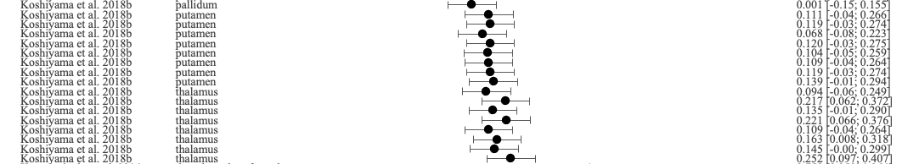
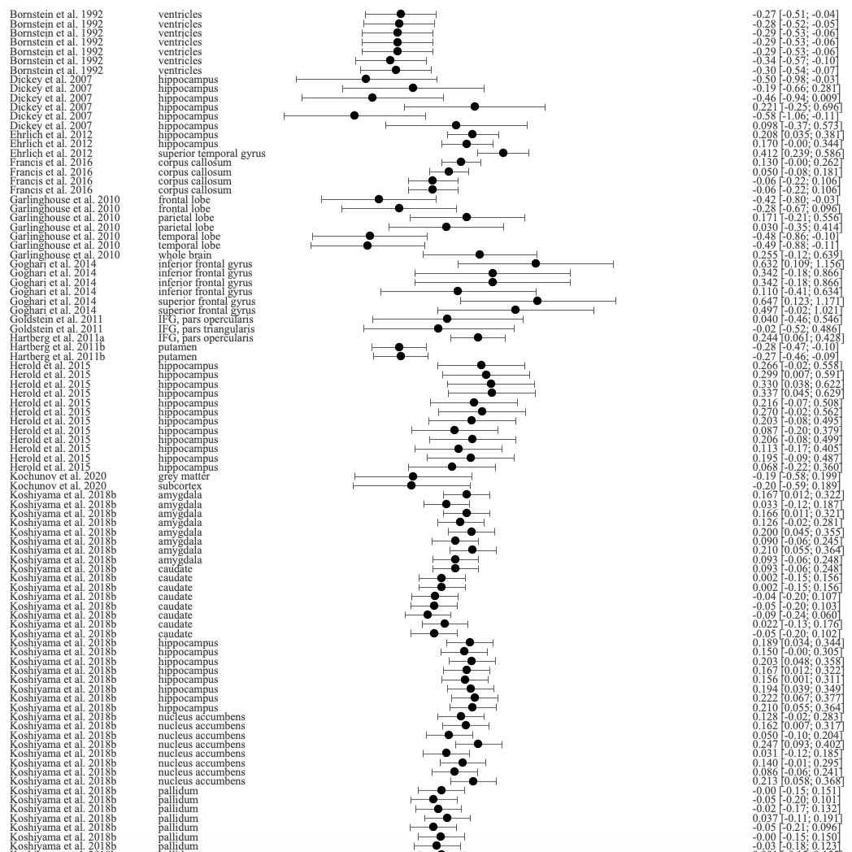
Fisher’s z [95% CI]

Brain region
Study

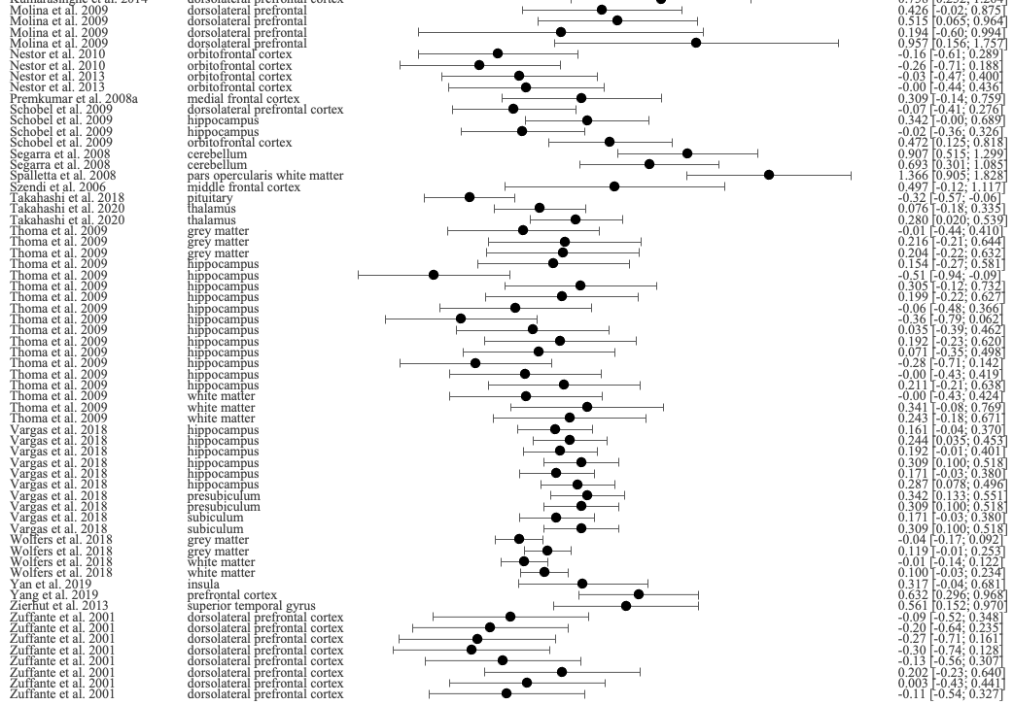
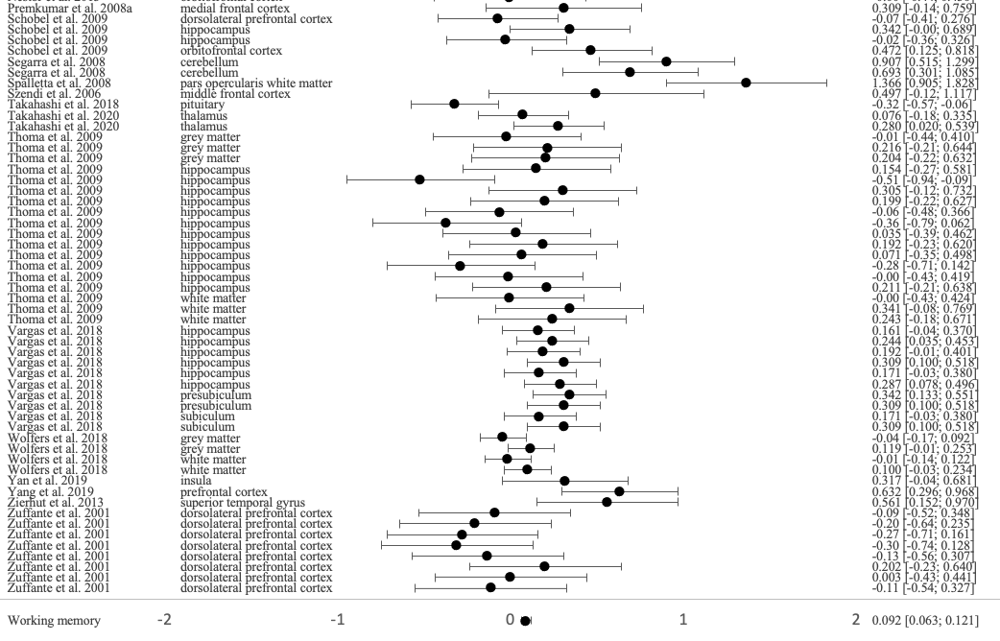
-1 0 1

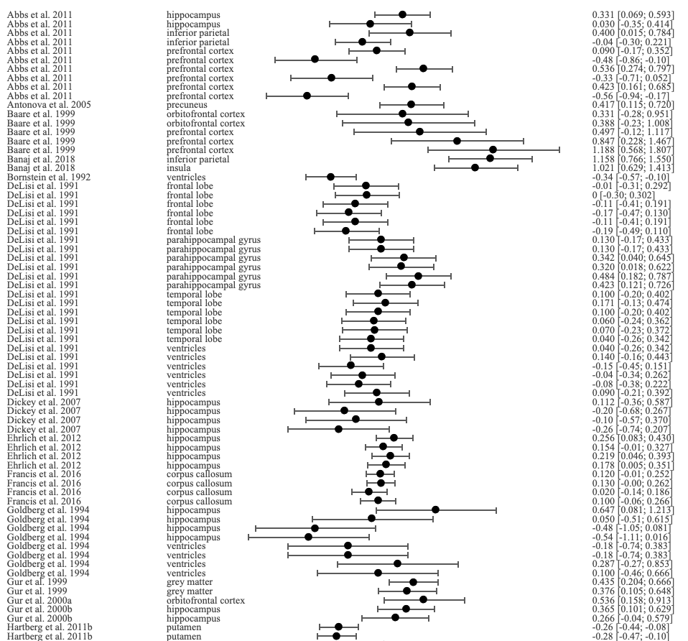
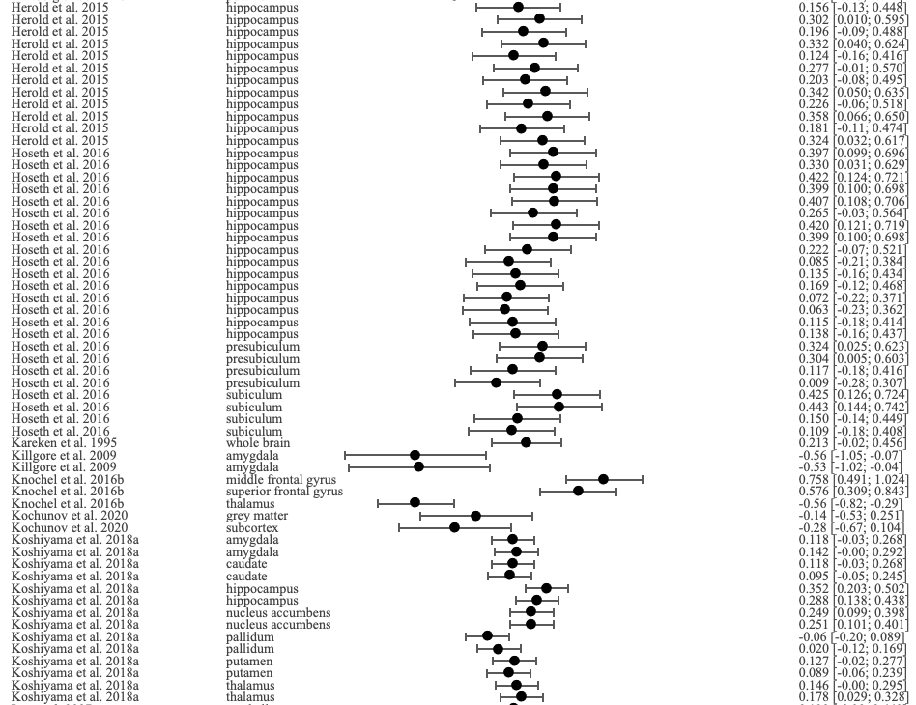
Figure S5. Forest plot of the correlation between verbal learning and memory and all brain structures reported in the included studies
Study
Brain region
Fisher’s z [95% CI]

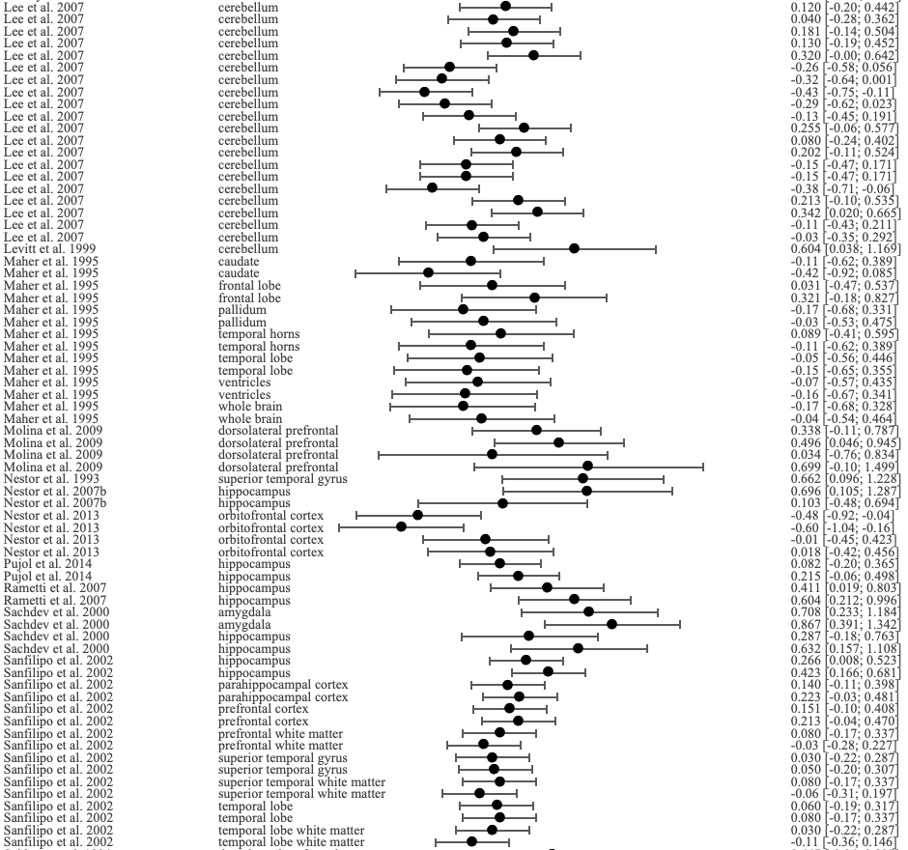
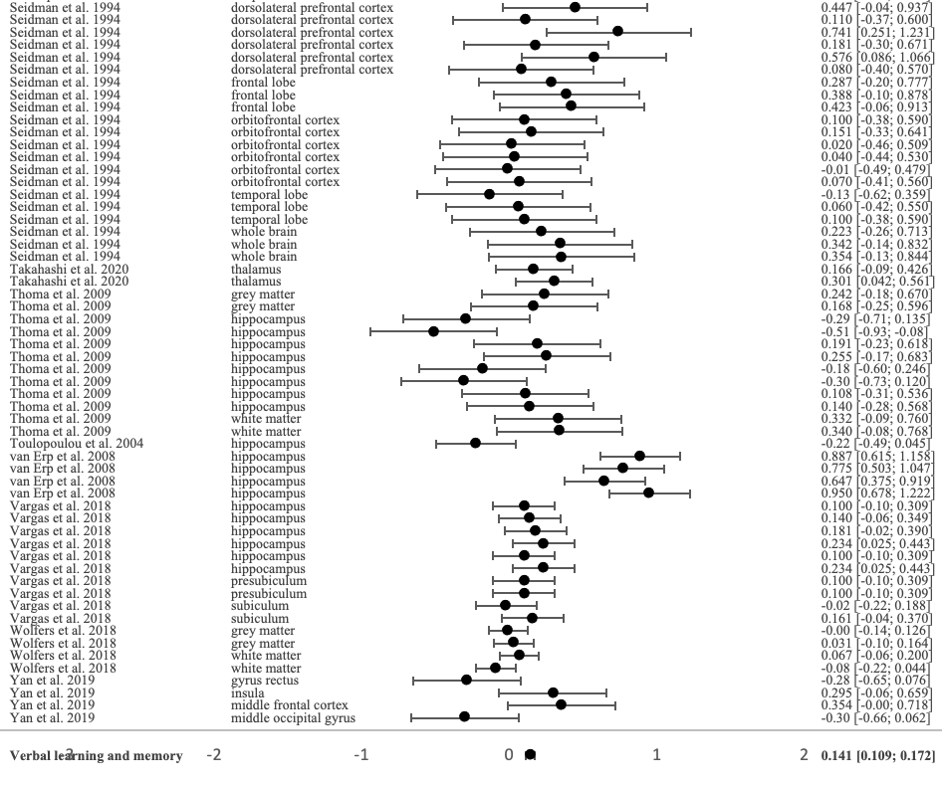
-1 0 1

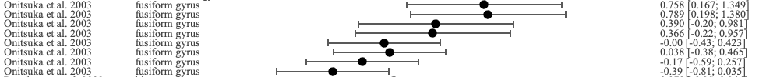
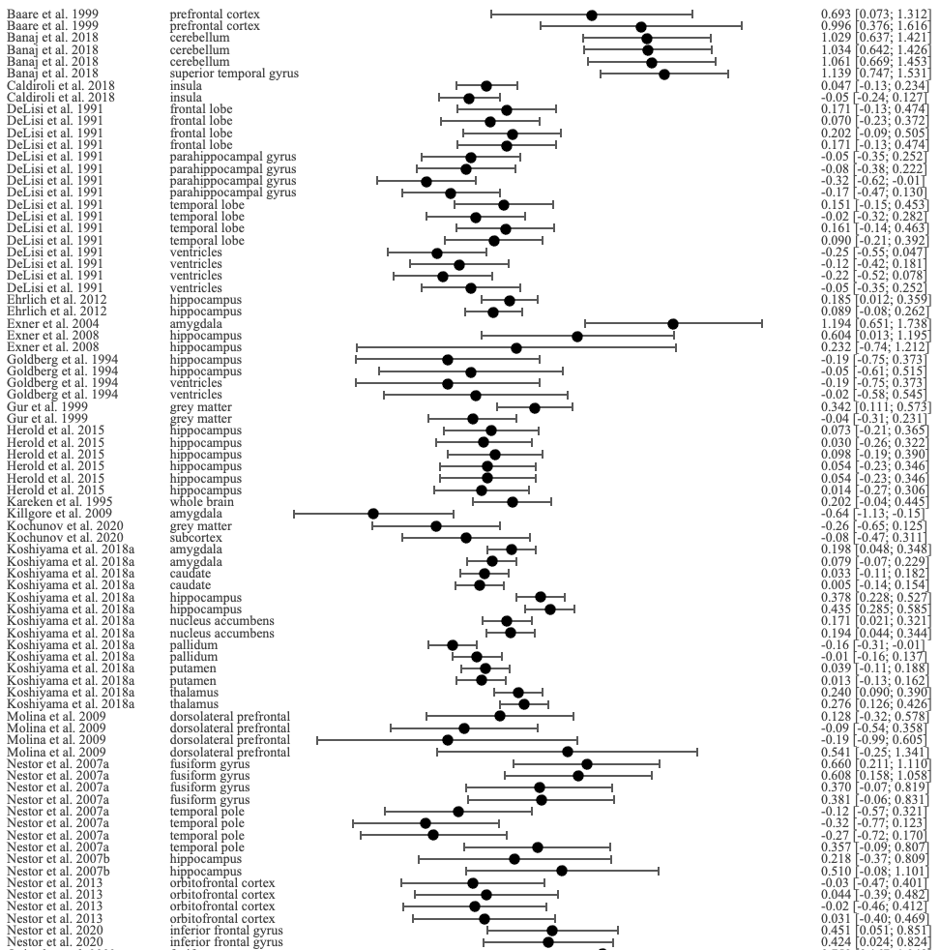
Figure S6. Forest plot of the correlation between visual learning and memory and all brain structures reported in the included studies
Fisher’s z [95% CI]

Brain region
Study

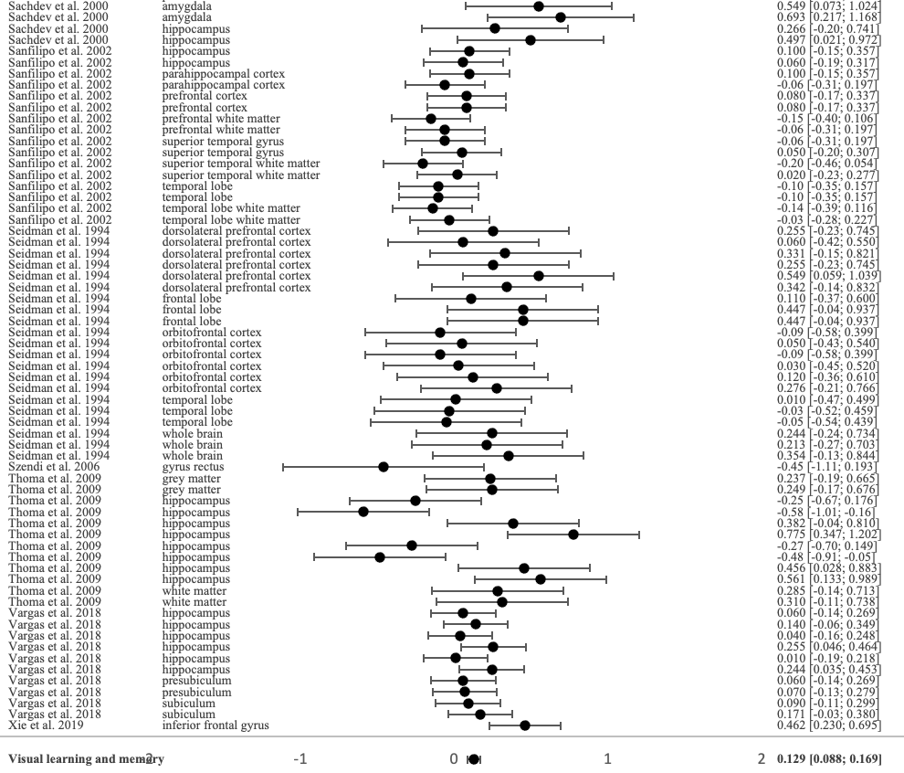
-1 0 1

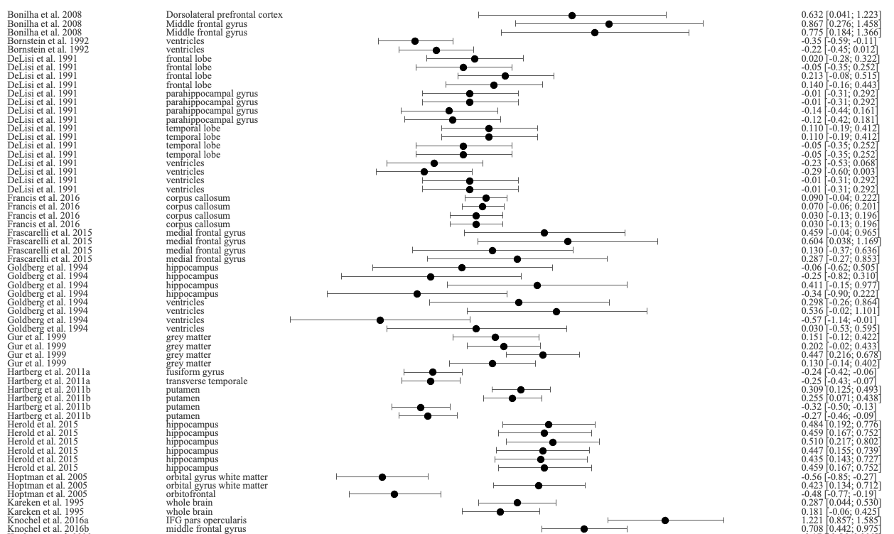
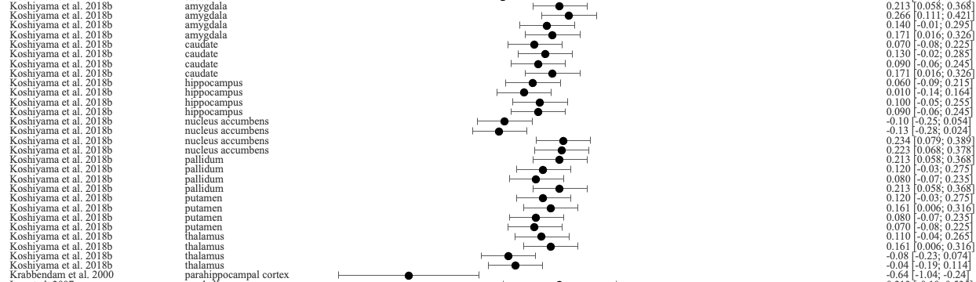
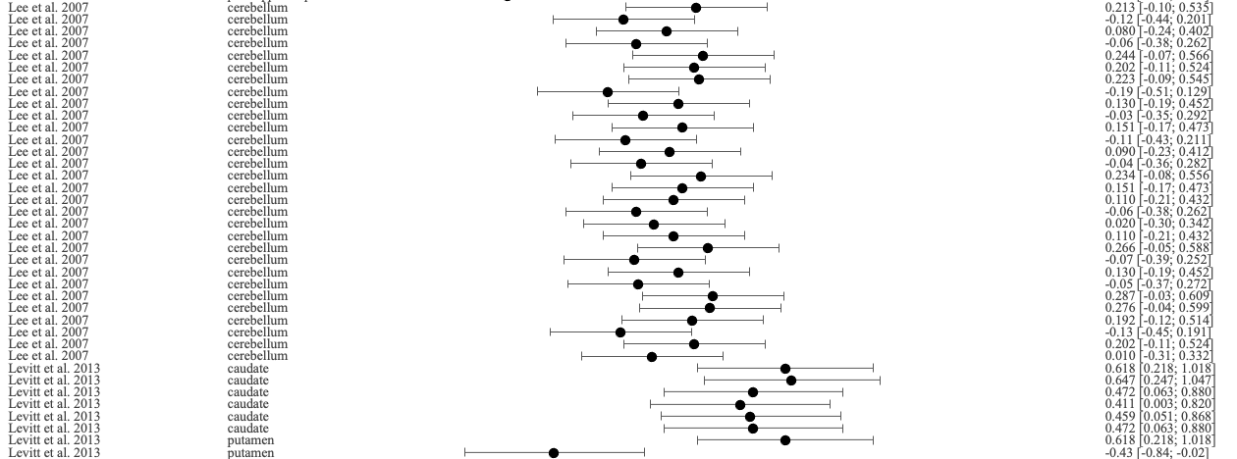
Figure S7. Forest plot of the correlation between reasoning and executive functions and all brain structures reported in the included studies
Study
Brain region
Fisher’s z [95% CI]

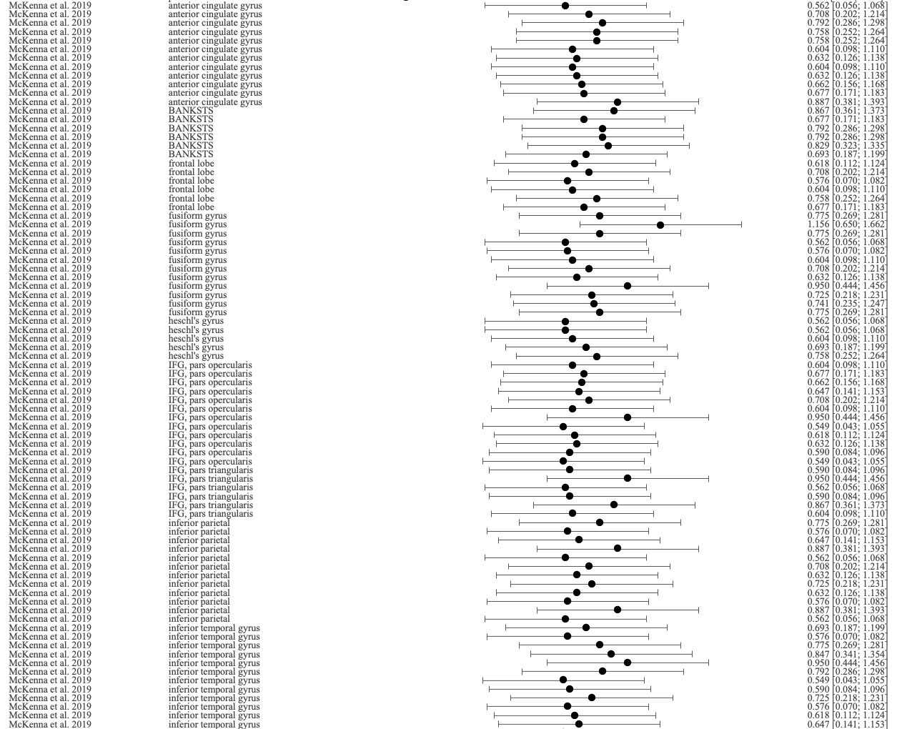
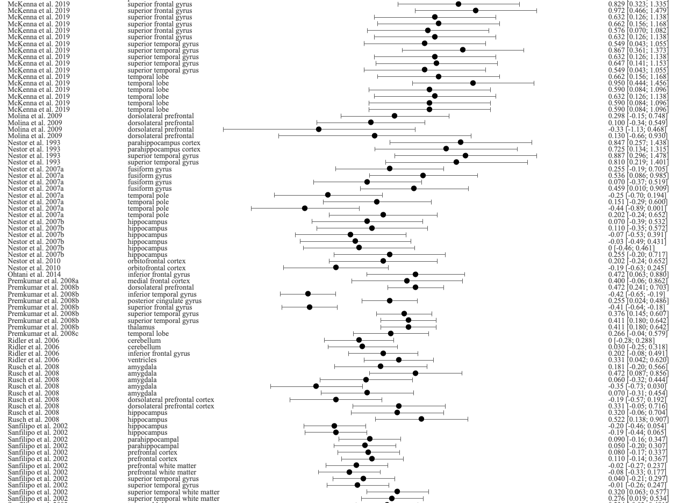
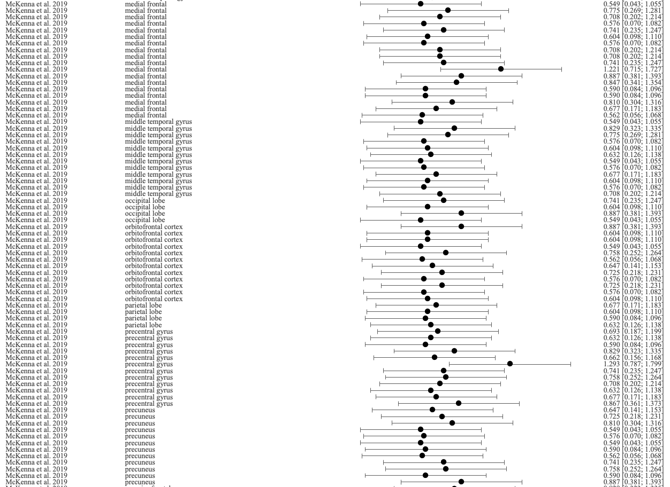

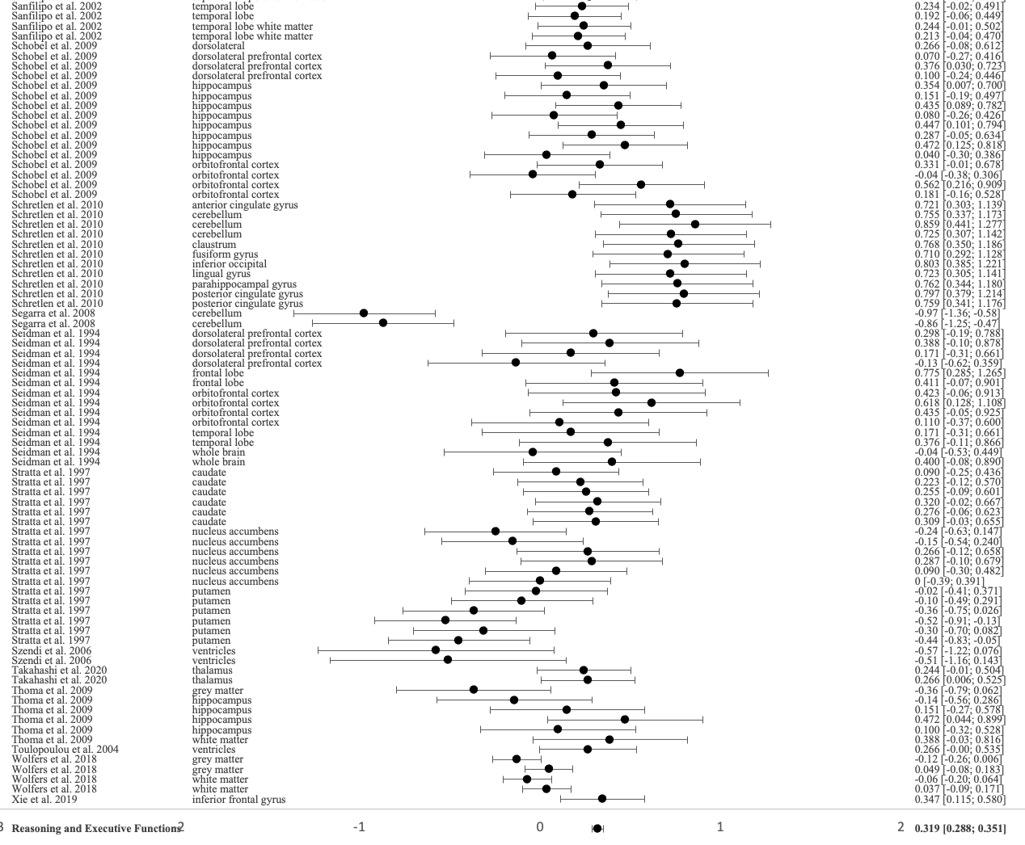
-1 0 1

Figure S8. Forest plot of the correlation between social cognition and all brain structures reported in the included studies
-1 0 1
Study
Brain region
Fisher’s z [95% CI]

Figure S9. Forest plot of the correlation between verbal fluency and all brain structures reported in the included studies
-1 0 1
Fisher’s z [95% CI]

Brain region
Study

Figure S10. Forest plot of the correlation between emotional processing tasks of social cognition and all brain structures reported in included studies
Study
Brain region
Fisher’s z [95% CI]

Figure S11. Forest plot of the correlation between theory of mind tasks of social cognition and all brain structures reported in included studies
Fisher’s z [95% CI]

Brain region
Study

Table S4. Values of effects, corrected with FDR, observed between the eight cognitive domains and the seven networks as well as brain regions categorized in the networks.
# | Network or  Brain structure | Cognitive Domain | S, C, N | Fisher’s z [95% CI] random model | p-value
DMN |  | SP | 2, 5, 135 | 0.508 [0.280; 0.737]  0.704 [0.346; 1.062]  0.423 [0.156; 0.690] | p < 0.001
4 | Inferior temporal gyrus |  | 1, 2, 18 |  | p < 0.001
8 | Temporal pole |  | 2, 3, 135 |  | p = 0.002
DMN |  | VM | 3, 4, 161  2, 3, 116  1, 1, 45 | 0.470 [-0.05; 0.946] | p = 0.052  p = 0.165  p = 0.007
3 | Inferior parietal lobule |  |  | 0.495 [-0.204; 1.194]  0.418 [0.115; 0.720]
7 | Precuneus
DMN |  | VisM | 1, 4, 22 | -0.094 [-0.400; 0.212]  -0.094 [-0.400; 0.212] | p = 0.548  p = 0.548
8 | Temporal Pole |  | 1, 4, 22
DMN |  | R&EF | 4, 69, 140  2, 13, 43  1, 12, 18  2, 13, 93  1, 12, 18  2, 3, 100  1, 12, 18  1, 4, 22 | 0.620 [0.542; 0.699]  0.694 [0.556; 0.832]  0.681 [0.535; 0.827]  0.593 [0.290; 0.897]  0.638 [0.492; 0.784]  0.571 [0.179; 0.963]  0.666 [0.520; 0.812]  0.330 [0.106; 0.555] | p < 0.001  p < 0.001  p < 0.001  p < 0.001  p < 0.001  p = 0.004  p < 0.001  p = 0.004
2 | Anterior cingulate gyrus
3 | Inferior parietal lobule
4 | Inferior temporal gyrus
5 | Middle temporal gyrus
6 | Posterior cingulate gyrus
7 | Precuneus
8 | Temporal pole
DMN |  | SC | 5, 31, 157  1, 1, 21  3, 18, 86  1, 1, 20  2, 5, 72  2, 5, 60  1, 1, 21 | 0.804 [0.356; 1.253]  0.880 [0.418; 1.342]  0.569 [0.372; 0.765]  0.523 [0.048; 0.998]  1.722 [0.134; 3.309]  0.592 [0.153; 1.032]  0.951 [0.489; 1.413] | p < 0.001  p < 0.001  p < 0.001  p = 0.031  p = 0.034  p = 0.008  p < 0.001
1 | Angular gyrus
2 | Anterior cingulate gyrus
34 | IFG, pars orbitalis
6 | Posterior cingulate gyrus
7 | Precuneus
8 | Temporal pole
DMN |  | VF | 2, 2, 50  1, 1, 18  1, 1, 32 | 0.447 [0.088; 0.806]  0.678 [0.172; 1.184]  0.302 [-0.062; 0.666] | p = 0.015  p = 0.009  p = 0.104
4 | Inferior temporal gyrus
7 | Precuneus
DAN |  | SP | 1, 1, 32  1, 1, 32 | 0.576 [0.212; 0.940]  0.576 [0.212; 0.940] | p = 0.002  p = 0.002
9 | IFG, pars opercularis
DAN |  | ATT | 1, 2, 51  1, 2, 51 | 0.352 [0.018; 0.687]  0.352 [0.018; 0.687] | p = 0.039  p = 0.039
9 | IFG, pars opercularis
DAN |  | WM | 2, 2, 135  2, 2, 135 | 0.221 [0.048; 0.394]  0.221 [0.048; 0.394] | p = 0.012  p = 0.012
9 | IFG, pars opercularis
DAN |  | R&EF | 2, 13, 50  2, 13, 50 | 0.729 [0.593; 0.864]  0.729 [0.593; 0.864] | p < 0.001  p < 0.001
9 | IFG, pars opercularis
DAN |  | SC | 2, 3, 41  2, 3, 41 | 0.929 [0.467; 1.391]  0.929 [0.467; 1.391] | p < 0.001  p < 0.001
10 | Superior parietal lobule
FPN |  | SP | 4, 7, 146  2, 5, 57  2, 2, 89 | 0.337 [0.106; 0.568]  0.017 [-0.199; 0.234]  0.616 [0.400; 0.831] | p = 0.004  p = 0.875  p < 0.001
11 | Dorsolateral prefrontal
15 | Middle frontal gyrus
FPN |  | ATT | 3, 10, 92  2, 6, 41  1, 2, 51  1, 2, 51 | 0.123 [-0.061; 0.307]  -0.114 [-0.386; 0.158]  0.288 [0.088; 0.488]  0.326 [0.126; 0.526] | p = 0.190  p = 0.411  p = 0.005  p = 0.001
11 | Dorsolateral prefrontal
13 | IFG, pars triangularis
15 | Middle frontal gyrus
FPN |  | WM | 8, 21, 168  4, 14, 98  1, 4, 17  1, 1, 18  1, 1, 22  1, 1, 13 | 0.154 [0.012; 0.295]  0.088 [-0.094; 0.271]  0.357 [0.095; 0.619]  -0.020 [-0.526; 0.486]  0.310 [-0.140; 0.759]  0.497 [-0.122; 1.117] | p = 0.034  p = 0.344  p = 0.008  p = 0.938  p = 0.177  p = 0.116
11 | Dorsolateral prefrontal
12 | Inferior frontal gyrus
13 | IFG, pars triangularis
14 | Medial frontal gyrus
15 | Middle frontal gyrus
FPN |  | VM | 4, 12, 130  2, 10, 41  2, 2, 89 | 0.440 [0.290; 0.590]  0.373 [0.211; 0.535]  0.576 [0.182; 0.970] | p < 0.001  p < 0.001  p = 0.005
11 | Dorsolateral prefrontal
 | Middle frontal gyrus
FPN |  | VisM | 4, 13, 142  2, 10, 41  2, 3, 101 | 0.322 [0.202; 0.443]  0.216 [0.054; 0.378]  0.465 [0.286; 0.645] | p < 0.001  p = 0.009  p < 0.001
11 | Dorsolateral prefrontal
12 | Inferior frontal gyrus
FPN |  | R&EF | 13, 51, 472  6, 16, 194  3, 3, 149  1, 6, 18  4, 23, 86  1, 3, 57 | 0.411 [0.298; 0.523]  0.240 [0.105; 0.375]  0.113 [-0.141; 0.368]  0.694 [0.556; 0.832]  0.643 [0.537; 0.749]  0.741 [0.517; 0.966] | p < 0.001  p < 0.001  p = 0.383  p < 0.001  p < 0.001  p < 0.001
11 | Dorsolateral prefrontal
12 | Inferior frontal gyrus
13 | IFG, pars triangularis
14 | Medial frontal gyrus
15 | Middle frontal gyrus
FPN |  | SC | 5, 15, 266  1, 2, 20  2, 3, 205  2, 3, 187  3, 7, 80 | 0.411 [0.237; 0.585]  0.219 [-0.118; 0.555]  0.157 [0.029; 0.284]  0.640 [0.056; 1.224]  0.543 [0.178; 0.908] | p < 0.001  p = 0.203  p = 0.016  p = 0.032  p = 0.004
11 | Dorsolateral prefrontal
12 | Inferior frontal gyrus
13 | IFG, pars triangularis
14 | Medial frontal gyrus
LIM |  | SP | 5, 9, 159  1, 2, 18  3, 5, 80  1, 2, 61 | 0.013 [-0.151; 0.177]  0.563 [0.205; 0.921]  -0.041 [-0.236; 0.155]  -0.085 [-0.267; 0.097] | p = 0.879  p = 0.002  p = 0.684  p = 0.359
16 | Entorhinal cortex
17 | Orbitofrontal cortex
18 | Parahippocampal cortex
LIM |  | ATT | 3, 5, 119  3, 5, 119 | 0.150 [-0.272; 0.573]  0.150 [-0.272; 0.573] | p = 0.486  p = 0.486
17 | Orbitofrontal cortex
LIM |  | WM | 3, 5, 80  3, 5, 80 | 0.025 [-0.252; 0.301]  0.025 [-0.252; 0.301] | p = 0.862  p = 0.862
17 | Orbitofrontal cortex
LIM |  | VM | 7, 22, 223  1, 1, 32  4, 13, 85  2, 8, 106 | 0.129 [0.012; 0.245]  -0.288 [-0.652; 0.076]  0.029 [-0.155; 0.212]  0.267 [0.165; 0.369] | p = 0.031  p = 0.121  p = 0.759  p < 0.001
35 | Gyrus rectus
17 | Orbitofrontal cortex
18 | Parahippocampal cortex
LIM |  | VisM | 5, 17, 160  1, 1, 12  2, 10, 42  2, 6, 106 | -0.049 [-0.139; 0.042]  -0.460 [-1.113; 0.193]  0.028 [-0.119; 0.176]  -0.084 [-0.200; 0.032] | p = 0.289  p = 0.168  p = 0.707  p = 0.158
35 | Gyrus rectus
17 | Orbitofrontal cortex
18 | Parahippocampal cortex
LIM |  | R&EF | 10, 33, 338  5, 23, 166  5, 10, 172 | 0.365 [0.216; 0.513]  0.423 [0.269; 0.577]  0.110 [-0.113; 0.334] | p < 0.001  p < 0.001  p = 0.333
17 | Orbitofrontal cortex
18 | Parahippocampal cortex
LIM |  | SC | 2, 8, 72  2, 2, 21  1, 6, 51 | 1.892 [0.547; 3.236]  0.912 [0.585; 1.239]  2.215 [0.585; 3.845] | p = 0.006  p < 0.001  p = 0.007
17 | Orbitofrontal cortex
18 | Parahippocampal cortex
LIM |  | VF | 2, 4, 106  2, 4, 106 | -0.119 [-0.257; 0.020]  -0.119 [-0.257; 0.020] | p = 0.093  p = 0.093
18 | Parahippocampal cortex
SOM |  | SP | 2, 3, 178  1, 1, 117  1, 2, 61 | 0.010 [-0.301; 0.321]  0.288 [0.104; 0.471]  -0.111 [-0.293; 0.071] | p = 0.951  p = 0.002  p = 0.234
20 | Heschl’s gyrus
23 | Superior temporal gyrus
SOM |  | ATT | 1, 6, 51  1, 2, 51  1, 4, 51 | 0.358 [0.205; 0.511]  0.551 [0.351; 0.751]  0.365 [0.165; 0.566] | p < 0.001  p < 0.001  p < 0.001
20 | Heschl’s gyrus
21 | Planum temporale
SOM |  | WM | 2, 2, 157  2, 2, 157 | 0.436 [0.276; 0.595]  0.436 [0.276; 0.595] | p < 0.001  p < 0.001
23 | Superior temporal gyrus
SOM |  | VM | 2, 3, 76  2, 3, 76 | 0.147 [-0.127; 0.421]  0.147 [-0.127; 0.421] | p = 0.292  p = 0.292
23 | Superior temporal gyrus
SOM |  | VisM | 2, 3, 89  2, 3, 89 | 0.358 [-0.271; 0.987]  0.358 [-0.271; 0.987] | p = 0.264  p = 0.264
23 | Superior temporal gyrus
SOM |  | R&EF | 6, 34, 310  1, 1, 25  2, 6, 135  2, 3, 43  1, 12, 18  4, 12, 168 | 0.537 [0.384; 0.690]  0.769 [0.351; 1.186]  0.636 [0.410; 0.863]  0.123 [-0.665; 0.911]  0.757 [0.611; 0.903]  0.455 [0.263; 0.647] | p < 0.001  p < 0.001  p < 0.001  p = 0.759  p < 0.001
19 | Claustrum
20 | Heschl’s gyrus
21 | Planum temporale
22 | Precentral gyrus
23 | Superior temporal gyrus
SOM |  | SC | 2, 11, 60  1, 3, 21  1, 2, 21  2, 6, 60 | 0.784 [0.545; 1.024]  0.935 [0.669; 1.202]  0.963 [0.637; 1.290]  0.667 [0.292; 1.043] | p < 0.001  p < 0.001  p < 0.001  p < 0.001
22 | Precentral gyrus
23 | Superior temporal gyrus
24 | Supplementary motor area
SOM |  | VF | 2, 4, 80  2, 4, 80 | 0.130 [-0.209; 0.470]  0.130 [-0.209; 0.470] | p = 0.452  p = 0.452
23 | Superior temporal gyrus
VAN |  | SP | 1, 1, 32  1, 1, 32 | 0.352 [-0.012; 0.716]  0.352 [-0.012; 0.716] | p = 0.058  p = 0.058
26 | Insula
VAN |  | WM | 2, 3, 49  1, 1, 32  1, 2, 17 | 0.443 [0.183; 0.702]  0.317 [-0.047; 0.681]  0.572 [0.202; 0.943] | p < 0.001  p = 0.088  p = 0.002
26 | Insula
28 | Superior frontal gyrus
VAN |  | VM | 3, 3, 117  2, 2, 60  1, 1, 57 | 0.622 [0.253; 0.992]  0.654 [-0.057; 1.366]  0.576 [0.310; 0.843] | p < 0.001  p = 0.071  p < 0.001
26 | Insula
28 | Superior frontal gyrus
VAN |  | VisM | 1, 2, 113  1, 2, 113 | -0.006 [-0.138; 0.126]  -0.006 [-0.138; 0.126] | p = 0.927  p = 0.927
26 | Insula
VAN |  | R&EF | 2, 13, 93  1, 6, 18  3, 7, 142 | 0.604 [0.511; 0.697]  0.775 [0.569; 0.982]  0.538 [0.046; 1.031] | p < 0.001  p < 0.001  p = 0.032
25 | BANKSTS
28 | Superior frontal gyrus
VAN |  | SC | 4, 41, 193  3, 29, 173  1, 3, 21  1, 7, 21  1, 2, 39 | 0.315 [0.214; 0.415]  0.142 [0.060; 0.225]  1.131 [0.658; 1.605]  0.964 [0.790; 1.139]  0.090 [-0.141; 0.321] | p < 0.001  p < 0.001  p < 0.001  p < 0.001  p = 0.443
26 | Insula
27 | Middle cingulate gyrus
28 | Superior frontal gyrus
36 | Temporoparietal junction
VAN |  | VF | 1, 1, 26  1, 1, 26 | 0.151 [-0.258; 0.560]  0.151 [-0.258; 0.560] | p = 0.469  p = 0.469
28 | Superior frontal gyrus
VIS |  | SP | 1, 1, 32  1, 1, 32 | 0.535 [0.171; 0.899]  0.535 [0.171; 0.899] | p = 0.004  p = 0.004
29 | Calcarine cortex
VIS |  | VM | 1, 1, 32  1, 1, 32 | -0.302 [-0.666; 0.062]  -0.302 [-0.666; 0.062] | p = 0.104  p = 0.104
33 | Middle occipital gyrus
VIS |  | VisM | 2, 12, 60  2, 12, 60 | 0.291 [0.072; 0.509]  0.291 [0.072; 0.509] | p = 0.009  p = 0.009
30 | Fusiform gyrus
VIS |  | R&EF | 4, 24, 182  4, 18, 182  1, 1, 25  1, 1, 25  1, 4, 18 | 0.592 [0.448; 0.734]  0.490 [0.241; 0.738]  0.723 [0.306; 1.141]  0.803 [0.385; 1.221]  0.695 [0.189; 1.202] | p < 0.001  p < 0.001  p < 0.001  p < 0.001  p = 0.014
30 | Fusiform gyrus
32 | Lingual gyrus
31 | Inferior occipital
 | Occipital Lobe
VIS |  | SC | 1, 3, 21  1, 3, 21 | 0.914 [0.648; 1.181]  0.914 [0.648; 1.181] | p < 0.001  p < 0.001
33 | Middle occipital gyrus
Significant results after FDR correction are in Figure 3A for networks and 3B for brain areas.
Both significant (color) and nonsignificant (grey) results are visualized in Figure S12A for networks and S12B for brain regions.
S: number of studies; C: number of correlations; N: sample size

Table S5. Values of effects, corrected with FDR, observed between the eight cognitive domains and the three structures selected.
Structure | Cognitive Domain | S, C, N | Fisher’s z [95% CI] random model | p-value
Amygdala | SP | 1, 6, 163 | 0.204 [0.141; 0.267] | p < 0.001
 | ATT | 1, 2, 174 | 0.100 [-0.006; 0.206] | p = 0.065
 | WM | 1, 8, 163 | 0.136 [0.081; 0.191] | p < 0.001
 | VM | 3, 6, 213 | 0.129 [-0.161; 0.419] | p = 0.384
 | VisM | 3, 6, 213 | 0.307 [0.000; 0.614] | p = 0.050
 | R&EF | 2, 9, 192 | 0.169 [0.075; 0.263] | p < 0.001
 | SC | 2, 4, 36 | 0.596 [0.351; 0.841] | p < 0.001
Hippocampus | SP | 7, 22, 346 | 0.130 [0.080; 0.180] | p < 0.001
 | ATT | 3, 14, 213 | -0.015 [-0.161; 0.131] | p = 0.841
 | WM | 7, 48, 512 | 0.159 [0.115; 0.202] | p < 0.001
 | VM | 17, 75, 967 | 0.234 [0.181; 0.287] | p < 0.001
 | VisM | 11, 35, 653 | 0.141 [0.063; 0.219] | p < 0.001
 | R&EF | 8, 36, 396 | 0.190 [0.111; 0.268] | p < 0.001
 | SC | 1, 1, 21 | 1.263 [0.801; 1.725] | p < 0.001
 | VF | 3, 5, 128 | -0.134 [-0.276; 0.009] | p = 0.066
Cerebellum | ATT | 1, 20, 40 | 0.109 [0.030; 0.188] | p = 0.07
 | WM | 1, 2, 28 | 0.800 [0.141; 1.078] | p < 0.001
 | VM | 2, 21, 55 | -0.004 [-0.112; 0.105] | p = 0.948
 | VisM | 1, 3, 28 | 1.042 [0.816; 1.268] | p < 0.001
 | R&EF | 4, 37, 142 | 0.078 [-0.015; 0.170] | p = 0.099
 | VF | 1, 30, 40 | 0.201 [0.135; 0.267] | p < 0.001

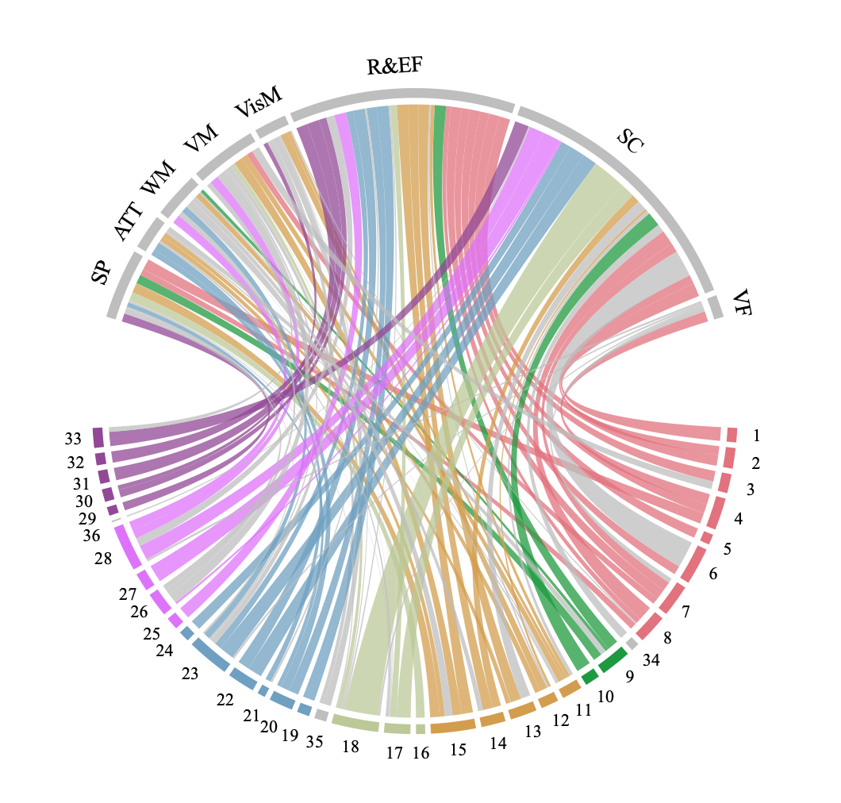
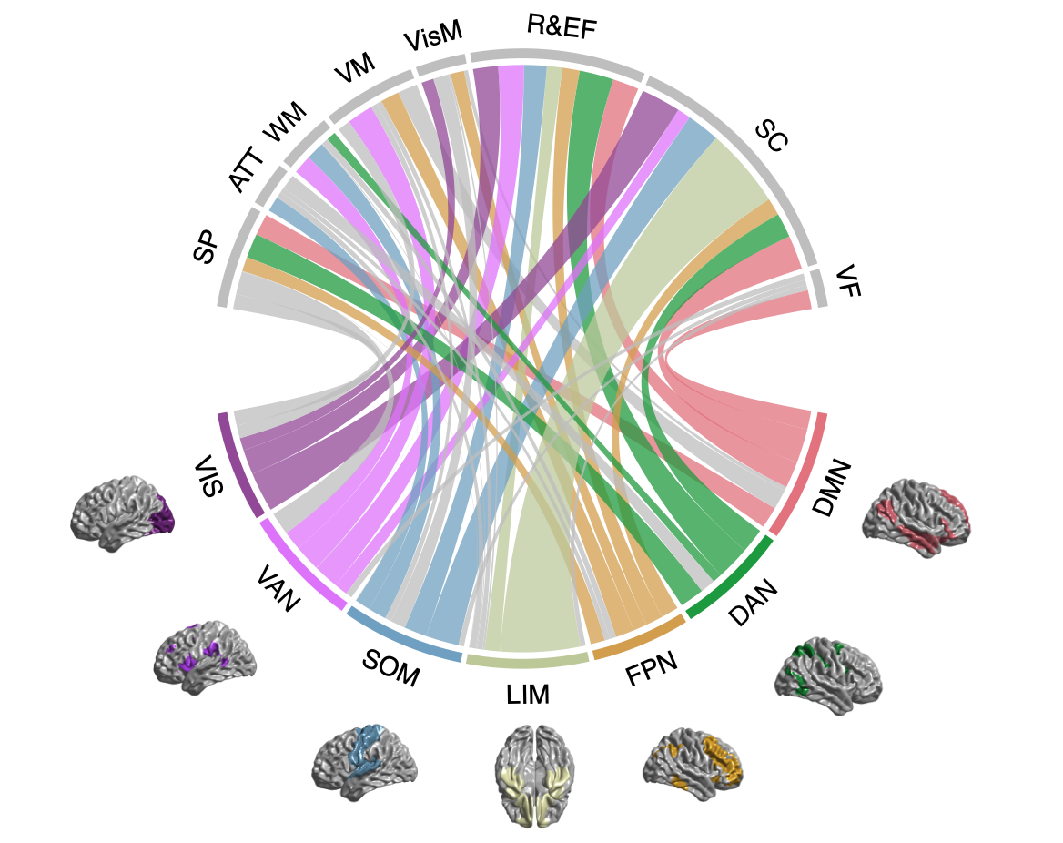
Figure S12. A) Circle plot of the FDR significant correlations between the seven brain networks and the eight cognitive domains. B) Circle plot of the correlations between the brain regions categorized in the seven brain networks and the eight cognitive domains.
B)
A)
The thickness of the link is proportional to the correlation strength. The colors of the brain regions correspond to the respective network. The grey links are nonsignificant with FDR. The legend and the values of the effect are in Table S4.

References of Included articles
Abbs, B., Liang, L., Makris, N., Tsuang, M., Seidman, L. J., & Goldstein, J. M. (2011). Covariance modeling of MRI brain volumes in memory circuitry in schizophrenia: Sex differences are critical. NeuroImage, 56(4), 1865-1874. doi:http://dx.doi.org/10.1016/j.neuroimage.2011.03.079
Antoniades, M., Schoeler, T., Radua, J., Valli, I., Allen, P., Kempton, M. J., & McGuire, P. (2018). Verbal learning and hippocampal dysfunction in schizophrenia: A meta-analysis. Neuroscience and Biobehavioral Reviews, 86, 166-175. doi:http://dx.doi.org/10.1016/j.neubiorev.2017.12.001
Antonova, E., Kumari, V., Morris, R., Halari, R., Anilkumar, A., Mehrotra, R., & Sharma, T. (2005). The relationship of structural alterations to cognitive deficits in schizophrenia: A voxel-based morphometry study. Biological Psychiatry, 58(6), 457-467. doi:http://dx.doi.org/10.1016/j.biopsych.2005.04.036
Antonova, E., Sharma, T., Morris, R., & Kumari, V. (2004). The relationship between brain structure and neurocognition in schizophrenia: A selective review. Schizophrenia Research, 70(2-3), 117-145. doi:http://dx.doi.org/10.1016/j.schres.2003.12.002
Baare, W. F., Hulshoff Pol, H. E., Hijman, R., Mali, W. P., Viergever, M. A., & Kahn, R. S. (1999). Volumetric analysis of frontal lobe regions in schizophrenia: relation to cognitive function and symptomatology. Biological Psychiatry, 45(12), 1597-1605. doi:10.1016/s0006-3223(98)00266-2
Banaj, N., Piras, F., Ciullo, V., Iorio, M., Battaglia, C., Pantoli, D., . . . Spalletta, G. (2018). Cognitive and psychopathology correlates of brain white/grey matter structure in severely psychotic schizophrenic inpatients. Schizophrenia Research: Cognition, 12, 29-36. doi:http://dx.doi.org/10.1016/j.scog.2018.02.001
Bonilha, L., Molnar, C., Horner, M. D., Anderson, B., Forster, L., George, M. S., & Nahas, Z. (2008). Neurocognitive deficits and prefrontal cortical atrophy in patients with schizophrenia. Schizophrenia Research, 101(1-3), 142-151. doi:http://dx.doi.org/10.1016/j.schres.2007.11.023
Bornstein, R. A., Schwarzkopf, S. B., Olson, S. C., & Nasrallah, H. A. (1992). Third-ventricle enlargement and neuropsychological deficit in schizophrenia. Biological Psychiatry, 31(9), 954-961. doi:http://dx.doi.org/10.1016/0006-3223%2892%2990121-F
Caldiroli, A., Buoli, M., van Haren, N. E. M., de Nijs, J., Altamura, A. C., & Cahn, W. (2018). The relationship of IQ and emotional processing with insula volume in schizophrenia. Schizophrenia Research, 202, 141-148. doi:https://doi.org/10.1016/j.schres.2018.06.048
Crespo-Facorro, B., Barbadillo, L., Pelayo-Teran, J. M., & Rodriguez-Sanchez, J. M. (2007). Neuropsychological functioning and brain structure in schizophrenia. International Review of Psychiatry, 19(4), 325-336. doi:http://dx.doi.org/10.1080/09540260701486647
DeLisi, L. E., Hoff, A. L., Schwartz, J. E., Shields, G. W., Halthore, S. N., Gupta, S. M., . . . Anand, A. K. (1991). Brain morphology in first-episode schizophrenic-like psychotic patients: A quantitative magnetic resonance imaging study. Biological Psychiatry, 29(2), 159-175. doi:http://dx.doi.org/10.1016/0006-3223%2891%2990044-M
Dickey, C. C., McCarley, R. W., Xu, M. L., Seidman, L. J., Voglmaier, M. M., Niznikiewicz, M. A., . . . Shenton, M. E. (2007). MRI abnormalities of the hippocampus and cavum septi pellucidi in females with schizotypal personality disorder. Schizophrenia Research, 89(1-3), 49-58. doi:http://dx.doi.org/10.1016/j.schres.2006.08.004
Edgar, J. C., Hunter, M. A., Huang, M., Smith, A. K., Chen, Y., Sadek, J., . . . Canive, J. M. (2012). Temporal and frontal cortical thickness associations with M100 auditory activity and attention in healthy controls and individuals with schizophrenia. Schizophrenia Research, 140(1-3), 250-257. doi:http://dx.doi.org/10.1016/j.schres.2012.06.009
Ehrlich, S., Brauns, S., Yendiki, A., Ho, B. C., Calhoun, V., Charles Schulz, S., . . . Sponheim, S. R. (2012). Associations of cortical thickness and cognition in patients with schizophrenia and healthy controls. Schizophrenia Bulletin, 38(5), 1050-1062. doi:http://dx.doi.org/10.1093/schbul/sbr018
Exner, C., Boucsein, K., Degner, D., Irle, E., & Weniger, G. (2004). Impaired emotional learning and reduced amygdala size in schizophrenia: a 3-month follow-up. Schizophrenia Research, 71(2), 493-503. doi:https://doi.org/10.1016/j.schres.2004.02.023
Exner, C., Nehrkorn, B., Martin, V., Huber, M., Shiratori, K., & Rief, W. (2008). Sex-dependent hippocampal volume reductions in schizophrenia relate to episodic memory deficits. Journal of Neuropsychiatry and Clinical Neurosciences, 20(2), 227-230. doi:http://dx.doi.org/10.1176/jnp.2008.20.2.227
Francis, A. N., Mothi, S. S., Mathew, I. T., Tandon, N., Clementz, B., Pearlson, G. D., . . . Keshavan, M. S. (2016). Callosal Abnormalities Across the Psychosis Dimension: Bipolar Schizophrenia Network on Intermediate Phenotypes. Biological Psychiatry, 80(8), 627-635. doi:http://dx.doi.org/10.1016/j.biopsych.2015.12.026
Frascarelli, M., Tognin, S., Mirigliani, A., Parente, F., Buzzanca, A., Torti, M. C., . . . Fusar-Poli, P. (2015). Medial frontal gyrus alterations in schizophrenia: Relationship with duration of illness and executive dysfunction. Psychiatry Research: Neuroimaging, 231(2), 103-110. doi:https://doi.org/10.1016/j.pscychresns.2014.10.017
Fujiwara, H., Hirao, K., Namiki, C., Yamada, M., Shimizu, M., Fukuyama, H., . . . Murai, T. (2007). Anterior cingulate pathology and social cognition in schizophrenia: A study of gray matter, white matter and sulcal morphometry. NeuroImage, 36(4), 1236-1245. doi:https://doi.org/10.1016/j.neuroimage.2007.03.068
Fujiwara, H., Yassin, W., & Murai, T. (2015). Neuroimaging studies of social cognition in schizophrenia. Psychiatry and Clinical Neurosciences, 69(5), 259-267. doi:http://dx.doi.org/10.1111/pcn.12258
Garlinghouse, M. A., Roth, R. M., Isquith, P. K., Flashman, L. A., & Saykin, A. J. (2010). Subjective rating of working memory is associated with frontal lobe volume in schizophrenia. Schizophrenia Research, 120(1-3), 71-75. doi:http://dx.doi.org/10.1016/j.schres.2010.02.1067
Goghari, V. M., MacDonald, A. W., & Sponheim, S. R. (2014). Relationship between prefrontal gray matter volumes and working memory performance in schizophrenia: A family study. Schizophrenia Research, 153(1-3), 113-121. doi:http://dx.doi.org/10.1016/j.schres.2014.01.032
Goldberg, T. E., Torrey, E. F., Berman, K. F., & Weinberger, D. R. (1994). Relations between neuropsychological performance and brain morphological and physiological measures in monozygotic twins discordant for schizophrenia. Psychiatry Research: Neuroimaging, 55(1), 51-61. doi:https://doi.org/10.1016/0925-4927(94)90011-6
Goldstein, K. E., Hazlett, E. A., Savage, K. R., Berlin, H. A., Hamilton, H. K., Zelmanova, Y., . . . New, A. S. (2011). Dorso- and ventro-lateral prefrontal volume and spatial working memory in schizotypal personality disorder. Behavioural Brain Research, 218(2), 335-340. doi:http://dx.doi.org/10.1016/j.bbr.2010.11.042
Gur, R. C., Ragland, J. D., & Gur, R. E. (1997). Cognitive changes in schizophrenia - A critical look. International Review of Psychiatry, 9(4), 449-458. Retrieved from http://www.tandfonline.com/loi/iirp20
http://ovidsp.ovid.com/ovidweb.cgi?T=JS&PAGE=reference&D=emexa&NEWS=N&AN=27499500
Gur, R. E., Cowell, P. E., Latshaw, A., Turetsky, B. I., Grossman, R. I., Arnold, S. E., . . . Gur, R. C. (2000). Reduced dorsal and orbital prefrontal gray matter volumes in schizophrenia. Archives of General Psychiatry, 57(8), 761-768. doi:http://dx.doi.org/10.1001/archpsyc.57.8.761
Gur, R. E., Cowell, P. E., Turetsky, B. I., Gallacher, F., Cannon, T., Bilker, W. B., & Gur, R. C. (1998). A Follow-up Magnetic Resonance Imaging Study of Schizophrenia: Relationship of Neuroanatomical Changes to Clinical and Neurobehavioral Measures. Archives of General Psychiatry, 55(2), 145-152. doi:10.1001/archpsyc.55.2.145
Gur, R. E., Turetsky, B. I., Bilker, W. B., & Gur, R. C. (1999). Reduced gray matter volume in schizophrenia. Archives of General Psychiatry, 56(10), 905-911. doi:http://dx.doi.org/10.1001/archpsyc.56.10.905
Gur, R. E., Turetsky, B. I., Cowell, P. E., Finkelman, C., Maany, V., Grossman, R. I., . . . Gur, R. C. (2000). Temporolimbic Volume Reductions in Schizophrenia. Archives of General Psychiatry, 57(8), 769-775. doi:10.1001/archpsyc.57.8.769
Habets, P., Krabbendam, L., Hofman, P., Suckling, J., Oderwald, F., Bullmore, E., . . . Marcelis, M. (2008). Cognitive performance and grey matter density in psychosis: Functional relevance of a structural endophenotype. Neuropsychobiology, 58(3-4), 128-137. doi:http://dx.doi.org/10.1159/000182889
Hanford, L. C., Pinnock, F., Hall, G. B., & Heinrichs, R. W. (2019). Cortical thickness correlates of cognitive performance in cognitively-matched individuals with and without schizophrenia. Brain and Cognition, 132, 129-137. doi:http://dx.doi.org/10.1016/j.bandc.2019.04.003
Hartberg, C. B., Sundet, K., Rimol, L. M., Haukvik, U. K., Lange, E. H., Nesvag, R., . . . Agartz, I. (2011). Brain cortical thickness and surface area correlates of neurocognitive performance in patients with schizophrenia, bipolar disorder, and healthy adults. Journal of the International Neuropsychological Society, 17(6), 1080-1093. doi:http://dx.doi.org/10.1017/S1355617711001081
Hartberg, C. B., Sundet, K., Rimol, L. M., Haukvik, U. K., Lange, E. H., Nesvag, R., . . . Agartz, I. (2011). Subcortical brain volumes relate to neurocognition in schizophrenia and bipolar disorder and healthy controls. Progress in Neuro-Psychopharmacology and Biological Psychiatry, 35(4), 1122-1130. doi:http://dx.doi.org/10.1016/j.pnpbp.2011.03.014
Herold, C. J., Lasser, M. M., Schmid, L. A., Seidl, U., Kong, L., Fellhauer, I., . . . Schroder, J. (2015). Neuropsychology, autobiographical memory and hippocampal volume in "younger" and "older" patients with chronic schizophrenia. Frontiers in Psychiatry, 6(MAR), 53. doi:http://dx.doi.org/10.3389/fpsyt.2015.00053
Hidese, S., Ota, M., Matsuo, J., Ishida, I., Hiraishi, M., Teraishi, T., . . . Kunugi, H. (2017). Association between the scores of the Japanese version of the Brief Assessment of Cognition in Schizophrenia and whole-brain structure in patients with chronic schizophrenia: A voxel-based morphometry and diffusion tensor imaging study. Psychiatry and Clinical Neurosciences, 71(12), 826-835. doi:http://dx.doi.org/10.1111/pcn.12560
Hirao, K., Miyata, J., Fujiwara, H., Yamada, M., Namiki, C., Shimizu, M., . . . Murai, T. (2008). Theory of mind and frontal lobe pathology in schizophrenia: A voxel-based morphometry study. Schizophrenia Research, 105(1-3), 165-174. doi:http://dx.doi.org/10.1016/j.schres.2008.07.021
Hooker, C. I., Bruce, L., Lincoln, S. H., Fisher, M., & Vinogradov, S. (2011). Theory of mind skills are related to gray matter volume in the ventromedial prefrontal cortex in schizophrenia. Biological Psychiatry, 70(12), 1169-1178. doi:http://dx.doi.org/10.1016/j.biopsych.2011.07.027
Hoptman, M. J., Volavka, J., Weiss, E. M., Czobor, P., Szeszko, P. R., Gerig, G., . . . Bilder, R. M. (2005). Quantitative MRI measures of orbitofrontal cortex in patients with chronic schizophrenia or schizoaffective disorder. Psychiatry Research: Neuroimaging, 140(2), 133-145. doi:https://doi.org/10.1016/j.pscychresns.2005.07.004
Hoseth, E. Z., Westlye, L. T., Hope, S., Dieset, I., Aukrust, P., Melle, I., . . . Andreassen, O. A. (2016). Association between cytokine levels, verbal memory and hippocampus volume in psychotic disorders and healthy controls. Acta Psychiatrica Scandinavica, 133(1), 53-62. doi:http://dx.doi.org/10.1111/acps.12467
Kareken, D. A., Gur, R. C., Mozley, P. D., Mozley, L. H., Saykin, A. J., Shtasel, D. L., & Gur, R. E. (1995). Cognitive functioning and neuroanatomic volume measures in schizophrenia. Neuropsychology, 9(2), 211-219. doi:http://dx.doi.org/10.1037/0894-4105.9.2.211
Karnik-Henry, M. S., Wang, L., Barch, D. M., Harms, M. P., Campanella, C., & Csernansky, J. G. (2012). Medial temporal lobe structure and cognition in individuals with schizophrenia and in their non-psychotic siblings. Schizophrenia Research, 138(2-3), 128-135. doi:http://dx.doi.org/10.1016/j.schres.2012.03.015
Kelly, S., Guimond, S., Lyall, A., Stone, W. S., Shenton, M. E., Keshavan, M., & Seidman, L. J. (2019). Neural correlates of cognitive deficits across developmental phases of schizophrenia. Neurobiology of Disease, 131, 104353. doi:http://dx.doi.org/10.1016/j.nbd.2018.12.013
Killgore, W. D. S., Rosso, I. M., Gruber, S. A., & Yurgelun-Todd, D. A. (2009). Amygdala volume and verbal memory performance in schizophrenia and bipolar disorder. Cognitive and Behavioral Neurology, 22(1), 28-37. doi:http://dx.doi.org/10.1097/WNN.0b013e318192cc67
Knochel, C., Reuter, J., Reinke, B., Stablein, M., Marbach, K., Feddern, R., . . . Oertel-Knochel, V. (2016). Cortical thinning in bipolar disorder and schizophrenia. Schizophrenia Research, 172(1-3), 78-85. doi:http://dx.doi.org/10.1016/j.schres.2016.02.007
Knochel, C., Stablein, M., Prvulovic, D., Ghinea, D., Wenzler, S., Pantel, J., . . . Oertel-Knochel, V. (2016). Shared and distinct gray matter abnormalities in schizophrenia, schizophrenia relatives and bipolar disorder in association with cognitive impairment. Schizophrenia Research, 171(1-3), 140-148. doi:http://dx.doi.org/10.1016/j.schres.2016.01.035
Kochunov, P., Fan, F., Ryan, M. C., Hatch, K. S., Tan, S., Jahanshad, N., . . . Hong, L. E. (2020). Translating ENIGMA schizophrenia findings using the regional vulnerability index: Association with cognition, symptoms, and disease trajectory. Human Brain Mapping. doi:http://dx.doi.org/10.1002/hbm.25045
Koshiyama, D., Fukunaga, M., Okada, N., Yamashita, F., Yamamori, H., Yasuda, Y., . . . Hashimoto, R. (2018a). Role of subcortical structures on cognitive and social function in schizophrenia. Scientific reports, 8(1), 1183. doi:http://dx.doi.org/10.1038/s41598-017-18950-2
Koshiyama, D., Fukunaga, M., Okada, N., Yamashita, F., Yamamori, H., Yasuda, Y., . . . Hashimoto, R. (2018b). Subcortical association with memory performance in schizophrenia: A structural magnetic resonance imaging study. Translational Psychiatry, 8(1), 69. doi:http://dx.doi.org/10.1038/s41398-017-0069-3
Krabbendam, L., Derix, M. M., Honig, A., Vuurman, E., Havermans, R., Wilmink, J. T., & Jolles, J. (2000). Cognitive performance in relation to MRI temporal lobe volume in schizophrenic patients and healthy control subjects. Journal of Neuropsychiatry & Clinical Neurosciences, 12(2), 251-256. doi:10.1176/jnp.12.2.251
Kumarasinghe, N., Rasser, P. E., Mendis, J., Bergmann, J., Knechtel, L., Oxley, S., . . . Schall, U. (2014). Age effects on cerebral grey matter and their associations with psychopathology, cognition and treatment response in previously untreated schizophrenia patients. Neurology Psychiatry and Brain Research, 20(2), 29-36. doi:http://dx.doi.org/10.1016/j.npbr.2014.01.001
Lee, K. H., Farrow, T. F. D., Parks, R. W., Newton, L. D., Mir, N. U., Egleston, P. N., . . . Woodruff, P. W. R. (2007). Increased cerebellar vermis white-matter volume in men with schizophrenia. Journal of Psychiatric Research, 41(8), 645-651. doi:http://dx.doi.org/10.1016/j.jpsychires.2006.03.001
Levitt, J. J., McCarley, R. W., Nestor, P. G., Petrescu, C., Donnino, R., Hirayasu, Y., . . . Shenton, M. E. (1999). Quantitative Volumetric MRI Study of the Cerebellum and Vermis in Schizophrenia: Clinical and Cognitive Correlates. American Journal of Psychiatry, 156(7), 1105-1107. doi:10.1176/ajp.156.7.1105
Levitt, J. J., Rosow, L. K., Nestor, P. G., Pelavin, P. E., Swisher, T. M., McCarley, R. W., & Shenton, M. E. (2013). A volumetric MRI study of limbic, associative and sensorimotor striatal subregions in schizophrenia. Schizophrenia Research, 145(1-3), 11-19. doi:http://dx.doi.org/10.1016/j.schres.2012.08.032
Maat, A., van Haren, N. E. M., Bartholomeusz, C. F., Kahn, R. S., & Cahn, W. (2016). Emotion recognition and theory of mind are related to gray matter volume of the prefrontal cortex in schizophrenia. European Neuropsychopharmacology, 26(2), 255-264. doi:http://dx.doi.org/10.1016/j.euroneuro.2015.12.013
Madre, M., Canales-Rodriguez, E. J., Ortiz-Gil, J., Murru, A., Torrent, C., Bramon, E., . . . Amann, B. L. (2016). Neuropsychological and neuroimaging underpinnings of schizoaffective disorder: A systematic review. Acta Psychiatrica Scandinavica, 134(1), 16-30. doi:http://dx.doi.org/10.1111/acps.12564
Maher, B. A., Manschreck, T. C., Woods, B. T., Yurgelun-Todd, D. A., & Tsuang, M. T. (1995). Frontal brain volume and context effects in short-term recall in schizophrenia. Biological Psychiatry, 37(3), 144-150. doi:http://dx.doi.org/10.1016/0006-3223%2894%2900203-F
Massey, S. H., Stern, D., Alden, E. C., Petersen, J. E., Cobia, D. J., Wang, L., . . . Smith, M. J. (2017). Cortical thickness of neural substrates supporting cognitive empathy in individuals with schizophrenia. Schizophrenia Research, 179, 119-124. doi:http://dx.doi.org/10.1016/j.schres.2016.09.025
Mathew, I., Gardin, T. M., Tandon, N., Eack, S., Francis, A. N., Seidman, L. J., . . . Keshavan, M. S. (2014). Medial temporal lobe structures and hippocampal subfields in psychotic disorders: Findings from the bipolar-schizophrenia network on intermediate phenotypes (B-SNIP) study. JAMA Psychiatry, 71(7), 769-777. doi:http://dx.doi.org/10.1001/jamapsychiatry.2014.453
Matsui, M., Suzuki, M., Zhou, S. Y., Takahashi, T., Kawasaki, Y., Yuuki, H., . . . Kurachi, M. (2008). The relationship between prefrontal brain volume and characteristics of memory strategy in schizophrenia spectrum disorders. Progress in Neuro-Psychopharmacology and Biological Psychiatry, 32(8), 1854-1862. doi:http://dx.doi.org/10.1016/j.pnpbp.2008.08.018
McCarley, R. W., Shenton, M. E., O'Donnell, B. F., & Nestor, P. G. (1993). Uniting Kraepelin and Bleuler: the psychology of schizophrenia and the biology of temporal lobe abnormalities. Harvard review of psychiatry, 1(1), 36-56. doi:http://dx.doi.org/10.3109/10673229309017055
McIntosh, A. M., Moorhead, T. W. J., McKirdy, J., Hall, J., Sussmann, J. E. D., Stanfield, A. C., . . . Lawrie, S. M. (2009). Prefrontal gyral folding and its cognitive correlates in bipolar disorder and schizophrenia. Acta Psychiatrica Scandinavica, 119(3), 192-198. doi:10.1111/j.1600-0447.2008.01286.x
McKenna, F. F., Miles, L., Babb, J. S., Goff, D. C., & Lazar, M. (2019). Diffusion kurtosis imaging of gray matter in schizophrenia. Cortex, 121, 201-224. doi:http://dx.doi.org/10.1016/j.cortex.2019.08.013
Molina, V., Solera, S., Sanz, J., Sarramea, F., Luque, R., Rodríguez, R., . . . Palomo, T. (2009). Association between cerebral metabolic and structural abnormalities and cognitive performance in schizophrenia. Psychiatry Research: Neuroimaging, 173(2), 88-93. doi:https://doi.org/10.1016/j.pscychresns.2008.09.009
Namiki, C., Hirao, K., Yamada, M., Hanakawa, T., Fukuyama, H., Hayashi, T., & Murai, T. (2007). Impaired facial emotion recognition and reduced amygdalar volume in schizophrenia. Psychiatry Research: Neuroimaging, 156(1), 23-32. doi:https://doi.org/10.1016/j.pscychresns.2007.03.004
Nestor, P. G., Forte, M., Ohtani, T., Levitt, J. J., Newell, D. T., Shenton, M. E., . . . McCarley, R. W. (2020). Faulty Executive Attention and Memory Interactions in Schizophrenia: Prefrontal Gray Matter Volume and Neuropsychological Impairment. Clinical EEG and Neuroscience, 51(4), 267-274. doi:http://dx.doi.org/10.1177/1550059419881529
Nestor, P. G., Kubicki, M., Kuroki, N., Gurrera, R. J., Niznikiewicz, M., Shenton, M. E., & McCarley, R. W. (2007). Episodic memory and neuroimaging of hippocampus and fornix in chronic schizophrenia. Psychiatry Research - Neuroimaging, 155(1), 21-28. doi:http://dx.doi.org/10.1016/j.pscychresns.2006.12.020
Nestor, P. G., Kubicki, M., Nakamura, M., Niznikiewicz, M., Levitt, J. J., Shenton, M. E., & McCarley, R. W. (2013). Neuropsychological variability, symptoms, and brain imaging in chronic schizophrenia. Brain Imaging and Behavior, 7(1), 68-76. doi:http://dx.doi.org/10.1007/s11682-012-9193-0
Nestor, P. G., Kubicki, M., Nakamura, M., Niznikiewicz, M., McCarley, R. W., & Shenton, M. E. (2010). Comparing prefrontal gray and white matter contributions to intelligence and decision making in schizophrenia and healthy controls. Neuropsychology, 24(1), 121-129. doi:http://dx.doi.org/10.1037/a0016981
Nestor, P. G., Onitsuka, T., Gurrera, R. J., Niznikiewicz, M., Frumin, M., Shenton, M. E., & McCarley, R. W. (2007). Dissociable contributions of MRI volume reductions of superior temporal and fusiform gyri to symptoms and neuropsychology in schizophrenia. Schizophrenia Research, 91(1), 103-106. doi:https://doi.org/10.1016/j.schres.2006.11.025
Nestor, P. G., Shenton, M. E., McCarley, R. W., Haimson, J., Smith, R. S., O'Donnell, B., . . . Jolesz, F. A. (1993). Neuropsychological correlates of MRI temporal lobe abnormalities in schizophrenia. American Journal of Psychiatry, 150(12), 1849-1855. doi:10.1176/ajp.150.12.1849
Ohtani, T., Levitt, J. J., Nestor, P. G., Kawashima, T., Asami, T., Shenton, M. E., . . . McCarley, R. W. (2014). Prefrontal cortex volume deficit in schizophrenia: A new look using 3T MRI with manual parcellation. Schizophrenia Research, 152(1), 184-190. doi:http://dx.doi.org/10.1016/j.schres.2013.10.026
Onitsuka, T., Shenton, M. E., Kasai, K., Nestor, P. G., Toner, S. K., Kikinis, R., . . . McCarley, R. W. (2003). Fusiform Gyrus Volume Reduction and Facial Recognition in Chronic Schizophrenia. Archives of General Psychiatry, 60(4), 349-355. doi:10.1001/archpsyc.60.4.349
Premkumar, P., Fannon, D., Kuipers, E., Cooke, M. A., Simmons, A., & Kumari, V. (2008). Association between a longer duration of illness, age and lower frontal lobe grey matter volume in schizophrenia. Behavioural Brain Research, 193(1), 132-139. doi:http://dx.doi.org/10.1016/j.bbr.2008.05.012
Premkumar, P., Fannon, D., Kuipers, E., Simmons, A., Frangou, S., & Kumari, V. (2008). Emotional decision-making and its dissociable components in schizophrenia and schizoaffective disorder: A behavioural and MRI investigation. Neuropsychologia, 46(7), 2002-2012. doi:http://dx.doi.org/10.1016/j.neuropsychologia.2008.01.022
Premkumar, P., Kumari, V., Corr, P. J. J., Fannon, D., & Sharma, T. (2008). Neuropsychological function-brain structure relationships and stage of illness: An investigation into chronic and first-episode schizophrenia. Psychiatry Research - Neuroimaging, 162(3), 195-204. doi:http://dx.doi.org/10.1016/j.pscychresns.2007.08.005
Pujol, N., Penades, R., Junque, C., Dinov, I., Fu, C. H. Y., Catalan, R., . . . Costafreda, S. G. (2014). Hippocampal abnormalities and age in chronic schizophrenia: Morphometric study across the adult lifespan. British Journal of Psychiatry, 205(5), 369-375. doi:http://dx.doi.org/10.1192/bjp.bp.113.140384
Rametti, G., Segarra, N., Junque, C., Bargallo, N., Caldu, X., Ibarretxe, N., & Bernardo, M. (2007). Left posterior hippocampal density reduction using VBM and stereological MRI procedures in schizophrenia. Schizophrenia Research, 96(1-3), 62-71. doi:http://dx.doi.org/10.1016/j.schres.2007.04.034
Ridler, K., Veijola, J. M., Tanskanen, P., Miettunen, J., Chitnis, X., Suckling, J., . . . Bullmore, E. T. (2006). Fronto-cerebellar systems are associated with infant motor and adult executive functions in healthy adults but not in schizophrenia. Proceedings of the National Academy of Sciences, 103(42), 15651. doi:10.1073/pnas.0602639103
Rodrigue, A. L., McDowell, J. E., Tandon, N., Keshavan, M. S., Tamminga, C. A., Pearlson, G. D., . . . Clementz, B. A. (2018). Multivariate Relationships Between Cognition and Brain Anatomy Across the Psychosis Spectrum. Biological Psychiatry: Cognitive Neuroscience and Neuroimaging, 3(12), 992-1002. doi:http://dx.doi.org/10.1016/j.bpsc.2018.03.012
Rusch, N., Tebartz van Elst, L., Valerius, G., Buchert, M., Thiel, T., Ebert, D., . . . Olbrich, H.-M. (2008). Neurochemical and structural correlates of executive dysfunction in schizophrenia. Schizophrenia Research, 99(1-3), 155-163. doi:10.1016/j.schres.2007.05.024
Sachdev, P., Brodaty, H., Cheang, D., & Cathcart, S. (2000). Hippocampus and amygdala volumes in elderly schizophrenic patients as assessed by magnetic resonance imaging. Psychiatry and Clinical Neurosciences, 54(1), 105-112. doi:10.1046/j.1440-1819.2000.00644.x
Sanfilipo, M., Lafargue, T., Rusinek, H., Arena, L., Loneragan, C., Lautin, A., . . . Wolkin, A. (2002). Cognitive performance in schizophrenia: relationship to regional brain volumes and psychiatric symptoms. Psychiatry Research: Neuroimaging, 116(1), 1-23. doi:https://doi.org/10.1016/S0925-4927(02)00046-X
Schobel, S. A., Kelly, M. A., Corcoran, C. M., Van Heertum, K., Seckinger, R., Goetz, R., . . . Malaspina, D. (2009). Anterior hippocampal and orbitofrontal cortical structural brain abnormalities in association with cognitive deficits in schizophrenia. Schizophrenia Research, 114(1-3), 110-118. doi:http://dx.doi.org/10.1016/j.schres.2009.07.016
Schretlen, D. J., Vannorsdall, T. D., Winicki, J. M., Mushtaq, Y., Hikida, T., Sawa, A., . . . Cascella, N. G. (2010). Neuroanatomic and cognitive abnormalities related to herpes simplex virus type 1 in schizophrenia. Schizophrenia Research, 118(1-3), 224-231. doi:http://dx.doi.org/10.1016/j.schres.2010.01.008
Segarra, N., Bernardo, M., Valdes, M., Caldu, X., Falcon, C., Rami, L., . . . Junque, C. (2008). Cerebellar deficits in schizophrenia are associated with executive dysfuntion. NeuroReport, 19(15), 1513-1517. doi:http://dx.doi.org/10.1097/WNR.0b013e3283108bd8
Seidman, L. J., Yurgelun-Todd, D., Kremen, W. S., Woods, B. T., Goldstein, J. M., Faraone, S. V., & Tsuang, M. T. (1994). Relationship of prefrontal and temporal lobe MRI measures to neuropsychological performance in chronic schizophrenia. Biological Psychiatry, 35(4), 235-246. doi:10.1016/0006-3223(94)91254-8
Spalletta, G., Tomaiuolo, F., Di Paola, M., Trequattrini, A., Bria, P., Macaluso, E., . . . Caltagirone, C. (2008). The neuroanatomy of verbal working memory in schizophrenia: A voxel-based morphometry study. Clinical Schizophrenia and Related Psychoses, 2(1), 79-87. doi:http://dx.doi.org/10.3371/CSRP.2.1.6
Stratta, P., Mancini, F., Mattei, P., Daneluzzo, E., Casacchia, M., & Rossi, A. (1997). Association between Striatal Reduction and Poor Wisconsin Card Sorting Test Performance in Patients with Schizophrenia. Biological Psychiatry, 42(9), 816-820. doi:https://doi.org/10.1016/S0006-3223(97)00017-6
Suazo, V., Diez, A., Montes, C., & Molina, V. (2014). Structural correlates of cognitive deficit and elevated gamma noise power in schizophrenia. Psychiatry and Clinical Neurosciences, 68(3), 206-215. doi:http://dx.doi.org/10.1111/pcn.12120
Szendi, I., Kiss, M., Racsmany, M., Boda, K., Cimmer, C., Voros, E., . . . Janka, Z. (2006). Correlations between clinical symptoms, working memory functions and structural brain abnormalities in men with schizophrenia. Psychiatry Research - Neuroimaging, 147(1), 47-55. doi:http://dx.doi.org/10.1016/j.pscychresns.2005.05.014
Takahashi, T., Higuchi, Y., Komori, Y., Nishiyama, S., Takayanagi, Y., Sasabayashi, D., . . . Suzuki, M. (2018). Pituitary volume and socio-cognitive functions in individuals at risk of psychosis and patients with schizophrenia. Frontiers in Psychiatry, 9(NOV), 574. doi:http://dx.doi.org/10.3389/fpsyt.2018.00574
Takahashi, T., Tsugawa, S., Nakajima, S., Plitman, E., Chakravarty, M. M., Masuda, F., . . . Suzuki, M. (2020). Thalamic and striato-pallidal volumes in schizophrenia patients and individuals at risk for psychosis: A multi-atlas segmentation study. Schizophrenia Research. doi:http://dx.doi.org/10.1016/j.schres.2020.04.016
Thoma, R. J., Monnig, M., Hanlon, F. M., Miller, G. A., Petropoulos, H., Mayer, A. R., . . . Canive, J. M. (2009). Hippocampus volume and episodic memory in schizophrenia. Journal of the International Neuropsychological Society, 15(2), 182-195. doi:http://dx.doi.org/10.1017/S1355617709090225
Toulopoulou, T., Grech, A., Morris, R. G., Schulze, K., McDonald, C., Chapple, B., . . . Murray, R. M. (2004). The relationship between volumetric brain changes and cognitive function: A family study on schizophrenia. Biological Psychiatry, 56(6), 447-453. doi:http://dx.doi.org/10.1016/j.biopsych.2004.06.026
Tully, L. M., Lincoln, S. H., Liyanage-Don, N., & Hooker, C. I. (2014). Impaired cognitive control mediates the relationship between cortical thickness of the superior frontal gyrus and role functioning in schizophrenia. Schizophrenia Research, 152(2), 358-364. doi:https://doi.org/10.1016/j.schres.2013.12.005
van Erp, T. G. M., Therman, S., Pirkola, T., Tuulio-Henriksson, A., Glahn, D. C., Bachman, P., . . . Cannon, T. D. (2008). Verbal recall and recognition in twins discordant for schizophrenia. Psychiatry Research, 159(3), 271-280. doi:http://dx.doi.org/10.1016/j.psychres.2007.03.003
Vargas, T., Dean, D. J., Osborne, K. J., Gupta, T., Ristanovic, I., Ozturk, S., . . . Mittal, V. A. (2018). Hippocampal subregions across the psychosis spectrum. Schizophrenia Bulletin, 44(5), 1091-1099. doi:http://dx.doi.org/10.1093/schbul/sbx160
Vita, A., Dieci, M., Giobbio, G. M., Caputo, A., Ghiringhelli, L., Comazzi, M., . . . Tenconi, F. (1995). Language and thought disorder in schizophrenia: brain morphological correlates. Schizophrenia research, 15(3), 243-251. doi:10.1016/0920-9964(94)00050-i
Wheeler, A. L., Chakravarty, M. M., Lerch, J. P., Pipitone, J., Daskalakis, Z. J., Rajji, T. K., . . . Voineskos, A. N. (2014). Disrupted prefrontal interhemispheric structural coupling in Schizophrenia related to working memory performance. Schizophrenia Bulletin, 40(4), 914-924. doi:http://dx.doi.org/10.1093/schbul/sbt100
Wojtalik, J. A., Eack, S. M., & Keshavan, M. S. (2013). Structural neurobiological correlates of Mayer-Salovery-Caruso Emotional Intelligence Test performance in early course schizophrenia. Progress in Neuro-Psychopharmacology and Biological Psychiatry, 40(1), 207-212. doi:http://dx.doi.org/10.1016/j.pnpbp.2012.09.013
Wolfers, T., Doan, N. T., Kaufmann, T., Alnæs, D., Moberget, T., Agartz, I., . . . Marquand, A. F. (2018). Mapping the Heterogeneous Phenotype of Schizophrenia and Bipolar Disorder Using Normative Models. JAMA Psychiatry, 75(11), 1146-1155. doi:10.1001/jamapsychiatry.2018.2467
Xie, T., Zhang, X., Tang, X., Zhang, H., Yu, M., Gong, G., . . . He, Y. (2019). Mapping convergent and divergent cortical thinning patterns in patients with deficit and nondeficit schizophrenia. Schizophrenia Bulletin, 45(1), 211-221. doi:http://dx.doi.org/10.1093/schbul/sbx178
Yamada, M., Hirao, K., Namiki, C., Hanakawa, T., Fukuyama, H., Hayashi, T., & Murai, T. (2007). Social cognition and frontal lobe pathology in schizophrenia: A voxel-based morphometric study. NeuroImage, 35(1), 292-298. doi:http://dx.doi.org/10.1016/j.neuroimage.2006.10.046
Yan, J., Cui, Y., Li, Q., Tian, L., Liu, B., Jiang, T., . . . Yan, H. (2019). Cortical thinning and flattening in schizophrenia and their unaffected parents. Neuropsychiatric Disease and Treatment, 15, 935-946. doi:http://dx.doi.org/10.2147/NDT.S195134
Yang, Z. Y., Wang, S. K., Li, Y., Wang, Y., Wang, Y. M., Zhou, H. Y., . . . Chan, R. C. K. (2019). Neural correlates of prospection impairments in schizophrenia: Evidence from voxel-based morphometry analysis. Psychiatry Research - Neuroimaging, 293, 110987. doi:http://dx.doi.org/10.1016/j.pscychresns.2019.110987
Zierhut, K. C., Schulte-Kemna, A., Kaufmann, J., Steiner, J., Bogerts, B., & Schiltz, K. (2013). Distinct structural alterations independently contributing to working memory deficits and symptomatology in paranoid schizophrenia. Cortex, 49(4), 1063-1072. doi:http://dx.doi.org/10.1016/j.cortex.2012.08.027
Zuffante, P., Leonard, C. M., Kuldau, J. M., Bauer, R. M., Doty, E. G., & Bilder, R. M. (2001). Working memory deficits in schizophrenia are not necessarily specific or associated with MRI-based estimates of area 46 volumes. Psychiatry Research - Neuroimaging, 108(3), 187-209. doi:http://dx.doi.org/10.1016/S0925-4927%2801%2900124-X

