Figure 1. Covariate balance between the treatment-naïve and MAO-B inhibitor subgroups of the PASADENA population (Love plot)
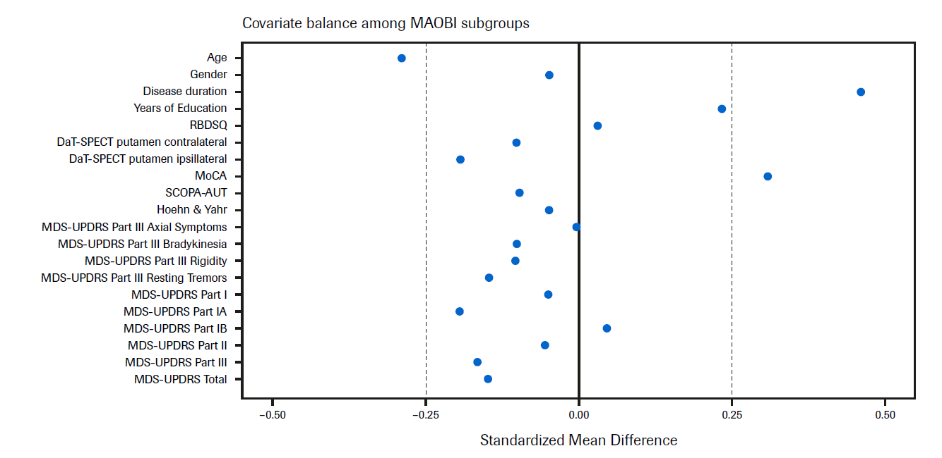
DaT-SPECT, dopamine transporter single-photon emission computerized tomography; MDS-UPDRS, Movement Disorder Society – Unified Parkinson’s Disease Rating Scale; MoCA, Montreal Cognitive Assessment; PPMI, Parkinson’s Progression Marker Initiative; RBDSQ, Rapid Eye Movement Sleep Behavior Disorder Screening Questionnaire; SCOPA-AUT, Scales for outcomes in Parkinson’s disease autonomic dysfunction.

