Supplementary Material: DNA methylation and brain dysmaturation in preterm infants
Emily N. W. Wheater, Paola Galdi, Daniel L. McCartney, Manuel Blesa¹, Gemma Sullivan¹, David Q. Stoye¹, Gillian Lamb¹, Sarah Sparrow¹, Lee Murphy², Nicola Wrobel², Alan J. Quigley³, Scott Semple^{4,5}, Michael J. Thrippleton^{4,6}, Joanna M. Wardlaw⁶, Mark E. Bastin⁶, Riccardo E. Marioni², Simon R. Cox⁷, James P. Boardman^{1,6}

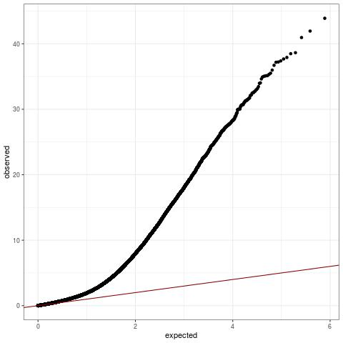

Supplementary Figure 1. Quantile-Quantile (QQ) plot for EWAS results. Genomic inflation factor: 1.72.
Supplementary Figure 2. Scatter plots showing the relationship between the beta values of top ten most significant CpG probes and gestational age at birth in weeks, with 95% confidence intervals.
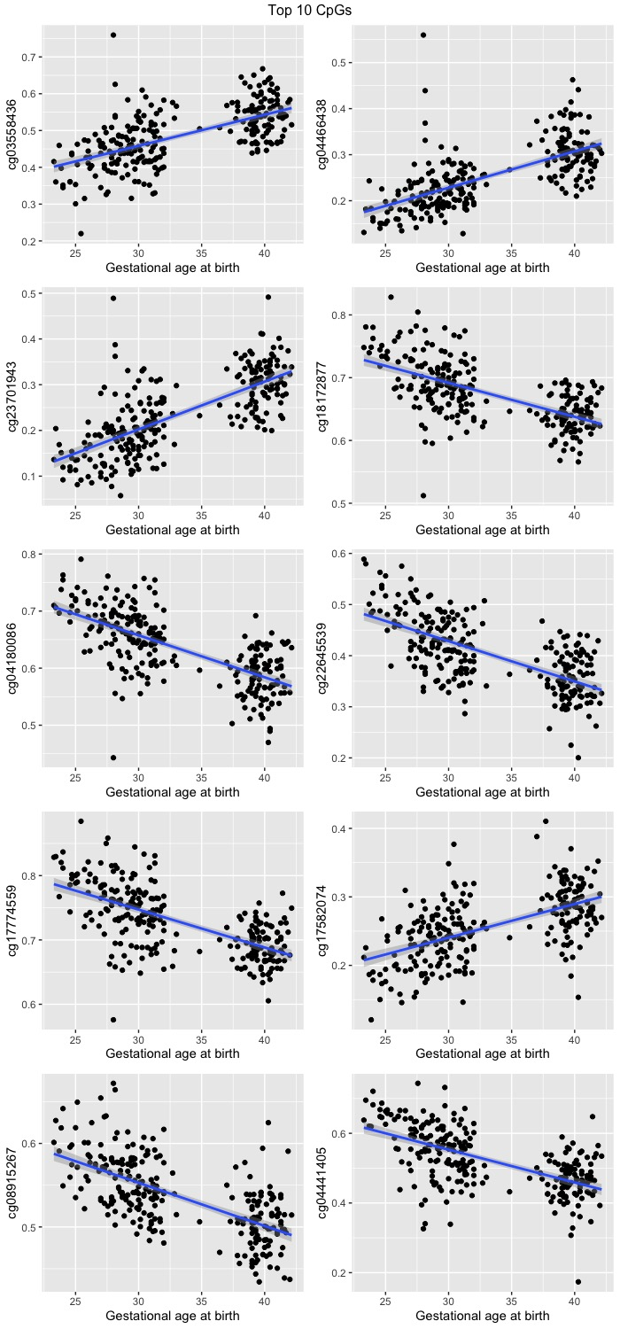
Supplementary Figure 3. Batch effects have been successfully removed from the residualised DNAm data based on the top 2 PCs derived from 8,870 CpG probes that reached genome-wide significance.

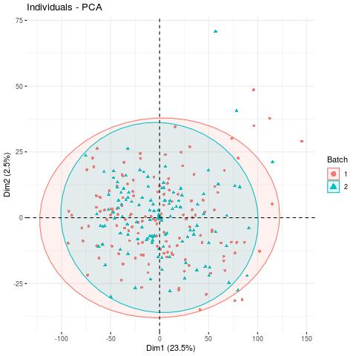

Supplementary Table 1. Demographics of participants with both PS (FA and MD) metrics and DNAm data
 | Preterm Infants  (n=127) | Term Infants  (n=87)
Gestational age at birth/weeks (range) | 29.14  (23.28 – 34.86) | 39.74  (36.43 – 42.14)
Gestational age at scan/weeks (range) | 40.44  (37.70-44.29) | 42.25  (39.84- 47.14)
Birth weight/g  (range) | 1184  (500 – 2100) | 3489  (2410 -4670)
Birth weight z-score  (range) | -0.2476  (-3.1324 – 1.5809) | 0.4521  (-2.2952 – 2.9620)
Maternal folate supplementation in pregnancy (%) | 110  (87) | 76  (87)
Sex: Female (%) | 63 (50) | 39 (45)
Maternal age (years) | 31.0  (17-44) | 33.9  (23 – 45)
Maternal tobacco smoker in pregnancy (%) | 24 (19) | 0 (0)

Supplementary Table 2. Demographics of participants with both PSNDI metric and DNAm data
 | Preterm Infants  (n=64) | Term Infants  (n=57)
Gestational age at birth/weeks (range) | 29.28  (23.43 – 32.00) | 39.71  (36.43 – 42.14)
Gestational age at scan/weeks (range) | 40.44  (38.29-44.29) | 42.25  (40.00- 47.14)
Birth weight/g  (range) | 1266  (500 – 2100) | 3502  (2410 -4560)
Birth weight z-score  (range) | -0.1083  (-3.1324 – 1.5809) | 0.4996  (-2.2952 – 2.5703)
Maternal folate supplementation in pregnancy (%) | 50  (78) | 47  (82)
Sex: Female (%) | 25 (39) | 25 (44)
Maternal age (years) | 31.2  (21-44) | 34.2  (23-44)
Maternal tobacco smoker in pregnancy (%) | 11 (17) | 0 (0)

