**Supplementary Information**

**SLAMP: A Rapid Fluorometric RT-LAMP Assay for Sensitive and Specific Detection of SARS-CoV-2 from Human Saliva**

**Authors:**

D. A. Bikosa,b, C. Hwangb, K. A. Brileyab, A. Parkerb,d, E. K. Lovedaya,b, M. Rodriguezc, T. LeFevrea,b, I. Thorntona,b, J. N. Wilkinga,b, M. Dills, S. T. Walkc, A. K. Adamse, R. Plowrightc, A. B. Hoeghd, J. R. Carterf, J. Morrowb, M. Taylorc, D. Keilc, M. W. Fieldsb,c*, and C. B. Changa,b*

**Affiliations:**

aDepartment of Chemical and Biological Engineering, Montana State University, Bozeman, MT 59717, United States

bCenter for Biofilm Engineering, Montana State University, Bozeman, MT 59717, United States

cDepartment of Microbiology & Immunology, Montana State University, Bozeman, MT 59717, United States

dDepartment of Mathematical Sciences, Montana State University, Bozeman, MT 59717, United States

eCenter for American Indian and Rural Health Equity (CAIRHE), Montana State University, Bozeman, MT 59717, United States

fHealth & Human Development, Montana State University, Bozeman, MT 59717, United States

**Keywords:** COVID-19; RT-LAMP; isothermal amplification; nucleic acid; virus; SARS-CoV-2; testing; saliva

**\*Co-corresponding authors:**

Connie B. Chang

Department of Chemical and Biological Engineering

Center for Biofilm Engineering

Montana State University

Matthew W. Fields

Department of Microbiology and Immunology

Center for Biofilm Engineering

Montana State University

**1. Supplementary Methods**

The following is a facsimile of the printed questionnaire provided to SLAMP pilot study participants:

**QUESTIONNAIRE FOR SALIVA TESTING SUBJECTS**

**Demographic Info:**

1. Age:
2. Gender:
   1. Male
   2. Female
   3. Other: _________________
   4. Prefer not to answer
3. Race:
   1. White
   2. Black or African American
   3. American Indian or Alaskan Native
   4. Native Hawaiian or Pacific Islander
   5. Asian
   6. Other race: __________________________________
   7. Prefer not to answer
4. What is your ethnicity?
   1. Hispanic or Latino
   2. Not Hispanic or Latino
   3. Prefer not to answer

**Testing criteria:**

1. Did you come for COVID testing today because you
   1. thought you had COVID symptoms?
   2. were exposed to someone who has COVID?
   3. just wanted to get tested?
2. In the last 30 minutes did you do any of the following (check all that apply):
   1. eat or drink anything (including water)?  If yes, what did you eat or drink?

Answer Yes or No to the following:

* 1. use mouthwash such as Listerine, or salt water? ______
  2. chew gum or use lozenges? ______
  3. smoke? ______
  4. chew tobacco? ______
  5. brush your teeth? ______

**A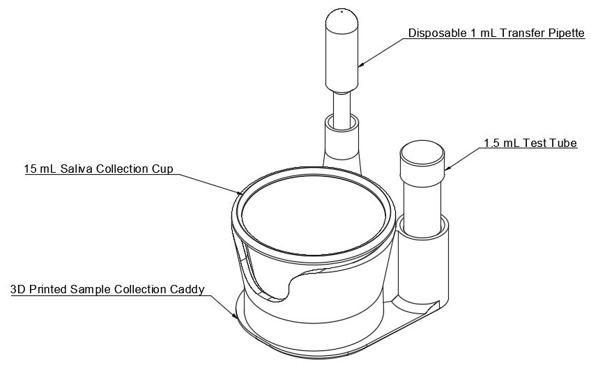B**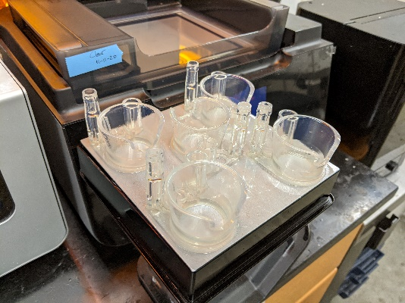

**SI Figure 1. Design and manufacture of 3D-printed accessory caddy for saliva collection.**