Supplementary Figure 1: Reported SARS-CoV-2 testing history in survey participants
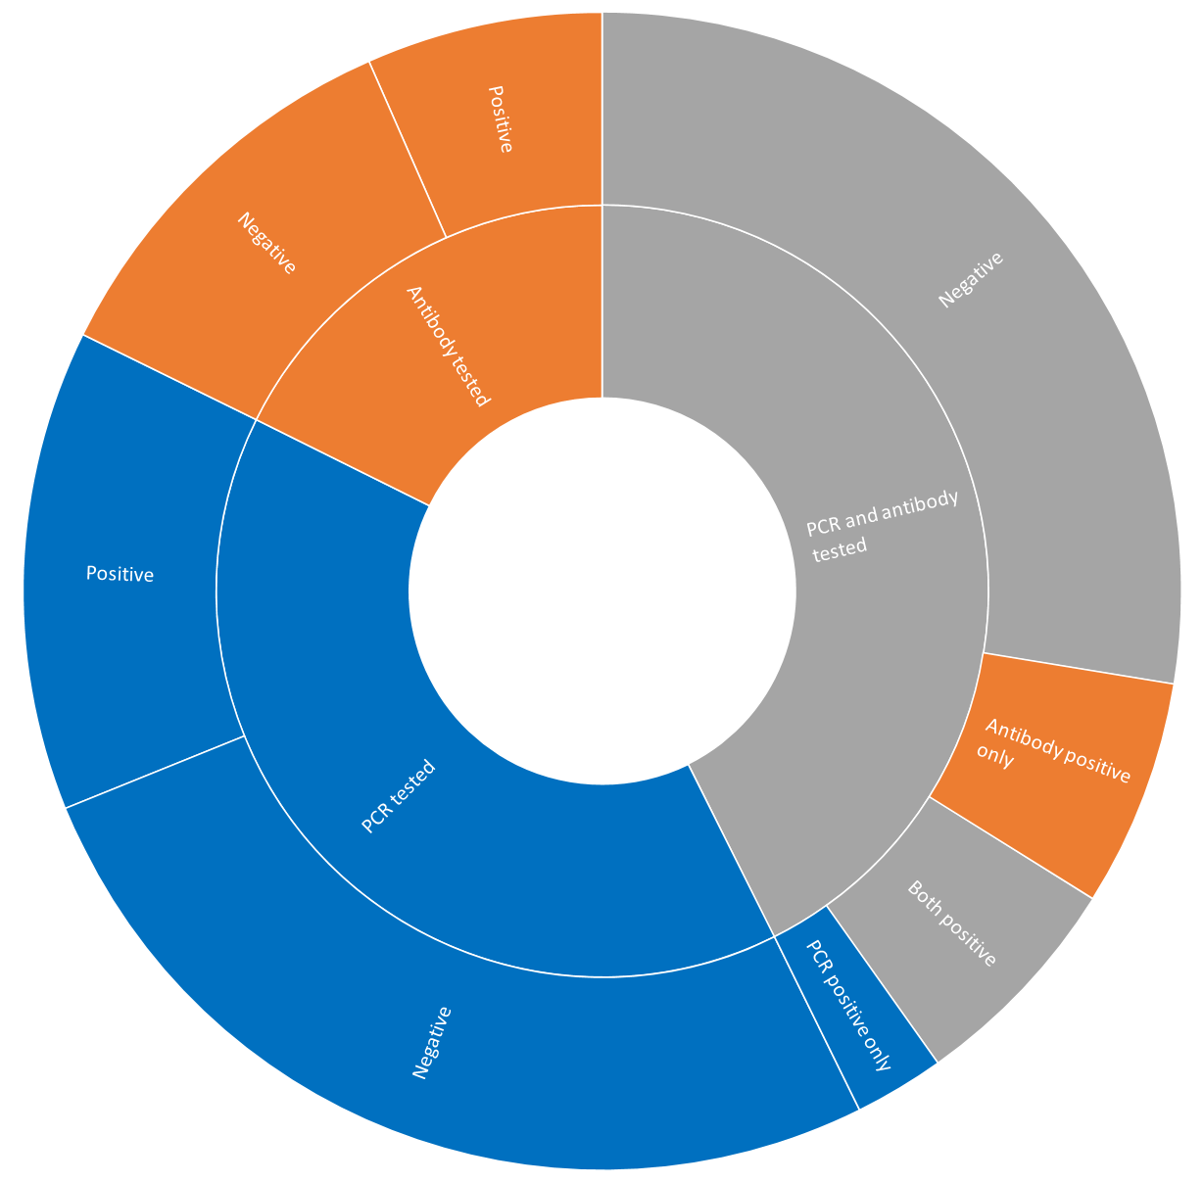

Supplementary Figure 2: Silhouette coefficient for 2 to 10 clusters

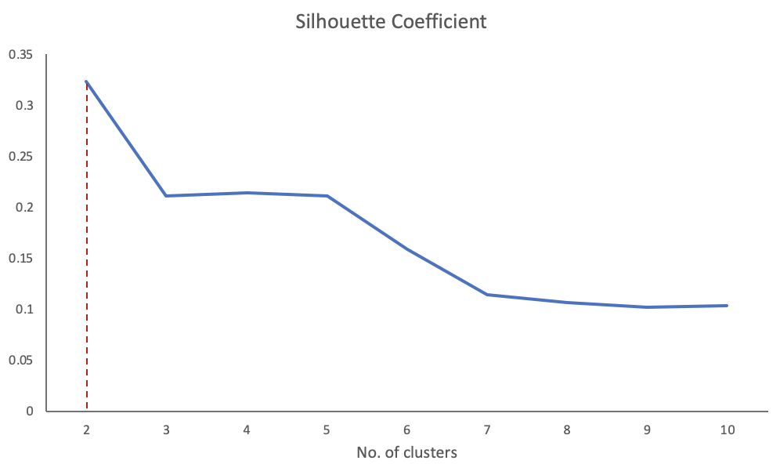

Supplementary Figure 3: Two clusters of acute symptoms and ongoing symptoms among these clusters

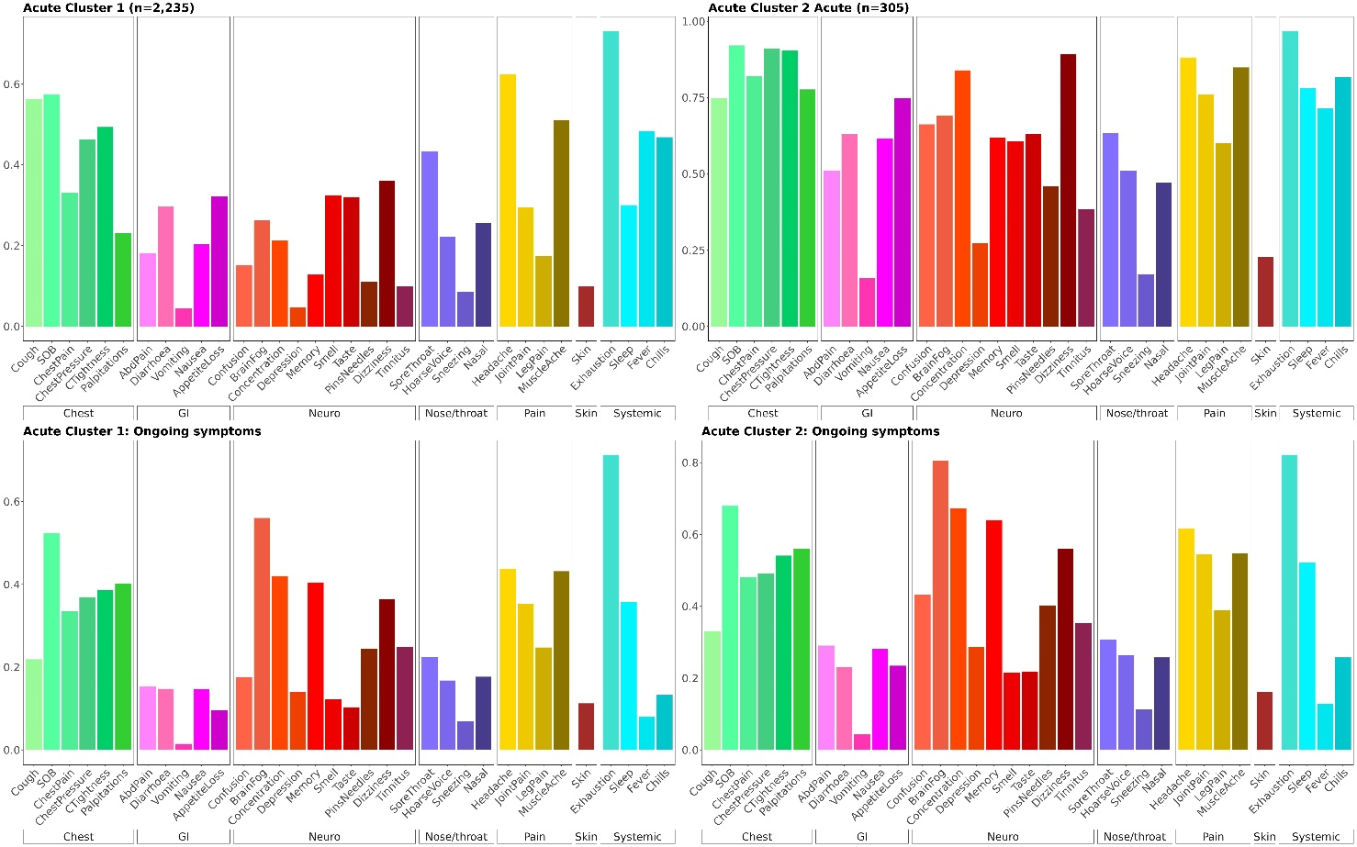

Supplementary Figure 4: Clustering of lab confirmed subgroup only identifies similar clusters to whole dataset

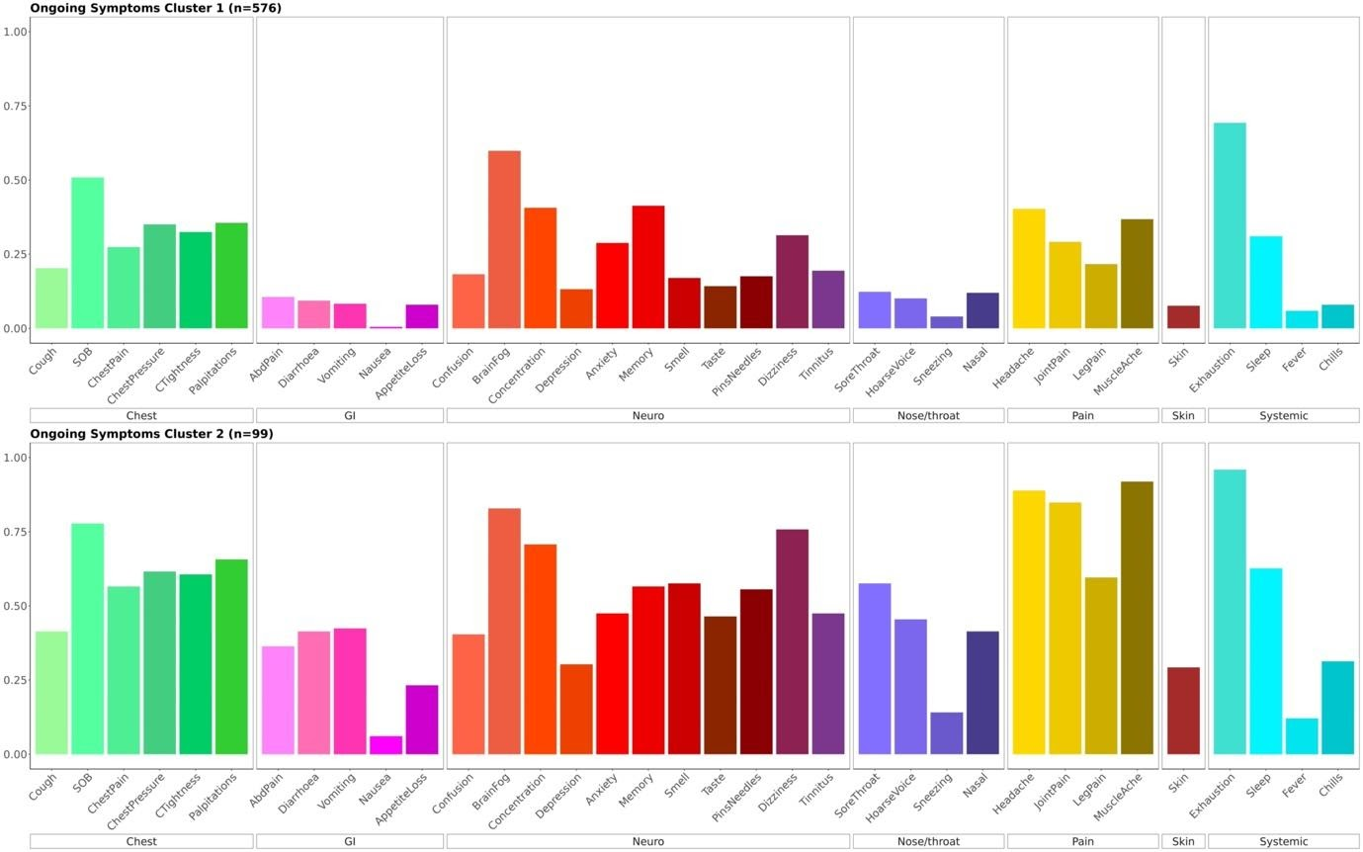

Supplementary Figure 5: Transition from acute symptom clusters to ongoing symptom clusters by number of affected systems

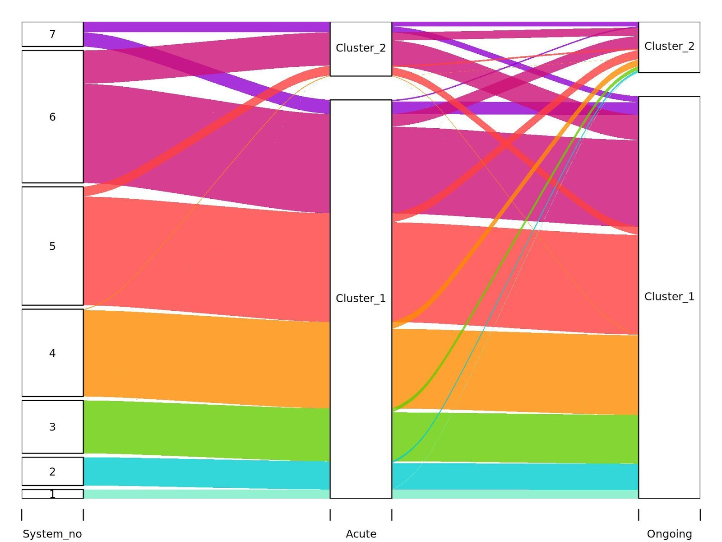

Supplementary Figure 6: Mutually adjusted predictors of transition from acute symptom cluster 1 (ASC1: cardiopulmonary predominant) to ongoing symptom cluster 2 (OSC2: multisystem)

