Supplementary materials to

**Essential hypertension is associated with changes in gut microbial metabolic pathways: A multi-site analysis of ambulatory blood pressure**

Michael Nakai, BSc1*; Rosilene V Ribeiro, PhD2,3*; Bruce R. Stevens, PhD4; Paul Gill, PhD5; Rikeish R. Muralitharan, B. Med Sci (Hons)1,6; Stephanie Yiallourou, PhD7; Jane Muir, PhD5; Melinda Carrington, PhD7; Geoffrey A. Head, PhD8,9; David M. Kaye, MD, PhD10,11,12; Francine Z. Marques, PhD1,10#

1Hypertension Research Laboratory, School of Biological Sciences, Monash University, Melbourne, Australia; 2Charles Perkins Centre, University of Sydney, Sydney, Australia; Department of Physiology, Monash University, Melbourne, Australia; 3School of Life and Environmental Sciences, Faculty of Science, The University of Sydney, Sydney, Australia; 4University of Florida, College of Medicine, Department of Physiology and Functional Genomics, Gainesville, FL, USA; 5Department of Gastroenterology, Monash University, Melbourne, Australia; 6Institute for Medical Research, Ministry of Health Malaysia, Kuala Lumpur, Malaysia; 7Preclinical Disease and Prevention, Baker Heart and Diabetes Institute, Melbourne, Australia; 8Neuropharmacology Laboratory, Baker Heart and Diabetes Institute, Melbourne, Australia; 9Department of Pharmacology, Faculty of Medicine Nursing and Health Sciences, Monash University, Melbourne, Australia; 10Heart Failure Research Group, Baker Heart and Diabetes Institute, Melbourne, Australia; 11Department of Cardiology, Alfred Hospital, Melbourne, Australia; 12Central Clinical School, Faculty of Medicine Nursing and Health Sciences, Monash University, Melbourne, Australia;

*Authors contributed equally as first authors

**Tables**

**Table S1.** TaqMan assays used in the study.

|  |  |
| --- | --- |
| **Genes** | **Assay ID** |
| *FFAR3* (GPR41) | Hs02519193_g1 |
| *FFAR2* (GPR43) | Hs00271142_s1 |
| *HCAR2* (GPR109A) | Hs02341584_s1 |
| *ACTB* (housekeeping gene) | Hs01060665_g1 |
| *GAPDH* (housekeeping gene) | Hs02786624_g1 |

**Table S2.** Dietary variables analysed in relationship with essential hypertension.

|  |  |  |  |
| --- | --- | --- | --- |
| **Food type in grams (mean±SEM)** | **Normotensives (n=46)** | **Hypertensives (n=23)** | ***P*-value** |
| Total dietary fibre | 23.54±1.3 | 22.9±2.0 | 0.781 |
| Total resistant starches | 2.09±0.1 | 2.07±0.2 | 0.947 |
| Total insoluble fibre | 8.44±0.5 | 8.02±0.8 | 0.672 |
| Total soluble fibre | 6.08±0.3 | 5.78±0.5 | 0.606 |
| Nuts | 18.15±3.3 | 14.5±2.6 | 0.384 |
| Vegetables | 249.0±20.6 | 228.8±19.4 | 0.479 |
| Dark green vegetables | 34.05±5.4 | 26.91±5.1 | 0.341 |
| Starchy vegetables | 32.69±3.8 | 30.61±4.2 | 0.716 |
| Legumes | 49.11±8.2 | 60.9±14 | 0.471 |
| Dry fruit | 11.26±2.8 | 6.91±2.1 | 0.218 |
| Fresh fruit | 266.9±25.3 | 234.9±33.3 | 0.448 |
| Grain source of fibre | 121.6±14.7 | 114.1±11.2 | 0.349 |
| Grains total | 213.0±18.0 | 216.4±15.6 | 0.885 |
| Grains low in fibre | 91.42±8.0 | 112.3±11.3 | 0.139 |

**Table S3**. Alpha diversity comparison between normotensive and hypertensive groups.

|  |  |  |  |
| --- | --- | --- | --- |
| **α diversity metric (mean±SEM)** | **Normotensives (n=46)** | **Hypertensives (n=23)** | ***P*-value** |
| Observed OTUs | 224.1±9.6 | 234.8±14.4 | 0.541 |
| Chao1 | 227.4±9.7 | 236.3±14.5 | 0.614 |
| Shannon | 3.7±0.1 | 3.8±0.1 | 0.972 |
| Simpson | 0.932±0.008 | 0.934±0.013 | 0.907 |
| Inverse Simpson | 21.6±1.7 | 21.9±2.1 | 0.906 |

**Legend**: OTUs, operational taxonomic units.

**Table S4.** Taxa differentially prevalent in the groups with P<0.1, adjusted by sex. (FM)

|  |  |  |  |  |
| --- | --- | --- | --- | --- |
| **Taxa** | **P-value** | **F Value** | **Fold Change** | **Changed in** |
| p__Firmicutes__g__Coprobacillus_OTU84 | 0.029 | 0.11 | -1.45 | Essential Hypertension |
| p__Verrucomicrobia__c__Opitutae_OTU119 | 0.035 | 6.8 | 2.7 | Essential Hypertension |
| p__Firmicutes__g__Acidaminococcus_OTU69 | 0.045 | 0.63 | 4.7 | Essential Hypertension |
| p__Firmicutes__g__Ruminococcus_OTU66 | 0.074 | 0.0024 | -1.32 | Essential Hypertension |
| p__Proteobacteria__o__Rhizobiales_OTU90 | 0.099 | 0.00017 | -3.41 | Essential Hypertension |
| p__Firmicutes__g__Clostridium__s__perfringens_OTU54 | 4.6E-06 | 27 | 4.3 | White coat hypertension |
| p__Bacteroidetes__o__Sphingobacteriales_OTU24 | 0.00067 | 13 | * | White coat hypertension |
| p__Bacteroidetes__g__Bacteroides_OTU16 | 0.029 | 5.1 | 7.9 | White coat hypertension |
| p__Firmicutes__g__Veillonella__s__dispar_OTU76 | 0.062 | 3.7 | 2.3 | White coat hypertension |
| p__Actinobacteria__g__Bifidobacterium_OTU5 | 0.081 | 3.2 | 2.7 | White coat hypertension |
| p__Bacteroidetes__g__Bacteroides__s__coprophilus_OTU18 | 0.089 | 3 | 4.6 | White coat hypertension |
| p__Firmicutes__g__Ruminococcus_OTU66 | 0.1 | 0.15 | -1.39 | Masked hypertension |

Legend: k, kingdom; p, phylum; c, class; o, order; f, family; g, genus; s, species. *Absent in white coat hypertensives.

**Table S5.** Pathways differentially regulated in essential hypertension (effect size < or >50% change and q<0.05).

|  |  |  |
| --- | --- | --- |
| **Taxcodes** | **Gene pathways names** | **Effect** |
| K17234 | arabinosaccharide transport system substrate binding protein 1 | -2.83 |
| K17235 | arabinosaccharide transport system permease protein 1 | -2.65 |
| K01308 | g D glutamyl meso diaminopimelate peptidase 1 | -2.60 |
| K17236 | arabinosaccharide transport system permease protein 2 | -2.57 |
| K10200 | N acetylglucosamine transport system substrate binding protein 1 | -2.45 |
| K00936 | two-component system sensor, histidine kinase PdtaS 1 | -2.43 |
| K10201 | N acetylglucosamine transport system permease protein 1 | -2.40 |
| K10202 | N acetylglucosamine transport system permease protein 2 | -2.33 |
| K07459 | putative ATP-dependent endonuclease of the OLD family 1 | -2.28 |
| K07321 | Codehydrogenase maturation factor 1 | -2.26 |
| K00042 | 2-hydroxy-3-oxopropionate reductase 1 | -2.19 |
| K04784 | yersiniabactin non-ribosomal peptide synthetase 1 | -2.15 |
| K05795 | tellurium resistance protein TerD 1 | -2.15 |
| K04783 | yersiniabactin salicyl AM Pligase 1 | -2.10 |
| K05341 | amylosucrase 1 | -2.05 |
| K06331 | spore coat proteinI 1 | -2.03 |
| K00786 | beta 1 6 galactosyltransferase 1 | -2.01 |
| K19504 | glucose lysine 6 phosphate deglycase 1 | -1.98 |
| K09696 | sodium transport system permease protein 1 | -1.94 |
| K09697 | sodium transport system ATP binding protein 1 | -1.93 |
| K19165 | antitoxin Phd 1 | -1.88 |
| K09703 | uncharacterized protein 223 | -1.87 |
| K01060 | cephalosporin C-deacetylase 1 | -1.77 |
| K18344 | two-component system, Omp R-family response regulator VanR 1 | -1.77 |
| K16139 | glucuronide carrier-protein 1 | -1.74 |
| K02598 | nitrite transporter 1 | -1.70 |
| K03486 | GntR-family transcriptional regulator trehalose operon transcriptional repressor 1 | -1.68 |
| K14205 | phosphatidyl glycerollysyl transferase 1 | -1.67 |
| K02977 | ubiquitin small subunit ribosomal protein S27Ae 1 | -1.66 |
| K00632 | acetyl CoA-acyltransferase 1 | -1.63 |
| K07130 | arylformamidase 2 | -1.60 |
| K00004 | (R,R)-butanediol dehydrogenase meso-butanediol dehydrogenase diacetylreductase 1 | -1.58 |
| K09685 | purine operon repressor 1 | -1.57 |
| K16907 | fluoroquinolone transport system ATP binding protein 1 | -1.53 |
| K22103 | DeoR family transcriptional regulator carbon catabolite repression regulator 1 | -1.52 |
| K07406 | alpha galactosidase 2 | -1.52 |
| K08981 | putative membrane protein 12 | -1.50 |
| K05363 | serine/alanine adding enzyme 1 | -1.50 |
| K14347 | solute carrier family 10 sodium bile acid cotransporte R member7 1 | 1.50 |
| K10806 | acyl CoA-thioesterase YciA 1 | 1.51 |
| K06181 | 23S rRNA pseudouridine2457 synthase 1 | 1.51 |
| K03652 | DNA 3-methyl-adenine glycosylase 1 | 1.52 |
| K07102 | N acetylmuramate1 kinase 1 | 1.53 |
| K14682 | amino acid N acetyltransferase 3 | 1.53 |
| K08300 | ribonucleaseE 1 | 1.54 |
| K06191 | glutaredoxin likeprotein NrdH 1 | 1.54 |
| K03117 | sec-independent protein translocase protein TatB 1 | 1.55 |
| K01792 | glucose 6 phosphate1 epimerase 1 | 1.57 |
| K01598 | phosphopantothenoylcysteine decarboxylase 1 | 1.62 |
| K00324 | H translocating NAD P-transhydrogenase subunit alpha 1 | 1.62 |
| K21977 | phosphopantothenate cysteine-ligase CTP 1 | 1.63 |
| K21030 | D-ribitol-5-phosphate cytidylyltransferase 1 | 1.64 |
| K01066 | acetylesterase 1 | 1.65 |
| K01708 | galactarate dehydratase 1 | 1.65 |
| K07219 | putative molybdopterin biosynthesis protein 1 | 1.66 |
| K03579 | ATP dependent-helicase HrpB 1 | 1.72 |
| K07318 | adenine specificDNA methyltransferase 3 | 1.73 |
| K01239 | purine nucleosidase 1 | 1.76 |
| K05939 | acyl-acyl carrier protein phospholipid O-acyltransferase long-chain fatty acid acyl carrier protein ligase 1 | 1.76 |
| K00184 | dimethyl sulfoxide reductase iron sulfurs ubunit 1 | 1.78 |
| K02584 | Nif specific-regulatory protein 1 | 1.79 |
| K12506 | 2-C-methyl-D-erythritol 4-phosphatecytidylyl transferase 2-C-methyl D erythritol 2-4-cyclodiphosphate synthase 1 | 1.81 |
| K00185 | dimethyl sulfoxide reductase membrane subunit 1 | 1.83 |
| K09007 | GTP cyclohydrolaseI B 1 | 1.86 |
| K03684 | ribonucleaseD 1 | 1.94 |
| K18816 | aminoglycoside 6-N-acetyltransferaseI 2 | 1.97 |
| K11934 | outer membrane protein-X 1 | 1.99 |
| K07304 | peptide methionine (S)-S oxide reductase 1 | 2.35 |
| K01905 | acetate CoA-ligase ADP forming subunit alpha 1 | 2.38 |

**Figures**

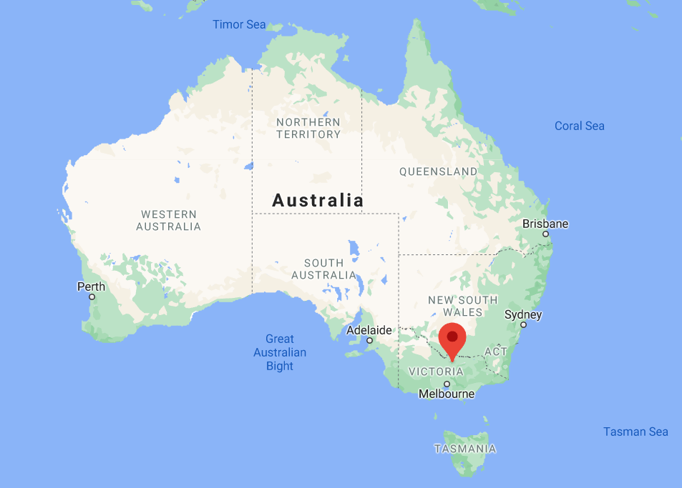

**Figure S1.** Map showing the two sites used for recruitment, Melbourne and Shepparton (marked with the red pin).

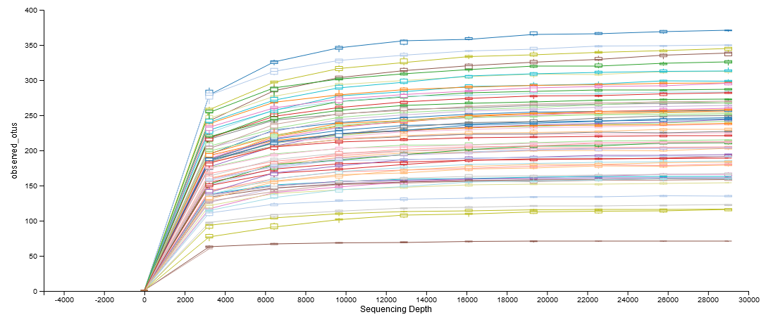

**Figure S2.** Rarefaction curve showing sample sequencing depth and that at the number used for rarefaction of samples (29,000 reads) diversity was consistent across samples.

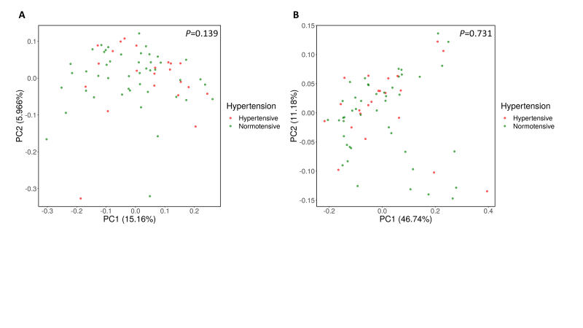

**Figure S3**. β diversity principal coordinate analysis plot showing no difference in the gut microbiome between normotensive (green) and hypertensive (red) participants. A, Unweighted (i.e., microbial diversity based on presence/absence) and B, weighted (i.e., microbial diversity based on abundance) UniFrac analyses.

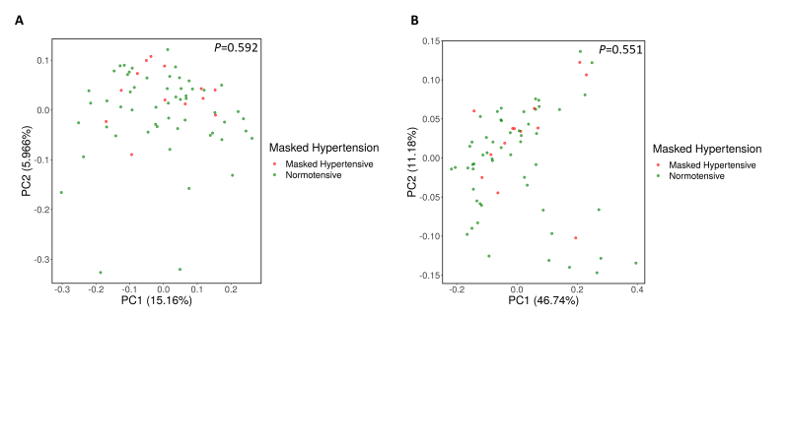

**Figure S4**. β diversity principal coordinate analysis plot showing no difference in the gut microbiome between normotensive (green) and masked hypertensive (red) participants. A, Unweighted (i.e., microbial diversity based on presence/absence) and B, weighted (i.e., microbial diversity based on abundance) UniFrac analyses.

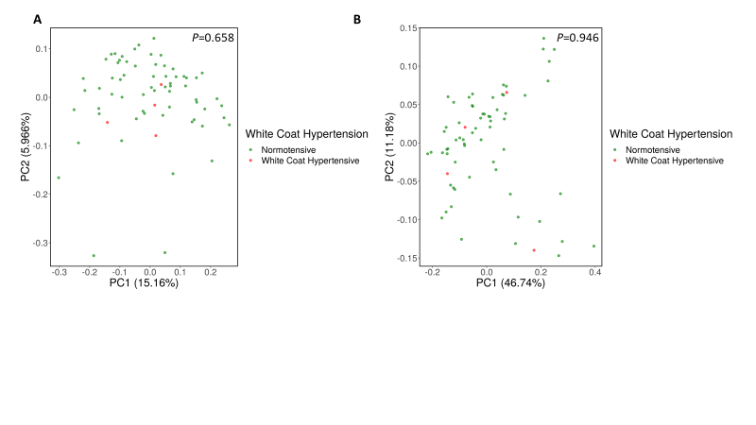

**Figure S5**. β diversity principal coordinate analysis plot showing no difference in the gut microbiome between normotensive (green) and white coat hypertensive (red) participants. A, Unweighted (i.e., microbial diversity based on presence/absence) and B, weighted (i.e., microbial diversity based on abundance) UniFrac analyses.

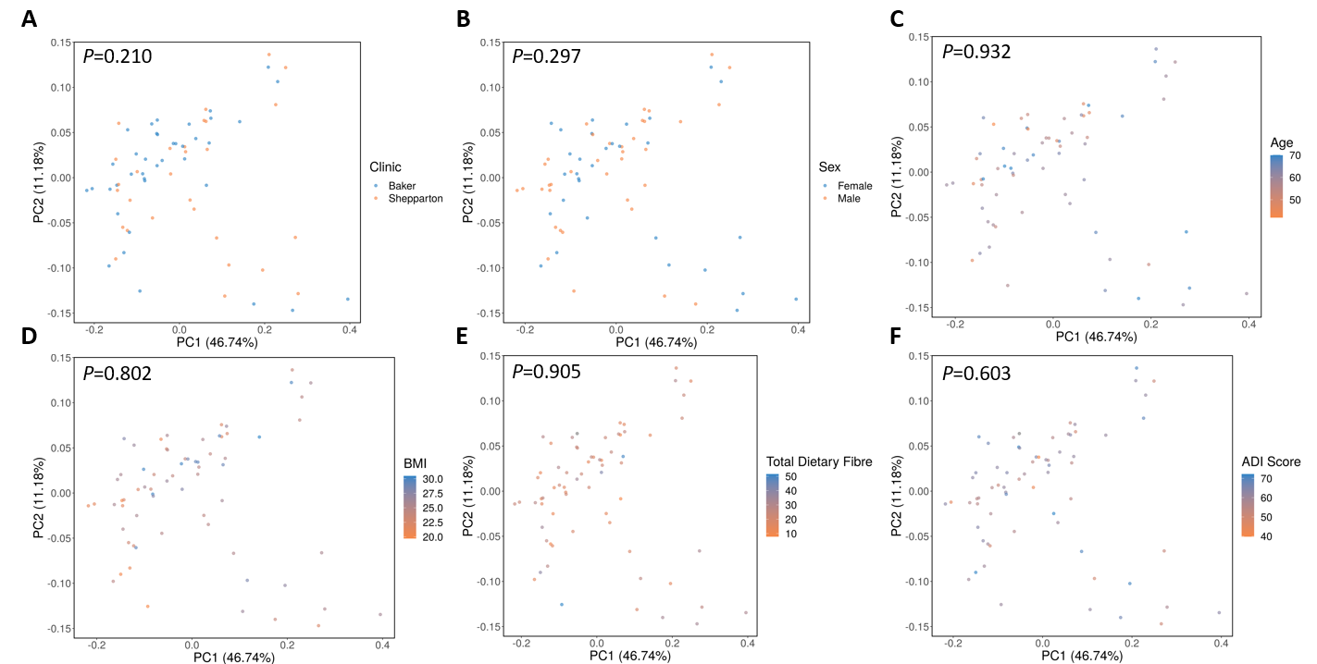

**Figure S6**. β diversity principal coordinate analysis plot showing no difference in the gut microbiome between A, clinics (Baker=metropolitan, Shepparton=regional), B, sexes, C, age, D, BMI, E, dietary fibre intake and F, Australia Dietary Index (ADI) score.

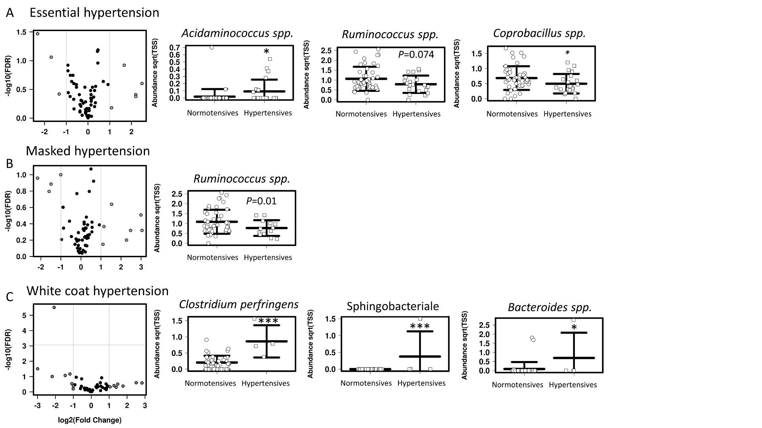

**Figure S7**. Multiple regression results of taxa that were associated with **A**, Essential Hypertension, **B**, Masked hypertension, **C** White coat hypertension after correction for sex. Showing volcano plots with dots in grey for taxa that had significantly altered levels (P<0.05 – see Table S4) and plots showing prevalence of specific taxa. Mean±SD. *P<0.05, ***P<0.001.

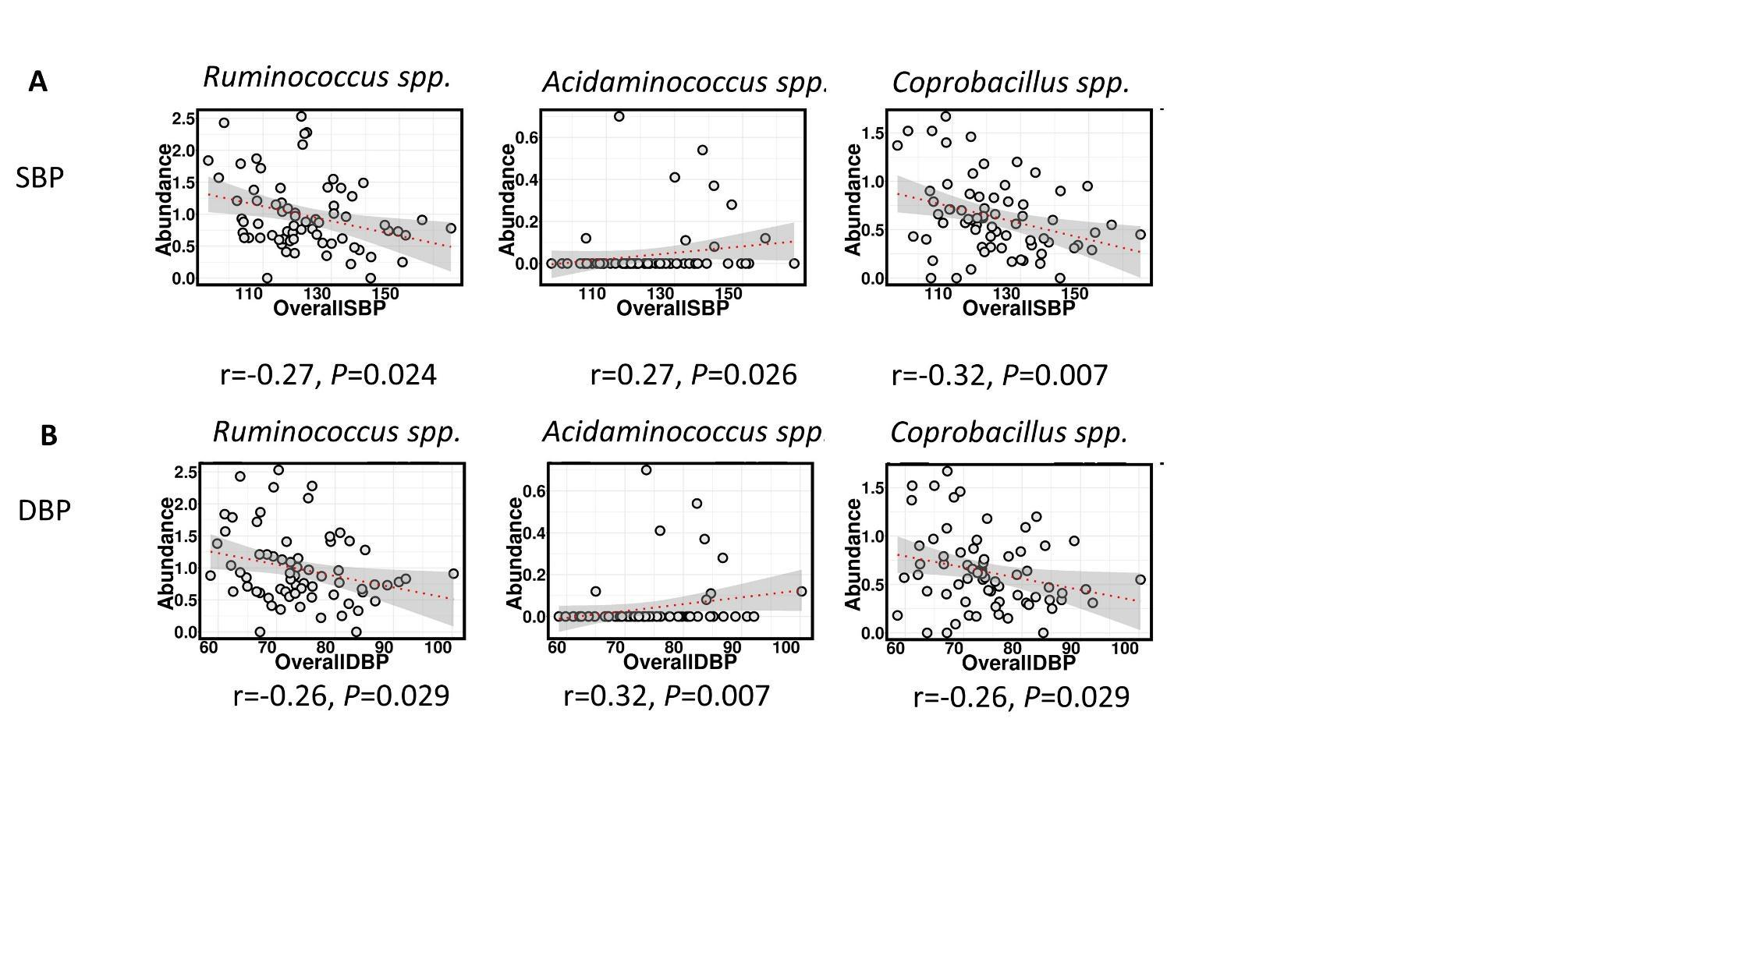

**Figure S8.** Validation of the 3 top taxa, showing Spearman correlation with 24-hour **A**, systolic and **B**, diastolic blood pressure after adjustment for sex.

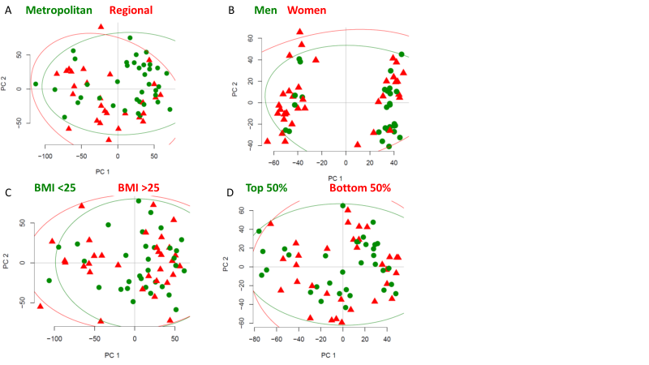

**Figure S9**. Pathway analyses plots showing no difference in the gut microbiome between **A**, clinics, **B,** sexes, **C,** BMI, **D,** Australia dietary score index.

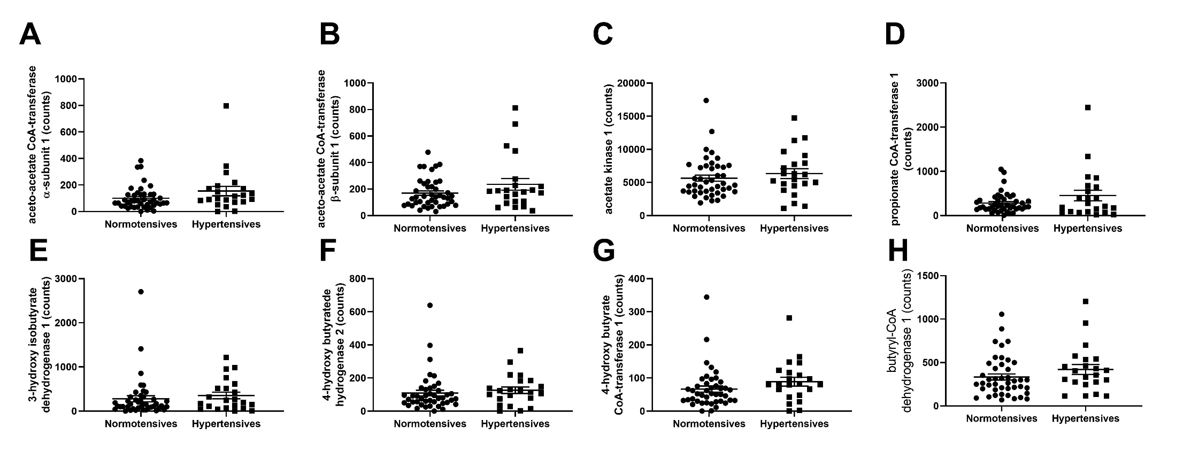**Figure S10**. Pathways relevant to short-chain fatty acid production that were not differentially regulated between hypertensive and normotensive participants.