supplementary material

Supplementary Fig. 1. Result of two-sample Kolmogorov-Smirnov test for all numerical parameters.
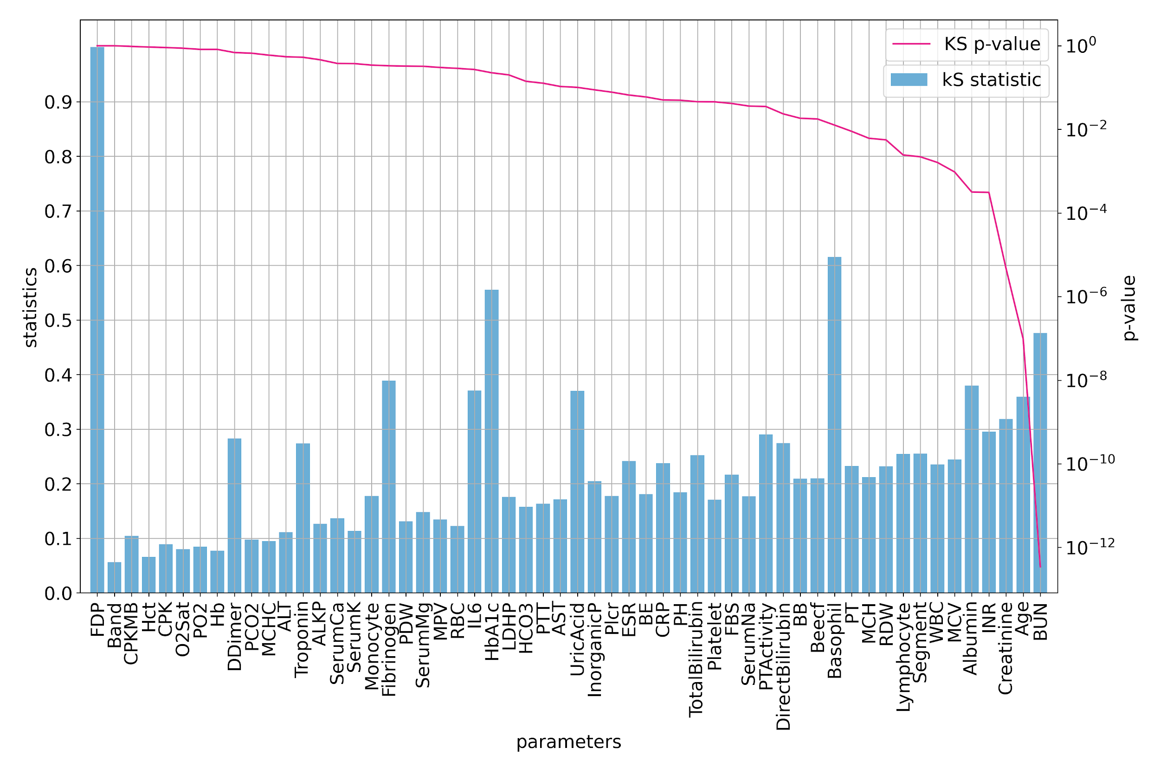
Supplementary Fig. 1. 11 out of 56 numerical features with least Kolmogorov-Smirnov P-values are used for modeling.

Supplementary Fig. 2. Result of 𝓧² test for all categorical parameters.
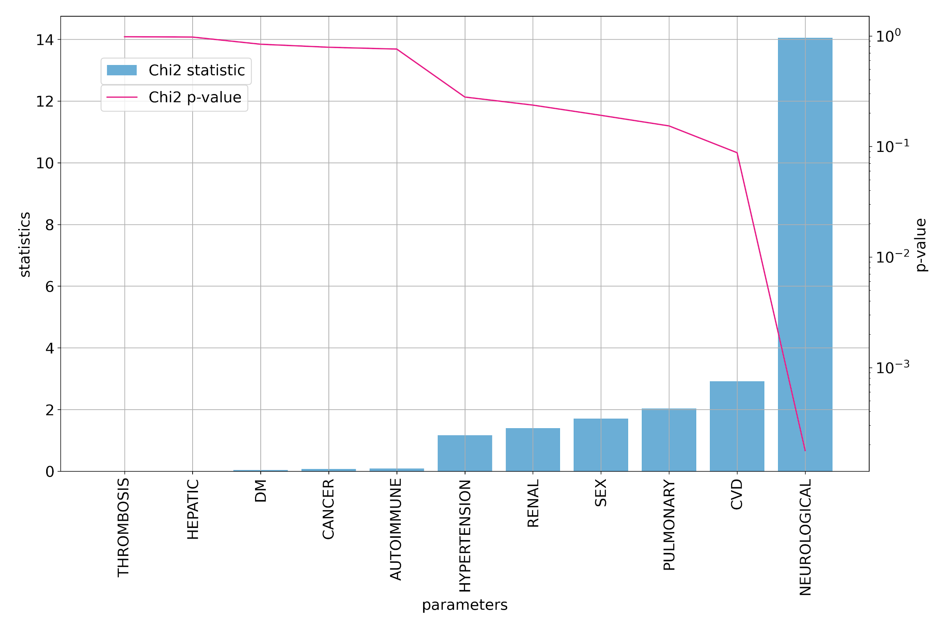
Supplementary Fig. 2. four out of 56 categorical features with least Kolmogorov-Smirnov P-values are used for modeling.

Supplementary Fig. 3. Regression coefficients of the logistic model.
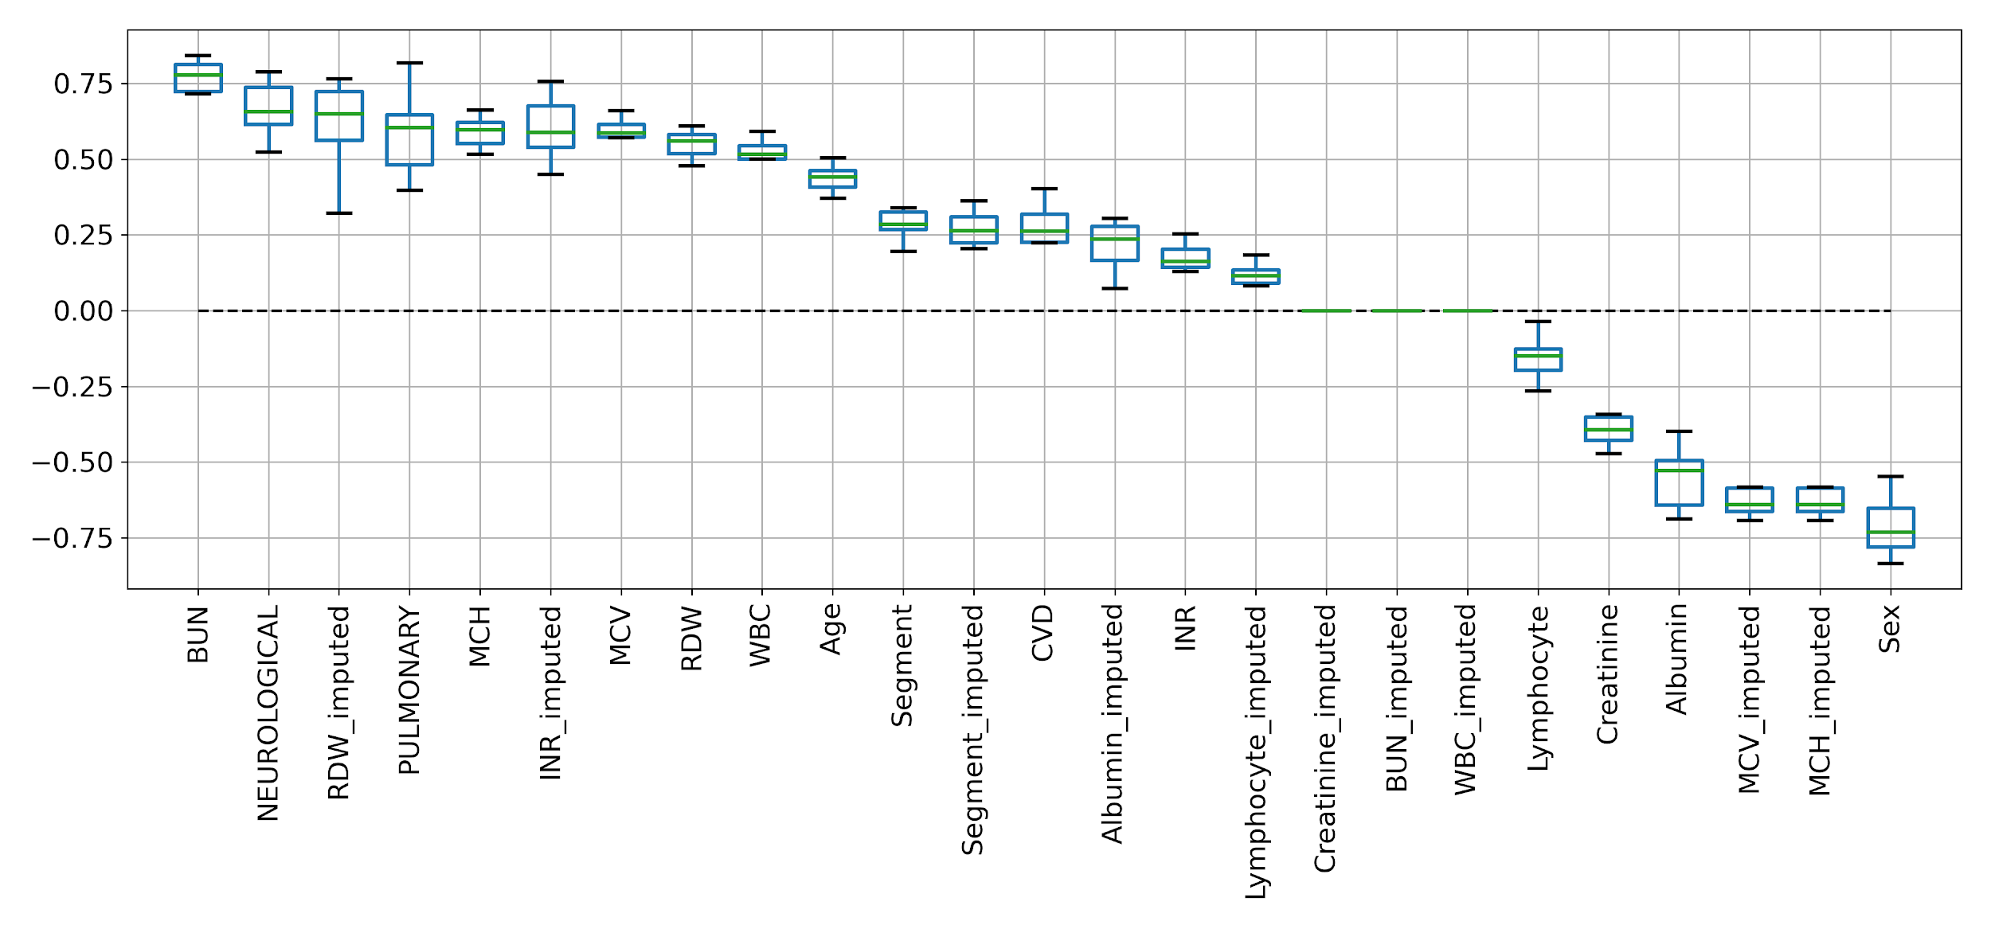
Supplementary Fig. 3. Features with higher coefficient absolute value are more crucial in the logistic model prediction.

Supplementary Fig. 4. Distribution of selected numerical variables.
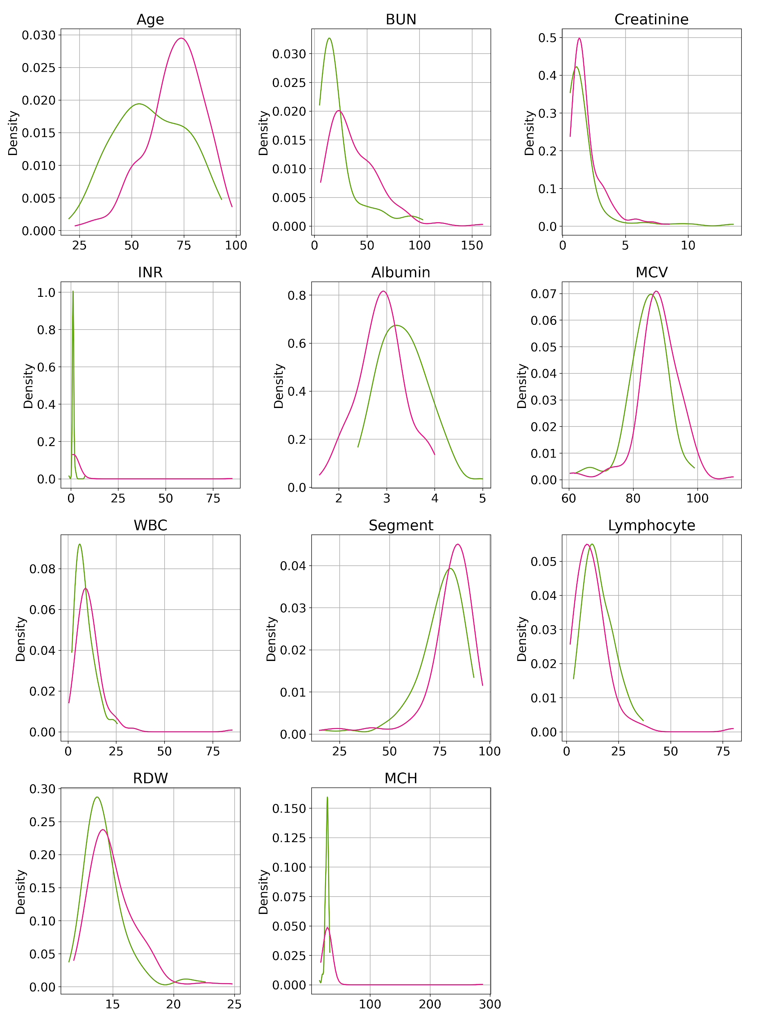
Supplementary Fig. 4. Comparison of categorical variables between released (green) on dead (red) patients.

Supplementary Fig. 5. Distribution of selected categorical variable.
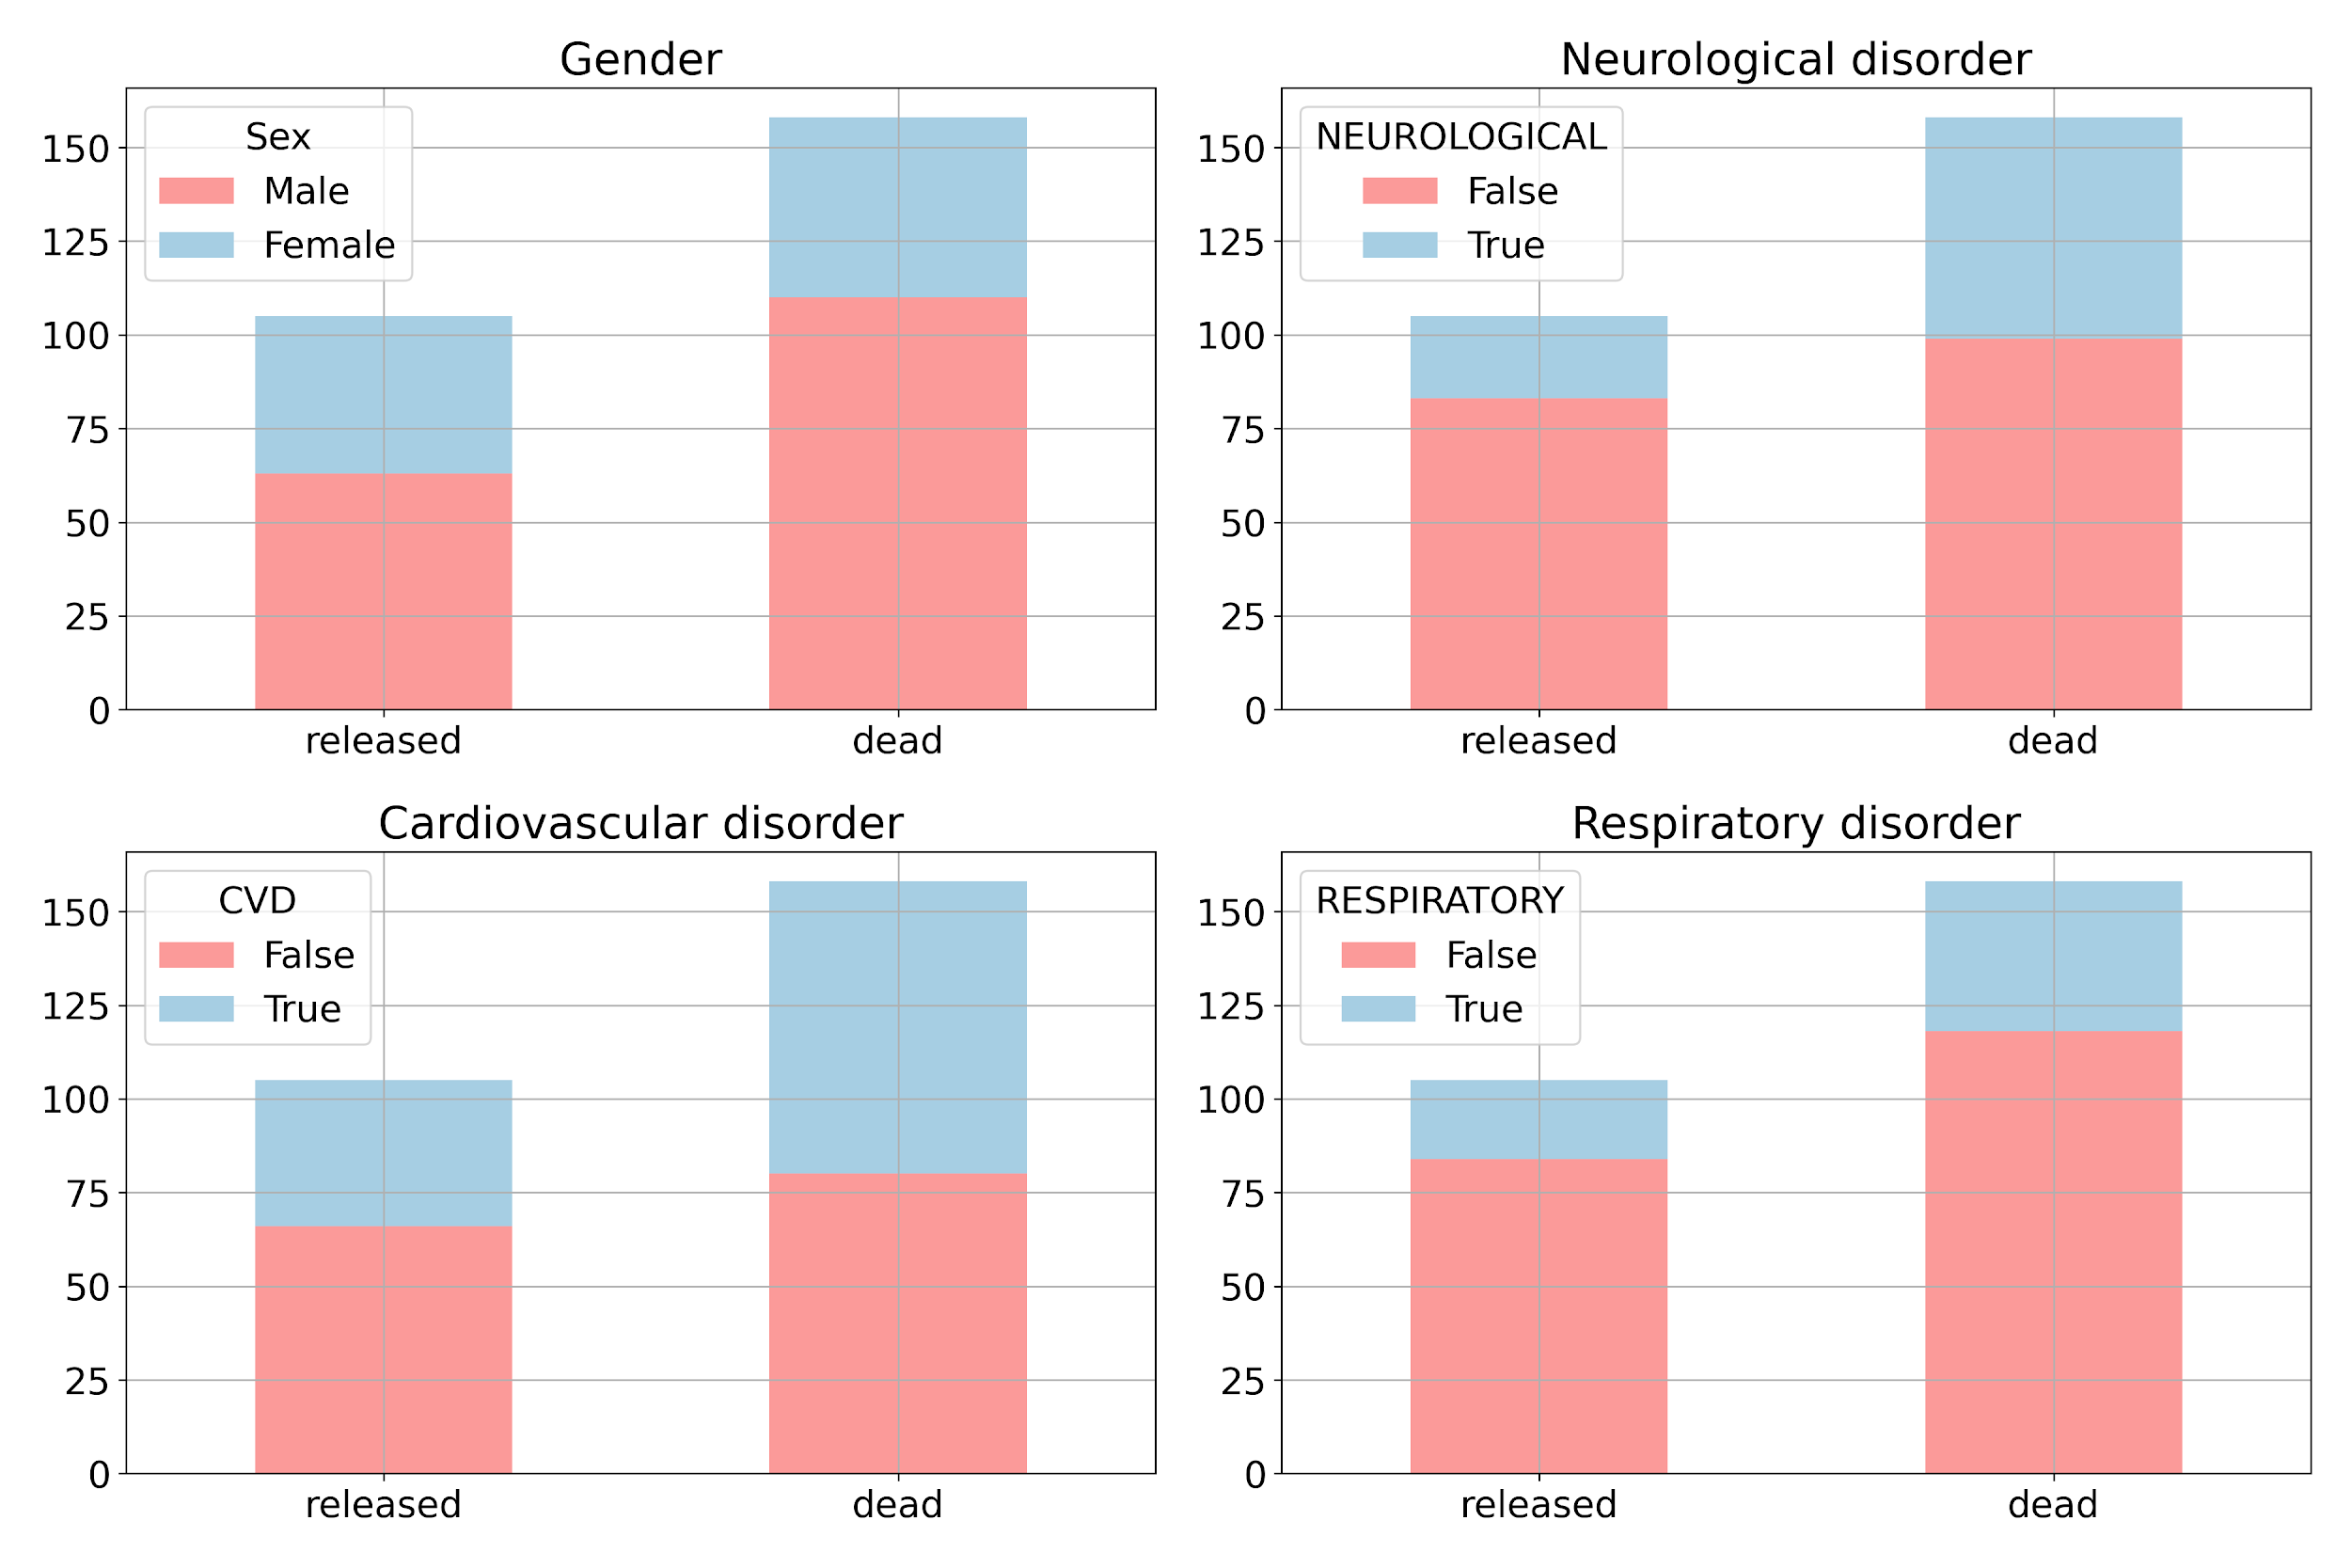
Supplementary Fig. 5. Comparison of categorical variables between released and dead patients.

