**The Generalizability of Clinical Prediction Models for Patients with Acute Coronary Syndromes: Results from Independent External Validations**

Benjamin S. Wessler MD MS,1,2 Jason Nelson MPH,1Jinny G. Park MPH,1 Hannah McGinnis MPH,1 Jenica Upshaw MD MS,1,2 Ben Van Calster PhD,3 David van Klaveren PhD,1,4 Ewout Steyerberg PhD,5 David M. Kent MD MS1

1. Predictive Analytics and Comparative Effectiveness (PACE) Center, Institute for Clinical Research and Health Policy Studies (ICRHPS), Tufts Medical Center, Boston, MA
2. Division of Cardiology, Tufts Medical Center, Boston, MA
3. KU Leuven, Department of Development and Regeneration, Leuven, Belgium
4. Department of Public Health, Erasmus University Medical Center, Rotterdam
5. Department of Biomedical Data Sciences, Leiden University Medical Centre, Leiden, Netherlands

**Short title:** Generalizability of ACS prediction models

**Keywords:** risk, clinical prediction models, acute coronary syndrome

**Address for Correspondence:**

David M. Kent MD MS

PACE, ICRHPS

Tufts Medical Center

800 Washington Street, Box #63

Boston, MA 02111

Phone: (617) 636-1475

Fax: (617) 636-8023

Email: [dkent1@tuftsmedicalcenter.org](mailto:dkent1@tuftsmedicalcenter.org)

**Supplemental Table 1** Heat Map of CPM/Database Matches

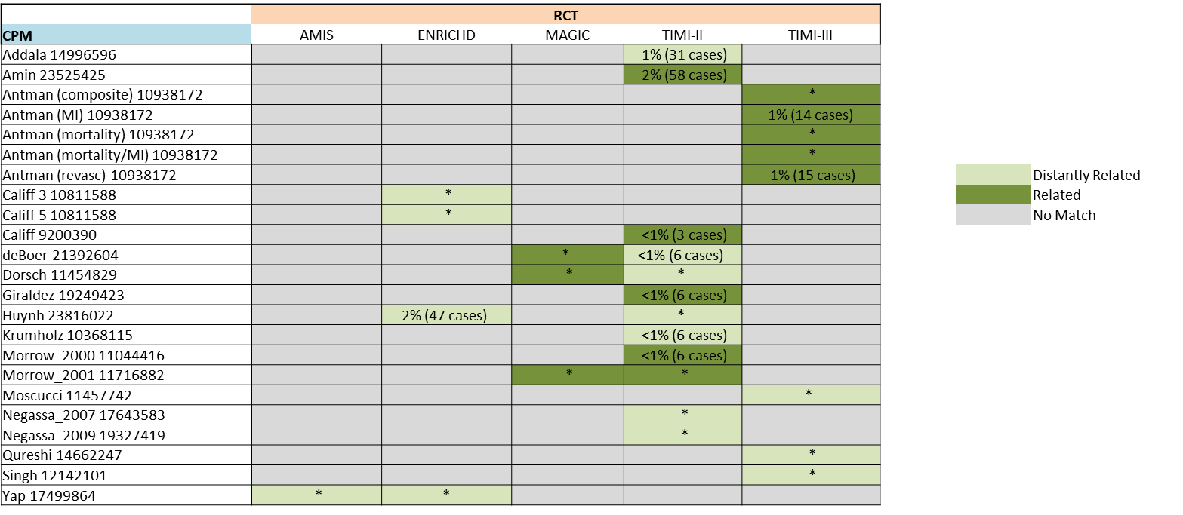

Supplement Table 1. CPM/Database Matches included in this analysis. AMIS is The Aspirin Myocardial Infarction Study, ENRICHED is The Enhanced Recovery in Coronary Heart Disease study. MAGIC is The Magnesium in Coronaries Trial, TIMI-II and TIMI-III are The Thrombolysis in Myocardial Infarction Trials. Light green represents ‘distantly related’ matches. Dark green represents ‘related’ matches. * represents validations done using the full RCT. Otherwise the percentage of vents (number of observations) that are censored because they occurred after the prediction time horizon are shown.