|  |  |  |  |  |
| --- | --- | --- | --- | --- |
| A | B | C | D | E |
| **Lab/Institute** | **District/State** | **City Codes** | **Sub Code** | **Date of Collection** |
| CSIR-Advanced Materials and Processes Research Institute (CSIR-AMPRI), Bhopal | Bhopal* | BPL |  | 15th Sep |
| CSIR-Central Building Research Institute(CSIR-CBRI), Roorkee | Haridwar | RK |  | 15th Sep |
| CSIR-Centre for Cellular Molecular Biology(CSIR-CCMB), Hyderabad | Hyderabad* | HYD | a | 10th Sep |
| CSIR-Central Drug Research Institute(CSIR-CDRI), Lucknow | Lucknow | LKO | a | 09th Sep |
| CSIR-Central Electrochemical Research Institute(CSIR-CECRI), Karaikudi | Sivaganga* | KKD |  | 17th Sep |
| CSIR-Central Electronics Engineering Research Institute(CSIR-CEERI), Pilani | Jhunjunu | PIL |  | 04th Sep |
| CSIR-Central Food Technological Research Institute(CSIR-CFTRI), Mysore | Mysuru* | MYS |  | 15th Sep |
| CSIR-Central Glass Ceramic Research Institute(CSIR-CGCRI), Kolkata | Kolkata* | KOL | a | 26th Aug |
| CSIR-Central Institute of Medicinal Aromatic Plants(CSIR-CIMAP), Lucknow | Lucknow | LKO | b | 23rd Sep |
| CSIR-Central Institute of Mining and Fuel Research(CSIR-CIMFR) Dhanbad | Dhanbad* | DHN |  | 15th Sep |
| CSIR-Central Leather Research Institute(CSIR-CLRI), Chennai | Chennai | CHE |  | 17th Sep |
| CSIR-Central Road Research Institute(CSIR-CRRI), New Delhi | South Delhi* | NDL | a | 22nd July |
| CSIR-Central Scientific Instruments Organisation(CSIR-CSIO), Chandigarh | Chandigarh | CDG | a | 18th Sep |
| CSIR-Central Salt Marine Chemicals Research Institute(CSIR-CSMCRI), Bhavnagar | Bhavnagar | BVC |  | 17th Sep |
| CSIR-National Aerospace Laboratories(CSIR-NAL), Bengaluru and 4 PI | Bengaluru | BEN |  | 08th Sep |
| CSIR-Institute of Genomics and Integrative Biology(CSIR-IGIB), Delhi | South Delhi* | NDL | b | 17th June |
| CSIR-Institute of Himalayan Bioresource Technology(CSIR-IHBT), Palampur | Kangra | PLM |  | 11th Sep |
| CSIR-Indian Institute of Chemical Biology(CSIR-IICB), Kolkata | Kolkata* | KOL | b | 25th Aug |
| CSIR-Indian Institute of Chemical Technology(CSIR-IICT), Hyderabad | Hyderabad* | HYD | b | 26th July |
| CSIR-Indian Institute of Integrative Medicine(CSIR-IIIM), UT of J&K | Jammu* | JAT |  | 09th Sep |
| CSIR-Indian Institute of Petroleum(CSIR-IIP), Dehradun | Dehradun | DDN |  | 26th Aug |
| CSIR-Institute of Minerals and Materials Technology(CSIR-IMMT), Bhubaneswar | Khordha* | BBS |  | 25th Aug |
| CSIR-Institute of Microbial Technology(CSIR-IMTECH), Chandigarh | Chandigarh | CDG | b | 21st Sep |
| CSIR-National Chemical Laboratory(CSIR-NCL), Pune | Pune | PUN |  | 12th Sep |
| CSIR-National Environmental Engineering Research Institute(CSIR-NEERI), Nagpur | Nagpur | NGP |  | 20th Aug |
| CSIR-North - East Institute of Science and Technology(CSIR-NEIST), Jorhat | Jorhat* | JTT |  | 20th Aug |
| CSIR-National Geophysical Research Institute(CSIR-NGRI), Hyderabad | Hyderabad* | HYD | c | 17th Sep |
| CSIR-National Institute For Interdisciplinary Science and Technology(CSIR-NIIST),Thiruvananthapuram | Thiruvananthapuram | TVC |  | 04th Sep |
| CSIR-National Institute of Oceanography(CSIR-NIO), Goa | North Goa* | GOA |  | 22nd Sep |
| CSIR-National Institute of Science, Technology And Development Studies(CSIR-NISTADS), New Delhi | Central Delhi* | NDL | c | 09th Sep |
| CSIR-National Physical Laboratory(CSIR-NPL), New Delhi | Central Delhi* | NDL | d | 1st Sep |
| CSIR-UNIT : Traditional Knowledge Digital Library(CSIR-TKDL), New Delhi | South West Delhi* | NDL | e | 27th Aug |
| CSIR-UNIT : Human Resource Development Centre(CSIR-HRDC), Ghaziabad | Ghaziabad* | GZB |  | 29th July |
| Head Quarters | Central Delhi* | NDL | f | 21st Aug |
| Pusa Complex | Central Delhi* | NDL | i | 16th Sep |
| Maharani Bagh Apartment | South Delhi* | NDL | g | 08th Aug |
| NEERI_Delhi Unit | South West Delhi* | NDL | h | 31st Aug |
| NEERI_Hyd Unit | Hyderabad* | HYD | d | 10th Sep |
| * State data have been taken instead of district | | | | |

eTable 1: Data for all labs/centers with city codes utilized for eFigure 2 and Figure 2. Lab, Districty, City Code and Sub-Code and Date of Collection (DOC) [Column A-E] Total Samples Collected, Number of sero-positive samples, sero-positivity in percentage (rounded Off), Number of samples tested and found positive for NAb. Columns [G-K] Number of confirmed cases and tests done for respective districts/states 15 days and 30 days prior and after the DOC. Columns [M-T] Data obtained from [www.covid19India.org](http://www.covid19India.org))

F G H I J K

|  |  |  |  |  |  |
| --- | --- | --- | --- | --- | --- |
| **Lab/Institute** | **Total**  **Samples** | **Positive**  **Samples** | **Sero-Positivity**  **(%)** | **Samples Tested**  **for NAb** | **Samples Positive**  **for NAb** |
| **AMPRI** | 195 | 12 | 6 | 12 | 11 |
| **CBRI** | 122 | 9 | 7 | Nil | Nil |
| **CCMB** | 407 | 118 | 29 | 118 | 116 |
| **CDRI** | 287 | 12 | 4 | 12 | 11 |
| **CECRI** | 167 | 19 | 11 | 19 | 19 |
| **CEERI** | 382 | 6 | 2 | 6 | 3 |
| **CFTRI** | 294 | 29 | 10 | 29 | 26 |
| **CGCRI** | 98 | 12 | 12 | 12 | 12 |
| **CIMAP** | 165 | 16 | 10 | 16 | 16 |
| **CIMFR** | 269 | 31 | 12 | 31 | 26 |
| **CLRI** | 437 | 69 | 16 | 65 | 63 |
| **CRRI** | 145 | 17 | 12 | 17 | 15 |
| **CSIO** | 223 | 14 | 6 | 14 | 13 |
| **CSMCRI** | 94 | 12 | 13 | 12 | 11 |
| **NAL & 4PI** | 639 | 61 | 10 | 61 | 59 |
| **IGIB** | 395 | 53 | 13 | 53 | 50 |
| **IHBT** | 471 | 9 | 2 | 9 | 8 |
| **IICB** | 288 | 28 | 10 | 28 | 28 |
| **IICT** | 1027 | 133 | 13 | 119 | 117 |
| **IIM** | 126 | 6 | 5 | 6 | 6 |
| **IIP** | 319 | 4 | 1 | Nil | Nil |
| **IMMT** | 398 | 4 | 1 | 4 | 2 |
| **IMTECH** | 232 | 22 | 9 | 22 | 22 |
| **NCL** | 367 | 25 | 7 | 25 | 25 |
| **NEERI** | 96 | 0 | 0 | 0 | 0 |
| **NEIST** | 708 | 67 | 9 | 67 | 66 |
| **NGRI** | 585 | 111 | 19 | 109 | 107 |
| **NIIST** | 368 | 3 | 1 | 3 | 2 |
| **NIO** | 138 | 6 | 4 | 6 | 6 |
| **NISTADS** | 140 | 40 | 29 | 40 | 36 |
| **NPL** | 245 | 21 | 9 | 21 | 19 |
| **TKDL** | 91 | 11 | 12 | 11 | 10 |
| **HRDC** | 72 | 9 | 13 | 9 | 9 |
| **HQ** | 109 | 18 | 17 | 18 | 17 |
| **Pusa Comp.** | 99 | 22 | 22 | 22 | 22 |
| **Apartments** | 119 | 12 | 10 | 12 | 8 |
| **NEERI,DEL** | 56 | 8 | 14 | 8 | 6 |
| **NEERI,HYD** | 54 | 9 | 17 | 9 | 9 |

|  |  |  |  |  |  |  |  |  |
| --- | --- | --- | --- | --- | --- | --- | --- | --- |
| L | M | N | O | P | Q | R | S | T |
| **Lab/Institute** | **No. of cases 15 days before DOC** | **No. of Test 15 days before DOC** | **Number of cases 15 days after DOC** | **No. of Tests 15 days after DOC** | **No. of cases 30 days before DOC** | **No. of tests 30 days before DOC** | **Number of cases 30 days after DOC** | **No. of Tests 30 days after DOC** |
| **AMPRI** | 10496 | 1377427 | 17408 | 2035134 | 8370 | 1035343 | 21714 | 2508619 |
| **CBRI** | 4718 | 64567 | 9361 | 117674 | 2990 | 43387 | 10417 | 140867 |
| **CCMB** | 111688 | 1082094 | 181627 | 2741836 | 82647 | 642875 | 210346 | 3500394 |
| **CDRI** | 23091 | 312196 | 49615 | 527385 | 13390 | 115193 | 57069 | 663082 |
| **CECRI** | 4114 | 4964141 | 5230 | 7526688 | 3478 | 3845803 | 5625 | 8856280 |
| **CEERI** | 838 | 34470 | 1352 | 54955 | 644 | 24031 | 1895 | 65453 |
| **CFTRI** | 17949 | 2895807 | 34518 | 4901083 | 10535 | 2037386 | 43733 | 6355809 |
| **CGCRI** | 29185 | 1159211 | 44957 | 2330283 | 18753 | 822190 | 53148 | 3011754 |
| **CIMAP** | 34333 | 366837 | 56656 | 655237 | 22585 | 307453 | 61175 | 756063 |
| **CIMFR** | 3082 | 913265 | 5128 | 2250439 | 1668 | 455715 | 5730 | 2767553 |
| **CLRI** | 137732 | 994038 | 170025 | 1360742 | 119059 | 799029 | 188944 | 1564783 |
| **CRRI** | 102831 | 679831 | 141531 | 1120318 | 62655 | 384696 | 158604 | 1392928 |
| **CSIO** | 5065 | 33007 | 12360 | 80300 | 2396 | 22730 | 13646 | 95022 |
| **CSMCRI** | 2922 | 80519 | 4239 | 158070 | 2165 | 40991 | 4564 | 185273 |
| **NAL & 4PI** | 109793 | 687860 | 204275 | 1484031 | 74185 | 414512 | 267362 | 1959586 |
| **IGIB** | 22132 | 223607 | 92175 | 572530 | 10054 | 139727 | 120107 | 777125 |
| **IHBT** | 753 | 44264 | 2091 | 60697 | 552 | 37577 | 2638 | 73397 |
| **IICB** | 28474 | 1132196 | 44476 | 2285936 | 18201 | 805185 | 52456 | 2967939 |
| **IICT** | 33402 | 162171 | 80751 | 624840 | 12349 | 75308 | 108670 | 1021054 |
| **IIM** | 2463 | 888127 | 11147 | 1487962 | 1613 | 725542 | 15051 | 1800252 |
| **IIP** | 2154 | 42735 | 6391 | 78077 | 1447 | 33220 | 12044 | 99741 |
| **IMMT** | 6663 | 669266 | 23332 | 2226436 | 3037 | 458120 | 33453 | 2956301 |
| **IMTECH** | 5763 | 35288 | 12707 | 82586 | 2776 | 24693 | 13797 | 97841 |
| **NCL** | 165592 | 657583 | 285534 | 1132508 | 122020 | 531664 | 316731 | 1284387 |
| **NEERI** | 6412 | 90721 | 34501 | 182605 | 2650 | 51287 | 62094 | 250923 |
| **NEIST** | 50446 | 1124683 | 121225 | 2436127 | 26773 | 689343 | 155453 | 2907044 |
| **NGRI** | 130589 | 1483267 | 195609 | 3104542 | 93937 | 772928 | 220675 | 3789460 |
| **NIIST** | 11400 | 1312992 | 25523 | 2384611 | 5849 | 884056 | 38600 | 3164072 |
| **NIO** | 21173 | 213469 | 36670 | 265959 | 13999 | 180716 | 41586 | 286711 |
| **NISTADS** | 164071 | 1462845 | 260623 | 2756516 | 146134 | 1204405 | 303693 | 3524930 |
| **NPL** | 153367 | 1317108 | 230269 | 2309578 | 137677 | 1063669 | 282752 | 3135388 |
| **TKDL** | 148504 | 1242739 | 209748 | 2022700 | 132275 | 976827 | 267822 | 2873338 |
| **HRDC** | 3458 | 1231939 | 6169 | 3501127 | 1463 | 707839 | 7884 | 5202557 |
| **HQ** | 141531 | 1120318 | 188193 | 1744466 | 126323 | 871371 | 246711 | 2555007 |
| **Pusa Comp.** | 177060 | 1607683 | 282752 | 3135388 | 153367 | 1317108 | 324459 | 3885309 |
| **Apartments** | 128389 | 908735 | 161466 | 1431094 | 107051 | 724148 | 193526 | 1803466 |
| **NEERI,DEL** | 152580 | 1302120 | 225796 | 2246985 | 136716 | 1050939 | 279715 | 3079965 |
| **NEERI,HYD** | 111688 | 1082094 | 181627 | 2741836 | 82647 | 642875 | 210346 | 3500394 |

|  |  |  |  |  |  |  |
| --- | --- | --- | --- | --- | --- | --- |
| **Blood Group** | **Distribution in our Cohort** | **National Distribution** | **Positivity** | **Blood Group Vs Non-Blood Group Comparison within Cohort** | **P value**  **(Corrected)** | **Odds-Ratio**  **(OR)** |
| **O** | 34.99 | 34.56 | 7.09 | O Vs Non O | 0.01 | 0.76 |
| **A** | 20.27 | 23.16 | 6.97 | A Vs Non A | 0.10 | 0.78 |
| **B** | 35.97 | 34.10 | 9.94 | B Vs Non B | 0.001 | 1.36 |
| **AB** | 8.76 | 8.18 | 10.19 | AB Vs Non AB | 0.35 | 1.27 |

eTable 2: Distribution for Blood group type in our cohort against national average and positivity amongst different blood groups (OR- Odds Ratio).

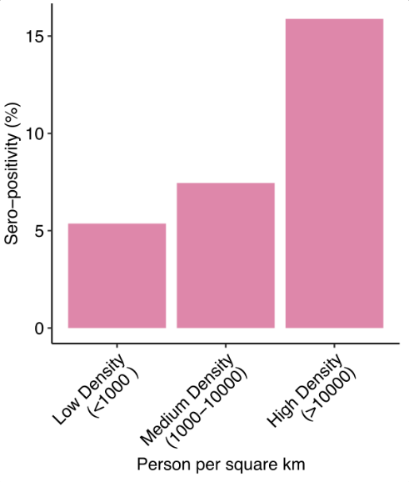

eFigure 1: Population Density wise seropositivity for cities sampled.

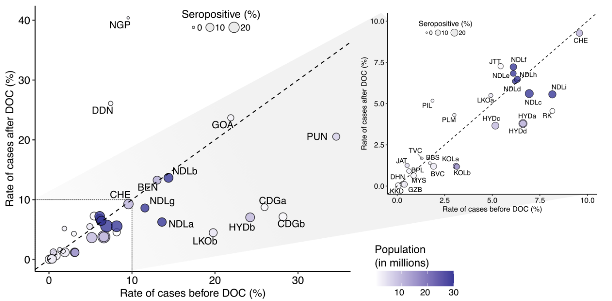

eFigure 2The rate of cases (total cases in the district/number of samples tested in the district*) pre and post 30 days of sample colletion date for serology (DOC). The region bounded by the square is shown as an inset. The population density of the cities are represented as a colour gradient (white to blue) while the size of the circles represent the seropositivity (%). The cities are denoted by three letter code: Bengaluru (BEN), Bhavnagar (BVC), Bhopal (BPL), Bhubaneshwar (BBS), Chandigarh (CDG), Chennai (CHE), Dehradun (DDN), Dhanbad (DHN), Ghaziabad (GZB), Goa (GOA), Hyderabad (HYD), Jorhat (JTT), Karaikudi (KKD), Kolkata (KOL), Lucknow (LKO), Mysuru (MYS), Nagpur (NGP), New Delhi (NDL), Palampur (PLM), Pilani (PIL), Pune (PUN), Roorkee (RK), Thiruvananthapuram (TVC), Jammu and Kashmir (JAT). Cities with multiple Institutes have been designated by alphabets as superscipt (Details in Supplementary Table 1). *For a few cities, district wise data for number of samples tested was not avaibale and hence state data has been utilzed as a surrogate).

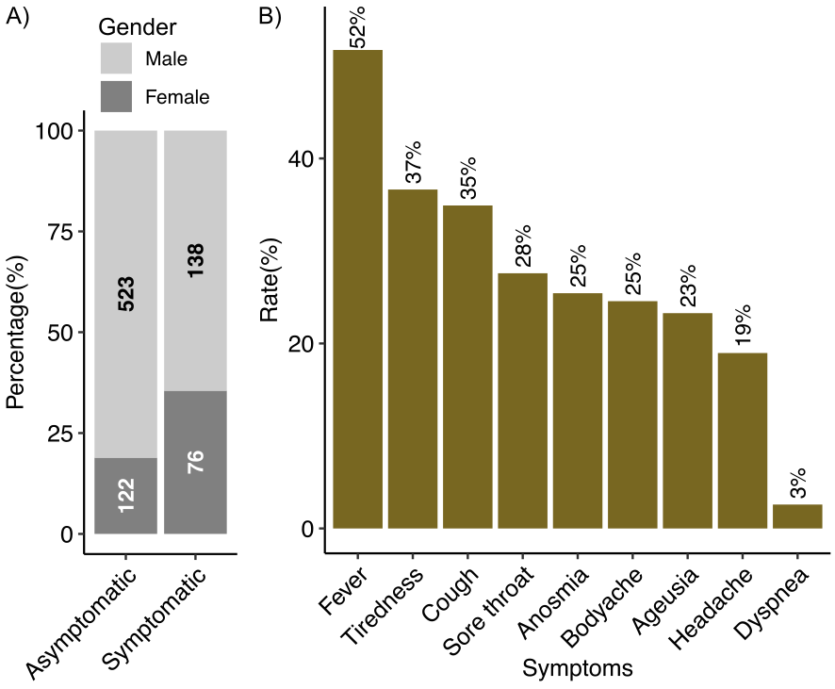

eFigure 3: A) Male: Female distribution amongst asymptomatic and symptomatic seropositive individuals. Frequency of symptoms in symptomatic seropositive individuals.