AUTOMATED PROCESSING OF THERMAL IMAGING TO DETECT COVID-19

SUPPLEMENTARY INFORMATION

Supp Figure 1: Lower back region of interest

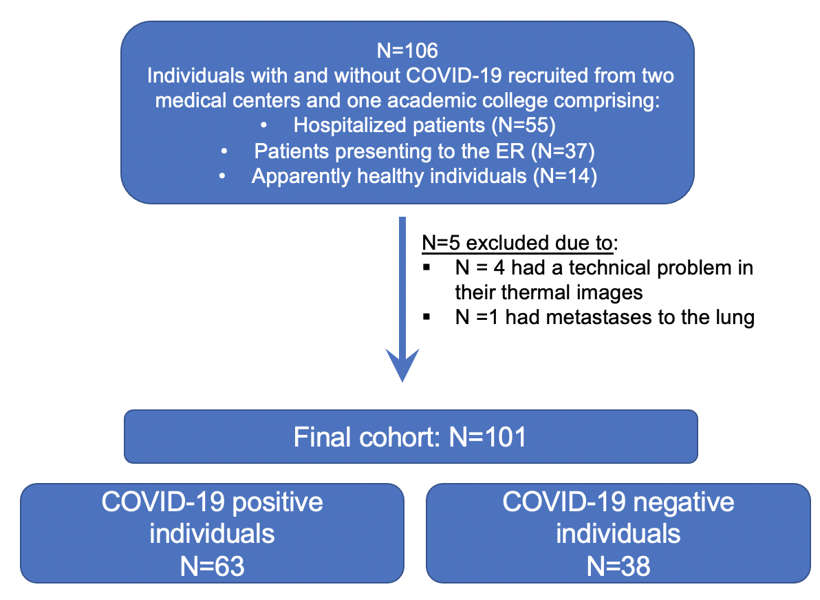
Supp Figure 2: Research design and patient selection
Supp Table 1: Sensitivity and specificity values of all three machine learning models according to training and validation phases

Phases and variables/model | Logistic regression |  | k-nn (k=3) |  | k-nn (k=7) |  | Kernel-SVM
 | Sensitivity | Specificity | Sensitivity | Specificity | Sensitivity | Specificity | Sensitivity | Specificity
Training set:  FD, SX | 82% | 84% | 78% | 66% | 80% | 63% | 88% | 59%
Validation set:  FD, SX | 69% | 100% | 77% | 71% | 77% | 71% | 77% | 57%
Training set:  FD, SX, Age, Sex | 82% | 81% | 82% | 47% | 83% | 53% | 83% | 59%
Validation set:  FD, SX, Age, Sex | 69% | 100% | 77% | 43% | 85% | 29% | 85% | 71%

* FD - Fractal dimension; SX – Sum of Extrema; k-nn - k-nearest neighbors; kernel-SVM - support machine vector.

