**SUPPLEMENTARY FILE**

**Unraveling COVID-19-related hospital costs: The impact of clinical**

**and demographic conditions**

**Miethke-Morais et al. 2020.**

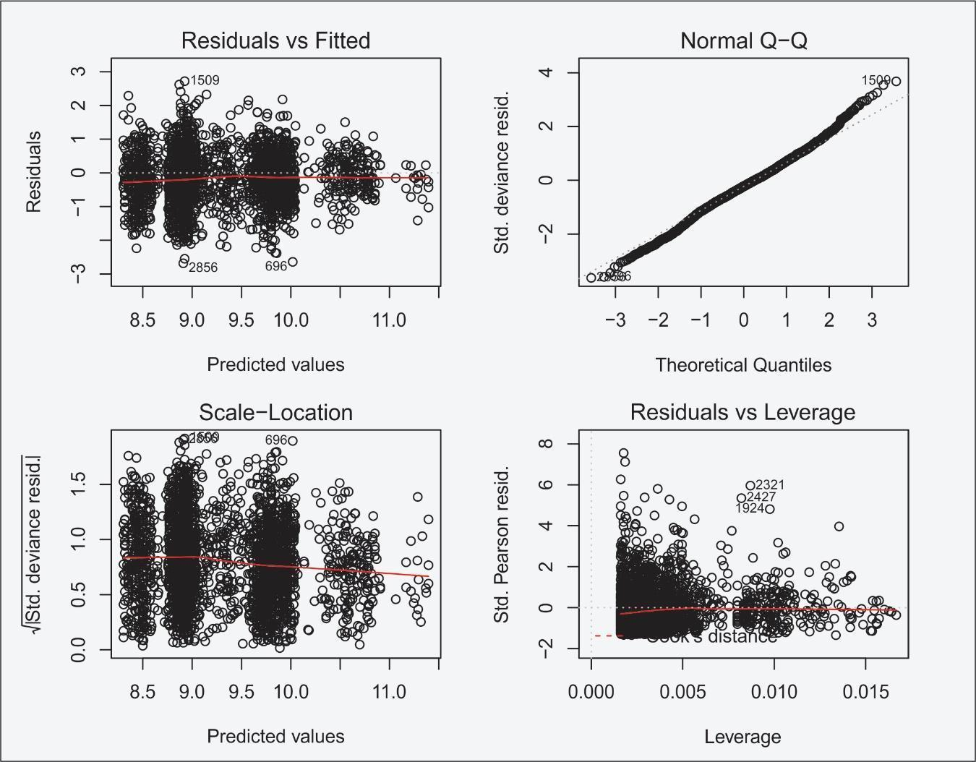

**Supplementary Figure 1.** Basic diagnostic plot of the multiple gamma generalized linear models (GLMs) for y with a log link function

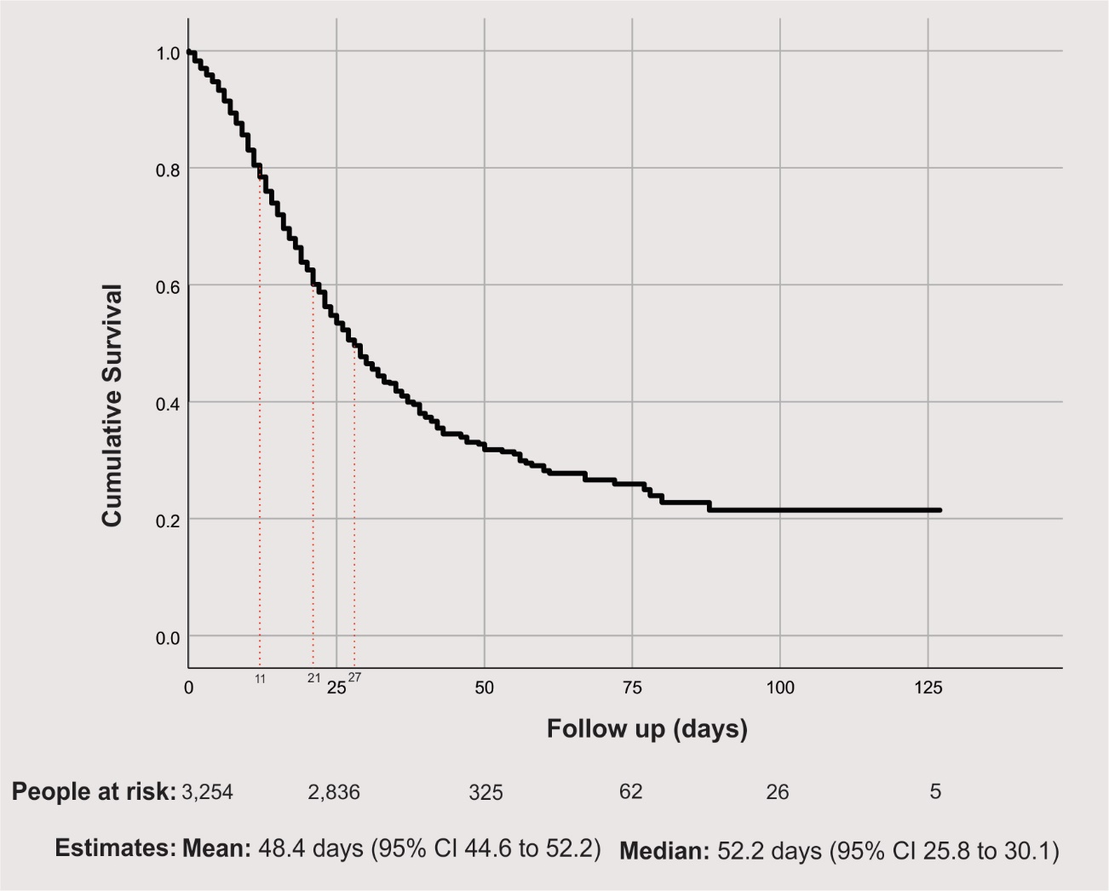

**Supplementary Figure 2.** General survival, where dotted red lines indicate a 20%, 40% and 50% risk of death