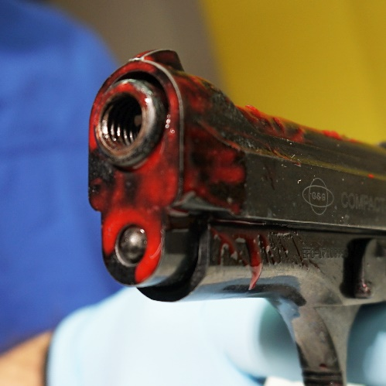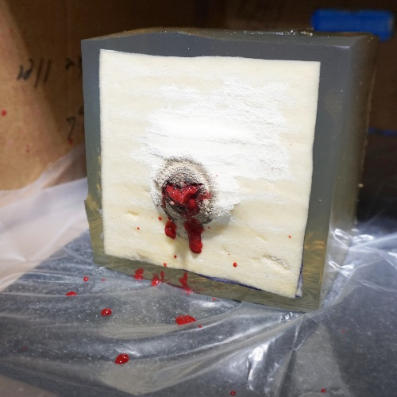  A  D | 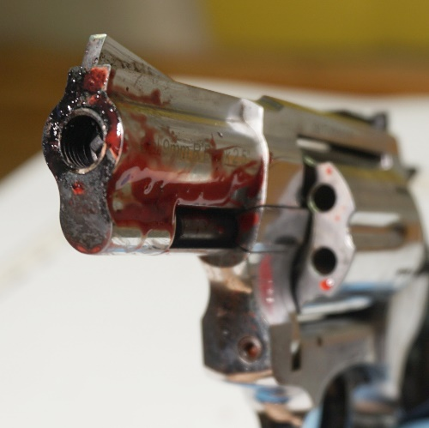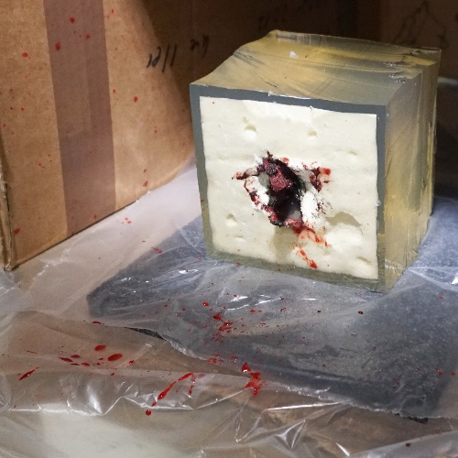  B  E | 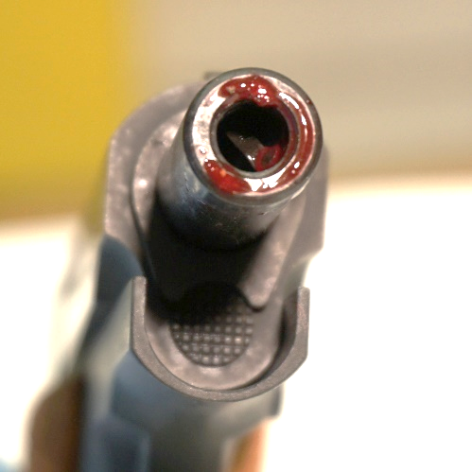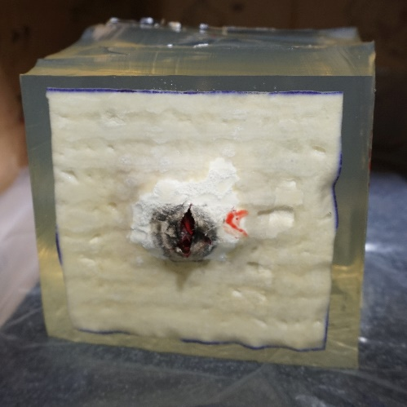  C  F
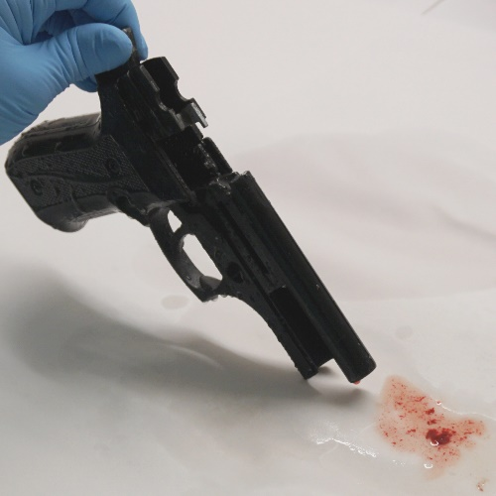  G | 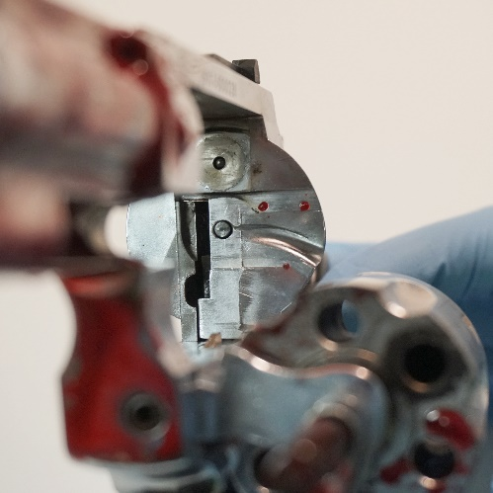  H | 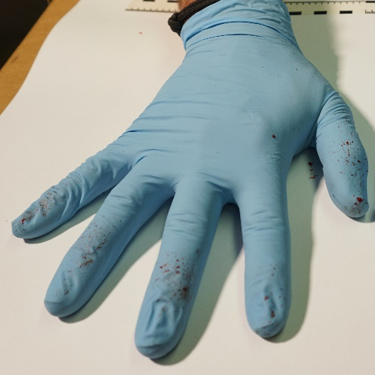  I
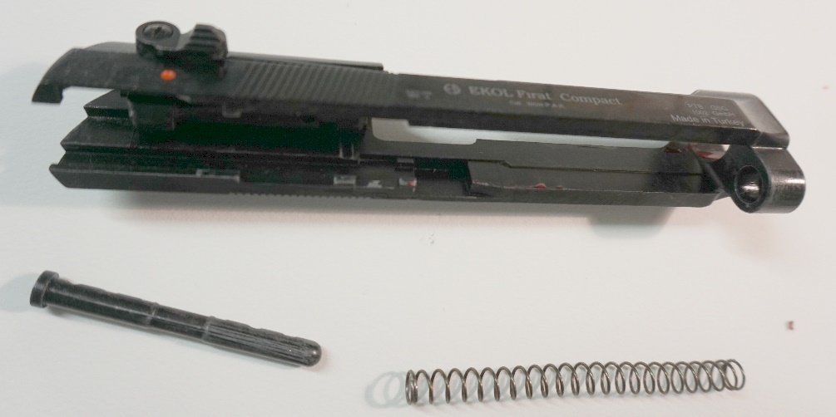
J
Figure 1
A Backspatter traces on Ekol pistol, after shot with Özkursan 9 mm ammunition B Backspatter traces on Zoraki revolver, after shot with Nobel black powder 9 mm ammunition C Backspatter traces on Reck pistol, after shot with Walther 8 mm ammunition D Gelatin block with double layer of chamois leather, after shot with Özkursan 9 mm ammunition E Gelatin block with single layer of chamois leather, after shot with Nobel black powder 9 mm ammunition F Gelatin block with single layer of chamois leather, after shot with Walther 8 mm ammunition G Flowthrough of barrel (see main text for context) H Backspatter traces on the revolver’s recoil shield I Backspatter on shooting hand J Backspatter traces on the slide of the Ekol pistol

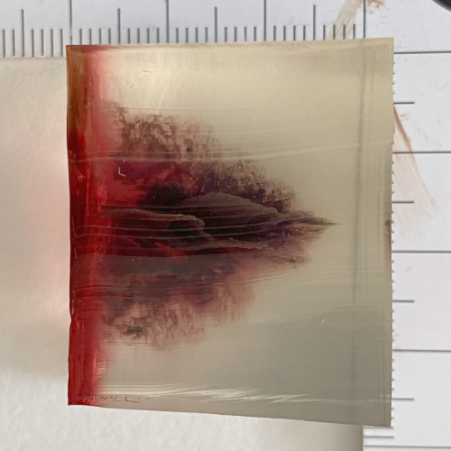 | 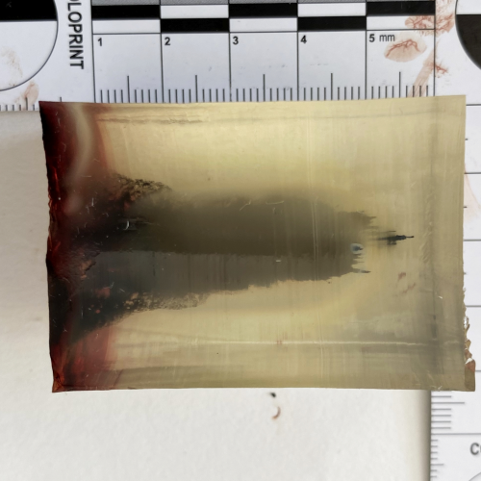 | 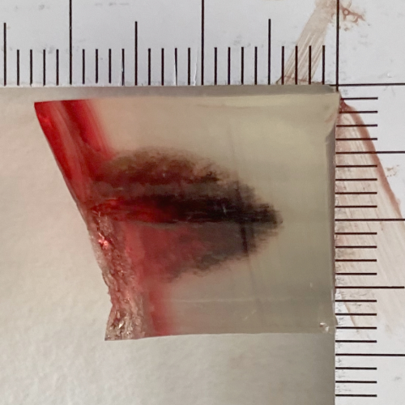
Figure 2
C
B
A
Wound channels in gelatin blocks after shots with A Ekol pistol, Özkursan 9mm nitrocellulose ammunition, to single layer chamois leather with vacuum bag, B Zoraki revolver, Nobel black powder 9 mm ammunition, to single layer chamois leather with vacuum bag, C Reck pistol, Walther 9 mm nitrocellulose ammunition, to single layer of chamois leather

