Rapid and lasting generation of B cell memory to SARS-CoV-2 spike and nucleocapsid proteins in COVID-19 disease and convalescence
Supplementary Tables (n= 4) and Figures (n=6)

Supplementary Table 1. Composition of the antibody panels
 | Fluorochrome
Tube | BUV395 | BUV496 | BUV737 | BV421 | BV480/  BV510 | BV605 | BV650 | BV711 | BV786 | FITC/  BB515 | PerCP-Cy5.5/  BB700 | PE | PE- CF594/ PE-Vio615 | PC7/  PE-Cy7 | APC | AF700 | APC-Cy7 / APC-H7
1. TruCount | - | - | - | - | - | - |  | - | - | CD3 | CD45 | CD16 + CD56 | - | CD4 | CD19 | - | CD8A
2. Ag-specific Bmem | NCP | CD3 | NCP | CD27 | RBD | - | RBD | CD21 | CD71 | IgG2 + IgG3 | IgD | IgG1 + IgG2 | IgA | CD19 | IgG4 | Viability | CD38
3. Streptavidin control | Strep | - | Strep | CD27 | Strep | - | Strep | - | - | CD3 | IgD | - | - | CD19 | - | Viability | -
4. T-effector | - | - | - | CD27 | CD4 | CD45RA | - | CD3 | - | CD45RO | CD28 | CD31 | CCR7 | TCRγδ | HLA-DR | - | CD8A
5. Th subset | - | - | - | CD25 | CD4 | CD45RA | - | CD3 | - | CXCR5 | CCR6 | CXCR3 | CCR7 | CCR4 | CD127 | - | CD8A

Supplementary Table 2. Antibody list
Marker | Fluorochrome | Clone | Source | Cat. number |  | Volume/  test (μl) | Tube(s)
CD3 | BUV496 | UCHT1 | BD Bioscience | 612940 | 1 |  | 2
CD3 | FITC | UCHT1 | BD Biosciences | 555332 | 3 / 1 |  | 1 / 3
CD3 | BV711 | UCHT1 | BD Biosciences | 563725 | 2.5 |  | 4 / 5
CD4 | PC7 | SFCI12T4D11 | Beckman Coulter | 6607101 | 0.2 |  | 1
CD4 | BV510 | RPA-T4 | Biolegend | 300546 | 1.5 |  | 4 / 5
CD8A | APC-H7 | SK1 | BD Biosciences | 560179 | 4 |  | 1
CD16 | PE | B73.1 | Biolegend | 360704 | 0.2 |  | 1
CD19 | APC | SJ25C1 | Biolegend | 363006 | 0.4 |  | 1
CD19 | PE-CY7 | SJ25C1 | BD Biosciences | 557835 | 5 |  | 2
CD21 | BV711 | B-ly4 | BD Biosciences | 563163 | 5 |  | 2
CD25 | BV421 | BC96 | Biolegend | 302630 | 2.5 |  | 5
CD27 | BV421 | M-T271 | BD Biosciences | 562513 | 1 |  | 2 / 3
CD28 | PerCP-Cy5.5 | CD28.8 | Biolegend | 302922 | 5 |  | 4
CD31 | PE | WM59 | BD Biosciences | 555446 | 5 |  | 4
CD38 | APC-Cy7 | HIT2 | Biolegend | 303534 | 0.2 |  | 2
CD45 | PerCP-Cy5.5 | 2D1 | BD Biosciences | 340953 | 2 |  | 1
CD45RA | BV605 | HI100 | Biolegend | 304134 | 0.2 |  | 4 / 5
CD45RO | FITC | UCHL1 | Biolegend | 304204 | 5 |  | 4
CD56 | PE | B159 | BD Biosciences | 555516 | 5 |  | 1
CD71 | BV786 | M-A712 | BD Biosciences | 563768 | 1 |  | 2
CD127 | APC | A019D5 | Biolegend | 351316 | 5 |  | 5
CCR4 | PE-CY7 | L291H4 | Biolegend | 359410 | 5 |  | 5
CCR6 | PerCP-CY5.5 | G034E3 | Biolegend | 353406 | 2.5 |  | 5
CCR7 | PE CF594 | 150503 | BD Biosciences | 562381 | 5 |  | 4 / 5
CXCR3 | PE | 1C6/CXCR3 | BD Biosciences | 557185 | 20 |  | 5
CXCR5 | BB515 | RF8B2 | BD Biosciences | 564624 | 5 |  | 5
HLA-DR | APC | L243 | Biolegend | 307610 | 2 |  | 4
IgA | PE-Vio615 | REA1014 | Miltenyi Biotec | 130-116-882 | 1.5 |  | 2
IgD | BB700 | IA6-2 | BD Biosciences | 566538 | 1 |  | 2
IgG1 | PE | SAG1 | Cytognos | CYT-IGG1PE | 1 |  | 2
IgG2 | FITC | SAG2 | Cytognos | CYT-IGG2F | 2 |  | 2
IgG2 | PE | SAG2 | Cytognos | CYT-IGG2PE | 2 |  | 2
IgG3 | FITC | SAG3 | Cytognos | CYT-IGG3F | 2 |  | 2
IgG4 | APC | SAG4 | Cytognos | CYT-IGG4AP | 2 |  | 2
IgM | BV510 | MHM-88 | Biolegend | 314522 | 1 |  | 2 / 3
Strep | BUV395 | - | BD Biosciences | 564176 | 0.36 |  | 3
Strep | BUV737 | - | BD Biosciences | 564293 | 0.36 |  | 3
Strep | BV480 | - | BD Biosciences | 564876 | 0.67 |  | 3
Strep | BV650 | - | Biolegend | 405232 | 0.13 |  | 3
TCRγδ | PC7 | IMMU510 | Beckman Coulter | B10247 | 1 |  | 4
Viability | AF700 | - | BD Biosciences | 564997 | 0.1 |  | 2 / 3

Supplementary Table 3. Flow cytometer set-up
LSRFortessa X-20 |  | LSRII |  | Fluorochromes used in this study
355 nm |  | -
379/28 | No LP | - | - | BUV395
525/50 | 505 LP | - | - | BUV496
740/35 | 690 LP | - | - | BUV737
405 nm |  | 405 nm
450/50 | No LP | 450/50 | No LP | BV421
525/50 | 505 LP | 525/50 | 505 LP | BV480, BV510
- | - | 586/15 | 570 LP | -
610/20 | 600 LP | 610/20 | 600 LP | BV605
670/30 | 635 LP | 660/20 | 630 LP | BV650
710/50 | 685 LP | 710/50 | 685 LP | BV711
780/60 | 750 LP | 780/60 | 750 LP | BV786
488 nm |  | 488 nm
488/10 | No LP | 488/10 | No LP | SSC
530/30 | 505 LP | 530/30 | 505 LP | FITC, BB515
710/50 | 685 LP | 710/50 | 630 LP | PerCP-Cy5.5, BB700
561 nm |  | 561 nm
586/15 | No LP | 582/15 | No LP | PE
610/20 | 600 LP | 610/20 | 600 LP | PE-CF594, PE-Vio615
675/50 | 635 LP | 685/35 | 635 LP | -
780/60 | 750 LP | 780/60 | 750 LP | PE-Cy7, PC7
640 nm |  | 640 nm
670/30 | No LP | 670/14 | No LP | APC
730/45 | 690 LP | 730/45 | 690 LP | Fixable Viability Stain 700
780/60 | 750 LP | 780/60 | 750 LP | APC-H7, APC-Cy7

Supplementary Table 4. Target values for 7th peak of rainbow beads in fluorescent channels
Fluorochrome | Channel | Lower (-15%) | Target MFI | Upper (+15%) | Recommendation
BUV395 | UV395 | 17,000 | 20,000 | 23,000 | In-house
BUV496 | UV525 | 23,800 | 28,000 | 32,200 | In-house
BUV737 | UV737 | 21,2500 | 25,000 | 28,750 | In-house
BV421 | V450 | 100,452 | 118,178 | 135,905 | EuroFlow
BV480/BV510 | V525 | 93,871 | 110,436 | 127,002 | EuroFlow
BV605 | V610 | 47,731 | 56,154 | 64,577 | In-house
BV650 | V670 | 34,383 | 40,450 | 46,518 | In-house
BV711 | V710 | 15,079 | 17,740 | 20,401 | In-house
BV786 | V780 | 1,903 | 2,239 | 2,575 | In-house
FITC/BB515 | B530 | 28,752 | 33,826 | 38,900 | EuroFlow
PerCP-Cy5.5/ BB700 | B710 | 66,846 | 78,642 | 90,438 | EuroFlow
PE | YG586 | 32,381 | 38,095 | 43,809 | EuroFlow
PE-CF594/  PE-Vio615 | YG610 | 178,500 | 210,000 | 241,500 | In-house
PE-Cy7 | YG780 | 8,316 | 9,783 | 11,250 | EuroFlow
APC | R670 | 158,639 | 186,634 | 214,629 | EuroFlow
AF700 | R730 | 121,550 | 143,000 | 164,450 | In-house
APC-H7 | R780 | 64,194 | 75,522 | 86,850 | EuroFlow
Spherotech Rainbow Calibration particles (8 peaks) 3.41µm; cat nr. RCP-30-5A, Lot No. EAG01
As per EuroFlow recommendation (Kalina et al. 2012)

Supplementary Figures (n=6)

Supplementary Figure 1. Absolute numbers of plasmablasts in COVID-19 patients
A) Examples of plasmablast populations (CD38^{high}CD27⁺) gated within total CD19⁺ B cells of two patients: patient 2, early in SARS-CoV-2 infection and patient 18, in convalescence (Tables 1 and 2). B) Absolute numbers of plasmablasts in 25 COVID-19 patients of which 11 patients sampled twice. Paired samples are connected with black lines.

Supplementary Figure 2. Frequencies of RBD- and NCP-specific IgG⁺ Bmem cells expressing CD27. Frequencies of A) RBD-specific (RBD⁺) and B) NCP-specific (NCP⁺) IgG⁺ Bmem cells expressing CD27 versus time since symptom onset for 25 COVID-19 patients, with 11 patients sampled twice. Paired samples are connected with grey lines.

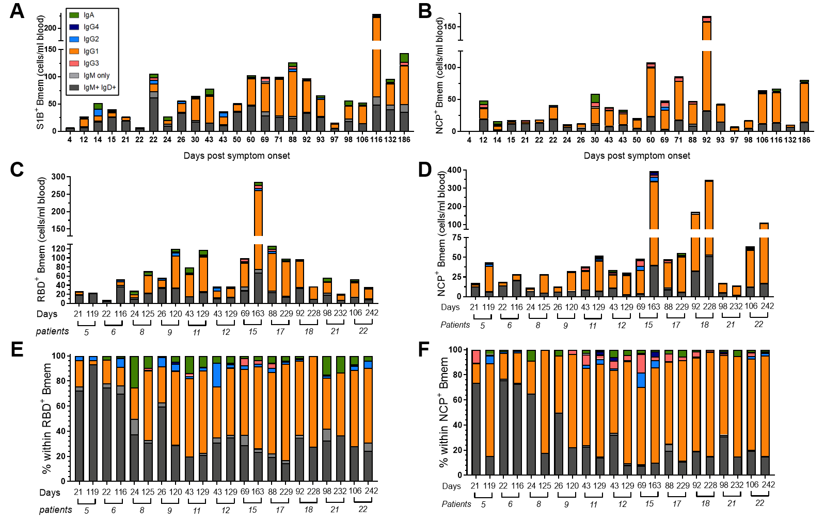Supplementary Figure 3. Absolute numbers and frequencies RBD- and NCP-specific Bmem cells expressing distinct Ig isotypes and IgG subclasses. Absolute numbers of A) RBD-specific (RBD⁺) and B) NCP-specific (NCP⁺) Bmem cells in all first samples of 25 patients. Absolute numbers of C) RBD⁺ and D) NCP⁺ Bmem cells from 11 paired samples. Relative distributions of Ig isotype and IgG subclass expression subsets within E) RBD⁺ and F) NCP⁺ Bmem cells for 11 paired samples. In all panels, patients are ordered by days post-symptom onset.

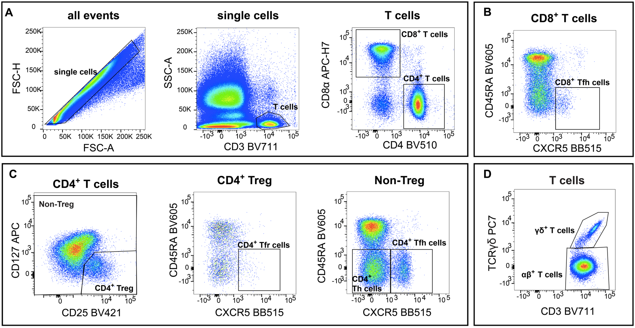 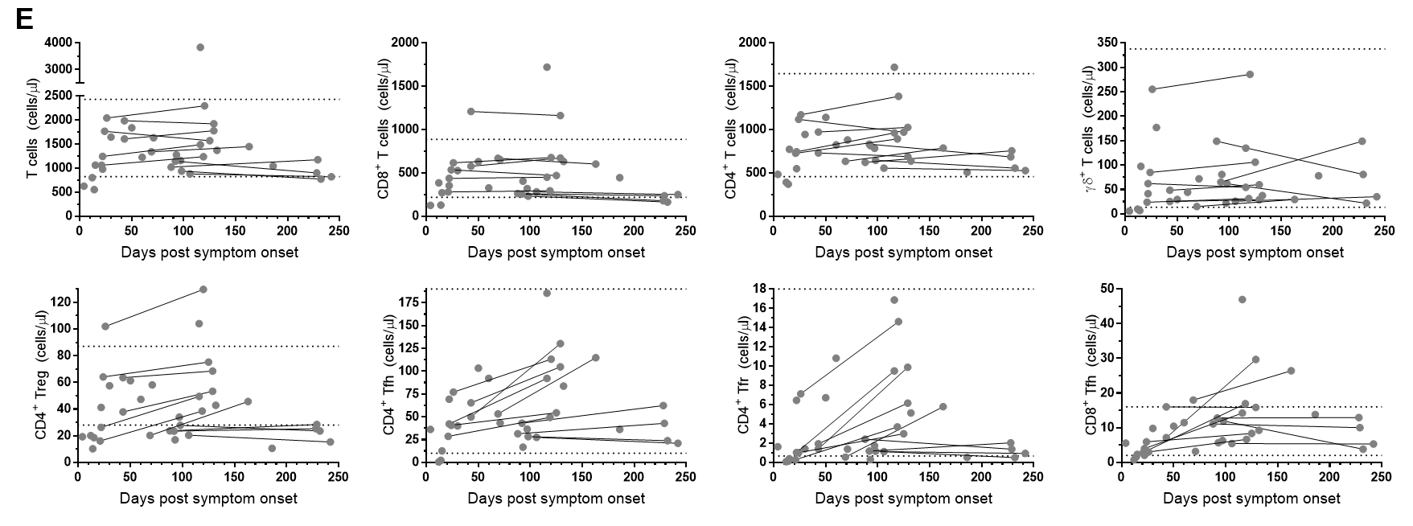Supplementary Figure 4. Absolute numbers of T helper cell subsets in COVID-19 patients. A) Gating strategy to delineate CD3⁺, CD4⁺ and CD8⁺ T cells. B) CD8⁺ Tfh gating within total CD8⁺ T cells. C) Gating strategies for CD4+ Treg, Tfr and Tfh cells. D) Gating strategy for γδ⁺ T cells within the total CD3⁺ population. E) Absolute numbers of total T cells, CD8⁺, CD4⁺, γδ⁺, CD4⁺ Treg, CD4⁺ Tfr, CD4⁺Tfh, and CD8⁺ Tfh subsets are plotted versus days post-symptom onset for 25 COVID-19 patients, with seven patients sampled twice. Paired samples are connected with grey lines. Horizontal dotted lines represent the 5th and 95th percentiles of the control group as defined previously (Edwards et al. 2019). Statistics were performed using the Wilcoxon matched-pairs signed rank test and the non-parametric Spearman’s rank correlation; * p < 0.05.
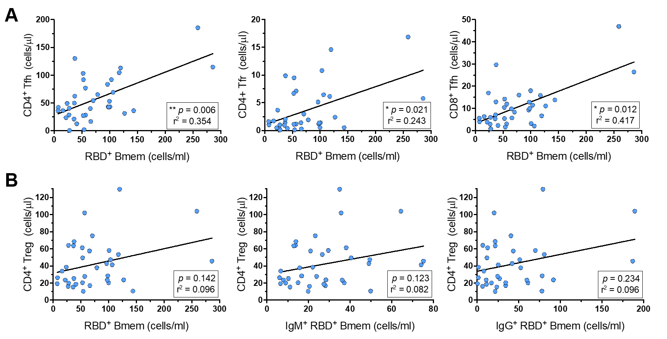Supplementary Figure 5. Correlations between absolute numbers of RBD-specific Bmem and T helper cell subsets.
A) Correlations between absolute numbers of RBD-specific (RBD⁺) Bmem cells and CD4⁺ Tfh, CD4⁺ Tfr and CD8⁺ Tfh cells. B) Correlations between CD4⁺ Treg cells and RBD⁺ Bmem cells, IgM⁺ Bmem cells and IgG⁺ Bmem cells. For population definitions, see Supplementary Figure 4. Trend lines depict linear correlations, statistics were performed using the non-parametric Spearman’s rank correlation; * p < 0.05, ** p < 0.01.

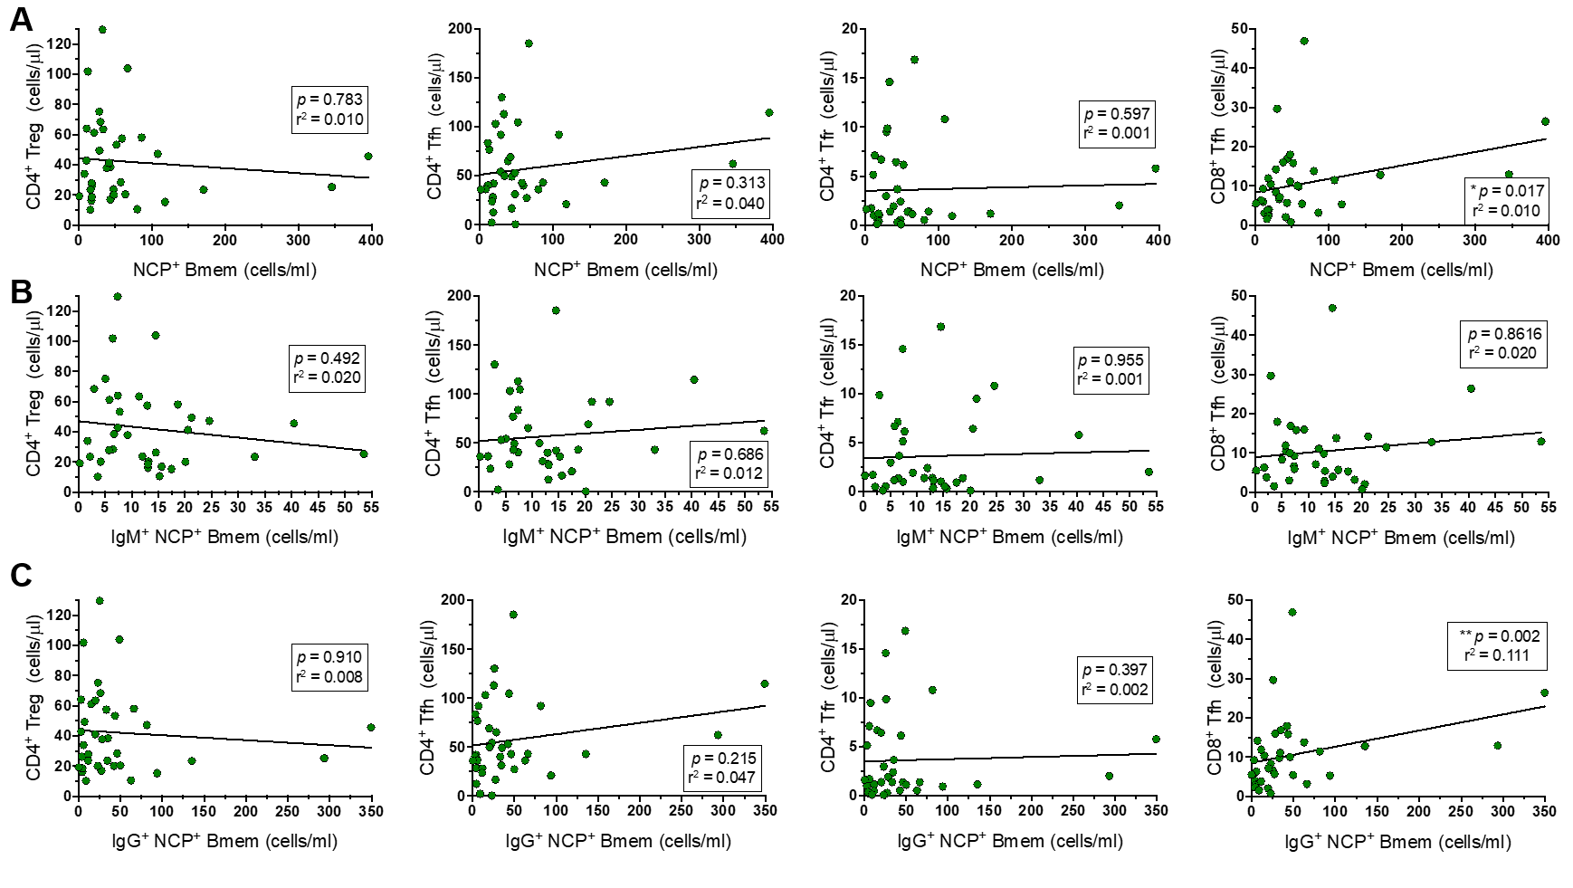Supplementary Figure 6. Correlations between absolute numbers of NCP-specific Bmem and T helper cell subsets. Correlations between CD4⁺ Treg, CD4⁺ Tfh, CD4⁺ Tfr and CD8⁺ Tfh cells and A) NCP-specific (NCP⁺) Bmem cells, B) NCP⁺ IgM⁺ Bmem cells and C) NCP⁺ IgG⁺ Bmem cells. For population definitions, see Supplementary Figure 4. Trend lines depict linear correlations, statistics were performed using Spearman’s rank correlation; * p < 0.05, ** p < 0.01.

