**Supplementary Material**

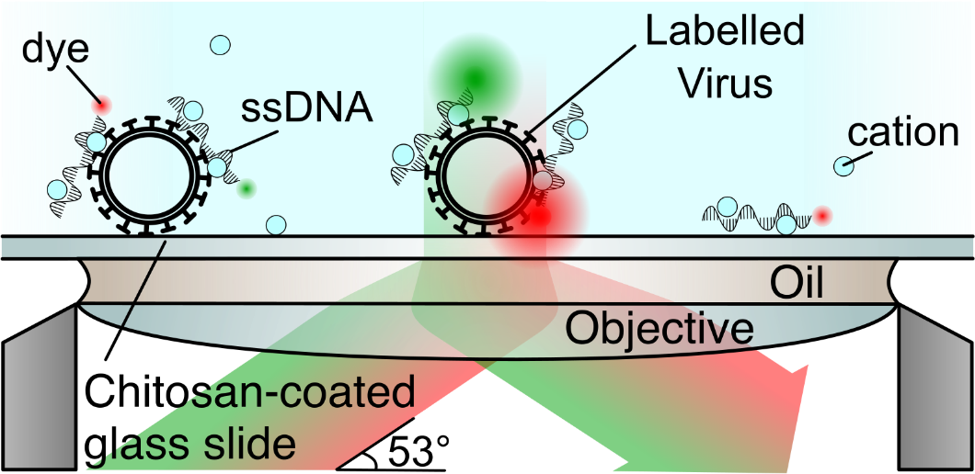

**Sup. Fig. 1. Schematic of virus labelling and immobilisation strategy.** Positively charged cations (e.g. calcium, strontium) bridge the lipid membrane of the virus and the negatively charged phosphate groups on the ssDNA, binding fluorescently labelled ssDNA to the surface of the virus. Labelled viruses were immobilised on a chitosan-coated glass slide and illuminated with red and green laser light on a widefield Total Internal Reflection Fluorescence (TIRF) microscope.

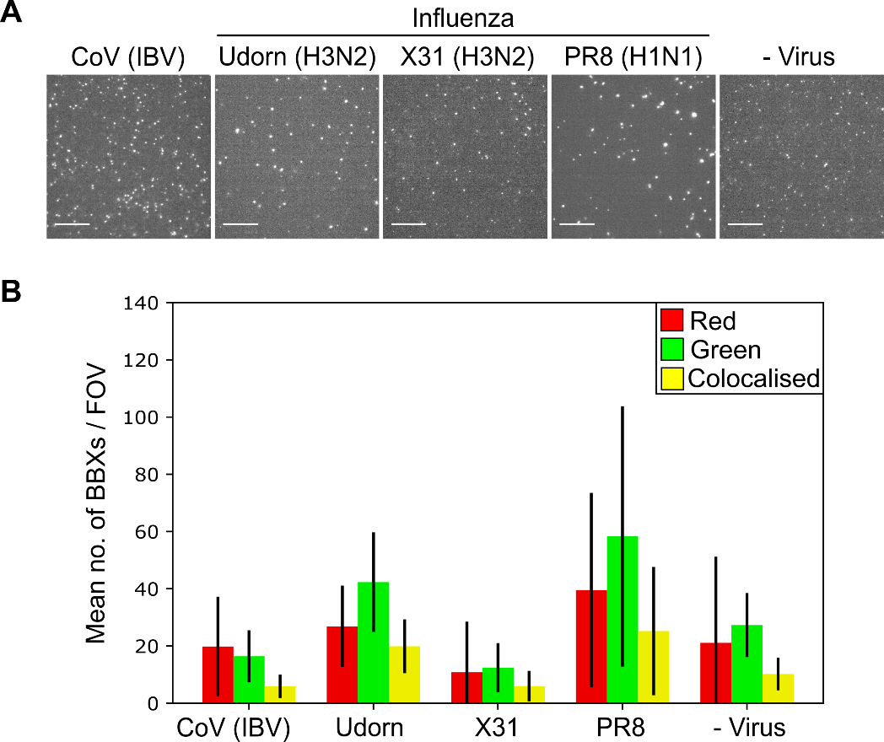

**Sup. Fig. 2. Imaging and segmentation comparison of four different viruses.** A) Representative fields of view (FOVs) of fluorescently labelled CoV (IBV), influenza A (Udorn, X31 and PR8) and a virus-negative control (- Virus). The samples were immobilized and labelled with 0.23M CaCl2, 1nM Cy3 (green) DNA and 1nM Atto647N (red) DNA before being imaged. FOVs from the red channel are shown. Scale bar 10µm. B) Plot showing the mean number of BBXs per FOV for each sample.

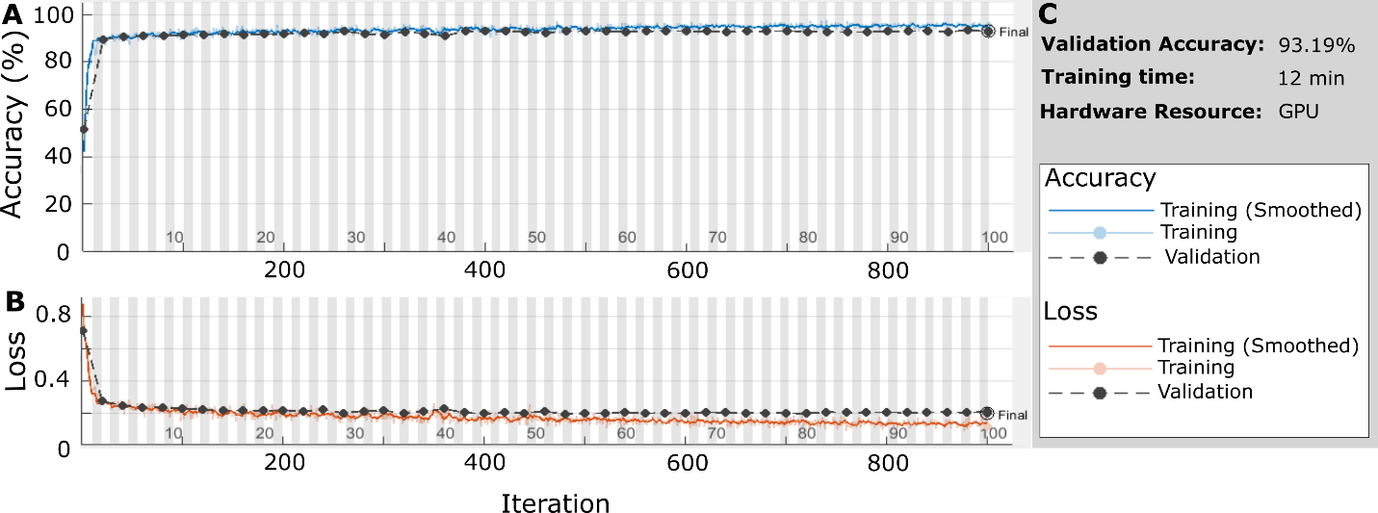

**Sup. Fig. 3 Training Progress for CoV (IBV) and the virus-negative control (- Virus).** A) Graph describing the validation accuracy of the network per iteration. B) Graph showing the loss function value for each iteration. C) Overall validation accuracy and training time.

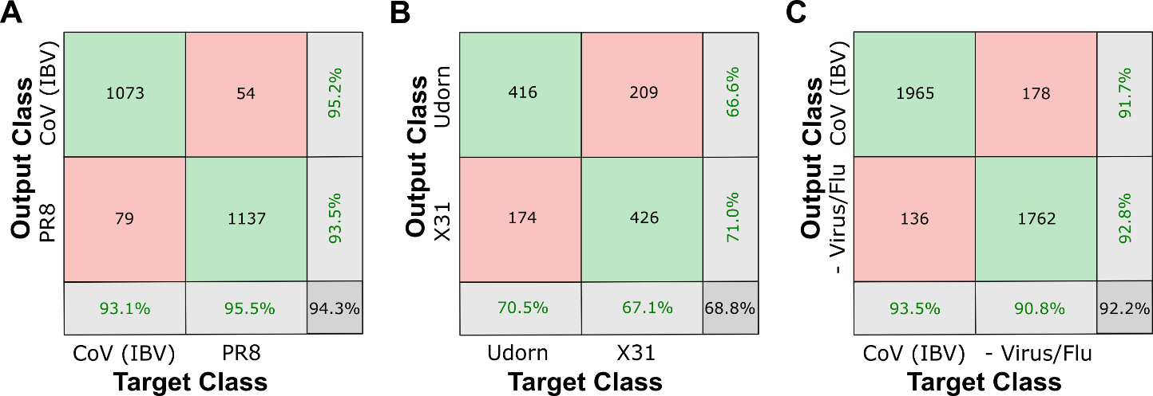

**Sup. Fig. 4. Network validation results for laboratory grown virus strains.** A)Confusion matrix showing that a trained network could differentiate between CoV (IBV) and the influenza strain PR8. B) Confusion matrix showing that a trained network could differentiate between two strains of influenza (Udorn and X31). C) Confusion matrix showing that a trained network could differentiate between CoV (IBV) and a pooled dataset consisting of the virus-negative control (- Virus) and the three influenza A (Flu) strains.

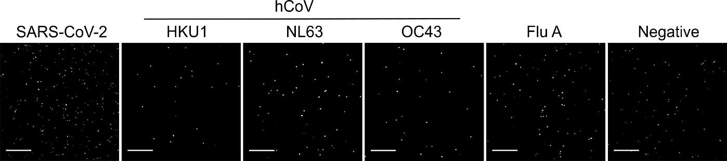

**Sup. Fig. 5. Imaging comparison of clinical samples.** Representative FOVs of fluorescently labelled SARS-CoV-2, three seasonal human coronaviruses hCoV, influenza A (Flu A) and a virus-negative control. The samples were immobilized and labelled with 0.23M CaCl2, 1nM Cy3 (green) DNA and 1nM Atto647N (red) DNA before being imaged. FOVs from the red channel are shown. Scale bar 10µm.

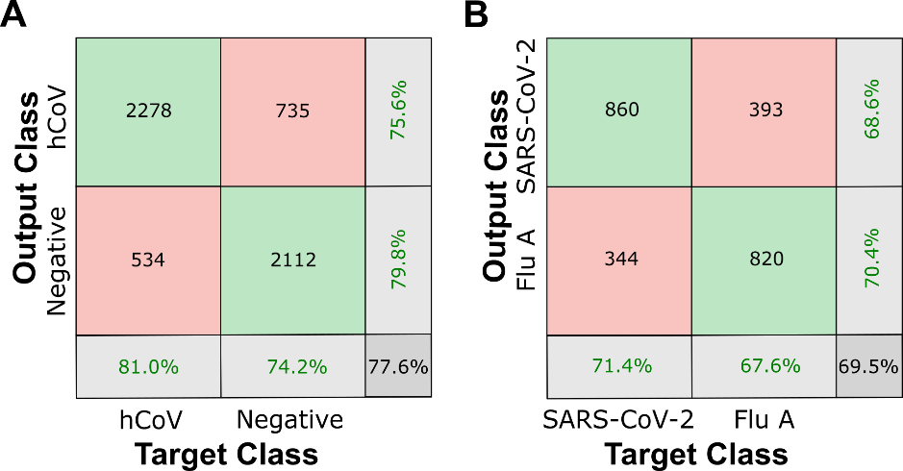

**Sup. Fig. 6. Network validation results for clinical samples.** A)Confusion matrix showing that a trained network could differentiate between seasonal human coronaviruses hCoV and negative samples. B) Confusion matrix showing that a trained network could differentiate between clinical influenza A samples (Flu A) and SARS-CoV-2 positive samples.

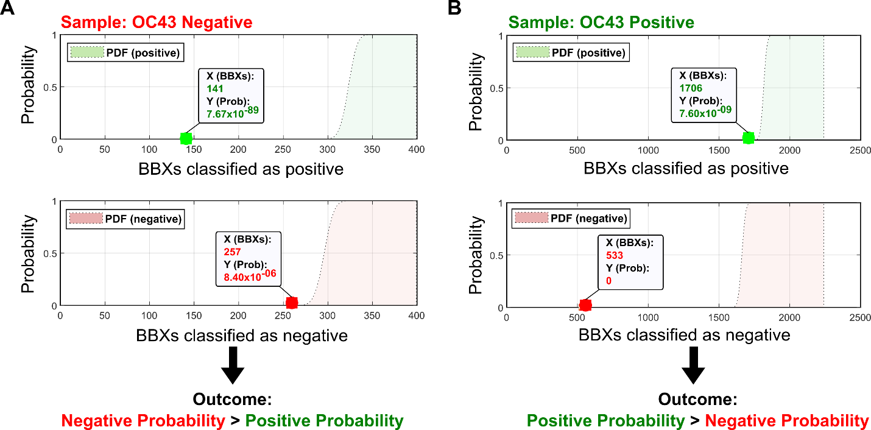

**Sup. Fig. 7. A deep learning network can diagnose the seasonal human OC43 coronavirus in clinical samples.** A) Output from running an RT-PCR confirmed OC43 negative sample through the trained network. The cumulative probability distribution function (PDF) assuming a sample is positive is shown in green (top panel), or assuming a sample is negative is shown in red (lower panel). Number of BBXs (X) and their associated probability values (Y) are given. B) Output from running an RT-PCR confirmed OC43 positive sample through the trained network.

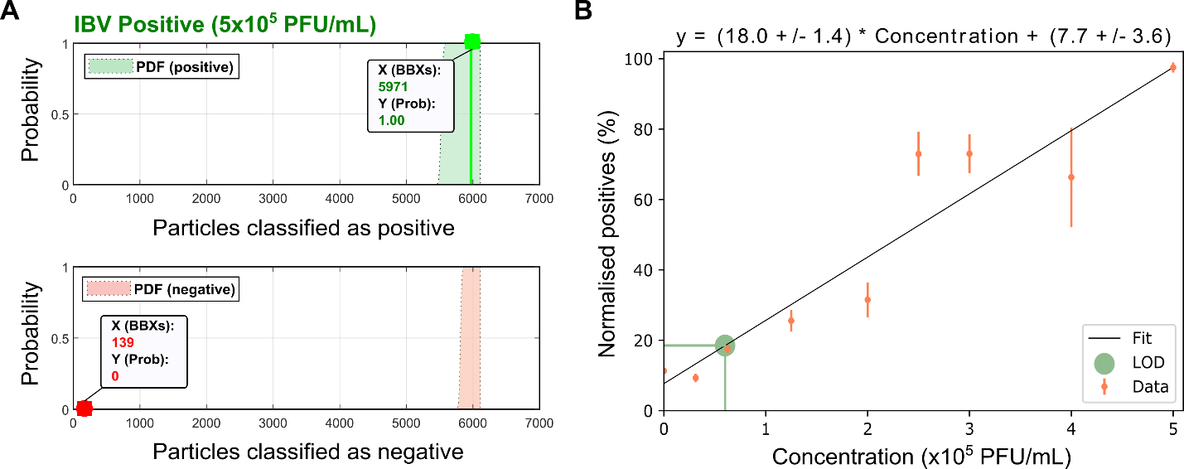

**Sup. Fig. 8. Defining the limit of detection for accurate machine learning classification.** A) Example output from running an IBV positive sample (at a concentration of 5x105 PFU/mL) through the trained network. The cumulative probability distribution function (PDF) assuming a sample is positive is shown in green (top panel), or assuming a sample is negative is shown in red (lower panel). Number of BBXs (X) and their associated probability values (Y) are given. B) The number of normalised positive particles (positive particles/all particles) increases linearly with increasing virus concentration. Error bars represent standard deviation. The limit of detection (LOD) was defined as 6x104 PFU/mL, with 99.85% certainty.

|  |  |  |  |  |  |  |
| --- | --- | --- | --- | --- | --- | --- |
|  | | | BBXs classified as: | | % BBXs classified as: | |
| Network | RT-PCR | Total # of BBXs | hCoV | Negative | hCoV | Negative |
| hCoV vs Negative | NL64 | 6467 | 4271 | 2196 | 0.66 | 0.34 |
| NL63 | 2672 | 1307 | 1365 | 0.49 | 0.51 |
| NL63 | 227 | 111 | 116 | 0.49 | 0.51 |
| OC43 | 2239 | 1706 | 533 | 0.76 | 0.24 |
| OC43 | 653 | 442 | 211 | 0.68 | 0.32 |
| OC43 | 840 | 555 | 285 | 0.66 | 0.34 |
| HKU1 | 6745 | 3797 | 2948 | 0.56 | 0.44 |
| NEG | 514 | 198 | 316 | 0.39 | 0.61 |
| NEG | 398 | 141 | 257 | 0.35 | 0.65 |
| NEG | 154 | 29 | 125 | 0.19 | 0.81 |
|  | | | SARS-CoV-2 | hCoV | SARS-CoV-2 | hCoV |
| SARS-CoV-2 vs hCoV | SARS-CoV-2 | 5589 | 3653 | 1936 | 0.65 | 0.35 |
| SARS-CoV-2 | 1762 | 1312 | 450 | 0.74 | 0.26 |
| SARS-CoV-2 | 284 | 86 | 198 | 0.30 | 0.70 |
| HKU1 | 1342 | 159 | 1183 | 0.12 | 0.88 |
| HKU1 | 1898 | 593 | 1305 | 0.31 | 0.69 |
| HKU1 | 3182 | 654 | 2528 | 0.21 | 0.79 |
| NL63 | 305 | 12 | 293 | 0.04 | 0.96 |
| NL63 | 968 | 89 | 879 | 0.09 | 0.91 |
| NL63 | 2269 | 349 | 1920 | 0.15 | 0.85 |

**Sup. Table 1.** **Results of testing the ability of the CNN to categorise samples imaged on a different day.** The network was trained and validated on data acquired on days 1-3. The same samples used for training and validation were then imaged on day 4, and this data was run through the trained network. NEG = negative. HKU1, NL63 and OC43 refer to samples positive for seasonal human coronaviruses (hCoV). Green coloured boxes represent samples confirmed as virus-positive by RT-PCR and the CNN, red coloured boxes represent samples confirmed as virus-negative by RT-PCR and the CNN. Red dotted boxes represent samples where the CNN gave a different outcome to the RT-PCR result (using the majority of BBXs as a metric).