Appendix A. Annotation agreement code.
Appendix B. Steps of the self-developed system for automated EEG analysis in the monitoring of patients with NCSE.
Steps for analyzing EEG signals in our self-developed system |  | Remarks
- Preprocessing | - Band-pass filtered [0.5-45 Hz];  - Subtract the average of all channel data from each channel data | To reduce interference caused by muscle or movement artefacts and direct current offsets.
- Feature extraction | - Commonly used time-frequency features in ictal detection: (Wang et al., 2017; Aldana et al., 2019)  - approximation and detail coefficients corresponding to brain wave bands via wavelet decomposition analysis using wavelet Daubechies 4;  - power spectrum within each brain wave band;  - sample entropy;  - distances between signal peaks and troughs | Brain wave bands we used:  delta wave:  0.5-3 Hz;  theta wave:  3-8 Hz;  alpha wave:  8-13 Hz;  beta wave:  13-30 Hz;  gamma wave:  30-45 Hz
- Classification | - Classified the EEG epochs into ictal discharge and normal activity using a binary RUSBoost classifier:  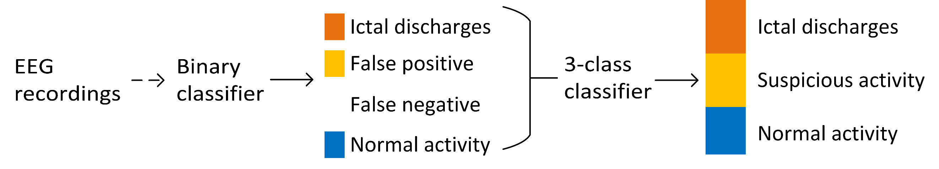  - Created a synthetic 3-class RUSBoost classifier from the results of the binary classifier;  - Used the synthetic 3-class classifier to classify EEG epochs into three categories: ictal discharges, suspicion activity, and normal activity | RUSBoost classifier extends AdaBoost classifier in addressing class-imbalance problems(Seiffert et al., 2010)
EEG: electroencephalography; NCSE: non-convulsive status epilepticus.
Aldana YR, Hunyadi B, Reyes EJM, Rodriguez VR and Van Huffel S. Nonconvulsive epileptic seizure detection in scalp eeg using multiway data analysis. IEEE J Biomed Heal Informatics 2019; 23(2): 660–671. doi: 10.1109/JBHI.2018.2829877.
Seiffert C, Khoshgoftaar TM, Van Hulse J and Napolitano A. RUSBoost: a hybrid approach to alleviating class imbalance. IEEE Trans Syst Man, Cybern - Part A Syst Humans 2010; 40(1): 185–197. doi: 10.1109/TSMCA.2009.2029559.
Wang L, Arends JBAM, Long X, Cluitmans PJM and van Dijk JP. Seizure pattern-specific epileptic epoch detection in patients with intellectual disability. Biomed Signal Process Control 2017; 35: 38–49. doi: 10.1016/j.bspc.2017.02.008.

Appendix C. The detailed characteristics of the individual subjects.
Table 1. NCSE patient demography
Patients | Intellectual disability:  normal  above 70;  light  (50-70); moderate (30–50); severe  (0–30) | Recording duration | Recorded sleep period | Preexisting epileptic encephalopathy | Clinical signs during recordings and seizure histories | Remarks
1 | Light | Continuous  46 minutes | Obscured by epileptic activity (cannot be seen anymore) | Yes | Some myoclonias and showed panic with impaired awareness | Not applicable
2 | Severe | Continuous  39 minutes | Not recorded | No | Tonic-clonic seizure with impaired awareness; atypical absence seizure with impaired awareness; myoclonic or atonic seizures with retained awareness | Not applicable
3 | Severe | Continuous  46 minutes | Not recorded | Yes | Absences with impaired awareness; atonic seizures with impaired awareness;  tonic seizures with impaired awareness | Kabuki Syndrome
4 | Severe | Continuous  8 hours and 50 minutes | Recognizable without specific sleep phenomena (not obvious sleep stages) | No | Laughing with impaired awareness; Tonic-clonic seizure with impaired awareness; NCSE with impaired awareness | Cardio-facio-cutaneous syndrome
5 | Light | Continuous  2 hours and 53 minutes | Not recorded | No | Myoclonic and atonic seizures and loss of urine with impaired awareness | Not applicable
6 | Severe | Continuous  22 hours and 19 minutes | Normal sleep but many seizures during sleep | No | Tonic-clonic seizures or tonic seizures with impaired awareness | Not applicable
7 | Moderate | Continuous  21 hours and 45 minutes | Normal sleep | No | Myoclonias and automatisms seizures with impaired seizures; myoclonic and clonic seizures with impaired awareness; tonic seizures with impaired awareness | Not applicable
8 | Normal | Non-continuous  50 hours and 50 minutes | Normal sleep | No | Focal seizure evolving into NCSE with impaired awareness | Ring chromosome 20 syndrome
9 | Normal | Non- continuous 24hours | Normal sleep | No | Focal seizure evolving into tonic-clonic seizures with impaired awareness; two of six recorded seizures evolving into NCSE | Not applicable
10 | Light | Non- continuous 25 hours and 24 minutes | 10% to 50% abnormal sleep due to the high frequency inter-ictal epileptic spikes and also normal sleep without spikes | No | Myoclonias with automatic behavior with impaired awareness; tonic-clonic seizures with impaired awareness; atypical absence (1-minute long) with impaired awareness; aphatic seizure with speak ability and retained awareness | Developmental encephalopathy and Genetic encephalopathy
11 | Light | Non- continuous 25 hours and 56 minutes | 50% to 85% abnormal sleep due to the high frequency inter-ictal epileptic spikes and also normal sleep without spikes | No | NCSE with impaired awareness; myoclonic seizures with impaired awareness; tonic seizures with impaired awareness | Not applicable
12 | Normal | Non- continuous 21 hours and 5 minutes | Normal sleep | No | Myoclonus, automatic behavior and vocalization with impaired awareness; NCSE evolved into tonic-clonic seizures with impaired awareness | Not applicable
13 | Normal | Non- continuous 23 hours and 36 minutes | Not recorded | No | NCSE evolved into tonic-clonic seizures with impaired awareness; eyelid myoclonias preceding a tonic-clonic seizure;  Tonic-clonic seizure due to withdrawal anti-epileptic drugs | Not applicable
14 | Normal | Non- continuous 24 hours and 25 minutes | Normal sleep | No | Tonic-clonic seizure with impaired awareness; atypical absences evolved into NCSE (1 hour and 15 minutes) with impaired awareness | Not applicable
15 | Normal | Non- continuous 23 hours and 55 minutes | Normal sleep | No | Tonic-clonic seizures evolved into NCSE with impaired awareness | Not applicable
16 | Normal | Non- continuous 23 hours and 23 minutes | Normal sleep | No | NCSE with slow reactions with impaired awareness; myoclonic-atonic seizures with retained awareness | Not applicable
NCSE: non-convulsive status epilepticus.

Table 2. Suspected NCSE patient demography
Patients | Intellectual disability:  normal  above 70;  light  (50-70); moderate (30–50); severe  (0–30) | Recording duration | Recorded sleep period | Preexisting epileptic encephalopathy | Clinical signs during recordings and seizure histories | Remarks
1 | Light | Continuous ca. 13 minutes | Not recorded | No | Myoclonic absence with impaired awareness | Not applicable
2 | Moderate | Continuous ca. 18 minutes | Not recorded | Yes | No | FIRDA
3 | Severe | Continuous  ca. 28 minutes | Unknown: difficult to distinguish between sleep and awake | Yes | Unknown (no seizure) | Not applicable
4 | Normal | Continuous ca. 21 minutes | Not recorded | Yes | Unknown (no seizure) | Not applicable
5 | Moderate | Continuous ca. 50 minutes | Sleep was recorded with many epileptiform (>85%) activities without status | Yes | Unknown (no seizure) | Not applicable
6 | Severe | Continuous ca. 1 hour 2 minutes | Short normal sleep | No | Tonic seizures with impaired awareness | Severe mentally impaired with normal EEG
7 | Normal | Continuous ca. 16 minutes | Not recorded | No | Focal seizures from left temporal lobe with impaired awareness | Not applicable
8 | Normal | Continuous ca. 11 minutes | Not recorded | No | Unknown (no seizure) | Not applicable
9 | Light | Continuous ca. 21 minutes | Normal sleep and slow wave sleep | Yes | Unknown (no seizure) | Not applicable
10 | Severe | Continuous ca. 16 minutes | Not recorded | No | Two short absences with impaired awareness | Not applicable
11 | Severe | Continuous ca. 5 minutes | Non-REM sleep patterns | Yes | Myoclonic seizure with retained awareness and motor signs; tonic seizure with retained awareness; absences with impaired awareness | High proportion of inter-ictal epileptic activities.
12 | Normal | Continuous ca. 33 minutes | Short normal sleep | No | Status biPLD with impaired awareness and no-motor signs | Not applicable
biPLD: bilateral period laterized discharges; EEG: electroencephalography; FIRDA: frontal intermittent rythmicdelta activity ; NCSE: non-convulsive status epilepticus; REM: rapid eye movement.

Appendix D. The interrater agreement of the individual subjects.
Subject | Cohen’s kappa | Fleiss’s kappa
1 | 1.00 | 1.00
2 | -0.14 | 0
3 | 0 | 0
4 | 0.32 | 0.47
5 | 0.64 | 0.65
6 | 0.69 | 0.89
7 | 0.25 | 0.51
8 | 0.21 | 0.49
9 | 0.60 | 0.66
10 | 0 | 0.01
11 | 0.33 | 0.51
12 | 0.18 | 0.28
13 | 0.01 | 0.01
14 | 0.48 | 0.48
15 | 0.73 | 0.74
16 | -0.02 | 0

Subject | Remarks on the individual subjects about EEG over-interpretation
1 | Only one status epileptic; no extra remarks from the neurologists
4 | Many potential false positives due to varied slow waves, and it was difficult for human raters to annotate ictal discharges
5 | Focal slow waves were the hallmark of the seizures, intermixed with some spike waves; some slow activities during drowsiness disturbed the accuracy of ictal annotation
6 | No extra remarks from the neurologists
7 | No extra remarks from the neurologists
8 | Same as the conclusion of subject 5
9 | The algorithm detected both ictal and abnormal activities
10 | Too many inter-ictal discharges, human raters had difficulties to distinguish ictal discharges from this recording
11 | There were several spike-wave concentrations with a high proportion of slow activities and inter-ictal activities, it was doubtful to determine ictal or inter-ictal activities
12 | Frequency of sharp waves in the ictal periods was a bit higher than the inter-ictal periods, which may lead to false positive events by the algorithm
13 | A tonic-clonic seizure and some abnormal activities were observed in this this recording
14 | Many short ictal discharges in this EEG recording, the annotated periods look not very typical “ictal”
15 | High agreement between annotations and the outputs of the algorithm; no extra remarks from the neurologists
16 | Abnormal EEG activities and no definite ictal discharges. This recording is not suitable for the algorithm, given its extremely low inter-agreement
Appendix E. The individual subject remarks about EEG over-interpretation and their proportions.

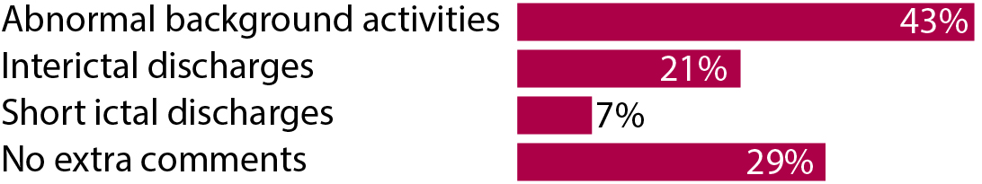
EEG: electroencephalography.

