Supplemental Material
Supplementary Figure 1. Systematic review search strategy.
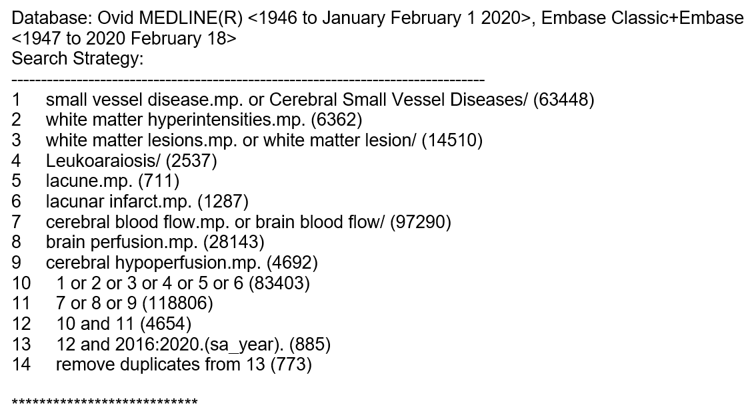

Supplementary Figure 2. Study quality according to the Strengthening the Reporting of the Observational studies in Epidemiology (STROBE) statement (Bailey et al. 2012).
Study | Overall Score
Bivard et al. 2016 | 8
Hashimoto et al. 2016 | 7
Turk et al. 2016a | 5
Turk et al. 2016b | 7
van Dalen et al. 2016 | 8
Promjunyakul et al. 2016 | 6
Bahrani et al. 2017 | 6
Arba et al. 2017 | 8
Shi et al. 2017 | 6
Zhong et al. 2017 | 7
Benedictus et al. 2017 | 7
Nylander et al. 2017 | 9
Ishibashi et al. 2018 | 7
Promjunyakul et al. 2018 | 5
Rane et al. 2018 | 7
Puglisi et al. 2018 | 6
Croall et al. 2018 | 7
Shokouhi et al. 2018 | 6
Parfenov et al. 2018 | 4
Jokumsen-Cabral et al. 2019 | 6
Wong et al. 2019 | 7
Kim et al. 2019 | 6
Li et al. 2019 | 8
Dolui et al. 2019 | 5
Staffaroni et al. 2019 | 6
Wu et al. 2019 | 5
Muller et al. 2019 | 5
Kate et al. 2019 | 6
Mark et al. 2020 | 6
Shi et al. 2020 | 9

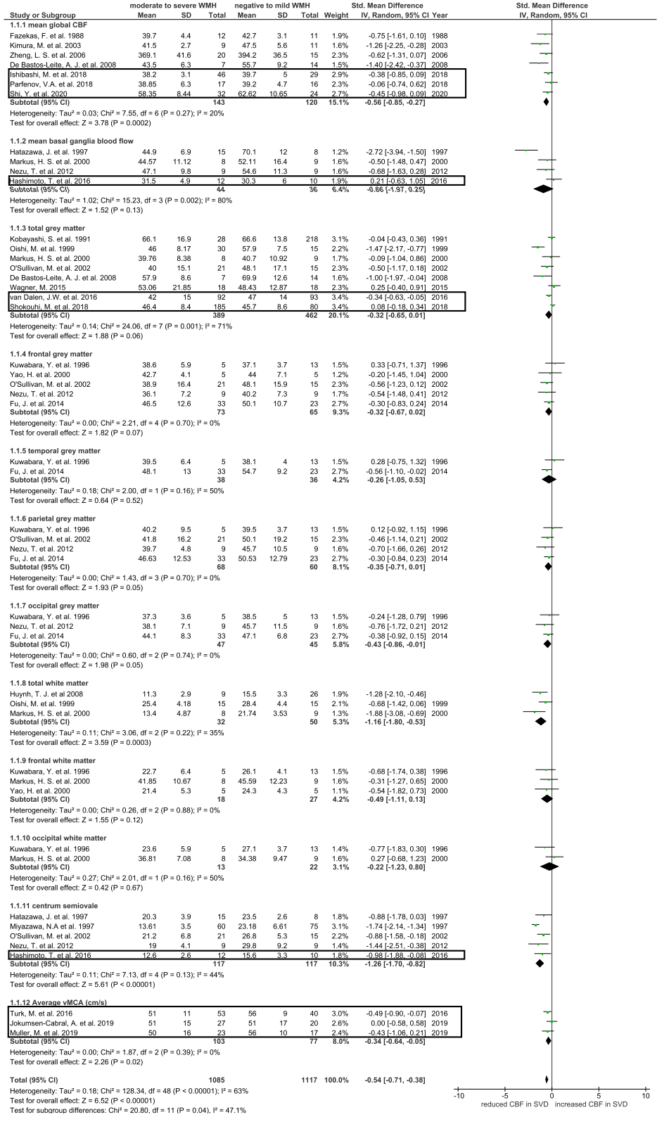
Supplementary Figure 3. Sensitivity analysis: forest plot showing standard mean differences in CBF in brain regions according to WMH burden, after excluding studies with dementia patients.

CBF: cerebral blood flow; WMH: white matter hyperintensity; vMCA: blood flow velocity in middle cerebral artery. Recent studies are outlined, all other studies were published in our previous review.

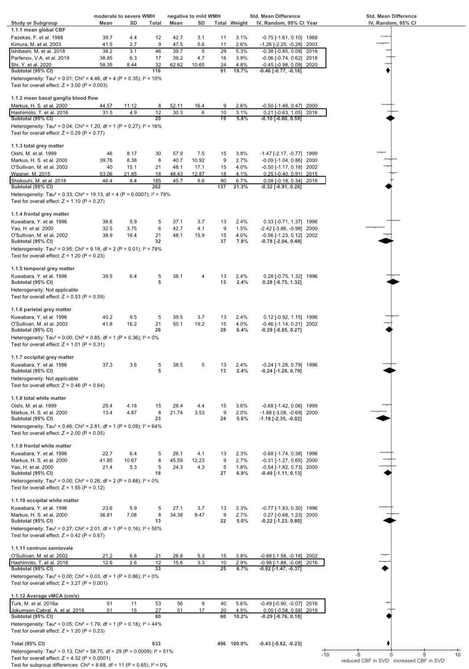
Supplementary Figure 4. Sensitivity analysis: forest plot showing standard mean differences in CBF in each brain region according to WMH burden, after excluding studies with dementia patients and studies without age-matching.

CBF: cerebral blood flow; WMH: white matter hyperintensity; vMCA: blood flow velocity in middle cerebral artery. Recent studies are outlined, all other studies were published in our previous review.

