Supplementary Materials for

Diagnostic performance and prediction of clinical progression of plasma phospho-tau181 in the Alzheimer’s Disease Neuroimaging Initiative

Running title: Diagnostic and prognostic performance of plasma p-tau181

Thomas K. Karikari^{1†}, Andréa L. Benedet^{2†}, Nicholas J. Ashton^{1,3,4,5†}, Juan Lantero Rodriguez¹, Anniina Snellman^{1,6}, Marc Suárez-Calvet^{7,8,9,10}, Paramita Saha Chaudhuri¹¹, Firoza Lussier², Hlin Kvartsberg^{1,13}, Alexis Moscoso Rial^{1,3}, Tharick A. Pascoal^{2,12}, Ulf Andreasson^{1,13}, Michael Schöll^{1,3}, Pedro Rosa-Neto^{2,12}, Kaj Blennow^{1,13‡}, Henrik Zetterberg^{1,13,14,15‡}*

¹Department of Psychiatry and Neurochemistry, Institute of Neuroscience and Physiology, The Sahlgrenska Academy, University of Gothenburg, Sweden; ²Translational Neuroimaging Laboratory, The McGill University Research Centre for Studies in Aging, H4H 1R3, Montreal, Canada; ³Wallenberg Centre for Molecular and Translational Medicine, University of Gothenburg, Sweden; ⁴King’s College London, Institute of Psychiatry, Psychology & Neuroscience, Maurice Wohl Clinical Neuroscience Institute, London, UK; ⁵NIHR Biomedical Research Centre for Mental Health & Biomedical Research Unit for Dementia at South London & Maudsley NHS Foundation, London, UK; ⁶Turku PET Centre, University of Turku, Kiinamyllynkatu 4-8, FI-20520 Turku, Finland; ⁷Barcelonaβeta Brain Research Center (BBRC), Pasqual Maragall Foundation. Barcelona, Spain; ⁸IMIM (Hospital del Mar Medical Research Institute), Barcelona, Spain; ⁹Servei de Neurologia, Hospital del Mar, Barcelona, Spain; ¹⁰Centro de Investigación Biomédica en Red de Fragilidad y Envejecimiento Saludable (CIBERFES), Madrid, Spain; ¹¹Department of Epidemiology and Biostatistics, McGill University, Montreal, Québec, Canada; ¹²Montreal Neurological Institute, H3A 2B4, Montreal, Canada; ¹³Clinical Neurochemistry Laboratory, Sahlgrenska University Hospital, Mölndal, Sweden; ¹⁴Department of Neurodegenerative Disease, UCL Institute of Neurology, London, UK; ¹⁵UK Dementia Research Institute at UCL, London, UK.

†Equal contribution as first authors
‡Equal contribution as senior authors

*Corresponding author: Professor Henrik Zetterberg, Department of Psychiatry and Neurochemistry, Institute of Neuroscience and Physiology, The Sahlgrenska Academy, University of Gothenburg, Mölndal, Sweden
Tel: +46 31-343 0142
Email: henrik.zetterberg@clinchem.gu.se

Supplementary Figures

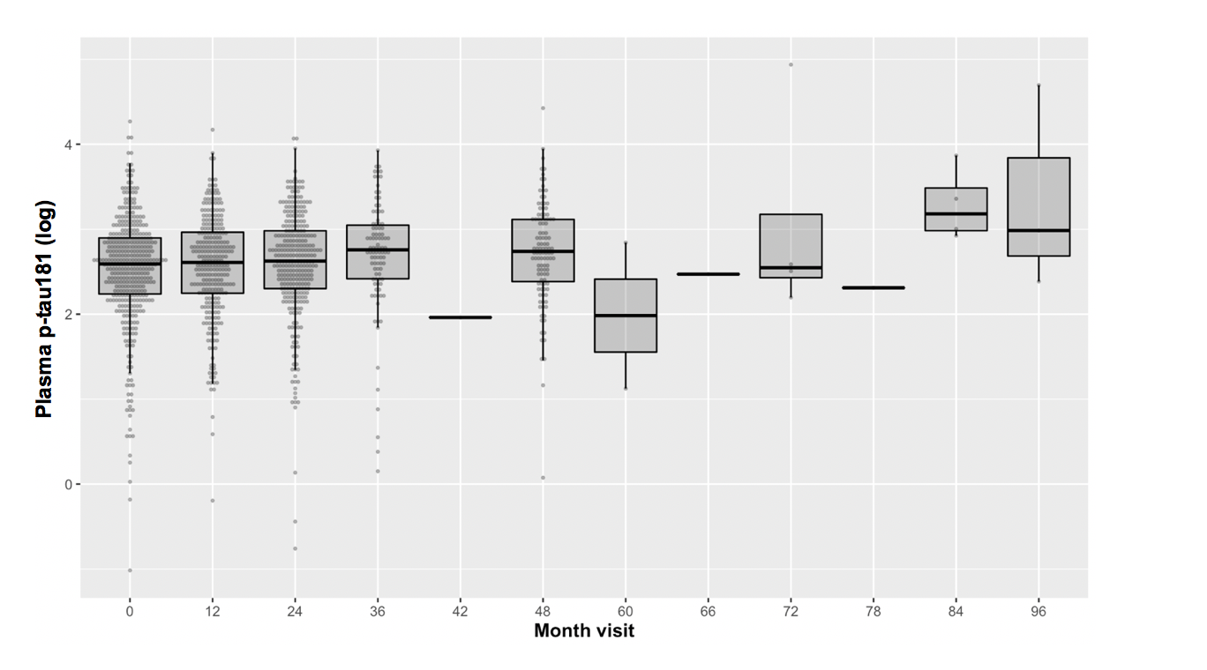

Fig. S1. Longitudinal plasma p-tau181 data. Distribution of plasma p-tau181 at all time points. Baseline (month 0) was defined as the date of first plasma p-tau181 quantification.

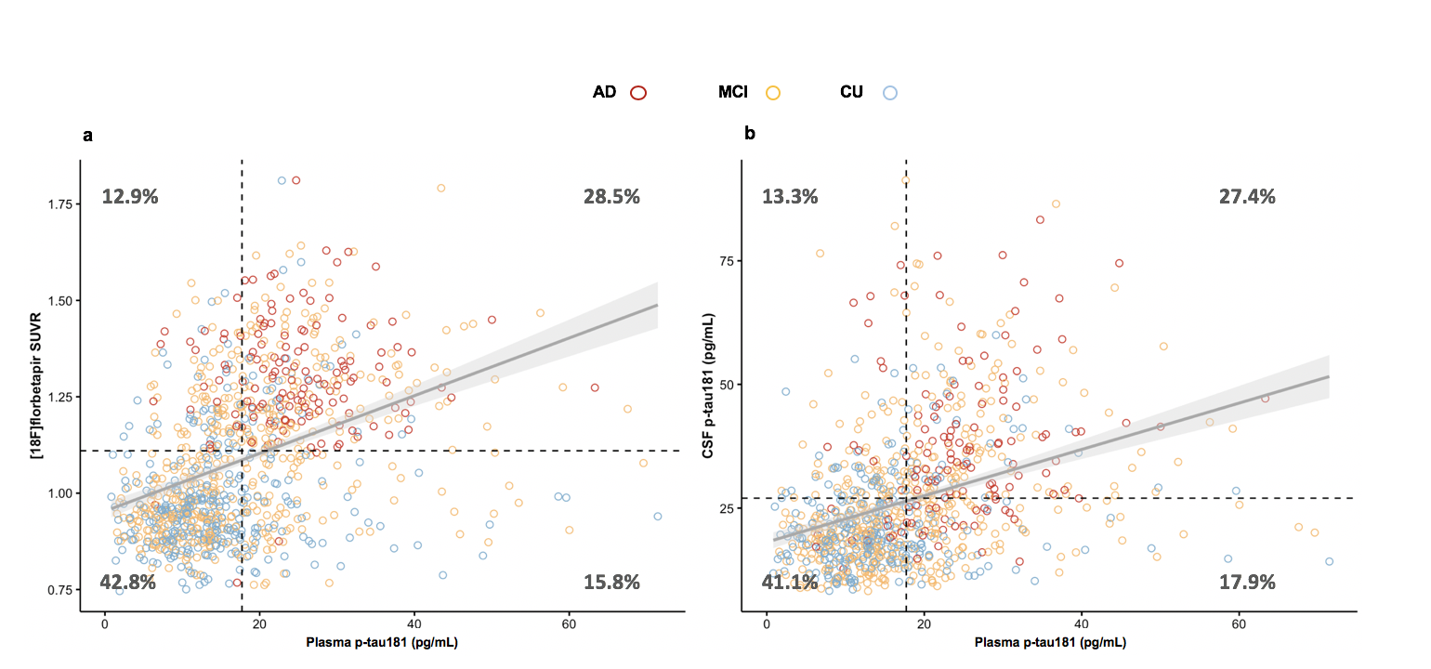

Fig. S2. Concordance between biomarker cut-offs. Concordance plots indicate the proportion of subjects similarly classified using Aβ PET (a) or CSF p-tau181 (b) and plasma p-tau181 cut-offs.

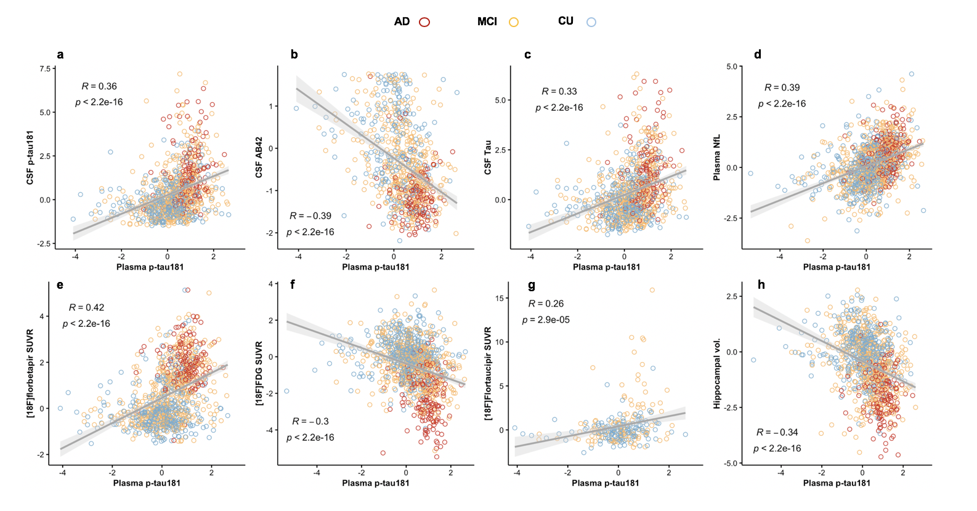

Fig. S3. Cross-sectional associations by Aβ status. Linear regression analyses showing that plasma p-tau181 is differently associated with CSF and imaging biomarkers depending on Aβ PET status (a-h). Detailed description of the findings is reported in Supplementary Table S5.

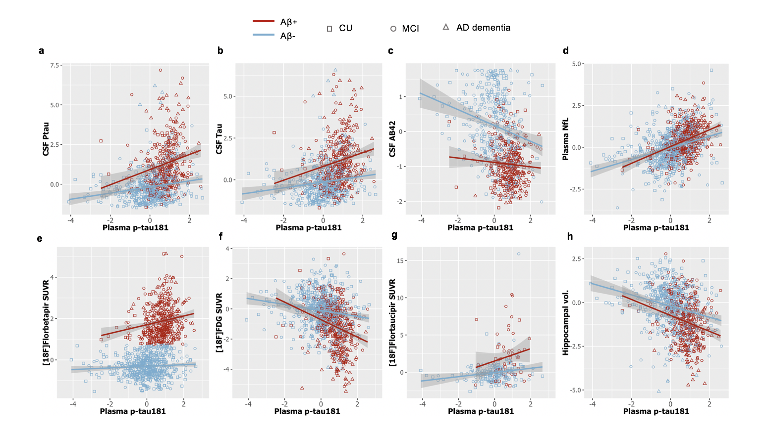

Fig. S4. Cross-sectional associations by Aβ status. Linear regression analyses have shown that plasma p-tau181 differently associated with CSF and imaging biomarkers depending on the Aβ status (a-h). Detailed description of findings is reported in Supplementary Table S6.

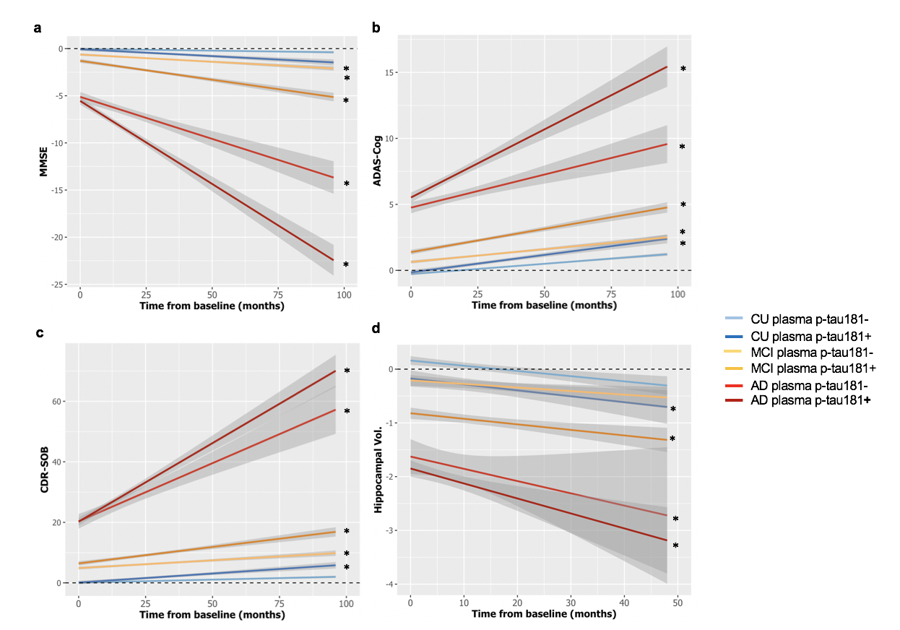

Fig. S5. Plasma p-tau181 predicting cognitive decline and neurodegeneration. Linear mixed effect models indicate that high baseline plasma p-tau181 levels are associated with worse cognitive performance (a-c) and faster hippocampal atrophy (d) across diagnostic groups. An important observation evidenced in these plots is that MCI subjects that are positive for plasma p-tau181 reach biomarker follow-up levels observed at baseline of AD dementia groups. The * indicates the longitudinal trajectories that are significantly different from plasma p-tau181 negative CU (reference group).

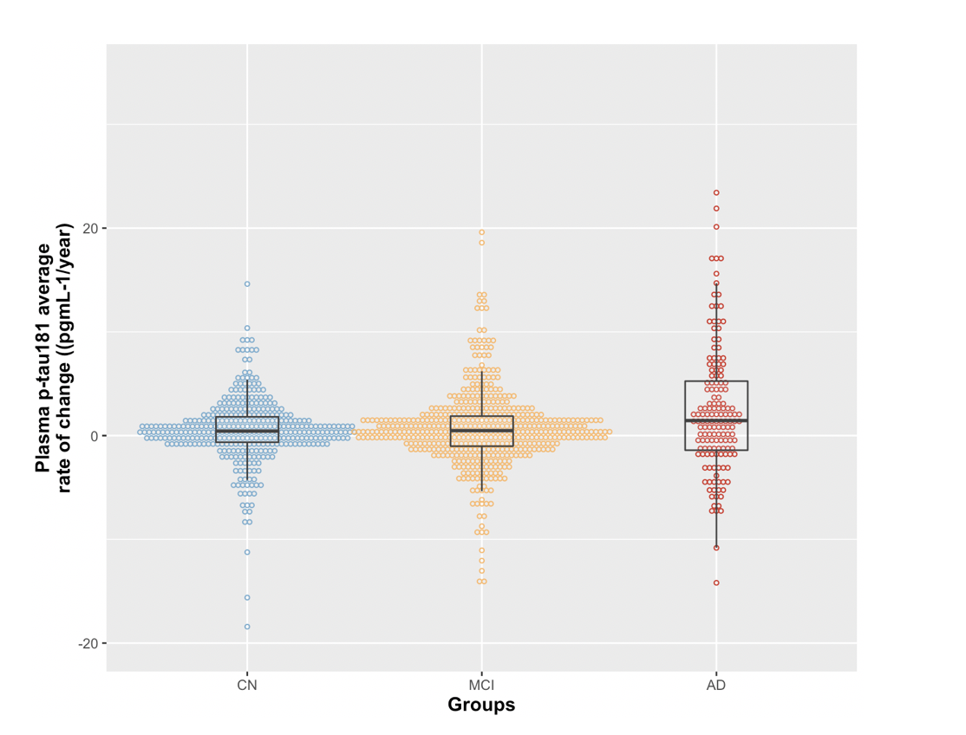Fig. S6. Plasma p-tau181 rate of change per group. Distribution of the average rate of change of plasma p-tau181 across diagnostic groups.

Supplementary Tables

Table S1. Analytical performance of plasma p-tau181 measurements across 3,758 ADNI samples.

Quality control sample | n* | Mean, pg/mL | Within-run CV% |  | Between-run CV%
 |  |  | SD | % CV | SD | % CV
Low plasma sample | 47 | 6.0 | 0.7 | 11.6 | 0.8 | 12.7
High plasma sample | 47 | 56.5 | 1.8 | 3.3 | 3.6 | 6.4

*pooled data from quality control samples measured in duplicates at the start and the end of 47 separate analytical runs.

Table S2. Baseline participant characteristics according to clinical diagnosis.

Characteristicª | CU (n=400) | MCI (n=558) | AD dementia (n=219)^{b}
Age at baseline, years | 74.8 (6.6) | 72.9 (7.9) *,# | 75.9 (7.9)
Sex (female), No. (%) | 213 (53.3%)* | 237 (42.5%)# | 89 (40.6%)#
≥ 1 APOE ε4, No. (%) | 113 (28.3%)* | 255 (45.7%)*,# | 147 (67.1%)#
Educational level, years | 16.5 (2.6) * | 16.2 (2.7) # | 15.7 (2.6) #

CSF biomarkers at baseline, mean(SD), ng/L
Aβ₄₂ | 1050.4 (378.6)* | 885.9 (341.3)*,# | 650.6 (268.1)#
P-tau181 | 21.9 (10.7)* | 26.8 (14.6)*,# | 37.5 (16.0)#
Total-tau | 234.2 (97.8) * | 276.8 (132.4)*,# | 378.1 (150.4)#

Neuroimaging measures at baseline, mean (SD)
Aβ PET | 1.0 (0.2) * | 1.1 (0.2)*,# | 1.2 (0.2) #
Hippocampal volume, mm³ | 7479.1 (827.8) * | 7018.9 (1076.4) *,# | 5825.4 (946.3) #
Whole brain, mm³ | 1050019.4 (65099.4) * | 1051191.1 (65135.9) * | 989678.1 (66609.9) #
Ventricular volume, mm³ | 35806.9 (16841.4) * | 37805.4 (18992.1)* | 50291.4 (20937.9) #
FDG-PET composite, | 1.3 (0.1) * | 1.3 (0.1) *,# | 1.1 (0.1) #

Cognitive measures at baseline, mean (SD)
MMSE | 29.0 (1.3) * | 28.0 (1.8) *,# | 22.7 (3.0) #
CDR-SOB | 0.08 (0.3) * | 1.5 (1.0) *,# | 5.1 (2.3) #
ADAS-Cog | 5.6 (2.9) * | 9.4 (4.4) *,# | 21.3 (7.9) #

Plasma biomarkers at baseline, pg/mL, mean (SD)
Plasma p-tau181 | 14.9 (9.0) * | 18.3 (10.8) *,# | 23.6 (8.8) #
Plasma NfL | 38.2 (23.0)* | 40.7 (23.5) * | 51.2 (22.6) #
ª Continuous variable are given as mean (SD)
^{b} The AD group includes both Aβ+ and Aβ- participants
*p<0.05 compared with the AD dementia group
#p<0.05 compared with the CU group
Continuous variables were compared with one-way ANOVA followed by Tukey’s post-hoc test. Categorical variables were compared with Chi-square test

Table S3. Number of participants with longitudinal biomarkers and cognitive measures.

Time-point,  month | Plasma | CSF | MRI | Aβ PET | FDG PET | Cognition
0 | 1177 | 288 | 969 | 1008 | 1022 | 1149
6 | 1 | 4 | 622 | 0 | 6 | 837
12 | 914 | 12 | 748 | 37 | 44 | 917
24 | 787 | 277 | 24 | 608 | 441 | 810
36 | 461 | 11 | 148 | 43 | 19 | 497
42 | 1 | 1 | 0 | 0 | 0 | 0
48 | 307 | 87 | 263 | 291 | 12 | 481
60 | 7 | 8 | 34 | 85 | 23 | 237
66 | 1 | 0 | 0 | 0 | 0 | 0
72 | 6 | 0 | 16 | 150 | 31 | 194
78 | 1 | 0 | 0 | 0 | 0 | 0
84 | 5 | 1 | 5 | 75 | 15 | 116
96 | 3 | 0 | 2 | 60 | 2 | 87
108 | 0 | 0 | 0 | 15 | 1 | 23
120 | 0 | 0 | 0 | 1 | 0 | 4

Table S4. Baseline associations between plasma p-tau181 and other biomarkers and cognitive measures according to clinical diagnosis.

 | All groups* |  | CU** |  | MCI** |  | AD^{** b}
Baseline measure | t | P-value | t | P-value | t | P-value | t | P-value
CSF Aβ42 | -8.271 | 6.11 x 10⁻¹⁶ | -3.125 | 0.00202 | -7.511 | 4 x 10⁻¹³ | -1.274 | 0.20482
CSF total-tau | 7.596 | 7.64 x 10⁻¹⁴ | 2.462 | 0.0144 | 6.747 | 4.5 x 10⁻¹¹ | 2.674 | 0.008446
CSF p-tau181 | 8.782 | < 2 x 10⁻¹⁶ | 3.093 | 0.00217 | 7.709 | 7.78 x 10⁻¹⁴ | 2.982 | 0.00342
Plasma NfL | 10.583 | < 2 x 10⁻¹⁶ | 5.678 | 2.63 x 10⁻⁸ | 7.795 | 3.21 x 10⁻¹⁴ | 4.143 | 5.34 x 10⁻⁵
Aβ PET | 10.390 | < 2 x 10⁻¹⁶ | 3.462 | 0.000606 | 10.136 | < 2 x 10⁻¹⁶ | 0.731 | 0.46578
Tau PET | 4.075 | 6.15 x 10⁻⁵ | 2.056 | 0.04172 | 3.710 | 0.00032 | NA | NA
Hippocampal volume | -4.477 | 8.48 x 10⁻⁶ | -2.249 | 0.0251 | -3.571 | 0.000391 | -0.782 | 0.43556
Ventricular volume | 3.188 | 0.00148 | 1.821 | 0.0694 | 1.940 | 0.0529 | 1.623 | 0.106580
Whole brain | -1.727 | 0.08452 | -0.352 | 0.725 | -1.395 | 0.164 | -1.039 | 0.30060
FDG PET | -4.917 | 1.02 x 10⁻⁶ | 0.581 | 0.561274 | -5.111 | 4.51 x 10⁻⁷ | -1.095 | 0.275130
MMSE | -2.601 | 0.00941 | -0.635 | 0.5258 | -3.000 | 0.002825 | -1.326 | 0.187
CDR-SOB | 2.100 | 0.035915 | 0.441 | 0.6592 | 2.403 | 0.0166 | 2.188 | 0.02997
ADAS-Cog | 5.040 | 5.43 x 10⁻⁷ | 2.772 | 0.005826 | 5.162 | 3.41 x 10⁻⁷ | 1.435 | 0.1530
* Main effects of plasma p-tau181 on the biomarkers: the linear regression models were independently performed for each biomarker and were adjusted for age, sex and diagnosis.
** Main effects of plasma p-tau181 on the biomarkers: the linear regression models were independently performed for each biomarker and within each diagnostic group. Models accounted for age and sex.
^{b} The AD group includes only Aβ+ participants

Table S5. Baseline associations between plasma p-tau181 and other biomarkers and cognitive measures according to Aβ PET positivity.

 | All groups* |  | Aβ+ vs Aβ-**
Baseline measure | t | P-value | t | P-value
CSF Aβ42 | -4.614 | 4.7 x 10⁻⁶ | 2.033 | 4.2 x 10⁻²
CSF total-tau | 4.796 | 1.91 x 10⁻⁶ | 2.274 | 2.3 x 10⁻²
CSF p-tau181 | 5.416 | 7.96 x 10⁻⁸ | 2.624 | 8.8 x 10⁻³
Plasma NfL | 9.662 | < 2 x 10⁻¹⁶ | 3.524 | 4.4 x 10⁻⁴
Aβ PET | 3.961 | 8 x 10⁻⁵ | 3.117 | 1.8 x 10⁻³
Tau PET | 2.61 | 9.5 x 10⁻³ | 1.576 | 0.11
Hippocampal volume | -5.360 | 1.06 x 10⁻⁷ | -2.446 | 0.014
Ventricular volume | 4.907 | 1.09 x 10⁻⁶ | 1.807 | 0.071
Whole brain | -3.589 | 3.9 x 10⁻⁴ | -1.567 | 0.11
FDG PET | -5.528 | 4.16 x 10⁻⁸ | -3.732 | 2.0 x 10⁻⁴
MMSE | -4.864 | 1.34 x 10⁻⁶ | -3.387 | 7.3 x 10⁻⁴
CDR-SOB | 5.604 | 2.71 x 10⁻⁸ | 5.202 | 2.39 x 10⁻⁷
ADAS-Cog | 5.936 | 4.03 x 10⁻⁹ | 4.915 | 1.04 x 10⁻⁶
* Main effects of plasma p-tau181 on the biomarkers: the linear regression models were independently performed for each biomarker and were adjusted for age, sex and Aβ PET status.
** Main effects of plasma p-tau181 on the biomarkers: linear regression models were performed testing the interaction between plasma p-tau181 and Aβ PET status. The outcomes reflect the difference between Aβ+ and Aβ- in the association between plasma p-tau181 and each of the biomarkers tested. Models were also adjusted for age and sex.

Table S6. Association of baseline plasma p-tau181 with downstream biomarkers of pathological progression

 | CU+* |  | MCI-* |  | MCI+*
Measure | t | p-value | t | p-value | t | p-value
Plasma NfL | 0.57 | 0.56 | 0.29 | 0.76 | 1.08 | 0.26
Hippocampal volume | -2.12 | 0.033 | -1.14 | 0.25 | -6.07 | 2.15 x 10⁻⁹
FDG PET | 0.26 | 0.78 | 0.43 | 0.66 | -2.07 | 0.038
MMSE | -2.23 | 0.025 | -2.87 | 4.2 x 10⁻³ | -10.63 | < 2 x 10⁻¹⁶
CDR-SOB | 1.90 | 0.057 | 2.90 | 3.8 x 10⁻³ | 9.28 | < 2 x 10⁻¹⁶
ADAS-Cog | 2.29 | 0.022 | 1.84 | 0.065 | 8.30 | 6.4 x 10⁻¹⁶

*groups defined by plasma p-tau181 positivity. Data generated by comparing each group with the CU- group.

