Supplementary appendix 1 for
Characterization of Microbial Co-infections in the Respiratory Tract of hospitalized COVID-19 patients
Huanzi Zhong^{1,3*}, Yanqun Wang^{2*}, Zhun Shi^{1*}, Lu Zhang^{4*}, Huahui Ren^{1,3*}, Weiqun He^{2*}, Zhaoyong Zhang^{2*}, Airu Zhu^{2*}, Jingxian Zhao^{2*}, Fei Xiao^{5*}, Fangming Yang^{1,6}, Tianzhu Liang^{1,7}, Feng Ye², Bei Zhong⁸, Shicong Ruan⁹, Mian Gan², Jiahui Zhu^{1,10}, Fang Li², Fuqiang Li^{1,11}, Daxi Wang^{1,7}, Jiandong Li^{1,7,12}, Peidi Ren^{1,7}, Shida Zhu^{1,13}, Huanming Yang^{1,14,15}, Jian Wang^{1,14}, Karsten Kristiansen^{1,3}, Hein Min Tun¹⁶, Weijun Chen^{17,12}, Nanshan Zhong², Xun Xu^{1,18#}, Yi-min Li^{2#}, Junhua Li^{1,6,19#}, Jincun Zhao^{2,4#}
* These authors contributed equally to this work.
#Correspondence should be addressed to Jincun Zhao (zhaojincun@gird.cn), Junhua Li (lijunhua@genomics.cn), Yi-min Li (dryiminli@vip.163.com), and Xun Xu (xuxun@genomics.cn).

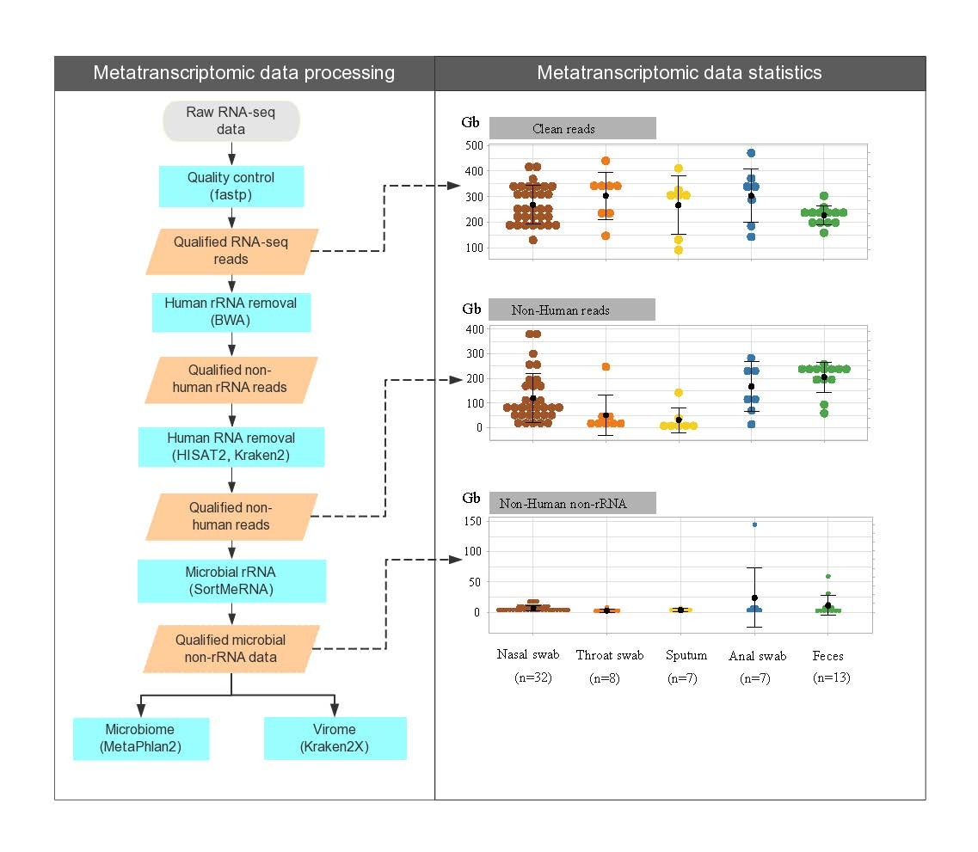
Supplementary figure 1: Flowchart of the metatranscriptomic analysis pipeline
Raw metatranscriptomic sequencing data from 67 clinical samples were processed as follows: 1) quality control by fastp and generation of clean data, 2) identification and removal of human rRNA from high-quality clean data by BWA, 3) identification and removal of human non-rRNA reads by HISAT2(hg19) and Kraken2 (hg38) and generation of non-human RNA-seq reads, 4) identification and removal of microbial rRNA reads by SortMeRNA and generation of non-rRNA microbial data for subsequent analyses of virome (by Kraken2X) and non-viral microbiome (by MetaPhlan2). Total clean RNA-seq data (upper panel), total non-human RNA-seq data (middle panel) and total non-human non-rRNA microbial RNA-seq data (lower panel) of 67 clinical samples are shown. Brown, throat swab (n=32); orange, nasal swab (n=8); yellow, sputum(n=7); blue, anal swab(n=7); and green, feces (n=13). Detailed statistics for each processing step are shown in appendix 2 p4, Table S3.

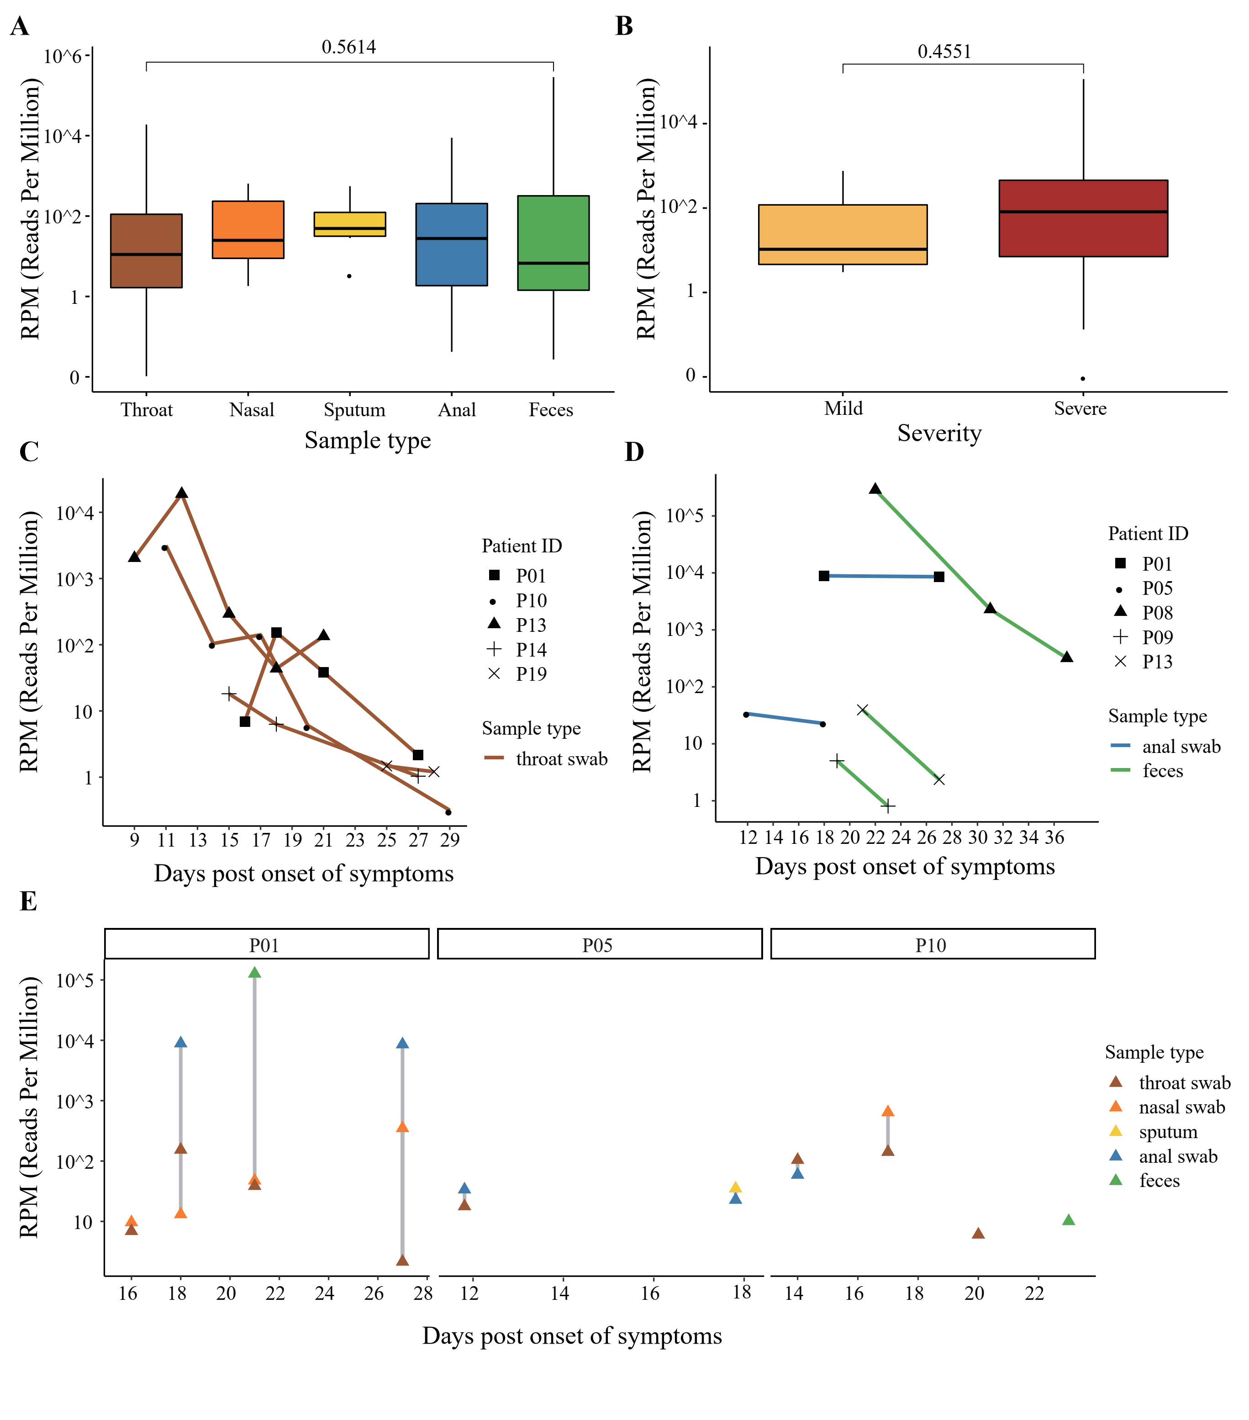

Supplementary figure 2: Comparison of SARS-CoV-2 viral loads across specimens and individuals
A, Bar plot showing the number of SARS-CoV-2-like reads in different types of clinical specimens.
B, Bar plot showing the number of SARS-CoV-2-like reads in respiratory tract specimens from mild (orange) and severe (brick red) cases.
C-D, Individual-based changes in the number of SARS-CoV-2-like reads in specimens from the respiratory tract (c) and the gastrointestinal tract (D). The x-axis indicates the days post-onset of symptoms (appendix 2 p2, Table S1).
E, Individual-based patterns in the number of SARS-CoV-2-like reads in different types of clinical specimens. Data have been normalized to total sequencing reads in reads-per-million (RPM). The number of SARS-CoV-2-like (Coronaviridae) reads of different sample types is colored as follows: brown, throat swab; orange, nasal swab; yellow, sputum; blue, anal swab; green, feces. Gray, number of non-Coronaviridae viral reads.

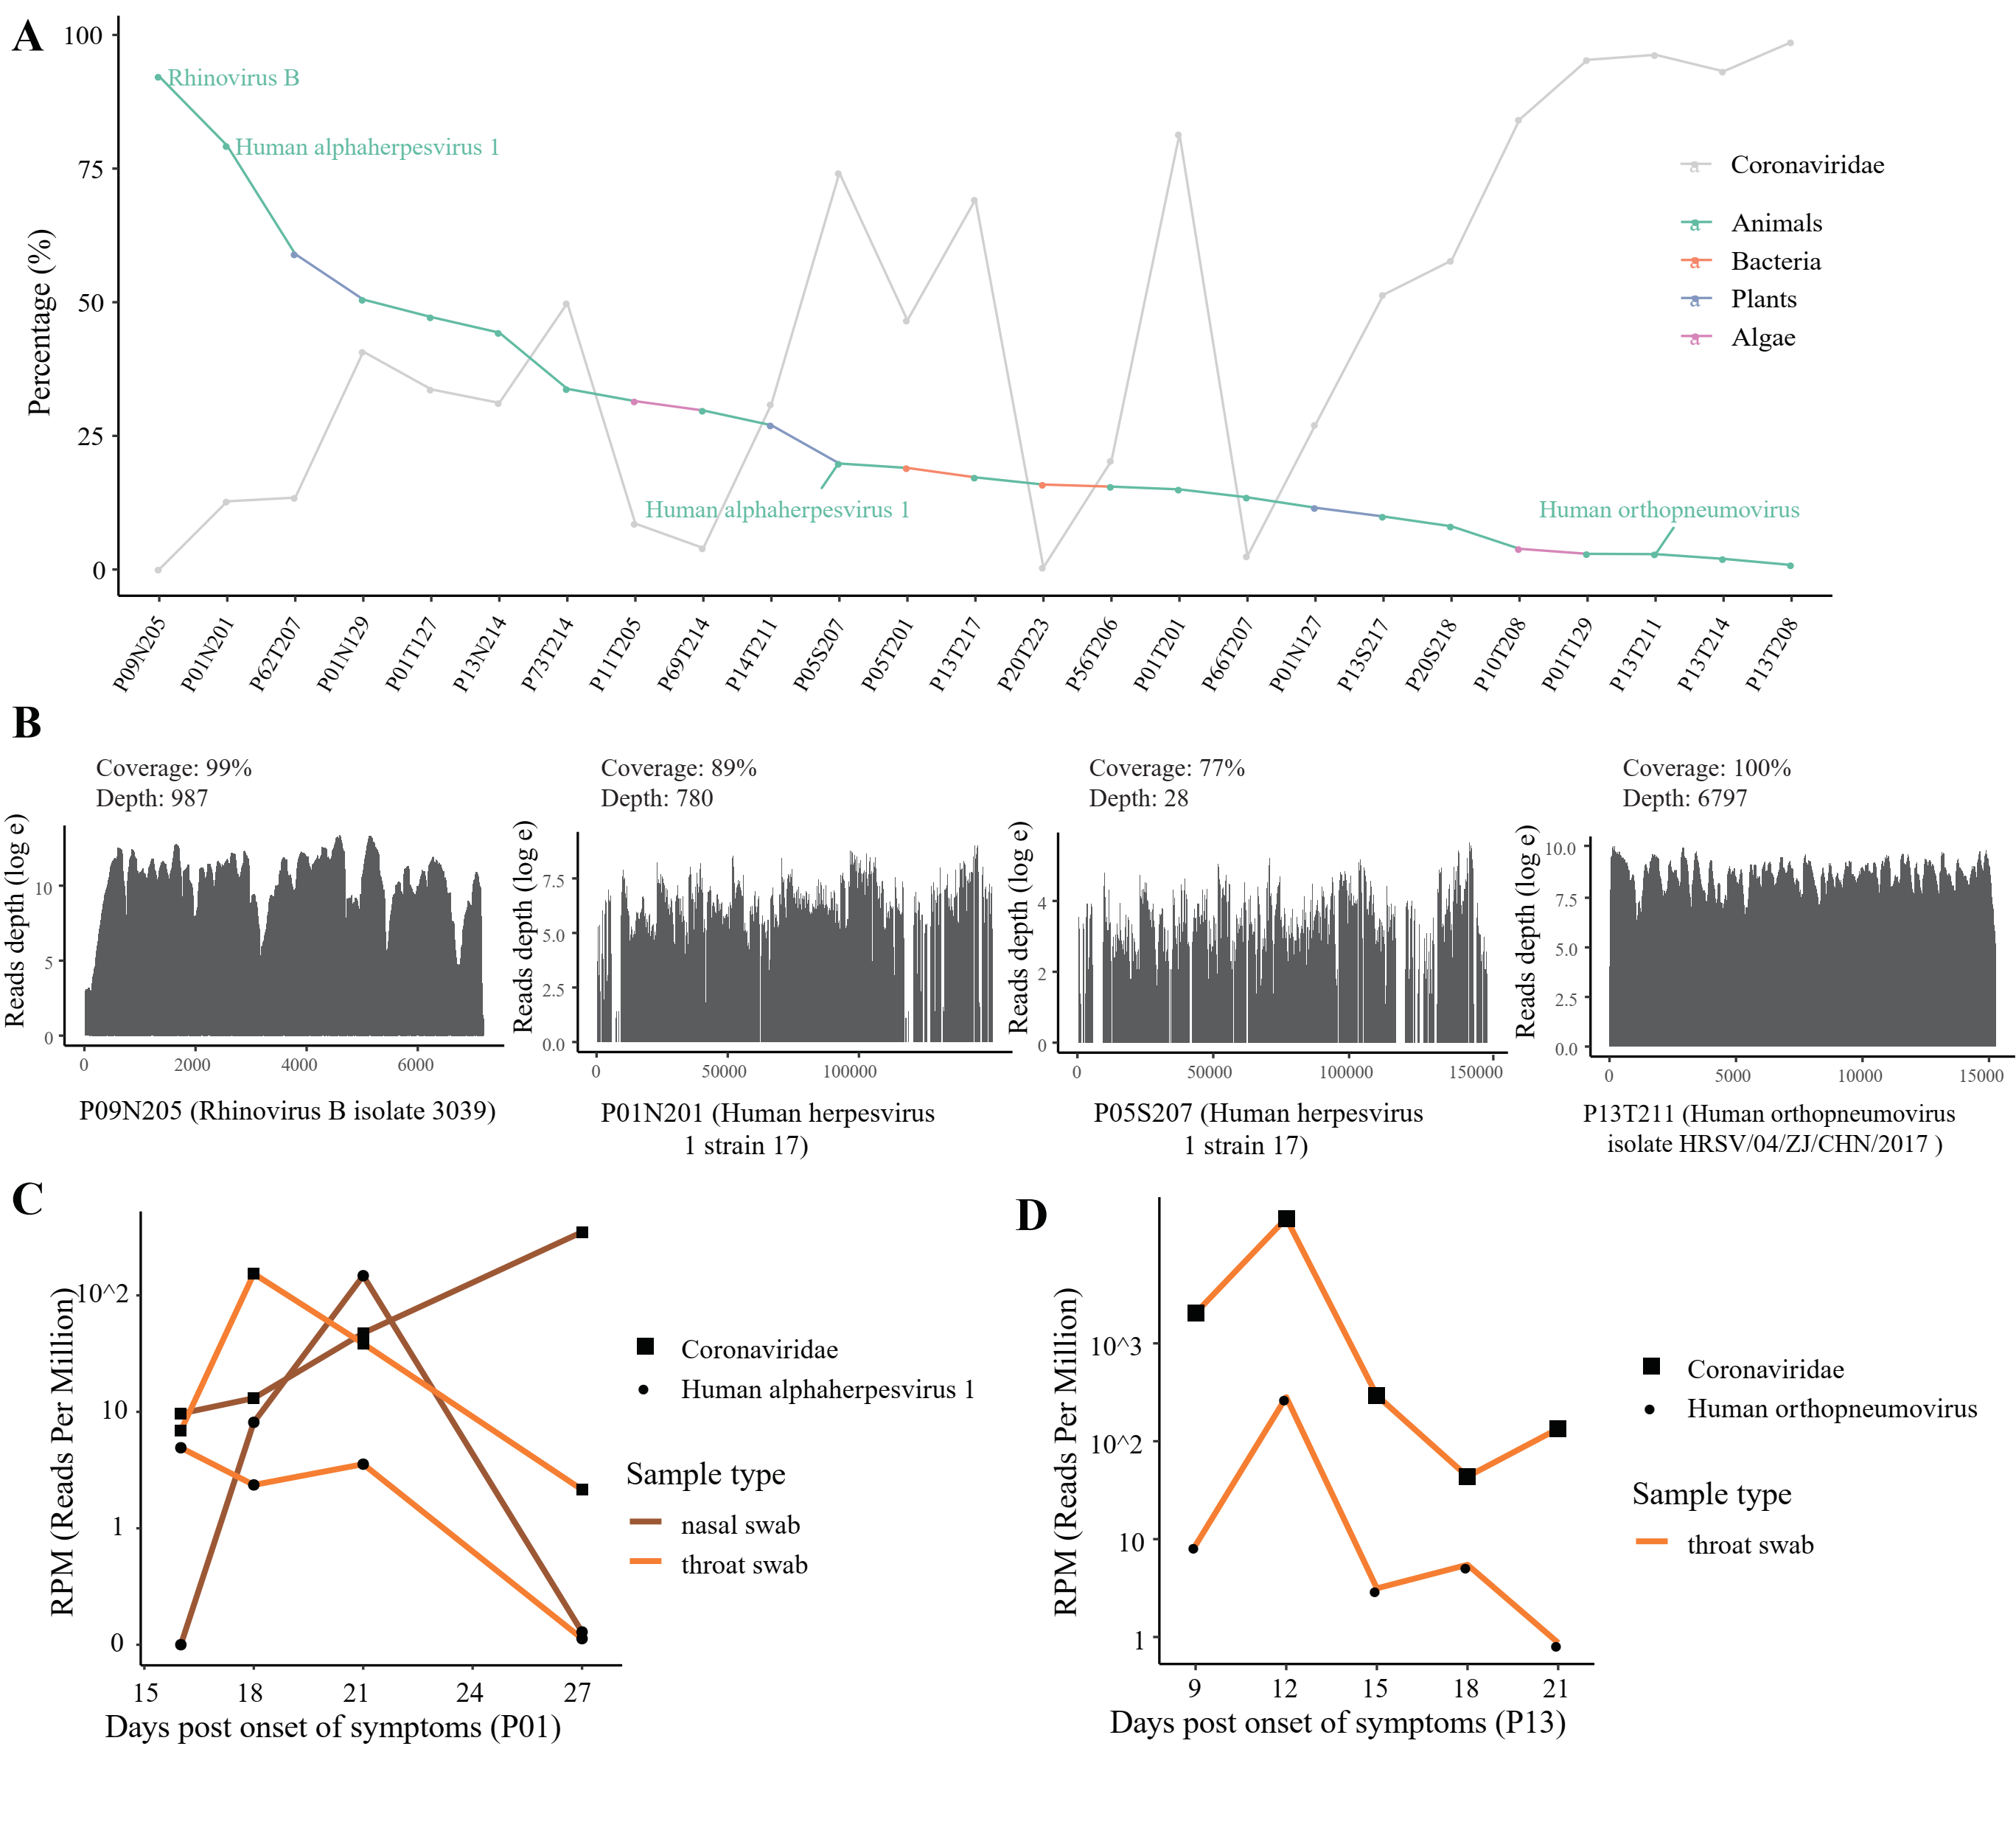
Supplementary figure 3: Highly abundant non-SARS-CoV-2 viruses identified in respiratory tract specimens
A, Percentage of Coronaviridae reads and highly abundant non-SARS-CoV-2 viral species to the total viral reads. Only non-SARS-CoV-2 viruses with >10,000 mapped reads and ranked in top 1 of all non-SARS-CoV-2 viruses are shown (See details in appendix 2 p6, Table S5). Viral species are colored according to their natural hosts: green, animals; pink, bacteria; light blue, plant; and purple, algae.

B, Depth and coverage of known respiratory viruses in four severe patients. Four representative specimens collected from four severe patients are co-detected (genome coverage>50%) with rhinovirus B (P09N205), human herpesvirus 1 (P01N201 and P05S207) and human orthopneumovirus (P13T211).

C-D, Individual-based changes in the number of SARS-CoV-2-like reads and other known respiratory viruses in respiratory tract specimens from P01 (C) and P13 (D). The x-axis indicates the days post-onset of symptoms. Data have been normalized to total sequencing reads in reads-per-million (RPM).

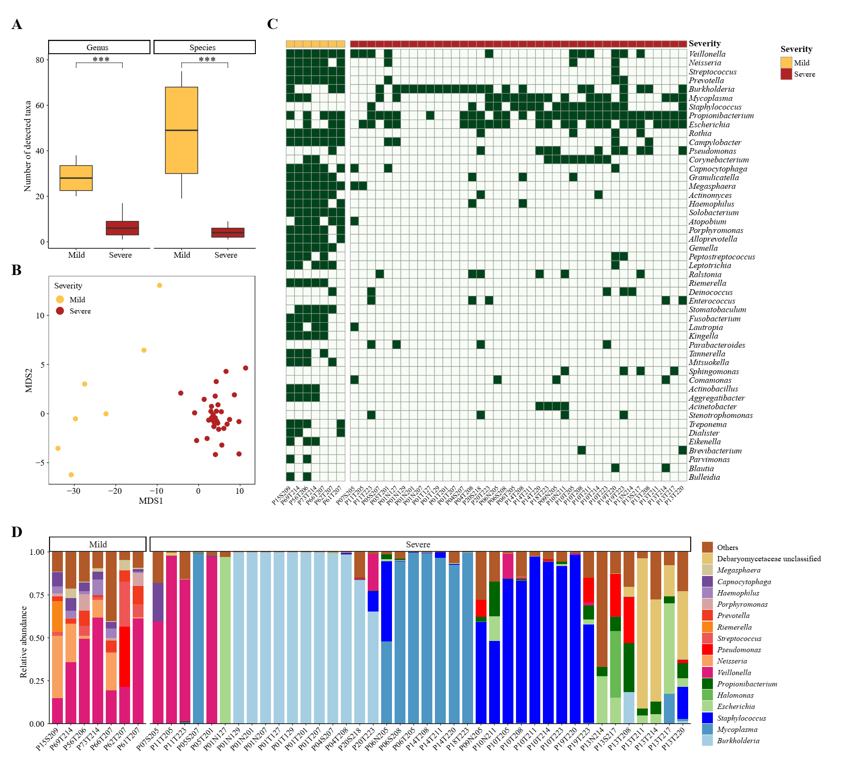
Supplementary figure 4: Distinct respiratory microbial signatures in respiratory specimens of mild and severe cases
A, Number of detected non-viral microbial genus and species in all respiratory specimens of mild (orange, n=7) and severe cases (brick red, n=40). ***, P < 0.001, Wilcoxon rank-sum test.
B, Non-metric multidimensional scaling (NMDS) plot displaying distinct respiratory microbial communities in specimens from mild (orange) and severe (brick red) cases. Manhattan distances based on presence/absence profile at the genus level are used for NMDS ordination.
C, Presence/absence profile of non-viral microbial genera in all respiratory specimens. Only genera presented in at least two samples are shown.
D, Bar plot showing the relative expression levels of non-viral microbes in all respiratory specimens.

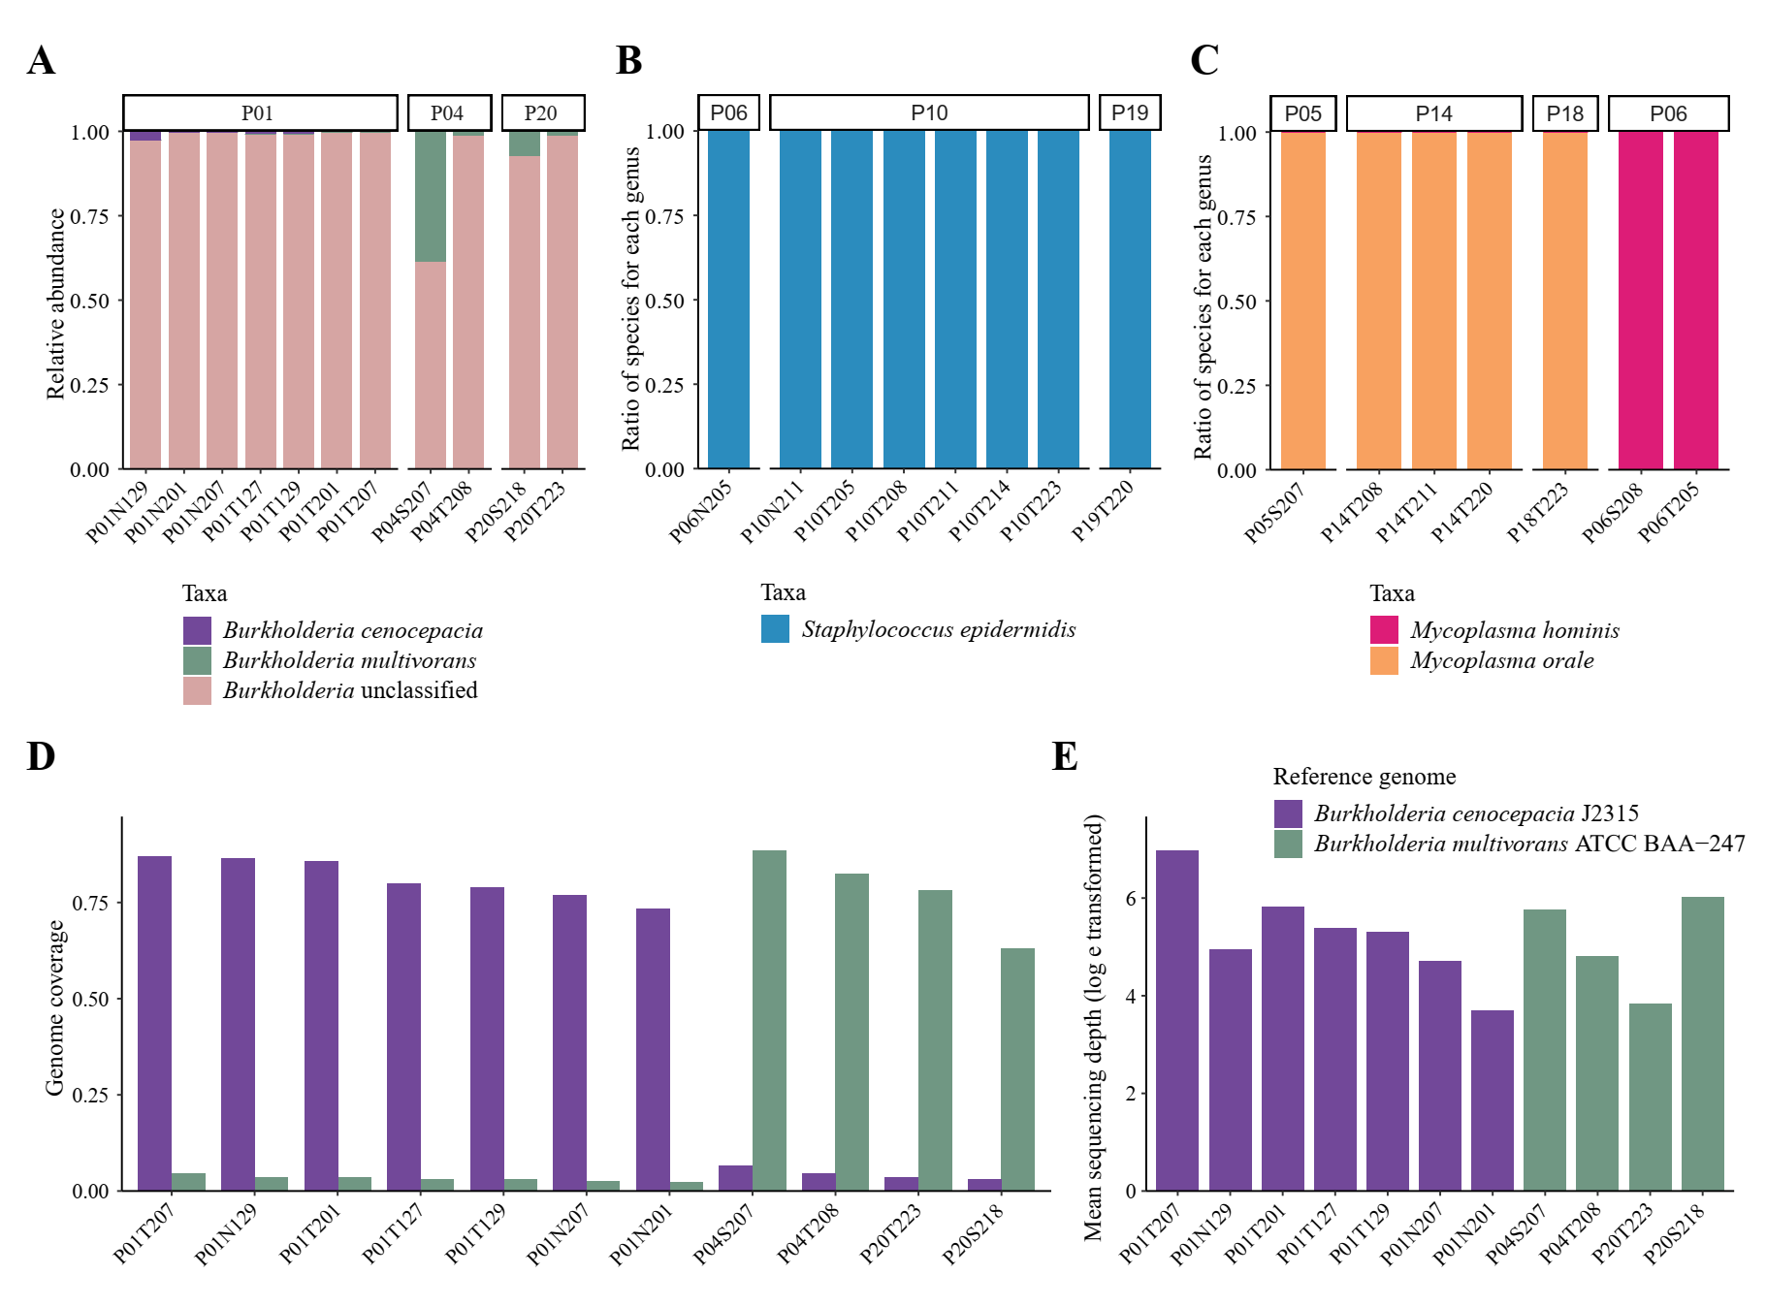Supplementary figure 5: Species-level identification of genera Burkholderia, Staphylococcus and Mycoplasma
A-C, Bar plot showing the ratio of assigned species within Burkholderia (A), Staphylococcus (B) and Mycoplasma (C) by MetaPhlAn2. Only respiratory samples with mono-dominance of one single genus (relative abundance >60%) are shown.
D, Average coverage of two references of Burkholderia cepacia complex. References are shown if 10% or more of the reference genome is covered by reads in at least one sample (appendix 2 p8, Table S7).
E, Average sequencing depth (log e-transformed) of the two Burkholderia references. Purple, Burkholderia cenocepacia J2315, green, Burkholderia multivorans ATCC BAA-247.

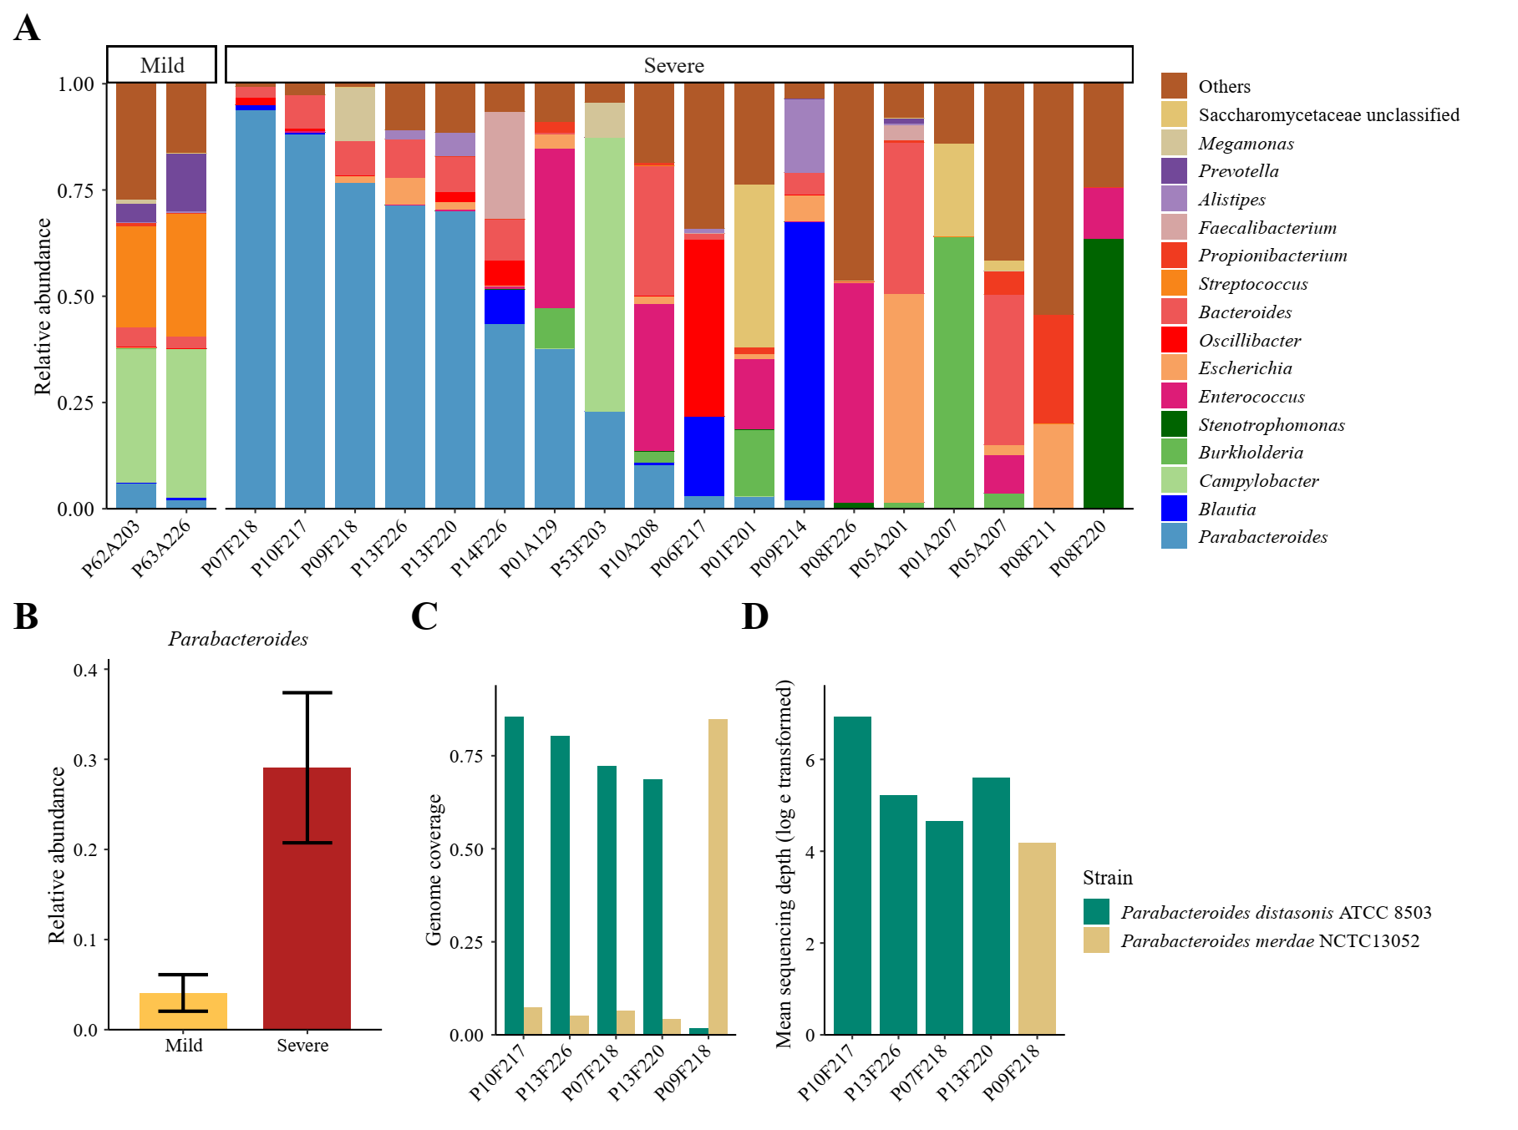
Supplementary figure 6: Gut microbial signatures in mildly and severely ill patients
A, Bar plot showing the relative expression levels of non-viral microbes in all gastrointestinal tract specimens.
B, Relative expression levels of Parabacteroides between gut specimens from mild and severe cases. The bar chart and black error bars denote the mean and standard error values of expression levels in mild (orange) and severe (brick red) cases.
C, Average coverage of two references of genus Parabacteroides. References are shown if 10% or more of the reference genome are covered by reads in at least one sample (appendix 2 p8, Table S7).
D, Average sequencing depth (log e-transformed) of the two Parabacteroides references. Green, Parabacteroides distasonis ATCC 8503, yellow, Parabacteroides merdae NCTC13052.

