Supplementary Information
Distributions and risks of SARS-CoV-2 in hospital outdoor environment
Dayi Zhang^{1,*}, Yunfeng Yang¹, Xia Huang¹, Jingkun Jiang¹, Miao Li¹, Xian Zhang¹, Haibo Ling², Jing Li³, Yi Liu¹, Guanghe Li¹, Weiwei Li², Chuan Yi², Ting Zhang³, Yongzhong Jiang³, Songqiang Deng⁴, Peng Zhao⁴, Jiuhui Qu^{1,5,*}
- School of Environment, Tsinghua University, Beijing 100084, P.R. China
- Hubei Academy of Environmental Sciences, Wuhan 430072, P.R. China
- Hubei Center for Disease Control and Prevention, Wuhan 430079, P.R. China
- Research Institute for Environmental Innovation (Tsinghua-Suzhou), Suzhou 215163, P.R. China
- Key Laboratory of Drinking Water Science and Technology, Research Center for Eco-Environmental Sciences, Chinese Academy of Sciences, Beijing 100085, P.R. China
Corresponding author
Dr Dayi Zhang
School of Environment, Tsinghua University, Beijing 100084, P.R. China
Email: zhangdayi@tsinghua.edu.cn
Tel: +86(0)10-62773232; Fax: +86(0)10-62795687
Prof Jiuhui Qu
School of Environment, Tsinghua University, Beijing 100084, P.R. China
Email: jhqu@tsinghua.edu.cn
Tel: +86(0)10-62849151; Fax: +86(0)10-62795687
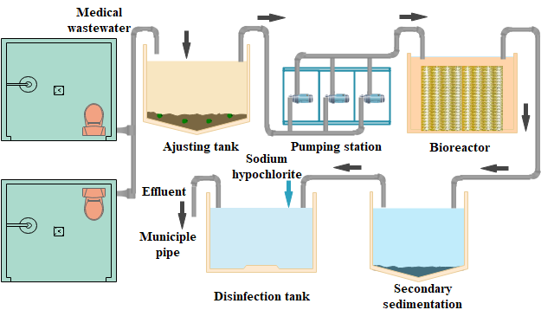
(A)
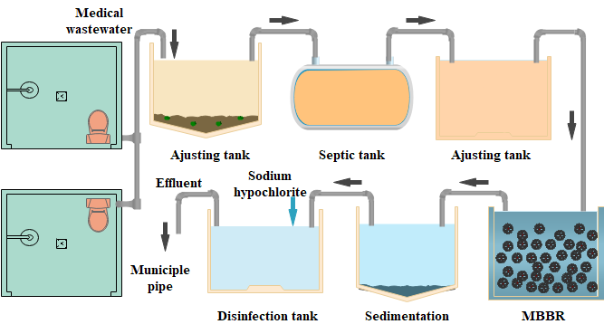
(B)
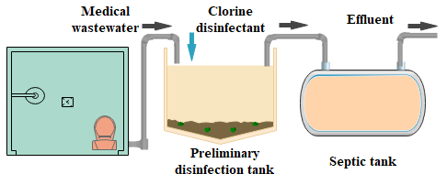
(C)
Figure S1. Schematic medical wastewater treatment sectors in Jinyintan Hospital (A), Huoshenshan Hospital (B) and Wuchang Fangcang Hospital (C).

Table S1. Copy numbers of SARS-CoV-2 viral RNA in each sampling points of hospital outdoor environment.
Hospital | Sampling sites | Samples | Description | SARS-CoV-2
Jinyintan | Wastewater treatment sector | Water | Adjusting tank | 255 copies/L
 |  | Water | Aeration tank | ND
 |  | Water | Secondary sedimentation tank | ND
 |  | Water | Disinfection tank | ND
 |  | Water | Effluent | ND
 |  | Aerosol | Inside adjusting tank | 285 copies/m³
 |  | Soil | 2 m away from the adjusting tank | 253 copies/g
 |  | Soil | 2 m away from the disinfection tank | ND
 | Out- and In-patient department | Aerosol | 5 m away from outpatient department | 1130 copies/m³
 |  | Aerosol | 5 m away from inpatient department | ND
 |  | Soil | 20 m away from outpatient department | ND
 |  | Soil | 10 m away from inpatient department | 205 copies/g
 |  | Surface | Road surface 5 m away from outpatient department | ND
 |  | Surface | Road surface 5 m away from inpatient department | ND
 | Background | Aerosol | 100 m away from inpatient department | ND
 |  | Soil | 100 m away from inpatient department | ND
 |  | Surface | Road surface 100 m away from inpatient department | ND
Huoshenshan | Wastewater treatment sector | Water | First adjusting tank | 633 copies/L
 |  | Water | Septic tank | ND
 |  | Water | Second adjusting tank | ND
 |  | Water | MBBR | ND-505 copies/L
 |  | Water | Sedimentation tank | ND-2.2×10³ copies/L
 |  | Water | Effluent after disinfection | ND
 |  | Aerosol | Inside septic tank | 603 copies/m³
 |  | Aerosol | Inside third adjusting tank | ND
 |  | Soil | 2 m away from first adjusting tank | 550 copies/g
 |  | Soil | 2 m away from second adjusting tank | ND
 |  | Surface | MBBR outside wall | ND
 |  | Surface | Road surface 2 m away from MBBR | ND
 | Background | Aerosol | Medical staff living area | ND
 |  | Soil | Medical staff living area | ND
 |  | Surface | Medical staff living area | ND
Wuchang Fangcang | Wastewater treatment sector | Water | Preliminary disinfection tank | ND
 |  | Water | Septic tank* | 557 to 1.9×10⁴ copies/L
 |  | Water | Septic tank** | ND
 |  | Aerosol | 2 m away from the septic tank | ND
 |  | Soil | 2 m away from the septic tanks | ND
 |  | Surface | Road surface 10 m away from the septic tank | ND
 | Entrance | Aerosol | 5 m away from the entrance | ND
 |  | Surface | Steps of the entrance | ND
 |  | Surface | Road surface 5 m away from the entrance | ND
 | Outdoor toilet | Aerosol | Outdoor toilet | ND
 |  | Surface | Ground of outdoor toilets | ND
 |  | Surface | Outside wall of outdoor toilets | ND
 |  | Surface | Road surface 5 m away from outdoor toilets | ND
 | Background | Aerosol | 100 m away from hospital | ND
 |  | Soil | 100 m away from hospital | ND
 |  | Surface | Road surface 100 m away from hospital) | ND
ND, non-detected.
* Before 5th March and ** after 5th March.

