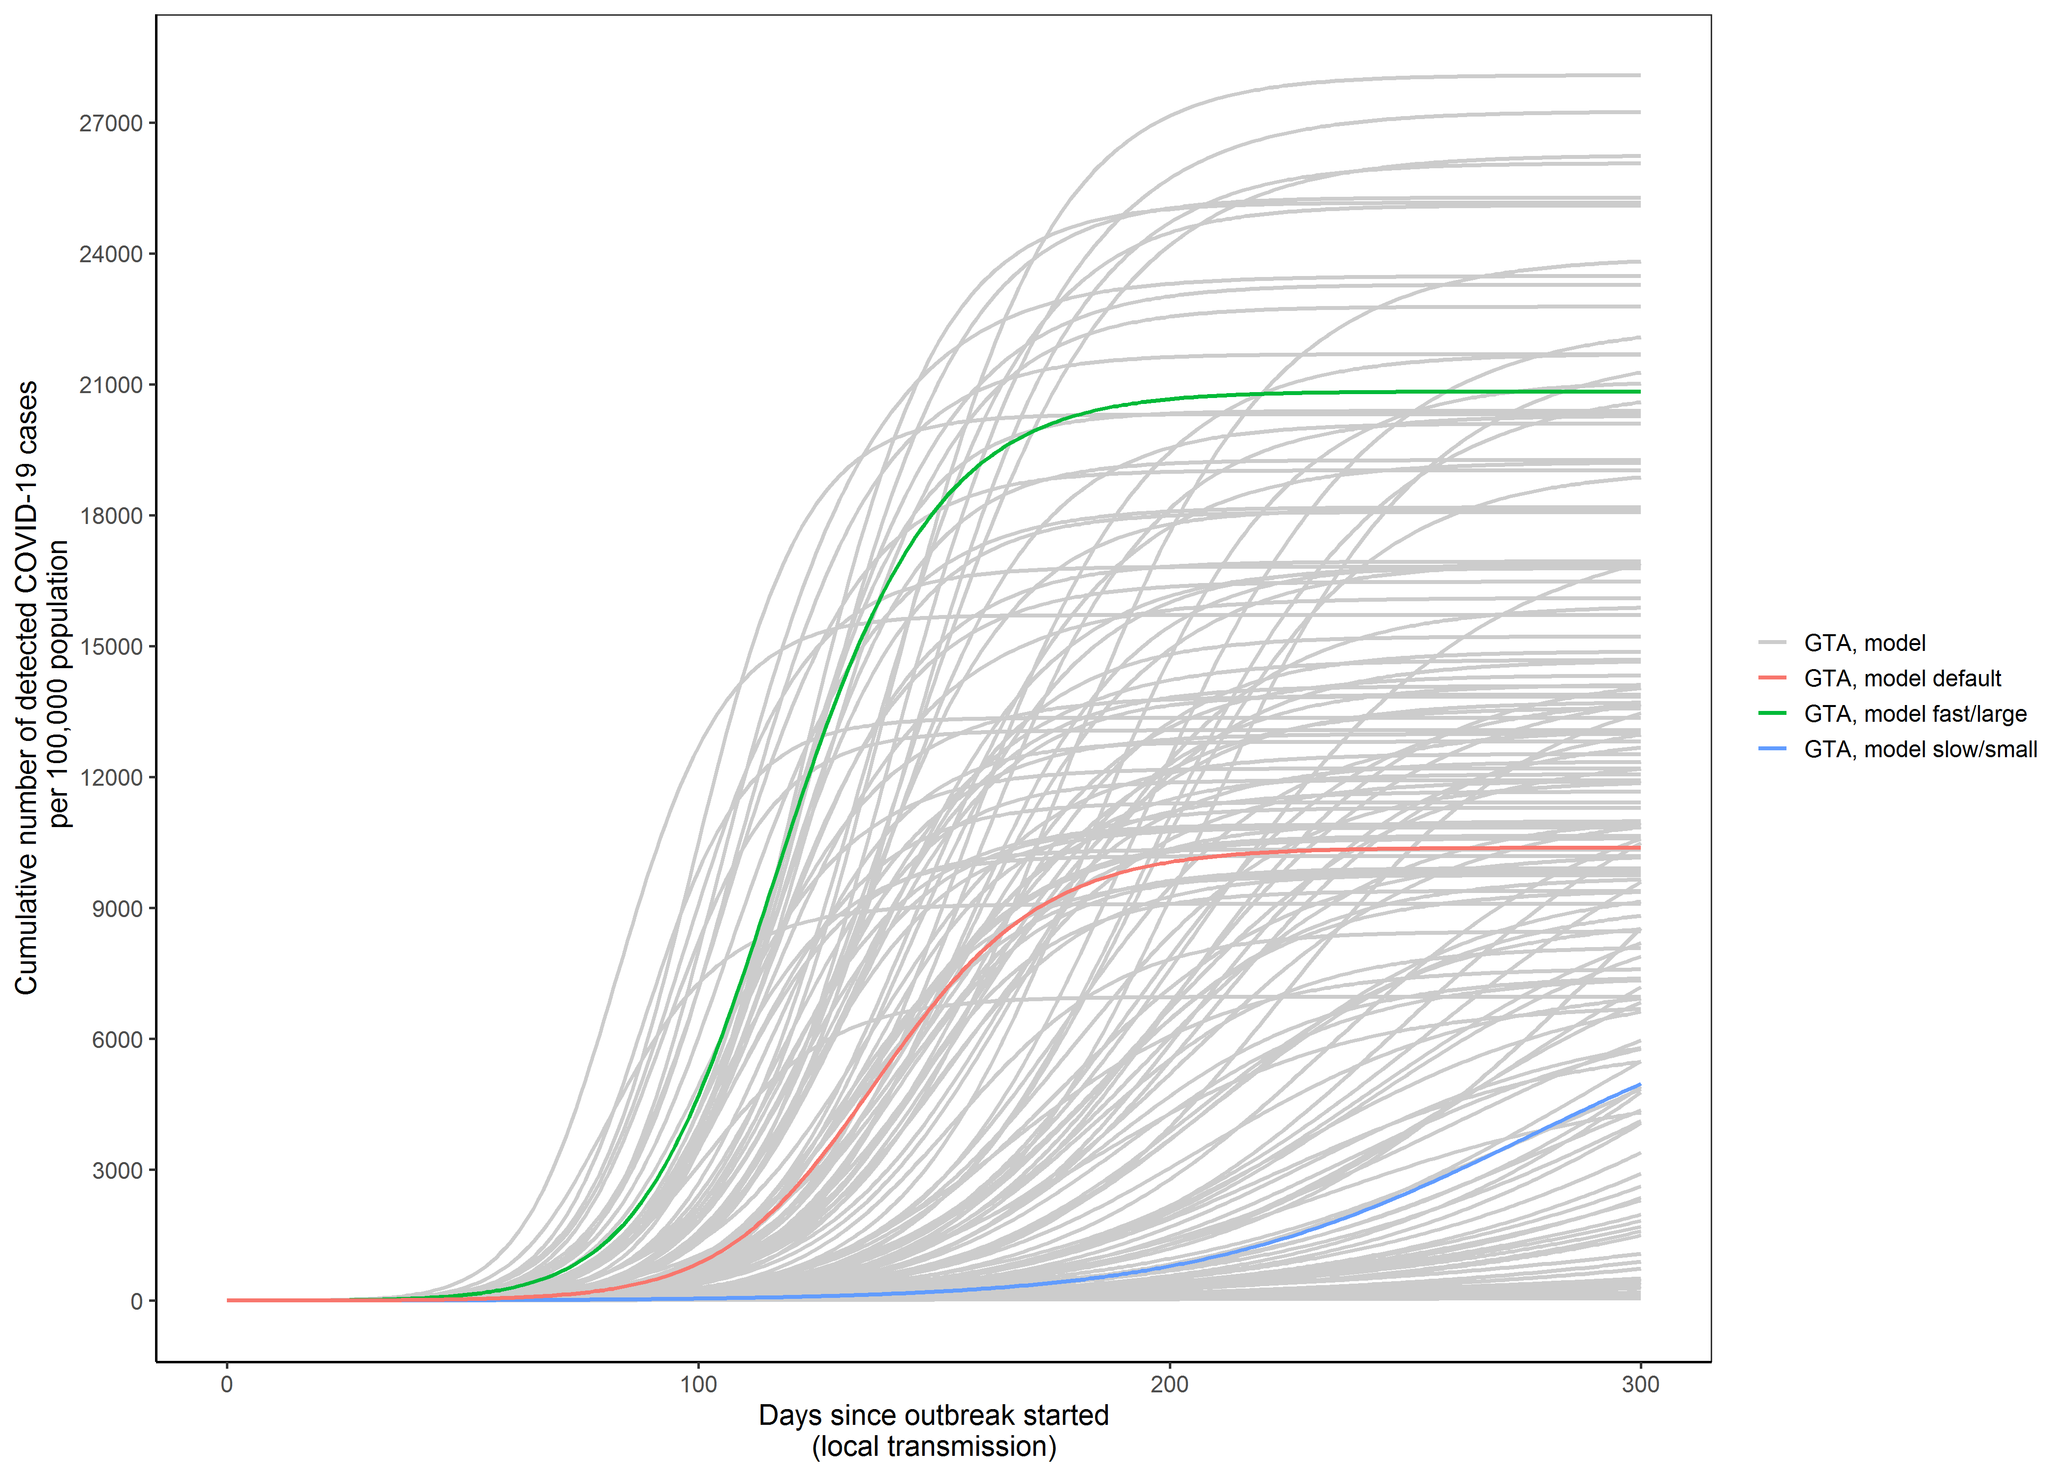
Appendix 2 Figure 2.1. Cumulative detected cases per 100,000 population across simulated epidemic scenarios. Model outputs from the sampled range of parameters in Table 1 which meet the model constraints are shown for detected cases as solid lines. The model output for the fast/large epidemic is shown in green and slow/small epidemic in blue, selected as the upper and lower quartile of peak incidence, respectively, within the first 300 days. The default (solid red line) depicts the default scenario (Table 1). Simulated timeline begins at the start of the ‘seeding’ of the population with 0.0011-0.0048% of the population already infected with SARS-Cov-2. For observed data, we define outbreak started when 3 confirmed cases were observed.
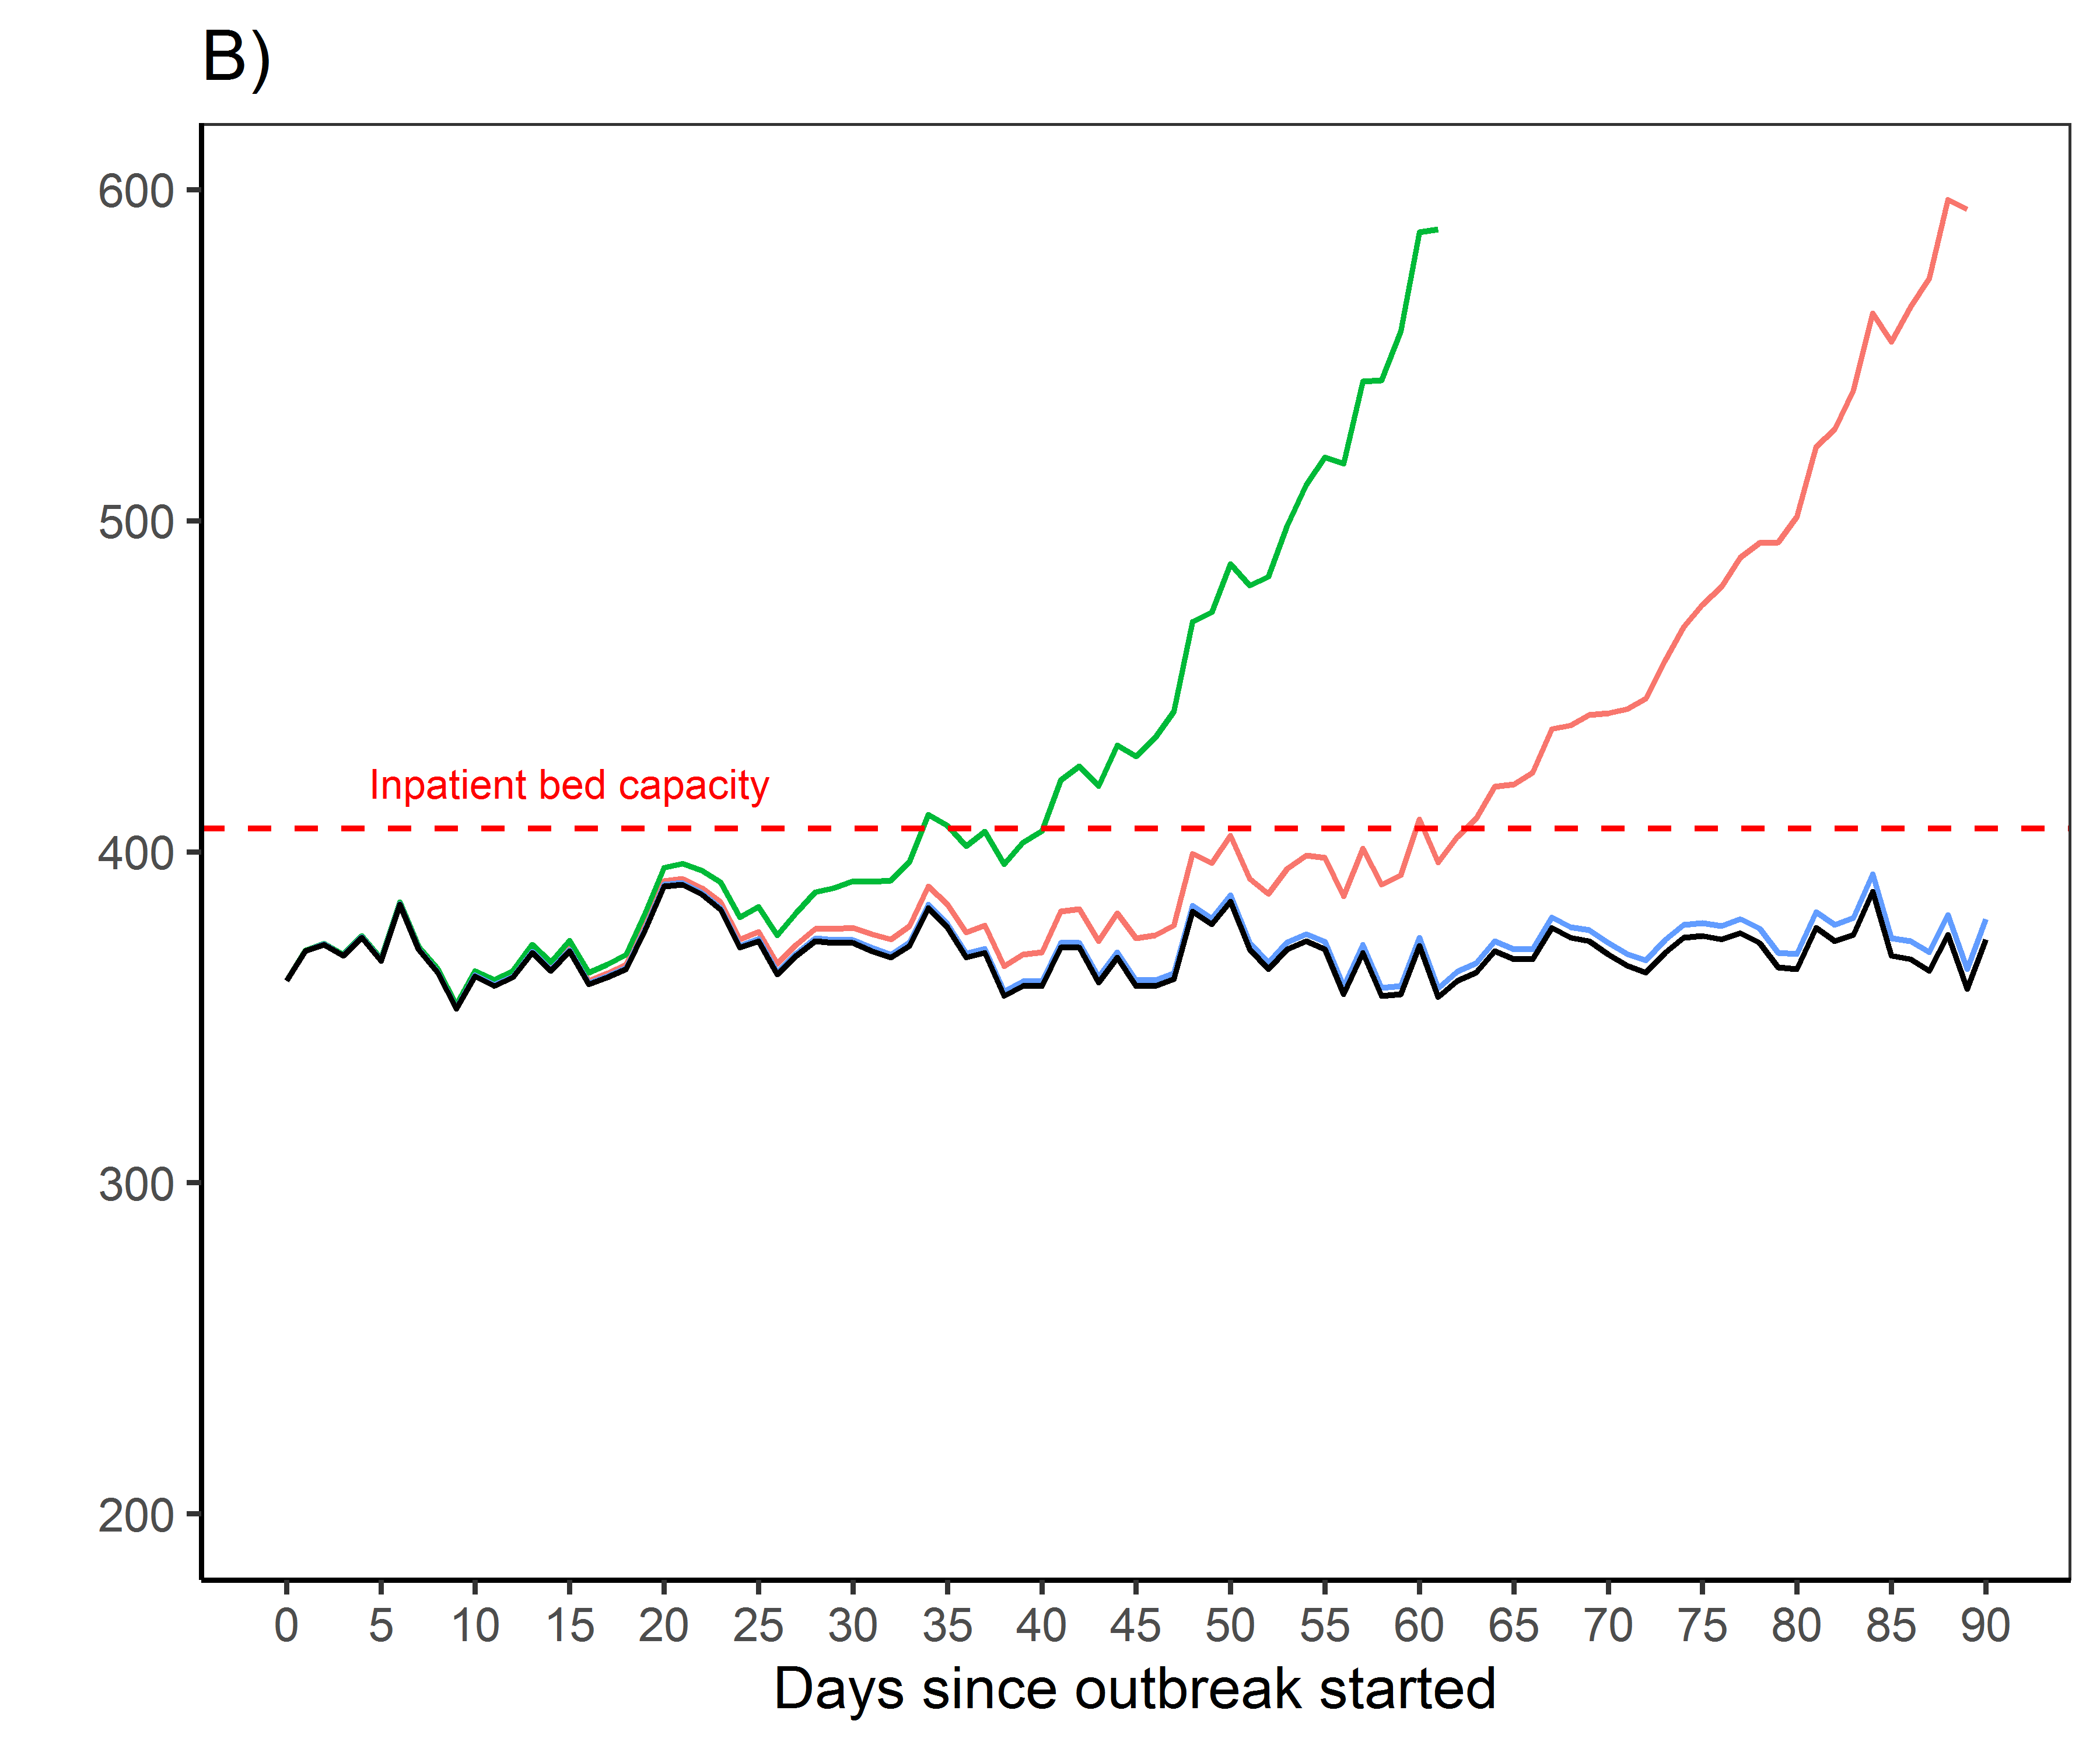
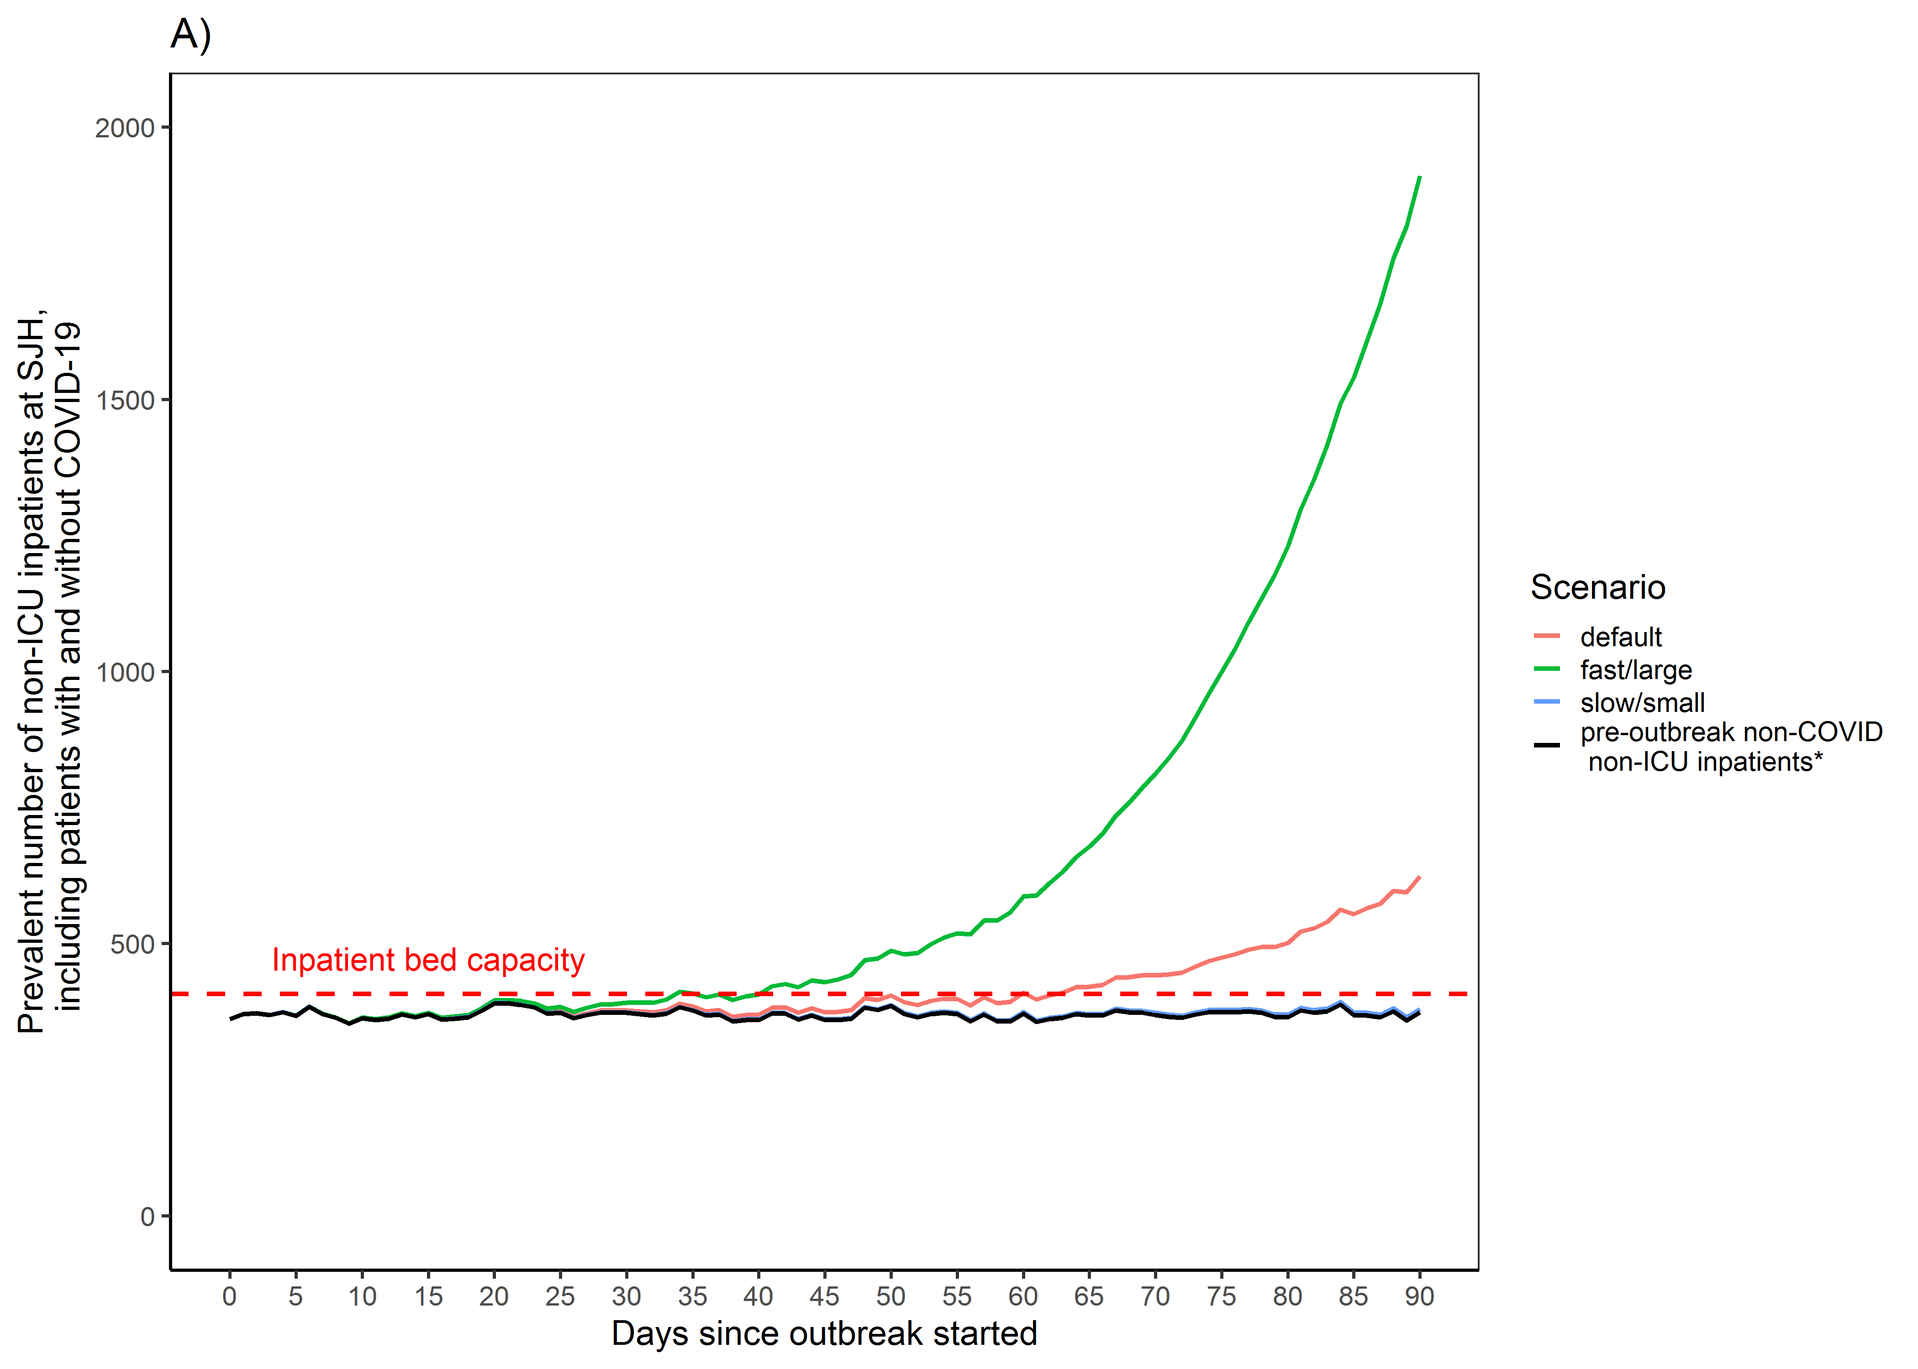
Appendix 2 Figure 2.2. Estimated surge and capacity for non-ICU hospitalization at St. Joseph's Hospital in the Greater Toronto Area. (A) Modeled number of non-ICU inpatients (including inpatients with and without COVID-19) and corresponding pre-outbreak baseline (non-COVID) number of non-ICU inpatients per day over 90 days. *Estimated by the median number of non-ICU inpatients at SJH between March – June, 2014-2019. (B) Same information as (A) but the y-axis ranged between 200-600. Estimates assume that distribution of non-ICU hospital admissions for patients with COVID-19 follows the pre-outbreak catchment of all non-ICU admissions across acute care hospitals in the Greater Toronto Area (March – August 2019), such that SJH receives 4.0% of all non-ICU hospital admissions. Our use of observed data on hospital-specific non-ICU admissions during March-June (black line) are not meant to indicate a start-date of the outbreak as March 1. All three scenarios (default, fast/large, and slow/small) assume that physical distancing started on day 30 and reduced contact rates by 20%, but has not increased nor decreased; and that the proportion of individuals with non-severe COVID-19 who self-isolate (e.g. via diagnosis of confirmed/suspected COVID-19) has not changed over the course of the epidemic. Abbreviations: ICU: intensive care unit; SJH: St. Joseph's Hospital.
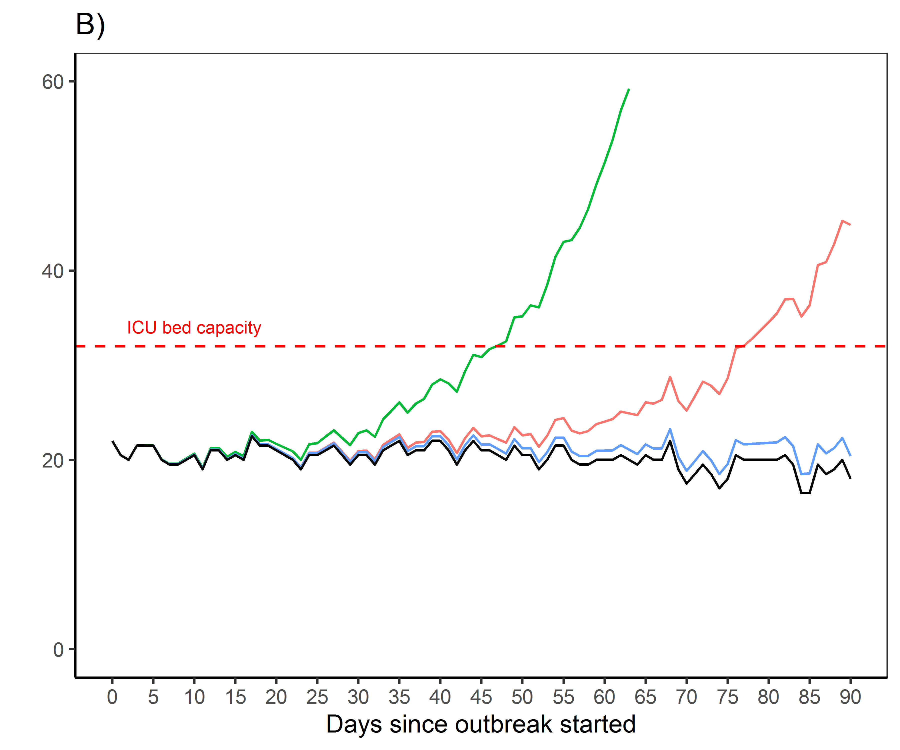
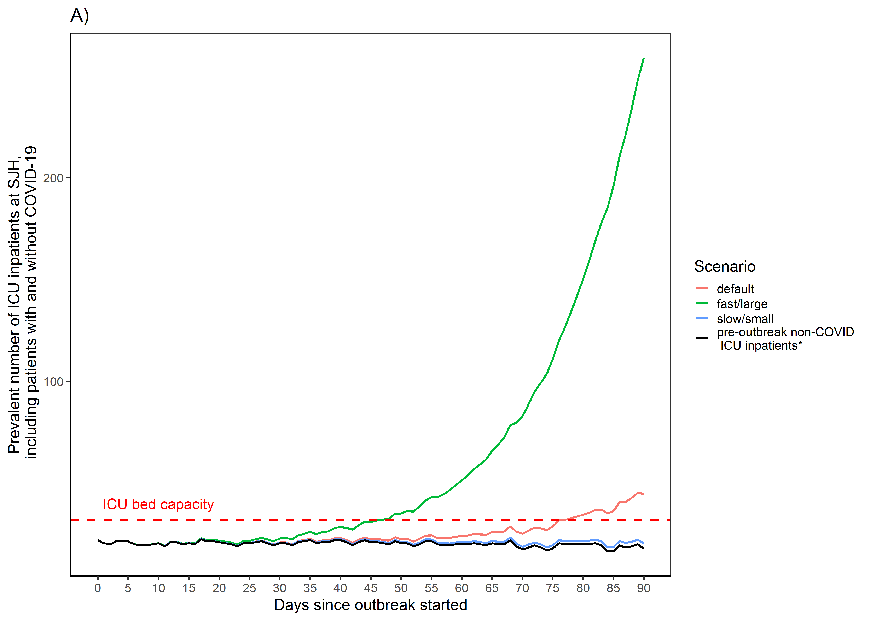
Appendix 2 for Figure 2.3. Estimated surge and capacity for ICU care at St. Joseph's Hospital (SJH) in the Greater Toronto Area. (A) Modeled number of ICU inpatients (including inpatients with and without COVID-19) and corresponding pre-outbreak baseline (non-COVID) number of ICU inpatients. *Estimated by the median number of ICU inpatients at SJH between March – June, 2014-2019). (B) Same information as (A) but the y-axis ranged between 0-60. Estimates assume that distribution ICU admissions for patients with COVID-19 follows the pre-outbreak catchment of all ICU admissions across acute care hospitals in the Greater Toronto Area (March – August 2019), such that SJH receives 2.3% of all ICU hospital admissions. Our use of observed data on hospital-specific ICU admissions during March-June (black line) are not meant to indicate a start-date of the outbreak as March 1. All three scenarios (default, fast/large, and slow/small) assume that physical distancing started on day 30 and reduced contact rates by 20%, but has not increased nor decreased; and that the proportion of individuals with non-severe COVID-19 who self-isolate (e.g. via diagnosis of confirmed/suspected COVID-19 or without) has not changed over the course of the epidemic. Abbreviations: ICU: intensive care unit; SJH: St. Joseph’s Hospital.

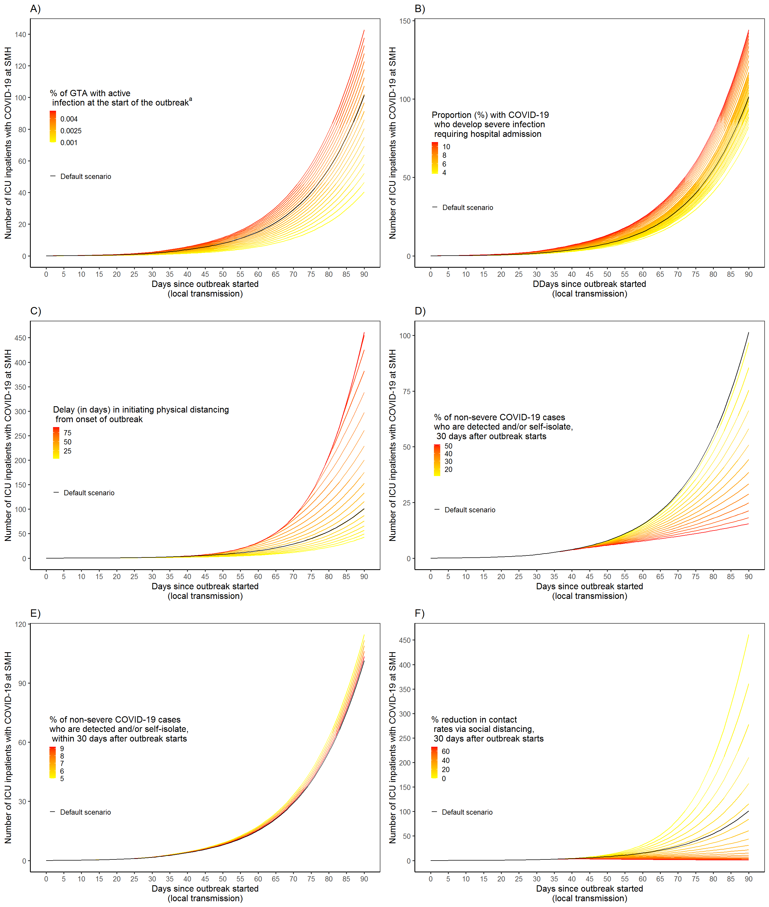
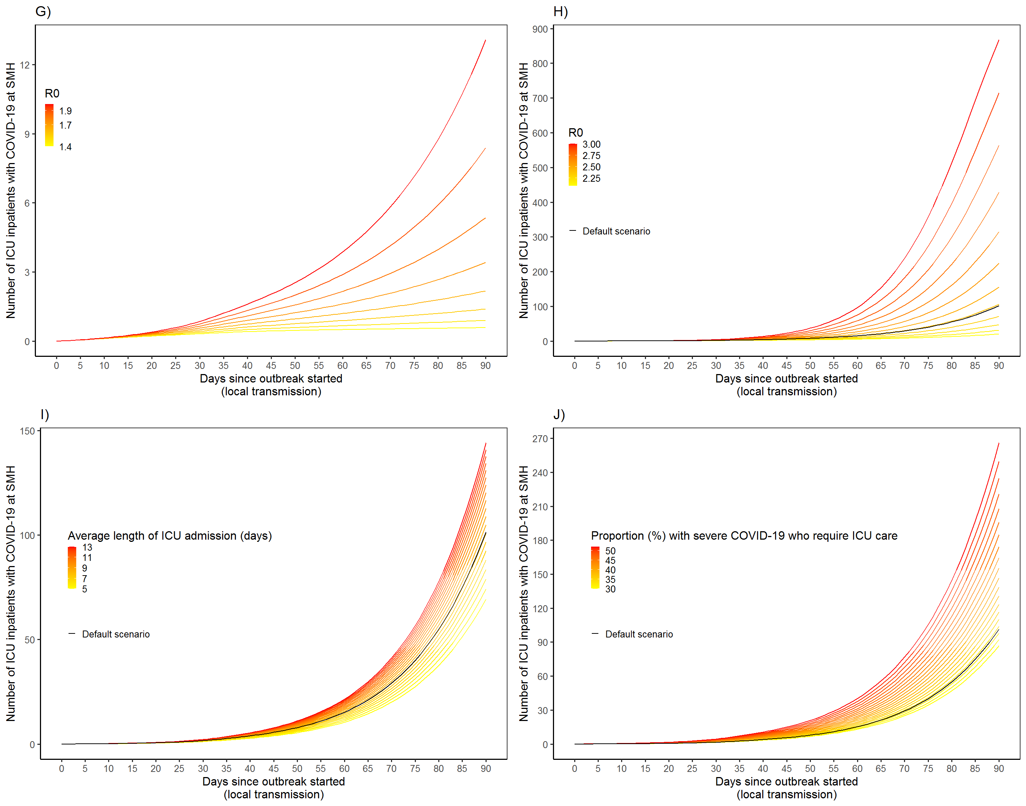

Appendix 2 for Figure 2.4. One-way sensitivity analyses using default epidemic scenario for prevalence of ICU inpatients with COVID-19 at St. Michael’s Hospital. The influence of (A) seeding (proportion of population already infected with COVID-19 just at the start of the outbreak); and (B) clinical severity (proportion of individuals infected with COVID-19 who require hospitalization); (C) earlier or later initiation of physical distancing (from start of outbreak to 60 days after outbreak started); (D) proportion of individuals with non-severe COVID-19 who are diagnosed and/or self-isolate, 30 days after outbreak starts (e.g. due to increase capacity in testing in the community); (E) proportion of individuals with non-severe COVID-19 who are diagnosed and/or self-isolate; within 30 days since outbreak starts; (F) proportion reduction in contact rates via social distancing, 30 days after outbreak starts (e.g. due to increase capacity in testing in the community); (G) R0 (1.4-1.9); (H) R0 (2.0-3.0); (I) average length of ICU admission (days); and (J) proportion of individuals with severe COVID-19 who require ICU care. Note that the y-axis scales for figures are different. Abbreviations: ICU: intensive care unit; SMH: St Michael’s Hospital; GTA: Greater Toronto Area.

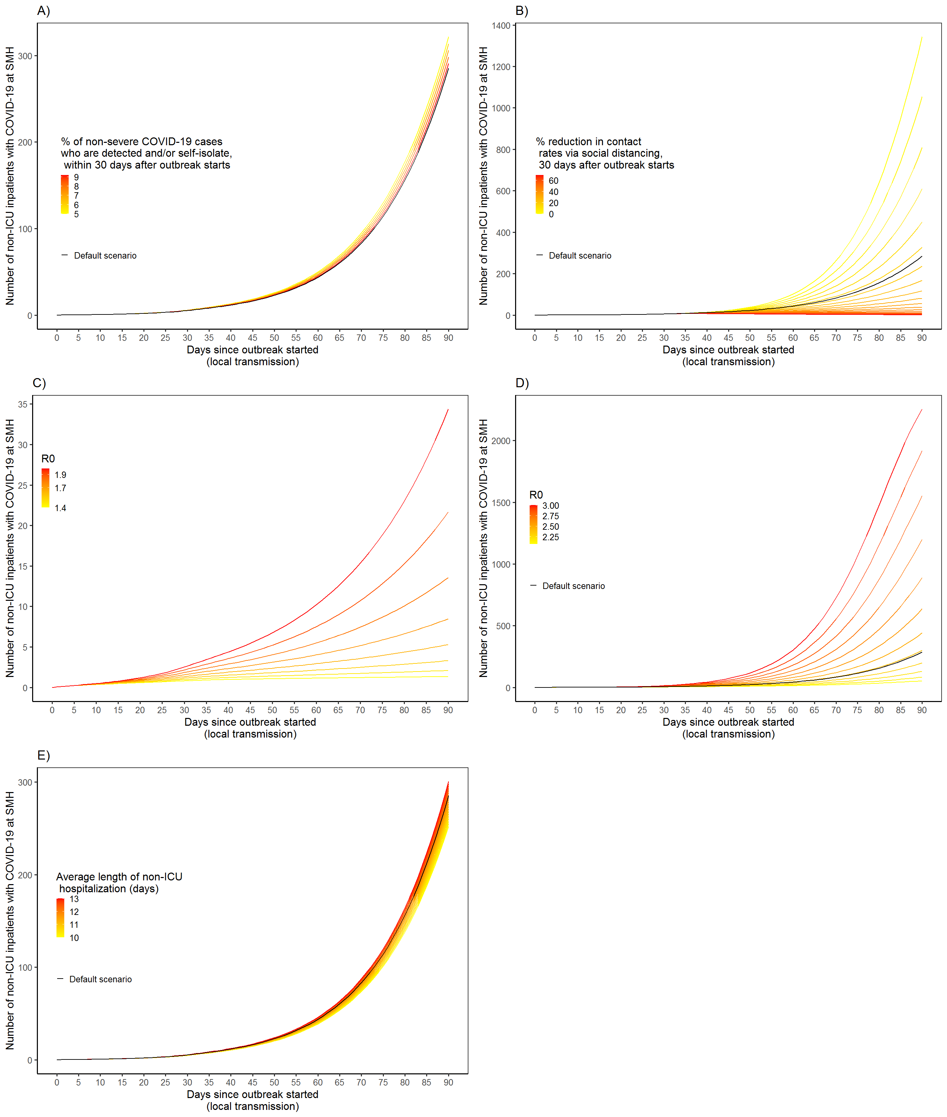Appendix 2 for Figure 2.5. One-way sensitivity analyses using default epidemic scenario for prevalence of non-ICU inpatients with COVID-19 at St. Michael’s Hospital. The influence of (A) proportion of individuals with non-severe COVID-19 who are diagnosed and/or self-isolate, within 30 days since outbreak starts; (B) proportion reduction in contact rates via social distancing, 30 days after outbreak starts (e.g. due to increase capacity in testing in the community); (C) R0 (1.4-1.9); (D) R0 (2.0-3.0); and (E) Average length of non-ICU hospitalization (days). Abbreviations: ICU: intensive care unit; SMH: St Michael’s Hospital; GTA: Greater Toronto Area.

