Appendix 1. Model Details & Parameterization

1.1 Overview
We developed a deterministic, compartmental mathematical model of SARS-Cov-2 virus transmission between person to person using a set of coupled differential equations. The state variables and their definitions are shown in Table A1, and the parameter definitions are shown in Table A2. The model simulates a closed population (no births, no baseline mortality). The model schematic with the state variables and transition parameters is shown in Figure A1. The model was written in R, and solved numerically using the deSolve package (1). The source code and all parameter files and outputs related to the study are available at our GitHub repository (2).

In the model, susceptible individuals acquired infection and entered a brief exposed or latent stage where they could not pass on the virus, followed by a subclinical but infectious stage (during which an individual may not experience symptoms), and then an infectious stage with or without symptoms. Following symptom onset, a subset of individuals developed severe disease and requires hospitalization; thus, we assumed that all individuals who develop severe disease are symptomatic. We assumed that among individuals with non-severe infection, a subset remained undetected and did not self-isolate when symptomatic; the rest self-isolated. The self-isolation compartment (I_{isol}) included individuals with a confirmed diagnosis based on polymerase chain reaction (PCR) testing, and suspect diagnosis based on symptoms and/or exposures (3, 4). Individuals within non-severe infections recovered and we assumed that all who recover had protective immunity during the time-period of analyses. Hospitalized individuals with COVID-19 could be detected as confirmed cases via testing. A proportion of individuals with severe infection required intensive care, among whom an COVID-19 attributable mortality rate was applied (5-13). Patients who recovered following inpatient and/or intensive care were discharged from the inpatient unit to the community.
The model included ‘super-spreading’ events as burst (one-time) events that occurred at a regular frequency to capture some dispersion around the average effective reproductive number and based on secondary attack rates from the literature and outbreaks in long-term care facilities or shelters (14, 15). Travel-acquired cases were included, of whom a subset with non-severe infection were diagnosed (confirmed or suspect) and isolated. We assumed that hospitalized patients were under isolation and did not contribute to the average contact rates at the population-level. We further assumed that hospitalized patients (and those who self-isolated) did not explicitly contribute to onward transmission. However, superspreading events may be interpreted as within-hospital (i.e. nosocomial), within long-term care or shelters, or via community transmission.

Table A1. State variables and their definitions.
Symbol | Definition
S | Susceptible
E | Exposed (latent stage), not infectious
I_{sc} | Infectious, subclinical
I_{ni} | Infectious, non-severe, not isolated (subclinical, symptomatic and not diagnosed)
I_{isol} | Infected, non-severe, self-isolation
I_{sev} | Infected, severe and hospitalized, isolation
I_{icu} | Infected, severe and admitted to intensive care unit (ICU)
R_{ni} | Recovered, never isolated and never diagnosed
R_{isol} | Recovered, had been in self-isolation and/or discharged from hospital

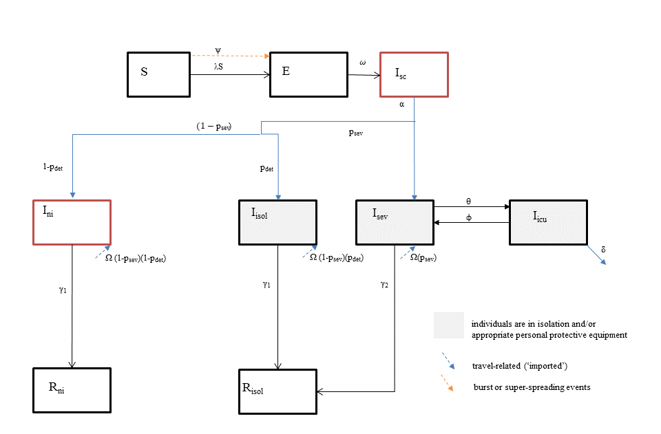
Figure A1. Transmission model schematic. State variables and parameters are defined in Table A1 and Table A2.
Table A2. Parameters and their definitions.
Symbol | Definition | Calculated
β | Probability of transmission (includes biological probability and contact rate) | $$β=\frac{R_{0}}{duration infectiousness}$$
λ | Force of infection per susceptible | $$=β\frac{(I_{sc}+I_{ni})}{(S+E+I_{sc}+I_{ni}+R_{ni}+R_{isol})}$$
$$ω$$ | Per-capita rate of transition from E to I_{sc} | 1/duration of latent (or exposed) period
Ω | Travel-related (imported) cases | See section 1.4 and (16)  Travel-related cases (Ω) are imported via removal of a daily time-series of individuals from the S compartment to the various infectious, symptomatic compartments, based on the probability of severe infection, and probability of self-isolation/diagnosis among travel-related cases with non-severe infections. We assume that travel-related cases continue until the reproductive ratio (R_{e}) was less than 1.
ψ | Super-spreading or burst events | Super-spreading events (ψ) are included as burst or clustered transmission events by a recurring frequency of cases which continue until reproductive ratio (R_{e}) is less than 1.  For the current analyses, we assumed 5 superspreading events every 11 days until the reproductive ratio was less than 1.
α | Per-capita rate of exit from I_{sc} | 1/duration of subclinical period
p_{sev} | Probability of severe infection requiring admission | Among all infected
p_{det} | Probability of detection and isolation | Among individuals with non-severe infection, not travel-related
p_{det_tr} | Probability of detection and isolation | Among individuals with non-severe infection, travel-related
$$γ_{1}$$ | Rate of recovery among individuals with non-severe infection | 1/duration of symptomatic infection
$$γ_{2}$$ | Rate of discharge to community, among patients hospitalized with severe infection | 1/duration of hospitalization in non-ICU care
$$condprob_{icu}$$ | Probability of ICU admission among patients admitted to hospital | See Table 1 in Main Text
θ | Rate of admission from non-ICU ward to ICU | $$θ=\frac{(-\ln\left(1-condprob_{icu}\right)*γ_{2})}{\left(1+\ln\left(1-condprob_{icu}\right)\right)}$$
$$φ$$ | Rate of transition from ICU to non-ICU ward | 1/duration of stay in ICU
$$condprob_{cfr}$$ | Probability of death among patients with COVID, in the ICU | See Table 1 in Main Text
δ | Per-capita morality rate among patients with COVID in the ICU | $$δ=\frac{(-\ln\left(1-condprob_{cfr}\right)*φ)}{\left(1+\ln\left(1-condprob_{cfr}\right)\right)}$$

1.2. Model equations
$\frac{dS}{dt}=-S-Ω-ψ$ (1)

$\frac{dE}{dt}=S+ ψ- ωE$ (2)

$\frac{dI_{sc}}{dt}=ωE- αI_{sc}$ (3)

$\frac{dI_{ni}}{dt}= αI_{sc}\left(1-p_{sev}\right)\left(1-p_{det}\right)+ Ω\left(1-p_{sev}\right)\left(1-p_{det_tr}\right)-γ_{1} I_{sc}$ (4)
$\frac{dI_{isol}}{dt}= αI_{sc}\left(1-p_{sev}\right){(p}_{det⁡}) + Ω\left(1-p_{sev}\right)\left(p_{det_tr}\right) -γ_{1} I_{isol}$ (5)

$\frac{dI_{sev}}{dt}= αI_{sc}\left(p_{sev}\right)+Ω\left(p_{sev}\right) + φI_{icu}- γ_{2} I_{sev}-θI_{sev}$ (6)

$\frac{dI_{icu}}{dt}= θI_{sev} -φ I_{icu}-δI_{icu}$ (7)

$\frac{dR_{ni}}{dt}= γ_{1} I_{sc}$ (8)

$\frac{dR_{isol}}{dt}= γ_{1} I_{isol}+ γ_{2} I_{sev}$ (9)

1.3. Force of infection
We assume a homogenous population and consider that individuals who are isolated are no longer contributing to contact rates. As such, the probability of contact with an infectious individual uses the following denominator: sum of individuals in S, E, I_sc, Rnd, Rd. The consequence of such an assumption is that the impact of interventions such as increasing detection (and thus self-isolation) may be underestimated because individuals in the isolation compartment do not explicitly contribute to herd immunity (they do not ‘consume’ potential contacts).

1.4. Biological, clinical, and epidemiological parameters
Parameter values and their data sources are shown in Main Text Table 1. For the GTA transmission model, we sourced data for biological, epidemiological, and clinical severity parameters; internal validity checks; and epidemic constraints.

For biological and clinical parameters, we searched the peer-reviewed literature, pre-print literature, and publicly available reports from January 1, 2020 onwards. The literature search was not limited by country; however, at the time of our search on March 25, 2020, the majority of the published and preprint evidence was based on the outbreak in China, with a few data points from other countries including Singapore and Europe. We additionally searched the provincial- and city-level government official websites for COVID surveillance in Ontario and City of Toronto, and extracted relevant parameters of interest, wherever data is available. We used estimates of the key epidemiological parameter - the basic reproductive number (R₀) - from published and pre-print modeling studies of COVID-19 outbreaks within and outside China (17-24) to generate a plausible range of R₀ that could be applied to the GTA. We extracted estimates on disease incubation period (5-7, 17, 25-32), symptomatic period (33), and serial intervals (17, 32, 34, 35) from pooled analysis as well as individual epidemiological and virological studies of COVID-19 to model the disease progression.

For parameters related to the probability of hospital admission and ICU admission, we used crude estimates the Public Health Agency of Canada reported on diagnosed COVID cases in Canada as of March 23rd as our default estimates (36). We extracted estimates on disease severity among confirmed and hospitalized cases in China (6, 7) to guide the range in probability of hospital admission and ICU admission, assuming all severe cases will require hospitalization and cases with critical conditions will require ICU care in the GTA context. We obtained estimates on the duration of hospital stay and ICU stay among hospitalized patients who were discharged without being admitted to ICU (5) and ICU patients who were discharged to the medicine ward (37), respectively, using data reported in China.

We extracted estimates on the case-fatality rate among ICU patients (5, 7-13) as well as among all confirmed cases in China (7, 11, 38) and in other countries or regions (39, 40). Wherever data is available, we sought for estimates adjusted for time-lag to death, and those stratified by age (details in Main Text Table 1).

1.4.2. Internal parameter validity checks on biological and clinical parameters

External estimates such as the overall case-fatality proportion among all diagnosed cases, and the serial interval were not directly used as input parameters in our model. However, they were correlated with other input parameters, and thus were used as interval validity checks to constrain our sampled parameter sets.

In the model, we assumed all deaths attributable to COVID are detected as confirmed cases and admitted to ICU prior to death. Therefore, we applied the following parameter in our model for COVID-19 attributable mortality: case-fatality proportion among patients in the ICU. As such, the overall case-fatality proportion among all diagnosed cases could be calculated using the product of the following parameters: probability of admission among diagnosed, probability of admission to ICU among hospitalized, case-fatality proportion among patients in ICU. We conducted internal validity checks to ensure the calculated case-fatality proportion among all diagnosed individuals fall within the external estimates of case-fatality among diagnosed cases obtained from the literature. The checks constrained the joint distribution of the above three parameters so that the overall case-fatality was consistent with observed data.

Similarly, we used estimates on duration of latent period, duration of sub-clinical period (calculated using the difference between incubation period and latent period), and duration of symptomatic period as our direct model parameter inputs to simulate disease progression. Given the definition of serial interval, we could calculate the minimum possible serial interval (incubation period minus sub-clinical period) and the maximum possible serial interval (incubation period plus symptomatic period) based on the above input parameters (41). We conducted internal validity checks to ensure the minimum calculated serial interval is lower than the upper bound of the external estimates on serial interval; and the maximum calculated serial interval is higher than the lower bound of the external estimates on serial interval. The checks constrained the joint distribution of the above parameters so that our modelled disease progression reflected epidemiological evidence on the serial intervals of COVID.

Modeled estimate of confirmed cases
To calculate the cumulative number of diagnosed cases in the simulated epidemics, we applied a probability of polymerase chain reaction (PCR) testing while admitted (I_{sev} and I_{icu}) and among those who self-isolate (I_{isol}); both values increased after the observed number of diagnosed cases in the GTA exceeded the expected number of travel-related, diagnosed cases 48 days after detection of the first confirmed case (Section 1.5).

The initial value for probability of PCR testing while admitted was 0.6 (tau_1), reflecting the practice of sentinel testing in the province and at the hospital-level prior to first diagnosed case of local transmission in the GTA. During the week of March 8, 2020, the provincial health laboratory had conducted 700 sentinel testing among inpatients with an acute respiratory illness whose health care providers had submitted a nasopharyngeal swab test for other respiratory viruses. Based on publicly available data from the Canadian Institute for Health Information data for 2017-2018, there are an average of 510 hospitalizations per week for pneumonia and 607 hospitalizations per week for chronic obstructive pulmonary disease or bronchitis. Assuming that pneumonia and chronic obstructive pulmonary disease or bronchitis are indications for nasopharyngeal swabs for respiratory virus testing, and all cases of severe COVID-19 could fit under these two diagnoses, then sentinel testing would have been conducted on 63% of hospitalized patients. At St. Michael’s Hospital, sentinel testing (prior to first diagnosed case of local transmission) was conducted for 30 patients per week, and the daily census of hospitalized patients with an acute respiratory illness was 60-70 with a median length of stay of 7 days, leading to 65 new admissions per week, and as such sentinel testing would have captured 0.5. We then increased tau_2 to 0.9 to reflect nearly perfect testing of all hospitalized patients with symptoms compatible with COVID-19, after observed number of diagnosed cases in the GTA exceeded the expected number of travel-related, diagnosed cases.

The values for probability of testing among those who self-isolate was based on initial and revised testing criteria at assessment centers in the GTA, which varied considerably. At the time of analyses, we did not have access to data on testing nor positivity rates in the GTA. Thus, we used a probability of PCR testing of 0.1 and then 0.2 (tau_1) after observed number of diagnosed cases in the GTA exceeded the expected number of travel-related, diagnosed cases. The low probability of PCR testing reflected limitations on diagnostic capacity (test reagents and swabs) in the GTA, which meant PCR testing had to be prioritized to patients requiring hospitalizations and other higher-risk groups.

1.5. Travel-imported cases
To generate a daily number of diagnosed, imported cases (based on date of diagnosis) for the transmission model, we used surveillance data on travel-related cases diagnosed in the Greater Toronto Area (42) between Jan 25 and March 12, 2020. We then extrapolated the cumulative number of diagnosed, travel-related cases using a linear extrapolation in the Greater Toronto Area (Figure A2). We used the extrapolation of the cumulative number to generate a daily time-series, and used the daily time-series for the Greater Toronto Area in the transmission model (16). We assumed that the proportion with non-severe infection who have a travel history are more likely to be diagnosed or self-isolate (default p_{det_tr} =0.2, range 0.10-0.50).

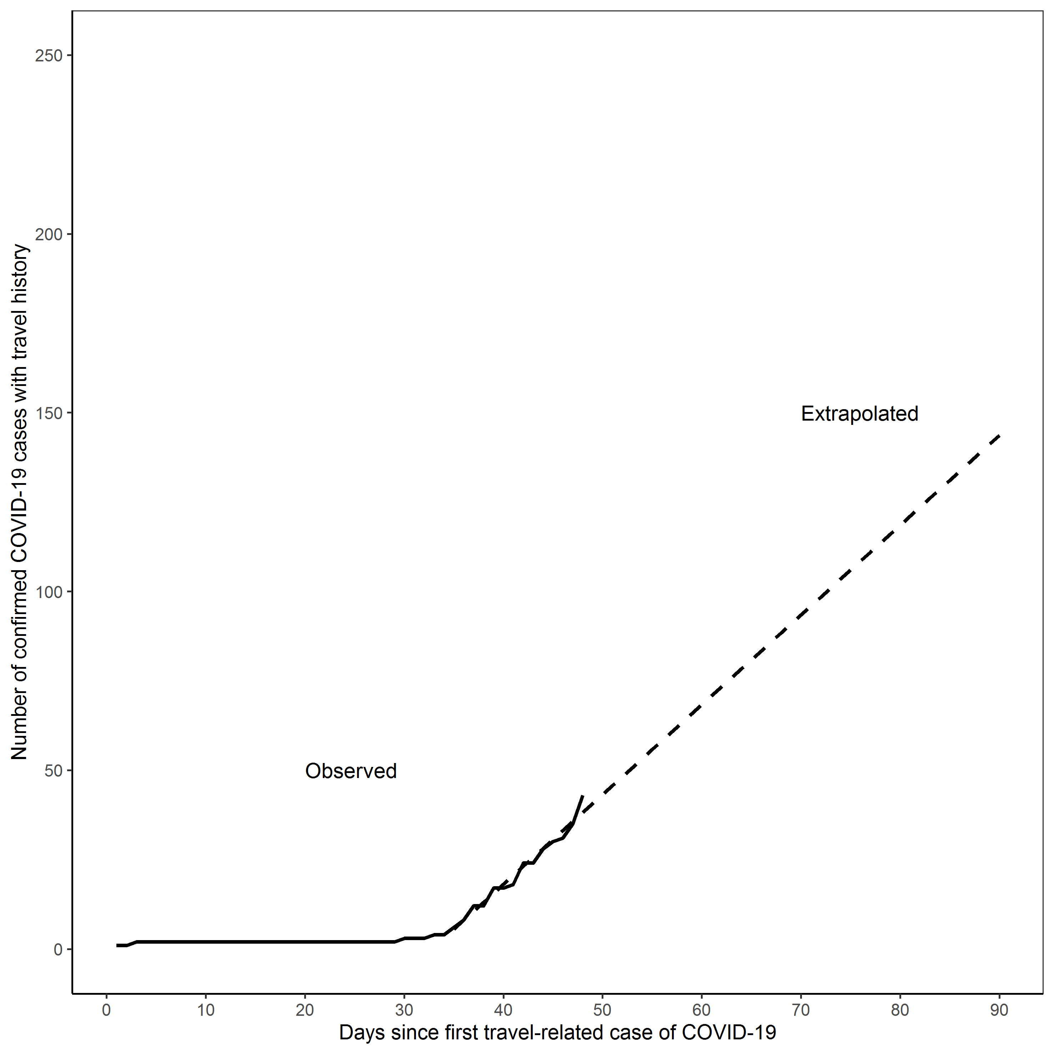
Figure A2. Observed and extrapolated number of travel-related COVID-19 cases in the Greater Toronto Area.

1.6. Data on epidemic curves for model constraints

1.7.1. Global confirmed cases by country and/or region

We obtained time series of daily cumulative confirmed cases in Spain, Sweden, South Korea, Singapore and Hong Kong, China from the open data sources provided by the John Hopkins dashboard (43, 44). We supplemented the open source data for Lombardy, Italy, using data provided from the Wikipedia page on the coronavirus pandemic in Italy (45). The epidemic trajectories in these settings are shown in Figure A3, reflecting a range of epidemic scenarios. We used the observed data 30 days after detection of at least 3 cases in Lombardy, Italy as the upper bound and in Hong Kong, China as the lower bound to constrain our model simulated epidemic scenarios.

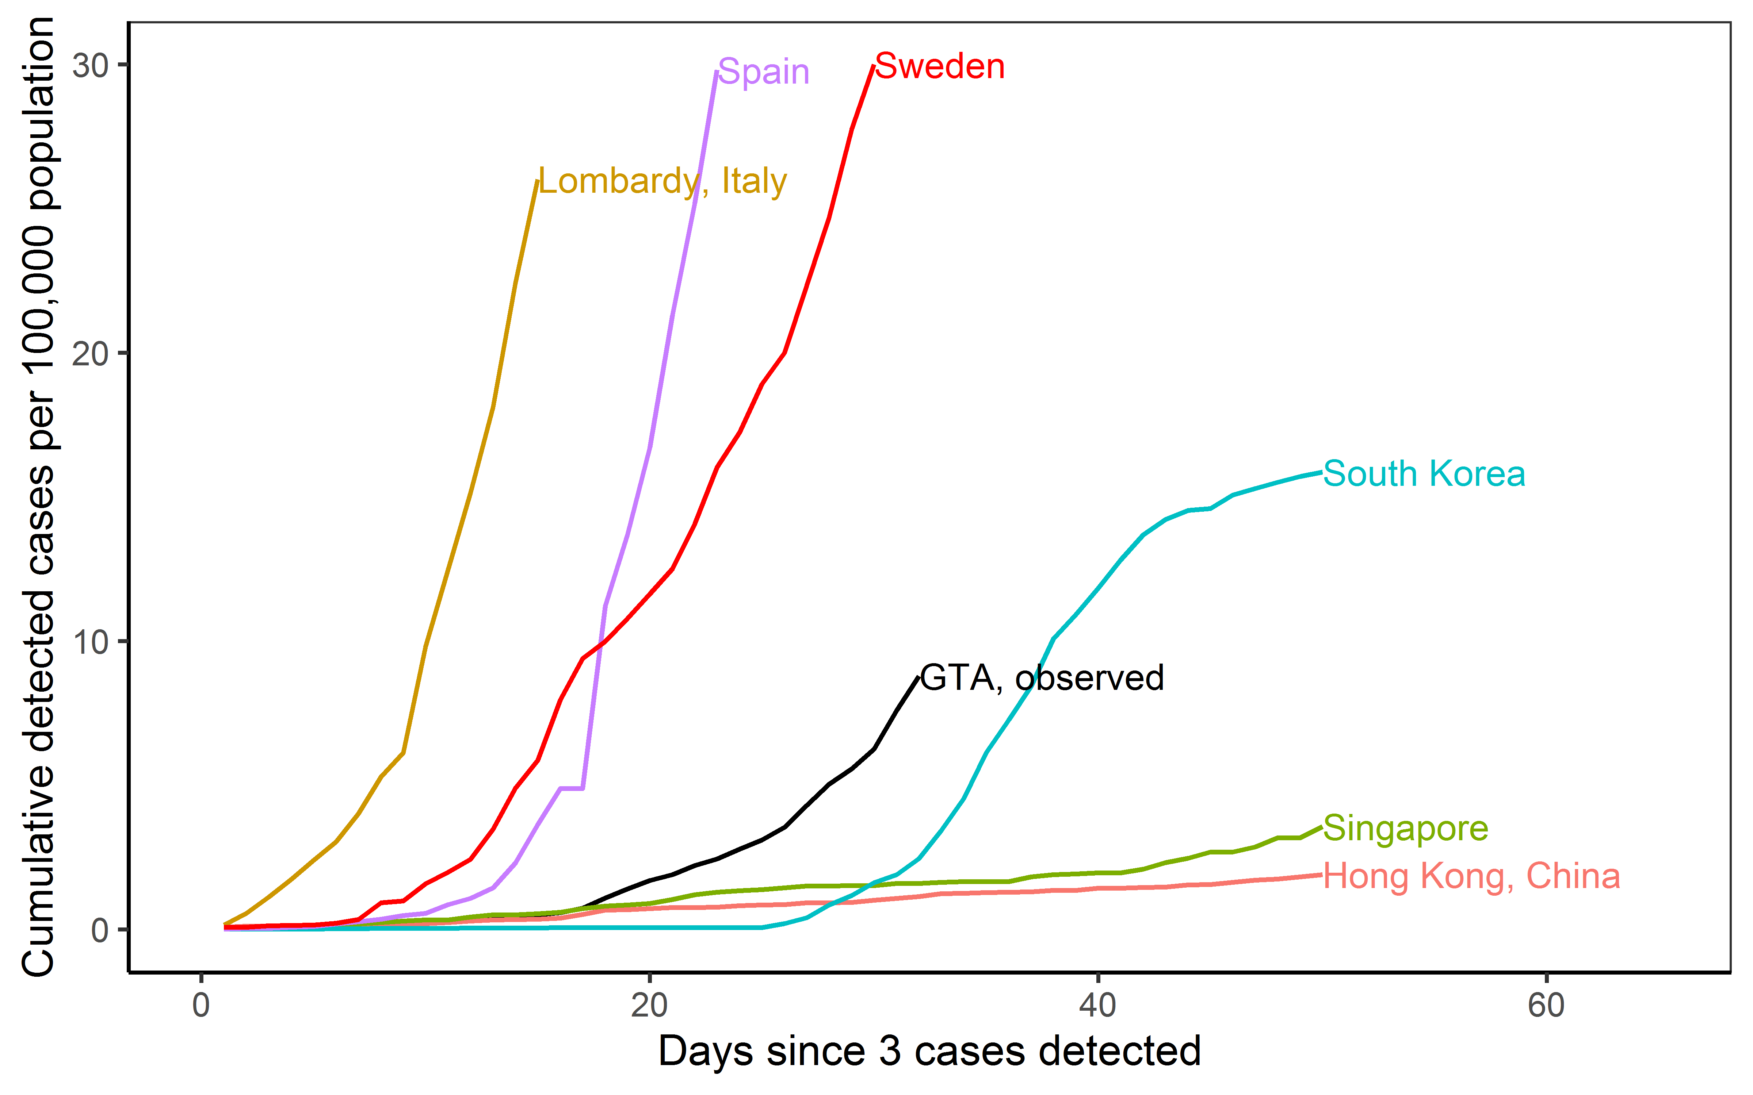

[Figure A3: Epidemic trajectories in the Greater Toronto Area and other settings. We chose 3 cases detected as the onset of epidemic based on the observed epidemic curve in the Greater Toronto Area, where the curve started to take off after detection of 3 cases. We applied the same threshold for other settings for comparability of epidemic curves across geographic locations. The last date shown in this figure for each of the regions are as follow: Greater Toronto Area (March 25, 2020); Hong Kong, China (March 14, 2020); Lombardy, Italy (March 6, 2020); Singapore (March 13, 2020); South Korea (March 15, 2020); Spain (March 18, 2020); Sweden (March 26, 2020). Abbreviations: GTA: Greater Toronto Area.
1.7.2. Greater Toronto Area (GTA)

At the time of analyses, data on number of diagnosed cases in the GTA were not publicly available from a single source. GTA data are now publicly available from iPHIS but are provided based on accurate episode date. We had to constrain epidemics using the data as reported in other settiings (i.e. by date of detection) and thus we manually collated data from all publicly available sources and synthesized into a single time-series which we made publicly available on our GitHub repository (46).

The GTA consists of the City of Toronto, Durham region, Halton region, Peel region, and York region. The daily cumulative number of cases in the GTA was obtained through the summation of individual daily case data for Toronto and the four regions. As of March 25, the number of confirmed cases for Toronto and the four regions were updated on a daily basis using data reported by their respective city/regional governments. Historical data prior to March 25 was obtained through various means, depending on availability of data from the city/regional governments’ websites. We used and presented data up to March 25 for the cumulative number of confirmed cases in GTA in the current study; the time series of GTA cases overall and by each region are available on the GitHub respository (46). We expect potential reporting delay of 2-3 days in our time series compared to the iPHIS data (the complete data with date of case detection is yet made publically available).

City of Toronto
Official press release from the City of Toronto was used as the primary source of data (47). Where this information was missing (due inconsistent frequency of reporting prior to March 17), one of the following methods was used to estimate the number of confirmed cases: referred to the data in the Public_COVID-19_Canada database created by the COVID-19 Canada Open Data Working Group (42) which recorded historical data from the Government of Ontario website (48); or imputed data given the known time lag in reporting between the provincial and regional governments as approximated from historical data from other regional governments.

Missing data from primary source:
March 6 and prior: using other regional datasets with consistent historical reporting of their daily cases (i.e., Durham region (49) and York region (50)) as a reference, it could be seen that data from the Public_COVID-19_Canada database is consistent with the reporting from the regional governments. Assuming the same for the City of Toronto, data from the Public_COVID-19_Canada database was used to fill in any missing information gap.

Between March 7 and 16: the missing data was imputed by using the observed time lag between other regional datasets and the Public_COVID-19_Canada database during this time period and using data from the Public_COVID-19_Canada database (42).

March 17 and onwards: data was obtained through daily press release by the City of Toronto (47) and if a single day of data was missing, the number of confirmed cases was approximated by using the median value of the number of cases reported the day prior and the day after.

Durham Region
Information posted on the Durham Region website was used as the primary source of data (49).

Halton Region
Information posted on the Halton Region website was used as the primary source of data (51). Where this information could not be obtained via the primary source (March 17-24), data was obtained through the Public_COVID-19_Canada database. Given the low number of cases reported by March 25 as well as a fairly slow increase in the number of cases, it was not necessary to impute the missing data using time lag.

Peel Region
Information posted on the Peel Region website was used as the primary source of data (52). Where this information could not be obtained via the primary source (March 9-24), data was obtained through the Public_COVID-19_Canada database. Given the low number of cases reported by March 25 as well as a fairly slow increase in the number of cases, it was not necessary to impute the missing data using time lag.

York Region
Information posted on the York Region website was used as the primary source of data (50).

Adjustments to the cumulative count for GTA
Data sources either report the daily number of new cases confirmed or the cumulative number of cases. If the daily number of cases was reported, the number was added to the previous day’s cumulative number of cases. Some news sources did not distinguish between presumptive and confirmed cases. In those instances, a second source was used to verify the status of the case. Where this was not possible, it was assumed that the case was confirmed as infected by COVID-19.

A time lag between the data reported by the Government of Ontario (as seen through the Public_COVID-19_Canada database) and the data reported by the city/regional governments was observed starting from March 8. The time lag issue was first brought to attention by the discrepancy between provincial and regional numbers for total confirmed cases (53). This discrepancy in reporting numbers was suggested to be the result of reporting delay (54). Given this, the time lag observed was assumed to be a general reporting delay between all city/regional levels of government and the provincial government. Thus, data released by the Government of Ontario (and by extension, the Public_COVID-19_Canada database) was not used as the primary source of data; but it was used when the primary source of data was not available or for the purposes of data imputations.

1.5. Data on hospital and ICU admissions in the Greater Toronto Area
We used the following report provided by ICES to Unity Health Toronto Infection Prevention and Control and Pandemic Planning Committee (55). The following ICES data sources were used to generate estimates of hospital and ICU admission. We excluded: Admissions of non-Ontario residents; those missing patient age or sex; those aged 105 y or older; those who had a death date before the admission date.

- Ontario Health Insurance Plan (OHIP) Registered Persons Database (RPDB): The RPDB provides basic demographic information (age, sex, location of residence, date of birth, and date of death for deceased individuals) for those issued an Ontario health insurance number. The RPDB also indicates the time periods for which an individual was eligible to receive publicly funded health insurance benefits and the best known postal code for each registrant on July 1st of each year.
- Canadian Institute for Health Information (CIHI) Discharge Abstract Database (DAD): The DAD is compiled by CIHI and contains administrative, clinical (diagnoses and procedures/interventions), demographic, and administrative information for all admissions to acute care hospitals, rehab, chronic, and day surgery institutions in Ontario.
- CIHI National Ambulatory Care Reporting System (NACRS): The NACRS is compiled by CIHI and contains administrative, clinical (diagnoses and procedures), demographic, and administrative information for all patient visits made to hospital- and community-based ambulatory care centres (emergency departments, day surgery units, hemodialysis units, and cancer care clinics).
- CIHI Same Day Surgery Database (SDS): The SDS is compiled by CIHI and contains administrative, clinical (diagnoses and procedures), demographic, and administrative information for all patient visits made to day surgery institutions in Ontario. The main data elements include patient demographics, clinical data (diagnoses, procedures, physician), administrative data (institution/hospital number etc.), financial data, service-specific data elements for day surgery and emergency.
- Ontario Healthcare Institution Information System (INST): The Institution Information System (INST) database contains information on health care institutions funded by the Ontario Ministry of Health. The database includes information on beds available in acute care hospitals and geographic information regarding hospital location.
- Ontario Health Insurance Plan (OHIP) Claims History Database: The OHIP claims database contains information on inpatient and outpatient services provided to Ontario residents eligible for the province’s publicly funded health insurance system by Ontario physicians. The main data elements include encoded patient and physician identifiers, fee codes for services provided, date of service, associated diagnoses, and the fees paid.

GTA residency was defined as census divisions (CD) in Toronto, Durham Region, Halton Region, Peel Region and York Region. Institutions in the GTA were defined using census subdivision (CSD) in Ajax, Clarington, Brock, Oshawa, Pickering Scugog, Uxbridge, Whitby, Burlington, Halton Hills, Milton, Oakville, Brampton, Caledon, Mississauga, Aurora, East Gwillimbury, Georgina, King, Markham, Newmarket, Richmond Hill, Vaughan, Whitchurch-Stouffville.
ICU admissions were defined using the DAD Special Care Unit variable coded as follows:
10 = Medical Intensive Care Nursing Unit
20 = Surgical Intensive Care Nursing Unit
25 = Trauma Intensive Care Nursing Unit
30 = Combined Medical/Surgical Intensive Care Nursing Unit
35 = Burn Intensive Care Nursing Unit
40 = Cardiac Intensive Care Nursing Unit Surgery
45 = Coronary Intensive Care Nursing Unit Medical
50 = Neonatal Intensive Care Nursing Unit Undifferentiated/General)
51 = Neonatal Intensive Care Nursing Unit Level 1
52 = Neonatal Intensive Care Nursing Unit Level 2
53 = Neonatal Intensive Care Nursing Unit Level 3
60 = Neurosurgery Intensive Care Nursing Unit
70 = Paediatric Intensive Care Nursing Unit
80 = Respirology Intensive Care Nursing Unit
90 = Step-Down Medical Unit
93 = Combined Medical/Surgical Step-Down Unit
95 = Step-Down Surgical Unit
98 = Provincially/Territorially Defined
The estimates from the report, including catchment area for the two hospitals are provided in Table A3.

Table A3. Descriptive statistics and proportions of acute care admissions and ICU admissions in the GTA by month in 2019.
 |  | Total number of hospital admissions in GTA in calendar month | Number of patients admitted to hospital per day |  |  | Total number of ICU admissions in GTA in calendar month | Number of patients admitted to ICU per day
Month | Year | Total | Median | IQR_lower | IQR_upper | Total | Median | IQR_lower | IQR_upper
March | 2019 | 43,429 | 1,549 | 1,064 | 1,610 | 5,652 | 192 | 145 | 211
April | 2019 | 43,233 | 1,602 | 1,056 | 1,643 | 5,936 | 211 | 152 | 231
May | 2019 | 44,620 | 1,572 | 1,088 | 1,633 | 6,085 | 212 | 160 | 223
June | 2019 | 42,781 | 1,599 | 1,063 | 1,653 | 5,927 | 211 | 158 | 227
July | 2019 | 43,442 | 1,524 | 1,083 | 1,576 | 6,038 | 208 | 168 | 217
Aug | 2019 | 42,335 | 1,509 | 1,079 | 1,551 | 5,841 | 202 | 164 | 212
GTA: Greater Toronto Area; ICU: intensive care unit; IQR: inter-quartile range. We used the minimum and maximum from the interquartile range for Figure 3 in the main text.

Table A4. Distribution of acute care (hospital) admissions and ICU admissions in the GTA by hospital, from March 1 to August 30, 2019
CI: confidence interval; GTA: Greater Toronto Area; ICU: intensive care unit.
 | GTA total | St. Michael’s Hospital |  |  | St. Joseph’s Health Centre |  |  | Sunnybrook Health Sciences Centre
 |  | N | % | 95% CI | N | % | 95% CI | N | % | 95% CI
Total number of inpatient admissions during the time-period | 259,840 | 11,805 | 4.543 | 4.462, 4.626 | 10,325 | 3.974 | 3.897, 4.051 | 16928 | 6.515 | 6.417, 6.614
Total number of ICU admissions during the time-period | 35,479 | 3,078 | 8.676 | (8.372, 8.988) | 814 | 2.294 | (2.139, 2.457) | 3,694 | 10.412 | 10.079, 10.753
Note that Sunnybrook Health Sciences was not included in the analyses presented in the study.

1.6. Data on prevalent (inpatient census) in non-ICU, medicine, and ICU at St. Michael’s Hospital and St. Joseph’s Health Centre

We received aggregate estimates from Decision Support at each of the two hospitals on the median and IQR (inter-quartile range) of daily census of patients cared for in non-ICU and ICU beds between March 1 and May 30, between 2014 and 2019 inclusive. Each hospital also provided their respective bed capacity. We used the median estimate as the basis for Main Text Figures 4-5, and in estimates for Table 2 surrounding number of non-ICU and ICU beds required to remain within capacity.

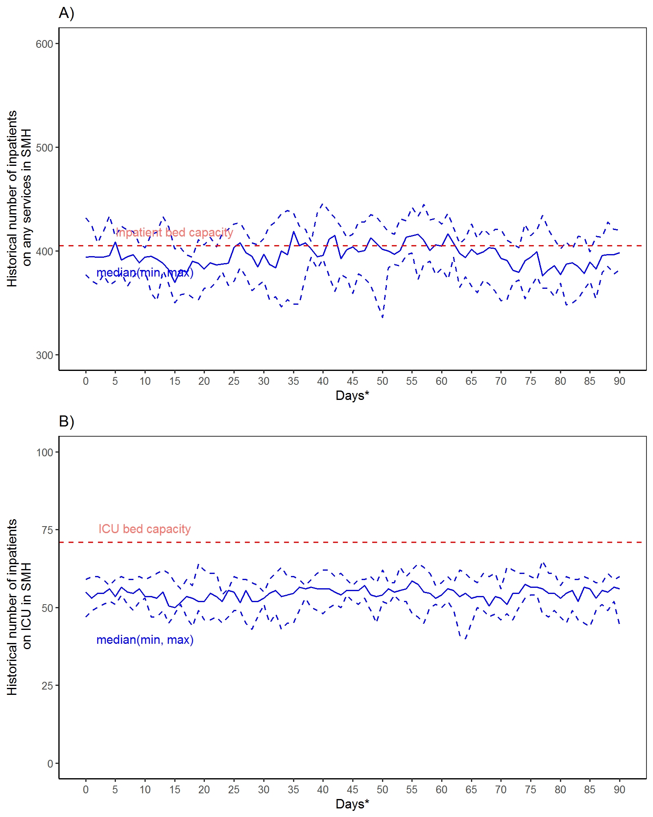

Figure A4. Baseline (2014-2019) daily census for non-ICU (A) and ICU (B) inpatients at St. Michael’s Hospital using March to May for the 90 day period. The dashed red line indicates each hospital’s bed capacity.

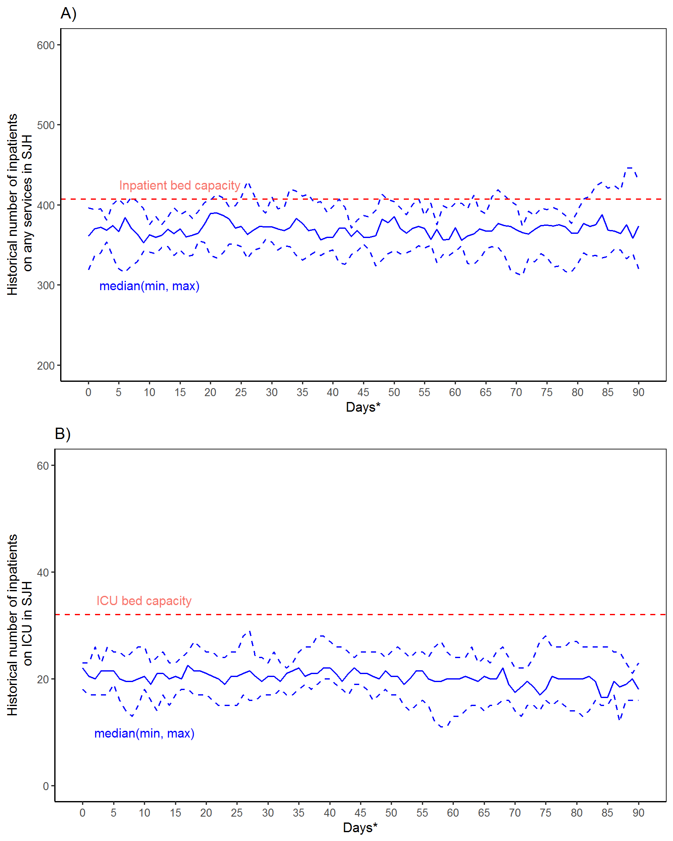
Figure A5. Baseline (2014-2019) daily census for non-ICU (A) and ICU (B) inpatients at St. Joseph’s Health Centre using March to May for the 90 day period. The dashed red line indicates each hospital’s bed capacity.

References

1. Soetaert K, Petzoldt T, Setzer RW. Solving differential equations in R: package deSolve. J Stat Softw. 2010;33(9):1-25. DOI:10.18637/jss.v033.i09.
2. Ma H, Wang L, Landsman D, Yiu K, Mishra S. COVID-19 GTA surge planning [Internet]. 2020. Available from: https://github.com/mishra-lab/covid-GTA-surge-planning.
3. World Health Organization. Laboratory testing for coronavirus disease (COVID-19) in suspected human cases: interim guidance. 2020 Mar 19, 2020. Available from: https://www.who.int/publications-detail/laboratory-testing-for-2019-novel-coronavirus-in-suspected-human-cases-20200117.
4. World Health Organization. Coronavirus disease 2019 (COVID-19): situation report – 73. 2020 Apr 2, 2020. Available from: https://www.who.int/docs/default-source/coronaviruse/situation-reports/20200402-sitrep-73-covid-19.pdf?sfvrsn=5ae25bc7_2.
5. Guan WJ, Ni ZY, Hu Y, Liang WH, Ou CQ, He JX, et al. Clinical characteristics of coronavirus disease 2019 in China. N Engl J Med. 2020. DOI:10.1056/NEJMoa2002032.
6. Guan WJ, Liang WH, Zhao Y, Liang HR, Chen ZS, Li YM, et al. Comorbidity and its impact on 1,590 patients with COVID-19 in China: a nationwide analysis. medRxiv [Preprint]. 2020. DOI:10.1101/2020.02.25.20027664.
7. World Health Organization. Report of the WHO-China joint mission on coronavirus disease 2019 (COVID-19). 2020.
8. Wang D, Hu B, Hu C, Zhu F, Liu X, Zhang J, et al. Clinical characteristics of 138 hospitalized patients with 2019 novel coronavirus-infected pneumonia in Wuhan, China. JAMA. 2020. DOI:10.1001/jama.2020.1585.
9. Spiteri G, Fielding J, Diercke M, Campese C, Enouf V, Gaymard A, et al. First cases of coronavirus disease 2019 (COVID-19) in the WHO European Region, 24 January to 21 February 2020. Euro Surveill. 2020;25(9). DOI:10.2807/1560-7917.es.2020.25.9.2000178.
10. Yang X, Yu Y, Xu J, Shu H, Xia J, Liu H, et al. Clinical course and outcomes of critically ill patients with SARS-CoV-2 pneumonia in Wuhan, China: a single-centered, retrospective, observational study. Lancet Respir Med. 2020. DOI:10.1016/s2213-2600(20)30079-5.
11. Wu Z, McGoogan JM. Characteristics of and important lessons from the coronavirus disease 2019 (COVID-19) outbreak in China: summary of a report of 72 314 cases from the Chinese Center for Disease Control and Prevention. JAMA. 2020. DOI:10.1001/jama.2020.2648.
12. Huang C, Wang Y, Li X, Ren L, Zhao J, Hu Y, et al. Clinical features of patients infected with 2019 novel coronavirus in Wuhan, China. Lancet. 2020;395(10223):497-506. DOI:10.1016/s0140-6736(20)30183-5.
13. Zhou W, Liu Y, Tian D, Wang C, Wang S, Cheng J, et al. Potential benefits of precise corticosteroids therapy for severe 2019-nCoV pneumonia. Signal Transduct Target Ther. 2020;5:18. DOI:10.1038/s41392-020-0127-9.
14. Liu Y, Eggo RM, Kucharski AJ. Secondary attack rate and superspreading events for SARS-CoV-2. Lancet. 2020;395(10227). DOI:10.1016/S0140-6736(20)30462-1.
15. Barnett ML, Grabowski DC. Nursing homes are ground zero for COVID-19 pandemic. JAMA. 2020;Epub ahead of print. Available from: https://jamanetwork.com/channels/health-forum/fullarticle/2763666.
16. Wang L, Mishra S. Travel-related COVID-19 cases in GTA [Internet]. 2020. Available from: https://github.com/mishra-lab/covid-GTA-surge-planning/blob/b7ab18067c9e7e19f07460398ad0fd8e2477fa0f/data/travel.csv.
17. Li Q, Guan X, Wu P, Wang X, Zhou L, Tong Y, et al. Early transmission dynamics in Wuhan, China, of novel coronavirus-infected pneumonia. N Engl J Med. 2020. DOI:10.1056/NEJMoa2001316.
18. Zhang S, Diao MY, Yu W, Pei L, Lin Z, chen D. Estimation of the reproductive number of novel coronavirus (COVID-19) and the probable outbreak size on the Diamond Princess cruise ship: a data-driven analysis. Int J Infect Dis. 2020;93(April):201-4.
19. Jung SM, Akhmetzhanov AR, Hayashi K, Linton NM, Yang Y, Yuan B, et al. Real-time estimation of the risk of death from novel coronavirus (COVID-19) infection: inference using exported cases. J Clin Med. 2020;9:523.
20. Zhao S, Cao P, Gao D, Zhuang Z, Chong MKC, Cai Y, et al. Epidemic growth and reproduction number for the novel coronavirus disease (COVID-19) outbreak on the Diamond Princess cruise ship from January 20 to February 19, 2020: a preliminary data-driven analysis. SSRN [Preprint]. 2020. Available from: https://ssrn.com/abstract=3543150.
21. Shen M, Peng Z, Xiao Y, Zhang L. Modelling the epidemic trend of the 2019 novel coronavirus outbreak in China. bioRxiv [Preprint]. 2020. DOI:10.1101/2020.01.23.916726. Available from: https://doi.org/10.1101/2020.01.23.916726.
22. World Health Organization. Statement on the meeting of the International Health Regulations (2005) Emergency Committee regarding the outbreak of novel coronavirus (2019-nCoV) [press release]. Geneva, Switzerland, Jan 23, 2020 2020.
23. Liu Y, Gayle AA, Wilder-Smith A, Rocklöv J. The reproductive number of COVID-19 is higher compared to SARS coronavirus. J Travel Med. 2020;27(2):taaa021. DOI:10.1093/jtm/taaa021.
24. Ferguson NM, Laydon D, Nedjati-Gilani G, Imai N, Ainslie K, Baguelin M, et al. Impact of non-pharmaceutical interventions (NPIs) to reduce COVID19 mortality and healthcare demand. 2020. Available from: https://www.imperial.ac.uk/media/imperial-college/medicine/sph/ide/gida-fellowships/Imperial-College-COVID19-NPI-modelling-16-03-2020.pdf.
25. Fan Z, Chen L, Li J, Tian C, Zhang Y, Huang S, et al. Clinical features of COVID-19-related liver damage. medRxiv [Preprint]. 2020. DOI:10.1101/2020.02.26.20026971.
26. Liu L, Gao JY, Hu WM, Zhang XX, Guo L, Liu CQ, et al. Clinical characteristics of 51 patients discharged from hospital with COVID-19 in Chongqing, China. medRxiv [Preprint]. 2020. DOI:10.1101/2020.02.20.20025536.
27. Tian S, Hu N, Lou J, Chen K, Kang X, Xiang Z, et al. Characteristics of COVID-19 infection in Beijing. J Infect. 2020. DOI:10.1016/j.jinf.2020.02.018.
28. Xu XW, Wu XX, Jiang XG, Xu KJ, Ying LJ, Ma CL, et al. Clinical findings in a group of patients infected with the 2019 novel coronavirus (SARS-Cov-2) outside of Wuhan, China: retrospective case series. BMJ. 2020;368:m606. DOI:10.1136/bmj.m606.
29. You C, Deng Y, Hu WM, Sun J, Lin Q, Zhou F, et al. Estimation of the time-varying reproduction number of COVID-19 outbreak in China. medRxiv [Preprint]. 2020. DOI:10.1101/2020.02.08.20021253.
30. Backer JA, Klinkenberg D, Wallinga J. Incubation period of 2019 novel coronavirus (2019-nCoV) infections among travellers from Wuhan, China, 20-28 January 2020. Euro Surveill. 2020;25(5). DOI:10.2807/1560-7917.es.2020.25.5.2000062.
31. Lauer SA, Grantz KH, Bi Q, Jones FK, Zheng Q, Meredith HR, et al. The incubation period of coronavirus disease 2019 (COVID-19) from publicly reported confirmed cases: estimation and application. Ann Intern Med. 2020. DOI:10.7326/m20-0504.
32. Tindale LC, Coombe M, Stockdale JE, Garlock ES, Lau WYV, Saraswat M, et al. Transmission interval estimates suggest pre-symptomatic spread of COVID-19. medRxiv [Preprint]. 2020. DOI:10.1101/2020.03.03.20029983.
33. Wolfel R, Corman VM, Guggemos W, Seilmaier M, Zange S, Muller MA, et al. Virological assessment of hospitalized cases of coronavirus disease 2019. medRxiv [Preprint]. 2020. DOI:10.1101/2020.0305.20030502.
34. Nishiura H, Linton NM, Akhmetzhanov AR. Serial interval of novel coronavirus (COVID-19) infections. Int J Infect Dis. 2020. DOI:10.1016/j.ijid.2020.02.060.
35. Zhao S, Gao D, Zhuang Z, Chong MKC, Cai Y, Ran J, et al. Estimating the serial interval of the novel coronavirus disease (COVID-19): a statistical analysis using the public data in Hong Kong from January 16 to February 15, 2020. medRxiv [Preprint]. 2020. DOI:10.1101/2020.02.21.20026559.
36. Government of Canada. Coronavirus disease (COVID-19): outbreak update 2020. Available from: https://www.canada.ca/en/public-health/services/diseases/2019-novel-coronavirus-infection.html.
37. Zhang GQ, Hu C, Luo LJ, Fang F, Chen YF, Li JG, et al. Clinical features and treatment of 221 patients with COVID-19 in Wuhan, China. SSRN [Preprint]. 2020. Available from: https://papers.ssrn.com/sol3/papers.cfm?abstract_id=3546095.
38. Sun P, Qie S, Liu Z, Ren J, Li K, Xi J. Clinical characteristics of hospitalized patients with SARS-CoV-2 infection: a single arm meta-analysis. J Med Virol. 2020. DOI:10.1002/jmv.25735.
39. Shim E, Tariq A, Choi W, Lee Y, Chowell G. Transmission potential of COVID-19 in South Korea. medRxiv [Preprint]. 2020. DOI:10.1101/2020.02.27.20028829.
40. Porcheddu R, Serra C, Kelvin D, Kelvin N, Rubino S. Similarity in case fatality rates (CFR) of COVID-19/SARS-COV-2 in Italy and China. J Infect Dev Ctries. 2020;14(2):125-8. DOI:10.3855/jidc.12600.
41. Fine PE. The interval between successive cases of an infectious disease. Am J Epidemiol. 2003;158(11):1039-47. DOI:10.1093/aje/kwg251.
42. COVID-19 Canada Open Data Working Group. Epidemiological data from the COVID-19 outbreak in Canada [Internet]. 2020. Available from: https://github.com/ishaberry/Covid19Canada.
43. Johns Hopkins University Center for Systems Science and Engineering. 2019 novel coronavirus COVID-19 (2019-nCoV) data repository [Internet]. 2020. Available from: https://github.com/CSSEGISandData/COVID-19.
44. Dong E, Du H, Gardner L. An interactive web-based dashboard to track COVID-19 in real time. Lancet Infect Dis 2020;Epub ahead of print. DOI:10.1016/S1473-3099(20)30120-1. Available from: https://doi.org/10.1016/S1473-3099(20)30120-1.
45. Wikipedia. 2020 coronavirus pandemic in Italy 2020. Available from: https://en.wikipedia.org/wiki/2020_coronavirus_pandemic_in_Italy.
46. Yiu K, Lin W, Mishra S. COVID-19 GTA cumulative time series (as of March 25, 2020) [Internet]. 2020. Available from: https://github.com/mishra-lab/covid-GTA-surge-planning/blob/b5be48bf3b45e4fa3c0a3b1fc3101336eba31133/data/time_series_19-covid_GTA_clean_Mar25.xlsx.
47. City of Toronto. COVID-19: Medical Officer of Health statements 2020. Available from: https://www.toronto.ca/home/covid-19/media-room/moh-statements/.
48. Government of Ontario. The 2019 novel coronavirus (COVID-19) 2020. Available from: https://www.ontario.ca/page/2019-novel-coronavirus.
49. Durham Region. COVID-19 update 2020. Available from: https://www.durham.ca/en/health-and-wellness/novel-coronavirus-update.aspx#.
50. York Region. COVID-19 2020. Available from: https://www.york.ca/wps/portal/yorkhome/health/yr/infectiousdiseasesandprevention/covid19/covid19/!ut/p/z1/tVRNc4IwEP0tHjwyWT4q8YhoBRyx01aFXJwIUdNKUIha-usbnX6clOm05JBsMrtv814yDxEUISLoka-p5LmgW7WPSWfhO0Pf80YQTCzsggMTJzBsDIOujuaXBMOwOp7uQgDeBIN_bz_c9bGnw8hA5Hb9DBFEdglPUWximtrpkmnUMqlm6TjRaLrsaOYSIO1YGOs2PWcnQu7kBsVVsUhyIZmQbajy4lVtSsnl4XKwyTOmZka3ctMGLlYsUZQOZcpLRktWUpHuCnZUuYpoG5L8yFO9-x188rpx8TMvuDIcUPWkLiVWLeyrLR4NND9ydkJTkReZeoqnXyrl1XbQ_9ihBt5sFN6GZuGNZuH_R5zAB1d3FPzQHJjgGL6Le2aAw7BZ7cNmtQ-b1T5s9t_P_ipOUOeZypSNYuyO1wqWyo2m3C1HUY3HoejL2n4CFPOX_Z44ylPPRvomUdSoqe6yaYbNShPvvVAbukt8el5lt5Z5vzo5rdYHUF08-Q!!/dz/d5/L2dBISEvZ0FBIS9nQSEh/#.XnpqLohKhPa.
51. Halton Region. COVID-19 (2019 novel coronavirus) 2020. Available from: https://www.halton.ca/For-Residents/Immunizations-Preventable-Disease/Diseases-Infections/New-Coronavirus.
52. Region of Peel. Novel coronavirus (COVID-19) 2020. Available from: https://www.peelregion.ca/coronavirus/.
53. Gamrot S. Peel Public Health and Ontario reporting different numbers for total confirmed coronavirus cases. Mississaugacom. 2020 Mar 20. Available from: https://www.mississauga.com/news-story/9912032-peel-public-health-and-ontario-reporting-different-numbers-for-total-confirmed-coronavirus-cases/.
54. Donovan K. Huge backlog in COVID-19 test results means Ontario is making decisions based on old information. Toronto Star. 2020 Mar 18. Available from: https://www.thestar.com/news/canada/2020/03/18/huge-backlog-in-covid-19-test-results-means-ontario-is-making-decisions-based-on-old-information.html.
55. Kim E, Paterson JM, Ischiguro L, Schull M. Surge planning for COVID-19 at the hospital level. Applied Health Research Question #2020 0950 074 000. Toronto: ICES; 2020.

