Supplementary Figure 1. MR analysis of expression of ACE in blood with schizophrenia
The top panel shows the strength of association (-log₁₀(p-value)) between SNPs in the region and schizophrenia (grey dots). The diamonds indicate the SMR p-value for association between expression of the annotated gene and schizophrenia. The lower panels show the strength of association (-log₁₀(p-value)) between SNPs and gene expression in blood i.e. eQTL association. Genes shown in maroon are statistically significant after multiple testing correction (SMR p-value < 7.6x10⁻⁴), while genes in blue are not significantly associated.

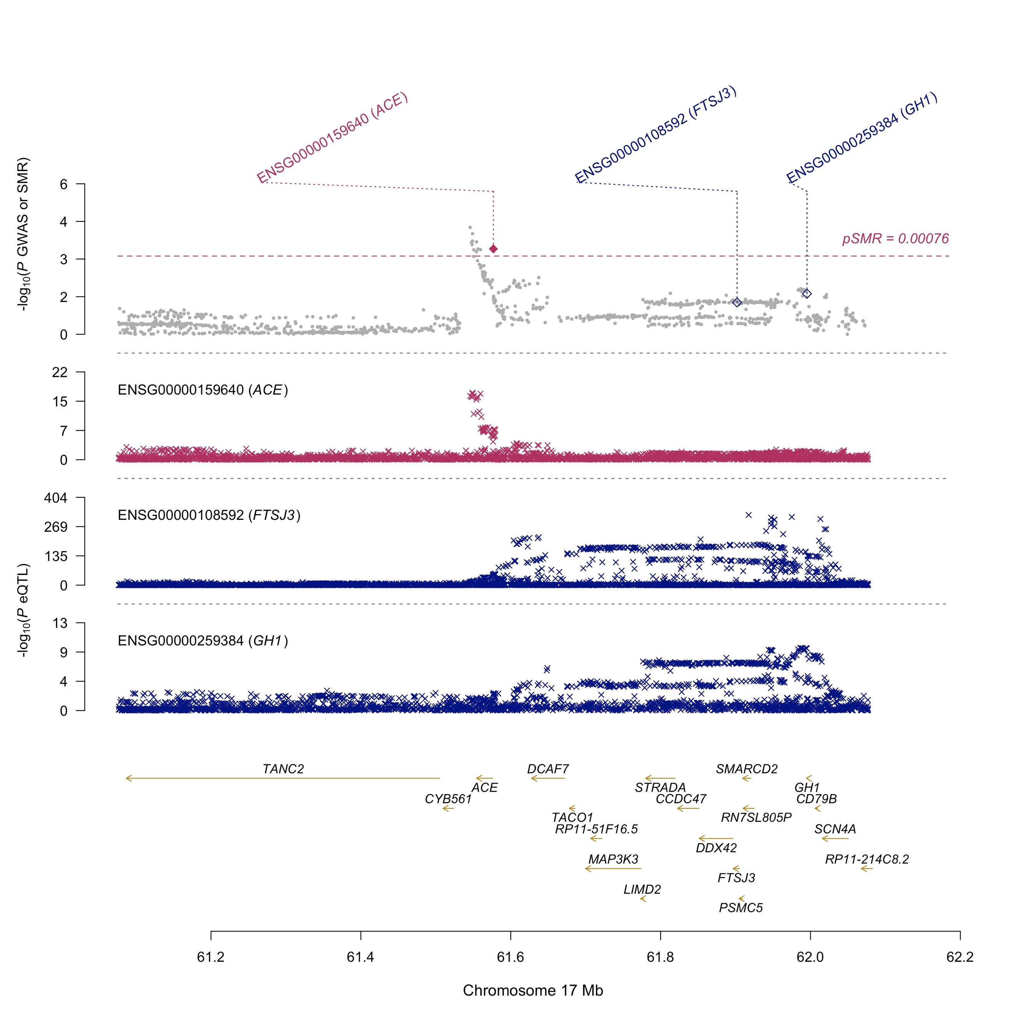

Supplementary Figure 1. MR analysis of systolic blood pressure as exposure with schizophrenia risk. The plots show the effect sizes and standard errors (error bars) for the associations of independent SNP instruments for the exposure of interest and schizophrenia. SNP effects on the systolic blood pressure (b_{zx} ; mmHg per effect allele) are shown on the x-axis, while the effects on schizophrenia risk (b_{zy} ; log odds per effect allele) are shown on the y-axis. The p-value for the MR association is shown

