Supplementary Figure 1. The computed tomography images of pneumonia patients with negative (A, B) and positive (C, D) real-time reverse transcription polymerase chain reaction test results for SARS-CoV-2.

Case 1  (Negative SARS-CoV-2) | Case 2  (Negative SARS-CoV-2)
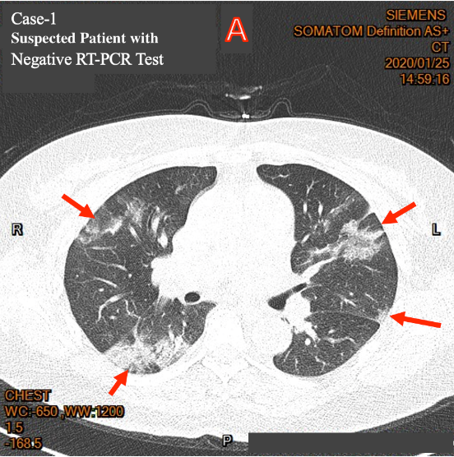 | 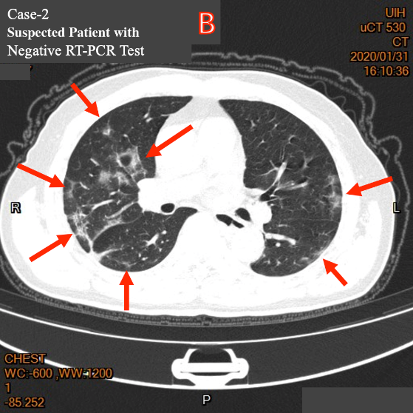
Case 3  (Positive SARS-CoV-2) | Case 4  (Positive SARS-CoV-2)
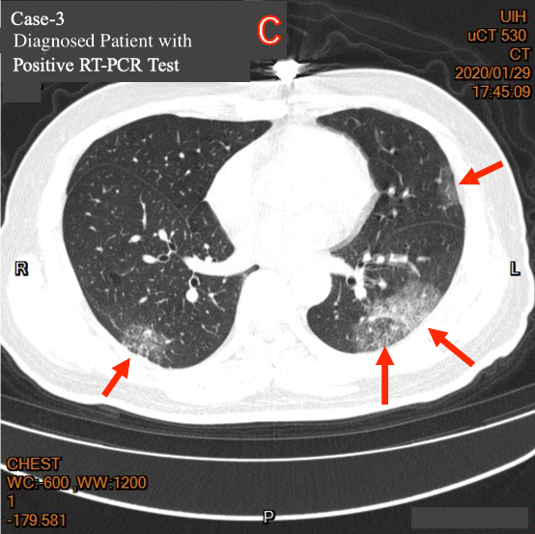 | 